MARKETING FUNDAMENTALS
Assignment Title: Marketing Process
Group Report by: Mirela Oprea
Iulian Neagu
Raducu Voinic
Module code: LCBB4004
Lecturer: Nazia Saeed

Table of Contents
Introduction 3
Company details 3
Business objectives 4
Role of the marketing environment 4
STP analysis 8
Different stages of marketing 9
4P marketing mixes and the role of marketing mix at every stage of the marketing process 10
Conclusion 12
References 13

Introduction < Made by Iulian Neagu>

Marketing helps businesses define their goal and make strategic decisions based on current trends (Eastmure et al., 2020). A business uses the marketing process to show customers a product or service's potential. Targeting customers, devising a marketing plan, implementing the strategy, and generating client value are its stages (Barry and MacDonald 2018). The study evaluates the marketing mix across the organisational marketing process for long-term performance (Jackson et al., 2019). It assesses Marks & Spencers' business potential (Mulder, 2019).

Company details
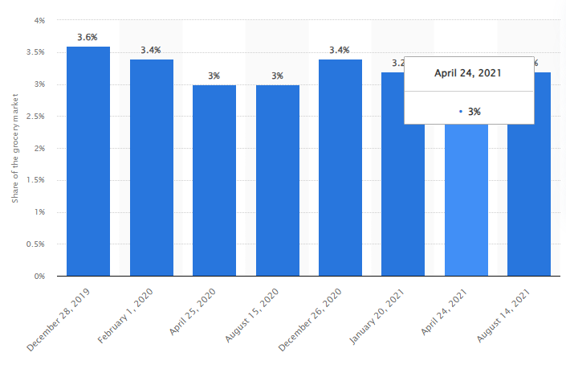
Figure: Company growth rate
Source: (Statista, 2022)

London-based Marks & Spencer Plc is a notable British multinational retailer. From 2019 to 2022, the company's revenue grew 4% (Pohjakallio, 2020). Market expansion is a goal together with corporate strategy and administrative process changes (Bocken, 2017). Sales generation potential increased 5% from 2020-2021.

Business objectives
- To identify the importance of pricing strategy in achieving success in the process of market segmentation.
- To analyse the strategy of the digital business promotion process to influence purchasing decisions of targeted demography.
- To understand the importance of product design in getting opportunities for competitive market positioning.

Role of the marketing environment
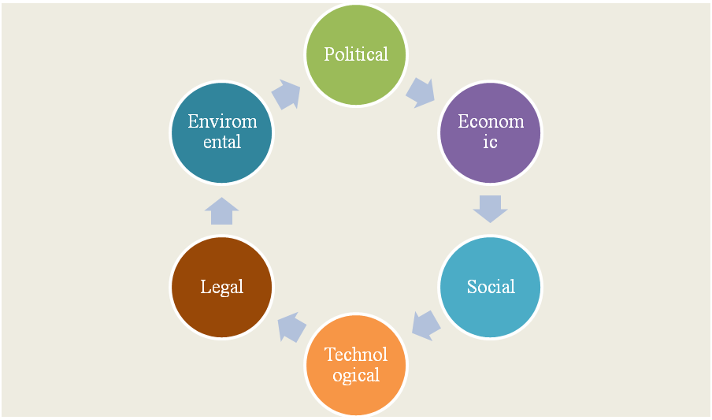
Figure: PESTLE analysis
Source: (made by the learner)
Factors | Impact
Political | - As a constitutional monarchy, it uses a unitary parliamentary system of government. It has given retailers more flexibility (Asioli et al., 2023). Retailers can expand their markets.  - UK government engagement with UK Trade & Investment Authority raised retail sales by 11% from 2021-2022. Marks & Spencer can expand its market (Asche et al., 2021).
Economic | - The nation has seen a 5% GDP growth rate in the past three years, with a 3% gain in purchasing power parity for retail companies. It has helped retail brands like Marks & Spencer grow (Asche et al., 2021).  - Government retail infrastructure investment has grown 7% in two years. It has allowed Marks & Spencer to expand (Parsons 2022).
Social | - About 15% of urban natives and 7% of rural natives prefer to shop in retail supermarkets. This makes market expansion simpler for retailers like Marks & Spencer (Parsons 2022).  - As a constitutional monarchy, the UK retail industry grew 3% from 2021-2022 due to social development. Marks & Spencer is expanding its market (Asche et al., 2021).
Technological | - In the past two years, AI and IoT tools have seen an 8% increase in their use in digital media promotions for organisations. Retailers like Marks & Spencer can expand their reach (Parsons 2022).  - The use of social media for customer contact has increased by 7% since mid-2020.  - ● Technology has altered marketing fundamentals, with 25% of retail firms adopting social media marketing. It cut promotional costs by 11%, giving Marks & Spencer increased business (Asioli et al., 2023).
Legal | - In the previous two years, AI and IoT solutions have increased 8% in digital media marketing for businesses. Marks & Spencer can grow (Parsons 2022).  - Customer communication on social media has grown 7% since mid-2020.  - • Technology has changed marketing principles, with 25% of retail enterprises using social media. It reduced promotional costs by 11%, increasing Marks & Spencer business (Asioli et al., 2023).
Environmental | - The 2014 Environment Protection Law prioritises carbon footprint and industry waste reduction. Its positive brand image gives it a market edge (Asioli et al., 2023).
Table: PESTLE analysis
Source: (Made by the learner)
All of the above variables indicate that UK retail companies have considerable market expansion potential. Understanding market needs optimises long-term performance.
Swot analysis <Made by Raducu Voinic>
Strengths | Weaknesses
- Global Operations  All brands aim worldwide expansion to attract customers. Global market-independent brands are strong. Global enterprises help Marks and Spencer. It has 1,035 UK and 452 international outlets from one booth. Amazon and physical retailers provide global service. Marks and Spencer's market dependence decreases with globalisation.  - Satisfied Customers  Any firm requires customers. Thus, customer happiness signifies business success. Brands assess customer happiness with feedback. Customer satisfaction is M&S's strength. Marks and Spencer has offered tempting deals for nearly a century.  A recent study found that UK buyers preferred Marks and Spencer in-store supermarkets. Love and support reassure Marks and Spencer.  - Vast Experience  Business success requires experience. Companies may confront unusual conditions. Inexperience in such situations might be disastrous. Marks and Spencer has sold products for over a century. It survived pandemics, recessions, and World Wars. With such experience, the retailer can overcome tremendous obstacles. | - Sales fall  Businesses increase sales to maximise profits. A reduction in a brand's sales will affect revenue and the company. Marks and Spencer sales have been falling. Mismanagement at Marks and Spencer caused this decrease. Sales fell in 2019 due to inadequate supply chain management. Sales fell due to a 2017 Christmas supply shortage.  - Many Outlets  Broad domestic and international operations are brand strengths. However, rising enterprises face several problems. M&S is global and domestic. Although strong, it is vulnerable. Marks and Spencer difficulties with shop management.  The brand's enormous operations make it hard to supervise each branch, which is a negative.  - High Operating Costs  Businesses maximise profit with reduced operational costs. Financial challenges may arise for enterprises. Marks and Spencer is expensive to run. Marks and Spencer did not automate to grow. Manual techniques cost time, resources, and labour for the company. This boosts costs and lowers profitability.
Opportunities | Threats
- Move to Automation  Labour can sometimes work. However, technology can operate faster and replace humans. Automation lowers operating expenses and boosts income. Marks and Spencer is expensive to run. Automation may fix this. Consider Marks and Spencer replacing machinery with workers. This increases company and brand efficiency and profit.  - E-Commerce  Internet use has increased, making eCommerce a vital platform for retailers to grow. Marks and Spencer's online store lacks. M&S can expand online via eCommerce. This will let the company enter new markets without retail setup fees.  - Increase Global Presence  Businesses enter global markets to boost profitability and reduce local dependence.  Marks and Spencer can enter new overseas markets. It grows in developing countries and populous nations like China and India. M&S sales and revenue will increase. | - Tough Competition  Businesses worry because competitors can grab market share at any time. Retail is very competitive. Marc and Spencer competes in this industry. Mark & Spencer faces Macy's and Tesco after 100 years in retail. Thus, Marks and Spencer must innovate or compete.  - Global Recession  Recessions scare businesses. Businesses suffer greatly during recessions. Inflation diminishes demand and raises operational costs.  Most recent global recession was 2008. However, another worldwide recession is likely. Marks and Spencer may fail in recession.  COVID-19 affects enterprises worldwide. Heavy losses for businesses. Global openness does not eliminate new COVID-19 strains.  Like others, COVID-19 lockdowns cost Marks and Spencer money. NEW COVID-19 waves will harm the corporation.

STP analysis <Made by Mirela Oprea>
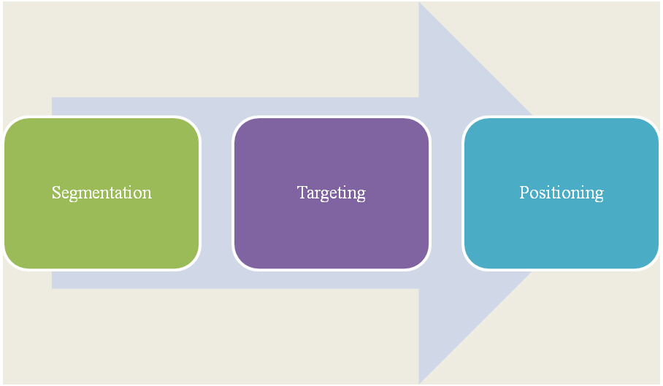
Figure: STP analysis
Source: (Made by the learner)
Segmentation
Market segmentation groups buyers by intent (Schovsbo, 2018). Four types include demographic, geographic, physiographic (Barry and MacDonald 2018). The company emphasised client age, gender, income, race, and nation for market expansion after demographic segmentation (Bocken, 2017).
Targeting
Corporate promotions influence a specific consumer segment's purchase decisions (Hull and Scott 2020). It targets both genders, age categories 20-65, medium and high-income levels, and receding in the UK and other targeted nations using demographic market segmentation.
Positioning
Branding and market implementation. Comparative marketing positioning gives the brand an edge and emphasises commercial value. Higher chances of long-term commercial success (Grębosz-Krawczyk & Siuda 2019).
Perceptual map
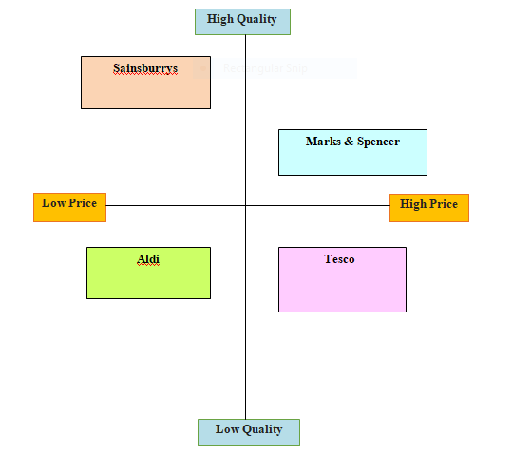
Figure: Perceptual map
Source: (Made by the learner)

Distinct stages of marketing

Marketing, the foundation of business growth, includes market analysis, customer identification, customer-driven marketing plan development, integrated market expansion principles, long-term customer relationships, and market value capture (Barry and MacDonald 2018). To succeed long-term, Marks & Spencer must use a 4P marketing mix that integrates product, price, place, and promotion (Schovsbo, 2018). Each marketing mix component can be justified and used to achieve the aim (Eastmure et al., 2020).

4P marketing mixes and the role of marketing mix at every stage of the marketing process
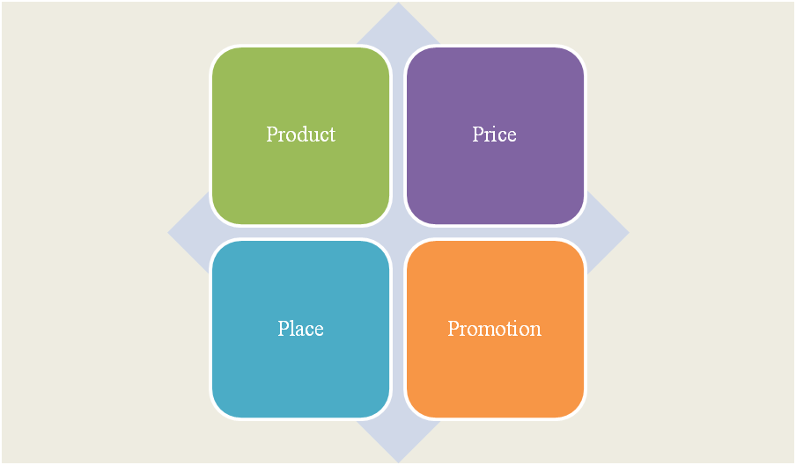
Figure: 4P marketing mix
Source: (Made by the learner)
Product  - The Product range of the company includes clothing, beauty products, food and beverage, and home furnishing goods (Grębosz-Krawczyk and Siuda 2019).  - Key features of product offerings include high quality, durability, and a well-made core structure. | Price  - Cost-based pricing strategy to ensure profitability regarding raw material, labour cost and resources for operation management (Hull and Scott 2020).  - Value-based premium pricing strategy has focused on quality, durability, and innovation regarding the products offered (Gilani and Cunningham 2017).
Place  - Online presence increased the scope of the company to diversify the international revenue stream (Barry and MacDonald 2018).  - Different store formats are followed in these places such as department stores, standalone food stores, and outlet stores. | Promotion  - The company engages PR agencies to develop a positive brand reputation in the market (Schovsbo, 2018).  - The traditional form of business promotion is followed with the help of television paper, and magazines.  - Different social media platforms such as Facebook, Instagram and LinkedIn are used to expand the brand image (Bocken, 2017).
Table: 4P marketing mix
Source: (Made by the learner)
The marketing mix gives the organisation an edge by covering all stages (Hull and Scott 2020). Clothing, beauty, food, drink, and home items are company products. So, different populations are easier to satisfy. Customers aged 20 and 40 have different product needs (Bocken, 2017). Customers of all genders, ages 20-65, middle and high income levels, and receding in the UK and other targeted nations are delighted with the product design concept.
Demographic segmentation and population access boost economic potential. Market growth is 7%, per Barry and MacDonald 2022. Market analysis, customer identification, customer-driven marketing strategy design, integrated market expansion concepts, long-term customer connections, and market value capture are balanced (Bocken, 2017).
To expand, companies need digital media marketing and customer engagement (Hull and Scott 2020). Barry and MacDonald (2018) identified the target audience and planned PR and digital expansion. UK retail has grown 8% annually for two years. Value-based pricing supports long-term company goals.

Conclusion
The talk said the organisation prioritises market and customer data, marketing strategy, value delivery, customer encounters, and value capture. Digital corporate marketing improve business goal implementation. Effective digital advertising help organisations manage their legacy and long-term performance.

References
Asche, F., Sogn-Grundvåg, G., Zhang, D., Cojocaru, A.L. and Young, J.A., 2021. Brands, labels, and product longevity: the case of salmon in UK grocery retailing. Journal of International Food & Agribusiness Marketing, 33(1), pp.53-68.
Asioli, D., Banovic, M., Barone, A.M., Grasso, S. and Nayga Jr, R.M., 2023. European consumers' valuation for hybrid meat: Does information matter? Applied Economic Perspectives and Policy, 45(1), pp.44-62.
Barry, C. and MacDonald, K., 2018. Ethical consumer of market vigilantism. Philosophy & Public Affairs, 46(3), pp.293-322.
Bocken, N., 2017. Business-led sustainable consumption initiatives: Impacts and lessons learned. Journal of Management Development, 36(1), pp.81-96.
Eastmure, E., Cummins, S. and Sparks, L., 2020. Non-market strategy as a framework for exploring commercial involvement in health policy: a primer. Social Science & Medicine, 262, p.113257.
Gilani, H. and Cunningham, L., 2017. Employer branding and its influence on employee retention: A literature review. The marketing review, 17(2), pp.239-256.
Grębosz-Krawczyk, M. and Siuda, D., 2019. Attitudes of young European consumers toward recycling campaigns of textile companies. Autex Research Journal, 19(4), pp.394-399.
Hull, A. and Scott, P., 2020. Tvalue ' off business archives: assessing the academic importance of corporate archival collections. Management & Organizational History, 15(1), pp.1-21.
Jackson, P., Evans, D.M., Truninger, M., Meah, A. and Baptista, J.A., 2019. The multiple ontologies of freshness in the UK and Portuguese agri‐food sectors. Transactions of the Institute of British Geographers, 44(1), pp.79-93.
Mulder, J., 2019. (Re) Conceptualising a Social Market Economy for the EU Internal Market. Utrecht L. Rev., 15, p.16.
Parsons, R., 2022. The role of plastic packaging in transforming food retailing. British Food Journal, 124(4), pp.1285-1300.
Pohjakallio, M., 2020. Secondary plastic products—examples and market trends. In Plastic waste and recycling (pp. 467-479). Academic Press.
Schovsbo, J., 2018. Mark My Words-Trademarks and Fundamental Rights in the EU. UC Irvine L. Rev., 8, p.555.

