

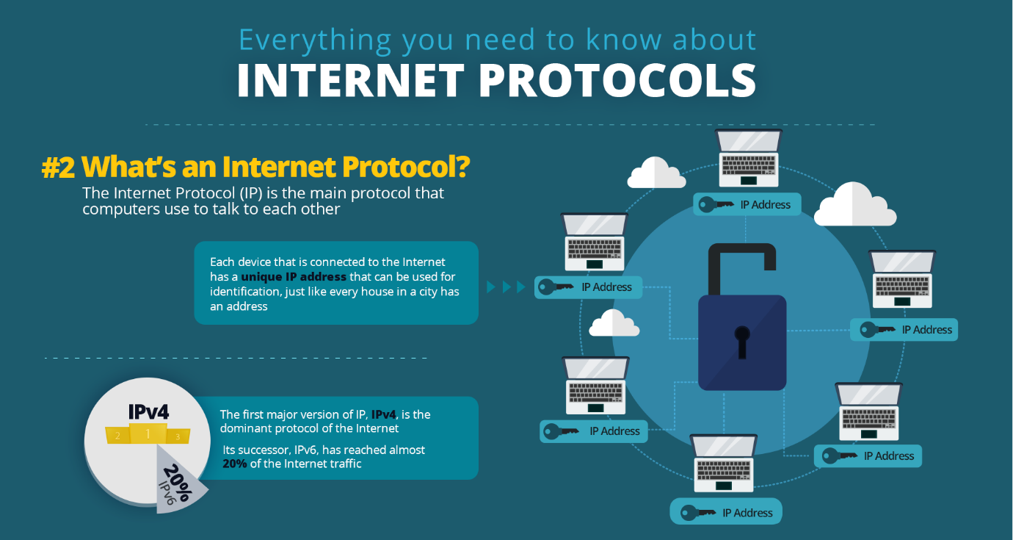

By
Asen Genov

University of wales Trinity Saint David
Student name: Asen Genov
Student id: 1906814
Course title: Internet Protocols
BSc Cloud Computing
Module Lecturer: Renuga Jayakumar

Table of Contents

I.Part. Introduction.

1.Ipv4 addressing ,unicast, multicast, broadcast.

1.1. IPv4 Addressing.

1.2. Unicast.

1.3. Multicast.

1.4 Broadcast.

2. IPv4 addressing and Classes A,B,C,D and E IP addressing.

3.Subneting IP Networks.

3.1. Fixed length subnet mask and Variable length subnet mask.

4.Public and Private IP addressing.

5.IPv6 addressing and Benefits.

6. Conclusion

II Part. Addressing scheme.

IPart1.Introduction.
The Internet Protocol , commonly referred to as the IP, is the main protocol to the Internet Protocol Suite. IP is a protocol used to communicate between devices linked to the internet. The main function of the IP is the transfer of datagrams from the source to the destination. There are two versions of IP that are IP version 4(IPv4) and (IPv6) IP version 6. IP addresses consist of binary numbers and are responsible for transmitting information over the internet.

1.1.IPv4 is the older version that supports a 32-bit address system. When IPv4 was developed, this address space was considered more than sufficient. But with the fast growing of the world of Internet and the computer technologies, wireless devises ,smartphones etc. this address space became too small, and we needed more address space.

1.2.Unicast.
The term used in this case has the meaning of the data that has been transported from the sender to the receiver via the communication channel to help them communicate, Unicast where the packet was sent from one device to another. This is the most widely used method of data transfer over the network, just like one-to-one transmission.
1.3.Multicast
IP multicasting allows a single host to send a packet to multiple receivers across a routed network. For example, routers use multicast routing algorithms to determinate the best route and transmit multicast datagrams over the network.
1.4.Broadcast.
A broadcast address is a network address used to transmit to all devices connected to a multi-access communication network. All network-attached hosts may receive a message sent to a broadcast address. In the broadcast address, all host bits are set to binary 1 and if all host bits are set to 0 then we are talking about subnet address. Each network or subnet has a dedicated broadcast address where all new users of the network may broadcast.
2.Ipv4 addressing and Classes A,B,C,D and E IP addressing.
IPv4 IP address has 5 separate types of IP ranges:
Class A IP address – the first bit is 0, with range between 0.0.0.0 to 127.255.255.255. This class is for large networks and has 8 network bits and 24 host bits.
Class B IP address-the first two bits are 10, and in range between 128.0.0.0 to 191.255.255.255.This class is for medium networks, which has 16 network bits and 16 host bits.
Class C IP address – the first three bits are 110, and range between 192.0.0.0 to 223.255.255.255. This class is for small networks and has 24 network bits and 8 host bits.
Class D IP address or multicast address - the first four bits are 1110 and range between 224.0.0.0 to 239.255.255.255
Class E IP address- the first five bits are 11110 and range between 240.0.0.0 to 255.255.255.255. This is a reserved class network; Its usage was never defined.

3. Subnetting IP networks.
Subnetting gives you the chance to create multiple logical networks that exist within a single class A,B or C network. Let us assume you split A,B and C networks into smaller subnetworks, which helps you to build a network of subnetworks that interconnect. And each source of data on that network will have a unique network / subnetwork ID. To subnet a network, the natural mask extension is required with some of the bits from the addresses host ID portion to create subnetwork. If you have even more host bits to use for a subnet mask you have more subnets available. However, if we have more subnets available, this means that we also have less host addresses per subnet available.
3.1.Fixed length subnet mask and Variable length subnet mask.
There is fixed length subnet mask and variable length subnet mask. If you are looking for public IP address VLSM is the best choice, but if you need private IP address FLSM is the best choice you can have. The reasons for this maybe that if we compare VLSM to FLSM, the key differences are that variable subnet mask has variable subnet sizes; variable number of hosts; different subnet masks. VLSM wastes minimum IP addresses, has more complex configuration and administration . It is also known as subnetting classes and only supports routing protocol classes. Therefore , subnetting is easy in VLSM subnets using block size-based requirement compared to FLSM , which allows all subnets to use same block size . We may place all segments in downward order based on block size. We may decide the subnet and some network facilities according to the network address and broadcast address. The first and the last address in each subnet are always reserved for the network address and broadcast address.
4. Public and private IP addresses
To access the internet a public IP address is used. Compared with private addresses, global IP addresses are routed over the internet. If you have a public IP address on your router or other device, you will be able to own a server – VPN,FTP,WEB. Etc .All internet servers and pages use public IP addresses. However , private addresses are not routed on the internet and can only function inside the local network. It is used to load network operating system.
5. IPv6 addressing.
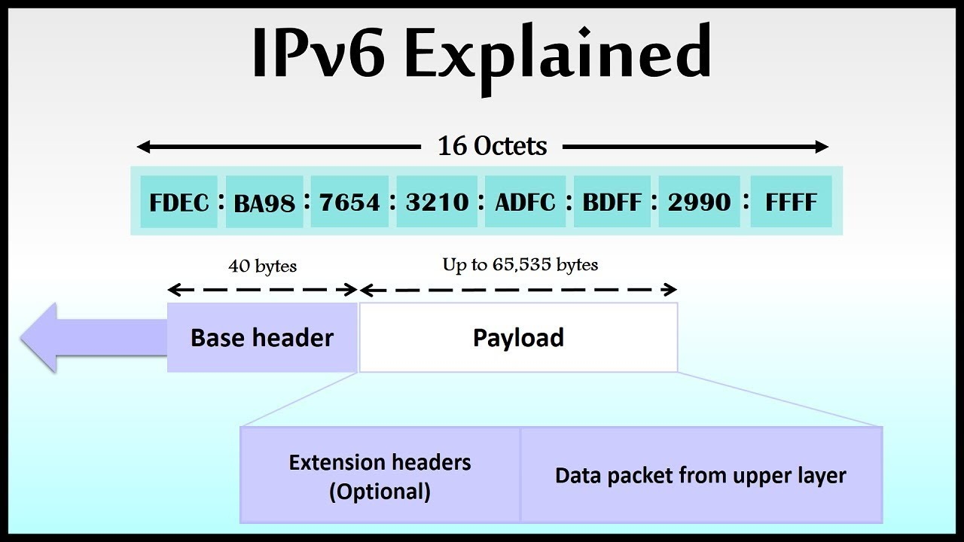
IPv6 was then developed by the IETF in 1998 to support the 128-bit IPv6 addressing scheme to replace IPv4 due IPv4 address exhaustion problem.
Later Internet Engineering Task Force declared IPv6 as an internet Standard in July 2017. The latest version of the internet Protocol is version 6 (IPv6). Apart from a wide room for URLS , IPv6 also offers several other advantages. But as we know, there are still some negative issues with all which has some positive aspects.
Benefits of IPv6.
The main advantage of using IPv6 is its large address space . The IPv6 address is 128 long . which means it can accommodate2128 different addresses. The subnet size in IPv6 is 264 addresses, which is about four billion times the size of the IPv4 address space. This vast subnet space makes possible to improve the overall efficiency of data transmission as well as the proper management of the network. Ipv4 has more efficient routing – simplified packet headers make processing more efficient. Direct data streams – Ipv6 supports non-broadcast multicasting. The IPv6 header has a new field named FLOW Label that can recognise packets belonging to the same flow. Also has a simplified network configuration – meaning Ipv6 has built-in auto-address configuration. Support for new services – without NAT (network address translation) a real end-to-end connection to the IP layer has been saved, allowing for new valuable services. The processing of IPv6 data packages is very efficient. When the data packet is transmitted , the checksum of the IP level does not need to be entered. IP level checksums is very important, but IPv6 can be ignored as there are already checksums on link layers and transport layers that provide error detection and then why waste the time when calculating the checksums for each router hop.
6.Conclusion.
When IPv4 address space was exhausted in 2011, and IPv6 was launched in June 2012, there was a major boom in the entire internet world. IPv6 was intended to replace IPv4 and provided a lot of benefits for users. Apart from a large address space, IPv6 also offers several other benefits. Various other benefits of IPv6 include multicasting, smooth data flow, enhanced security, efficient routing, and much more. But , as we know, there are negative issues with everything that have several positive aspects also. The issues surrounding the transition from IPv4 to IPv6 will be addressed in depth. These include compatibility issues, configuration problems resolved, problems with IP monitoring , problems with network performance etc. These problems will lead to a good transition from Ipv4 to IPv6, if treated correctly with a prior and sufficient preparedness.

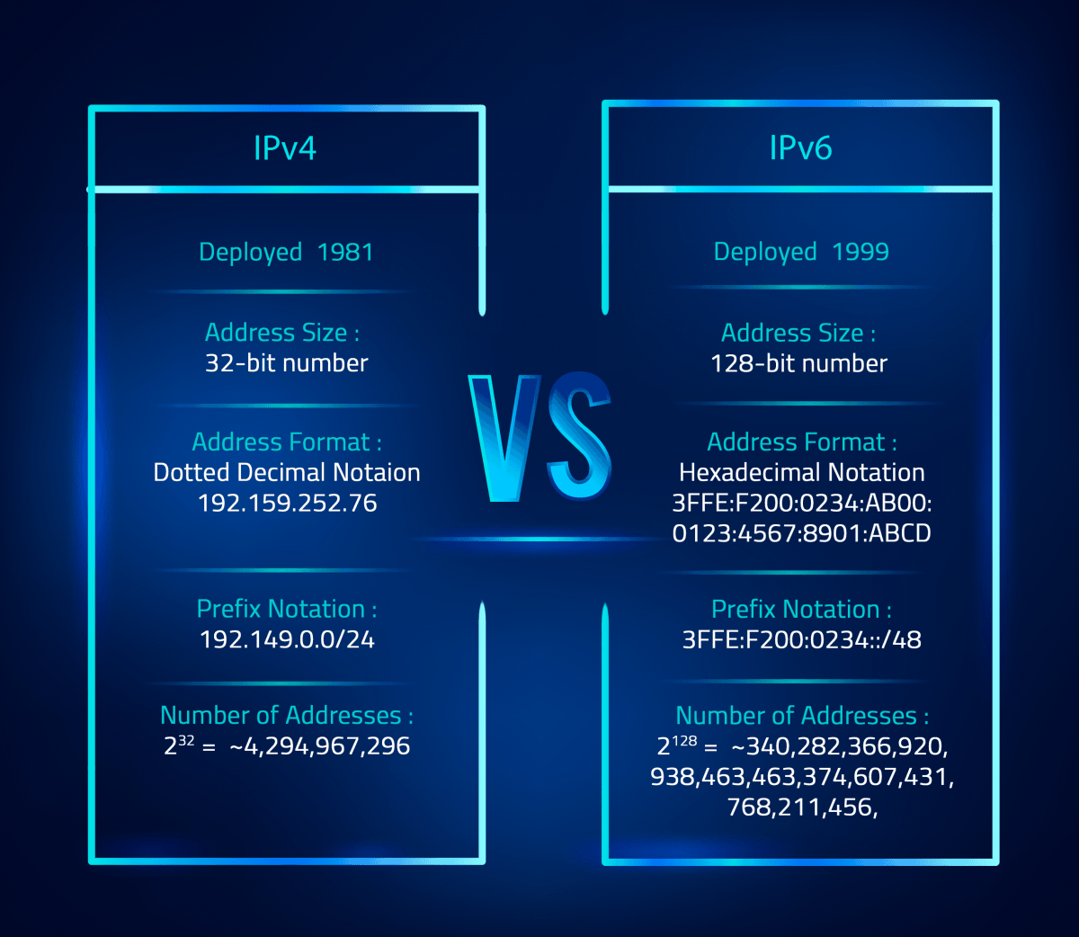

II.Part.2: IP addressing Scheme

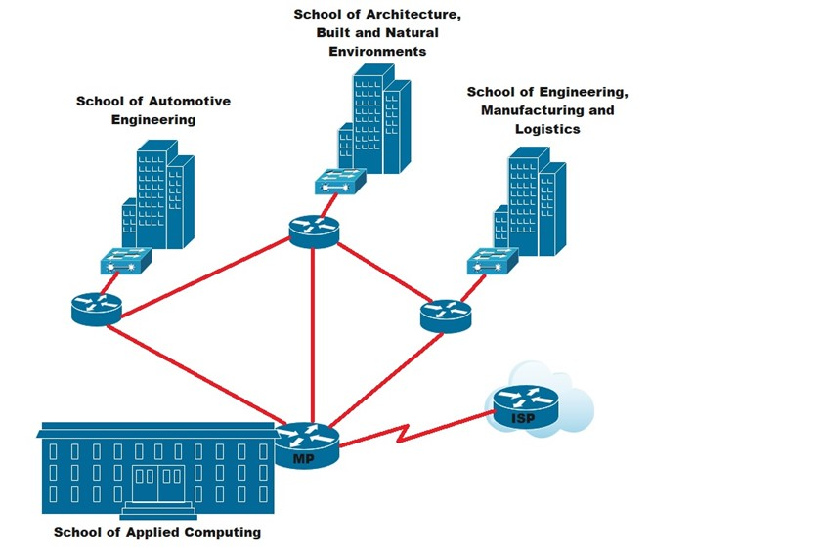

I choose the following address for the Facility’s network: 172.16.0.0/20.This is a class B address and can accommodate up to 4,094 hosts, which is more than enough to support 2000 users and future grow. I have subdivided it into four networks:
1.School of Applied Computing with network address:172.16.0.0/20, 1,022 allocated hosts,704 required for the labs, including an Open Access lab with 240 pcs and 5 printers.
2. School of Automotive Engineering with Network Address: 172.16.6.0/23, 510 hosts allocated, 285 hosts required for the labs.
3. School of Architecture, built in and Natural Environment with network address 172.16.3.0/23, 510 hosts allocated, 337 required for the labs.
4. School of Engineering Manufacturing and Logistics with network address 172.16.8.0/23, 510 hosts allocated ,278 required for the labs.

School of Applied Computing – Network Address 172.16.0.0/22
Lab no | Network Address | First IP Address | Last IP Address | Broadcast | Subnet Mask
OA – 245 devices | 172.16.0.0/24 | 172.16.0.1 | 172.16.0.254 | 172.16.0.255 | 255.255.255.0
TC-18 | 172.16.3.32/27 | 172.16.3.33 | 172.16.3.62 | 172.16.3.63 | 255.255.255.224
Staff 25 pcs | 172.16.2.224/27 | 172.16.2.225 | 172.16.2.254 | 172.16.2.255 | 255.255.255.224
Lab 201- 50 pcs | 172.16.1.192/26 | 172.16.1.193 | 172.16.1.254 | 172.16.1.255 | 255.255.255.192
Lab202- 30 pcs | 172.16.2.128/27 | 172.16.2.129 | 172.16.2.158 | 172.16.2.159 | 255.255.255.224
Lab 204 – 30 pcs | 172.16.2.160/27 | 172.162.161 | 172.16.2.190 | 172.16.2.191 | 255.255.255.224
Lab 205 – 20 pcs | 172.16.3.0/27 | 172.16.3.1 | 172.16.3.30 | 172.16.3.31 | 255.255.255.224
Lab 206 - 40 pcs | 172.16.2.0/26 | 172.16.2.1 | 172.16.2.62 | 172.16.2.63 | 255.255.255.192
Lab 301 – 120 pcs | 172.16.1.0/25 | 172.16.1.1 | 172.16.1.126 | 172.16.1.127 | 255.255.255.128
Lab 302 – 30 pcs | 172.16.2.192/27 | 172.16.2.193 | 172.16.2.222 | 172.16.2.223 | 255.255.255.224
Lab 303 – 60 pcs | 172.16.1.128/26 | 172.16.1.129 | 172.16.1.190 | 172.16.1.191 | 255.255.255.192
Lab 304 – 36 PCS | 172.16.2.64/26 | 172.16.2.65 | 172.16.2.126 | 172.16.2.127 | 255.255.255.192

School of Automotive Engineering – Network Address 172.16.0.0/23
Lab no | Network Address | First IP Address | Last IP Address | Broadcast | Subnet Mask
Staff – 20pcs | 172.16.7.64/27 | 172.16.7.65 | 172.16.7.94 | 172.16.7.95 | 255.255.255.224
Lab 101- 25 pcs | 172.16.7.32/27 | 172.16.7.33 | 172.16.7.62 | 172.16.7.63 | 255.255.255.224
Lab 102- 35pcs | 172.16.6.192/26 | 172.16.6.193 | 172.16.6.254 | 172.16.6.255 | 255.255.255.192
Lab 103 – 30 pcs | 172.16.7.0/27 | 172.16.7.1 | 172.16.7.30 | 172.16.7.31 | 255.255.255.224
Lab 206 -20 pcs | 172.16.7.96/27 | 172.16.7.97 | 172.16.7.126 | 172.16..7.127 | 255.255.255.224
Lab 207- 55 pcs | 172.16.6.128/26 | 172.16.6.129 | 172.16.6.190 | 172.16..6.191 | 255.255.255.192
CAD Lab – 20 pcs | 172.16.7.128/27 | 172.16.7.129 | 172.16.7.158 | 172.16..7.159 | 255.255.255.224
Lab 208 – 80 pcs | 172.16.6.0/25 | 172.16.6.1 | 172.16.6.126 | 172.16.6.127 | 255.255.255.192

School of Architecture, Build and Natural environments – Network Address 172.16.6.0/23
Lab no | Network Address | First IP Address | Last IP Address | Broadcast | Subnet Mask
Staff – 32 pcs | 172.16.4.0/26 | 172.16.4.1 | 172.16.4.62 | 172.16.4.63 | 255.255.255.192
Lab 301 – 54 pcs | 172.16.4.64/26 | 172.16.4.65 | 172.16.4.126 | 172.16.4.127 | 255.255.255.192
Lab 302 – 25 pcs | 172.16.4.128/27 | 172.16.4.129 | 172.16.4.158 | 172.16.4.159 | 255.255.255.224
Lab 303 – 30 pcs | 172.16.4.192/27 | 172.16.4.193 | 172.16.4.222 | 172.16.4.223 | 255.255.255.224
Lab 304 – 28 pcs | 172.16.5.0/27 | 172.16.5.1 | 172.16.5.30 | 172.16.5.31 | 255.255.255.224
Lab 401 – 35 pcs | 172.16.4.5.64/26 | 172.16.5.65 | 172.16.5.126 | 172.16.5.127 | 255.255.255.192
Lab 404 28- pcs | 172.16.5.128/27 | 172.16.5.129 | 172.16.5.158 | 172.16.5.159 | 255.255.255.224
Lab 406 – 60 pcs | 172.16.5.192/26 | 172.16.5.193 | 172.16.5.254 | 172.16.5.255 | 255.255.255,192
Lab 411- 45 pcs | 172.16.5.160 | 172.16.5.129 | 172.16.5.190 | 172.16.5.191 | 255.255.255.192

School of Engineering, Manufacturing and Logistics – Network Address 172.16.8.0/23
Lab no | Network Address | First IP Address | Last IP Address | Broadcast | Subnet Mask
Staff – 18 pcs | 172.16.8.0.27 | 172.16.8.1 | 172.168.30 | 172.16.8.31 | 255.255.255.224
Lab 301 -35 pcs | 172.16.8.32/26 | 172.16.8.1 | 172.16.8.62 | 172.16.8.63 | 255.255.255.192
Lab 302 – 30 pcs | 172.16.8.64/27 | 172.16.8.65 | 172.16.8.94 | 172.16.8.95 | 255.255.255.224
Lab 303 – 30 pcs | 172.16.8.96/27 | 172.16.8.97 | 172.16.8.126 | 172.16.8.127 | 255.255.255.224
Lab 304 – 25 pcs | 172.16.9.0/27 | 172.16.9.1 | 172.16.9.30 | 172.16.9.31 | 255.255.255.224
Lab 305 – 50 pcs | 172.16.8.192/26 | 172.16.8.193 | 172.16.8.254 | 172.16.8.255 | 255.255.255.192
Lab 307- 90 pcs | 172.16.9.160/25 | 172.16.9.129 | 172.16.9.254 | 172.16.9.255 | 255.255.255.128

DNS server | ::ffff:ac10:48
Email server | ::ffff:ac10:48
Finance server | ::ffff:ac10:48
Registry server | ::ffff:ac10:48
File server | ::ffff:ac10:48
Printer server | ::ffff:ac10:48
Link between MP and ISP server | ::ffff:ac10:48

