Project Management Processes
Rachel Vetter
1708006
March 2019
BMSP5008
Glenn Behenna

1.0 Executive summary
This report will Study some of the methodologies used within Project Management. The structured approach of PRINCE2, which is popular within the Private sector in the UK. Waterfall, that offers its users a traditional approach and the relatively new guy Agile, with its benefits of adaptability..
It will go on to define the process in Project Management, from conception to completion through the lifecycle. The inevitability of risks, identifying, analysing and managing them to avoid failure of the project.
Finally, it will look at the role of the stakeholder and study how they are analysed and managed by the Project Manager and their team.

2.0 Contents
1.0 Executive Summary…………………………………………………... 2
2.0 Contents………………………………………………………………. 3
3.0 Introduction………………………………………………………….... 5
4.0 Project Management and the Role of a Project Manager.……………. 6
5.0 Project Management tools and Technics……………………………... 7
5.1 PRINCE2……………………………………………………... 7
5.1.1 How Does It Work………………………………….. 8
5.2 Waterfall……………………………………………………… 9
5.3 Agile………………………………………………………….. 10
5.3.1 Principles and Manifesto…………………………… 10
5.4 Comparisons of the Three Methods..……………………….... 11
6.0 Lifecycle of a Project………………………………………………… 12
7.0 Business Case………………………………………………………… 13
8.0 Project Initiation Document………………………………………….. 13
9.0 Scope…………………………………………………………………. 13
10.0 Risk…………………………………………………………………. 14
10.1 Identifying Risk…………………………………………….. 15
10.2 Managing Risk……………………………………………… 16
11.0 Stakeholders
11.1 What is a Stakeholder………………………………………. 17
11.2 Stakeholder Analysis……………………………………….. 18
11.3 Stakeholder Planning……………………………………….. 19
11.4 Stakeholders Management…………………………………. 19
12.0 Why do projects go wrong………………………………………….... 20
13.0 Closing the Project………………………………………………….... 21
14.0 Conclusion…………………………………………………………… 21
15.0 References……………………………………………………………. 22
16.0 Appendix……………………………………………………………..
16.1 Process, Themes and Principles……………………………… 24
16.2 Advantages and Disadvantages of PRINCE2………………... 25
16.3 Life cycle of Waterfall……………………………………….. 27
16.4 Advantages and Disadvantages of Waterfall……………….... 27
16.5 Principles and Manifesto for Agile…………………………... 27
16.6 Advantages and Disadvantages of Agile…………………….. 29

3.0 Introduction
This report has been commissioned to provide a critical assessment studying the usefulness of methods, tools and techniques used when managing a project. There are many tools available however, this report will analyse only a small selection. Furthermore, it will also review the implementation of a project and consider the management of appropriate stakeholders and risks involved within a project.
In order to understand what is meant by project management we must first understand what is meant by the word ‘Project’. Project can be defined in several ways, first as a temporary venture that is undertaken in order to produce an individual product or service. By stating the project as temporary it is acknowledged as having a defined beginning and end. Kerzner (2009) compares the successful execution of a project to the use of a ladder, only one step is taken at a time because each rung is as important as the next, meaning once one step has been successfully completed then it is time to move to the next one. A project can also be described as a precise set of processes designed to achieve a single goal (Kerzner, 2009).
Projects within an organisation, could be software development produced to enhance a business process, the progression of an organisation entering into a new market through sales expansion, or it could simply be the building of a structure. These detailed projects must be proficiently managed in order for them to be delivered on time and on budget. Each project has a specific objective with a clear start and end date and a set budget.

4.0 Project management and the Role of a Project Manager
“Project management is the application of processes, methods, knowledge, skills and experience to achieve the project objectives” (APM, 2018).
“Project management is a method of organizing all activities related to a project and its parts” (Techopedia, 2018)
Kerzner (2009) defines project management as “planning, organising directing and controlling of company resources”, he continues that this process is “established to complete specific goals and objectives” (Kerzner, 2009). Project Management is the discipline of carrying out certain skills and techniques while using specific tools available to meet the projects requirements. Achieved with the help of a carefully chosen team, made up of people from within the business, from different organisations and even from different countries (Meredith & Mantel JR, 2017). The Project Manager is the key planner, procurer and implementer of a project. They are responsible for implementing the requirements of the client, they should be adaptable to differing situations and possess impeccable communication skills. Management of the ‘Project Management Triangle’, which is a model of a project’s constraints, cost, time, quality and scope.
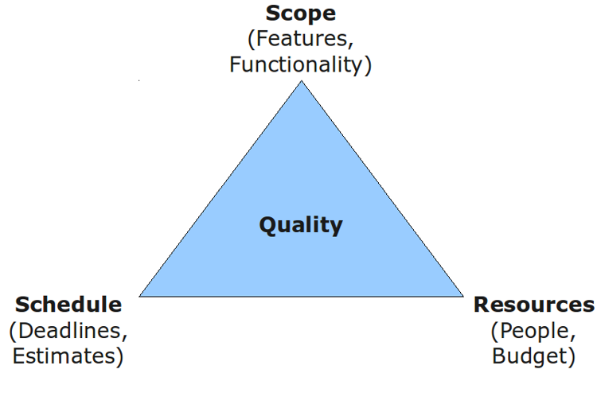
(Yeomans & Rogers, 2017)

The triangle is a way of measuring the project success through balancing the constraints. It looks at the time it takes to complete the project, the budget that has been given and the quality and scope of the deliverable (Yeomans & Rogers, 2017).

5.0 Project Management Tools and Techniques
There are a large number of PM tools and techniques available, all with their own benefits and weaknesses. This report will be looking at three methods, PRINCE2, Agile and Waterfall. Others available include, Six Sigma, Critical Chain, PRiSM, Scrum, Spiral, Lean, Event Chain Methodology and Kanban.

5.1 PRINCE2
PRINCE2 is a structured method of project management that organises the processes within the project. It takes its user from the very start of the process, through the managing phase, to the completion of the project. This is achieved by guiding the project manager through the processes using direction, development and delivery. PRINCE2 is one of the most widely used forms of project management tools in the world, applied in over 150 countries and managed by over one million certified professionals.
Originating from an earlier method called PROMPT 11 it was fostered as a UK Government standard for IT project management. Initially named PRojects IN Controlled Environments, the number 2 refers to the number of extensive revisions made to the method in 1996 and 2009 (Bentley, 2012).
One of the key benefits of PRINCE2’s is its ability to work equitably with large and small projects, from a newly formed company to a multinational organisation. This tool has also been successfully employed in some of the worlds emerging economies. Predominately seen as a management tool for technology-based projects, it should be noted that it is not restricted to IT. PRINCE2 has actually been used as a tool in projects as diverse as movie production and during company mergers. In the UK it has been used in the construction of London’s summer Olympic 2012 facilities, and the transfer of the London-based Eurostar train services to continental Europe from Waterloo Station to St Pancras Station (Dodd & Sathasivucm, 2010).

5.1.1 How does it work
The system PRINCE2 is primarily made up of seven Principles (why), Processes (how) and Themes (what), it is important to note that these Principles cannot be altered or tailored. A full copy of these can be seen in appendix 16.1.
Through these steps it divides the project into two levels, the project management and project specialists. Here it concentrates on the development of an accurate process to allocate work effectively, leaving the specialist to do their job. For example, during a construction project it is essential to effectively coordinate all the different professions involved, it is inefficient and costly for example if the plasterers arrive on the job before the electricians. PRINCE2 anticipates these complications and reallocates them, this allows the job to run smoothly.

5.1.2 Advantages and Disadvantages
PRINCE2 state that the advantages to using this method are unlimited and that there are no disadvantages. Literature proves this is not the case, here are some examples of both. A list of Advantages and disadvantages for PRINCE2 can be found in Appendix 16.2.

5.2 Waterfall
Waterfall is one of the earliest Project management methods, it was developed in the 1970s by Winston Royce and is often used in software development. This linier method’s name is inspired by the movement of its lifecycle, with stages moving downwards through the development like that of a cascading waterfall. Unlike PRINCE2, the phases of the Waterfall model do not overlap. Completion of each phase must therefore be achieved before the project can move on to the next step (Viergever, 2015). Once the next stage has begun then the project is unable to revisit any previous stages. Therefore, this system demands extensive work to be carried out at the start of the project and requires all conditions are fully understood before the project can commence. Waterfall is considered to be most useful to small projects and those with specific documentation and ample resources.

Waterfall’s lifecycle is made up of six, non-overlapped phases, these include designing of the project, construction or development, testing and maintenance. A full list and explanation can be found in Appendix 16.2

Waterfall’s popularity in the software industry has wavered in the past several years with Agile and Scrum becoming more widely used. It was the preferred method of use by the Department of Defence, Military and aircraft programs, due to its stringent standards. However, methods like Agile have managed to move in to these areas to (Skumar, 2017).

5.3 Agile
Agile’s use within project management has grown in popularity over the past decade. This method concentrates on the continual improvements, scope adaptability, contribution and input from the team and the delivery of necessary quality products (PM-training, 2018).
Agile uses several approaches, tools and techniques within its programme. These include ‘SCRUM’ (used as a framework) and ‘Extreme Programming (XP)’. These tools along with many other techniques assist the individuals and teams within the organisation to adhere to Agile’s Manifesto (M Fowler, 2011).
5.3.1 Manifesto and Principles
February 2001, in the Wasatch mountains, Utah, a group of software development gurus produced a Manifesto for Agile Software Development. Alongside their twelve principles the manifesto acts as a guide of concepts, supporting the Project management team during the implementation of an Agile project. The principle concentrates on people, communication, product and flexibility (PM-training, 2018). A copy of the manifesto statement, and their principles is available in appendix 16.5
Agile’s structure allows for projects to be administered in smaller phases. It has the ability to be adaptable during times of change and refining and fine-tuning the developmental processes when needed (Henderson Sellers & Serour, 2005). The principles accommodate these changes during any stage of the project’s development. Additionally, the involvement of the customer is actively encouraged throughout the development process. This style of structure facilitates feedback, and reflection that positively impacts on the project’s outcomes (Dingsoyr, Nerur, Balijepally, & Brede Moe, 2012).

5.4 Comparison of the Three Methods
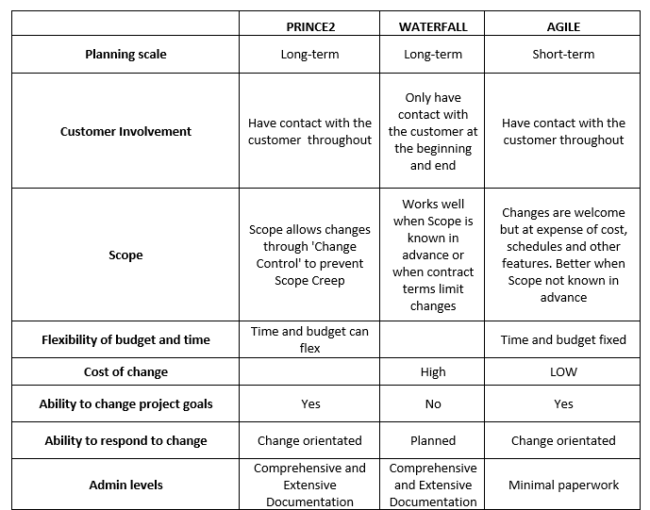
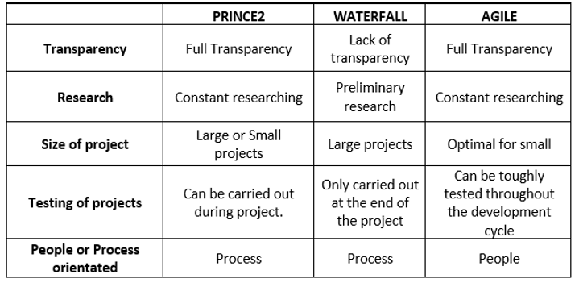
(Compiled by Vetter 2019)

- Life Cycle of a Project
When ‘the life cycle’ is described in the context of Project Management, it relates to the journey of the project from its starting point to completion. Different methodologies use several paths to reach their goal, however, the basic journey is the same.
Each journey begins with the conception of an idea, this is closely followed by the selection of a project manager and their team. At this stage the initial implementation of resources can be sourced. Now work on the project can begin; as it moves through the various stages’ momentum builds and the project progresses until it nears its completion. A job cannot be successfully closed, until all the many phases re-join at the end of the project (Meredith & Mantel JR, 2017). In reality the life cycle does not always run so straight forwardly, issues like cost, time, performance and risk, all add to the uncertainty of a project. These problems can be predicted to some level, but never completely eradicated, though the certainty of problems occurring does decrease as the project moves forward.
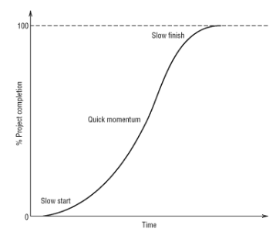
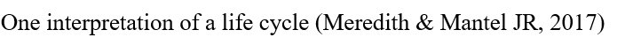

7.0 Business Case
A simple explanation of business case is the initial thoughts that reason a new project. It can be in the form of a comprehensive structured document, an informal or brief document and in some cases a verbal understanding. When resources for example money are consumed by the project, the business case states that this should be to support a particular business need. Therefore, there are options that need to be considered before the project is given the green light or in some cases rejected. These options include but are not limited to, expected cost, likely risks and Gap analysis (Cooper & Edgett, 2008). The business case is not a job undertaken solely by the Project Manager, input is also needed from interested stake holders and sponsors (Raymond, 2009)

8.0 Project Initiation Document
After the initial completion of a Business case a Project initiation document (PID) must be compiled. It contains documentation Compiled from project controls, project planning, management strategies and the Business case. This highly detailed plan expresses the details of the project or product, what are expected costs and when it will be delivered. Details within the PID can be revised once the project commences.
9.0 Scope
When scope management is processed poorly it can result in badly defined requirements, uncontrollable and false expectations, dissatisfied stake holders and adverse impacts to the organisations bottom line. Many Project Managers define the scope on day one of the project. Best practice is the use of ‘Progressive Elaboration’. This method allows for plans to be constantly and frequently modified and improved, while up-to-date and improved information becomes available (Yeomans & Rogers, 2017).
10.0 Risk
To be able to assess the risks involved in a project we must first understand what is meant by risk.
“The possibility that something unpleasant or unwelcome will happen.”
”A person or thing regarded as likely to turn out well or badly in a particular context or respect.” (oxford dictionaries,2019)
Risk within a project is the likelihood that targets that have been set to produce a product cannot be met due to an unexpected occurrence. All projects carry with them an element of risk; however, these risks can increase if,
- The project runs for a long time
- If the team, or organisation is inexperienced
- The time between preparation and work beginning is extensive.
- If new technology is used within a project.
Every project must therefore determine, evaluate and manage any risk that could affect the project. This process includes, identification of the risk, assessing any effects the risk will have on the project, assess the risk and agree how to shield the project from any consequences the risk could bring. The fourth step is completed throughout the production phase, monitoring the risk, this step determines the existence of new risks, or whether existing risks have amplified or diminished. The fifth step is communication, this phase must occur throughout the entire duration of a project to ensure its success. By keeping key stakeholders informed of potential project risks from the beginning of the project to the end can evoke openness, honesty and professionalism (Raz, Shenhar, & Dvir, 2002).

10.1 Identifying the Risks
In order to successfully control risks, they must first be identified. It is important to acknowledge that not all risks carry the same scale of complications to the project. One method used to identify the importance and severity of the risk is to compile a scatter chart to plot all identified risks.
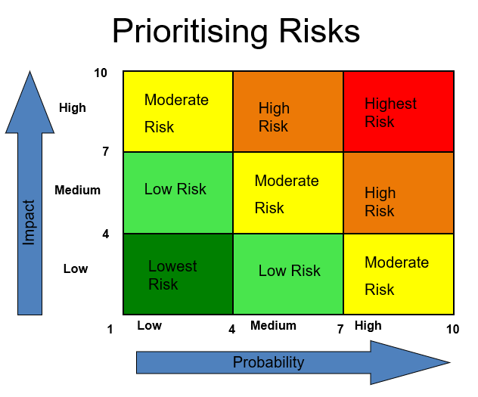
(Yeomans & Rogers, 2017)
These risks should now be assessed for probability, or likelihood of it happening and its Impact or cost to the project both financial and time related. Likelihood can be gauged in a number of ways these include, studying the probability of occurrence, this is achieved by attributing a number to signify the chance of the risk occurring from 0.0 – will never occur to 1.0 will always occur. Another system that can be use is category ranking, where each risk is classified into a category for example – Low, Medium and High.
It is possible to evaluate the chance of a risk happening by relating it to a similar project, to be confident in the findings as many different situations should be considered as possible. By sitting down with experts in the business and those who have been involved in similar projects, a team is able to gather opinions and offer solutions, this could also lead to reduced chances of things being overlooked. By being specific when communicating the risks, allows for an improved assessment of the potential effects it may have on the project (Surnit & Mukherjee, 2001).
There are hundreds of risks big and small that can affect a project, these can occur from the very start of the process all the way till the end. Common problems include increased costs, running out of time, lack of focus. Other risks could be linked to the technologies used to produce the item.
10.2 Managing Risk
A strategy must now be developed to minimise the adverse effects these threats can have on the project. Below is a list of some ways this can be achieved.
- 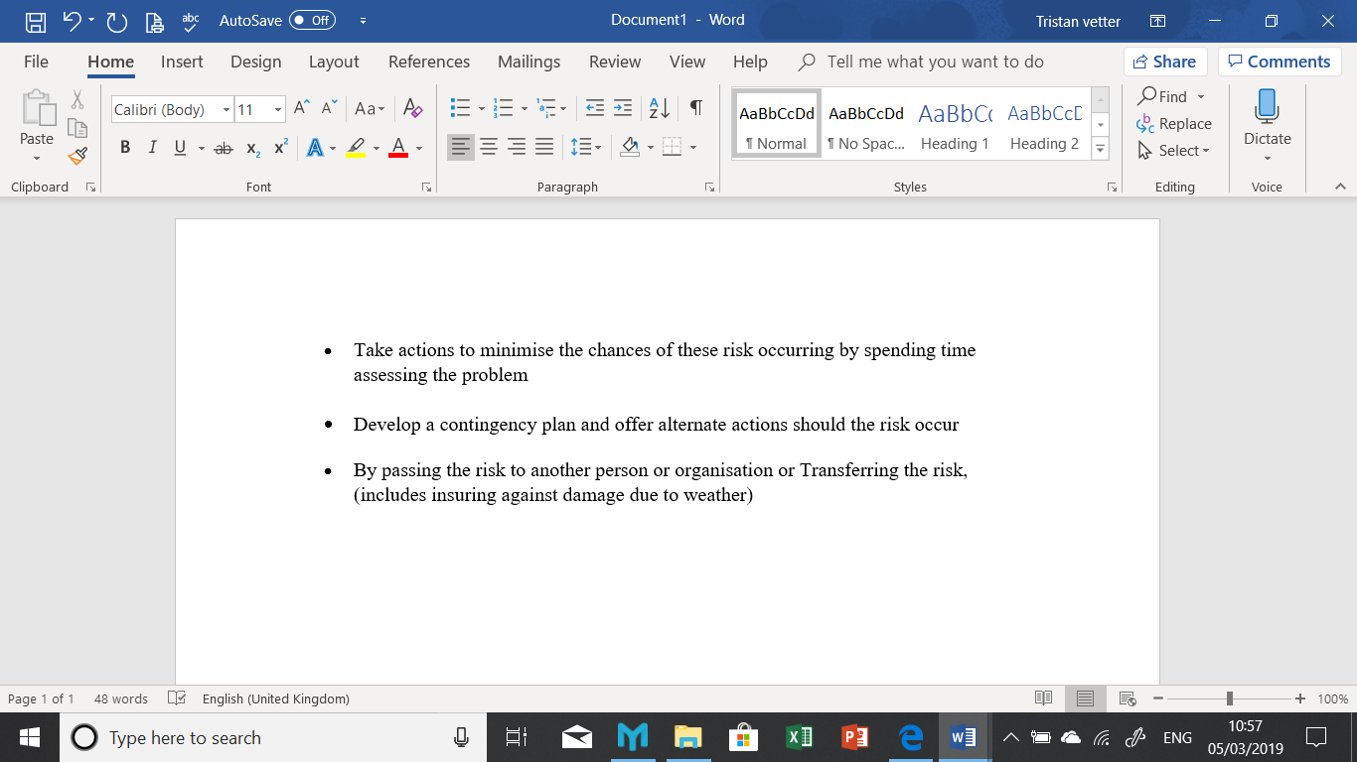

One thing is clear when it comes to management of risks and threats, if they go ignored by the team, then they will inadvertently only delay what is inevitable (Williams, 2008).
There are many reasons why projects fail, these failures can cost organisations millions of pounds. They can often be prevented by having a clear, detailed plan and objectives, efficient monitoring and good communication. Barriers to success include an unrealistic budget, insufficient staff levels, unclear Scope, and no risk management.

11.0 Stakeholders
11.1 What is a stake holder?
“A person with an interest or concern in something, especially a business.”
A stakeholder is a person or group of people with a vested interest in an action, venture, or business. The actions, objectives and policies undertaken by an organisation, can both influence and be influenced by its stakeholders.
Johnson, Scholes, & Whittington, (2008) defined stakeholders as the “people or small groups who depend on the organisation to fulfil their own goals and on whom, in turn, the organisation depends” .
There are two categories of stakeholders, Internal and external. Internal stakeholders are those who exist inside the organisation, examples are managers, employees, project team, and sponsors (Johnson, Scholes, & Whittington, 2008). These stakeholders can directly benefit from their contribution to the company growth. External Stakeholders are concerned parties, although they are not directly part of the management they are indirectly affected by the work produced by the organisation. (External stakeholders can also be known as secondary stakeholders.) They include Suppliers, General Public, Shareholders and users of the end product or service.

Below is a list of typical key stakeholders found in a project
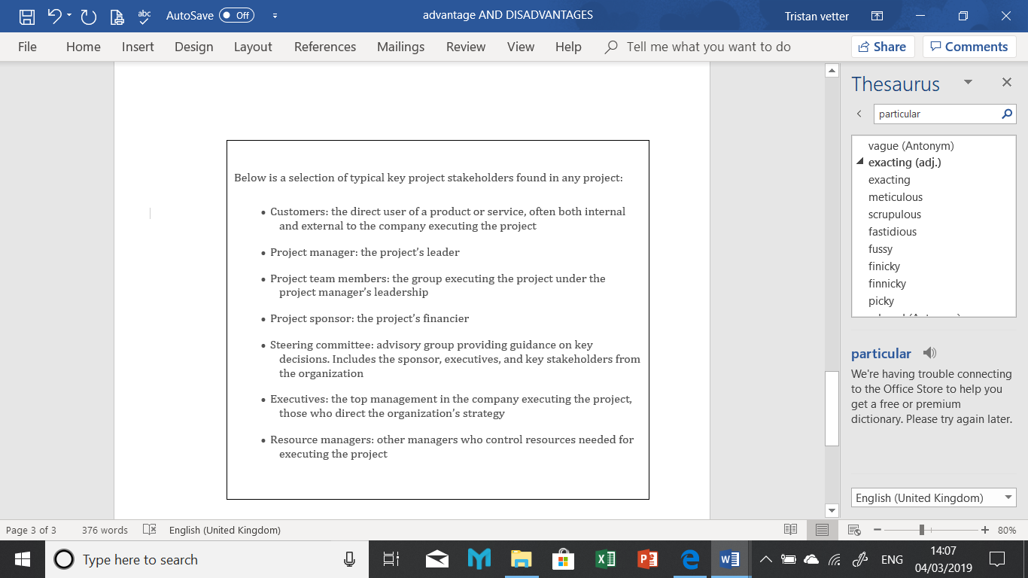

(Wrike, 2018)
11.2. Stakeholder Analysis
Analysis is the identification of key individuals or groups within the project. An assessment of their areas of influence, interest and the power that these stakeholders hold is completed, followed by a compilation of information and requirements they may have. The involvement of stakeholders varies, some have a greater interest in the project and demand more involvement than others. Projects benefit from analysing stakeholder opinions and interests, opinions can differ as do individual principles. By conducting these processes early on in the Project Management stage any issues can be sorted early resulting in a greater organisational performance.
There are three stages to this analysis, identification, prioritising and understanding the stakeholders.

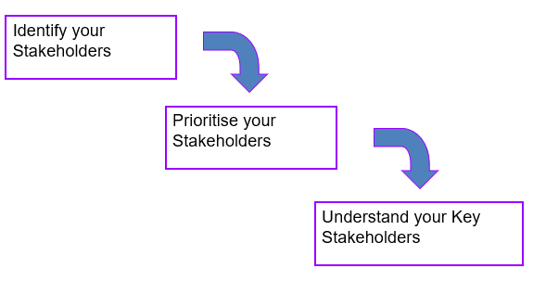
Stages of analysis.

11.3 Stakeholder Planning
This stage involved planning how the project team will engage with the stakeholders through efficient communication approaches.
11.4 Stake Holder Management
This discipline within Project Management can be the difference between the failure and success of the project. This process consists of three stages, Stakeholder Analysis, Planning and Management.
This stage uses management to create a constructive relationship with the stakeholders, while managing their expectancies and agreed objectives to ensure they are all happy.
Poor stakeholder management includes, inefficient communication, allowing stakeholders to be involved too early in the decision-making process. Inclusion of the wrong stakeholders in this decision-making process and not valuing the contribution offered by stakeholders.
An essential procedure during these processes is assessing the levels of the stakeholder’s power or influence over any decisions that affect the project. It assesses the level of interest they have in decisions that affect the outcome of the project, this can also be seen as the depth of their relevance . This method can be achieved by plotting stakeholders into a Power and Interest Matrix.
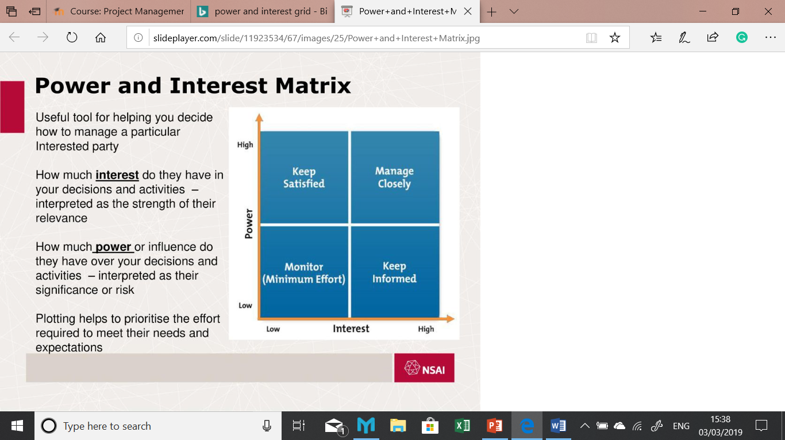
Power and Interest Matrix
12.0 Why do projects go wrong?
Projects can fail for many reasons, these failures cost the industry millions of pound each year. Below are is a list of reasons for these failures.
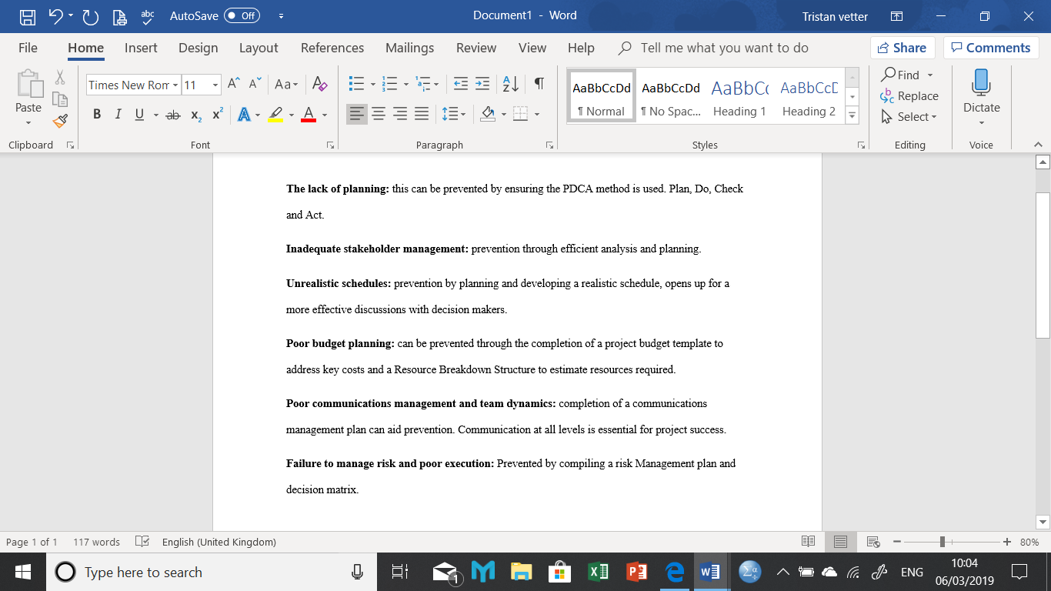

Efficient Project Management can reduce the chances of any of these occurring.
13.0 Closing the project
Before the team and Project Manager can complete the project and move on to another they must successfully close the project. This process studies all the phases of the project and determines whether all the objectives have been met and analyse any issues or risks that have occurred. It includes recommendations looks at what went well and did not as well as why this occurred, as well as determining that the project is fit for purpose, The PM collects the information and passes it to the project board.
14.0 Conclusion
This report was commissioned to study the methods and tools used when managing a project. For the purpose of this report three methods were picked PRINCE2, Waterfall and Agile. PRINCE2 is one of the leading method in the UK used within both private and public sectors. Waterfall, one of the original more traditional approaches offers longevity but lacks the ability to allow alterations once the programme is up and running. Agile as its name suggests offers its user leverage and the ability to change and adapt. No one method is perfect, and its success is dependent on the type of project undertaking.
The role of the project manager was briefly studied and included the triangle, which was a tool used by the PM to manage the project constraints. The risks faced by the project and the team were considered and how these risks can be analysed and managed. Poor management of these risks will inevitably end in project failure.
One subject was evident in each stage of project management and that is communication. The communication between the client and the PM, the PM and their team, The PM and the stakeholders and suppliers. If there is a communication breakdown at any point during a project it will lead to a breakdown of the project and failure.
15.0 References

References
APM. (2018). Project Management. Retrieved from Association of Project Management: https://www.apm.org.uk/body-of-knowledge/context/governance/project-management/
Bentley, C. (2012). PRINCE2 a Practical Handbook (Second ed.). Oxford: Butterworth Heinemann. Retrieved February 25, 2019, from file:///C:/Users/User/AppData/Local/Packages/Microsoft.MicrosoftEdge_8wekyb3d8bbwe/TempState/Downloads/9780080497792_googlepreview%20(1).pdf
Blue Rhino Training. (2015, September 13). PRINCE2 Themes, Principles and Processes! Retrieved Febuary 24, 2019, from Project Management: https://project-management.com/7-prince2-themes-principles-and-processes/
Cooper, R., & Edgett, S. J. (2008). Portfolio Management for New Products : Picking Winners. Product Innovation Best Practices Series . Product Development Institute Inc. Retrieved March 2019, 3, from https://s3.amazonaws.com/academia.edu.documents
Dingsoyr, T., Nerur, S., Balijepally, V., & Brede Moe, N. (2012, June). A decade of agile methodologies: Towards explaining agile software development. Journal of Systems and Software, 85(6), 1213-1221. doi:10.1016/j.jss.2012.02.033
Dodd, S., & Sathasivucm, V. (2010). Mega Project Management; A Case Study of the London Olympic Games 2012. UK Academy fro Information Systems. London: AIS Electronic Library. Retrieved Febuary 24, 2019, from http://aisel.aisnet.org/ukais2010/19
Henderson Sellers, B., & Serour, M. K. (2005). Creating a dual-agility method: the value of method engineering. Journal of Database Management, 16(4), 1-23.
Johnson, G., Scholes, K., & Whittington, R. (2008). Exploring Corporate Strategy (8th ed.). Pearson Education. Retrieved March 2019, 5, from https://books.google.co.uk/books?id=SmjnLQwlSdsC&printsec=frontcover&source=gbs_ge_summary_r&cad=0#v=onepage&q&f=false
Kerzner, H. (2009). Project Management: A Sysyems Approach To Planning, Scheduling and Control (Tenth Edition ed.). Hoboken, New Jersey/New York, USA: Wiley. Retrieved from 202.166.170.213:8080/xmlui/bitstream/handle/123456789/3849/Project%20management%20%20a%20systems%20approach%20to%20planning%2C%20scheduling%2C%20and
M Fowler, J. H. (2011, August). Manifesto for Agile Software Development. Software Development. Retrieved March 1, 2019, from users.jyu.fi/~mieijala/kandimateriaali/Agile-Manifesto.pdf
Meredith, J. R., & Mantel JR, S. J. (2017). Project Management: A Managerial Approach (Tenth ed.). Danvers, MA, USA: John Wiley and Sons. Retrieved February 20, 2019, from https://www.amazon.co.uk/Project-Management-Managerial-Jack-Meredith/dp/0470533021
Olic, A. (2017, June 21). Disadvantages of Agile Project Management. Project Management, 50-55. Retrieved March 1, 2019
PM-training. (2018). Waterfall Versus Agile Project management. Retrieved Febuary 21, 2019, from Project Management Training: https://www.projectmanagement-training.net/category/waterval-versus-agile/
Raymond, D. (2009, January 8). Building a Project’s Business Case. Project Management Best Practice. Retrieved March 2, 2019, from https://pmhut.com/building-a-projects-business-case
Raz, T., Shenhar, A. J., & Dvir, D. (2002). Risk Management, Project Success and Technological Uncertainty. R and D Management, 32(2), 101-109. Retrieved March 10, 2019, from https://www.researchgate.net/profile/Aaron_Shenhar/publication/227644860_Risk_Management_Project_Success_and_Technological_Uncertainty/links/5a7f1e19a6fdcc0d4baa7407/Risk-Management-Project-Success-and-Technological-Uncertainty.pdf
Skumar. (2017). What is Waterfall model- Examples, advantages, disadvantages & when to use it? Retrieved March 2, 2019, from TRY-QA: tryqa.com/what-is-waterfall-model-advantages-disadvantages-and-when-to-use-it/
Surnit, D., & Mukherjee, S. K. (2001). Developing a risk management matrix for effective project planning – an empirical study. Project Management Journal, 32(2), 45-57. Retrieved from https://www.pmi.org/learning/library/risk-management-matrix-effective-project-planning-5279
Techopedia. (2018). What does Project Management Mean? Retrieved Febuary 24, 2019, from Tecnopedia: https://www.techopedia.com/definition/13132/project-management-software
Viergever, N. (2015). PRINCE2 and Waterfall. Netherlands: NVI Project Management . Retrieved March 2, 2019, from http://www.viergever.info
Williams, M. (2008). The Principles of Project Management (Vol. 2). (G. Laidlaw, Ed.) Collingwood, Australia : Sitepoint Pty LTD. Retrieved March 2, 2019
Wrike. (2018). What is a Stakeholder in Project Management? Project Management Guide:The Ultimate Introduction to Project Management Fundamentals. San Jose, California, USA: Wrike. Retrieved March 2, 2019, from https://www.wrike.com/project-management-guide/faq/what-is-a-stakeholder-in-project-management/
Yeomans, D. C., & Rogers, p. (2017). Project Management Made Simple and Effective (2 ed.). Indianapolis, USA: Dog Ear Publishing. Retrieved March 2, 2019, from https://books.google.co.uk/books

16.0 Appendix
Appendix 16.1
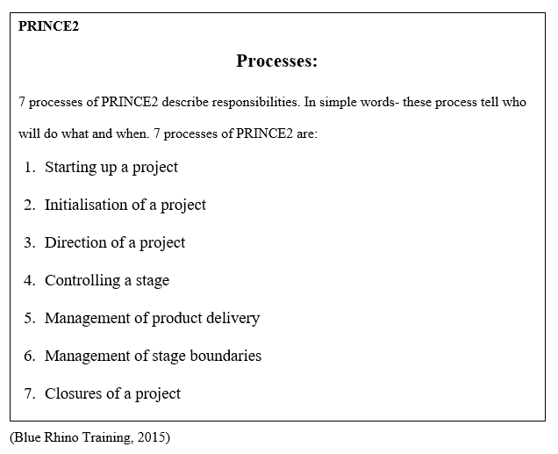
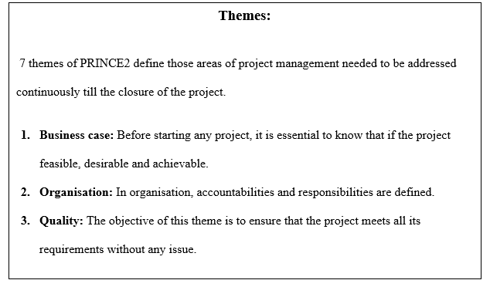

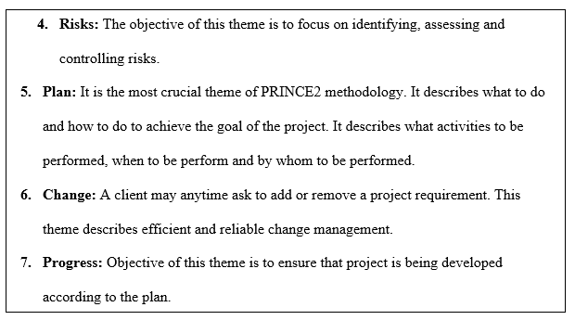

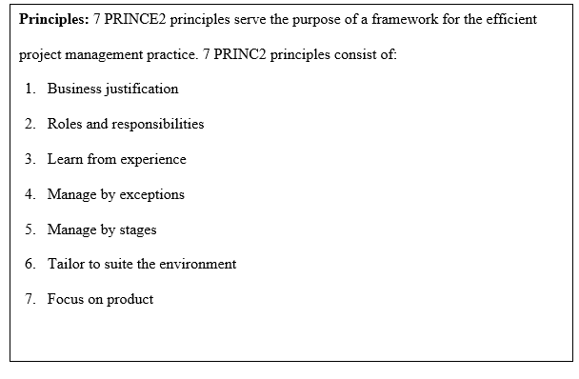

16.2 Advantages of PRINCE2
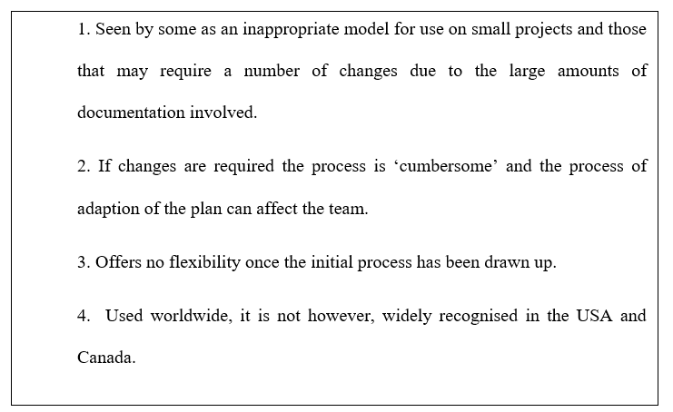
Disadvantages of PRINCE2
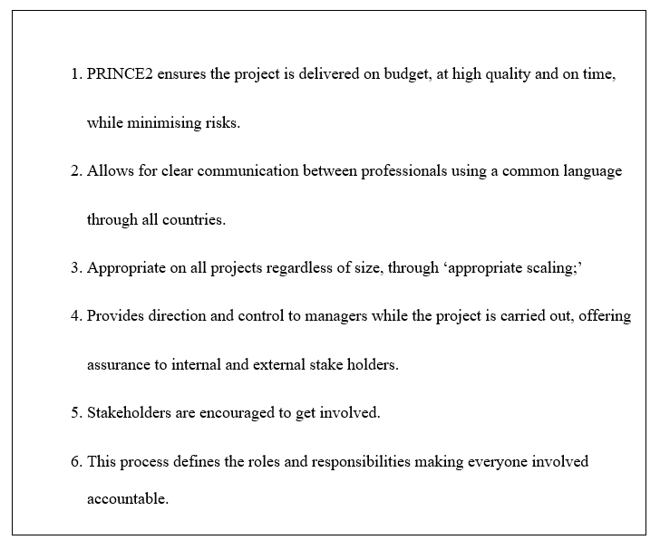

16.3
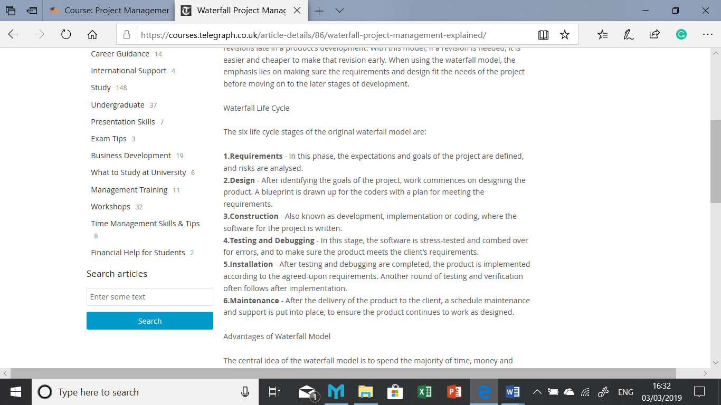
16.4 advantages and Disadvantages of Waterfall
Advantages of Waterfall
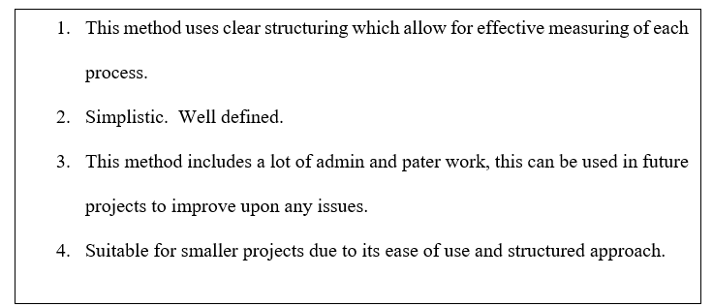
Disadvantages of Waterfall
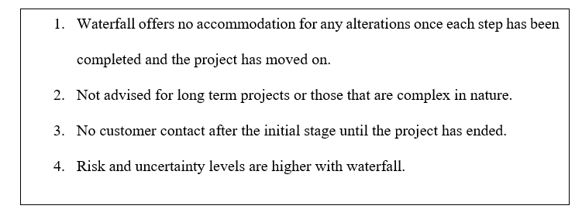

16.5
Principles and Manifesto of Agile
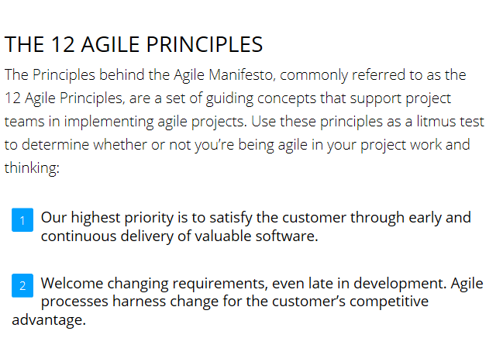
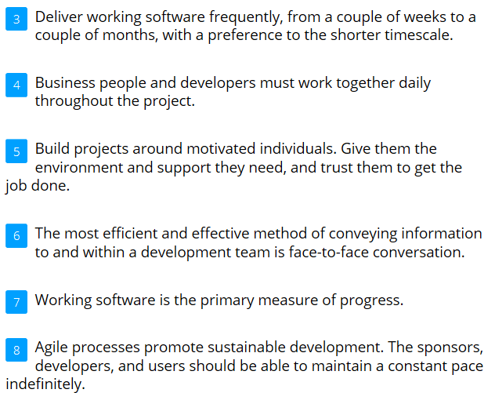
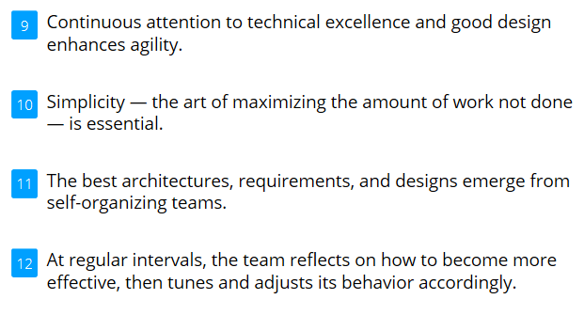

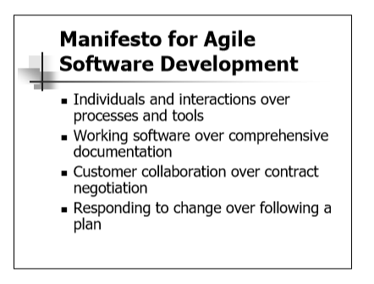
(M Fowler, 2011)
16.6 Advantages and Disadvantages of Agile
Advantages
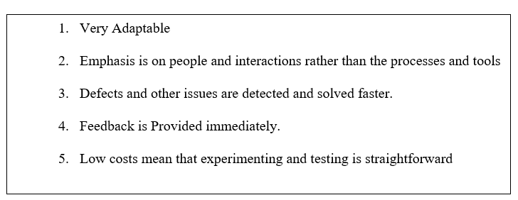
Disadvantages


