A critical evaluation and the identification of next teaching and learning steps focusing on a case study of an individual learner or a group of learners, based on an observed critical incident.

Introduction

This piece of writing will analyse literature surrounding the role of critical reflection within the teaching profession and the effects this has on teachers teaching practice. This will be explored by way of a critical incident (CI) observed whilst visiting a school. Critical incident refers to an unplanned observable moment/event/ or experience in the classroom that affords the opportunity to be analysed and can be both positive and negative (Tripp, 1993; Richards and Farrell, 2010; Harrison and Lee, 2011). Analysing critical incidents through a reflective practice helps student teachers to take a deeper look at themselves, looking at why they teach, what they teach and how they teach it (Donaldson, 2015; Joshi, 2018; Furlong, 2020). This process of reflecting on critical incidents is very important to student teachers continuing professional development (CPD) as they provide opportunities for identifying good teaching practices as well as those that are ineffective (Tripp, 1993; Brookfield, 1995; McCalister, 2012). Critical reflection is explored in more depth in the next section

The role of critical reflection

When examining the role of critical reflection in Initial Teacher Education (ITE) it is worth noting that there are various interpretations of what reflection actually is, and how it is conducted. Boud, Keogh and walker (1985) refers to reflection as the bridge between what teachers experience and what they learn. Bulman, Lathlean and Gobbi (2014) agree with Boud Keogh and Walker, however, they have taken the definition a little further by acknowledging reflection provides teachers with a means to learn from, although, the practice of teaching is very complex. Reflection involves recalling something specific, analysing and evaluating the situation (Fakude and Bruce 2003; Gray,2007; Pollard, 2019). To ensure critical reflection takes place and is effective there must be a significant personal investment into the process and alterations based on new knowledge gained from the critical reflection (Griggs et al. 2015). Reflection is viewed as a tool or a concept and that being a reflective practitioner leads to better quality teaching thus providing a higher quality of education for the student (Poom-Valickis and Mathews, 2013; Pollard, 2019) There are various ways a student teacher is able to critically reflect (Berglund, Sjögren, and Ekesbergh 2012). For example, a reflective diary (Schön,1991), a reflective journal (Chirema, 2007) or as part of an educational portfolio (Pereira, Parente, and Da Silva, 2016). In teaching it is not enough just to reflect, student teachers need to critically reflect with mentors and implement changes from guidance they have received (Beavers, Orange, and Kirkwood 2017). There are many variants of reflective models that can help student teachers critically reflect on their chosen critical incidents. Below are just few of the models.
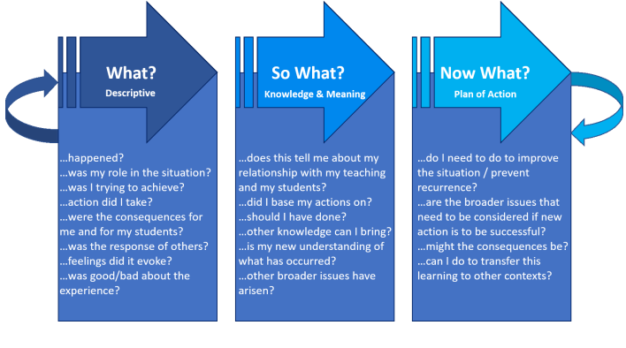

The ‘what’ model by Rolfe, Freshwater and Jasper (2001)

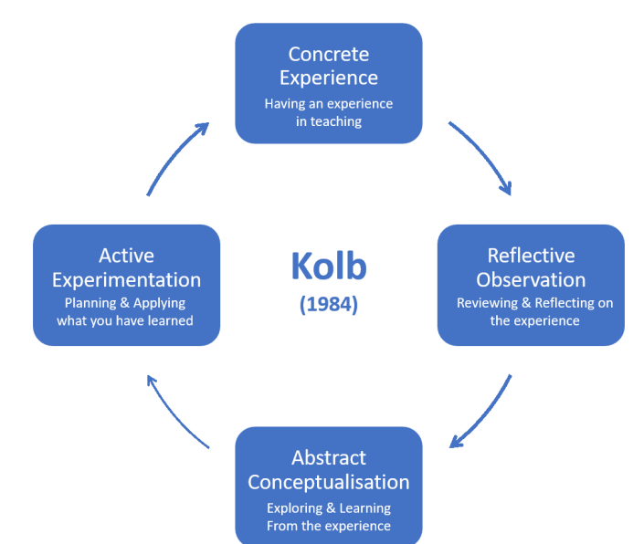

Kolb’s Model of Experiential Learning (1984)

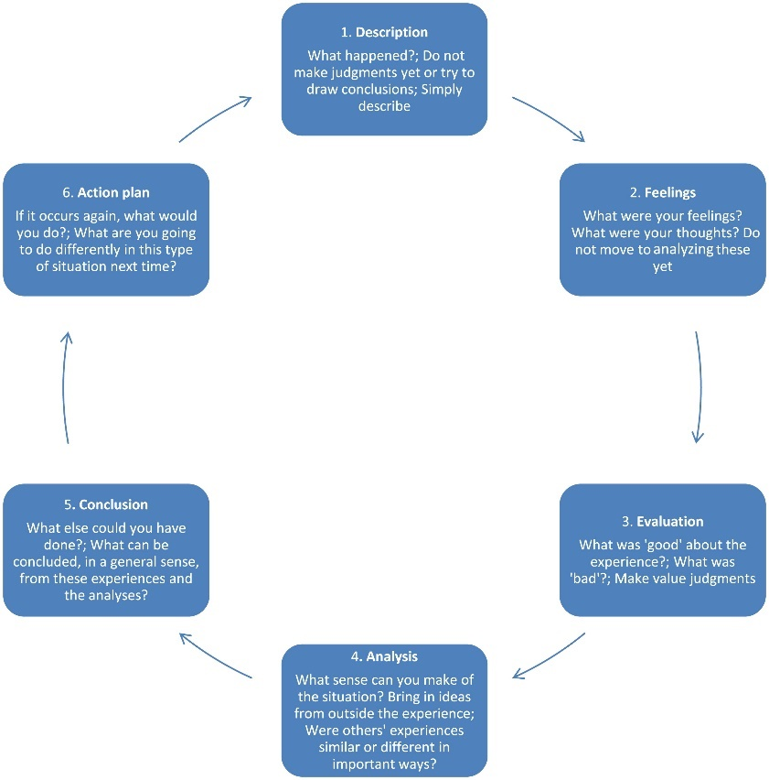

Gibbs’s Reflective Cycle (1998)

From the three models shown, most teachers prefer Gibbs’s reflective cycle as it allow feelings to be taken into consideration (Griggs et al. 2018; Pollard, 2019).

Just as the Welsh Government commissioned Professor Graham Donaldson to review the curriculum leading to the Successful Futures document (Donaldson, 2015). They also set up a task and finish group headed up by Professor John Furlong to review the way in which teachers were trained in Wales, as the current way was no longer suitable. This led to a published document, Teaching tomorrow’s teacher (Furlong, 2015; WG, 2017)). The Welsh Government saw this as a vital part to ensuring that the successful implementation of the new curriculum for Wales and changed the criteria for ITE accreditation (WG,2018). This led to a decision that universities must work in collaboration with a network of schools so that new student teachers spent more time based in school settings, as certain aspects of teaching can only be learnt experientially in a classroom (WG,2018). Another part of the process of becoming a teacher, is how the student teacher finds their teaching identity when incorporating their values, beliefs and teaching standards (Pillen, Den Brok and Beijaard, 2013; Pollard, 2019) which can only be achieved whilst on the job, this cannot be taught out of context( Winch et al.,2015). Student teachers need the opportunities to examine ideas, test them in the classroom setting, reflect and then make changes, if need be (Burn and Mutton, 2015; Furlong, 2020) in accordance with the professional teaching standards set by the accrediting board, Education Workforce Council (EWC, no date).

The observation
As part of the observation, it was vital to recognise and acknowledge that the confidentiality, anonymity of school, staff and students and compliance with the ethics of conducting research was adhered to, as according to British Educational Research Association (BERA) guidelines (BERA,2018; DePoy and Gitlin, 2020).

The setting of the observation was a large secondary school catering for ages 11-18, with a wide geographical area based in Cardiff. There are approximately 1,260 of mixed gender students on roll, with around 300 of them in sixth form. The school embraces students of all faiths and those without a faith background. Although, Estyn (2018), the inspectorate of education and training in Wales, states there is a strong Christian ethos promoted through various values. Out of the full total of students 16% have additional learning needs, which is below the current national average. Also, at 9%, students eligible for free school meals is well below the national average of 17% The school currently has around 18% of students coming from minority ethnic groups and all students have English as their first language (Estyn,2018).

The observation took place in a year 7, middle ability registration class at 8:50 am. The teacher was very welcoming and explained they were at the start of the process of electing their class captain for 2021. She confirmed that she had explained the role of class captain to the student the day before.

Critical incident and the Four Purposes

The teacher explained the role of class captain and that the students will be given an opportunity to decide who this would be. Firstly, the teacher asked for a show of hands of those interested and wanted to be considered for the role. Two children raised their hands to show they were interested. The teacher continued explained that they would need to give a speech to persuade their peers as to why they should be elected. Each student delivered their speech with passion and enthusiasm. The teacher asked the rest of the students to write their nomination on a piece of paper and hand it in to her at the front, she went on to explain that she would count the nominations and let the students know the results the next morning in registration. The teacher proceeded to dismiss them to their next class, smiling and thanking them for their input and wishing them a great day.

Through the process of electing class captain, the teacher facilitated a democratic voting situation thus providing the students with authentic context in which to learn, linking to the work of theorist John Dewey “developing democratically minded and inquisitive young learners for the future”(Aubrey and Riley, 2019). Importantly, this gives students a voice and a safe and encouraging platform to have their say, as per their rights. “Every child has the right to express their views, feelings and wishes in all matters affecting them, and to have their views considered and taken seriously” as stated in article 12 of the United Nations Convention on the Rights of the Child (UNCRC, 1989; Welsh Government, no date).

This section will look at how the CI links and promotes the four purposes. As the two students who wanted to be class captain had to: engage with contemporary issues based upon their knowledge and values; understand and consider the impact of their actions when making choices and acting; respect the needs and rights of others, as a member of a diverse society and understand and exercise their human and democratic responsibilities and rights (Donaldson, 2015). The rest of the class had to consider these points, however they also had to evaluate the two students speeches and form views on who they were going to vote for, thus preparing all the students to be ethically informed citizens, who are ready to be citizen of Wales and the world (Donaldson, 2015). From this unique situation, the students were able to: have the confidence to participate in performance; take measured decisions about lifestyle and manage risk; face and overcome challenge; have the skills and knowledge to manage everyday life as independently as they can and also form positive relationships based upon trust and mutual respect (Donaldson, 2015), as they trusted the teacher to count the votes and give them the results the next day. This allow the students to be healthy, confident individuals, who are ready to lead fulfilling lives as valued members of society (Donaldson,2015). The critical incident encompasses many different elements of the four purposes not just the two mentioned.

LITERATURE REVIEW

This section will be exploring various literature under two themes identified as part of the critical refection on the critical incident. The first theme will be the significance of teacher and student relationships. From the critical incident, it was identified that the relationship between student and teacher is very important as students spend a considerable amount of their time in the school setting (Baker, Grant and Morlock, 2008; Curby, Downer and Booren, 2014). The relationship between student and teacher resembles the relationship the student has with their primary caregiver (Trang and Hansen, 2021). This dyadic relationship is invaluable in the development of the students cognitive, social and emotional well-being, self-regulatory skills and academic performance (Roorda et al. 2011; Hughes, 2012; Lang et al. 2013; Sarkova et al. 2014; Wentzel, 2016). However, it has been noted by teachers that the most difficult part of building positive relationships with students is challenging behaviour in the classroom, this can include verbal aggression, misbehaviour when off-task and low-level disruption (Sun and Shek, 2012; Alter, Walker, and Landers, 2013). The environment and atmosphere in the class affects all students engagement, as the teacher may have to stop the lesson to deal with the behaviour the rest of the students are waiting and not learning (Webb and Neuharth-Pritchett, 2011), in contrast Sullivan et al. (2014) and Trang and Hanssen, (2021) suggests keeping the focus on student engagement is more effective at building and sustaining relationship rather than investigating the behaviour and dealing in punishments. This support an interactive environment that is conducive of shared learning (Orly and Harel, 2019). Classroom situations like these are made more difficult as the term ‘challenging behaviour’ is complex and leaves no definitive definition, so what one teacher finds challenging another teacher may not (Grieve, 2009; Nash, Schlösser, and Scarr, 2016).

Teachers acknowledge their supportive role towards students (Reinke et al. 201; Sisask et al. 2014) and understand that a positive relationship with students help to foster feelings of security (Zatto and Hoglund, 2019). Though, when it involves supporting students with their mental health, teachers express they have insufficient knowledge to help, especially with students who have challenging complex needs (Graham et al. 2011; Garland, Garland, and Vasques, 2013). This lack of knowledge is concerning, as students will naturally become reliant and dependant on the teacher to ease any worries and anxieties (Sherman, Rice and Cassidy, 2015; Mejia and Hoglund, 2016). No doubt these students would require more support in the classroom, and this will impact on the teachers lesson (Klassen, Perry, and Fenzel, 2012). Sarakova et al. (2014) refers to research that finds having a good level of teacher-student relationship help to lower students feeling of sadness, depression or anxieties.

This is why it important for teachers to keep trying to connect and make positive relationships with students even if it fails at first, being able to build and sustain relationships is considered an essential part of teacher competence (Nordenbo et al. 2008; Aspelin and Jonsson, 2019). A report conducted by the Programme for International Student Assessment (PISA) showed that students stated that having positive relationships with their teachers led to them achieving personal satisfaction and a good life (OECD, 2017). Research shows that it is essential to earn students trust and show them respect as quickly as you can especially at the start of the year (Patrick, Kaplan, and Ryan, 2011; Aspelin, 2017), this can easily be achieved through any of the multiple interactions a teacher can have with student. This will then be the foundation to build on trusting and respectful relationship with the student (WG, 2018). Building trustworthy relationships take time but is worth the effort (Sabol and Pianta (2012. It has been reported that teachers seem to have a close trusting relationship with girls and struggle with resistance and conflict with boys (Portilla et al., 2014). However, research indicates that if teachers take the time to really listen to their students and show a genuine interest in them, this will make building a trusting and respectful relationship easier, regardless of the gender (Verschueren and Koomen, 2012; Aspelin, Östlund and Jönsson, 2020). A noteworthy point to highlight that some while teacher are trying to buils quality relationships, research indicates that students could develop too much of a dependency on the teacher which can lead to the student less opportunity for social interaction with peers and supress student agency (De Boer et al., 2012 Östlund (2015)

The second theme will explore the role of student voice. There was a strong sense of democracy inline with the work of theorist John Dewey, who believed that all young students should develop a democratic and inquisitive mind (Aubrey and Riley, 2019). This was clearly demonstrated in the critical incident in the form of pupil voice, demonstrating that the school takes its legal and moral responsibilities and commitments towards student rights very seriously. Student voice has been developed from the recordings of the UNCRC and placing
the child’s rights at the centre and enshrined into Welsh law (UNCRC, 1989; Fielding, 2011; WG, no date). Student voice allows students to take an active part in their education and be involved in the democratic society on issues that affect them, thus promoting a real, positive contribution from students as they have a unique perspective of being the student (Ferguson, Hanreddy, and Draxton, 2011; Bron and Veugelers, 2014). This could be in the form of; talks with teachers and peers to discuss the classroom environment and curriculum topics( Quinn and Owen, 2016) school policies, for example co-constructing the contents of the anti-bullying policy( Ball, Maguire, and Braun, 2012). Adopting a whole-school approach to enacting student voice signifies that every stakeholder in the school community is onboard with the concept and is listening to students (Lewis, 2010). Rowlands, Chief Inspector of Estyn states, “A strong pupil voice has clear benefits for both schools and learners”.(Estyn,2016). As part of the curriculum reform, student voice has been written into the four purposes that sit at the centre of the Successful Futures’ and “meaningful and purposeful pupil participation” feature strongly (Donaldson, 2015). However, research has identified some challenges faced by schools trying to implement student voice (Demetriou and Wilson, 2010) Schools are met with scepticism and unfortunately students do not believe that having and using their student voice will lead to any real or significant change in their school (Mayes et al., 2019) Other challenges include engaging younger students in student voice tasks, particularly Foundation Phase, Year 1 and 2 as the level of understanding differ greatly (Adams et al., 2017), an issue reported from both teachers and older student trying to engage the younger years (Quinn and Owen, 2016). Also reported were issues with lack of motivation from students, lack of support from teacher and school management and student voice matters clashing with head teacher (Bassell, 2017). With the right guidance issues that have been mentioned could be resolved for the greater good of the students, teachers and the school community.

REFLECTION / EVALUATION & NEXT STEPS

Reflecting on this process I now see the importance of critical reflection to enhance my knowledge and my teaching practice. Moving forward I plan to use a combination of Gibbs reflective cycle(1998) I feel the six stages break the process down into more manageable pieces of information to process. I also like that fact I am able to account for my feelings when I reflect and the end of a lesson or the end of the day, as I feel this is important to me particularly if the lesson did not go as planned. Using Gibbs reflective cycle would help me to write what happened, what was my thoughts and feelings, analyse the good and the bad parts, can I make sense of what happened, where I went wrong then establish if there was anything else I could have done differently and lastly devise an action plan to this does not happen again. I could do this independently at first and then with my class mentor.

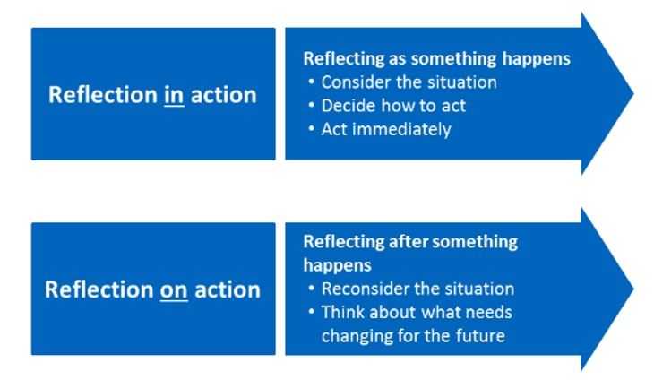
Schon’s reflective model,(1991 I would also try to use the first part of Schon’s reflective model, Reflection in action as I feel that this would be helpful during a lesson if I could feel the lesson was not going right. I could pause, consult and reflect with my mentor on the current situation and alter my plans accordingly, rather than waiting until the end of the lesson.

After observing the student teacher relationship and comparing literature I can see the significance of developing positive individual relationships with all the students in my class. I also realise from the literature that this is going to be laborious but well worth the effort in terms of student development and well-being for myself and the students. I intend to take on board the way the teacher interacted with the student and utilise this in my own teaching practice.

From the student voice point of view, the literature shows that it can be challenging to implement throughout the school, and a whole-school initiative is hard but not impossible. Using the student voice is something I really want to develop and utilise, so I feel I need to do a lot more research on different ways of incorporating student voice into my class. Also, for various ages so that it can meet their level of understanding. On the day the teacher remained quiet and impartial and let the students control the process, which I felt was showing the students that she respected their rights. The only thing I may have done different from the teacher is that I would have tried to count the votes in the same session to show transparency of the whole democratic system and avoiding the possibility thoughts about tampering.

CONCLUSION

This piece set out to look at what it means to be able to critically reflect as a teacher through the process of identifying a critical incident, which is an observable moment that can be analysed (Tripp, 1993). As part of gaining qualified teacher status, QTS, reflection is an essential part of documenting your experiences on your Personal Learning Passport, PLP with the EWC. The reflections will help in gaining valuable insight, to use your learning, development and ongoing practice (EWC, no date) This is a form of gathering evidence as proof of meeting Professional Standards as you progress through the ITE (Furlong, 2020). Arising from the critical incident a literature review was undertaken to the significance of student teacher relationship and the importance of student voice. Using the information gathered to establish next step in progression.

Appendices

OBSERVATION / FIELD NOTES

Record 1
Date and time, year group:
22/9/2021 Year 7
Where and When: Context of the observation – subject/AOLE, general classroom context

This observation was a Design and Technology lesson. The classroom tables are set in rows facing the teacher. The children entered and sat in pairs. The children were working on a project about Games. They had collected data as part of a survey and created a graph from these results in the previous lesson. The lesson was cross-curricular, intergrating, English, Maths, Art, and ICT.
The children were asked to cut out the graph and glue them into their books. The teacher the told the children to get thier phones out to take a picture of the page for their Digital Passport.

What happened: a detailed description of the critical incident (the more detail the better to refer to in your later work)

For me this highlighted a CI.
The Digital Passport is a small booklet containing the DCF and the LNF broken down into sections and is written in child friendly language. The passport is a place where the children are expected to submit evidence to on completion of task that meets specific criterion. The children are able to tick off the sections as they complete tasks throughout their academic year.
All bar one proceeded to take a picture of their work to be uploaded at another time. One child had forgotten her phone, so another child offered to take one for her. The children all put their phone away as soon as they had taken their picture.
The teacher then asked the children to sit at a computer as he was going to introduce CAD Computer Aided Design and demonstrate how to use it before they had a go.

Areas of possible exploration: what you think could be” under the hood” in these incidents? What avenues of research could you consider?

How could this Digital Passport work in other schools, particularly deprived areas.

Notes: any details you can note (is it a busy environment, is it after lunch, are there lots of distractions, are directions made explicit - the more you can refer to the better here)

Record 1 SHARE NOTES

This CI highlighted the need for children to have their mobile phone at school. This can lead to problems as children will want to compare who has the lastest phone and may feel the presuure to have the best. However, I do like the concept as this allows children to develop their knowledge of frameworks they are assessed by (DCF and LNF) allowing them take responsibilty for thier own learning as well as cutting down on teachers paperwork when trying to evidence childrens work. This way of working is also preparing children for a future full of technology.

This link to various teaching standards, for example;
Pedagogy-
refining teaching (Recording and reporting, involving partners in learning as the are a major stakeholder)
Advancing learners (inclusion of the four puposes, cross-curicular)
influencing learners (listening to learners, learner leading learning)
Collaboration- (supporting and developing others, enabling improvement)
Innovation – (developing new techniques, offering expertise CAD)

Links to
This CI links to ZPD as the children were recalling their knowledge from previous lesson and being in given new information to build up the knowledge
Record 2
Date and time, year group:
23/9/21 Year 7 Registration class
Where and When: Context of the observation – subject/AOLE, general classroom context

What happened: a detailed description of the critical incident (the more detail the better to refer to in your later work)

The children were gathered in their registration class. Some children had just delivered a speech to the class as to why they should be voted as class capt. The class then wrote their nomination on a piece of paper and the teacher collected them in. She proceeded to inform them that she would count the votes and let them know the result in the next morning’s registration.
The teacher then dismissed them row by row and said goodbye and have a good day to all the students as they were leaving.

Areas of possible exploration: what you think could be” under the hood” in these incidents? What avenues of research could you consider?

How does giving students a voice and a platform impact on their education.

Notes: any details you can note (is it a busy environment, is it after lunch, are there lots of distractions, are directions made explicit - the more you can refer to the better here)

Record 2 SHARE NOTES

This CI is important as it not only as it represents the students rights under the UNCRC, but i also gives them a platform to construct knowledge and raise concerns in a safe and encouraging environment, knowing their voices will be heard. This supports the views of theorist John Dewey who advocates democracy within education and the wider society..
This was valuable experience as i observed part of the four purposes being enacted. Giving students their voice, empowers student to take owbership of their education. Helping them to become critical thinkers, increases their independance therefore creating ethically informed citizens who will use the knowledge to contribute to the classroom, the school, their community and the world.
It is important to continue giving students these opportunities and not fall back into a system that was written by policy makers and just delivered by teachers without any input from the student. That previous system failed students and we must learn from those past mistakes.

This link to various teaching standards, for example;
Pedagogy-refining teaching (involving partners in learning as the are a major stakeholder) Adancing learners (inclusion of the four puposes, providing authentic context)
influencing learners (listening to learners, learner leading learning)
Collaboration- (supporting and developing others, enabling improvement)

For this CI I could link to theorists Vygotsky ZPD and building upon previous knowledge, Brofrenbrenners ecological system

Record 3
Date and time, year group:
23/9/2021 Year 7
Where and When: Context of the observation – subject/AOLE, general classroom context

This observation was in a Geography class, and was the first lesson after registration. At the start the teacher asked for children to open their books to show the homework that had been set the lesson before. Whilst the children were doing this the teacher wander around glancing at the books. All bar one had completed the homework task.

The teacher counted down tri, dau, un to end the childrens discussions for the return to silence in the classroom.The teacher prceeded to talk through the lesson plan form the IWB – using the terms Identify, Enquire and Hypothosise during the class task of investigating an aspect of their schools community.

What happened: a detailed description of the critical incident (the more detail the better to refer to in your later work)

For me this highlighted a CI
While the children were busy, I took the opportunity to ask if the class task had been differentiated in any way.
She then explains that the terms Identify, Enquire and Hypothosise were used to differentiate the lesson without letting the class know who would be doing what. She knew that all would be able to Identify, most could Enquire and some would be able to Hypothesise.

Areas of possible exploration: what you think could be” under the hood” in these incidents? What avenues of research could you consider?

What other strategies/ techniques could be used to differentiate without the whole class knowing?

Notes: any details you can note (is it a busy environment, is it after lunch, are there lots of distractions, are directions made explicit - the more you can refer to the better here)

Record 3 EXTRA NOTES

This CI is important as i feel that if children are working at different level in you class room they should be afforded privacy so that this does not lead into children making fun.

This link to various teaching standards, for example;
Pedagogy-Advaning Learners – Four Purposes for learners having the knowledge and understanding of the learners needs. -Real life, authentic conext, looking at their local community.
Pedagogy-Influencing Learners – Challenge and Expectation, providing appropriate levels of challenge and expectations for the range of student
Pedogogy-refining teaching, differentiating the task to meet learners need, whatever they may be.

Possible link to Bronfrenbrenner and his ecological sytem.

REFERENCE LIST
Adams, L, Tindle, A., Basran, S. Dobie, S. Thomson, D, Robinson, D, and Shepherd, C. (2017) available at: https://www.gov.uk/government/publications/education-health-and-care-plans-parents-and-young-people-survey [accessed 21.10.21]
Alter, P., Walker, J.N, and Landers, L. (2013). ‘Teachers’ Perceptions of Students’ Challenging Behavior and the Impact of Teacher Demographics.’ Education and Treatment of Children, 36 (4) pp.51–69.
Aspelin, J. 2017. “We Can Recite It in Chorus Now!: An Interactionist Approach to the Teacher student Relationship and Teachers’ Relational Competence.” Classroom Discourse 8 (1): 55–70.
Aspelin, J., and A. Jonsson. 2019. “Relational Competence in Teacher Education. Concept Analysis and Report from a Pilot Study.” Teacher Development 23 (2): 264–283.
Baker, J. A., Grant, S., and Morlock, L. (2008). T’he teacher–student relationship as a developmental context for children with internalizing or externalizing behavior problems’. School Psychology Quarterly, 23(1), pp.3–15.

Ball, S. J., Maguire, M., and Braun, A. (2012). ‘How schools do policy: Policy enactments in secondary schools’. Oxon & New York: Routledge.
Bassell, L. (2017). The politics of listening: Possibilities and challenges for democratic life. London:Palgrave Macmillan
Beavers, E., A. Orange, and D. Kirkwood. 2017. “Fostering Critical and Reflective Thinking in an Authentic Learning Situation.” Journal of Early Childhood Teacher Education 38 (1): 3–18. doi:10.1080/10901027.2016.1274693.
Berglund, M., R. Sjögren, and M. Ekesbergh. 2012. “Reflect and Learn Together – When Two Supervisors Interact in the Learning Support Process of Nurse Education.” Journal of Nursing Management 20: 152–158.
Boud, D., R. Keogh, and D. Walker. 1985. Reflection: Turning Experience into Learning. London: Kogan Page.
British Educational Research Association (BERA) (2018) Ethical Guidance for Educational Research, 4th ed, London.
Bron, J., and Veugelers, W. (2014). ‘Why we need to involve our students in curriculum design: Five arguments for student voice’. Curriculum and Teaching Dialogue, 16(1 & 2), pp.125–139
Brookfield, S.D. 1995. Becoming a critically reflective teacher. San Francisco: Jossey-Bass Inc.
Chirema, K. D. 2007. “The Use of Reflective Journals in the Promotion of Reflection and Learning in Post-registration Nursing Students.” Nurse Education Today 27 (3): 192–202. doi:10.1016/j. nedt.2006.04.007.
Curby, T. W., Downer, J. T., and Booren, L. M. (2014). ‘Behavioral exchanges between teachers and children over the course of a typical preschool day: Testing bidirectional associations’. Early Childhood Research Quarterly, 29, pp.193–204.

De Boer, A., Pijl, S.J., Post, W. and Minnaert, A. (2012). ‘Peer Acceptance and Friendships of Students with Disabilities in General Education: The Role of Child, Peer, and Classroom Variables.’ Social Development 22 pp.831–844.
Demetriou, H., & Wilson, E. (2010). Children should be seen and heard: The power of student voice in sustaining new teachers. Improving Schools, 13(1), 54–69
DePoy, W. and Gitlin, L.N. (2020) Introduction to Research: Understanding and applying Multiple strategies. 6thed, Missouri: Elsevier
Education Workforce Council (no date) Available at: https://www.ewc.wales/site/index.php/en/professional-development/professional-learning-passport.html [accessed 24.10.21]
Education Workforce Council. (No date) Available at: https://www.ewc.wales/site/index.php/en/documents/fitness-to-practice/157-ewc-code-of-professional-conduct-and-practice/file.html [accessed 16.11.21]
Estyn (2018) Bishop of Llandaff C I W High School report. Available at: https://www.estyn.gov.wales/system/files/2020-08/The%2520Bishop%2520of%2520Llandaff%2520C.I.W.%2520High%2520School_1.pdf [Accessed 01.10.21]
Estyn, (2016) Pupil voice’ benefits pupils and helps schools to improve. Available at: https://www.estyn.gov.wales/news/pupil-voice-benefits-pupils-and-helps-schools-improve [access 22.10.21]
Fakude, L. P., and J. C. Bruce. (2003). “Journaling: A Quasi-experimental Study of Student Nurses’ Reflective Learning Ability.” Curations 26: 2. doi:10.4102/curationis.v26i2.783.
Ferguson, D., Hanreddy, A., and Draxton, S. (2011). ‘Giving students voice as a strategy for improving teacher practice’. London Review of Education, 9(1), pp.55–70
Fielding, M. (2011). ‘Student voice and inclusive education’. Revista Interuniversitaria de Formaci_on Del Profesorado, 70(1), pp.1-14.
Furlong, J. (2020) ‘Re-forming Initial Teacher Education in Wales: A Personal Review of the Literature’, Wales Journal of Education, pp.37-58
Garland, D., Garland, K.V. and E. Vasques, E. (2013). ‘Management of Classroom Behaviors: Perceived Readiness of Education Interns.’ Journal of the Scholarship of Teaching and Learning 13 (2) pp.133–147.
Gibbs, G. (1998). Learning by Doing: A Guide to Teaching and Learning. London: Further Educational Unit
Graham, A., Phelps, R., Maddison, C. and Fitzgerald, R. (2011.) ‘Supporting Children’s Mental Health in Schools: Teacher Views.’ Teachers and Teaching: Theory and Practice 17 (4) 479–496.
Gray, D. E. 2007. “Facilitating Management Learning: Developing Critical Reflection Through Reflective Tools.” Management Learning 38 (5): 495–517.
Grieve, A. M. (2009). ‘Teachers’ Beliefs about Inappropriate Behaviour: Challenging Attitudes?’ Journal of Research in Special Educational Needs 9 (3) pp.173–179.
Griggs, V., Holden, R., Lawless, A. and Rae, J. (2018) ‘From reflective learning to reflective practice: assessing transfer’, Studies in Higher Education, 43 (7) pp.1172-1183
Griggs, V., R. Holden, J. Rae, and A. Lawless. 2015. “Professional Learning in Human Resource Management: Problematising the Teaching of Reflective Practice.” Studies in Continuing Education, 37 (2): 202–17.
Hughes, J. N. (20120. ‘Teacher-Student Relationships and School Adjustment: Progress and Remaining Challenges.’ Attachment & Human Development 14 (3) pp.319–327
Klassen, R. M., Perry, N. E., and Fenzel, A. C. (2012). ‘Teachers’ relatedness with students: An underemphasized component of teachers’ basic psychological needs’. Journal of Educational Psychology, 104(1) pp.150–165
Kolb, D. (1984) Experiential learning. New Jersey: Prentice Hall
Lang, I. A., Marlow, R., Goodman, R., Meltzer, H. and Ford, T (2013). ‘Influence of Problematic Child-teacher Relationship on Future Psychiatric Disorder: Population Survey with 3-follow Up.’ The British Journal of Psychiatry 202 (5) pp.336–341.
Lewis, A. (2010). Silence in the context of ‘child voice’. Children & Society, 24(1), 14–23.
Mayes, E., Finneran, R. and Black, R. (2019) ’The challenges of student voice in primary schools: Students ‘having a voice’ and ‘speaking for’ others’, Australian Journal of Education 63(2) pp.157–172
McAlister, C. M. (2012) ‘Modelling in initial teacher education (ITE): reflections on the engagement of student teachers with cooperative learning in ITE’, Teacher Development, 16 (3) pp. 303-320
Mejia, T. M. and Hoglund, W. L. G. (2016). ‘Do children’s problems contribute to teacher–child relationship quality? Support for a child-driven model’. Early Childhood Research Quarterly, 34, pp.13–26
Merrick, R. (2020) Pupil participation in planning provision for special educational needs: teacher perspectives’, Support for Learning 35 (1) pp.101-118
Nash, P., Schlösser, A. and Scarr, T. (2016). ‘Teachers’ Perceptions of Disruptive Behaviour in Schools: A Psychological Perspective.’ Emotional and Behavioural Difficulties 21 (2) pp.167–180
Nordenbo, S. E., Larsen,M.S., Tiftikci, N., Wendt, R.E. and S. Østergaard. (2008). Laererkompetenser og Elevers Laering i Förskole og Skole. Ett Systematisk Review utfört for Kunnskapsdepartementet, Oslo [Teacher Competences and Student Achievement in Pre-school and School]. Copenhagen: Danmarks Paedagogiske Universitetsskole & Danish Clearinghouse for Educational Research.
OECD. (2017). PISA 2015 Results (Volume III) Students’ Well-being. PISA, OECD Publishing, Paris, France
Orly, S and Harel, M. (2019) You have to prove yourself, initiate projects, be active’: the role of novice teachers in their own induction process, Professional Development in Education 45,(2) pp.190–204
Östlund, D. (2015) ‘Students with Profound and Multiple Disabilities in Education in Sweden: Teaching Organisation and Modes of Student Participation.’ Research and Practice in Intellectual and Developmental Disabilities 2 (2) pp.148–164.
Patrick H, Kaplan A, and Ryan A.M. (2011) Positive classroom motivational environments: Convergence between mastery goal structure and classroom social climate’. Journal of Educational Psychology, 103, pp.367–382.
Pereira, I. S. P., M. C. C. Parente, and C. V. da Silva. 2016. “Guided Portfolio Writing as a Scaffold for Reflective Learning in In-service Context: A Case Study.” Teacher Development 20 (5): 614–630. doi:10.1080/13664530.2016.1185029
Pillen, M.T., Den Brok, P.J and Beijaard, D. (2013) ‘Profiles and change in beginning teachers’ professional identity tensions’, Teaching and Teacher Education, 34 pp. 86-97
Pollard, A. (2019) Reflective Teaching in Schools, 5th ed. London: Continuum
Poom-Valickis, K., and Mathews, S. (2013) ‘Reflecting Others and Own Practice: An Analysis of Novice Teachers’ Reflection Skills.’ Reflective Practice 14 pp 420–434.
Portilla, X. A., Adler, N. E., Boyce, W. T., Ballard, P. J., and Obradovic, J. (2014). ‘An integrative view of school functioning: Transactions between self-regulation, school engagement, and teacher-child relationship’. Child Development, 85(5) pp.1915–1931.
Quinn, S., and Owen, S. (2016). ‘Digging deeper: Understanding the power of ‘student voice’. Australian Journal of Education, 60(1), pp.60–72
Richards, J. C., & Farrell, T. S. C. (2010). Professional development for language teachers. Cambridge: CUP.
Rolfe, G., Freshwater, D., and Jasper, M. (2001). Critical Reflection for Nursing and the Helping Professions: A user’s guide. London: Palgrave Macmillan
Roorda, D.L., Koomen, H.M.Y, Spilt, J. L and Oort. F.J. (2011). ‘The Influence of Affective Teacher Student Relationships on Students’ School Engagement and Achievement: A Meta Analytic Approach.’ Review of Educational Research 81 (4) pp.493–529
Sabol T, and Pianta RC. (2012) ‘Recent trends in research on teacher-child relationships’. Attachment and Human Development, 14.
Sarkova, M., M. Bacikova-Sleskova, A. Madarasova, A. Geckova, Z. Katreniakova, W. van den Heuvel, and J. P. van Dijk. (2014). ‘Adolescents’ Psychological Well-being and Self-esteem in the Context of Relationships at School.’ Educational Research, 56 (4) pp.367–378
Schön, D.A. (1991). The Reflective Practitioner: how professionals think in action. London: Temple
Schön, D.A. (1991). The Reflective Practitioner: how professionals think in action. London: Temple
Sherman, L. J., Rice, K., and Cassidy, J. (2015). ‘Infant capacities related to building internal working models of attachment figures: A theoretical and empirical review’. Developmental Review, 37, pp.109–141
Sullivan, A. M., Johnson, B., Owens, L. and Conway, R. (2014). ‘Punish Them or Engage Them? Teachers’ Views of Unproductive Student Behaviours in the Classroom.’ Australian Journal of Teacher Education 39 (6) p.39.
Sun, R. C. F., and Shek. D.T.L (2012). ‘Student Classroom Misbehaviours: A Exploratory Study Based on Teachers’ Perceptions.’ The Scientific World Journal.
Trang, K.T. and Hansen, D.M (2021) The Roles of Teacher Expectations and School Composition on Teacher–Child Relationship Quality’ Journal of Teacher Education, 72 (2) pp.152-167

Tripp, D. 1993. Critical incidents in teaching – Developing professional judgement. London: Routledge Falmer.
United Nations. (1989). Convention on the rights of the child, 20th November 1989, Treaty Series, vol. 1577. Geneva: United Nations General Assembly.
Verschueren K, and Koomen H.M.Y. (2012) ‘Teacher-child relationships from an attachment perspective’. Attachment and Human Development, 14.
Webb, M. L., and Neuharth-Pritchett, S. (2011). ‘Examining the factorial validity and measurement invariance of the Student-Teacher Relationship Scale’. Early Childhood Research Quarterly, 26, pp.205–215.
Welsh Government (2017). Consultation – Summary of Response: Draft criteria for the accreditation of Initial Teacher Education programmes in Wales and the proposal for the Education Workforce Council to accredit initial teacher education
Welsh Government (2018) Criteria for the accreditation of initial teacher education
Welsh Government (no date) An introduction to the United Nations Convention on the Rights of the Child available at: https://gov.wales/sites/default/files/inline-documents/2021-03/childrens-rights-booklet.pdf [accessed 22.10.21]
Welsh Government, (2018) Criteria for the accreditation of initial teacher education programmes in Wales, Teaching tomorrow’s teachers. Cardiff: WG
Wentzel, K. R. (2016). Teacher-student relationships. In K. R. Wentzel and D. B. Miele (Eds.), Handbook of motivation at school Taylor and Francis pp. 211–230.

