

AMAZON.COM , the power of organizational culture
Workplace Culture and its impact on Organisational Efficiency BMSW5105

Report was compiled by
student: Zilvinas Miksys (1815997) Date:01/04/21

Executive Summary
Workplace culture is an essential element in the growth of any business organisation. Moreover, every organisation should implement this important practice. It refers to the atmosphere inside a company that includes building a positive relationship between the employee and their seniors and maintaining a healthy and safe workplace where everyone would feel valued. A healthy workplace culture motivates the employees to do better at their jobs, and it also influences new people to the company. It increases organisational efficiency, as well. The workplace culture includes the company's ethical aspect, and it highly depends upon the quality of employees the organisation adds and excels on how well they perform for the company.

Table of Contents
1. Introduction 4
2. Background of the Company 4
3. Critical analysis of the workplace 6
4. Analysis of the positive cultural elements 9
5. Analysis of the organisation's ethical stance 11
6. Analysis of the skills, knowledge, and behaviour of an employee 12
7. Conclusions 13
8. Recommendations 13
References 15

1. Introduction
The term workplace culture refers to the environment created for the employees at their workplaces. It plays a crucial role in influencing the work satisfaction of the employees. Workplace culture reflects the character and the personality of the organisation, and this makes the business unique and highlights the organisation's beliefs, tradition, attitude, behaviour, interactions, and values. Positive workplace culture attracts talents and creates engagements and relationships that drive happiness and satisfaction (Cravens , 2015). The following study will analyse the importance of workplace culture and its impact on the organisation's efficiency. The study will be based on Amazon, an American multinational technology giant that focuses on e-commerce, digital streaming, artificial intelligence, and cloud computing (Lai, Shankar, and Khalema, 2017). The current research will analyse the organisation's external factors and provide critical analysis of the workplace and cultural elements and ethical stance. There will be recommendations provided at the end of the study that may help the organisation increase efficiency.

2. Background of the Company
Amazon is a multinational technology company based in Washington, American. It is among the top five companies in the information technology industry in the USA. The company is also helmed as the world's most valuable brand and one of the most influential cultural and economic forces worldwide (Kantor and Streitfeld, 2015). Jeff Bezos, who is the current CEO of the company, founded the company in 1994. It started its journey as an online book-selling company and later expanded into electronics, apparel, food, software etc. (Kantor and Streitfeld, 2015). Amazon is renowned as a leading technological innovative company. It is also the largest online marketplace, live streaming platform, cloud computing, and AI assistant provider globally.
2.1. External Factors
An organisation's external factors can include various factors such as its political context, social presence, technological implementation, or economic context. The current study will undertake the PESTEL analysis to identify the external factors for Amazon.
- Political: Amazon, being a global company, faces different political issues from different countries. Therefore, the company needs political and legal support to operate in those countries. Although their business is entirely supported by the USA and European countries' governments, they face severe threats from Asian e-commerce giants like Alibaba from China (Onyusheva and Seenalasataporn, 2018).
- Economic: As discussed, the company's economic factor is also aided by the USA government or the European government. However, the severe threat from China's e-commerce giant has been causing an economic recession.
- Social: An identified threat to the company in this regard is the increasing wealth disparity. Besides, increasing consumerism in developing countries due to the availability and use of social influences is a great opportunity for the company.
- Technological: Being a technology-driven company, various factors affect the company's profits (Wittig, Wittig, and Whaley, 2018). They have to continually look for new technological advancements and solutions well before their competitors.
- Environmental: The company is nowadays focusing more on environmental programs to improve their sustainability. However, it cannot be denied that they have been highly criticised over carbon emission (Lauerwald, 2017).
- Legal: Likewise, various political factors, there are several legal issues that the company has to face, especially entering a foreign marketplace for the first time. Every country has its own set of rules and regulations, and legal procedures for businesses to enter (Ortega, 2019).
Based on the above PESTEL analysis, its most important external factors are the economic and environmental factors. The company's profit margin is still on the lower side. Although the company does vast business throughout the world, they do not get the profit they can potentially get. Besides, their environmental approaches have been highly criticised. They are labelled as one of the carbon-emitting organisations in the world. However, they have promised to make their half shipments carbon neutral by 2030 (Harney, and Dundon, 2020).
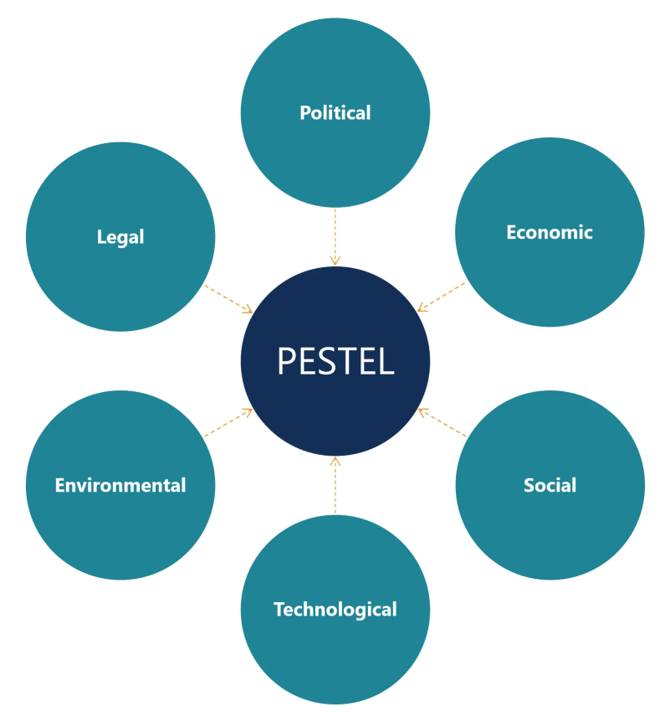
Figure: PESTEL Analysis
(Source: Pan, Chen and Zhan, 2019)

3. Critical analysis of the workplace
Organisational culture is all about building a healthy workplace for the employees. It helps in employee satisfaction and retention. Amazon believes in a culture that is well-aligned with its strategies and vision. The workplace of Amazon is such that when people get the opportunity to work at Amazon, they are aware that the workplace environment would be friendly and intense. To do a detailed critical analysis, the SWOT analysis will identify the factors influencing the workplace culture.
- Strengths: The strengths of Amazon include its exceptional growth despite small margins of profit (Majed, Nuraddin, and Hama, 2018). Another strength of the company is that it continuously strives for innovation. The fact cannot be denied that the company has built a solid reputation over time which is a positive advantage.
- Weaknesses: One of the significant weaknesses of the company is that its profit margin is still very low (Majed, Nuraddin, and Hama, 2018). They have a struggling success with their electronic devices. The company has a high employee turnover rate and has been often criticised as a harsh place to work.
- Opportunities: Their membership plan has been a successful one where the customers enjoy multiple services, including the e-commerce service (Wayne, 2018,). This membership is also a symbol of loyalty to the company. They have an excellent opportunity to make their cloud service more productive and reach more customers.
- Threats: The biggest threat for any company comes from its competitors (Gürel and Tat, 2017). Amazon's biggest competitive threat is Walmart, following an almost similar multi-service approach for the customers. Besides, already established companies like Alibaba in China or Flipkart in India are still dominating their respective markets.
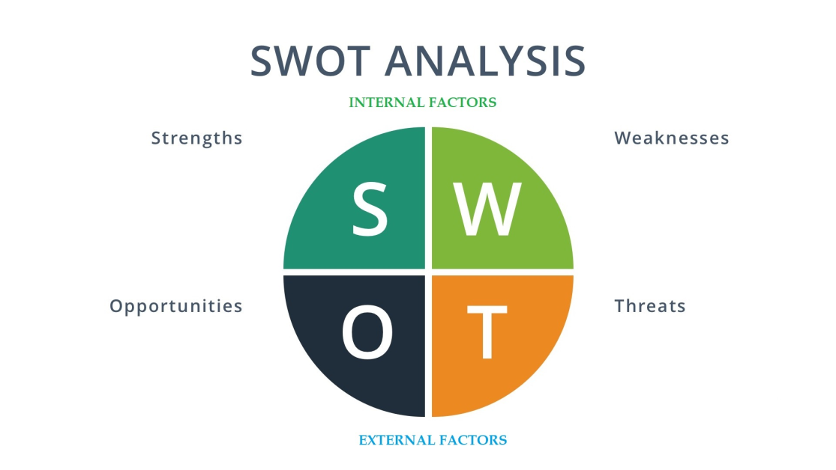
Figure: SWOT Analysis
Source: Sarsby, 2016
On the other hand, the cultural web model, developed by Gerry Johnson and Kevan Scholes in 1992, helps define the paradigm or live the reality of an organisation's work culture (Morris, 2020). This model helps identify and explore various elements of a company and analyse these elements' effect in shaping employees' experiences within the workplace. This model helps to analyse the company's present culture and explores its journey – where the company was when it started and how far it has travelled, and ultimately to which direction it wants to move (Johnson, 2015). There are six elements in the cultural web model that are discussed below -
- Rituals and routines: Rituals refer to the actions that are important to the company. It reflects how the company deals with matters, whereas routines can be taken for its employees' expectations. After the end of any creative session at Amazon, each team gathers for an hour with snacks and has some timeout together. Moreover, the employees get rewarded when they perform some exceptional tasks, motivating all the employees (Jenkins, Ford and Green, 2018).
- Stories: This element refers to the most talked-about stories within the organisation. The company, Amazon, has a rich history, and numerous stories can inspire and motivate their employees. The company, since its inception, has seen many lean times, and it cannot be denied that the company has successfully surpassed all those situations.
- Symbols: This element in the cultural web model refers to the company's branding and defines its recognition around the marketplaces it works in. Amazon is a multinational company; there is no doubt that it is a globally recognised and reputed brand. Starting from their logo, office look, dress’s code at work, advertisements etc., are highly influential throughout the world.
- Control system: This element defines the process of controlling an organisation. In other words, this element talks about performance management and the way employees can successfully achieve the desired outcomes in their roles. This element includes quality control, financial system, and rewards. The higher management of Amazon takes detailed care of these aspects and thrives on doing better.
- Power structure: This element directly relates to the paradigm of the cultural web model. This element includes the most influential people within the organisation who significantly impact the company's performance. A person like Jeff Bezos of Amazon is often regarded as the boss or its central power. Bezos and the company's other major members are the ones who have the core ideas and assumptions within the company.
- Organisational structure: This element refers to the company's hierarchical composition and relationships between the employees and their seniors or upper management. This element involves written and unwritten influence. The former refers to the organisational chart, which is the actual organisational structure of who works in the company and which individual reports. On the other hand, unwritten influence refers to the people who are not included in the organisational chart but greatly influence the company. Amazon has always maintained a social structure where everyone can participate, providing their opinions and be a part of the decision-making process.
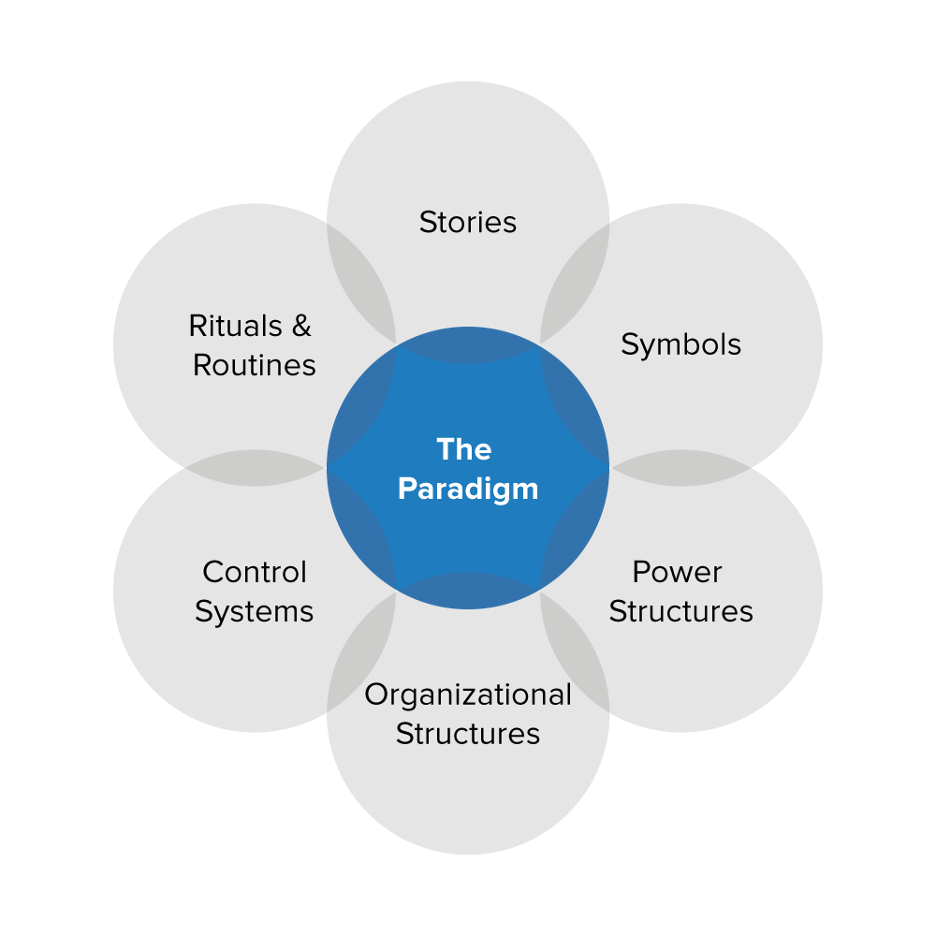
Figure: Cultural web model
(Source: Johnson, 2015)

4. Analysis of the positive cultural elements
Amazon is among the world's most reputed and desired workplaces for people. The company was ranked second in the world's best employers list in 2020 and is currently recognized as the 2nd most admired company worldwide (Cutter, 2019). The positive culture at the workplace enables Amazon to respond to the demands in the e-commerce market critically. The company's workplace culture always pushes its employees to move beyond its traditional limits and thrive on developing innovative ideas and solutions (Chai, 2015). The company's culture lets its employees take risks and thus increase the capacity to explore new opportunities for its ultimate benefit (Kwon, Marzec, and Edington, 2015). Some positive elements or characteristics contribute heavily to a company's performance. These elements or characteristics are discussed below –
- Value: The positive cultural value within the company is evident in its current success throughout the world. Amazon always motivates its employees are to identify new ideas and view themselves as no less than others. The company also allows its leaders to think like an owner and think for long term results more than the short term results (Taplin, 2017). The company also values its customers and always looks to provide the best products and services to them.
- Boldness: Amazon has always pushed its employees to be bold in every aspect of their work. They believe that boldness increases confidence in taking risks. This is evident in how the company has managed to provide many products and services to their customers in numerous fields. To emphasise boldness, the company also practices openness among the employees towards sharing new ideas with others. This feature enables the company to have the best ideas possible to make decisions or solve any issue.
- Customer centricity: Amazon has always prioritised its customer services. They try to provide the best customer services possible and meet the requirements of their customers. The workplace culture at Amazon has always pushed its employees to serve its customers better. The company constantly looks after the needs and demands of the customers. The company continuously analyses the ever-changing trends and changes in customer preferences to provide the best services possible. With this characteristic of the corporate culture, the company maintains a positive and effective level of customer satisfaction and thrives to excel better in the future continuously (Fader, 2020).
The report published by Spurk and Straub, 2020, includes job satisfaction during pandemic times. The report states that the employees of Amazon did a great job during the pandemic by making sure that people get their desired products and services to their doorsteps in time. This has been successful due to the positive culture throughout the workplace of the company. The company has over 875,000 people worldwide and has further hired more than 175,000 new employees during the pandemic. The company has also spent billions of dollars on COVID safety measures that included 100 million face masks to their employees and introduced various processes to measure the safety at all of its work sites worldwide. These highlight the company's positive approach towards maintaining a healthy workplace culture, especially during pandemic times.

5. Analysis of the organisation's ethical stance
Amazon is one of the leading technology companies around the world today. The company, throughout its past, has successfully established a strong brand image and has many partnerships in the world. The company enforces and encourages strict adherence to its local and international laws through its Code of Ethics (Boddington, 2017). Amazon emphasises building and maintaining a safe and healthy workplace culture free from any sort of harassment and dangers. They believe in providing freedom among the employees to do their duties without any hindrance. The company strongly deals with any behaviour against their ethics or their employees or suppliers, or their customers. The employees within the organisation must follow the rules and regulations all the time. Employees with any issue or complaint regarding the application or interpretation of rules and regulations can contact the legal department. The company allows employees to use their personal opinion and judgment at work, but the 'conflict of interest' issue arises when that judgment interferes with its interest (Jeanes, 2017). Amazon provides a healthy and safe work environment, and it is the responsibility of the employees and leaders to maintain that environment positively (Taplin, 2017).
On the other hand, Amazon can be easily termed as unethical when adopting the eco-centric approach. The company considers its customers as their most important stakeholders. Their next-day delivery policy has been criticised heavily due to its increasing emission of greenhouse gas or carbon dioxide (Lauerwald, 2017). However, the company promises to make half of its shipments carbon neutral by the end of this decade. Moreover, Amazon treats its employees as it is another valuable stakeholder. Although Amazon falls into the list of most desired workplaces, its environment has been criticised several times for being full of discrimination and abuses. They also oppose unionisation (Kim, 2018). There are groups like the Interfaith Center on Corporate Responsibility (ICCR) that suppress organisations on such issues. For example, a group of activist investors in affiliation with ICCS had proposed several concepts to Amazon to reduce the company's much-talked issue of food waste (Waddock, 2017). Another talked-about issue of the company is that they have several temporary employees majorly working in their warehouses (Delfanti, 2019). There have been several reports that they have to face abuses from their seniors. Another ethical issue associated with the company is that of tax avoidance. For instance, the company still does not pay the sales tax in all US states (Kubick, 2015). From its initial days, Amazon has been skipping taxes as in the '90s, and the physical stores used to pay the majority of the taxes.
Overall, Amazon has a set of well-structured ethical policies for its employees and mainly for business operations, but there have been several unethical practices over the company (Raji, 2020).

6. Analysis of the skills, knowledge, and behaviour of an employee
The company is particular regarding its choice of workers to only attract and desire those kinds of people suited ideally to their requirements. This makes the workplace filled with people who have goals and vision matched with the company. They have a wide number of products and services, and therefore they seek talents in various fields. People with skills like software engineering, network engineering, program manager, product manager, front-end developer, data scientist, business analyst, data engineering etc., are in high demand. The company is a technology-based company, and therefore they look to enlarge and empower their technological part at all times. Alongside skills, technical knowledge is highly rated for being hired as an employee at Amazon. The company, during the pandemic, increased their employee numbers, and it cannot be denied that their online services were highly benefited during this time. From the behavioural aspect, it can be said that the company strives for a healthy and safe workplace. Therefore, they seek desired responses from their employees to achieve this goal. Moreover, they propose that their employees work freely and share their opinions and thoughts with their seniors.
On the other hand, the company's workplace has been criticised several times for being very harsh on new employees and temporary employees, especially in the warehouses. There have been several instances that they suffer from abuse from others and are pushed to work beyond their limits. This increases the burden on the employees, and they feel reluctant at work. Amazon also opposes the implementation of trade unions in the UK and the US (Kim, 2018). Various reports state that, at Amazon, the employees are encouraged to give their ideas and rip them apart in team meetings. Reports also state that an employee needs to be alert even during the night and reply to any e-mails or attend calls (Cutter, 2019).
Therefore, for an employee to perform well at Amazon, they need to have the required skills and knowledge, and they must be ready to accept the given environment in the workplace. The employee must earn the trust of his higher management and create a healthy image of himself among everyone. Moreover, the employee must be open to criticism to deliver the best results possible an employee may come under criticism often. The company, to relax its employees, arranges many fun activities like parties, sports events, communities etc. and it is crucial to take part in these activities to have refreshment. Moreover, an employee also needs to socialise with others, make suggestions, or leave their opinions on things they can. This is a great way to contribute to the company's performance. Besides all these, an employee continually needs to look for improving his skills and knowledge.

7. Conclusions
The following study is focused on the e-commerce multinational giant Amazon. The study addresses the workplace culture within Amazon and discusses its current impact on employee satisfaction and retention (Cutter, 2019). Healthy workplace culture is highly rated among the top organisations, primarily by Amazon. Moreover, organisations with a strong culture have the power to outperform their competitors and are more successful. It is a common denominator in most successful organisations. The management, the HR, and the organisation's leaders impact the culture in the workplaces. The study has undertaken the PESTEL analysis to identify the top factors affecting the company. The study also includes a critical analysis using the SWOT and Cultural Web Model. The positive cultural elements highlight the factors that have contributed to its success. The study also includes the company's ethical stance, and the study further discusses the skills, knowledge, and behaviour required to perform well in the organisation. Lastly, some recommendations are provided at the end of the study that could help the company excel.

8. Recommendations
The work environment of Amazon is full of empowering people who learn from each other, share knowledge and help each other to understand the world better. However, there is certainly room to improve their workplace culture. Here are some recommendations for the enhancement of the workplace culture inside Amazon -
- The employees always look forward to knowing that their senior leaders and higher authority value them. Therefore, the company needs to show that they care for them and care for improving the workplace culture. The seniors or team leaders can take time to listen to their junior employee's needs and requirements and should respect that (Gilani, and Cunningham, 2017).
- Organisational leaders must provide the employees with the correct information, tools, support, time, and power to make their own decisions and be a part of the company's more extensive decision-making process (Anitha, 2016). There should be a friendly cultural ambience all around the workplace. Other major companies like Microsoft, Apple, etc., empower and value their employees and respect their opinions, leading them to become the top desired workplaces for employees.

References
Anitha, J., 2016. Role of organisational Culture and Employee Commitment in Employee Retention. ASBM Journal of Management, 9(1).
Boddington, P., 2017. Towards a code of ethics for artificial intelligence (pp. 27-37). Cham: Springer.
Chai, C., Bao, D., Sun, L. and Cao, Y., 2015. The relative effects of different dimensions of traditional cultural elements on customer product satisfaction. International Journal of Industrial Ergonomics, 48, pp.77-88.
Cravens, K.S., Oliver, E.G., Oishi, S. and Stewart, J.S., 2015. Workplace culture mediates performance appraisal effectiveness and employee outcomes: A study in a retail setting. Journal of Management Accounting Research, 27(2), pp.1-34.
Cutter, C., 2019. Amazon to retrain a third of its US workforce. Wall Street Journal.
Delfanti, A., 2019. Machinic dispossession and augmented despotism: Digital work in an Amazon warehouse. New Media & Society, p.1461444819891613.
Fader, P., 2020. Customer centricity: Focus on the right customers for strategic advantage. Wharton digital press.
Gilani, H. and Cunningham, L., 2017. Employer branding and its influence on employee retention: A literature review. The Marketing Review, 17(2), pp.239-256.
Gürel, E. and Tat, M., 2017. SWOT analysis: a theoretical review. Journal of International Social Research, 10(51).
Harney, B. and Dundon, T., 2020. Amazon: HRM and change in the house of neo-liberalism. In Case Studies in Work, Employment and Human Resource Management. Edward Elgar Publishing.
Jeanes, E., 2017. Are we ethical? Approaches to ethics in management and organisation research. Organisation, 24(2), pp.174-197.
Jenkins, H., Ford, S. and Green, J., 2018. Spreadable media: Creating value and meaning in a networked culture (Vol. 15). NYU press.
Johnson, G., 2015. Cultural Web. Wiley Encyclopedia of Management, pp.1-2.
Kantor, J. and Streitfeld, D., 2015. Inside Amazon: Wrestling big ideas in a bruising workplace. The New York Times, 15(08).
Kim, J.G., 2018. Digital Media and Unionisation in the "Guilded" Age: How Labor Organizations in the Entertainment Industry Are Swimming Against the Current of Streaming New Media and Technology.
Kubick, T.R., Lynch, D.P., Mayberry, M.A. and Omer, T.C., 2015. Product market power and tax avoidance: Market leaders, mimicking strategies, and stock returns. The Accounting Review, 90(2), pp.675-702.
Kwon, Y., Marzec, M.L. and Edington, D.W., 2015. Development and validity of a scale to measure workplace culture of health. Journal of occupational and environmental medicine, 57(5), pp.571-577.
Lai, D.W., Shankar, J. and Khalema, E., 2017. Unspoken skills and tactics: Essentials for immigrant professionals in integration to workplace culture. Journal of International Migration and Integration, 18(3), pp.937-959.
Lauerwald, R., Regnier, P., Camino-Serrano, M., Guenet, B., Guimberteau, M., Ducharne, A., Polcher, J. and Ciais, P., 2017. ORCHILEAK (revision 3875): a new model branch to simulate carbon transfers along the terrestrial–aquatic continuum of the Amazon basin. Geoscientific Model Development, 10(10), pp.3821-3859.
Majed, S.Z., Nuraddin, S.H. and Hama, S.V.S., 2018. Analysing the amazon success strategies. Journal of process management. New Technologies, 6(4), pp.65-69.
Morris, J.P., 2020. Is this the culture of academies? Utilising the cultural web to investigate the organisational culture of an academy case study. Educational Management Administration & Leadership, 48(1), pp.164-185.
Onyusheva, I. and Seenalasataporn, T., 2018. Strategic Analysis of Global E-Commerce And Diversification Technology: The Case Of Amazon. Com INC. The EUrASEANs: journal on global socio-economic dynamics, (1 (8)), pp.48-63.
Ortega, R.G., Rodríguez, M.D.O., Vázquez, M.L., Ricardo, J.E., Figueiredo, J.A.S. and Smarandache, F., 2019. Pestel analysis based on neutrosophic cognitive maps and neutrosophic numbers for the sinos river basin management. Infinite Study.
Pan, W., Chen, L. and Zhan, W., 2019. PESTEL analysis of construction productivity enhancement strategies: A case study of three economies. Journal of Management in Engineering, 35(1), p.05018013.
Raji, I.D., Gebru, T., Mitchell, M., Buolamwini, J., Lee, J. and Denton, E., 2020, February. Saving face: Investigating the ethical concerns of facial recognition auditing. In Proceedings of the AAAI/ACM Conference on AI, Ethics, and Society (pp. 145-151).
Sarsby, A., 2016. SWOT analysis. Lulu. com.
Spurk, D. and Straub, C., 2020. Flexible employment relationships and careers in times of the COVID-19 pandemic.
Taplin, J., 2017. Move fast and break things: How Facebook, Google, and Amazon have cornered culture and what it means for all of us. Pan Macmillan.
Taplin, J., 2017. Move fast and break things: How Facebook, Google, and Amazon have cornered culture and what it means for all of us. Pan Macmillan.
Waddock, S., 2017. The difference makers: How social and institutional entrepreneurs created the corporate responsibility movement. Routledge.
Wayne, M.L., 2018. Netflix, Amazon, and branded television content in subscription video-on-demand portals. Media, Culture & Society, 40(5), pp.725-741.
Wittig, M., Wittig, A. and Whaley, B., 2018. Amazon web services in action. Manning,.

