Series Hybrid Vehicle Part 1a
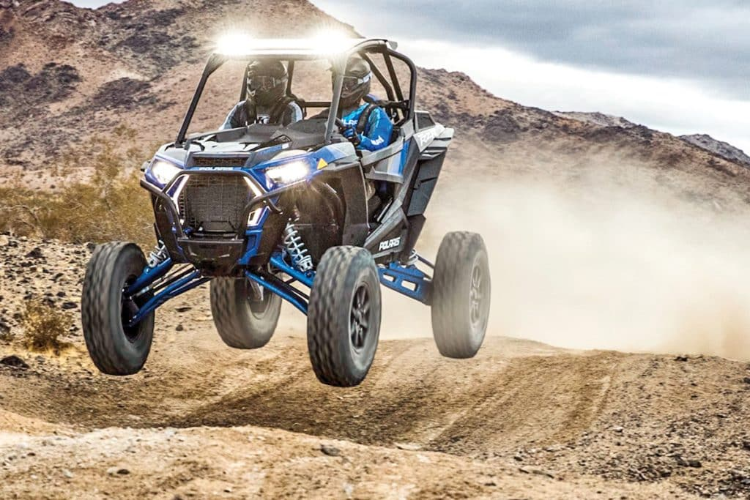

Benjamin Coney
1703189
Alternative Powertrain Technology
BSc Motorsport Engineering

Contents Page
Introduction Page 3
Research Pages 4 and 5
Calculation Page 6
Analysis Page 7
Conclusion Page 8
Appendix Pages 9 - 16
References Page 17

Introduction
Within this assignment, an off road track will be designed, from here research on the most adequate buggy for the track will be made. The specifications of the chosen buggy will then be used to produce an analytical evaluation of the performance of the chosen buggy on the chosen track, the required power and total tractive effort will be calculated using the vehicle specification and assumptions of the performance of the buggy on the track. The results produced will then be analysed and a conclusion on whether the buggy is adequate for the application will be made, the possibility of adapting the buggy to harness a series hybrid system will also be discussed.
Research

The Buggy

Figure 1 – Illustrates the Polaris RZR XP Turbo S (VELOCITY, 2019)
The chosen buggy for the application was the 2020 Polaris RZR XP Turbo S as can be seen in figure 1, this is the fastest and most powerful buggy that Polaris manufactures at this current time. With a power of 168hp or 125kw and a weight of 808kg, this buggy has ample power for the track chosen. The buggy can do a top speed of 85mph or 38m/s, it also has a 0-60mph time of 7.53 seconds, and thus meaning it should be more than adequate for the application. The full specification of the buggy can be found in figure 4.

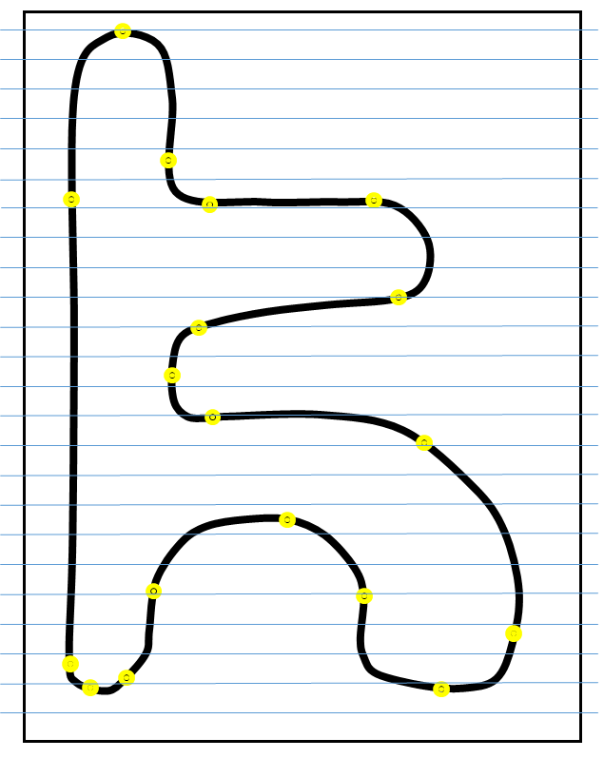
The Track
1 m
2 m
3 m
4 m
5 m
6 m
7 m
8 m
9 m
10 m
11 m
12 m
13 m
14 m
15 m
16 m
17 m
18 m
19 m
20 m
21 m
22 m
23 m
0 m
22 m
20 m
10 m
18 m
16 m
14 m
Elevation

Figure 2 – Illustrates the track design and the elevation
The above track (figure 2) was designed to ensure that there was a good mixture of fast straight and tight corners, there is also a more technical aspect to the track that involves a steep up and downhill sections as shown on the track map. The uphill section has a gradient of just under 20 degrees, this assent will test the skill and obstacle perception of the driver. Further information on the track can be found in figures 5, 6 and 7.
Calculations
Velocity = $Distance ÷Time$
Acceleration = $\frac{change in velocity- velocity}{time}$
Gradient Resistance = $m×g×\sin{(θ)°}$
Rolling Resistance = $m×g×rc$
Aerodynamic Resistance = $0.5×Cd×A×P×V^{2}$
Total Tractive Resistance = $Total Resistive ×Velocity$
Power Required = $Total Tractive Resistance ×Velocity$
Average Power = $sum of all ÷no. of sectors$
Gradient = $\sin^{-1}{(\frac{change in height }{distanace travelled }})$
Analysis
From the results produced on Excel using the specifications of the Polaris RZR XP Turbo S it is evident that the buggy is more than adequate for the application. The specifications of the Polaris can be found on figure 3, the weight, power and top speed of the Polaris are shown. Assumptions made on the rolling resistance, air density and coefficient of drag can be found in figure 4, these assumptions were based upon figures found through research. Figure 5 shows sectors of the track and the cumulative distance of each sector, these distances will then be used alongside assumptions of the length of time taken to get through each sector to calculate the velocity of the buggy in each sector, this can be found in figures 6 and 7. The elevation of the track can be found in figure 6 along with the change in elevation in each sector. The velocity and acceleration of the Polaris in each sector was the calculated, the results for these can be found in figure 7. The gradient resistance was also calculated and can be found in figure 7. Figure 8 shows the results for the rolling resistance, aerodynamic resistance and cumulative tractive resistance. The power required, power unused and the average power required per sector was then calculated, the results for these can be found in figure 9. Figure 10 shows the graphical representation of the velocity in m/s against the cumulative distance of the track can be found, from the graph it is evident that the average velocity of the buggy is near to 12m/s. The maximum acceleration of the buggy on the track can then be seen on figure 12, the graph shows that the maximum acceleration of the buggy id just over 6m/s². Figure 14 shows the aerodynamic resistance of the Polaris against the time taken to complete a lap of the track, the results show that as the speed of the Polaris increases as does the aerodynamic resistance. Figure 16 shows the elevation changes from the start until the end of the track, the track has a difference of 23m, thus meaning that the design of the track is to the specifications of the brief. Figure 17, like figure 16, shows the elevation of the track, however in figure 17, it shows the elevation of the track compared against time, the results show that the track goes predominantly uphill but it also has a few downhill sectors. Figure 18 shows the gradient of each sector of the track against the time taken to complete the lap, the maximum gradient shown is just over 17°, this gradient allows for the skill of the driver to be tested.
Conclusion
The Polaris RZR XP Turbo S would be more than adequate for the application, as it has more than ample power and the acceleration of the buggy would be enjoyable and controllable. The track that has been designed would make for a thrilling experience for all involved as it has a variety of fast and technical sections, the length of time that it would take to get around the track would be enjoyable as it allows for more laps to be made. If the track was to be redesigned then a few more technical sections would be added, such as a pool of water or maybe a jump or two, these additions would make for a more exciting experience. Although the Polaris has ample power for the application, the addition of a series hybrid system wouldn’t go amiss, having the hybrid system would allow for a power increase and an improved acceleration, meaning that a faster speed could be achieved on the finishing straight.
Appendix
Vehicle Information
Make and model | 2020 Polaris RZR XP Turbo S
Engine | turbocharged two cylinder 4-stroke DOHC
Engine Capacity (cc) | 925
Power (Kw) | 125
Torque (ft-lbs) | 114
Top Speed (Km/h) | 137
0 - 60 Time (Secs) | 7.53
Drivetrain | AWD/2WD
Transmission | Automatic (Low and High)
Front Tyres (inch) | 32x10-15 ITP Coyote (8-ply rated) Quad
Rear Tyres (inch) | 32x10-15 ITP Coyote (8-ply rated) Quad
Dry Weight (Kg) | 808
Ground Clearance (mm) | 4060
Height (m) | 1.9
Width (m) | 1.82

Figure 3 – Illustrates the vehicle specification of the chosen buggy (Rzr.polaris.com, 2019)
Assumption data based on research
Rolling Resistance Coefficient on dirt | 0.08
Coefficient of drag | 0.38
Air Density | 1.2

Figure 4 – Illustrates the assumptions made (Engineeringtoolbox.com, 2019) (Engineersedge.com, 2019)
Sector No. | Description | Distance per Sector (m) | Cumulative Distance (m)
0 | Start | 0 | 0
1 | str1 tr1 | 60 | 60
2 | str2 tr2 | 50 | 110
3 | tr2 | 15 | 125
4 | str3 | 60 | 185
5 | tr3 | 25 | 210
6 | str4 | 65 | 275
7 | tr4 | 10 | 285
8 | tr4 | 10 | 295
9 | str5 | 75 | 370
10 | ltr5 | 55 | 425
11 | tr6 | 35 | 460
12 | tr7 | 40 | 500
13 | tr8 | 30 | 530
14 | tr9 | 50 | 580
15 | sstr6 | 20 | 600
16 | tr10 | 7.5 | 607.5
17 | tr10 | 5 | 612.5
18 | str1 finish | 160 | 772.5

Figure 5 – Illustrates the first part of the Excel spreadsheet
Elevation (m) | Change in Elevation (m) | Time in Section (sec) | Cumulative Time (sec)
5.8 | 0 | 0 | 0
0 | -5.8 | 3 | 3
4.4 | 4.4 | 3 | 6
6 | 1.6 | 2 | 8
5.8 | -0.2 | 3 | 11
9 | 3.2 | 2 | 13
10 | 1 | 4 | 17
11.5 | 1.5 | 1 | 18
13 | 1.5 | 1.5 | 19.5
14 | 1 | 5 | 24.5
20.3 | 6.3 | 6 | 30.5
22.2 | 1.9 | 3 | 33.5
16 | -6.2 | 3.5 | 37
11 | -5 | 3 | 40
16 | 5 | 5 | 45
22 | 6 | 4 | 49
22.3 | 0.3 | 1 | 50
21.5 | -0.8 | 0.5 | 50.5
5.8 | -15.7 | 7 | 57.5

Figure 6 – Illustrates the second part of the Excel spreadsheet

Gradient (Degrees) | Velocity (m/s) | acceleration (m/s^2) | Gradient Resistance
0 | 0 | 0 | 0
-5.547254339 | 20 | -6.666666667 | 5320.867568
5.048558958 | 16.66666667 | 1.111111111 | -7482.795367
6.123198866 | 7.5 | 4.583333333 | -1262.726475
-0.190986285 | 20 | -4.166666667 | -1504.662609
7.35403521 | 12.5 | 3.75 | 6956.344214
0.881508307 | 16.25 | -0.9375 | 6116.856858
8.626926559 | 10 | 6.25 | 5674.230106
8.626926559 | 6.666666667 | 2.222222222 | 5674.230106
0.763966364 | 15 | -1.666666667 | 5483.467383
6.577408266 | 9.166666667 | 0.972222222 | 2298.649775
3.111872011 | 11.66666667 | -0.833333333 | 235.5454019
-8.916796253 | 11.42857143 | 0.068027211 | -3855.557187
-9.594068227 | 10 | 0.476190476 | 1335.475573
5.739170477 | 10 | 0 | -4102.551003
17.45760312 | 5 | 1.25 | -7800.053257
2.292442776 | 7.5 | -2.5 | 5950.559673
-9.206896221 | 10 | -5 | -1713.403214
-5.631209839 | 22.85714286 | -1.836734694 | 4809.454059

Figure 7 – Illustrates the third part of the Excel spreadsheet

Rolling Resistance | Aerodynamic Resistance | Cumulative Tractive Resistance
0 | 0 | 0
0.08 | 214.32 | 5535.267568
0.08 | 148.8333333 | -7333.882034
0.08 | 30.13875 | -1232.507725
0.08 | 214.32 | -1290.262609
0.08 | 83.71875 | 7040.142964
0.08 | 141.4846875 | 6258.421545
0.08 | 53.58 | 5727.890106
0.08 | 23.81333333 | 5698.12344
0.08 | 120.555 | 5604.102383
0.08 | 45.02208333 | 2343.751858
0.08 | 72.92833333 | 308.5537353
0.08 | 69.98204082 | -3785.495146
0.08 | 53.58 | 1389.135573
0.08 | 53.58 | -4048.891003
0.08 | 13.395 | -7786.578257
0.08 | 30.13875 | 5980.778423
0.08 | 53.58 | -1659.743214
0.08 | 279.9281633 | 5089.462222

Figure 8 – Illustrates the fourth part of the Excel spreadsheet

Power Required (w) | Power Unused (w) | Average Power Required per second (w)
0 | 125,000.00 | 0
110705.3514 | 14,294.65 | 36901.78379
-122231.3672 | 247,231.37 | -40743.78908
-9243.807939 | 134,243.81 | -4621.903969
-25805.25218 | 150,805.25 | -8601.750728
88001.78705 | 36,998.21 | 44000.89353
101699.3501 | 23,300.65 | 25424.83753
57278.90106 | 67,721.10 | 57278.90106
37987.4896 | 87,012.51 | 25324.99306
84061.53574 | 40,938.46 | 16812.30715
21484.39203 | 103,515.61 | 3580.732006
3599.793578 | 121,400.21 | 1199.931193
-43262.80167 | 168,262.80 | -12360.80048
13891.35573 | 111,108.64 | 4630.45191
-40488.91003 | 165,488.91 | -8097.782006
-38932.89129 | 163,932.89 | -9733.222821
44855.83817 | 80,144.16 | 44855.83817
-16597.43214 | 141,597.43 | -33194.86429
116330.5651 | 8,669.43 | 16618.65215

Figure 9 – Illustrates the fifth part of the Excel spreadsheet

Figure 10 – Illustrates the Velocity over Distance graph

Figure 11 – Illustrates the Velocity over Time graph

Figure 12 – Illustrates the Acceleration against Time graph

Figure 13 – Illustrates the Cumulative Time over Distance graph

Figure 14 – Illustrates the Aerodynamic Resistance over Time graph

Figure 15 – Illustrates the Rolling Resistance over Time graph

Figure 16 – Illustrates the Elevation Change over Distance graph

Figure 17 – Illustrates the Elevation over Time graph

Figure 18 – Illustrates the Gradient over Time graph
References
https://www.engineeringtoolbox.com/rolling-friction-resistance-d_1303.html
https://rzr.polaris.com/en-us/rzr-xp-turbo-s-ghost-gray/specs/
https://www.engineeringtoolbox.com/drag-coefficient-d_627.html
https://www.engineersedge.com/calculators/air-density.htm
https://utvactionmag.com/2020-polaris-rzr-xp-turbo-s-turbo-s-velocity/

