

Assessment 1
Programme: Applied Computing
Module: Usability Engineering
Module code: ACCB6017
Lecturer: Dr Nassir Ibrahim
Submission deadline: 31st October 2025
14:00 (2 PM)
Natalia Goncearuc
Student number 2228229
Table of Contents
1.0 Introduction 2
2.0 Creation of user personas, along with their specific user and experience requirements 2
3.0 User Research and Persona Development 6
4.0 Usability Design Considerations 12
5.0 Wireframe Storyboards 15
6.0 Feedback Collection and Analysis 19
7.0 Conclusion 21
8.0 References 22
9.0 Appendices 23

Introduction
This report investigates the user interface design process for the University of Wales Trinity Saint David (UWTSD) version of Cluedo, emphasising the importance of developing a User Interface Design that aligns with both functional specifications and the emotional connections that users desire. As defined by the International Organisation for Standardisation (ISO), usability is critical; it reflects the degree to which users can effectively, efficiently, and satisfactorily achieve specified objectives within a given context [1].
To ensure the successful delivery of the product, the report is structured into six key sections. It commences with the formulation of user characters intended to address specific usage scenarios and experience requirements. This section introduces four distinct user personas that accommodate diverse player preferences and needs, highlighting their frustrations, requirements, and expectations in order to foster a deeper understanding of users and inform subsequent design enhancements.
The report then shifts the focus to User Research and Character Development, employing structured questionnaires to gather data from a broad audience effectively. The application of the MOSCOW technique will prioritise user requirements, which is essential for enhancing user experience. Following this segment, Usability Design Considerations will address the necessity of a straightforward user interface, clear navigation, and practical game tutorials. By implementing Jakob Nielsen's usability principles, the design will strive to ensure aesthetic appeal, user compatibility, reduced cognitive load, and consistency, thereby enhancing the overall gaming experience.
Finally, the report will present wireframes and conclude with an analysis of Feedback Collection and Analysis. This analysis will utilise the insights gained to refine the user interface to better align with user expectations and emotional comfort.

2.0 Creation of user personas, along with their specific user and experience requirements

Personas, defined as imaginary people who describe real user segments, are considered a powerful technique for user understanding and user-centred design in human-computer interaction [2]. Based on the analysis of research results, the characteristics of the user personas for the game Cluedo, UWTSD version, were identified, reflecting different user archetypes, which will include the character's name, demographic data, a short biography, and their habits, goals, needs, and frustrations regarding digital games [3]
Persona 1: Emily – The Creative Gamer
Age 26, a Creative Arts and Design student who enjoys reading science fiction and drawing. Occasionally plays puzzle games on her smartphone.
Frustrations:
- Confusing navigation
- Rules that are too complex
- Lack of guidance and Customisation options
- Inconsistent design
User Requirements
- Easy navigation
- Visually appealing and intuitive game interface
- Simple rules, easy to understand
- Interactive tutorial
- Customisable character appearance and environments.
- Social media integration for sharing creative moments
Experience Requirements
- Enjoys relaxing gameplay with beautiful design
- Enjoys customising character appearance and environments
- Likes occasional multiplayer with friends online

Persona 2: James – Social Board Gamer
Age 40, a part-time Business Management student and full-time retail manager. Values social interaction and prefers role-playing games.
Frustrations:
- Confusing navigation
- Small or unreadable text.
- Too many pop-ups or notifications
- Confusing rules
User requirements
- Easy navigation
- Minimal clutter and readable text
- Simple rules, easy to understand
- Customisation of game level difficulty
- Social features (chat, emojis, team play)
- Presence of achievement and leader board
- Optional multiplayer for casual interaction
Experience requirements
- Interactive tutorials as options to learn
- Minimal distractions with well-placed buttons and clean UI
- Social features, elements, and gameplay with real people.
- Enjoys leaderboards and achievements

Persona 3: Jane – Accessibility- Focused Gamer
35-year-old Education and Psychology student with visual needs. Rarely plays games and values comfort and ease of use. Enjoys puzzle games and cartoonish or retro-style games.
Frustrations:
- Small elements or unreadable text
- Complex rules and overwhelming interfaces.
- Too many buttons make navigation difficult
- Lack of customisation options for accessibility
- Distracting notifications and flashy visuals.
User requirements
- Scalable text and clear UI elements
- Simple rules, easy to understand
- Minimal clutter
- Minimal text and icon-based UI
- Customisable sound and music settings
Experience requirements
- Large text and scalable UI elements for readability
- Games that are relaxing and stress-relieving.
- Minimalistic or retro visuals for clarity
- Customisable control schemes (touch, keyboard, etc.)
Persona 4: Nick – The Competitive Gamer
27-year-old full-time IT student, sociable and competitive. Enjoys daily gaming on a smartphone and a laptop, and connecting with friends. Likes music, podcasts, and enjoys puzzle and strategy games with realistic or hand-drawn visuals.
Frustrations:
- Confusing navigation
- Poorly placed important buttons
- Too many pop-ups and notifications
- Lack of customisation options and social features
- Lack of interaction feedback
- Delayed in-game responses
- Games that require long-term commitment without clear progression.

User Requirements:

- Easy navigation
- Presence of achievements and leaderboards to track performance
- Customisable character appearance and environments
- Keyboard shortcuts
- Social features (chat, emojis, team play)
- Clear visual feedback for actions
- Advanced performance settings for competitive play
Experience Requirements
- Enjoys dynamic gameplay and challenges.
- Values immersive visuals and responsive controls.
- Prefers games with strategic depth, clear instructions, and adjustable difficulty.

3.0 User Research and Persona Development

To develop four detailed user personas, a combination of quantitative and qualitative research methods was employed. These methods helped identify users' needs, frustrations, and expectations regarding their gameplay experiences[4]. Survey participants were provided with comprehensive information about the research's purpose and their roles in the study. A consent form was meticulously prepared to ensure the responsible management of data and enhance transparency in the research process. This form serves as a critical indicator of ethical practices in research involving human subjects [5].
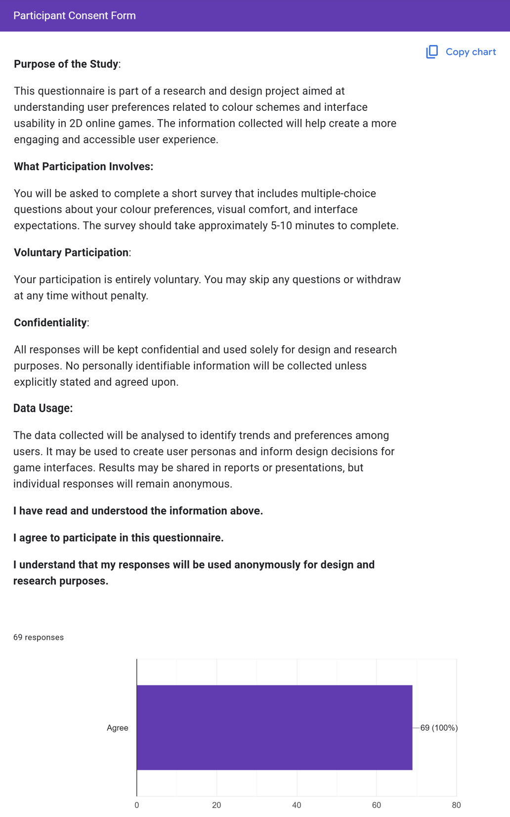
Figure 1 Consent Form
Questionnaire research method
The questionnaire method was used to collect quantitative data from 69 participants across various age groups and professions. Created in Google Forms (Appendix C) and distributed via email and social media, it included multiple-choice and scaled questions on demographics (age, gender, occupation), gaming habits (frequency, device), preferences (genres, visual styles, learning methods), frustrations (interface issues, rule complexity), and accessibility needs. This data enabled statistical analysis of user preferences, helped create user personas, and identified essential elements for developing the user interface of the 2D digital version of the Cluedo UWTSD board game.
Results and discussion
User demographics indicate that most participants are aged 18 to 45, with a strong representation of IT professionals and students, and a nearly equal gender distribution (50.7% female/49.3% male). User gaming behaviour shows that the majority play rarely or occasionally, while a significant portion plays daily or weekly. The preferred device for playing is the smartphone (73.1%).
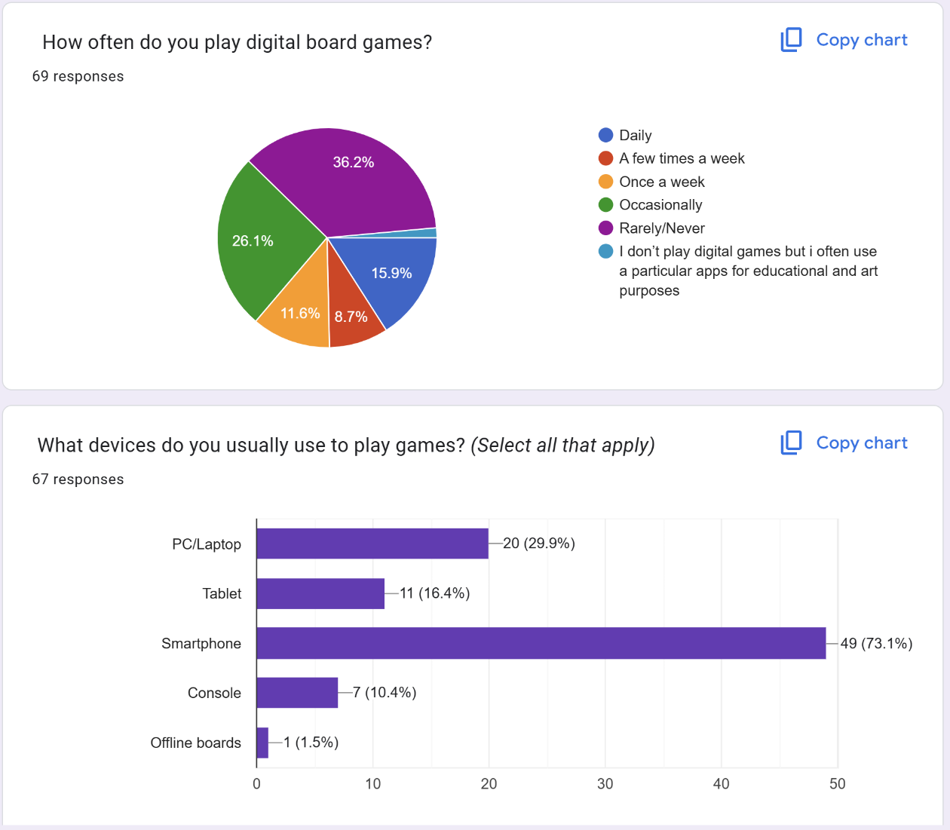
Figure 2 User gaming behaviour

User game preferences indicate a strong inclination towards Puzzle games (39.7%), Role-Playing games (35.3%), and Strategy games (33.8%). Additionally, 54% of users prefer Cartoonish visual styles, while 45% favour Realistic styles. They also value easy navigation, clear text, and interactive tutorials.
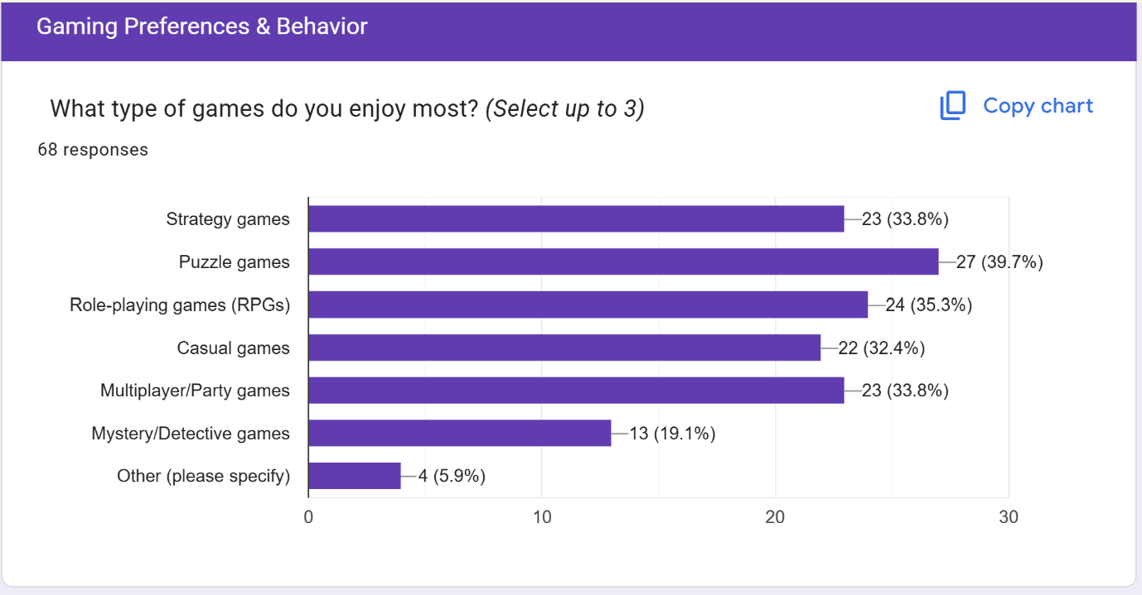
Figure 3 User gaming preferences

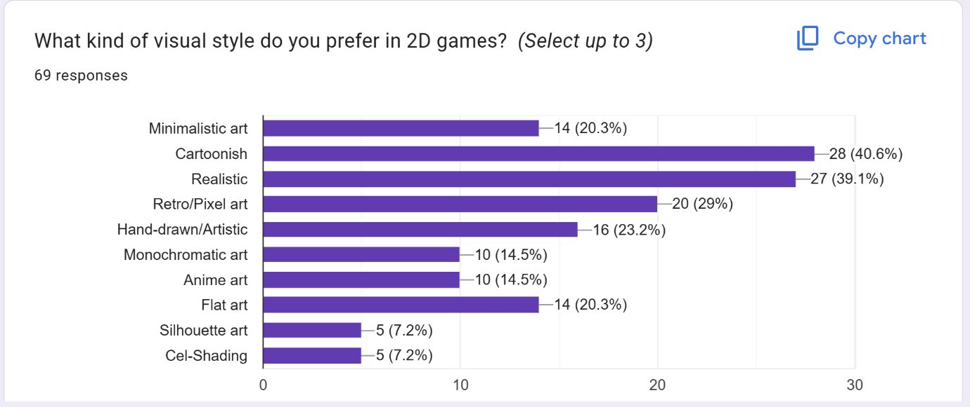
Figure 4 User visual style preferences
Users experience frustrations when faced with too many pop-ups (46.3%), slow performance (41.8%), confusing navigation, and small text (37.3%), along with complex rules and long-term commitments.

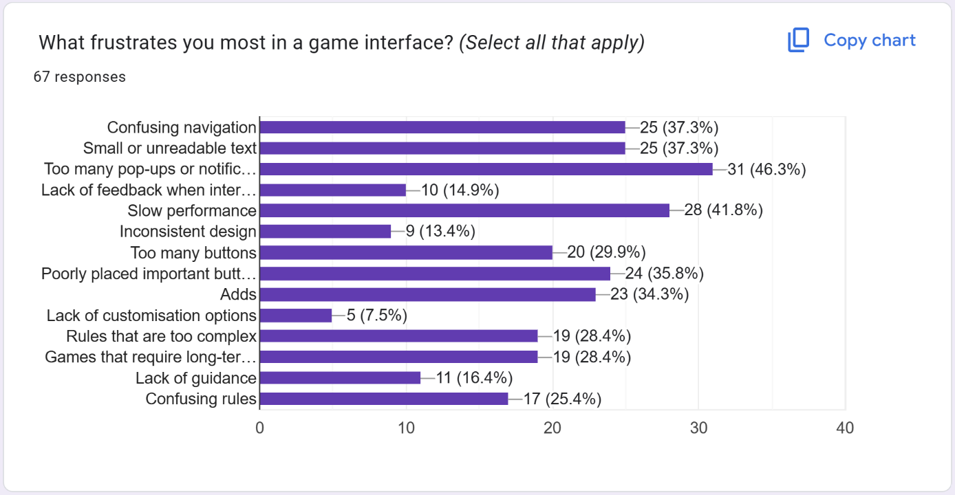
Figure 5 User frustrations

From a customisation and accessibility perspective, it was noted that users are highly interested in customising character appearance (47.7%) and adjusting difficulty level (27.7%). For accessibility, scalable UI elements and simplified controls are needed.
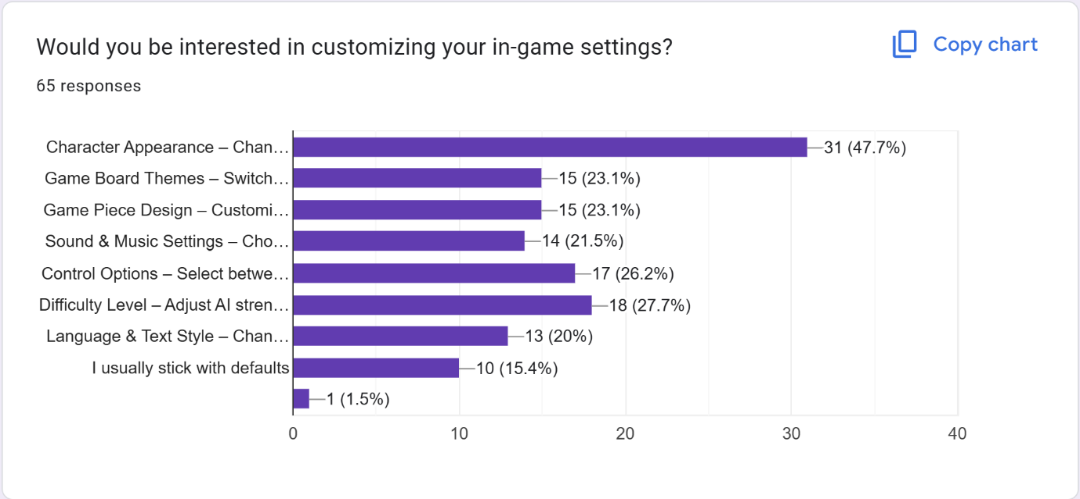
Figure 6 Customisation of user preferences

Users' preferences for Play Mode Features are mixed: many appreciate solo play (54.4%) and online play with friends (45.6%). Regarding social features, they also value emojis or reactions in an in-game chat (40.9%).
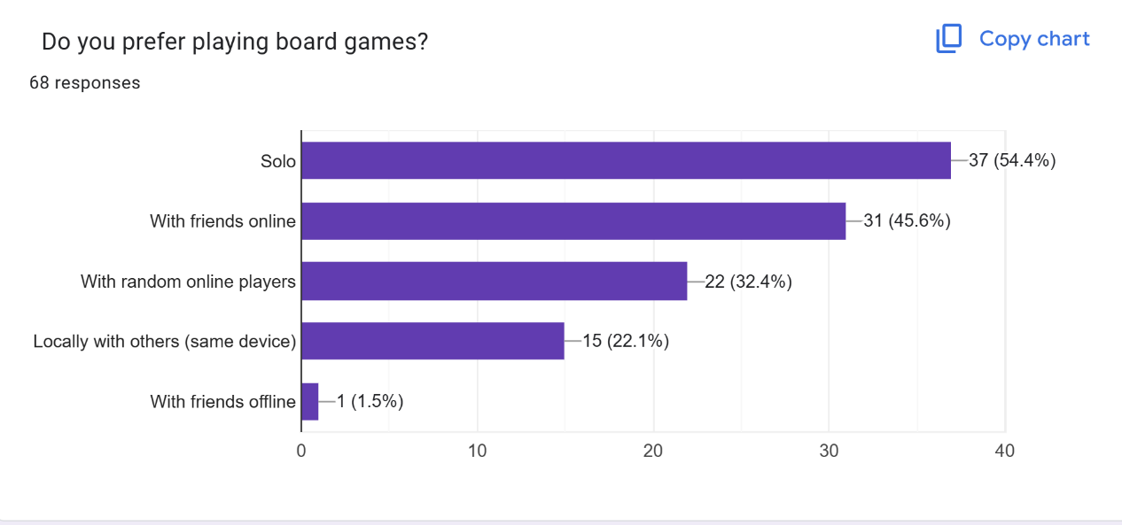
Figure 7Mode play game preferences

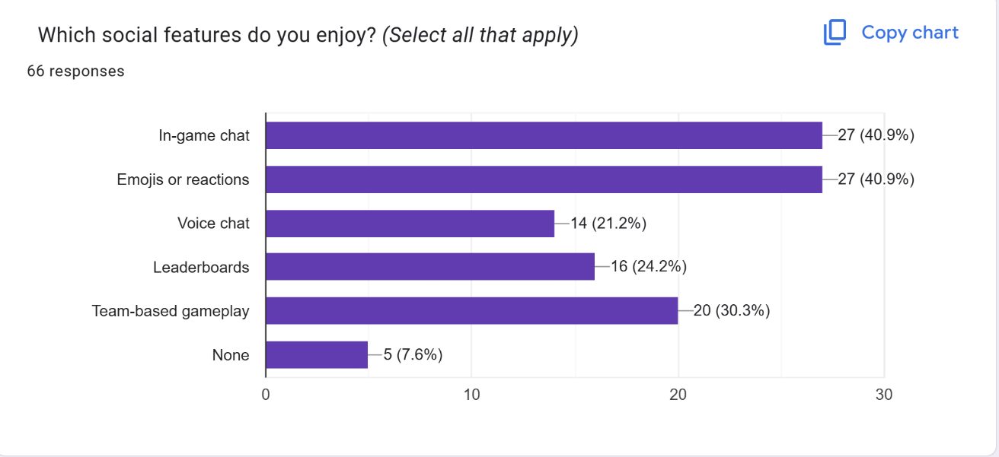
Figure 8 Social features preferences

Interview research method
To further explore the information gathered from the questionnaire, an interview was conducted with the participant who plays daily. The purpose of this interview is to understand the player's typical gaming routine and what makes digital games enjoyable.

Results and discussion
The participant enjoys playing games during his free time, such as on his commute, breaks, and weekends, usually on his phone and occasionally on his computer. He prefers shorter game sessions for better time management. An exciting game must have appealing visuals and engaging challenges that encourage skill development. He enjoys mobile games like Brawl Stars, Angry Birds, and Bad Piggies, as well as PC titles like Cuphead and Apex Legends for their dynamic gameplay.
He is drawn to colour palettes, high-quality graphics, and intuitive controls, which enhance the gaming experience. While he appreciates various visual styles, minimalist designs are his favourites for their cleanliness and immersion. He dislikes excessively violent or visually cluttered styles, which can create a negative experience.
The participant favours multiplayer games for their unpredictable interactions, while complicated controls or unclear navigation can lead to frustration. A good game should be challenging yet rewarding, with a clear learning curve. He values a well-designed, intuitive interface that flows smoothly without overwhelming the player. Character customisation is less important to him, but setting adjustments significantly enhance playability.
Social interactions, such as chat and team play, are generally welcomed, provided they don't become distracting through excessive notifications or garish effects. Overall, these elements contribute to a more enjoyable gaming experience.
Based on the results and findings, the decisions are classified using the MoSCoW prioritisation technique[6] (Appendix A).

4.0 Usability Design Considerations

Research highlights three key elements in successful game design: game rules, player-game interaction, and user experience. A simple interface enhances gameplay by streamlining controls, while distractions can hinder combat. Game tutorials are vital for teaching mechanics and improving player understanding. An interactive interface ensures clear navigation and engagement, using clear text or symbols to clarify functions. Consistent control design helps players learn and minimises distractions. A responsive interface fosters connectivity and allows for customisation. Preventing errors, like save issues, is crucial for maintaining gameplay and reducing frustration[7] [8].

Design Principles Applied According to Nielsen Heuristics & Mobile-First Approach
Jakob Nielsen outlines five critical attributes of usability that significantly enhance the user experience: Learnability, Efficiency, Memorability, Low Error Rate, and Satisfaction [9]. By integrating these attributes into design principles, we can create intuitive and user-friendly interfaces.
1. Aesthetic and minimalist design
Focus on the essential elements of the game while eliminating unnecessary distractions, as studies indicate that 23.9% of users prefer a less cluttered interface.
Regarding pop-ups, they will be used sparingly, presenting only essential information in the game to maintain immersion. Implement high-contrast fonts and a clean layout that promote easy readability, make effective use of white space, and establish a clear visual hierarchy to guide users' attention to the game's important elements.
2. Compatibility between the system
Compatibility between the system and the user will ensure that the language, concepts, and visual elements used align with user expectations, reducing cognitive load. Using familiar terminology, such as "Menu", "Achievements", and "Rules", to improve understanding and usability, and promote a smoother user experience.
3. Minimise user memory load
Display available actions and critical information within the game interface to alleviate memory demands, especially for casual players. By keeping a hint history panel visible at all times to provide players with ongoing context. Use tooltips when hovering over icons, such as “Detective Sheet,” to clarify options and improve usability. Ensure that key action buttons (e.g., “Ask a Question,” “Make a Charge”) are easily visible on the screen.
4. Consistency and Structure
Maintain design consistency across the platform to help users navigate intuitively. Feedback from user studies indicates that 13.4% of players find inconsistent design elements frustrating. Use standardised icons for standard functions, with rounded corners and consistent font choices, to reinforce familiarity across settings, help, and menus.

5. Status Visibility
Implement clear loading indicators, notifications, and feedback mechanisms to keep users informed about their actions. As user studies show, 26.9% of participants want visual feedback, which instils a sense of control and confidence in navigation. Design intuitive menu options, such as “New Game,” “Continue,” “Achievements,” and “How to Play,” to convey user options clearly. And navigation buttons (e.g., “Back,” “Next,” “Play”) provide immediate feedback to indicate progress and improve usability.
6. Clearly marked exits
According to research, 16.4% of users express concern about a lack of guidance, which can contribute to frustration. Therefore, “Back” and “Next” buttons will be included for seamless navigation between screens. Confirmation prompts will be provided for meaningful actions, ensuring that users feel secure in their choices.
7. Shortcuts for efficiency and flexibility in use
According to research, 26.2% of users appreciate control options that appeal to a range of skill levels, from beginners to experts. A quick-access menu for everyday actions will be created to improve workflow efficiency.
8. Support for error recognition, diagnosis, and recovery
Provide descriptive error messages, such as "You have not selected a weapon," and visually highlight invalid actions to draw attention to problems. Provide clear suggestions for next steps to guide users toward successful gameplay.
9. Error prevention
Protect users from confusion and support smoother gameplay by disabling action buttons when certain conditions are not met (e.g., "Make Accusation" is greyed out until the requirements are met). Include confirmation windows asking "Are you sure you want to make an accusation ?" with clear Yes/No options to prevent accidental actions.

10. Help and Documentation
Considering that 31.9% of users prefer interactive tutorials that can support integration and improve accessibility, it will be included by accessing the 'How to play' button. Accordingly, to provide additional support, a help icon will be included in the corner, providing a direct link to the game rules and FAQ for easy access.
By adhering to these design principles inspired by Jakob Nielsen's heuristics, we ensure that our game interface is not only easy to use but also intuitive and engaging, ultimately enhancing player satisfaction and experience.

Mobile-first principles
Nielsen's principles are practical in the UI and UX design of the 2D Cluedo mobile version at UWTSD. The development also incorporates Mobile-First Design, focusing on optimisation for small screens with minimal text and an icon-based interface. Large, well-spaced buttons will aid touch controls, and scalable text and UI elements will ensure accessibility for diverse users. Performance will be optimised for fast loading and low latency, emphasising essential features like easy navigation, simple rules, and quick access to actions.

5.0 Wireframe Storyboards

Design Tools Used
During the wireframing process for the UWTSD version of Cluedo, Inkscape was the primary design tool. Its features enabled detailed visual representations and the integration of interactive elements, improving design accuracy and simplifying testing and evaluation of the game's mechanics and user experience[10].
Home screen
The main page consists of the game logo and the start button; it also displays the game loading bar, which is an essential feature for users.

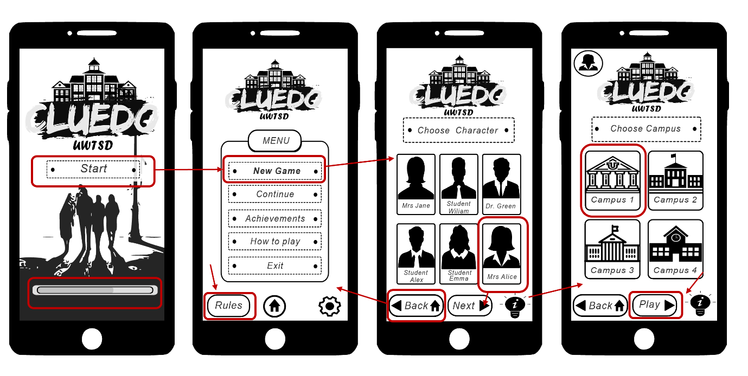
Figure 9 Starting game, character, and campus selection

Menu screen
This page provides options that include initiating a new game, resuming a previously started game, viewing achievements, and accessing a video tutorial titled "How to Play." Additionally, users can reference written rules and adjust settings on this page.
Character and Campus selection
This interface lets users select a character from six options. Clicking "Next" takes them to the campus selection page, which offers four choices. Pressing "Play" starts the game, and there's also an option to return to the main menu for more information.
Clue collection interface
This page offers features to enhance user experience. The hint icon provides steps for successful gameplay, while the clue icon leads to a puzzle. Solving the puzzle unlocks a record to help with the case. This puzzle element, based on feedback from 39,7% of players, adds excitement to our Cluedo game. To exit, users can use the small close button.

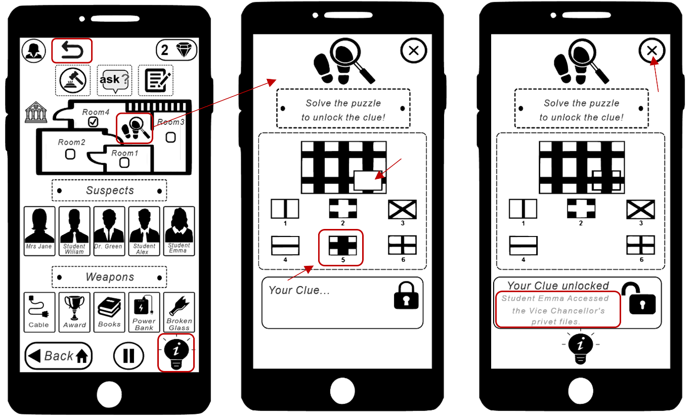
Figure 10 Access clue details in puzzle style

Accusation screen
This page allows users to select the suspect, weapon, crime scene, and evidence to formulate an accusation. After this process, a confirmation window appears. If the accusation is correct, users can advance to the next level; if incorrect, they will be removed from the current level. A successful accusation triggers a congratulatory window with rewards symbolised by a briefcase containing a diamond. Users are then prompted to proceed to the next mission.

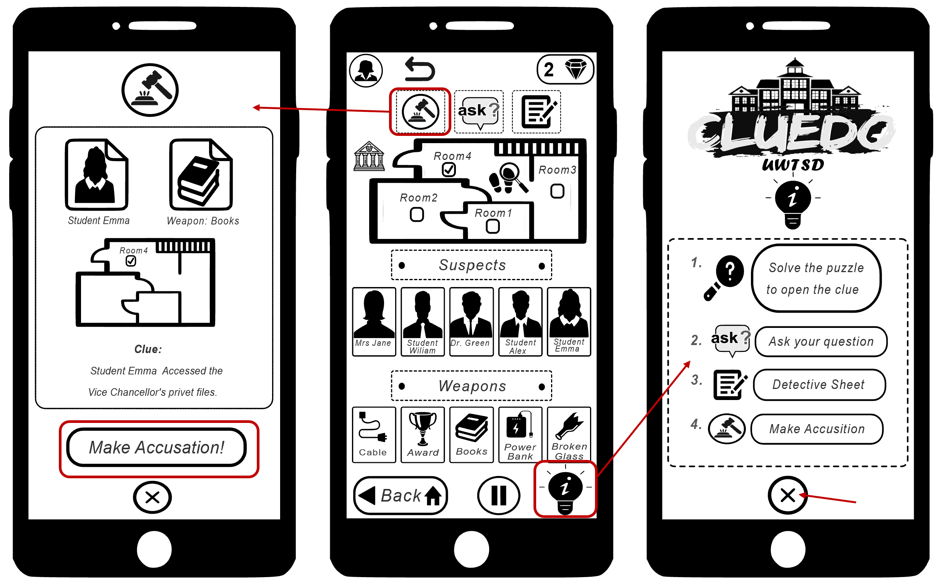
Figure 11 Make an accusation and access help.

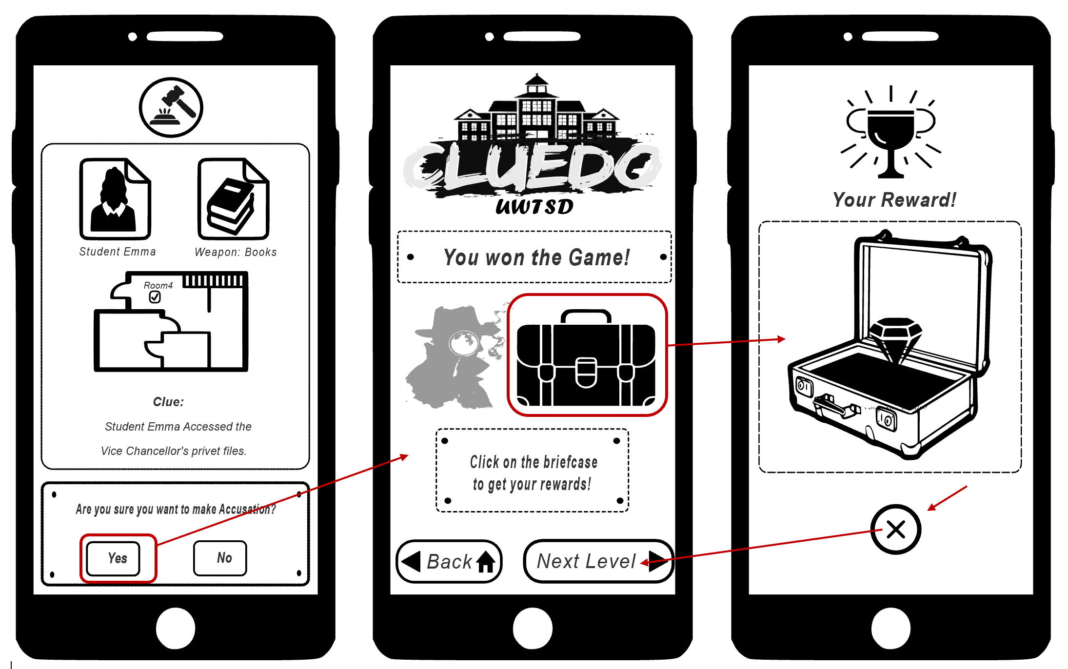
Figure 12 Preventing error messages in important actions

6.0 Feedback Collection and Analysis

The interactive prototype of the Cluedo 2D board game was tested with six participants representing our four personas. Usability testing was conducted using Microsoft Teams and a structured questionnaire, targeting participants who met the specified characteristics. Each participant completed tasks such as starting a game, setting the rules, and playing a solo session. Feedback was collected through observation and post-test surveys.
The goal of this test is to evaluate the usability of the UWTSD version of the Cluedo 2D board game, including layout, navigation, readability, accessibility, and overall user experience.
Usability Findings:
Participants appreciated the visual design but found navigation slightly confusing. Participant valued clue features but requested more explicit instructions on how to play. The participant highlighted the need for larger text on some screens, confirming accessibility priorities. Participant praised responsiveness but wanted more levels and customisation options.
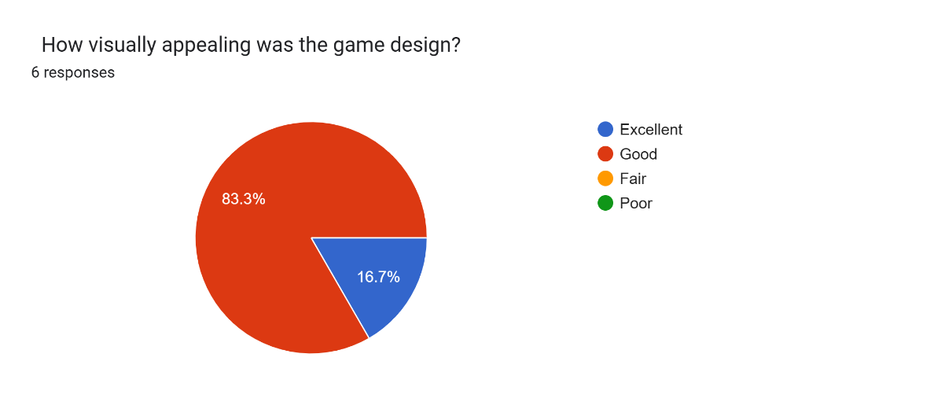
Figure 13 Testing results in a visually appealing design
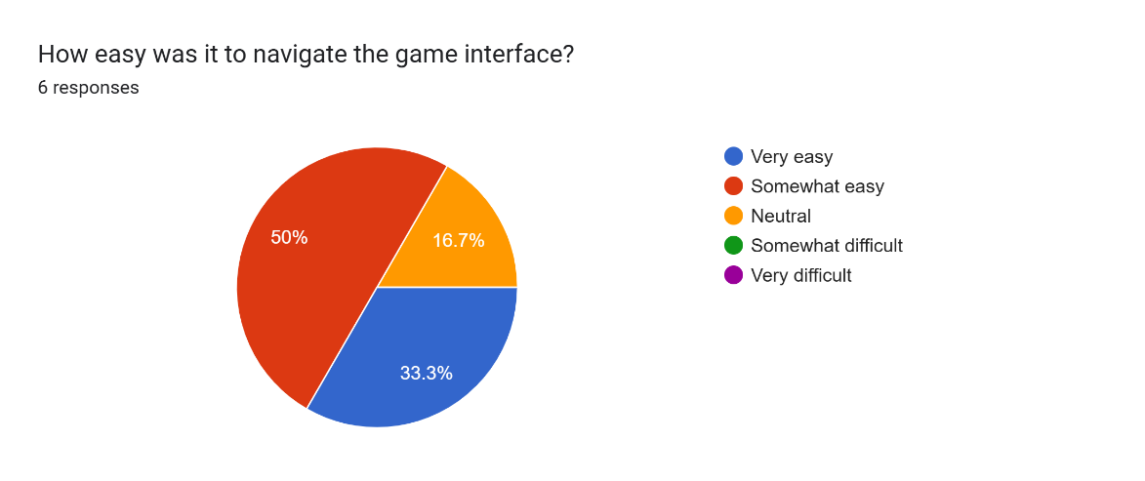
Figure 14 Testing results in navigation
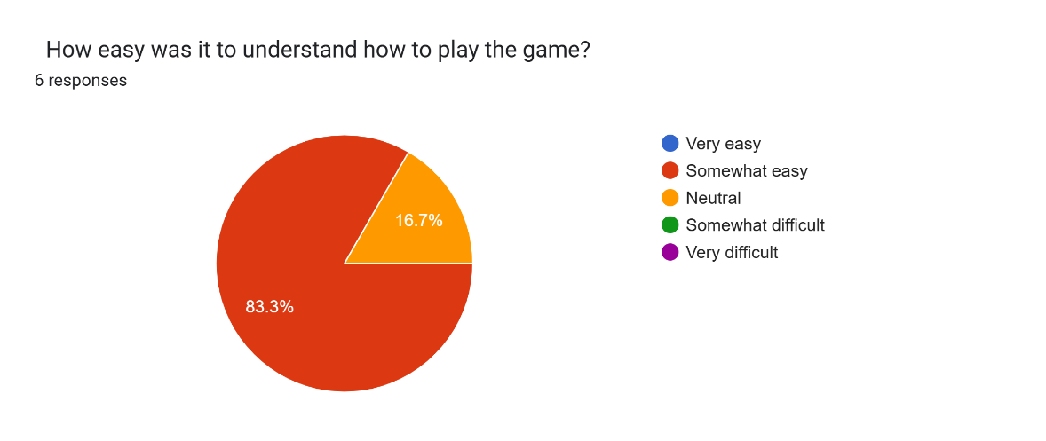
Figure 15 Testing results in an intuitive learning curve of playing
Emotional response
Most users had a good experience, finding the design engaging and visually pleasing. However, there were frustrations with the small text, the lack of avatar customisation, and the unclear instructions.
Feature Adjustments
We will refine navigation, add scalable text options, and work on instructions. We will add leaderboard, achievements, avatar customisation, and difficulty-level options to ensure alignment with user expectations and emotional comfort.
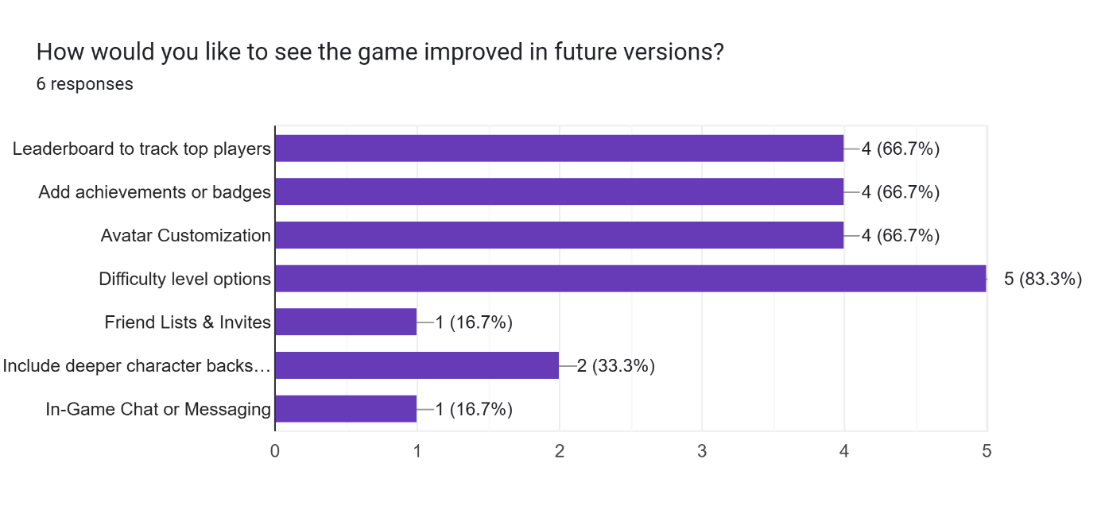
Figure 16 Recommendations for improvements of the game

7.0 Conclusion

In conclusion, the user-centred design process is fundamentally driven by thorough research that employs a variety of information-gathering techniques. These methodologies are crucial for shaping the user interface's planning and design. Initially, the process begins with the creation of user personas, which serve as detailed representations of target users based on demographic data, behaviours, and needs. Following this, user requirements are meticulously established using the MOSCOW technique, an acronym for Must-have, Should-have, Could-have, and Won't-have. This strategic approach helps prioritise features based on user needs and project constraints.
Subsequently, user expectations are systematically tested through methods such as usability testing, surveys, and interviews, followed by a comprehensive analysis of the feedback received. This iterative cycle allows designers to refine their understanding of user expectations and identify areas for enhancement. Collectively, these steps contribute to a well-rounded view of user needs and preferences, laying a solid foundation for planning subsequent improvements. Ultimately, this thorough groundwork prepares us to develop an engaging and functional full-colour prototype that meets or exceeds user expectations.

8.0 References
[1] H. N. Turner and E. J. Rose, "What do we teach when we say we teach UX? A study of the practices of TPC instructors," Programmatic Perspectives, vol. 13, no. 1, pp.61–102, 2022.
[2] J. Salminen, et al., "A survey of 15 years of data-driven persona development," International Journal of Human–Computer Interaction, vol. 37, no. 18, pp.1685–1708, 2021.
[3] F. Staiano, Designing and Prototyping Interfaces with Figma: Learn essential UX/UI design principles by creating interactive prototypes for mobile, tablet, and desktop, Packt Publishing Ltd, 2022.
[4] B. J. Jansen, et al., "How to create personas: Three persona creation methodologies with implications for practical employment," Pacific Asia Journal of the Association for Information Systems, vol. 14, no. 3, pp.1, 2022.
[5] S. S. Alhabsi, "Ethical considerations in obtaining informed consent in research participation," International Journal of Educational Contemporary Explorations, vol. 1, no. 1, pp.22–32, 2024.
[6] S. Vijayakumar, "Assessing the Effectiveness of MoSCoW Prioritization in Software Development: A Holistic Analysis across Methodologies." EAI Endorsed Transactions on Internet of Things, vol. 10, 2024.
[7] A. Kramarzewski and E. De Nucci,Practical Game Design: A modern and comprehensive guide to video game design, Packt Publishing Ltd, 2023.
[8] K. Y. Zamri, "The effects of 10 User Interface (UI) elements on game design process," EDUCATUM Journal of Science, Mathematics and Technology, vol. 9, no. 2, pp.82–89, 2022.
[9] A. C. dos Santos Pergentino, et al., "Usability heuristics evaluation in search engine," International Conference on Human-Computer Interaction, 2020.
[10] D. Kirsanov, The book of inkscape: the definitive guide to the graphics editor, No Starch Press, 2021.

9.0 Appendices

Appendix A: MoSCoW Requirements Table

Priority | User requirements
Must Have | - Easy navigation  - Visually appealing and intuitive interface  - Minimal clutter and readable text  - Minimal text and icon-based UI  - Simple rules, easy to understand
Should Have | - Clear visual feedback for actions  - Scalable text and clear UI elements  - Customisation of game level difficulty  - Achievements and leaderboards  - Customisable character appearance and environments
Could Have | - Social features (chat, emojis, team play)  - Customizable sound and music settings  - Social media integration for sharing creative moments  - Optional multiplayer for casual interaction  - Keyboard shortcuts  - Advanced performance settings for competitive play
Won’t Have | - Overly complex rule sets or mandatory long sessions  - Excessive notifications or spammy social features  - Flashy visuals or overwhelming notifications  - Long-term commitment without clear progression

Appendix B: Full Wireframe Storyboards

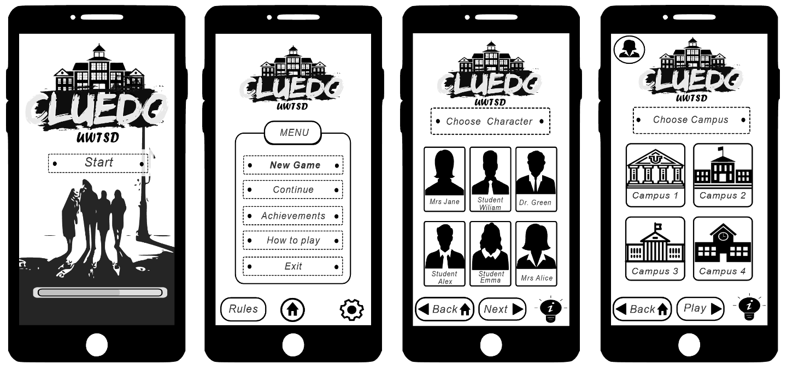

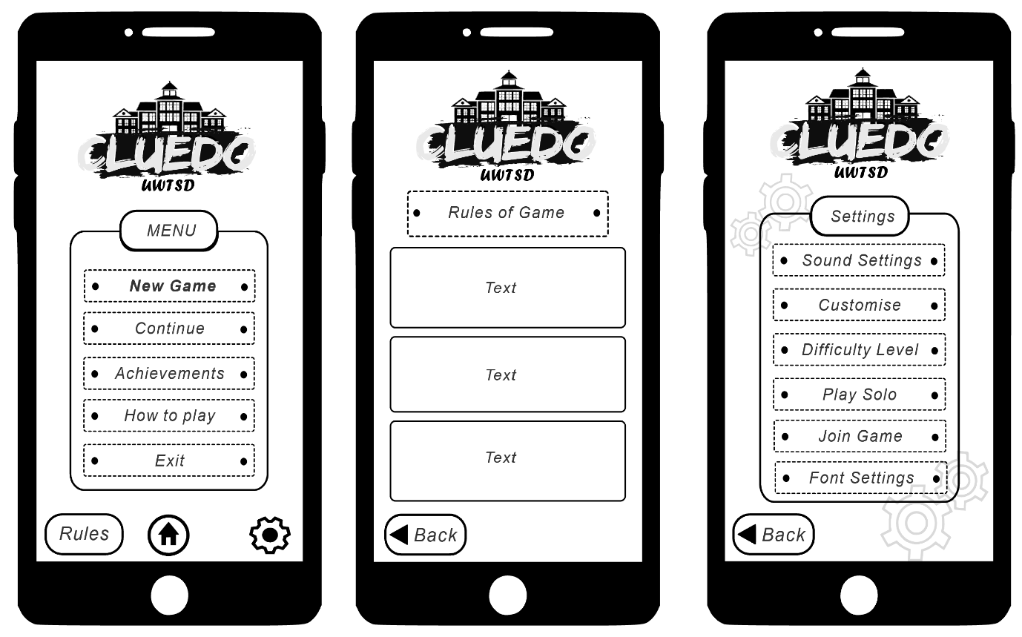

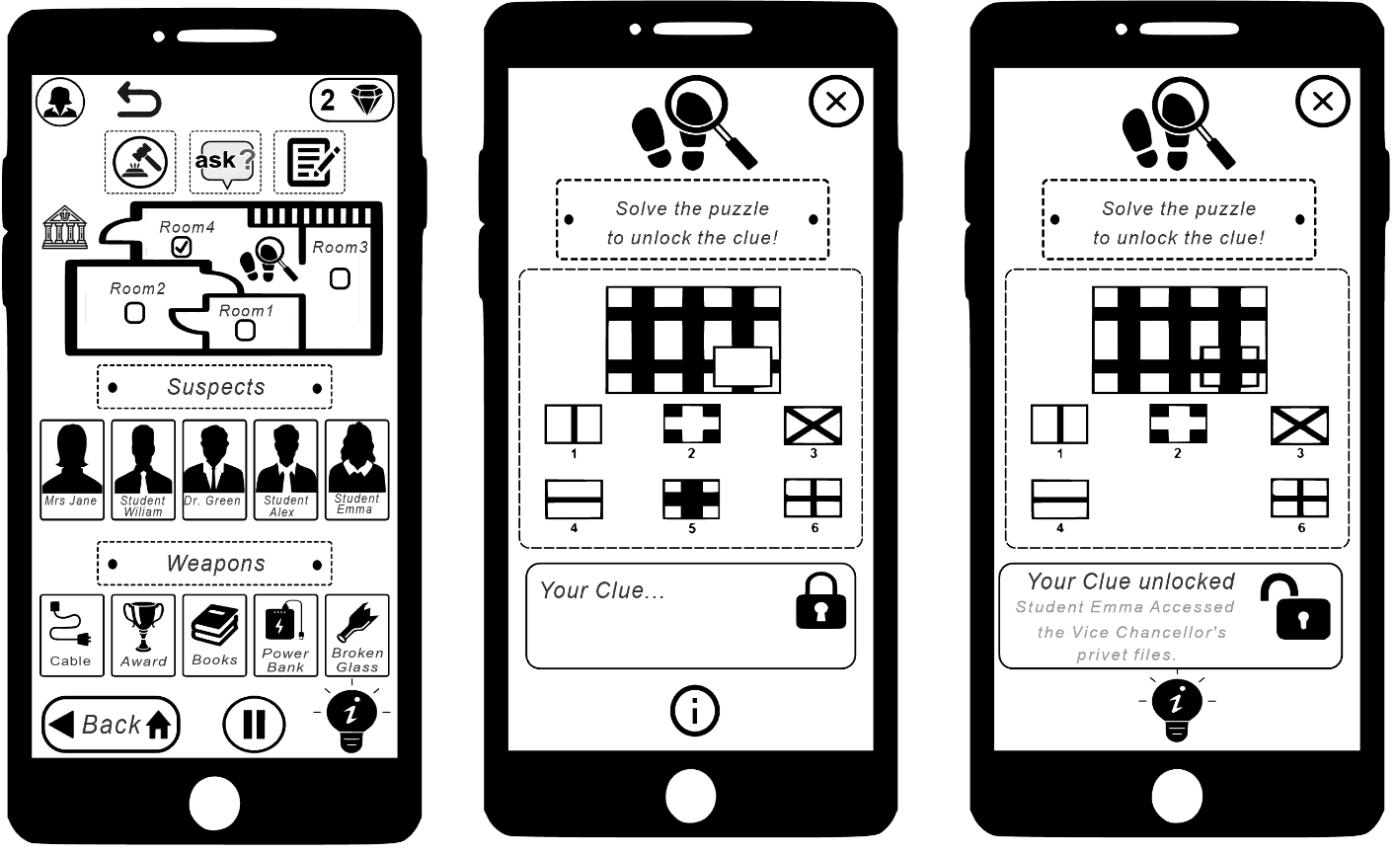

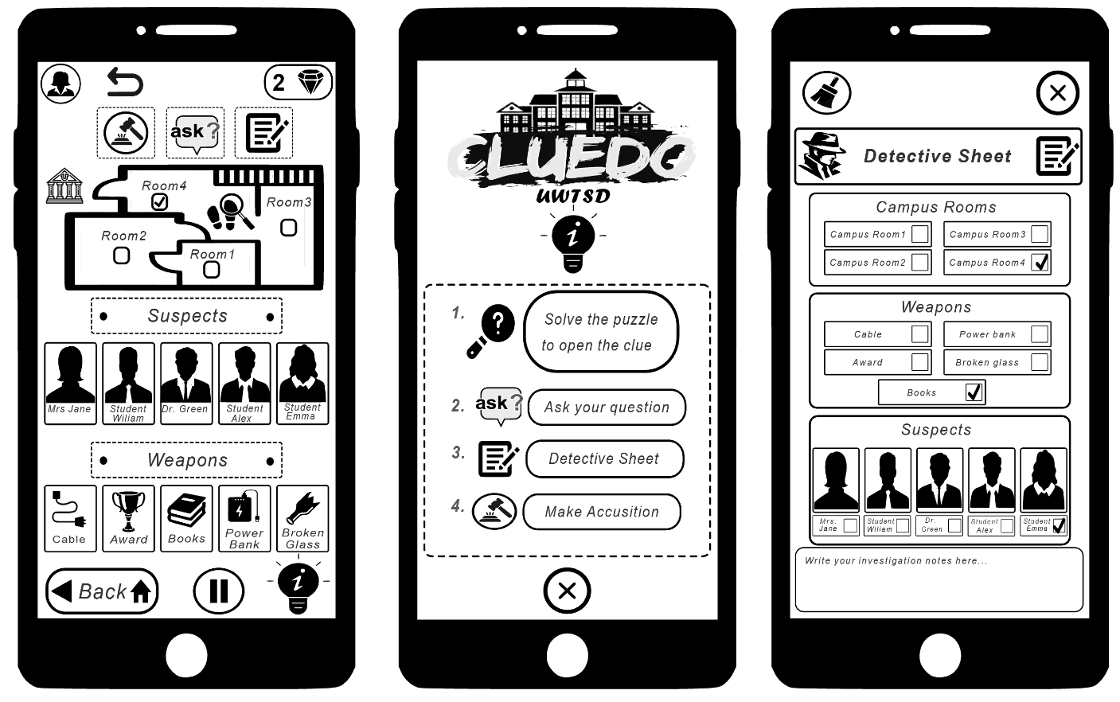

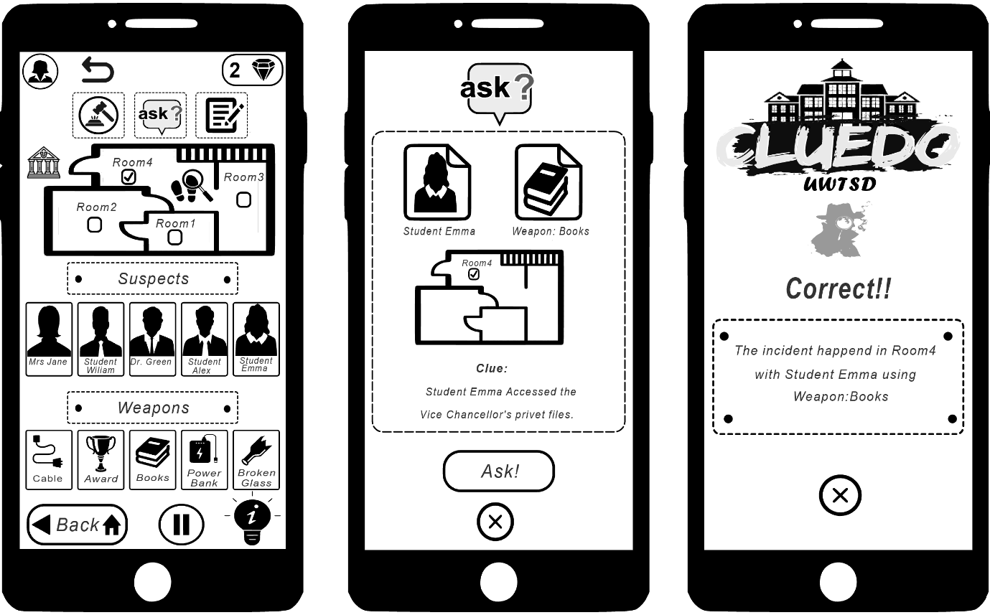

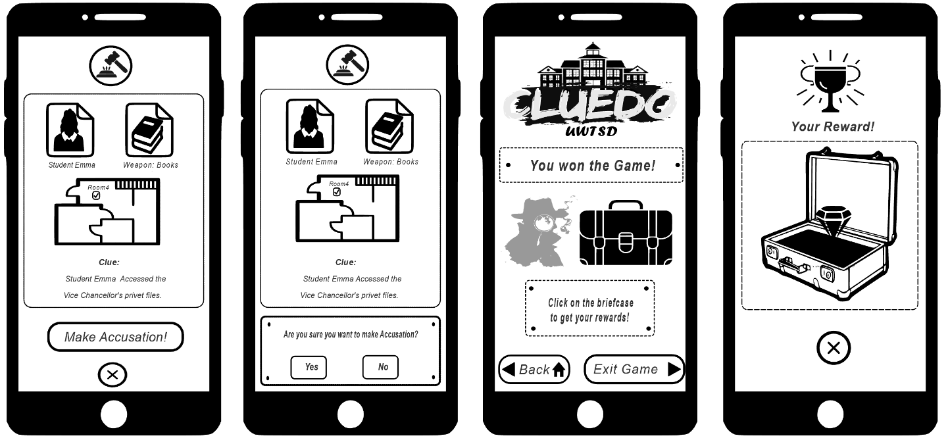

Appendix C: Survey/Interview Questions and Results 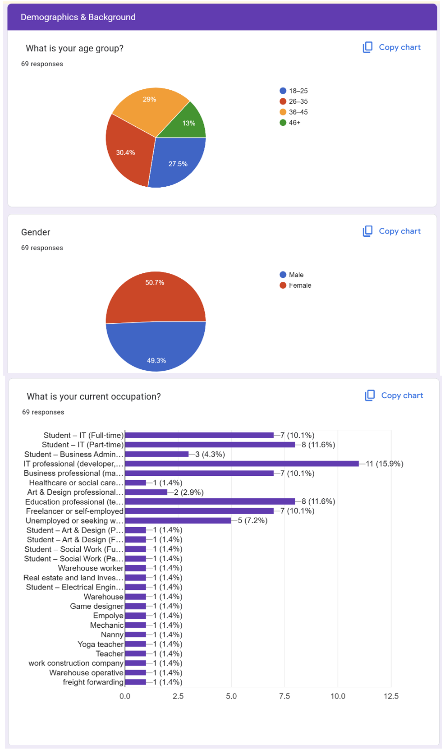
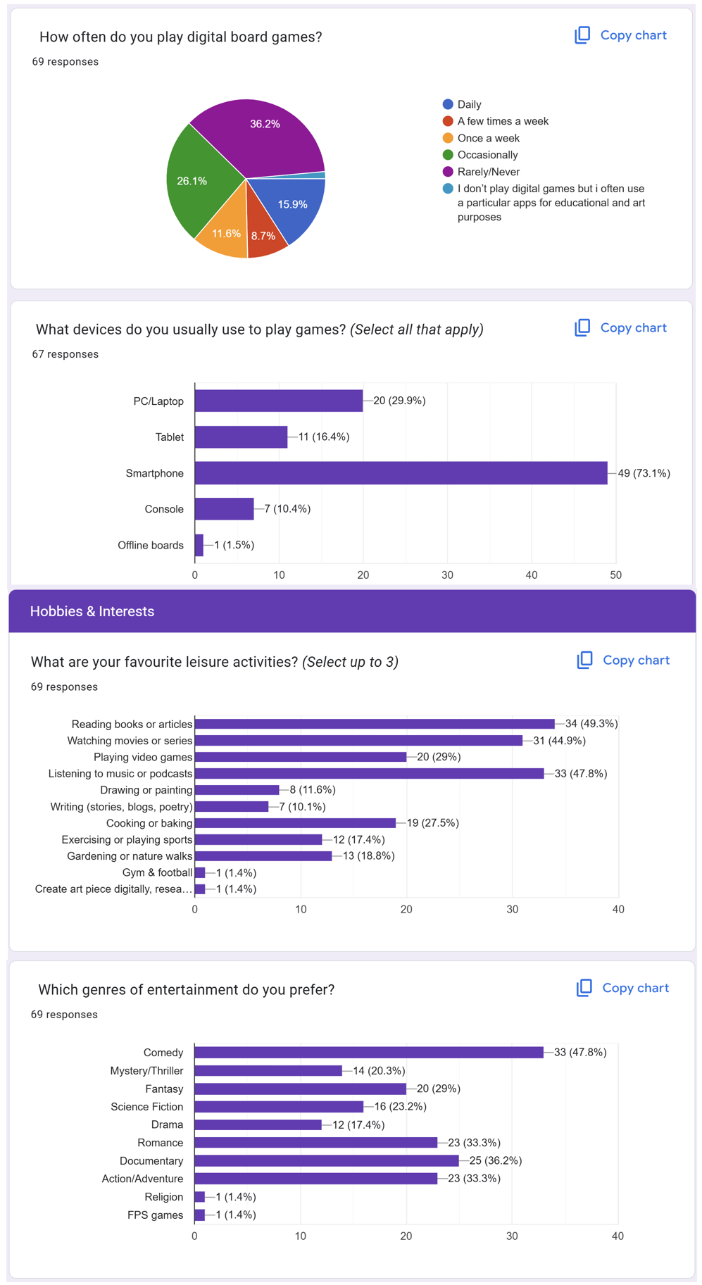
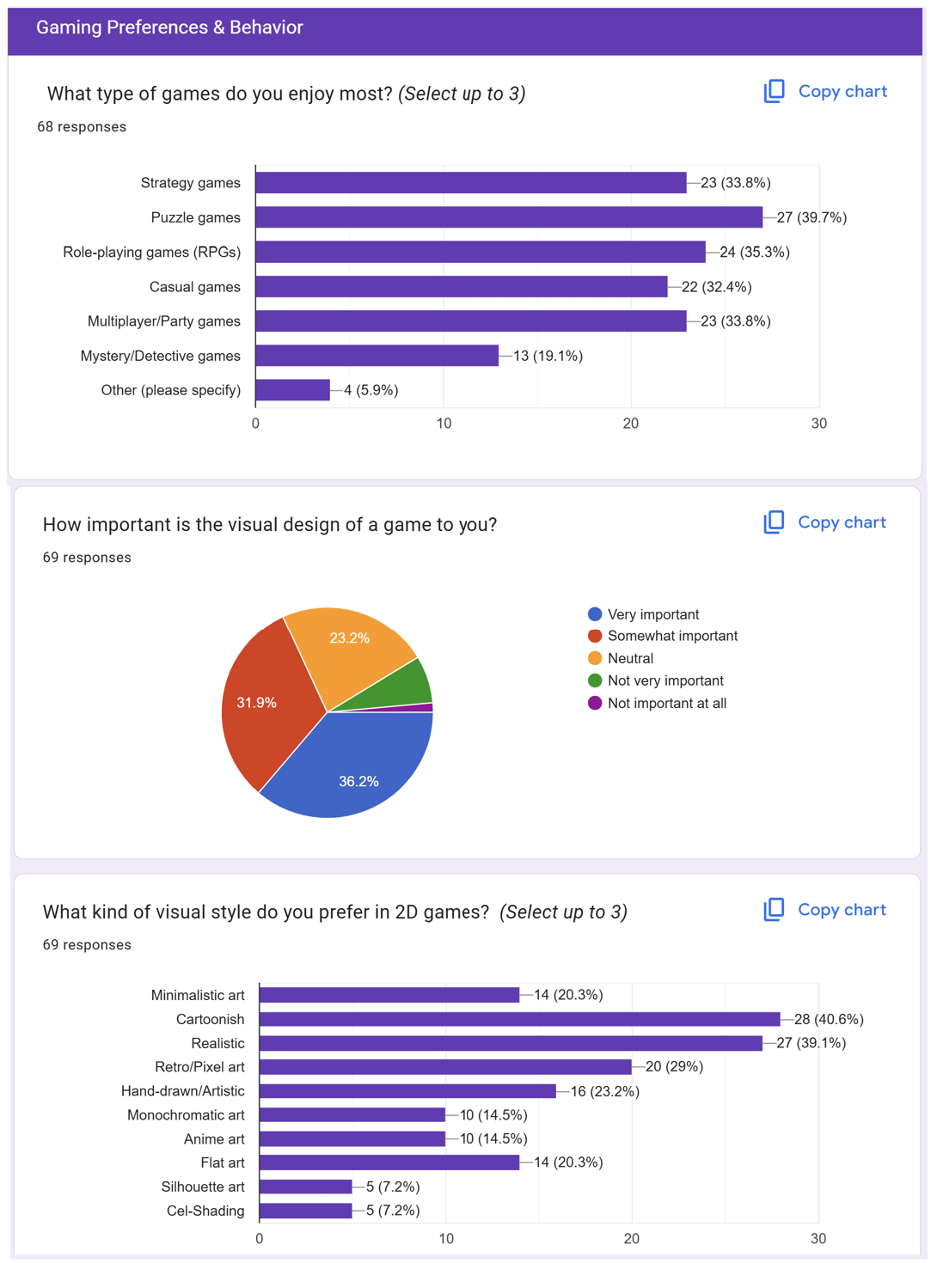

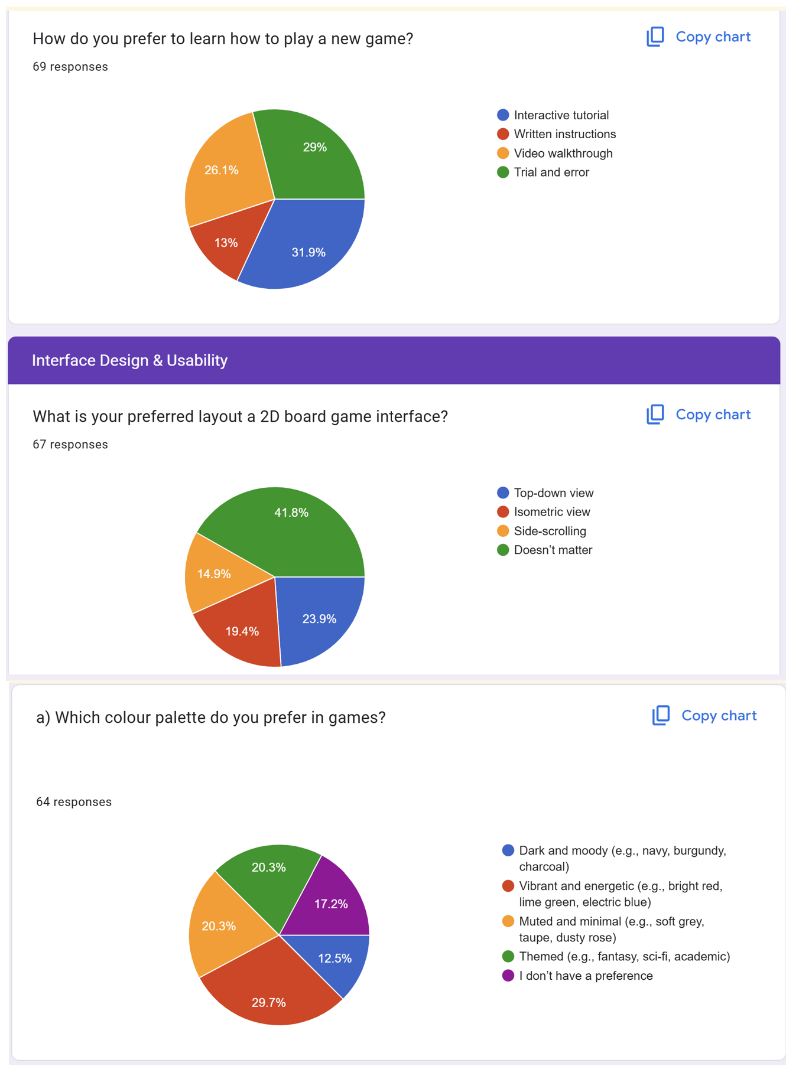
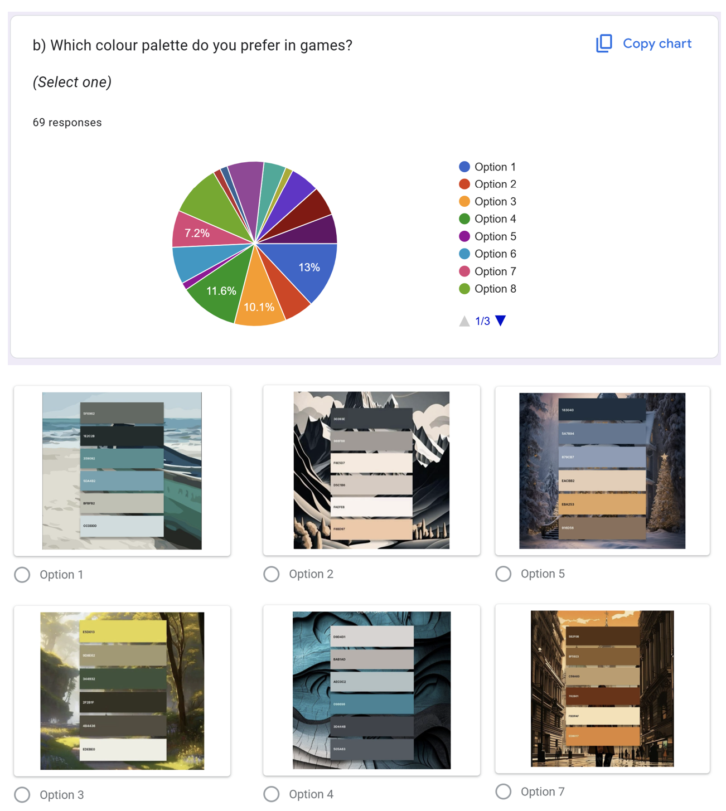
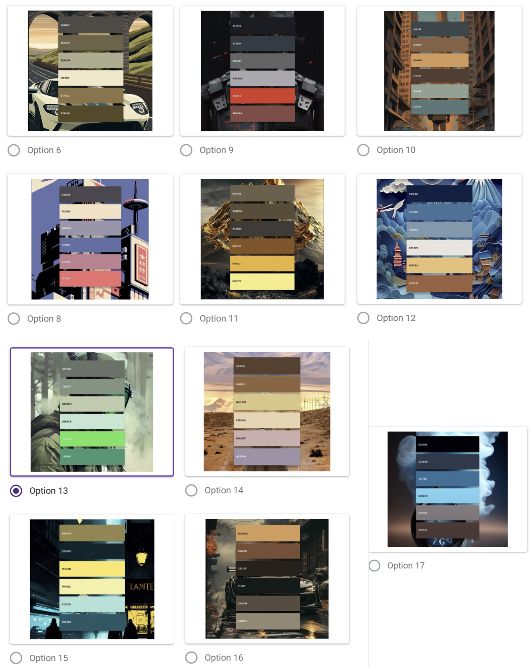

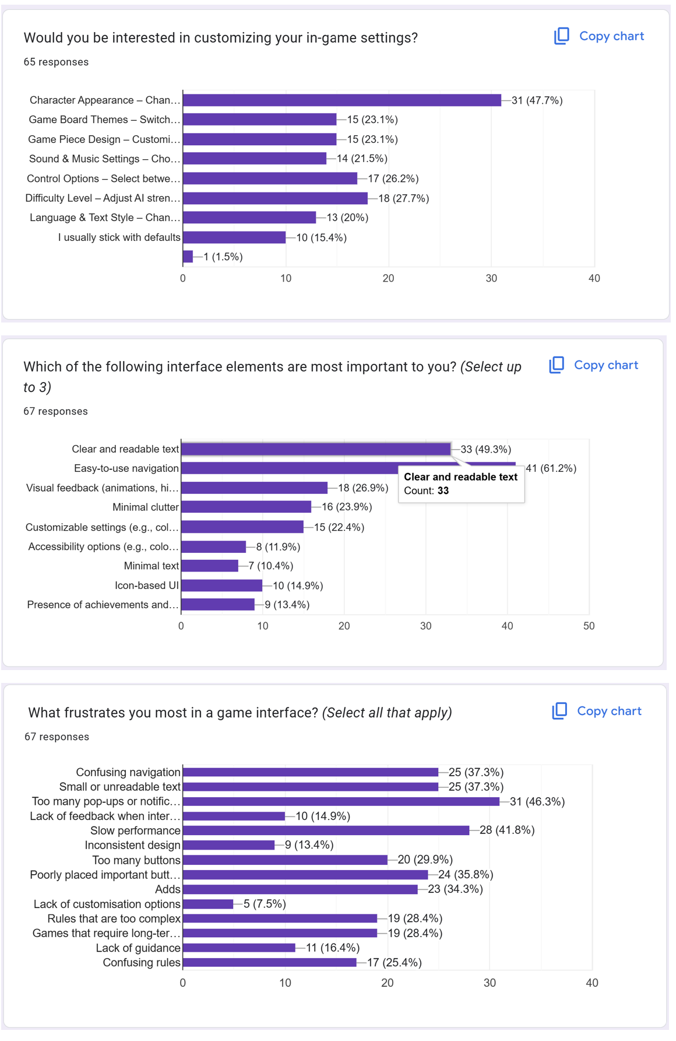
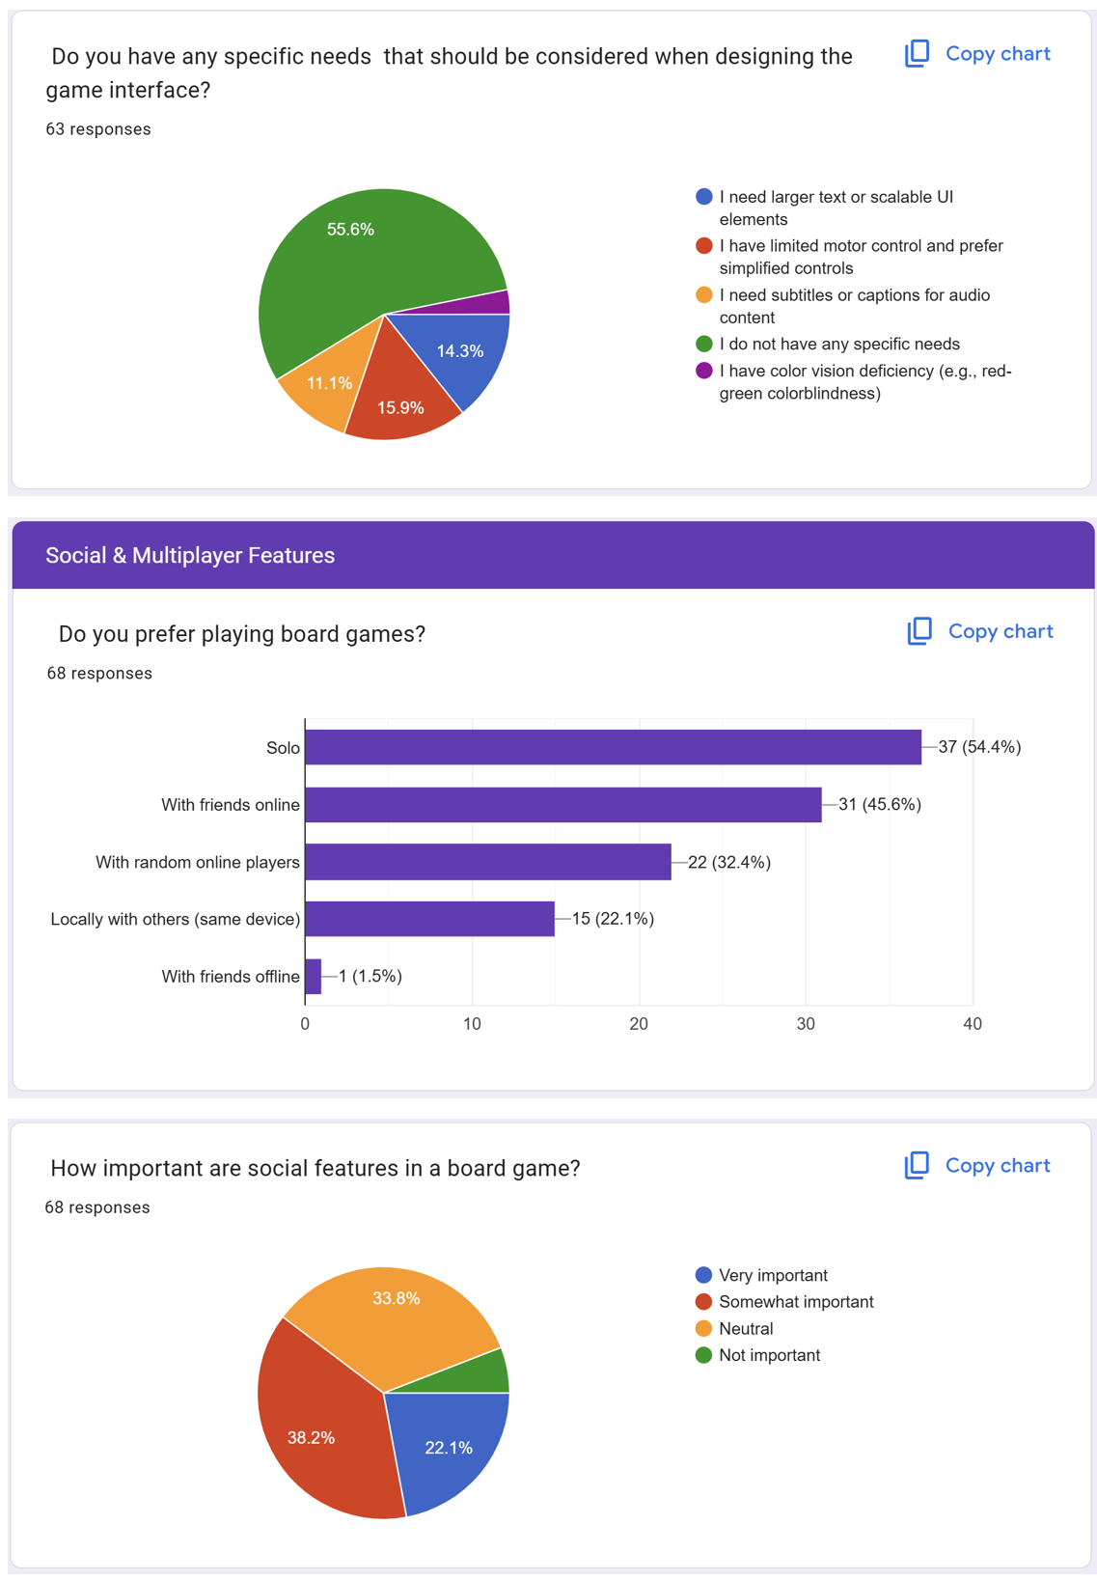
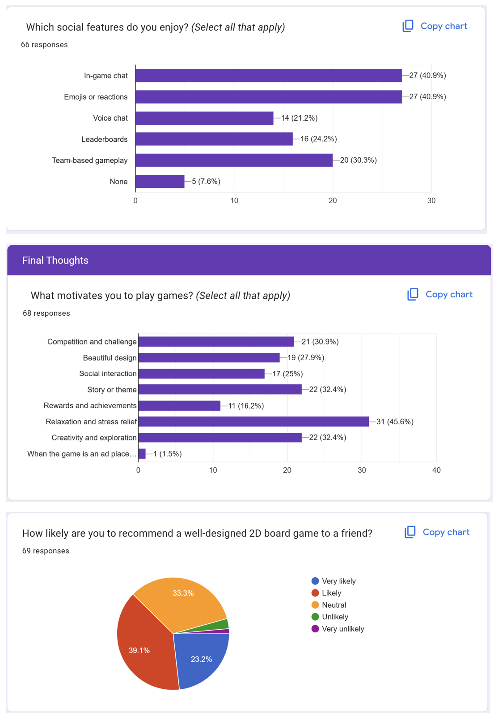

Form link: https://forms.gle/wmLbthrJnGDuvAGD9

