

Name: Maryam Hassan
Student ID: 2311534
Programme: BSc Health and Social Care
Module: Changemakers: Building your Personal Brand for Sustainable Employment
Module code: BMPH5015
Assignment Title: Assignment (Report)
Word count: 2327

Contents
1.0 Introduction 4
1. Analysis of Key Employability Skills 8
2. Evaluation of Personal Skills and Professional Development Strategy 10
2.1 Introduction 10
2.2 Self-Evaluation against the Job role 10
2.2.1 Strengths and Areas for Improvement: 10
2.2.2 Assessment Tools and Support: 11
2.2.3 Building a Personal Brand and Demonstrating Unique Value 12
3. Action Plan and Timeline for Skill Development 13
3.1 Introduction 13
3.2 The action plan and time line 14
3.2.1 Phase 1: Foundation and Entry (Years 0-1) 14
3.2.2 Phase 2: Skill Acquisition and Formal Qualification (Years 1-3) 14
3.2.3 Phase 3: Consolidation and Application (Years 3-5) 14
Reference List 16

Introduction
The Band 4 Therapy Assistant Practitioner job role in the Lewisham and Greenwich NHS Trust (LGT) is an occupation that is clinically oriented and needs the combination of technical, interpersonal, and self-management competencies (Nhsjobs.com, 2025). This report examines the major personal employability-skills required in this post as stipulated in the job description and personal specifications. This paper has provided a personal and professional development plan to move to a role of a Band 4 Therapy Assistant Practitioner in the NHS. It starts with a close examination of the job requirements that came with the particular job and then a critical examination of my existing skills and qualifications versus this profile. The report then develops a strategic, time-limited action plan to develop the required competencies, identifies ways of creating an attractive personal brand and professional network and finally develops the distinct value I would bring to the position, thus developing a definite road map to the accomplishment of my career goals.
Job screen short
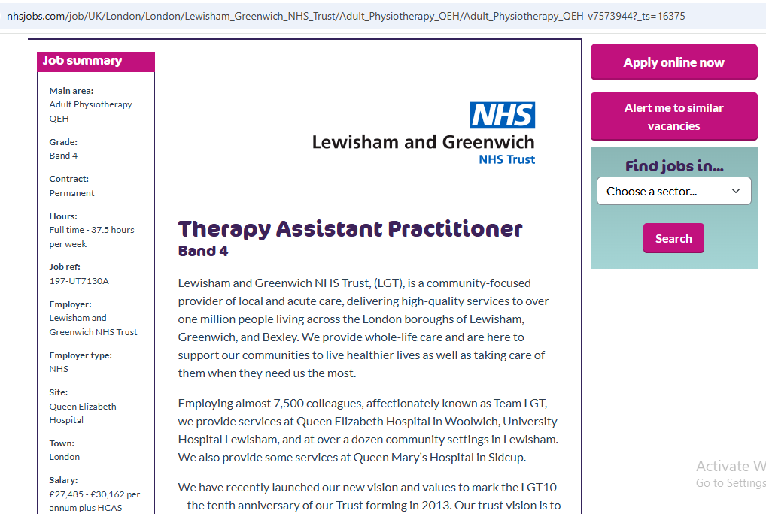
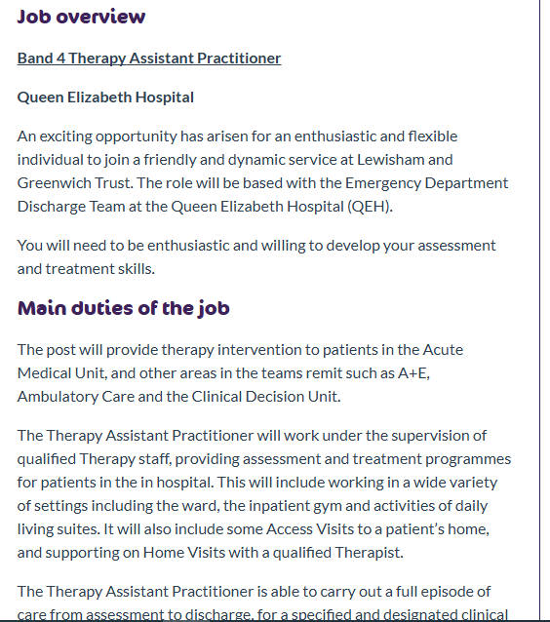
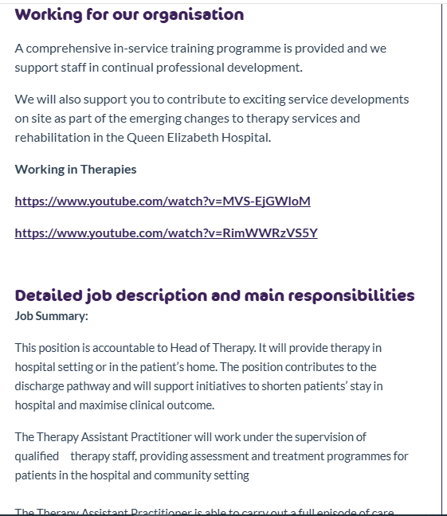
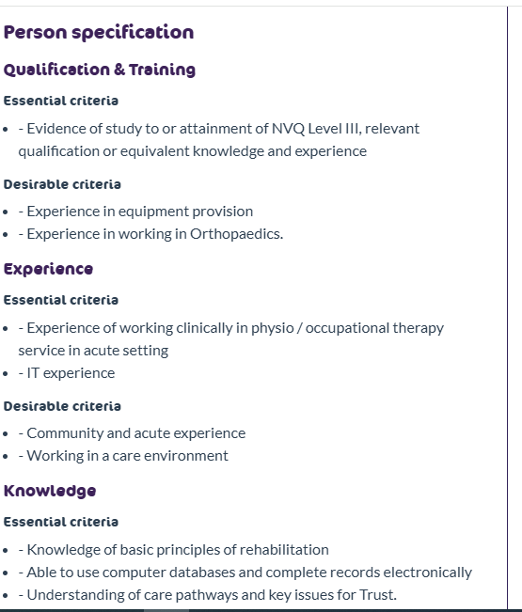
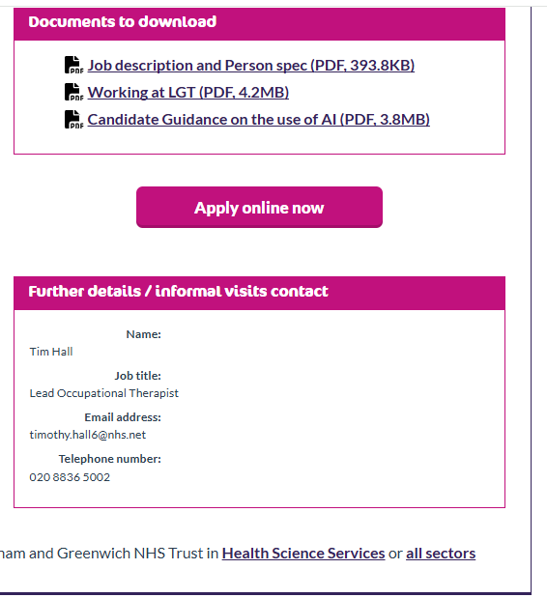
Figure 1 Health and social care job
Source: https://www.nhsjobs.com/job/UK/London/London/Lewisham_Greenwich_NHS_Trust/Adult_Physiotherapy_QEH/Adult_Physiotherapy_QEH-v7573944?_ts=16375

Analysis of Key Employability Skills
Foremost, the role demands a high degree of autonomy and accountability (Nhsjobs.com, 2025). The post-holder should have the capability to perform a full episode of care (assessment to discharge) on a specific caseload of patients independently with indirect oversight (Lewisham and Greenwich NHS Trust, 2025). This involves high initiative, time management, and the ability to make clinical decisions within a fixed scope, which is the direct correlation with the Trust value of being accountable over staying comfortable. Outstanding communication and interpersonal abilities are essential. The occupation will involve using persuasion, motivation and negotiation to achieve co-operation with patients (Lewisham and Greenwich NHS Trust, 2025). This is a key competence in developing therapeutic relationships and achieving compliance with treatment. The experience of being a Beauty Therapist proves to be in client-related interaction, so it serves as a base of these skills, but these need to be translated into a more clinical, multidisciplinary setting with subordinate patients. There are also the principles of teamwork and collaboration. The post will entail being active in the following: multidisciplinary / multi-agency team meetings and case conferences to coordinate the patient care and discharge planning (Lewisham and Greenwich NHS Trust, 2025). This is a reflection of the principle of working in partnership contained in the NHS Constitution (Department of Health and Social Care, 2015). This role requires to work in coordination with healthcare professionals, and thus had applicable and transferable experience in a collaborative health environment. Lastly, organizational and practical competence is one of the requirements of this role. The job role entails the assessment and provision of equipment, proper maintenance of electronic records, and also administrative tasks (Lewisham and Greenwich NHS Trust, 2025). The experience that I have in running business operations as a self-employed therapist and in the clerical work as a receptionist reveals some of the foundational organizational, administration, and IT expertise that are directly applicable in this role.
Conclusion
In summary, Therapy Assistant Practitioner position depends on an individual to show his or her independence, teamwork, and effective communication with others as well as organizational skills. These employability skills based on the caring and respectful attitude are essential in offering high quality care to the patients as part of the vision of the Trust.

Evaluation of Personal Skills and Professional Development Strategy

2.1 Introduction
Below is a critical evaluation of my existing competencies with respect to the band 4 Therapy Assistant Practitioner position at Lewisham and Greenwich NHS Trust (LGT). It also provides a strategic plan of how to establish a professional brand, advance my professional identity, and create a network that will help me secure successful employment in the health and social care sector in the UK.

2.2 Self-Evaluation against the Job role
Reviewing the job description reveals to identify the main skills necessary to work in the position, as well as such competences as clinical rehabilitation expertise, work on own, multidisciplinary collaboration, and administrative skills (Lewisham and Greenwich NHS Trust, 2025)..

2.2.1 Strengths and Areas for Improvement:
My professional background provides a foundation of transferable skills. I have been a Self-Employed Beauty Therapist and a Care Worker which has developed my skills in interpersonal and communication at the advanced level. In the position, there is a need to have skills in persuasion, motivation and negotiation (Lewisham and Greenwich NHS Trust, 2025), which I regularly apply to learn about the needs of the clients and form a connection with them. Moreover, my experience as a Receptionist sharpened my skills in administration and IT, which are immediately related to the process of keeping patient records and a caseload. My proven independence and responsibility is a massive strength. My experience of having my own business meant that I had to be self-motivated, manage my time well, and responsible in delivering services, which is in line with the Trust value of Being accountable (Lewisham and Greenwich NHS Trust, 2025). Another experience in care that I had was in individualized care plans, which is an antecedent to adhering to therapy treatment programs (DiMatteo, M.R., et al., 2025). Nevertheless, the most essential field of development is direct application of these skills in an acute clinical therapy setting. Although my Level 2 is in Health and Social Care, the job position requires certain knowledge of the basic principles of rehabilitation and experience in an acute setting (Penner, J.D., et al., 2025). My practical experience in personal care is strong, and I do not have formal experience in functional assessment and rehabilitation methods of physiotherapy and occupational therapy services.

2.2.2 Assessment Tools and Support:
In order to make a systematic self-evaluation, one can use such tools as SWOT (Strengths, Weaknesses, Opportunities, Threats) analysis to help me visualize my situation (Antoniadou, M. and Kanellopoulou, A., 2024). Moreover, getting mentorship with a practicing Therapy Assistant Practitioner or a licensed therapist would give me an insider knowledge of what the role is like. Career guidance and resources available in university career services and professional bodies such as Chartered Society of Physiotherapy (CSP) or Royal College of Occupational Therapists (RCOT) can help to identify and close the skills gap.
Relevant Experience and Qualifications
My CV demonstrates a foundational relevance to this role. My Level 2 qualification in Health and Social Care offers theoretical knowledge of the principles of care (McLeish, L., 2025). Although this is not the said NVQ Level 3, it is a knowledge base that can be built on. My work experience as a Care Worker is the most relevant. I offered personal care, collaborated with healthcare plans, and assisted patients in performing activities of daily life, which is the main goal of most of the therapy interventions (Katta, V.S., Kushwah, V.K. and Thawkar, S., 2025). This proves me to have a compassionate nature, knowledge of patient dignity, and having knowledge of an environment that is health-based.
Building a Personal Brand and Professional Identity
According to Szántó, P., Papp-Váry, Á. and Radácsi, L.,( 2025), in a competitive job market, a strong personal brand is crucial. The special claim of value a professional makes is what makes them so special (McNally and Speak, 2002). The brand I will develop in reference to this position will be a proactive, caring, and competent support professional who makes the difference between qualified therapists and patient care.
My key resources and information include the following;
LinkedIn Profile: I will make my LinkedIn profile a business center. It will contain such a headline as Compassionate Care Professional, who wants to switch to the therapy service (McGonagle, I., 2025) and a summary that will show my level of knowledge about the NHS values and principles of therapy and specific description of my transferable skills. Through Digital Footprint, I will create some visibility by using social media to follow and comment on the CSP, RCOT, and Lewisham and Greenwich NHS Trusts, as well as, share and comment on pertinent topics. Similarly through Professional Portfolio, i will describe my accomplishments, examples of solution to problems in my business, testimonies of previous care clients, and reflective journal on how my professional skills apply to a therapeutic environment. This proves a sense of reflective practice, which is one of the major qualities in healthcare work (Gibbs, 1988).

2.2.3 Building a Personal Brand and Demonstrating Unique Value
To build a compelling personal brand for the Band 4 Therapy Assistant Practitioner role, I will position myself as a candidate who is able to combine both the client-centred service that is provided by the beauty industry and hands-on pertinent compassionate care provided by the social care industry. I will create my brand on the values of active support, sensitive communication, and administrative outstanding. The most significant inputs towards this are a LinkedIn profile that is professionally polished. The title will be, Compassionate Care Professional bridging Therapy and patient-centred support and the summary should clearly relate my transferable skills to the values of NHS Trust statement of respect, Compassion, and Inclusion (McGonagle, I., 2025). To show my desire and create a relevant professional network, I will regularly track and participate in the activities of Lewisham and Greenwich NHS Trust, the Chartered Society of Physiotherapy, and the Royal College of Occupational Therapists online. The details I will present and comment will be based on the principles of rehabilitation, the significance of assistant practitioner, and the importance of multidisciplinary interaction, based respectively on these professional institutions and the publications of the trust itself. My USP will be: A novice combination of customer-focused service offered by the beauty business, practical and understanding care offered by the social care business, supported by established entrepreneurial spirit and administrative competence. Practically, this implies that I can add value through: The implementation of an extremely thorough customer-service attitude towards improving the patient experience, so that they feel listened to, respected and inspired during their rehabilitation process. By using my administration and organizational skills to effectively handle my caseload, keep proper records, and help my therapy team run smoothly, which would enable the skilled staff to work on more intricate evaluations. Being an autonomous individual with business acuity responsible toward accomplishing my responsibilities with minimum oversight, a self-driven and proactive arms-length individual to recognize and resolve issues to the benefit of the group goals.

Action Plan and Timeline for Skill Development

3.1 Introduction
To successfully bridge the gap between my current skills and the requirements for the Band 4 Therapy Assistant Practitioner role, I have developed a structured five-year action plan. This plan is designed to systematically acquire the necessary qualifications, experience, and professional recognition.
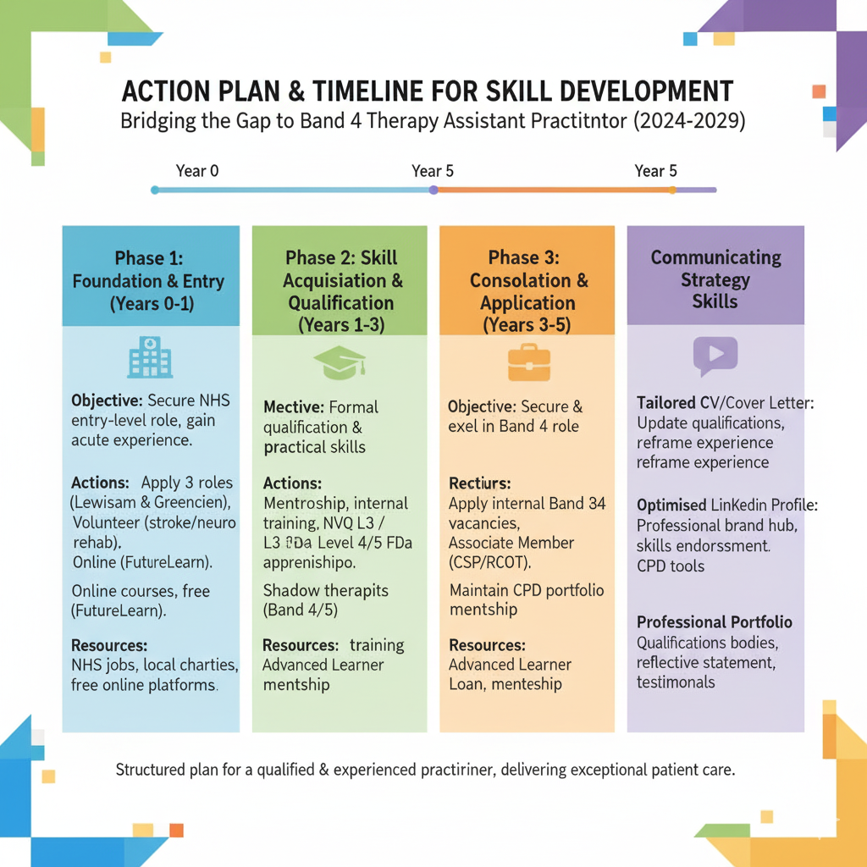

Figure 2 My Action Plan and Timeline for Skill Development
Source: Authors’ own work

3.2 The action plan and time line

3.2.1 Phase 1: Foundation and Entry (Years 0-1)
Secure an entry-level position within the NHS to gain acute sector experience and understand multidisciplinary team workings.
Actions include immediately apply for Band 3 Healthcare Assistant or Therapy Assistant roles at local NHS trusts, particularly Lewisham and Greenwich, Volunteer with a community stroke or neuro-rehabilitation charity to gain direct insight into therapy principles and patient handling and Complete short online courses on platforms like FutureLearn (e.g., "Introduction to Physiotherapy" or "Occupational Therapy") to build foundational knowledge.
Resources needed are NHS jobs portal, local volunteer services, free online learning platforms.

Phase 2: Skill Acquisition and Formal Qualification (Years 1-3)
To attain the formal qualification specified in the person specification and consolidate practical skills, my actions include upon securing a Band 3 role, express my career ambitions to my line manager to seek mentorship and identify internal training opportunities (e.g., moving and handling, falls prevention), Enroll in and complete an NVQ Level 3 in Health and Social Care or, ideally, a Level 4/5 Assistant Practitioner Foundation Degree apprenticeship, or BSc Health and Social Care which may be sponsored by an NHS employer and Shadow Band 4 and Band 5 therapists in different specialties to deepen my understanding of assessment and rehabilitation techniques.
Resources needed are Employer training budgets, Advanced Learner Loan, apprenticeship schemes, mentorship from senior therapy staff.

3.2.3 Phase 3: Consolidation and Application (Years 3-5)
To secure and excel in a Band 4 Therapy Assistant Practitioner role my actions include Apply for internal Band 4 vacancies, using my qualification and accumulated experience as evidence of competence, Join the Become an Associate Member of the Chartered Society of Physiotherapy (CSP), Royal College of Occupational Therapists (RCOT) or University of Wales Trinity Saint David to receive resources, networks and continuing professional development (CPD), and Starting with a CPD portfolio, where I write on cases that I have dealt with and complicated cases that I treated.
The resources required include Professional body membership, internal NHS vacancies, CPD portfolio tools.
Communicating Skills to a Potential Employer
My developing skill set that I will communicate with the help of a multi-channel strategy includes:
- Tailored CV and Cover Letter: I will do refine my CV regularly by incorporating my experiences and qualifications as well as new skills and diplomas I gain. I will strategically reframe my self-employed background to accentuate key attributes such as autonomous working, client management, and proactive problem-solving
- Optimized LinkedIn Profile: LinkedIn will serve as a dynamic hub for my vibrant professional brand. It will have a professional headline for my. It will also articulate my Unique Selling Point. It will also describe my experience in the NHS, and recommendations of my capabilities such as rehabilitation and multidisciplinary team-working.
- Professional Portfolio: For interviews, I will present a portfolio containing my qualifications, a reflective statement on my journey into healthcare, testimonials, and examples of how I have applied my skills in practice. This tangible evidence will demonstrate my commitment and reflective practice, a key requirement for the role.
This structured plan ensures that within five years, I will transition from a motivated candidate with potential to a fully qualified and experienced practitioner, ready to deliver exceptional patient care.

Reference List
- Antoniadou, M. and Kanellopoulou, A., 2024. Educational approach: application of SWOT analysis for assessing entrepreneurial goals in senior dental students. European Journal of Investigation in Health, Psychology and Education, 14(3), pp.753-766.
- DiMatteo, M.R., Martin, L.R. and Haskard-Zolnierek, K.B., 2025. Health behavior change and treatment adherence: Evidence-based guidelines for improving healthcare. Oxford University Press.
- Department of Health and Social Care (2015) The NHS Constitution for England. Available at: https://www.gov.uk/government/publications/the-nhs-constitution-for-england (Accessed: 24 October 2025).
- Gibbs, G. (1988) Learning by Doing: A guide to teaching and learning methods. Oxford: Further Education Unit, Oxford Polytechnic.
- Katta, V.S., Kushwah, V.K. and Thawkar, S., 2025. 5G Technology in Assisted Living: Revolutionizing Healthcare and Enhancing Quality of Life. Ambient Assisted Living, p.131.
- McLeish, L., 2025. Healthcare Educators NET Conference 2025-Sustainability of Healthcare Education: Enabling the Future. Future.
- McNally, D. and Speak, K.D. (2002) Be Your Own Brand: A Breakthrough Formula for Standing Out from the Crowd. San Francisco: Berrett-Koehler Publishers.
- McGonagle, I., 2025. An Introduction to Compassion in Healthcare Practice. John Wiley & Sons.
- Penner, J.D., Snively, A., Packham, T.L., Henderson, J., Principi, E. and Malstrom, B., 2020. Viewpoints of the occupational therapist assistant–physiotherapist assistant role on inter-professional teams: a mixed-methods study. Physiotherapy Canada, 72(4), pp.394-405.
- Szántó, P., Papp-Váry, Á. and Radácsi, L., 2025. Research Gap in Personal Branding: Understanding and Quantifying Personal Branding by Developing a Standardized Framework for Personal Brand Equity Measurement. Administrative Sciences, 15(4), p.148.

