Problem
Analysis and Solution
Development

Module Name: Analysing and Solving Problems
Module Code: ACCA 4019
Student Name: Maksym Krainii
Student ID: 2441872
Group: 2
Lecturer’s Name: Dr Redhwan Al-amri

Table of Contents
Table of Contents 1
1. Introduction 2
2. Deconstruct the Problem 2
2.1 MoSCoW Technique Requirement 2
2.2 Variables Identification 2
3. Proposed Solution 2
3.1 Flowchart 2
3.2 Flowchart Explanation 2
4. Reflection and Justification 2
4.1 Abstract thinking 2
4.2 Sub-dividing 2
4.3 Justification of solution 2
4.4 Limitation 2
4.5 Assumption 2
5. Conclusion 2
References 2

Introduction
Across ‌modern ‌colleges, ‌managing resources well is central to keeping the learning experience consistent and effective. A recurring operational difficulty is assigning classrooms in a way that makes sense. If allocation is handled poorly, a chain of problems tends to follow, rooms end up overcrowded, other spaces sit empty, timetables overlap, and students and staff are pushed into needless travel between buildings. These weaknesses are not only practical headaches, but they also feed into academic outcomes. When too many students are placed in one room, comfort drops and participation can suffer. On the other side, a room that is barely used still costs money to maintain, so it signals waste within the institution. And when classes are spread far apart, the extra walking increases the chance of lateness, adds tiredness, and cuts into time that could be spent learning or preparing. Over longer periods, it is reasonable to expect lower satisfaction and weaker overall performance. This report sets out to examine classroom allocation as a problem that can be approached systematically. This report involves breaking the issue into manageable parts, setting out the main requirements alongside the limits the system must work within, then producing a solution that stays logical and general enough to be reused. The key aim is to design a classroom allocation system that matches class numbers to room capacity, keeps travel time between sessions as low as possible, and avoids clashes in the schedule. The proposed outcome is intended to be practical for college use, able to scale, and suitable for real operational settings.

Deconstruct the Problem
The classroom allocation problem can be viewed as a system composed of multiple interdependent elements. At its core, the system includes classes, rooms, and a timetable. These elements interact with each other, and inefficiencies arise when they are not properly coordinated. Classes represent the demand within the system. Each class has specific attributes such as the number of students, subject requirements, and scheduled time slots. Rooms represent the available resources, each with a fixed capacity, location, and sometimes specialised equipment. The timetable acts as a controlling structure that determines when classes take place and ensures that resources are not double-booked. From a logical perspective, this problem can be treated as a constraint-based allocation task. The goal is to assign rooms to classes while satisfying a set of conditions. In addition to these constraints, the problem also involves optimisation, as there is a need to minimise movement between classes and maximise room utilisation. The thing about this problem is that it's always changing. Even though we're looking at a set schedule in this report, in real life, classrooms might need to be switched around because of last-minute cancellations or rooms being unavailable. But for now, we're going to simplify things and treat it like a static problem, just to make it easier to solve. This means we're not going to worry about all the unexpected things that could happen and just focus on finding a solution that works for the schedule we have.

MoSCoW Technique Requirement
The MoSCoW method is used to prioritise requirements based on their importance.
Must Have: Every class must be assigned exactly one room. The room must have sufficient capacity to accommodate all students. No room for two classes at once, it's only available for one class at a time. All timetable constraints must be strictly followed.
Should Have: Movement time between consecutive classes should be minimised. Specialised rooms should be allocated to relevant subjects.
Could Have: Lecturer preferences for specific rooms. Balanced distribution of room usage across the campus.
Won’t Have: Real-time dynamic rescheduling. Highly complex optimisation algorithms.
This approach makes sure that the system first checks if something can be done, before trying to make it better or faster.

Variables Identification
Variables: | Description:
Time slots | Fixed time intervals for scheduling classes
Class size | Number of students enrolled in a class
Subject type | Determines if specialized facilities are required
Lecturer schedule | Availability and timetable of instructors
Room location | Physical location of the room
Room availability | Indicates whether a room is free at a given time
Room capacity | Maximum capacity of each room

Proposed Solution
The proposed solution is a structured allocation system that combines rule-based, decision-based optimisation techniques. The system is divided into two main parts: initial allocation and optimisation.

Flowchart
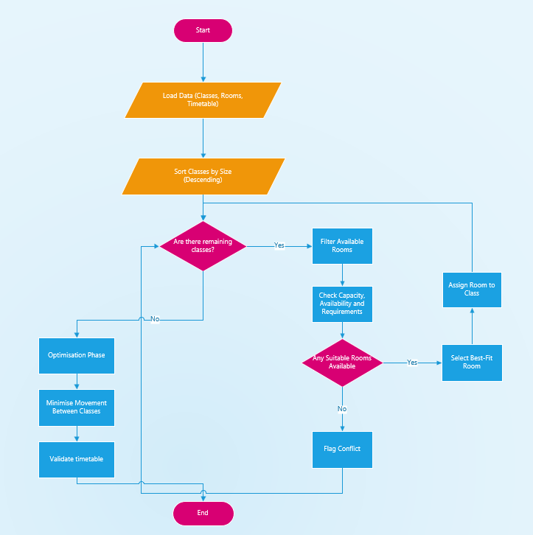

Flowchart Explanation
Getting everything ready is the first step. This means gathering all the necessary information and putting it in order. We're talking about things like how many students are in each class, how many rooms are available, what the schedules look like, and where all the rooms are located. It's important to make sure all this information is accurate, because if there are mistakes at this stage, it can throw off the whole process of assigning rooms and classes. Now that we have a plan in place, the next thing to do is to sort the classes by how many students are in them, starting with the biggest ones. This makes sense because the larger classes are usually the hardest to fit in, so we want to deal with them first. If we can figure out where to put these big classes, it will be easier to avoid problems later when we're trying to fit in the smaller ones. When it comes to assigning rooms, the system looks at each class one by one. It starts by finding all the rooms that are free at the right time and then narrows down the options based on some important rules. For example, the room needs to be big enough to fit everyone, it can't already be booked by someone else, and it must have the right features to meet the class's specific needs. When the system can't find a room that fits, it sends out a warning signal. This lets the people in charge see what's going on and make changes if they need to. If there are a few rooms that could work, the system picks the one that's just the right size - not too big, not too small. This way, the school can make the most of the space they have. Now that all the classes have been assigned, the system is moving on to the next step, which is to make sure everything runs as smoothly as possible. This is called the optimisation phase. Here, the focus is no longer just about making sure everything is feasible, but about finding the most efficient way to do things. The system takes a close look at the schedules of both students and lecturers, trying to spot any cases where classes are scheduled one after the other but are located really far apart. The system tries to cut down on unnecessary movement by switching rooms around when it can. Let's say two classes can swap rooms without causing any problems, and this ends up making their travel distances shorter. In that case, the system will make the swap. It keeps doing this over and over to make small improvements each time. This way, it can find the best way to assign rooms to classes, making it easier for everyone to get where they need to go. In the end, the system does a final check to make sure everything is okay and that none of the rules have been broken during the process of creating the best schedule. After this check is done, the system creates the final timetable. This way of doing things makes sure that everything important gets taken care of, and it also helps make the whole system work better.

Reflection and Justification

Abstract thinking
Abstract thinking has been heavily used in designing the solution for this problem. The normal complexity of the real world has been minimised by using class representations of real-world objects (people, books, doors) and rooms and time slots as requirements (constraint objects). This way a general solution has been designed which should be flexible enough for most real-world libraries.

Sub-dividing
The problem was divided into several steps such as requirement analysis, capacity allocation and optimisation. It was easier to solve broken down.

Justification of solution
This solution first solves for essential constraints to create a valid timetable and then attempts to use linear optimization techniques to make as small of an improvement as possible to the timetable. It is a good idea to avoid arranging similar pieces in vertical stacks, as this can create conflicts when covering. Some people also find it helpful to arrange the different classes of pieces by height beforehand.

Limitation
There is no guarantee of optimality. There will always be an attempt to optimise but this solution is designed to improve over time but there may not be an optimal solution.

The game is set in a static environment; no provision is made for handling unexpected events and the actual distance needed to move in any direction is not related to real life.

Assumption
The solution is based on several assumptions:
All data is accurate and up to date.
Timetables are fixed in advance.
Room capacities are strictly enforced.
Travel distance can be approximated.

This is often a simplification made to make the problem more tractable but is not necessarily realistic.

Conclusion
Classroom allocation is a complex problem that can be solved by using structured problem-solving methods to tackle the issue in a systematic way, break it down into smaller sub-problems, solve each of them using logical decision making and come up with an efficient solution that is fair and causes minimum conflicts.
The reorganisation of courses aims to make better use of the classroom space; to reduce unnecessary walking around the college; and to provide a more regular timetable for students. There are a few limitations, but these should be workable.

There is room for improvement/optimisation and perhaps some dynamic/real time features.

References

