Design Diary by Pan Su

Part1
I am a person with a quick thinking. I started thinking about these five designs in Teacher TIMI's class.
In that class, TIMI shared the design method of bionic design in class, which gave me a lot of inspiration. Therefore, I had the first design idea, a bionic orange car aromatherapy. As shown in the picture below:
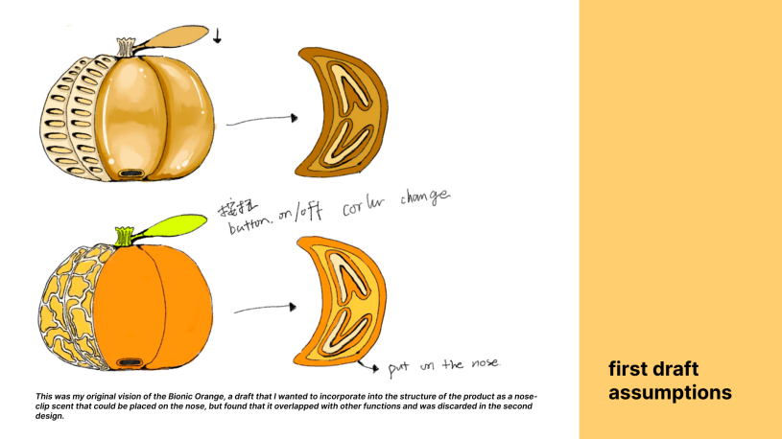
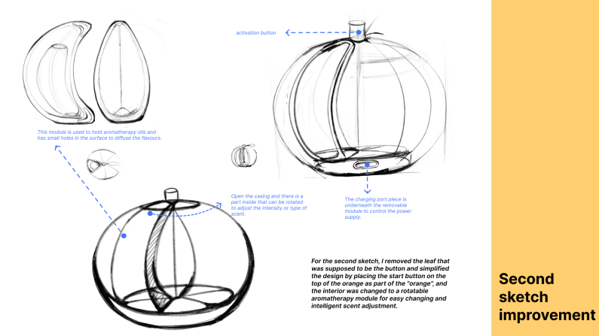
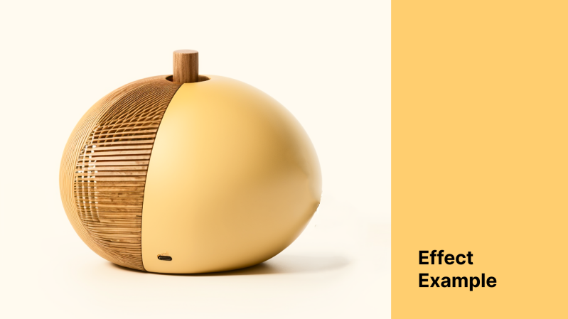

Here are my thoughts and explanations for the first design：

problem and think process

1）Often in life there are people who get sick and feel sick when riding in a car ......
For example, my grandma.
So how do you solve the problem of motion sickness or ease their symptoms a bit?

Motion sickness medicine: One of the most common methods on the internet is to take motion sickness pills, but taking pills can cause psychological stress for some people and increased metabolic stress on the body, so is there another way?

Physical method：In addition to taking medication online there are these two physical methods, one is to use ginger paste to the wrist, the other is to bring a special bracelet, press this bracelet can stimulate acupuncture points to alleviate the symptoms of motion sickness

4）How about orange?:One of the more interesting methods is to peel a fruit such as tangerines, oranges, grapefruit, papaya, etc. and put it in front of your nose to smell them all the time, which is said to relieve symptoms

So I'm thinking of making a car fragrance based on the shape and flavor of some fruits, etc. to ease motion sickness.

Design introduction

This product is trying to design a fun car fragrance for motion sickness, the use scenario is to provide relief for families travelling with elderly and children experiencing motion sickness.
Shape and Material:
It was designed in the shape of an orange, a bionic shape that would be more relatable to the elderly and children, and would also complement the citrus flavour of the fragrance. In terms of material, when I first sketched, I wanted to use silicone or wood splicing PVC, silicone is safer for children to use, and wood splicing may be more preferable for the elderly, in the refinement of the user's usage, the second time I sketched, I chose to use wood splicing material. Because children are active, it is not suitable for physical interaction with the fragrance (security risks), while the elderly can hold it in their hands, one more way of interaction, so I chose the wood splicing.

Function and interaction:
In the drawing of the sketch, I consulted a lot of car fragrance information, found that many scents are essential oils or solid fragrance tablets, I want to choose natural plant essential oils, the taste is citrus, there are scientific studies have shown that the taste of citrus can effectively alleviate the symptoms of motion sickness, and the taste of natural plant essential oil extracts will be more gentle, green and and sustained, the flavour and the shape also complement each other to give the user a real hand holding an orange Experience.
In terms of interaction, my grandmother gave me great inspiration, she often get carsick, so when she was travelling in the car, she would hold a few oranges in her hand and smell them from time to time. So I thought there are three ways to use this aromatherapy, the first one is to hold it in your hand, this kind of interaction will have an additional therapeutic effect on the user because of the touching experience. The second is to put it in the car's fixed cup slot or other fixed position, just like the normal aromatherapy.

Voice Interaction
The third is about the way to adjust the aromatherapy flavour, I choose voice interaction, because in the process of vehicle driving the user is already physically uncomfortable, and then go to find the button will be even more strenuous, if it is with the side of the people to raise the appeal of the first may be distracted by the driver's attention, and the second is to increase the cost of more communication. Voice interaction in addition to adjusting the smell of incense, if there is a need for medical treatment, you can find the nearest nearby rest stop or hospital, to further solve the user's problem of motion sickness.

The above is my design idea for the first small design. I remember Mr. TIMI said to me to think about the circumstances under which this design is used and the uniqueness of your design. My mind jumped from this moment on and I thought of something more interesting to practice.

Part 2&Part 3
I think of a journey, think of the distant homeland, my grandmother used to go out on the car always sick, but now because of poor health has not been a long time to travel with me.When I was very young, my grandmother always carried me out of the house, and I wore the patchwork clothes made by my grandmother. At that time, my mother was very busy with work, my grandmother would hold me at the door and wait for my mother to come home.
My grandmother would sew auspicious tigerhead shoes for each of her grandchildren, so I thought of a very similar intangible cultural heritage - Yangxin cloth patch. Yangxin cloth patch is a practical plastic arts craft used by women in Yangxin, Hubei province to create collages with cloth scraps left over from clothes, commonly known as "sticky flowers".

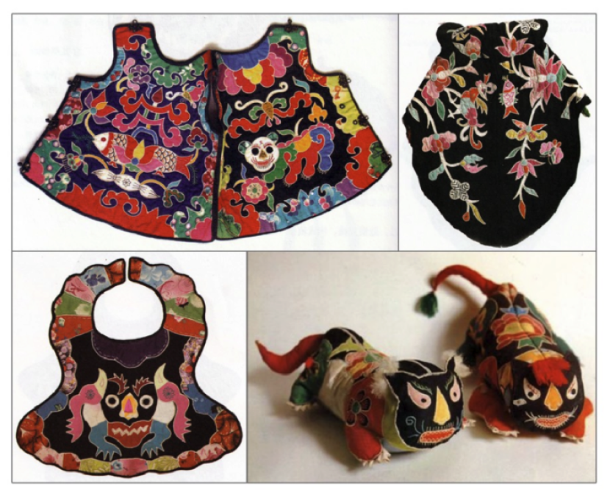
Yangxin cloth paste picture

Yangxin cloth paste "take in life, use in life, blend in life", has the characteristics of artistic and practical integration, is the materialized product of farmer's affection, mainly used in children's clothing, wedding supplies and religious supplies. Such as: baby's wrap skirt, children's hat, bag and pillow and other children's play; Daily necessities such as waists, tablecloths and wall hangings for cooking; There are temple ornaments, wedding ornaments, and so on.

Yangxin cloth paste is an intangible cultural heritage in Yangxin County, Hubei Province, China, and is also a traditional embroidery craft. Compared with other intangible heritage embroidery, Yangxin cloth stickers have the following special features:

1. Unique embroidery techniques: Yangxin cloth paste is a comprehensive use of a variety of embroidery techniques, including embroidery, patching, filling and so on. The combination of these techniques makes the Yangxin cloth more fine on the details, and the pattern is more rich.

2. Special cloth material: The cloth material used in Yangxin cloth is mainly local specialty linen, after special treatment and dyeing, so that its texture is soft, good toughness, very suitable for the expression and display of embroidery process.

3. Unique pattern style: The pattern style of Yangxin cloth stickers is unique, often with flowers and birds, figures, landscapes and other natural elements as the theme, and these patterns are vividly presented on the cloth through the way of embroidery. The pattern has smooth lines and bright colors, and is strongly decorative and ornamental.

- Rich application fields: Yangxin cloth can not only be made into a variety of embroidery and ornaments, such as clothing, curtains, cushions, etc., but also can be used in architectural decoration, art and gifts. Its unique style and craft characteristics make Yang Xin cloth has a wide range of applications in cultural and artistic creation and practical life.

The production materials of Yangxin cloth paste are mainly divided into paste cloth and base cloth. The paste cloth is the corner cloth left by the daily accumulation of the producer. The base cloth is mostly black or dark blue thick cotton cloth. Auxiliary materials are beads, bells, cotton, tassels and other decorative accessories. Production tools are mainly daily home scissors, sewing steel needle, thimble, wood scraper, different thickness of cotton thread, glutinous rice paste, paper and so on.

How can traditional patterns be applied in modern times?
(1) isomorphic reconstruction of pattern shape ——（Second design）
The naive effect brought by the flatness and exaggeration of Yangxin cloth pattern is very vivid and amiable, which is compatible with the modern popular flat design. The isomorphism of Yangxin cloth pattern also provides a method for the reconstruction of pattern shape.

Continuation of the uniform modeling method of Yangxin cloth paste, strengthening the connection between traditional folk art and modern life, adding modern life elements, can make the pattern more full of affinity and fun, so that people are easier to accept and love.

(2) The multiple combinations and structures of "spelling"——（Third design）
The technological characteristics of Yangxin cloth stickers are the use of corner pieces for collage combination. Corner fabrics, as the main materials for the production of Yangxin cloth stickers, come from different types of clothing, new and old, with different thickness and thinness, and the texture of materials is also very different. During the creation, a variety of materials have differences, pluralism and changes in continuous replacement, decomposition and composition. The works of Yang Xin cloth stickers show a diversified visual sense and touch sense. Through the decomposition and combination of patterns, a new shape, a new composition and a new meaning are produced.

Inheritance and innovation in the multiple combination and deconstruction through the method of "patchwork" is the most prominent technological characteristics of Yangxin cloth stickers.

Think of this，I have some design ideas around Yang Xin cloth stickers.Starting from the patterns and "collage" of Yang's new cloth, I deconstructed and reshaped it, designed some patterns and patterns, and designed puzzle toys based on the action of "collage", which is the source of my second and third designs.

Basic idea
1. Extract the basic pattern elements from the Yangxin cloth paste
2. Deconstruct the basic patterns and then carry out assembly design, mainly using new materials (photochromic materials), so that more patterns can be displayed on the original color and transparent surface
3. Photosensitive, you need a hardware as a light source, which can be a chassis, that is, let the children explore the photosensitive effect of different components one by one
4. Provide assembly instructions for reference (Introduction of Heyang New Cloth intangible cultural Heritage)
(The program focuses on the use of new materials, the extension of Yangxin subsidy "collage" this interactive way, and the extraction and application of Yangxin cloth pattern and color)

The basic pattern elements were extracted from Yangxin cloth paste：
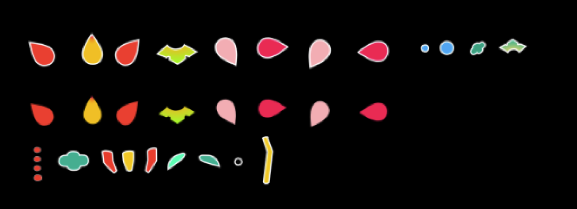

Pattern Design（Second design）：
The patterns of Yangxin cloth are auspicious, the following are some common pattern themes of Yangxin cloth, I will choose the appropriate pattern from these themes for dismantling design
The pattern theme of Yangxin cloth paste is very extensive and rich, mainly divided into plants, animals, people, utensils four categories, each theme pattern types are very rich, plants are daffodils, lotus, peony, hibiscus, camellia, lotus and so on; Animals include bats, phoenix, carp, unicorn, chicken, crab, etc. Characters include children, Guanyin, champion and so on; Utensils include eight diagrams, copper coins, lanterns and so on. Yangxin is a place with many mountains and lakes, and aquatic plants such as fish and lotus are very common in Yangxin cloth patterns.

All kinds of theme patterns are usually combined, and each combination pattern expresses good wishes and blessings about a happy marriage, happiness, descendants and descendants, and gold list titles, reflecting the characteristics of our folk decorative patterns of "map will be intentional, meaning will be auspicious".

For example, the five son Denke pattern sustents the family's good expectations of the child, hoping that the child can be excellent in character and study; The meaning of Guanyin sitting lotus pattern is to pray for family safety and health; Kirin son is to express the good wishes of many children and more happiness; Magpie plum meaning auspicious, festive, the arrival of good luck; Even in the three implied exam results are excellent

The pattern design inspiration comes from the basic pattern of Yangxin cloth.

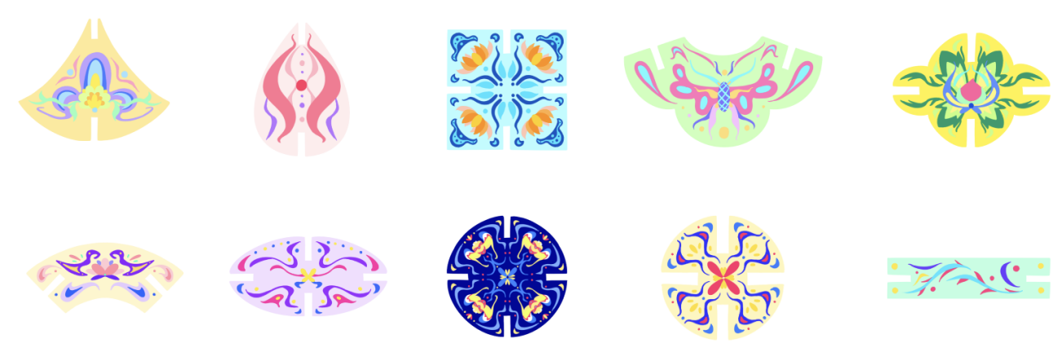
After designing the pattern, I began to think about the toy design based on "spelling"
The first is the choice of materials:

Photosensitive color-changing plastic is a special type of plastic material that is sensitive to light and, when exposed to light or ultraviolet light, causes color changes or displays new patterns. Photochromic plastics are often used in areas such as art creation, design and toy making to bring unique visual effects and interactivity to the work or product.
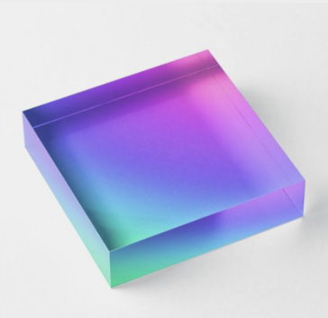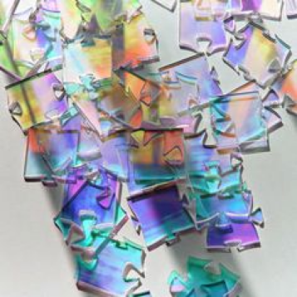photosensitive color-changing plastic

Here are some of the characteristics and applications of photochromic plastics:
1. Color change effect: photochromic plastic can achieve color change according to the effect of light intensity or ultraviolet light. When plastic is exposed to a light source or ultraviolet light, it changes from one color to another, creating a rich changing effect.
2. Invisible effect: photochromic plastic can be designed to be transparent or show a certain pattern under normal conditions, but when exposed to light or ultraviolet light, the hidden pattern will emerge. This kind of design can increase the mystery and interest of the work or product.
3. Touch sensing: Some photochromic plastics have touch sensing characteristics, and the color will change when touched or affected by body temperature. This interactivity can be used to design inductive toys or works of art that engage users and create a more interesting experience.
4. Environmental response: photochromic plastic will also respond to changes in environmental light. For example, plastic may show bright colors when exposed to strong light; In a dim environment, the color may become muted or dull. This environmental response can be used to design works or products with a sense of context.
After selecting the materials, I began to think about the shape of the assembled toy. In the 3D modeling software, I combined and assembled the basic patterns previously decomposed as a game. Considering the characteristics of photochromic plastic, I designed a light at the bottom of the toy, and when the toy was assembled and the switch was turned on, beautiful patterns would emerge. In order to let users understand its deeper culture through this toy, I completed the design. The toy instruction manual is further designed.
The design of the toy and instruction manual is as follows:
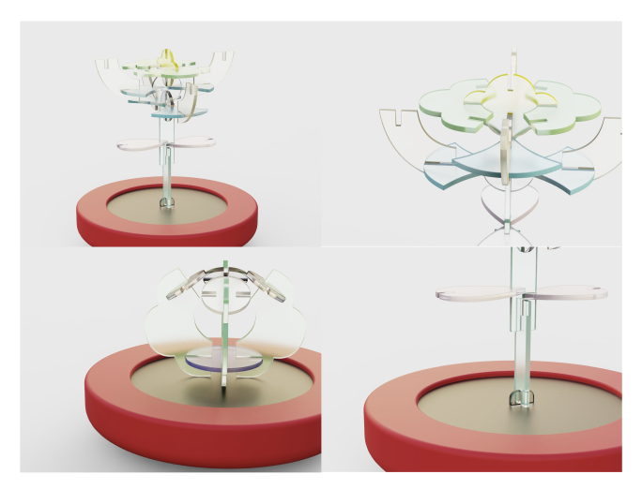
Assembly example
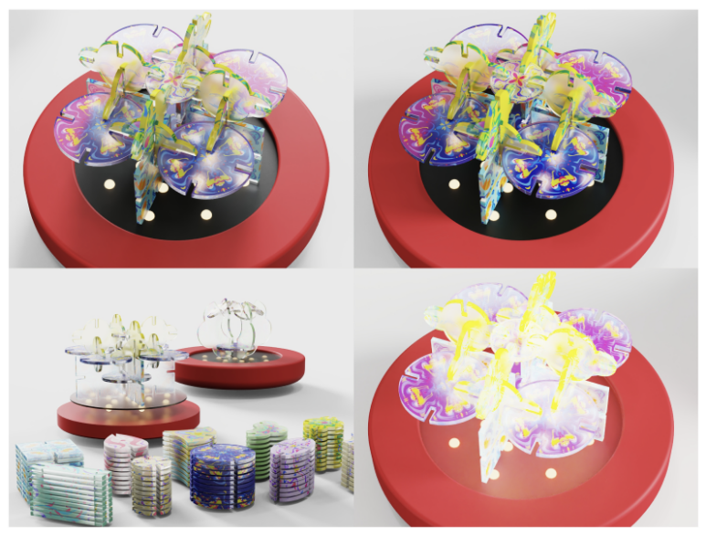
Turn on the light and change color
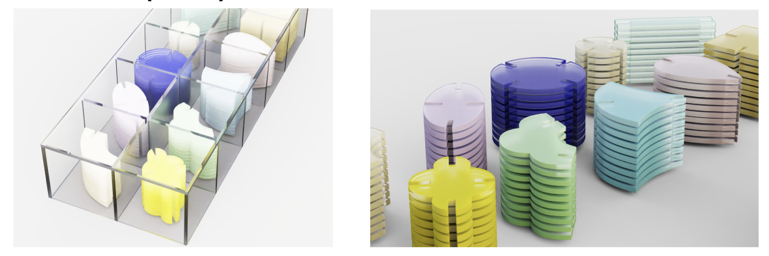
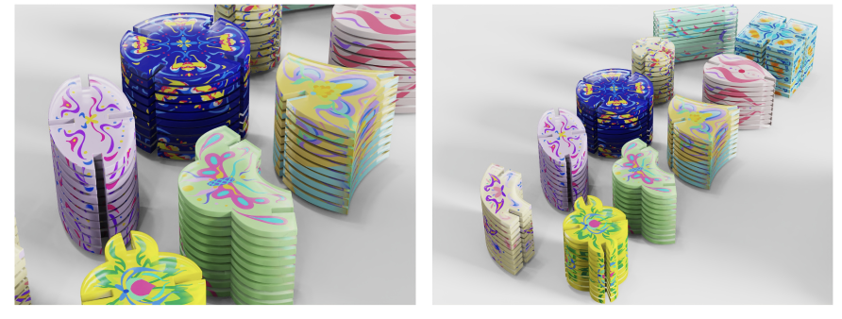
Storage display

Toy instruction manual design
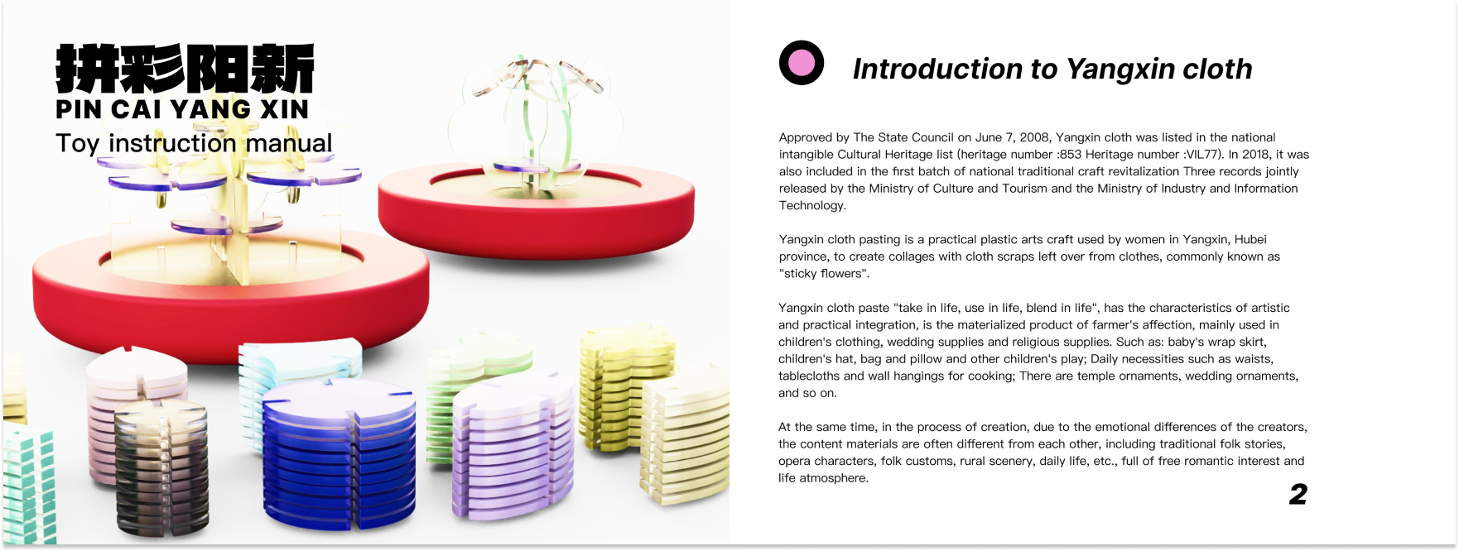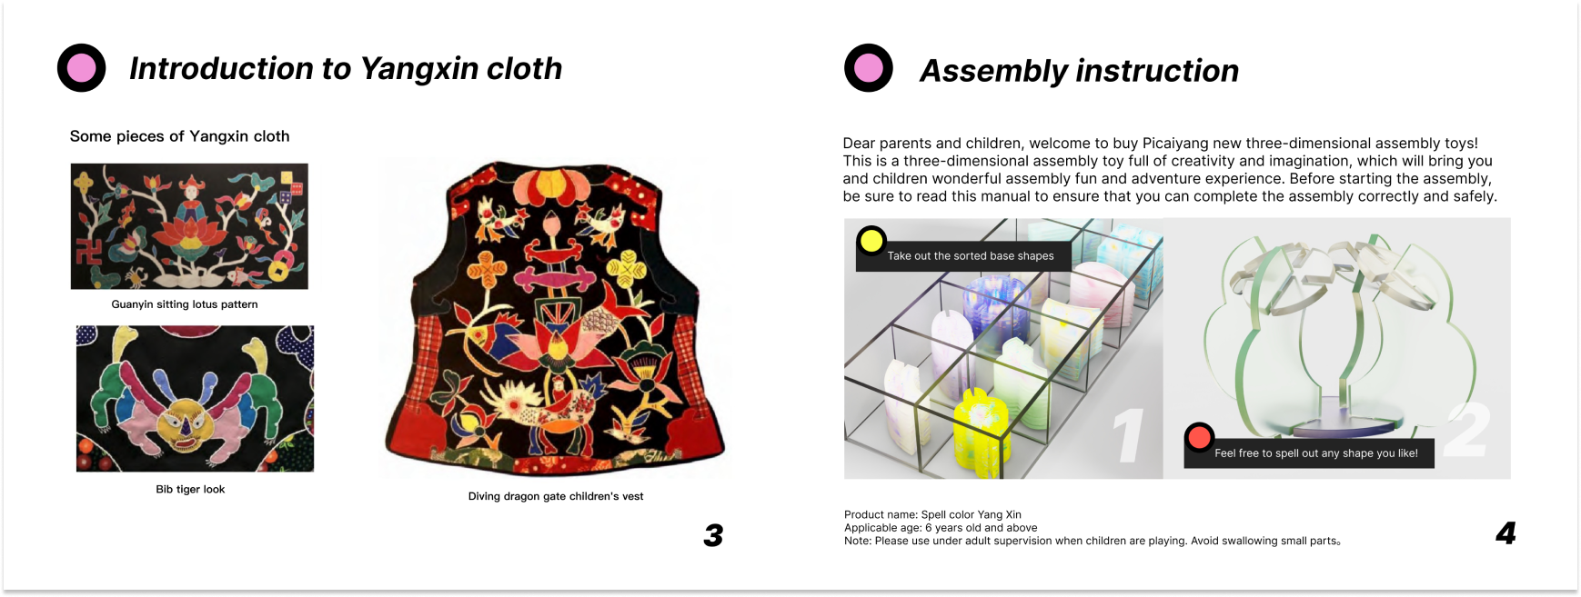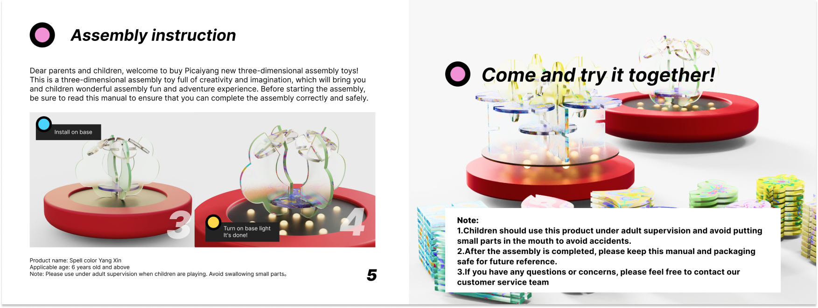

Part 4&part 5
After the second and third designs I started to think again, what should I do next? Going back to that trip, I thought that we would go to various scenic spots during the trip. I thought of going to the amusement park before. Many tourists bought drinks in the park and threw them into the trash can after drinking them without caring about garbage classification, and beverage bottles were not well recycled and reused. The British "Guardian" has reported that about 1 million plastic bottles are sold every minute in the world, and this number will jump by 20% by 2021, when more than 500 billion plastic bottles are sold every year, far more than the degree of recycling. Science shows that plastic is not effectively absorbed into the food chain, and no matter where it is digested, it will bring toxins to our plates. So how to increase the recycling rate of plastic bottles in scenic spots and make them sustainable?

After preliminary data review and investigation of pain points in this situation, I think there are the following pain points:
1）Tourists throw it away
2）Cannot be absorbed by the food chain
3）The cleaners picked up the rubbish after the tourists left
4）The recycling rate is only 7%
Summary: Most tourists throw plastic bottles into the trash after using them, and rarely recycle them, most of them think that waste drinking bottles cause damage to the environment and the image of scenic spots, and affect the mood of play.

Next, I conducted a competitive analysis of various similar plastic bottle recycling machines：
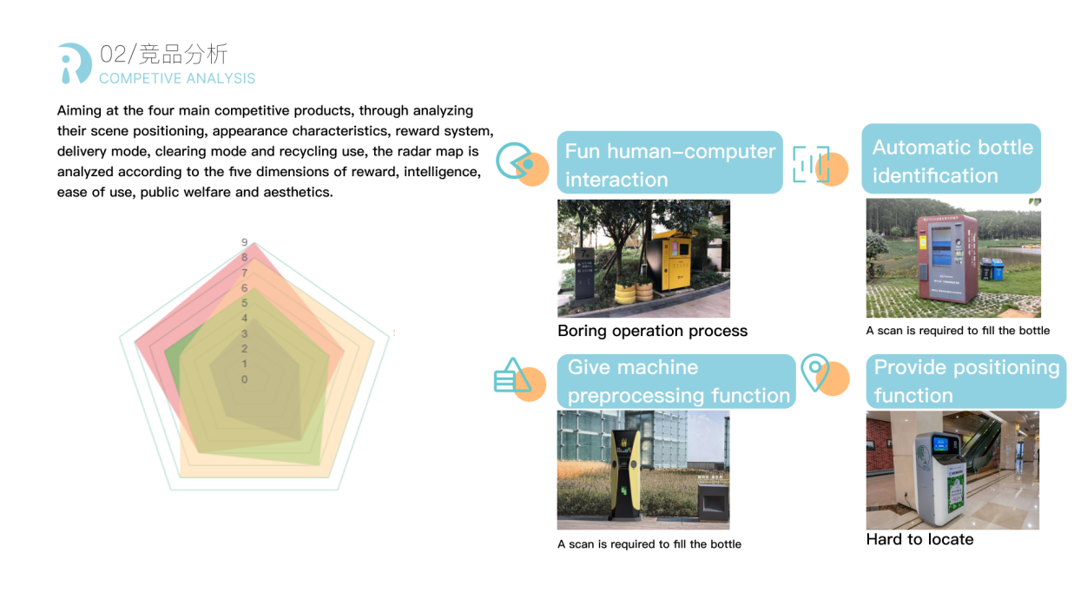
After the insight of the pain points and the reference of other people's similar types of design, I conducted a design positioning thinking：
- Increase the recycling rate of plastic bottles in scenic spots
- It is convenient for users to find the recycling site quickly
- Human-computer interaction is more interesting，improve the user experience

Then I began to design this bottle recycling machine. In order to enhance the fun of the design, I came up with the design method of gamification, thinking of the arcade games in my childhood, and an idea began to form in my head:
What if you think of the bottle recycling machine as a gaming arcade? The plastic bottle is the "game currency", and every time you cast the "game currency", you can play a game, which sounds good! So which game to play? I think of a classic single-player game that was particularly popular when I was a child - Gold Miner. The content of this game is probably similar to grabbing a doll, a miner can grasp the Angle of the gripper each time to grasp the underground gold, the more points caught the higher.

I transplanted this game idea to the bottle recycling machine, and changed the scene of miners into a boat drifting in the sea, in which a person is fishing for plastic bottles in the ocean, which is in line with the concept of environmental protection and sustainability. I hope this game interface can also indirectly remind people of environmental awareness.
Here is my fourth design：
My recycled little game interface design：
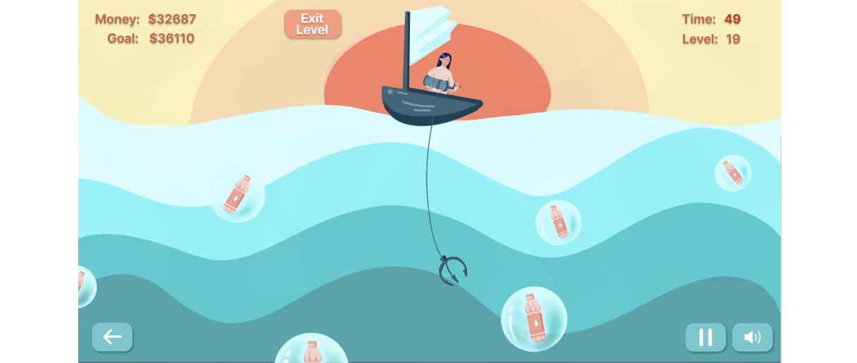
I put this little game on the bottle recycling machine, and here's what happened:

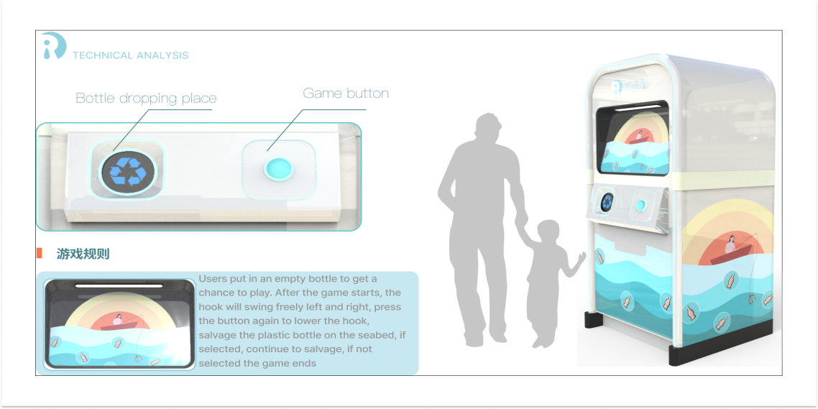
I imagine the inner workings of the machine：
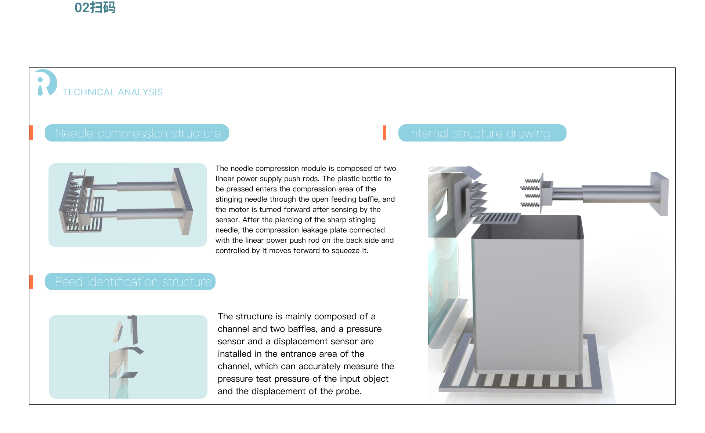
I combed through the entire use process and came up with two problems to be solved: how to let tourists know the location of the plastic bottle recycling machine, and how to further motivate tourists to play the game?
Based on these two problems, I designed a small program of navigation and points exchange on the basis of this recycling machine, which is convenient for tourists to use:
Here is my fifth design and how to use it:
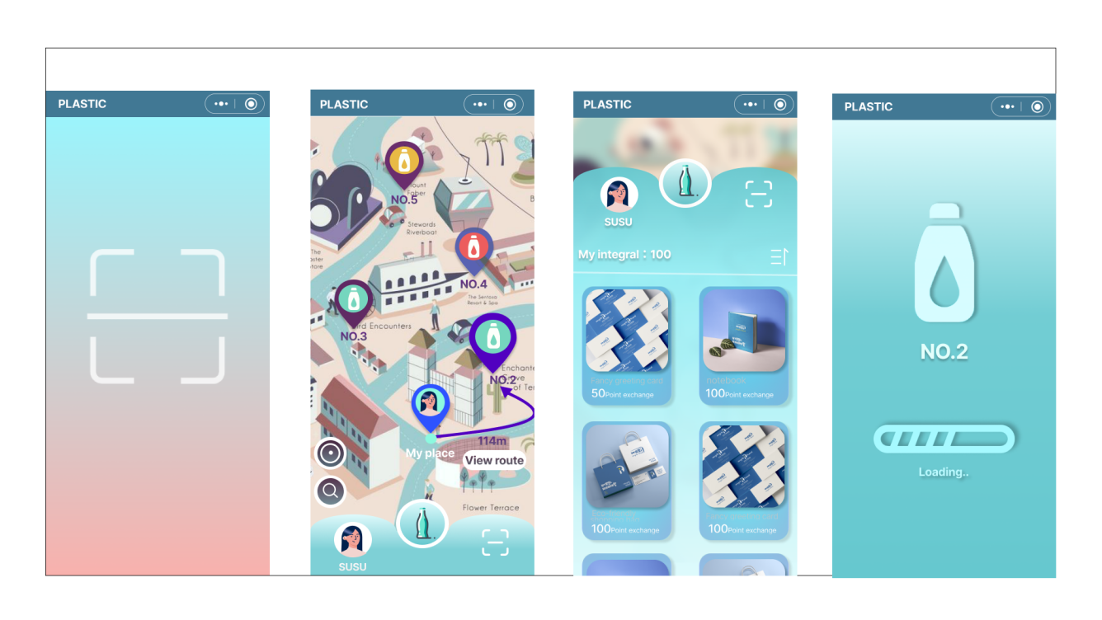

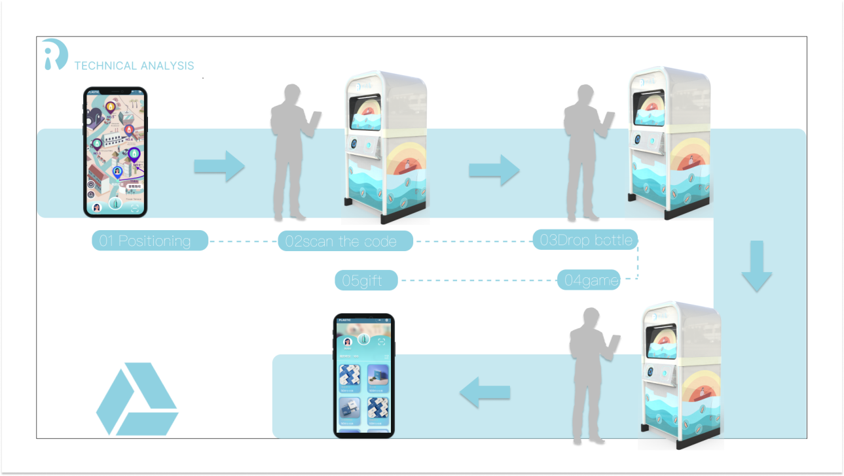

These are the five small designs I have made this semester. I have tried different types of designs and I am quite happy with them. However, some of the designs are not very in-depth and need to be refined later.

