George Davies
Word Count: 1032
MOBILE ENABLED WEBSITE UTILISING REST SERVICES

Contents
1 Introduction 1
1.1 File Structure 1
2 Discussion 1
2.1 Getting Data 1
2.2 Performing a search using AJAX 4
2.3 Showing fields to user 9
2.4 Random Item 10
2.5 Mobile Features 10
2.6 Weather API 13
3 Conclusion 14
Bibliography 15

Figure 1 – Old PHP only solution 2
Figure 2 – Search bar 2
Figure 3 – Result of initial JSON array from animedata.php 3
Figure 4 – JSON output using JSON_PRETTY_PRINT and JSON_UNESCAPED_SLASHES from animedata.php 4
Figure 5 – Getting search term from user 4
Figure 6 – AJAX data showing but not displaying the correct first result (One Punch Man) 5
Figure 7 – Original code (no case insensitivity) 6
Figure 8 – Change implemented to fix the issue 6
Figure 9 – AJAX comparing user input to titles in anime array (fixed) 6
Figure 10 – Testing that “animedata.php” is being called when the search is used 7
Figure 11 – Searching for “One Piece” in the anime table 7
Figure 12 – Searching for One Piece continuation 8
Figure 13 – Searching for “One” (returning One Punch Man, One Piece and more) 8
Figure 14 – Table script 9
Figure 15 – Table on anime page 9
Figure 16 – Code for getting the random item 10
Figure 17 – Code for displaying the random item 10
Figure 18 – Navigation bar 11
Figure 19 – Navigation bar code (navigation.php) 11
Figure 20 – Collapsibles on the home page 12
Figure 21 – Random anime collapsed 12
Figure 22 – Example search of Weather 13
Figure 23 – Weather API call 14

1 Introduction

With the goal of making a mobile friendly website, I have created a site that can display different types of medias including games, anime and tv shows. The website’s functionality revolves around grabbing data from a JSON array that has been populated with data from a database and then dynamically displaying it once it has been filtered with a search term by the end user.

File Structure

For the website to work properly, ensure that the “mobileapp” folder and the “DBAssignment2” folder are both in the same folder so that the images can be retrieved. Also ensure that the “mediadb.sql” has been imported into phpMyAdmin.

2 Discussion

The website I have created uses sticky mobile [1] as a foundation for the design of the website, using their CSS and customisation options to make my website better. This allowed me to make my website completely mobile with a suitable navigation and view. The website was also developed using the iPhone 13 Pro screen to test for mobile responsiveness. Alongside Sticky Mobile I also implemented jQuery Mobile [2] features to make the website visually appealing while making it more suitable for mobile users. For other developers to utilise my API, I have created a readme.txt file with instructions on how to implement it in their own website in the mobileapp folder.

2.1 Getting Data

Initially when creating the API calls for each table I was going to implement a full PHP solution, taking inspiration from a resource from Eli the Computer Guy [3]. While developing this however I noticed that the search results were very slow and required a full page refresh every time I searched for data.
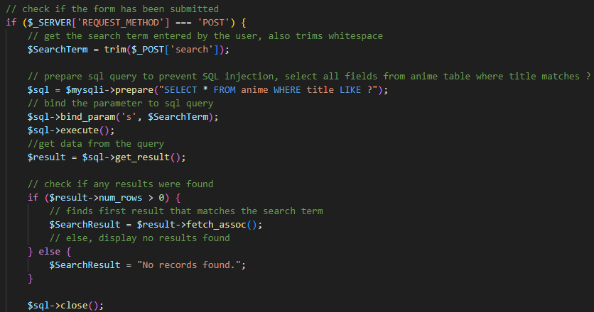
Figure 1 – Old PHP only solution

The new solution instead used AJAX to directly search a JSON array by comparing data from a search bar the user can interact with to the items in the array, being a much more effective solution as it didn’t require a refresh to function.
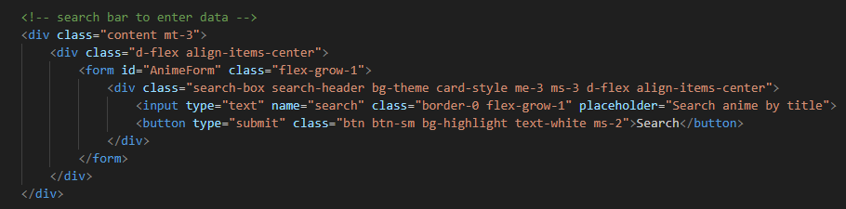
Figure 2 – Search bar

The first part of using this method was to create an array with JSON that contained all of the data that I needed for the search, which I took inspiration from w3schools to assist me [4]. I decided to take the approach of dynamically grabbing data from the database and performing a while loop to continuously grab data from the database while there are still rows left, which would all be inserted into the array. Once all the anime data was selected, the array would be echoed so that when the php file is called it will display all the data.

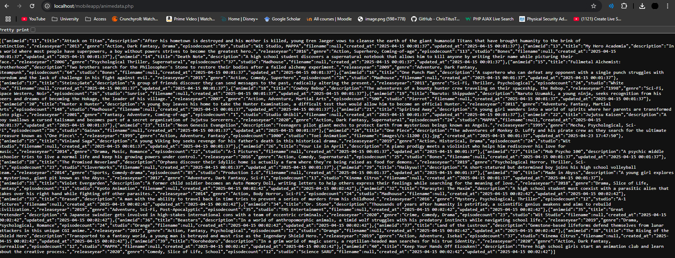
Figure 3 – Result of initial JSON array from animedata.php

While the data was returned, the content was not readable and had some issues that caused data to be incorrectly interpreted. I solved this by adding JSON_PRETTY_PRINT, which formatted the data in a readable format. JSON_UNESCAPED_SLASHES was also implemented to stop the image file path names from being give an additional “/” which would alter the file path and make them unusable. I also used JSON_UNESCAPED_UNICODE so that any Unicode characters would be returned in their original format instead of hexadecimal.
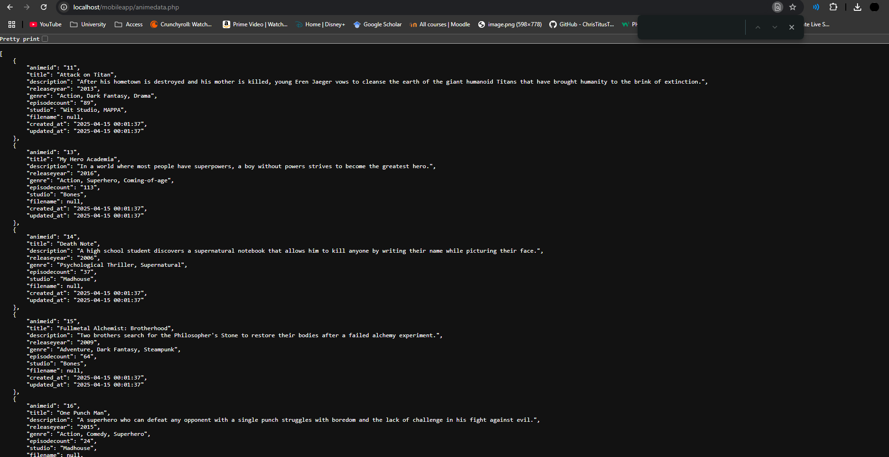
Figure 4 – JSON output using JSON_PRETTY_PRINT and JSON_UNESCAPED_SLASHES from animedata.php

2.2 Performing a search using AJAX

The search function works by utilising JavaScript and AJAX to allow a search without any page reloads and dynamic content retrieval. It functions by performing a script when a HTML form is submitted that will prevent it from being submitted which would typically refresh the page. The user’s input will then be converted into a variable (SearchTerm). AJAX is then used to retrieve data from animedata.php and filter the data inside of the data array to include the search the user entered.
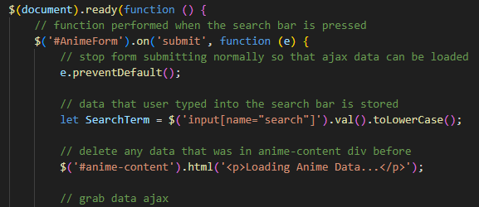
Figure 5 – Getting search term from user
The search will then set the search result to any fields that include the user input by filtering out anything that doesn’t match. Once the filter has been performed, it will remove any data that was previously in the container instead of refreshing the page and check the data. The data will be checked to ensure that the length is greater than 0 and if so will append the anime-content div for every piece of data that contained the search term, which can be multiple results at once. All the image files are contained in the folder for the database management website, with the database returning the file names that are needed to call the file. I initially had an issue with this which, when I clicked search, the results were not showing properly even though the AJAX data was being returned. To fix this, I had to set the result of the search that the user inputted to lowercase to make it case insensitive, which allowed the search to go through regardless of capitalisation.
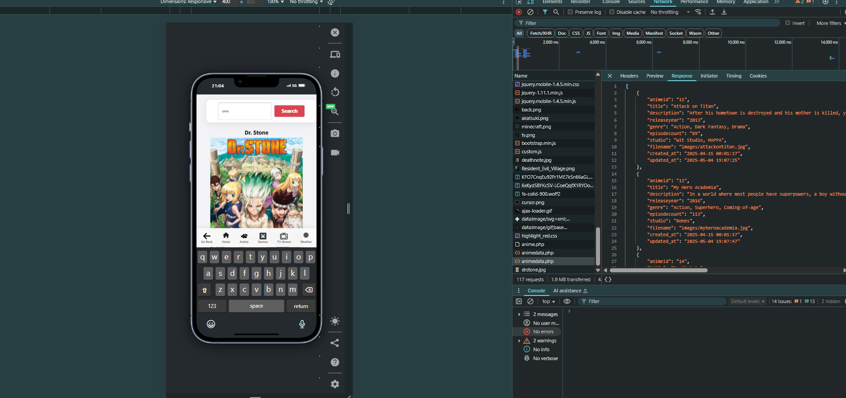
Figure 6 – AJAX data showing but not displaying the correct first result (One Punch Man)
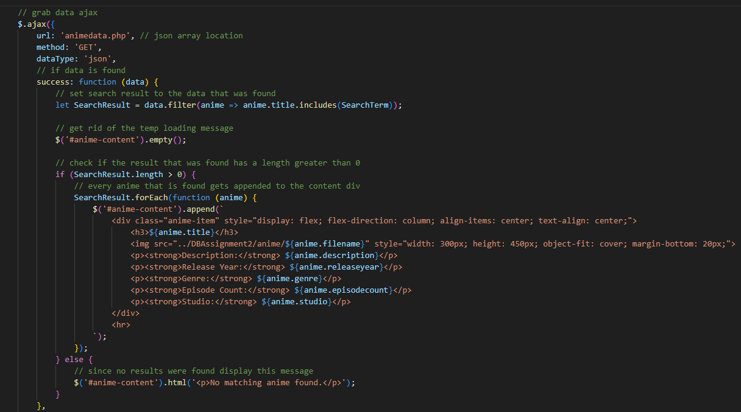
Figure 7 – Original code (no case insensitivity)

Figure 8 – Change implemented to fix the issue
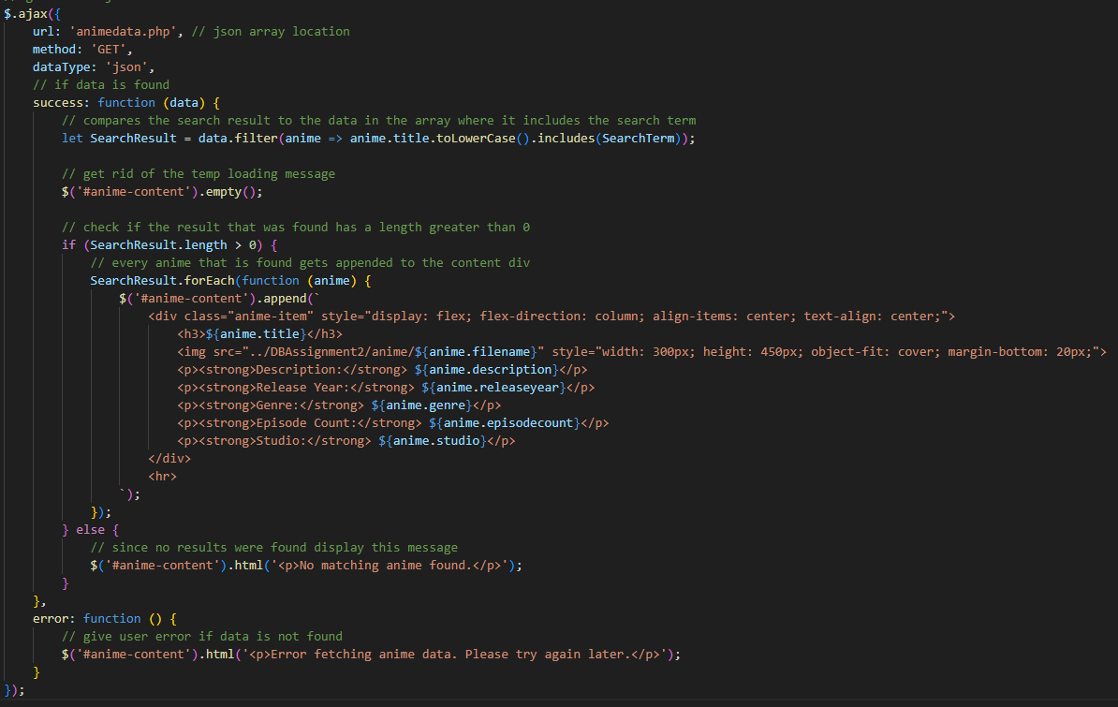
Figure 9 – AJAX comparing user input to titles in anime array (fixed)
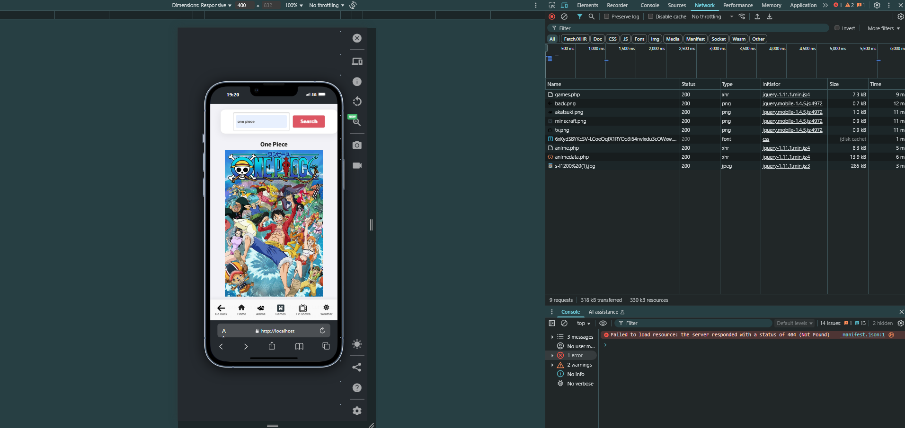
Figure 10 – Testing that “animedata.php” is being called when the search is used
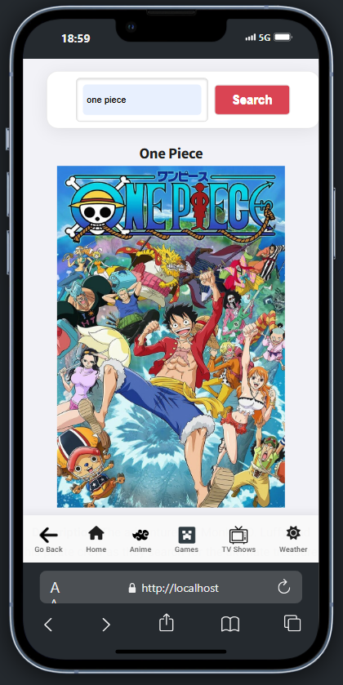
Figure 11 – Searching for “One Piece” in the anime table
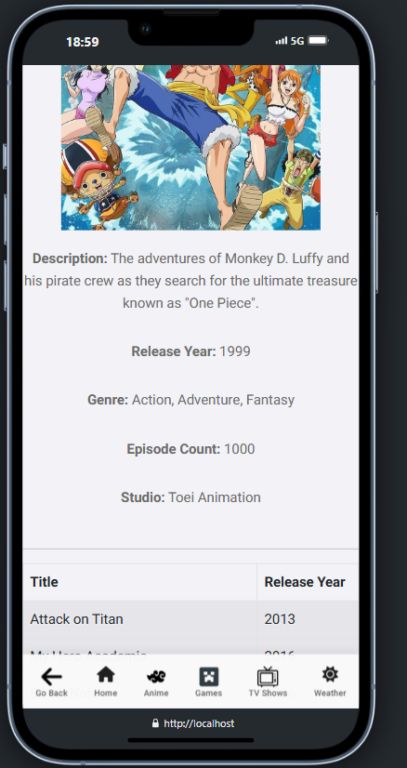
Figure 12 – Searching for One Piece continuation

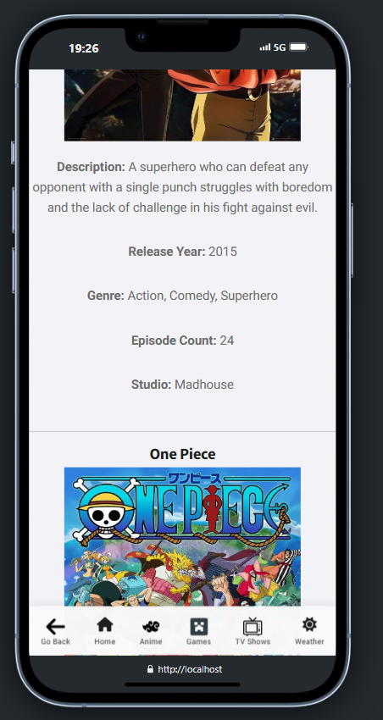
Figure 13 – Searching for “One” (returning One Punch Man, One Piece and more)

2.3 Showing fields to user
Each page also had a php script that would display all of the fields that existed to the user in a table so that they can see what options they can search for.
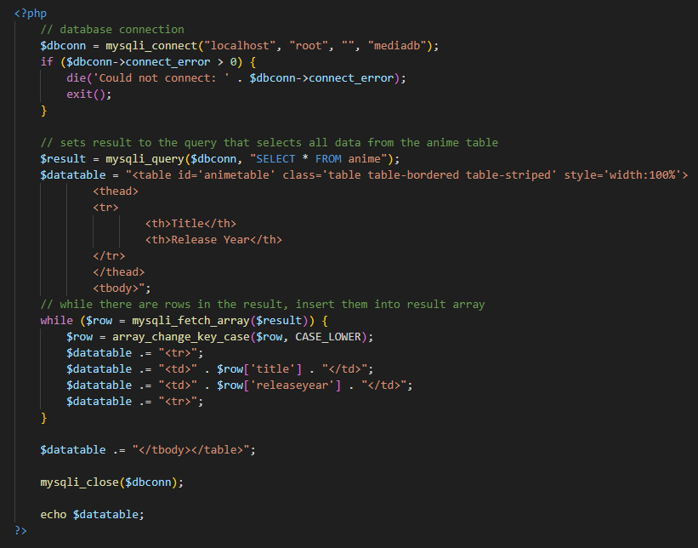
Figure 14 – Table script
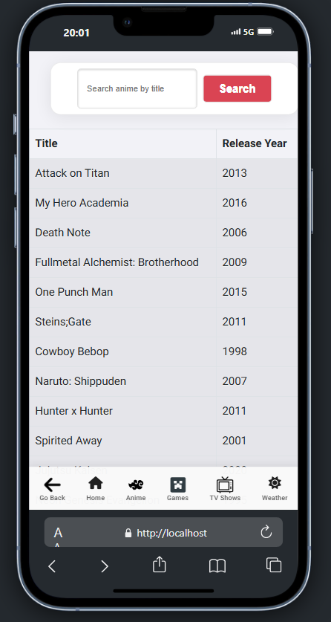
Figure 15 – Table on anime page

2.4 Random Item

I also implemented a “random item” feature for my home page that will generate a random field from each table and display it to the user on the home page. It does this by using order by rand() and putting it into a variable for the user to call.
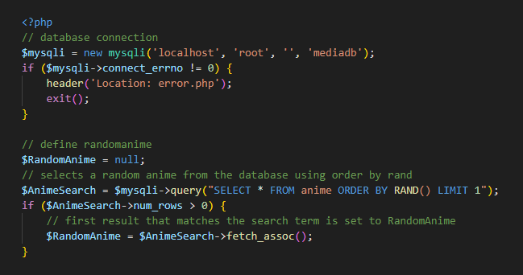
Figure 16 – Code for getting the random item

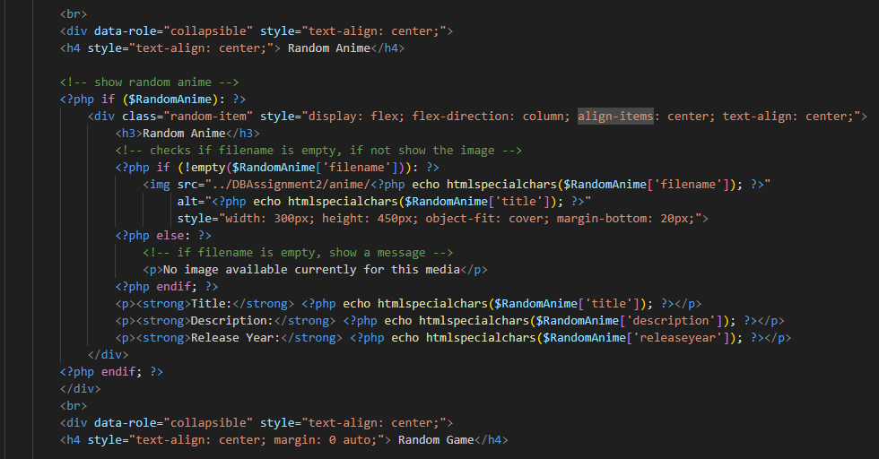
Figure 17 – Code for displaying the random item

2.5 Mobile Features
The navigation bar for the website was designed to allow for instant access to any page without being intrusive in the site, using sticky mobile styling. It is always present at the bottom of the screen for the users with links to every page as well as a “go back button” that utilises jQuery mobile. Using jQuery mobile, I also implemented a fade transition to each link to make loading pages seamless.
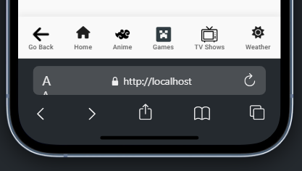
Figure 18 – Navigation bar
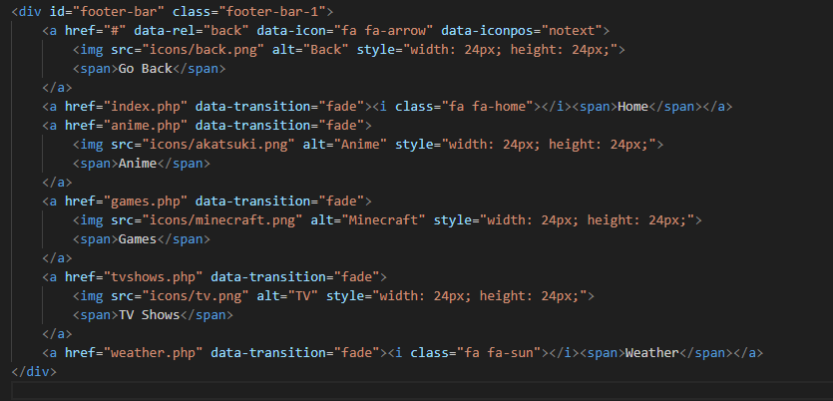
Figure 19 – Navigation bar code (navigation.php)

I also added collapsible items from jQuery mobile which when clicked will drop down a div that contains a random item from the database to the user.
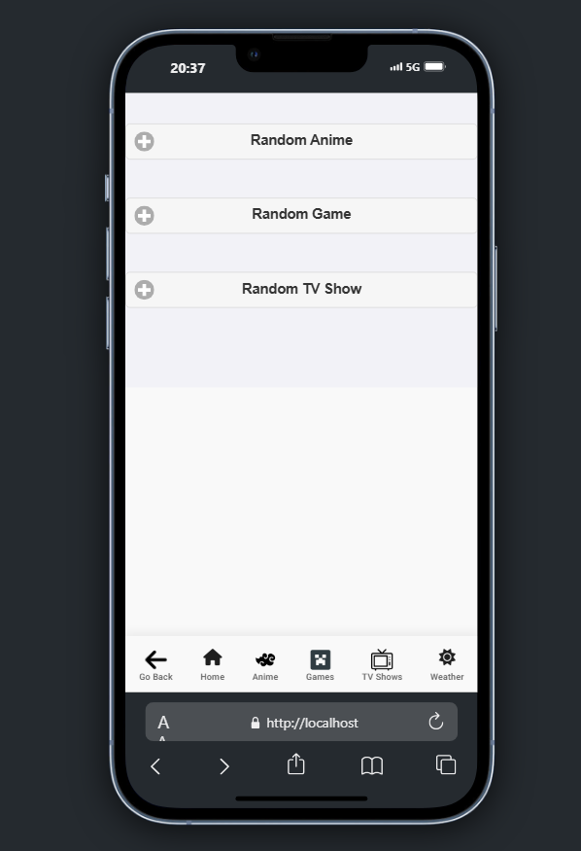
Figure 20 – Collapsibles on the home page

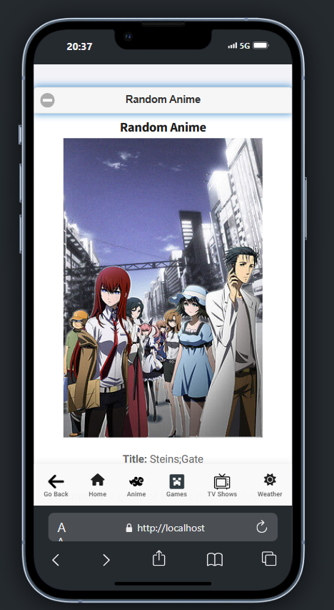
Figure 21 – Random anime collapsed

2.6 Weather API

I also implemented the OpenWeather API [5] in my website which allows the user to search for a city and display relevant information about the weather in the area. This is done similarly to my other tables except instead of grabbing data from my own JSON arrays, it uses a link to the OpenWeather website that returns all the data necessary which I then implemented using their documentation.
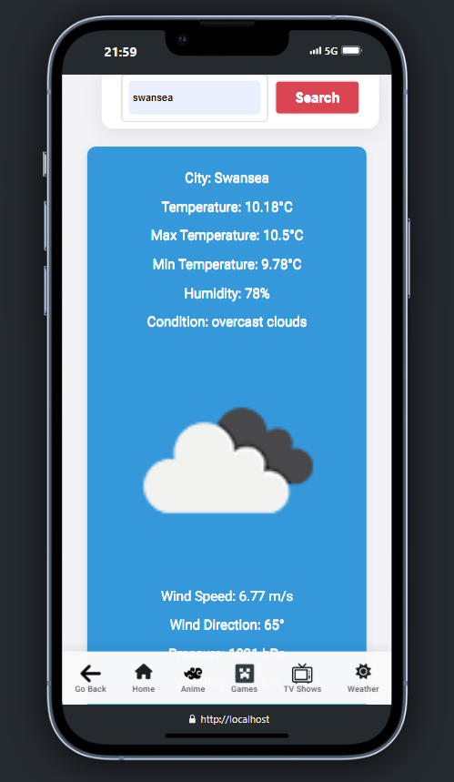
Figure 22 – Example search of Weather

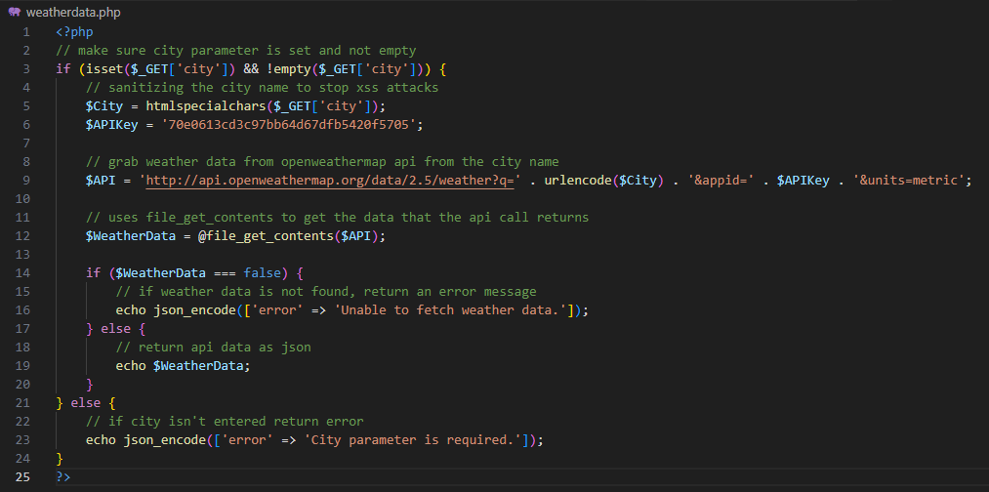
Figure 23 – Weather API call

3 Conclusion

In conclusion, the mobile site I created meets the requirements of being responsive and retrieving data dynamically from the database while also remaining visually appealing and smooth due to the easy navigation options and the transitions between pages which makes the user experience much better.

Bibliography

[1] | Enabled, “Sticky Mobile,” 30 January 2019. [Online]. Available: https://themeforest.net/item/sticky-mobile-mobile-template/23229237. [Accessed 4 May 2025].
[2] | jQueryMobile, “A Touch-Optimized Web Framework,” [Online]. Available: https://jquerymobile.com/. [Accessed 4 May 2025].
[3] | E. t. C. Guy, “MySQL – SEARCH Form with HTML and PHP,” [Online]. Available: https://www.elithecomputerguy.com/2019/12/mysql-search-form-with-html-and-php/. [Accessed 4 May 2025].
[4] | w3schools, “PHP and JSON,” [Online]. Available: https://www.w3schools.com/php/php_json.asp. [Accessed 4 May 2025].
[5] | OpenWeather, “Weather API,” [Online]. Available: https://openweathermap.org/api. [Accessed 4 May 2025].

