Grace Davies
2220599

Operations Management Plan

Deborah Jenkins

Operations Management for Tourism, Leisure and Events

(BMTP5019)

Introduction
What is operations management?
According to a journalist at the University of York (2024), “operations management is the area of a business that focuses on optimising its operation and processes in order to maximise organisational efficiencies, productivity and profits.” This aspect umbrella term of ‘operations management’ also referred to as ‘production management’ covers all of the ins and outs of a business, this includes food and beverage, marketing, conferencing and events, the box office, and operations both internal and external (Jenkins, 2023). To make an event run smoothly all of these aspects must be well thought out and developed to a high standard. A great way to understand operations management is to think of it as a production line, each part of the process is done by a different person, yet they all work together to get the job done more efficiently. Effective operations management will guide those in the business to avoid wasting valuable materials and show them how to use these materials efficiently. Financial waste is a huge problem in businesses where operations management is not put to use correctly, money is poured into aspects of the business where it is simply not necessary. Poor operations management is usually down to the following factors, insufficient management, lack communication between teams, job allocation decisions, conflict, and demotivated employees (Scoro, 2024). Successful events all stem from a team that work well together, without this, the business will fail. Examples of this happening include the bankruptcy of Blockbuster, Toys-R-US, and Woolworths (e-careers, 2019). The heart of any team is the management, a huge part of operations management is having a strong leader to delegate and oversee procedures, they must have a general understanding of each part of the business as well as being able to connect with their staff on an emotional level to help avoid and alleviate conflict within the team (archive it, 2024). Successful teams are made up of people with different perspectives and knowledge, with this conflict is inevitable. Conflict at work is occasionally very constructive, when people first get together there are bound to be things that they disagree on, ironing out these problems early on in the operations process mean that when it gets close to launching an event these conflicts are resolved and the team is running smoothly (Mind tools, 2023). Good managers have the skillset to diffuse conflicts in an educated manor to avoid further disruptions. In 2011, Forbes reported that “3 quarters of all CEO’s came from and operational background”. This is because in order to have a deep understanding of the operational management of an event it is important that you have worked within the industry prior to becoming a manager, it gives you an advantage as you are able to empathise with your employees. Operations management has been used for centuries, it was first recorded in 5000 B.C. by the Sumerinas that tracked their inventories and taxes using operations management, it has come a long way since then, in 1913, the CEO of Ford cut down his production time by 9 hours by using efficient operations management techniques (Eby, K, 2023). Now we use operational management in businesses every day, thanks to new technology it is more advanced than ever, this is essential as there is such a high demand for excellence. Operational management covers many complex and in-depth areas, these include risk management, legalities and licencing, development and design, crisis management, finances as well as overall customer satisfaction. Marketing management is a vital part of the operations marketing process, it is what captures the attention of stake holders to begin with. The exact definition of marketing operations is “the practical implementation of marketing activities as executed through people, procedures, and technology.” (CoSchedule, 2023). This includes the organisation of staff involved in the marketing department, the procedures involved in marketing and the equipment needed to make the marketing materials (CoSchedule, 2023. fig.1). Doing all of these things maximises efficiency, consistency, and results (CoSchedule, 2023). The main purpose of marketing operations is to “improve the output of marketing teams” this helps to save the business money as well as producing a high functioning work force that implement innovative and effective materials (CoSchedule, 2023). The success of digital marketing has reached an all-time high, in 2021, the UK reached a record of £14.13billion being spent on mobile advertising. This is a huge area of the marketing sector; it reaches a large amount of people in a short amount of time. The best way to measure operational procedures it to use a Gantt chart, it allows you to easily track different departments and see their progress levels along with an estimated finish time for each task. Marketing is defined by Investopedia (2023), as “activities a company undertakes to promote the buying or selling of a product or service” in terms of events at the arena, this includes everything from ticket sales to VIP experiences as well as investment advertisement for stakeholders in the arena itself. In the 1950’s a man named Neil Borden popularised the term marketing mix and the 4 P’s, these are the main processes of which marketing follows. They include “product, price, place and promotion” (Investopedia, 2023). Product is what you are wanted to sell, you must set a price for that product taking into consideration how much the product costs to make and how much the net profit should be, next the place of which the product is sold from, in this case Swansea Digital Arena and finally promotion, this includes things such as sales promotions, digital marketing, sponsorships, public relations, and selling the product at its face value that was decided on outgoings. The Swansea Digital Arena, offer a multitude of different products, including rentals of meeting and event rooms, tickets for shows and concerts and food & beverage (Swansea Arena, 2024c). This range of products means that the staff at the arena have to be vigilant with their marketing operations to ensure the smooth running of all departments. This report will take a closer look at these topic areas and relate back to the processes used at the new Swansea Digital Arena. More specifically, it will analyse the marketing involved in the completion of a successfully run event.
Operational Planning and Procedures
The event chosen for this report is SIX the musical, it is a touring show that originated in the West End and Broadway. As it is a double Tony Award winner it already attracts a large audience (Swansea Arena, 2024). This section will cover the legalities of putting on an event of this size, the process of setting up the event and any emergency procedures or risk assessments that are needed. These processes will be linked to marketing where possible.
- Event Plan - Logistics and Emergency Procedures
Operational processes include the control of the event space, when putting on a large-scale event it is imperative to consider everything involved in regard to the safety of the consumers this includes having somewhat of a police presence, medically trained staff, and emergency procedures in place in case of an unplanned incident occurs, all of these must be in line with the guidance set out by the purple book. When compared to other events at Swansea arena, Six the musical is generally considered a low-risk event, it is all seated tickets and is catered for people above the age of 10 therefor there is less likely to be alcohol involved, this lowered the chances of accident happening (Swansea Arena, 2024). When Patrick Topping performed at the arena there had to be an increased level of security and medical staff. Patrick Topping is a well-known Electric Dance Music DJ, his performance was strictly for over 18’s as there was predicted to be a large amount of alcohol and drug misuse, this was identified using a target market audit. In operations management there are different procedures that are used for different types of events, these are; Normal operations procedures (NOP), standard operating procedures (SOP) and emergency operations procedures (EOP), which of these you use is dependent on the target audience of your event, the situation at hand and whether there is potential risk to anyone involved in the process (Peinel, G., Rose, T., 2013).
As SIX is a musical production, there are other factors that must be considered including lighting and sound for the stage set, ticket sales prior to the event and promotional advertisement for the event. All of these things come with financial weight, it is important to correctly gauge the extent of which each of these things are needed to avoid a loss of money. Stage productions have their own set routine with lighting and music, as a result it is their responsibility to fund this. Production company’s pay the arena, this price covers everything needed to put on the show. The production company makes its money by ticket sales, this money does not go to the arena. The new Arena in Swansea holds a maximum of 3,500 guests, this is at full capacity in the main auditorium, the arena also has a multitude of smaller meeting rooms that can hold business meeting and smaller conference meetings (Swansea Arena, 2024a). The ability to hold multiple events at once means that the arena has multiple income streams, therefor it can generate a larger profit when its fixed costs are the same.
Swansea Arena speaks for itself, as it is a new building situated on the entrance to the city, it is an immediate talking point for tourists. For local people to the city, there has been some controversy surrounding the appearance of the building, many believe that it an eye sore when on the other hand many are excited and intrigued by the new building in the city (Hoggan, K., 2023). These reactions are in line with Doxey’s irritation index, this theory discusses the reactions that people will have when a new landmark is opened. These reactions are euphoria, apathy, annoyance, and antagonism (Tourism Teacher, 2023). All of these emotions can be seen in the Wales Online report by Katie Hoggan as she interviews locals about the new development prior to its opening in March 2022.
Swansea’s Digital Arena has the ability to advertise new productions on the outside of their building. The 95,000 LED light display on the walls of the building are used to display promotional information, this is a new and revolutionary form of marketing (Swansea Council, 2024). It is a unique selling point for the city and therefore will attract more visitors. From a marketing perspective this is a time and energy efficient solution to generating a generous influx of visitors and raising those profits. Swansea Arena’s marketing manager Vicki Francis has a 20-year marketing career, she has an extensive amount of knowledge when it comes to catching the consumers attention, she was involved in the idea of creating the digital display and oversees all marketing produced by the arena. Vicki must work closely with the management for the production managers at SIX the musical as they already have a criterion that people are aware of. The SIX poster is the same for every show therefore Vicki doesn’t have to design any new marketing material. Swansea Arena has a large presence on social media, they post lots of engaging TikTok videos and Instagram photos to promote upcoming events.
- Operational Policies and Procedures including Legal Aspects

According to Workspace.gov (2024) “Operational policies provide the detail of the activities that contribute to programmes and overall interventions that achieve the objective of legislation”. In other words, these are the procedures that are put in place to abide by Law, this includes things such as music licences, alcohol licences, fire exists, clear escape roots, terrorism prevention, and weather contingency plans. No matter the size of the event, there are always policies and procedures that are applied. In the instance of ‘SIX, The Musical’ all of the procedures mentioned above are necessary, the Arena are liable for any incidents that may occur, therefor these procedures are essential to avoid any lawsuits against them. At the Arena, fire exits are clearly labelled with the green symbol all throughout the building. Terrorism prevention escape roots are known to all members of staff so that in the unlikely instance there is a threat they can safely aid attendees out of the building and to the safe area at the back of the building. Swansea Arena has an alcohol and music licence that allows them to operate between the hours of 10am and 2am every day of the year, although this is in line with the Alcohol Licencing act 2003, there have been many complaints by local residents regarding the misuse of substances in a residential area. The emails formed by residents and received by the Arena have been published online for an unspecified reason, they can be seen in appendices as figures 2,3 and 4. Although these concerns are valid, they were ignored by the authorities to improve the overall outcome for the Arena. In a document released by ATG limited, the owners of the Arena, they state that “an event and site-specific Event Management Plan will be developed and shared with the Licencing Authority, Police and other responsible authorities on an ongoing basis” (Democracy Swansea, 2021).
This document also includes details on the specific plans used for their events the list goes as follows.
- “Site plan
- Layout plans
- Risk assessments
- Artist’s profile
- Counter terrorism measures
- Fire risk assessment
- Security management plan
- Capacity control
- The use of glass drinking vessels
- Drug policy
- Alcohol management plan
- Traffic management plan
- Medical management plan
- Adverse weather plan
- Crisis communication plan
- Noise management plan
- Access, egress, and dispersal plan
- Child welfare/vulnerable persons policy
- Residents and local community engagement”
(Democracy Swansea, 2021).

This document is detailed and clearly identifies the plans needed to abide by legal requirements. The purple guide is a book released by the Health and Safety Executive for businesses producing live events, this book includes details on the “health, safety and welfare of attendees of music and other events” (UK Events, 2024). The purple guide is a piece of legislation that was designed to guide businesses in the right direction in regard to safety at events.

Section 2: HR & staffing Operations
This section will cover the HR and staffing operations at the Swansea Digital Arena. It will include details on the staff already working at the arena and how their roles work together to ensure the smooth functioning of the events that are run there.
- Talent Selection
As mentioned previously, Vicki Francis is the Head of Marketing and Sales for Swansea Arena. The role of a marketing manager is to conduct market research, prepare the marketing budgets, and set goals for themselves and their staff” (Recourses for employers, 2024). When visiting Swansea Arena, Vicki Francis gave a seminar about how she organises the budgets for the business. Her main role was to generate a spread sheet with all meetings, events and conferences at the arena and work out their individual profit margins. By doing this she could identify patterns and trends within the business to see what sort of events run the best and generate the most profits. Using this information, she can market her events towards different audiences to further increase the income for the arena, this is also known as an EPOS.
When hiring new staff in managerial roles, it is important that they have a preunderstanding of the business, to determine this, interviews tests and assessments are used to ensure you are a good fit for the job. When working in the marketing sector of any business it is key to have creativity and problem-solving skills, have a close attention to details, an approachable demeanour and communicate well not just within your team but with the public as well, to be able to analyse data correctly and be able to take leadership roles if necessary (Champlain College, 2023). Any of these skills are trainable, there is a set structure in place for new staff to follow, this may include shadowing staff with experience and as it often is in the hospitality sector, learning on the job.
Swansea Digital Arena hire a lot of temporary or part-time staff, this is due to majority of their large-scale events happening in the evening and on weekends, they can apply their staffing budgets proportionately to the number of staff needed for each different types of events. As mentioned earlier EPOS can be used to work out what type of events need the most staff. EPOS is a new form of tilling system, it stands for electronic point of sales, it allows you to quickly assess daily figures to identify patterns and trends in the business. It is useful for things such as stock availability in ticket sales, promotional material and the food and beverage sector. It can also help identify operational issues within the business. EPOS can be used for a multitude of different things, its sole purpose is to make it easier to run a business, plan ahead and jeep records of trade (Clover, 2024).
As mentioned in the introduction to this report, it is important to have a diverse and inclusive workforce. People from different backgrounds have different perspectives on things, this reinforces innovation and creativity. When a team works well together they can bounce ideas off each other and come up with new ideas that will help the business be more effective.
- Workforce Planning

The Arena have a partnership with the University of Wales Trinity Saint David (Swansea Arena, 2024d) they work closely with the students studying Events and Festival Management at UWTSD, this is because the students have already expressed an interest in the events sector by studying the course and are more likely to have the skill set to do the jobs sufficiently. This is part of workforce planning; the Arena want staff that are motivated and inspired by the events that are run there. They are investing in students so that they can be provided with a skill set that may be useful to their future careers in the industry, whether that be at Swansea arena or elsewhere. Forbes (2021) express the importance of investing in your workforce, this includes not just training in their jobs but also offering mental health guidance and support. Roy Ferman is a council member at Forbes and a CEO of Seek Capital, in an article he published he says that “fostering a productive and employee-focused workplace, and making sure each member of your organization is appropriately compensated, rewarded and held accountable can have wide-ranging and beneficial effects on your company” (Forbes, 2021). Taking care of employees means that they are happier and healthier and as a result perform better at work.

Section 3: Financial and Budgeting
This section will be looking at how different factors can change the financial outcomes of an event. It will also look at different methods of financial forecasting and the best ways to determine marginal profits and revenue streams.
- Event budgeting
Event budgeting can be done in many different ways, most commonly businesses use spreadsheets with data collected from every department involved. The best way to budget is to use Incremental budgeting, this is when you take your financial spend for last year and counter in any changes that may be happening in your business or the world surrounding it (Corporate Finance Institute, 2024). For example, during COVID-19, businesses all around the world hit serious financial trouble, the events industry in particular lost a detrimental amount of income. Billboard (2024) reported that over 332 major music events and festivals were either cancelled or postponed because of the coronavirus. This is an unplanned hit to the industry, one that they are still recovering from. Using Incremental budgeting allows a business to counter in this factor and leave room in the budget for anything unexpected, whether its COVID related or not.
There are many different expenses to consider, the most important ones to counter in to the budget are the fixed operating expenses, these are the things that are always going to be there no matter what type of event it is or what the extenuating circumstances are. These include the rental of the building, in this case the Swansea Digital Arena, heating/cooling systems, electricity bills etc. Swansea Arena serves as a multi-purpose venue, to make any kind of profit and even break even on their fixed operating expenses, they offer services such as meetings, and business dinners to hold down the fort in-between the larger scale events (Swansea Arena, 2024b). This allows them to keep paying their staff and to pay the rent each month. The other type of outgoing the Arena has are Variable Operating expenses, these are the things that change each day depending on what is happening inside. This includes things such as food and beverage, marketing materials, entertainment, police presence, medical presence and staff wages. Each and every event is different, SIX for example needs to have a lot more temporary staff working than some of the other events, therefore more wages must be paid. SIX also has a much larger audience meaning that more food and beverage must be stocked. Compared to events such as Bingo Lingo, the Alcohol intake of the ticket holders at SIX will be much lower and therefore less alcohol must be stocked to save money where possible.
Marketing requires a slightly larger budget compared to other areas of the event. As recommended by the Bauer Entertainment Marketing company (2024), recommend that event companies “follow a general rule of thumb by allocating 15%-20% of their potential gross revenue.”. This statistic is ignorant to the factor that the Swansea Digital Arena is a new building and therefore the budget for marketing may be higher as there is a lack of pre-existing knowledge of the business from the public and a lack of equipment needed to produce advanced marketing strategies. The arena has a known online presence, this is one marketing technique that is cheap yet effective, they can reach a large audience in a short period of time. Social media marketing makes it easier to identify youre target market, as statistics are easily generated into demographics therefore you can track the data and optimise advertisement spending (Future Learn, 2024). Majority of marketing expenses come from software needed to digitally produce quality materials as well as the licencing required to release those materials.
- Financial forecasting
Financial forecasting is all about logging and leading with the quantifiable future influences that may affect the net profit of the event. Identifying detrimental factors can benefit the business in the long run. Investopedia (2023) defines financial forecasting as “examining whether the budget's target will be met or not throughout the proposed timeline. It shows the expectations of how the budget will be met”. Financial forecasting is different to budgeting because “a budget is a financial representation of a planning process” (University of Cambridge, 2024).
External factors can change the outcomes of any event, things as little as the weather can drastically change the entire process, in poor weather conditions people are less likely to leave the house, this may be because of public transport delays or even dangerous driving conditions. Being planned and prepared for an unexpected lack of attendees at your event is a huge part of financial forecasting. Economic factors such as the cost-of-living crisis can cause a decline in revenue, in the UK inflation has increased by 10.4% (Sports Pro Media, 2023) and since the 1990’s concert ticket prices have increased by over 300% (Clash, 2023). Because of this, people have less money to spare so they are being cautious with their spending, overpriced concert tickets are simply not on their priority list.
- KPIs
KPI stands for Key Performance Indicators, are the quantifiable forms of data that help analyse the success of the event, KPI’s are gathered after the event is finished. They can be used to quickly compare the results of the event to the predictions set out in the financial forecast and budgeting done prior to the event. Data that is used to generate KPI’s within marketing include the number of tickets sold, the amount of check ins on the day, post event surveys by customers, any changes in social media engagements post event, and the gross revenue of the event (Bizzabo, 2024). These specific areas will gauge an overview of the success or failure of the marketing strategies used in the event.

Bibliography
Archive it (2024) 13 notorious examples of strategic planning and failure. Available at: https://www.achieveit.com/resources/blog/13-notorious-examples-of-strategic-planning-failure/ (accessed: 15th Jan 2024).

ATG Tickets (2024) Swansea Arena. Available at: https://www.atgtickets.com/venues/swansea-arena/ (accessed: 17^{h} Jan 2024).

Bauer Entertainment Marketing company (2024) Problem Solved: How Much Should I Spend on Event Advertising? Available at: https://www.bauerentertainmentmarketing.com/event-advertising-budget#:~:text=Many%20follow%20a%20general%20rule,gross%20revenue%20at%20sell%2Dout. (accessed: 19th Jan 2024).

Billboard (2024) here are all the major music events cancelled due to coronavirus (updating). Available at: https://www.billboard.com/pro/concerts-canceled-coronavirus-list/ (accessed: 19th Jan 2024).

Bizzabo (2024) 23 Important KPIs for Measuring Event Success. Available at: https://www.bizzabo.com/blog/kpis-to-measure-event-success (accessed: 19th Jan 2024).

Brooks, R. (2024) University of York: what is operations management? Available at: https://online.york.ac.uk/what-is-operations-management/ (accessed: 15th Jan 2024).

Champlain College (2023) What Skills do you need for Marketing in 2023? Available at: https://online.champlain.edu/blog/what-skills-do-you-need-for-marketing (accessed: 19th Jan 2024).

Clover (2024) EPOS Solutions. Available at: https://uk.clover.com/point-of-sale-pos/epos-electronic-point-of-sale/#:~:text=EPOS%20stands%20for%20'Electronic%20Point,you%20run%20your%20business%20better. (accessed: 19th Jan 2024).

CoSchedule (2023) What Is Marketing Operations Management? Definition, Importance, Responsibilities, & Strategy Management. Available at: https://coschedule.com/marketing/marketing-management/marketing-operations-management#what-are-marketing-operations- (accessed: 15th Jan 2024).

Donagohy, K., McMahon, U., McDowell, D. (1995) International Journal of Hospitality Management. University of Ulster at Magee, Londonderry, U.K : Elsevier Ltd.

E-careers (2019) 10 Businesses that failed due to poor management. Available at: https://www.e-careers.com/connected/10-business-that-failed-due-to-poor-management (accessed: 15th Jan 2024).

Eby, Kate. (2023) Operations Management 101 & 102: Definitions, Pro Tips, Trends. Available at: https://www.smartsheet.com/operations-management (accessed: 15th Jan 2024).
Forbes (2011) The Path to Becoming a Fortune 500 CEO. Available at: https://www.forbes.com/sites/ciocentral/2011/12/05/the-path-to-becoming-a-fortune-500-ceo/ (accessed: 15th Jan 2024).
Forbes (2021) why you should invest in your staff. Available at: https://www.forbes.com/sites/forbesfinancecouncil/2021/08/23/why-you-should-invest-in-your-staff/ (accessed: 19th Jan 2024).

Future learn (2024) What are the benefits of social media marketing? Available at: https://www.futurelearn.com/info/courses/social-media-strategy-essentials/0/steps/260946 (accessed: 19th Jan 2024).

Hoggan, K. (2023) Wales Online. Available at: https://www.walesonline.co.uk/news/wales-news/swansea-bridge-golden-copr-bay-26375020?utm_source=mynewsassistant.com&utm_medium=referral&utm_campaign=embedded_search_item_mobile (accessed: 18th Jan 2024).

Investopedia (2023) Budgeting vs. Financial Forecasting: What's the Difference? Available at: https://www.investopedia.com/ask/answers/042215/whats-difference-between-budgeting-and-financial-forecasting.asp (accessed: 19th Jan 2024).
Investopedia (2023) Marketing in Business: Strategies and Types Explained. Available at: https://www.investopedia.com/terms/m/marketing.asp#:~:text=Investopedia%20%2F%20Lara%20Antal-,What%20Is%20Marketing%3F,on%20behalf%20of%20a%20company. (accessed: 17th Jan 2024).

Jenkins, D. (2023) ‘Operations Management’ [Lecture]. BMTP5019: Operations Management for Tourism, Leisure and Events. University of South Wales Trinity Saint David’s. 17 January.
Local Government Association (2024) Licencing Act 2003. Available at: https://www.local.gov.uk/sites/default/files/documents/10%2036_Licensing_Act_2003_V04%203_1.pdf (accessed: 18^{h} Jan 2024).

Mind tools (2023) How to Manage Workplace Conflict? Available at: https://www.mindtools.com/ahlzx36/resolving-team-conflict (accessed: 15th Jan 2024).

Open university (2024) Understanding Operations Management. Available at: https://www.open.edu/openlearn/money-business/leadership-management/understanding-operations-management/content-section-2.1 (accessed: 17^{h} Jan 2024).

Peinel, G., Rose, T. (2013) Business Processes and Standard Operating Procedures: Two Coins with Similar Sides. Available at: https://link.springer.com/chapter/10.1007/978-3-642-40358-3_19 (accessed: 17th Jan 2024).
Resources for Employers (2024) Head of Marketing job description. Available at: https://resources.workable.com/head-of-marketing-job-description (accessed: 19th Jan 2024).

Scoro (2024) This is What Poor Operations Could Be Costing You. Available at: https://www.scoro.com/blog/consequences-of-poor-operations/ (accessed: 15th Jan 2024).

Sports Pro Media (2023) ‘It’s a perfect storm’: How the cost-of-living crisis is hitting the UK live events business. Available at: https://www.sportspromedia.com/insights/features/cost-of-living-crisis-live-events-industry-inflation-brexit-covid-the-o2/?zephr_sso_ott=cwwu5k (accessed: 19th Jan 2024).

Swansea arena (2024) From the West End to Broadway, the international smash hit musical SIX is going on tour in 2023! Available at: https://www.swansea-arena.co.uk/shows/six (accessed: 17th Jan 2024).

Swansea arena (2024a) A World of Live Events. Available at: https://www.swansea-arena.co.uk/about-us/the-venue (accessed: 18th Jan 2024).

Swansea Arena (2024b) About Us. Available at: https://www.swansea-arena.co.uk/about (accessed: 19th Jan 2024).

Swansea Arena (2024c) Coming Soon. Available at: https://www.swansea-arena.co.uk/whats-on (accessed: 18^{h} Jan 2024).

Swansea Arena (2024d) Partners. Available at: https://www.swansea-arena.co.uk/about-us/partners#Corporate (accessed: 18^{h} Jan 2024).

Swansea Council (2024) Lighting tests start at Swansea Arena. Available at: https://www.swansea.gov.uk/LEDTest?lang=en (accessed: 18th Jan 2024).

Tony Awards (2024) SIX: The Musical. Available at: https://www.tonyawards.com/shows/six-musical/ (accessed: 17^{h} Jan 2024).

Tourism Teacher (2023) What is Doxey’s Irritation Index and How Does it Work? Available at: https://tourismteacher.com/doxeys-irritation-index/ (accessed: 17th Jan 2024).
Trip Advisor (2024) Swansea Arena. Available at: https://www.tripadvisor.co.uk/Attraction_Review-g186466-d24106162-Reviews-Swansea_Arena-Swansea_Swansea_County_South_Wales_Wales.html (accessed: 17t^{h} Jan 2024).

UK Events (2024) The Purple Guide. Available at: https://ukevents.org.uk/best-practice/426-the-purple-guide#:~:text=It%20is%20considered%20to%20be,as%20well%20as%20event%20organisers. (accessed: 18th Jan 2024).

Visit Wales (2024) Swansea Arena. Available at: https://www.visitwales.com/attraction/theatre-or-performing-arts-venue/swansea-arena-2169354 (accessed: 17^{h} Jan 2024).

Workspace (2024) Operational Policy Framework. Available at: https://www.worksafe.govt.nz/laws-and-regulations/operational-policy-framework/#:~:text=Operational%20policies%20provide%20the%20detail,to%20support%20discretionary%20decision%20making (accessed: 18th Jan 2024).

Appendices

Fig.1- CoSchedule (2023) available at: https://coschedule.com/marketing/marketing-management/marketing-operations-management#what-are-marketing-operations- (accessed: 15th Jan 2024).
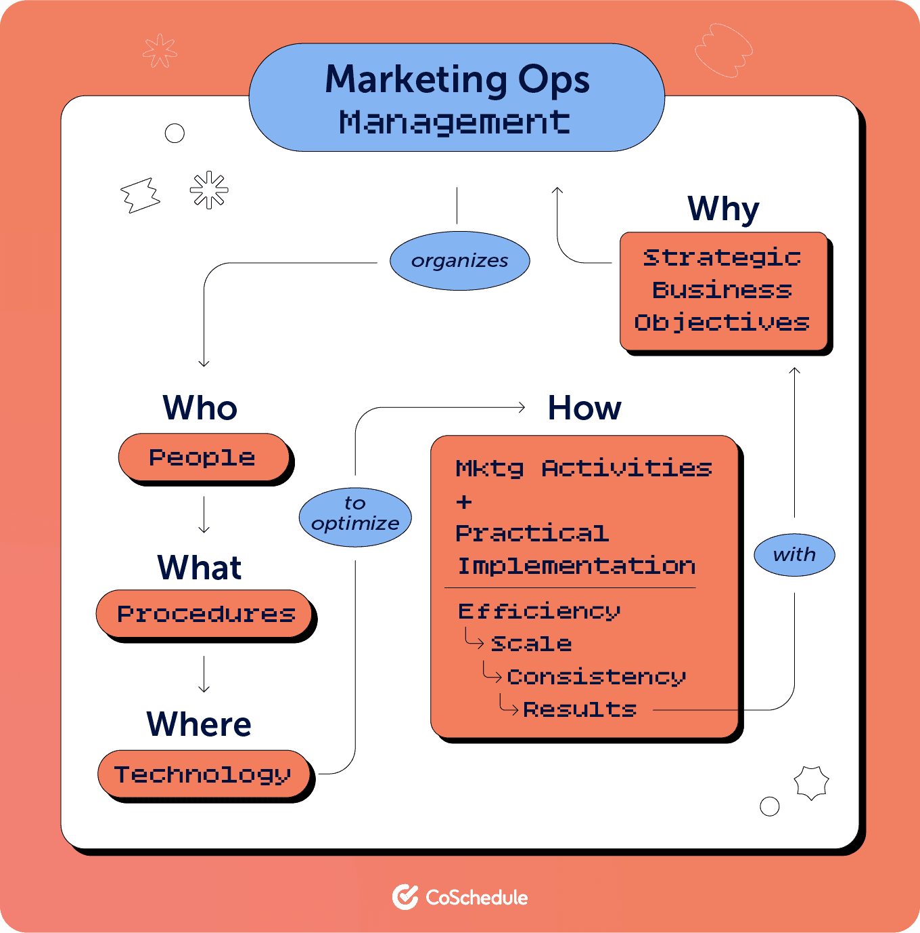

Fig. 2 - https://democracy.swansea.gov.uk/documents/s77185/Appendix%20E%20-%20Swansea%20Arena.pdf
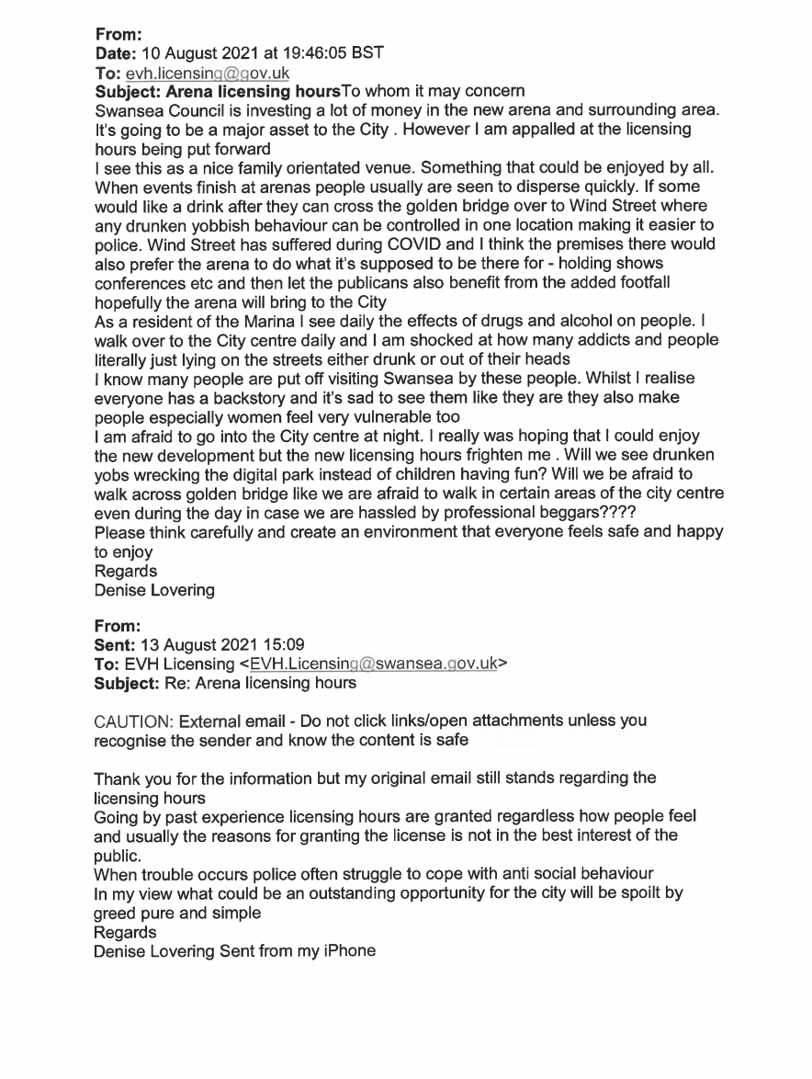

Fig. 3 - https://democracy.swansea.gov.uk/documents/s77185/Appendix%20E%20-%20Swansea%20Arena.pdf

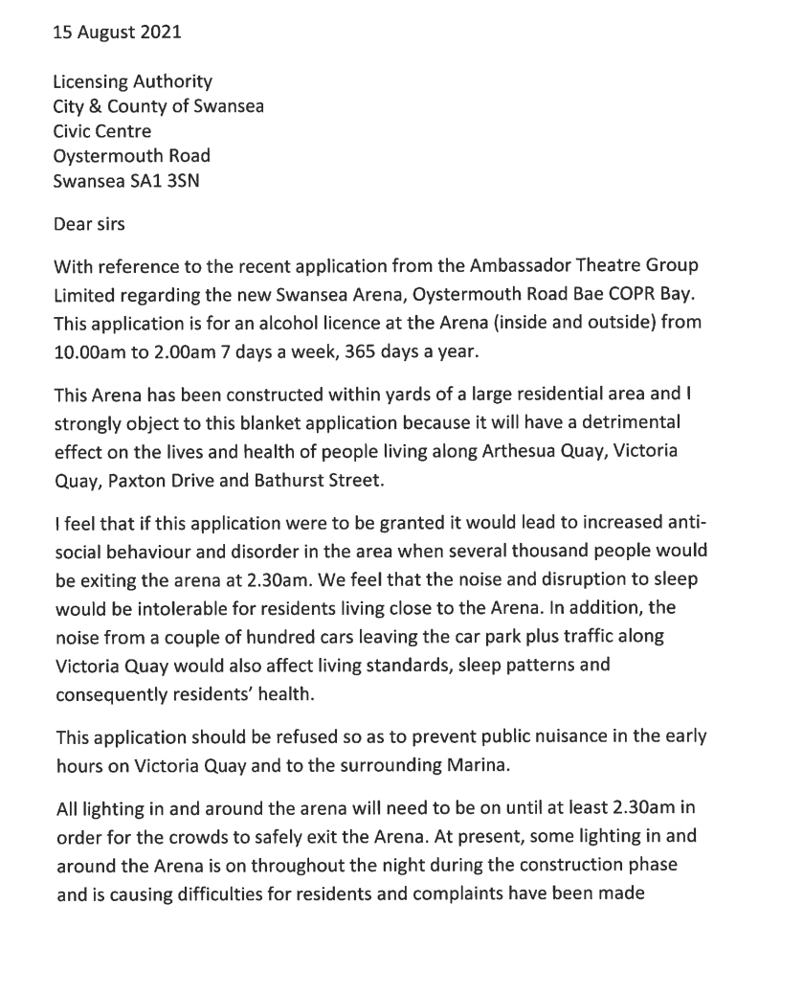
Fig. 4 - https://democracy.swansea.gov.uk/documents/s77185/Appendix%20E%20-%20Swansea%20Arena.pdf


