UNIVERSITY OF WALES
TRINITY
SAINT DAVID
Knowledge and Information Management Skills for the Workplace
Case Study: John Deer
Seyed Nasirpourosgoei

BMSW5106

Peolita Douglas- 1911615

Table of Content
Introduction………………………………………………………………………………….Page 3
Question 1……………………………………………………………………………………Page 5
Seed Optimization System…………………………………………………………………………………………Page 7
Weather Data System……………………………………………………………………………………….Page 8
Question 2……………………… …………………………………………… ……….Page 10
What is CRM………………………………………………………………………………..Page 10
Advantages of CRM through John Deere…………………………………………………Page 11
The Challenges of John Deere……………………………………………………………Page 12
Question 3………………………………………………………………………………….Page 13
Information Systems……………………………………………………………………..Page 13
Porters Five Forces………………………………………………………………………Page 14
Competitive Rivalry…………………………………………………………………………Page 15
Buyer Power………………………………………………………………………… …….Page 16
Threat of Substitution………………………………………………………………………Page 17
Supplier Power………………………………………………………………………………Page 18
Threat of Entry……………………………………………………………………………….Page 19
Question 4…………………………………………………………………………………….Page 20
Question 5……………………………………………………………………………………..Page 21
Conclusion……………………………………………… ……………………………….Page 22
Bibliography…………………………………………………………………………………Page 24
Appendices………………………………………………………………………………….Page 27

Introduction
In this report you will find information about the John Deere Agriculture company, demonstrating how they sort data information collated in their machinery.
I will use some analytic tools to show how business manage data information is processed in the John Deere company.
‘John Deere has launched several data-enabled services that let farmers benefit from real-time monitoring of data collected from users of John Deere equipment’. (Bernard Marr & Co, March 2021).

John Deere provides various services to dispute information on land preparation seeding, harvesting, and fertilising, to predicting the weather which is controlled in a central hub. John Deere has an online system that provides farmers access to data which is gathered from the sensors in the farming machinery combine harvest and tractors.
Information stored is solely to help companies progress and move with the time John Deere aims to be the best provides on this system.
Farmers can improve the amount of crop product, increase efficiency, reduce downtime, and reduce costs hence maximize their profit.

‘We rely on more than 180-years of experience and terabytes of precision data to know them and their businesses better than anyone else. Our easy-to-use technology helps deliver results they see in the field, on the job site, and on the balance sheet’. (John Deere, 2021)

One of the equipment is used to predict maintenance, means to predict when machinery needs maintenance, for example, updating the machine, the machine would give a warning sign that can detect an error, this can be fixed and looked at before the machine breaks down and prevent any serious damage. This would save the farmer time long term.

The numerous data collection services that John Deere provides for farmers consists of several big data enabled services. This service enables farmers to monitor and prepare the best crop production, through the data provided by John Deere.
The main achievement of John Deere is moving their software and equipment to adapt with precision agriculture, their collective data is about giving the best individual care to each farm product.

- Identify information systems implemented within John Deere Company and list a range of typical data collected to generate knowledge from the use of sensors in their machinery.
‘John Deere is an example of a company shifting from selling hardware and selling bigdata enabled services’. JohnDeere (2021).
John Deere has online portal My John Deere.com that enables farmers to access data. This is gathered from sensors from their machinery. This connects to external datasets, including weather and financial data. This data can be shared with engineers who will stand ready to supply new parts or service machinery.
‘Data, including agronomic (crop management) data and machine operation data (e.g., fuel level, location, machine hours, engine RPM) is collected primarily from sensors embedded both in the machines and in the field (soil), but also pulls from external sources (e.g., weather prediction data, commodity pricing). C. Williams, (2019).
This quote explains how John Deere is innovating their collected data through their machinery which can collect the various sources such as weather, timing, soil quality, moisture and nutrient levels which can assist farmers making the best decision for their annual outcome for their harvest products.
John Deere has Weather prediction data in the fields, but also data collected in their sensors in the machinery. John Deere has been able to provide crop management along with machine operation data. John Deere’s aim through their information system is about running farms through computer technology.

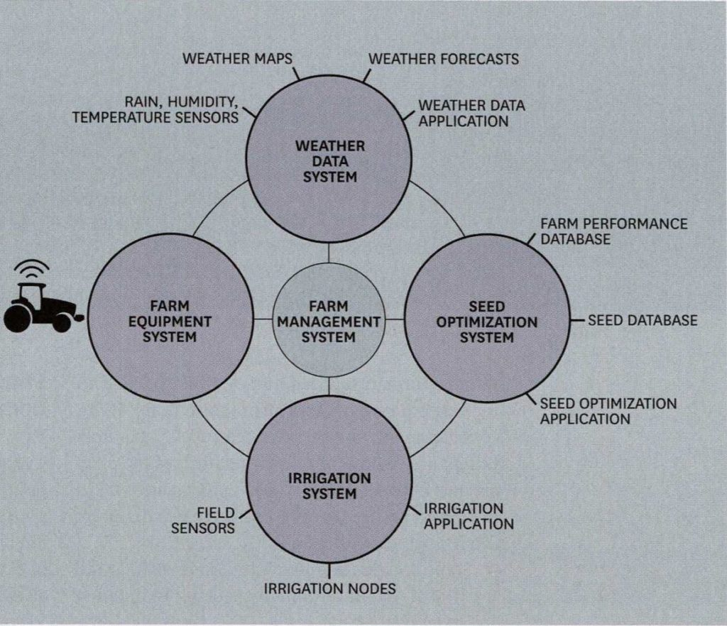
Farm to Data Table: John Deere and Data in Precision Agriculture - Digital Innovation and Transformation (hbs.edu) (Appendix 1)

Seed Optimization System
As shown above the data in the machinery can detect the performance, the sensors in the field, farm performance data and weather forecast this is an advantage to farmers because it helps the farmers dictate the right time, in the seasons to plant their crops.
Sometimes soil can be contaminated, some seasons the soil may not be suitable for a particular crop, this enables the farmers to make better decisions throughout the year when planting the right product.
John Deere provides Water monitoring system which can help them gage the right amount of water to water the soil, saving the drowning of the crops, this can prevent crop loss.

Weather Data System
Confidently apply crop protectants according to label requirements by knowing the current weather conditions including wind speed, wind direction, and humidity’. (John Deere, Mobile Weather, 2021).
John Deere has created a Mobile Weather system which can calculate the speed of the wind accuracy, this prevents farmers from sewing their seeds at the wrong time.
To the best result John Deere recommends not to use the Mobile Weather vehicles out in extremely high winds, which is anything above 32 km/h an hour.
Weather data is an advantage because if it is predicted there will be heavy showers, it would not be advisable to go and plant your crops, crops could wash away.
‘We’ve got a centrally-organized technology stack organization. We call it the intelligent solutions group, and its job is really to do exactly that. It’s to make sure that we’re developing technologies that can scale across the complete organization, across those combines you referenced, and the tractors and the sprayers, and the construction products, and deploy that technology as quickly as possible’. (The Verge, Patel)
This quote states John Deere has one central system that is collects all the information from all the combined harvesters and tractors for the farmers. With this information John Deere can generate the correct information for each farmer equipment and supply farmers with the correct measures to restore their equipment. This process is known as Enterprise system. (See Appendix 2)
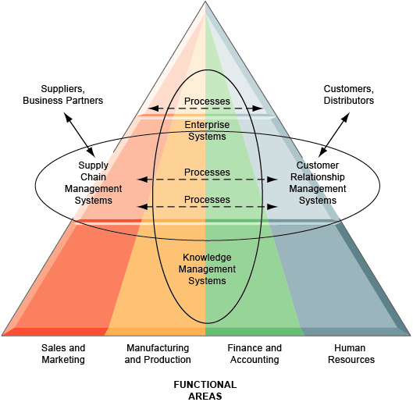
( Appendix 3 )

- Do you think that the use of Customer relationship management (CRM) systems would benefit the efficient operation of John Deere- explain both advantages and challenges of implementing a CRM system?

What is CRM?
A customer relationship management system is designed in companies to encourage retailers, businesses, to supply on demand the best quality products and services for their customers.
‘Customer- directed operations implies the external orientation of operations to meet customer requirements. (Hannagan, T, Management Concept and Practices)
The advantage of having CRM (Customer relationship Management) is when you are informing your customers of new products, promotions, if there is any upgrades or discounts provided for customers. This service encourages customers to be loyal and return to you for products.
Customer Relationship management is also about giving your customers what they need and when they need it. For example: John Deere provides an upgrade system ‘Rights to Repair’ which enables John Deere to give their customers parts for their combine harvesters and tractors to be fixed as quickly as possible.

Advantages of CRM through John Deere
John Deere works with a company called Anvil App, which enables John Deere to manage their customer relationships and business process. Anvil’s cloud software app helps customers build their CRM which helps each dealership company to communicate, also share their information across the countries that use John Deere’s system. (See Appendix 4).
By John Deere receiving information about their customers’ needs, reduces time and repairs and upgrades to be met on time.
John Deere streams the collected data to any technology device for farmers to access, whether a computer, tablet, mobile access. This procedure enables John Deere to give their customers the advantage of knowing when to repair, when to change and when to improve their product.
The advantages of John Deere’s software data system are that they give accuracy to their collected data. John Deere provides a speed in their internet system, also the programming provide can work on different data and information.
Another advantage of John Deere using CRM is the managers can use their experience to create new ideas regarding their internet information system. This would benefit John Deere rather than just making decisions from the calculated results of the machinery.
It is always an advantage for companies to be loyal and open to their customers regarding their products and services. Research has proven that John Deere provides the most up-to-date software and provides machinery mobile access quicker than any other agriculture company.
‘Deere & Company was the world’s largest farm machinery manufacturer in 2020. That same year, the Fortune Global 500 company employed almost 69,600 people in divisions around the world’. (Mazareanu, March 2021). This quote explains that John Deere is the biggest growing agriculture company in the world.

The Challenges of John Deere
A Challenge of John Deere’s information system is the security of the data collected, this is because their relying on information technology with the mechanical designs of their structure.
Beforehand farmers would have to rely on their own manual wit, for example the farmers could only decide based on their opinions or experiences during the seasons of producing crops every year. This information explains that John Deere would have to think about creating an online secure system that would ensure their clients information is stored safely.

Although John Deere is a multinational company this can be a challenge, because of weather systems there can be errors within amongst the poorer countries that may not have sophisticated i.t this can prevent their data from being accurate to help provide them with the best service.

‘Meeting the needs of a diverse, global customer base can be difficult. In the advanced economies of North America, South America, and Europe, farms tend to be very large and technologically sophisticated. In the emerging economies of Africa and Asia, most farms are much smaller, and farmers are generally poorer and with less access to technology’. (John Deere, December 2015).
Research shows that John Deere faces a challenge with the prevision of products due to there being more population of people in some countries. Furthermore, these countries may have less farmland, resources and i.t systems, to produce enough food in the third world countries.

- How could John Deere apply IS/IT to counter each of Porter’s five forces? Explain your answers with examples.

Information Systems
Information Systems is a method used for companies to develop obtaining information that’s necessary form subordinates. The company would decide on a solution to the problem with the information given. Information gained will be used to make overall decision.
John Deere has a software platform that services all their customers in their equipment
Where very they are in the world.
The services given to their customers is based on accurate data and can inform farmer of information needed to produce their crops.

Porter’s Five Forces

Porter’s Five Forces is a analytic tool that analyses competition of a business. This method measures the external forces such as the economics that can affect the company.
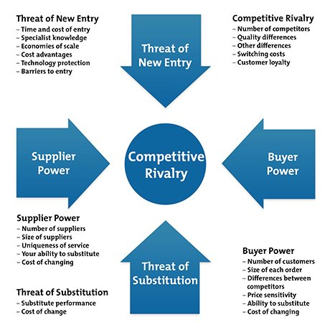
porters-five-forces-1-new.jpg (460×460) (mindtools.com)
(See Appendix 5)

Competitive Rivalry

Through the results of looking for competitors to John Deere, this suggests that Caterpillar, Kubtoa are the two strongest rivals behind John Deere (See Appendix 6).

‘Caterpillar is perceived as one of John Deere’s biggest rivals. Caterpillar Company was founded in 1925, and its headquarters are in Peoria, Illinois. Like John Deere, Caterpillar also works in the field of heavy machinery and vehicles. Caterpillar employs 28,300 more people than John Deere’.
This quote shows that Caterpillar revenue is gained from other products within their company. Although Caterpillar has a larger workforce than John Deere, John Deere is still rated as the better service due to their customer’s ratings. (See Appendix 7)

Due to this information John Deere would benefit from applying customer feedback to improve their customer relations to stay ahead of their competitors. Overall, from the graph shown the ratings higher for their agriculture systems. (See appendix 8). However, John Deere will benefit from keeping on top of their information technology services to please their customers, so they can provide the best products ahead of their competitors.

Buyer Power

Buyer Power is about how many buyers prefer your products compared to other companies you rival with. This is about the company thinking about if their buyers are strong enough to dictate terms to the company, the company have to think about how big their orders are from the customers.

‘Caterpillar is the world's largest manufacturer of construction and mining equipment and dabbles in agricultural equipment, while Deere is the one of the world's foremost producers of agricultural equipment as well as a leading manufacturer of construction, forestry, along with commercial and consumer equipment’. (Zacks, 2018)
This quote argues that John Deere is more leading in agriculture than Caterpillar, whereas Caterpillar lead more in construction equipment.

In the future, John Deere could maintain their craftsman in order to keep buyers happy due to the craftsman producing the customers what they want and keeping customer satisfactory. To keep the customers happy, the company of John Deere would have to retain in keeping their staff happy at work, while keeping a positive work environment.

Caterpillar's stock has rallied 25.6% in the past year, against the Industrial Products sector's 0.4% dip and S&P 500's 14.2% rise. Deere's 9.3% gain came in ahead of the Industrial Products sector's performance but lagged the S&P 500. Caterpillar is a clear winner here. (Zackz, 2021)

Caterpillar can produce similar equipment this is why their net rating is not far behind from John Deere for these products (see Appendix 9). However, John Deere has a higher rating, this suggests the quality of John Deere equipment is still popular to the customers because of the quality provided in their products.

Threat of Substitution

The threat of substitute products in comparison to John Deere, is low. Therefore, because there are very few competitors that produce the quality of equipment that John Deere supplies to their customers. There are no direct threats within the industry.
John Deere’s equipment is unique to the industry, so buyers do not switch easily due to the products being original and wanting to stay loyal to John Deere.
John Deere in the future would have to the keep up the pace with producing upgrade and forming new ideas for a unique quality of products for their customers.

Supplier Power

‘Our company has a robust strategic sourcing process. We maintain a short list of preferred suppliers for each of the categories of goods and services we purchase. We have long term contracts in place with our significant suppliers’ (JDSN.com, 2021)
John Deere has an organised structure where they stick to their regular suppliers, however John Deere leaves opportunity should other suppliers become available.

John Deere has a diverse group of suppliers and buys from different suppliers from all over the world, this is beneficial because it portrays how John Deere represents themselves worldwide, as multicultural company. This helps John Deere to be broader along with bringing in new ideas and innovations through the different diverse suppliers, therefore John Deere will put them in a better position to produce at a high standard.

Due to John Deere being diverse with their group of suppliers, for the future John Deere could use their information technology to communicate with different countries on different levels, because not all countries have the upgraded technology to have the resources they need from John Deere.

Threat of Entry

It is beneficial for John Deere to create barriers to prevent new competitors coming on board and taking business from the industry. Access to raw materials could be difficult to the new competitors, therefore John Deere would not suffer due to already establishing with the top companies that supply for John Deere and its customers.
John Deere has top consultants working on behalf of John Deere to ensure that as a company they stay ahead of the new inventions and ideas to enable them to improve on their products and the agriculture of their technology system.
John Deere should continue to invest in their top consultants, to enable them to always upgrade new products, keeping their customer service up to date along with keeping costs down.

Creating new products for customers can also give an opportunity to get new customers, which can build a wider marketing audience. By John Deere creating more customers for similar products, the unit can reduce their cost of inventions, this can prevent threats of customers losing interest, also enabling workers to produce more with satisfactory in the working environment.

- Do you think that Big data analytics and the Internet of Things (loT) can help to manage knowledge at John Deer company? Explain both pros and cons of the use of such technologies.

John Deere stores all their information from all over the world, for customers through Anvil App, this is beneficial because the use of data collection provides the customers and John Deere with all the information, they need to help the customers. Furthermore, John Deere’s Big Data platform software online is known as “MyJohnDeere”, both Anvil App and My JohnDeere is a highlight to the standard of how John Deere connects everything online from their resources, machinery, collected data and standalone management.

The positive outcome is customers and John Deere can access the information easily from any part of the world, the negative outcome is that system cans fail.

‘Big Data can create value in the Agricultural industry including, “increasing the resilience of production systems; improving understanding of genotype by environmental interactions; and enhancing human and animal health’ (Perlman, 2017).

It is beneficial for John Deere to use their service because the amount of information gathered through their technology system, saves the company from relying on administration and manpower.

John Deere as a company already have a high status for managing large amounts of information, the pros with John Deere is the fact they always keep a large team of information technology (Agriculture) along with business relations to make sure they keep up to date with the data and technology used on a regular basis.

John Deere as a company majors on the next move, in terms of technology, as a company they care about being successful both in their machinery and data system. (See appendix 2)

- Offer recommendations on how the company John Deer strengthened their knowledge management practices, considering their current challenges amid the Covid-19 pandemic.

John Deere faced challenges due to health risk of their employees, supply chain issues and government mandated shutdown.

‘As a supplier to farmers and other food producers, Deere will keep its operations running to the extent possible. Its statement said that some facilities are scaling back operations, and others are temporarily halting production due to the pandemic effects. It did not specify which operations are temporarily idled’. (Smith, 2020)
From research found John Deere do not have a clear insight to where cutbacks can be made, however John Deere where it depends on how long the restrictions globally will last.

It is recommended on a whole due to the pandemic, John Deere could analyse making payment plans for companies in certain parts of the world, that cannot afford extra cost with supplying data and machinery for their business.
Due to covid-19 affecting farms, way of living, home isolation, John Deere should consider reviewing local businesses overheads offering ways to reduce the cost of their service.

Although John Deere faced challenges their strategy is to make reductions like all over companies when the pandemic has come down to a reasonable end. John Deere can resume their business strategies ensuring to give their customers the best quality as previously gained.

Conclusion

In conclusion to all information about John Deere, it is evident that John Deere is a well-established company which values both customers and workforce within the farmers, the food production with their machinery, equipment and data collected.
John Deere as a company has managed the crisis well regarding the pandemic, they are committed to returning to doing business again with their customers, to the same high standard.
It is quoted John Deere are looking into adapting their technology to enable their data is always improved through information technology rather than human intuition and human errors. Given we are in a society where business and technology are moving quickly, this is a good idea because John Deere have the capability of running their company in this way, due to having UpToDate services.

Bibliography

Books
80/20 Management Works Smarter, not harder, and quadruple your results 2001 – Chapter 3- Problem Solving- Page 37
Management Concepts & Practices – Section D- Second Edition 1998- Page 435

Journals
Farm to Data Table: John Deere and Data in Precision Agriculture - Digital Innovation and Transformation (hbs.edu) By C. Williams, November 12th, 2019 (Accessed 6th July 2021)

Podcasts
Patel, Nilay, 15 CTO Jahmy Hindman on farming, data, and right to repair, June, 2021 (Podcast)
(Accessed 12th July 2021)

Websites
Caterpillar (CAT) or Deere (DE): Which Is the Better Stock? | Nasdaq , July 2018
(Accessed) 13th July 2021

Cloud Based Software | John Deere | Dealership Platform (anvilappworks.com) Anvil App About Us
(Accessed 12th July 2021)

Supplier Opportunities | John Deere UK & Ireland
(Accessed 20th July 2021)
Our Supplier Network | John Deere US
(Accessed 20th July 2021)

https://digital.hbs.edu/platform-digit/submission/farm-to-data-table-john-deere-and-data-in-precision-agriculture/
(Accessed 21st June 2021)

https://www.deere.co.uk/en/index.html
(Accessed 21st June 2021)

https://www.deere.com/en/technology-products/precision-ag-technology/
(Accessed 21st June 2021)

https://www.theverge.com/22533735/john-deere-cto-hindman-decoder-interview-right-to-repair-tractors
(Accessed 21st June 2021)

https://digital.hbs.edu/platform-digit/submission/farm-to-data-table-john-deere-and-data-in-precision-agriculture/
(Accessed 21st June 2021)

Farm Forward with John Deere

114,123 views
https://www.youtube.com/watch?v=nKAz-g7MAxs&t=82s
(Accessed 21st June 2021)

Field and Water Management | Mobile Weather | John Deere US
(Accessed 6th July 2021)

https://www.deere.co.uk/en/our-company/news-and-media
News, Media and Announcements | John Deere UK & IE
(Accessed 12th July 2021)

John Deere: Big Data and farming (bernardmarr.com) ,Bernard & Co, March 2021
(Accessed 12th July 2021)

https://www.theverge.com/22533735/john-deere-cto-hindman-decoder-interview-right-t0-repair-tractors

John Deere turned tractors into computers — what’s next? - The Verge
(Accessed 12th July 2021)

6 Tips for Health Customer Relationships | John Deere
(Accessed 12th July 2021)
12 Key Benefits CRM Systems Provide to a Business (hubspot.com)
(Accessed 12th July 2021)
John Deere - statistics & facts | Statista (E. Mazareanu, March 2021)
(Accessed 12th July 2021)

The challenge of feeding the world | The John Deere Journal, December 2015
(Accessed 12th July 2021)

Cloud Based Software | John Deere | Dealership Platform (anvilappworks.com)

https://anvilappworks.com
(Accessed 13th July 2021)

Port of Five Forces porters-five-forces-1-new.jpg (460×460) (mindtools.com)
(Accessed 13th July 2021)

John Deere’s Competitors, Revenue, Number of Employees, Funding, Acquisitions & News - Owler Company Profile
(Accessed 13th July 2021)

Top 3 John Deere Competitors, Alternatives & similar companies In 2021 - What Competitors (Accessed 13th July 2021)

John Deere Intelligent Solutions Group | Center For Digital Strategies (dartmouth.edu) Tech@Tuck, May 2017
(Accessed 13th July 2021)

Prospective Suppliers (deere.com)

(Accessed 20th July 2021)

Word count: 3367

Appendices

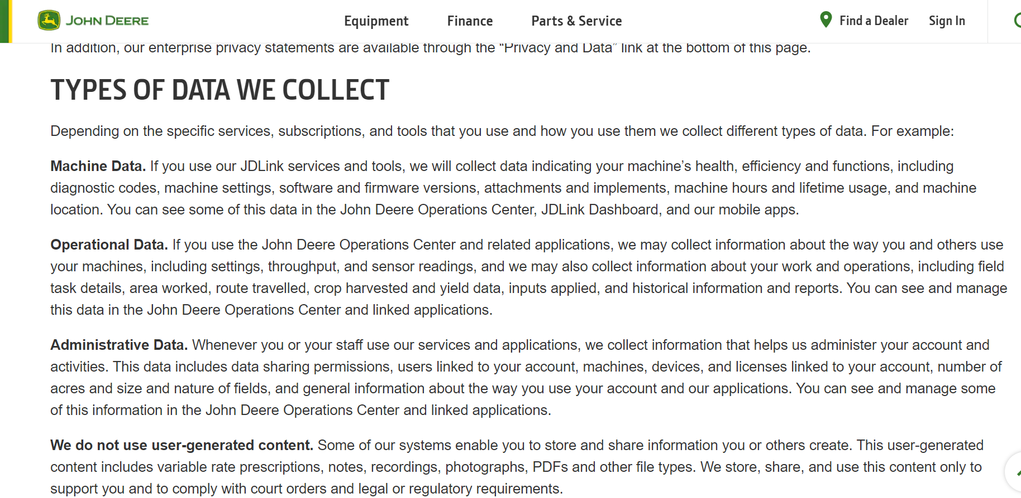
Appendix 1

Data Services | John Deere S

Appendix 2



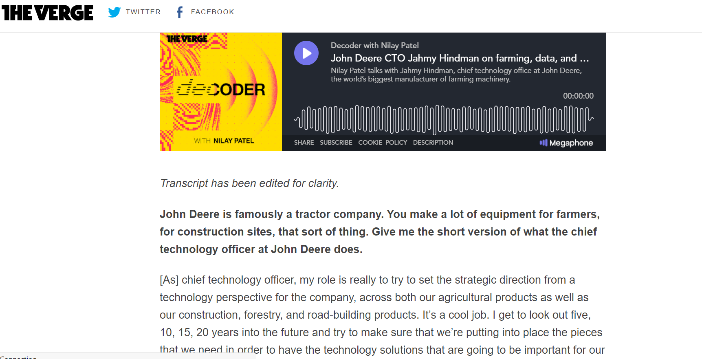
John Deere turned tractors into computers — what’s next? - The Verge
One of the reasons I am very excited to have you on Decoder is there are a lot of computer solutions in your products. There’s hardware, software, services that I think of as sort of traditional computer company problems. Do you also oversee the portfolio of technologies that [also] make combines more efficient and tractor wheels move faster?
We’ve got a centrally-organized technology stack organization. We call it the intelligent solutions group, and its job is really to do exactly that. It’s to make sure that we’re developing technologies that can scale across the complete organization, across those combines you referenced, and the tractors and the sprayers, and the construction products, and deploy that technology as quickly as possible.

Is that how you see a tractor or a combine or construction equipment — that these are gigantic computers that have big mechanical functions as well?
They absolutely are. That’s what they’ve become over time. I would call them mobile sensor suites that have computational capability, not only on-board, but to your point, off-board as well. They are continuously streaming data from whatever it is — let’s say the tractor and the planter — to the cloud. We’re doing computational work on that data in the cloud, and then serving that information, those insights, up to farmers, either on their desktop computer or on a mobile handheld device or something like that.
As much as they are doing productive work in the field, planting as an example, they are also data acquisition and computational devices.
How much of that is in-house at John Deere? How big is the team that is building your mobile apps? Is that something you outsource? Is that something you develop internally? How have you structured the company to enable this kind of work?
We do a significant amount of that work internally. It might surprise you, we have more software development engineers today within Deere than we have mechanical design engineers. That’s kind of mind-blowing for a company that’s 184 years old and has been steeped in mechanical product development, but that’s the case. We do nearly all of our own internal app development inside the four walls of Deere.
That said, our data application for customers in the ag space, for example, is the Operations Center. We do utilize third parties. There’s roughly 184 companies that have been connected to Operations Center through encrypted APIs, that are writing applications against that data for the benefit of the customers, the farmers that want to use those applications within their business.

Appendix 3

Appendix 4

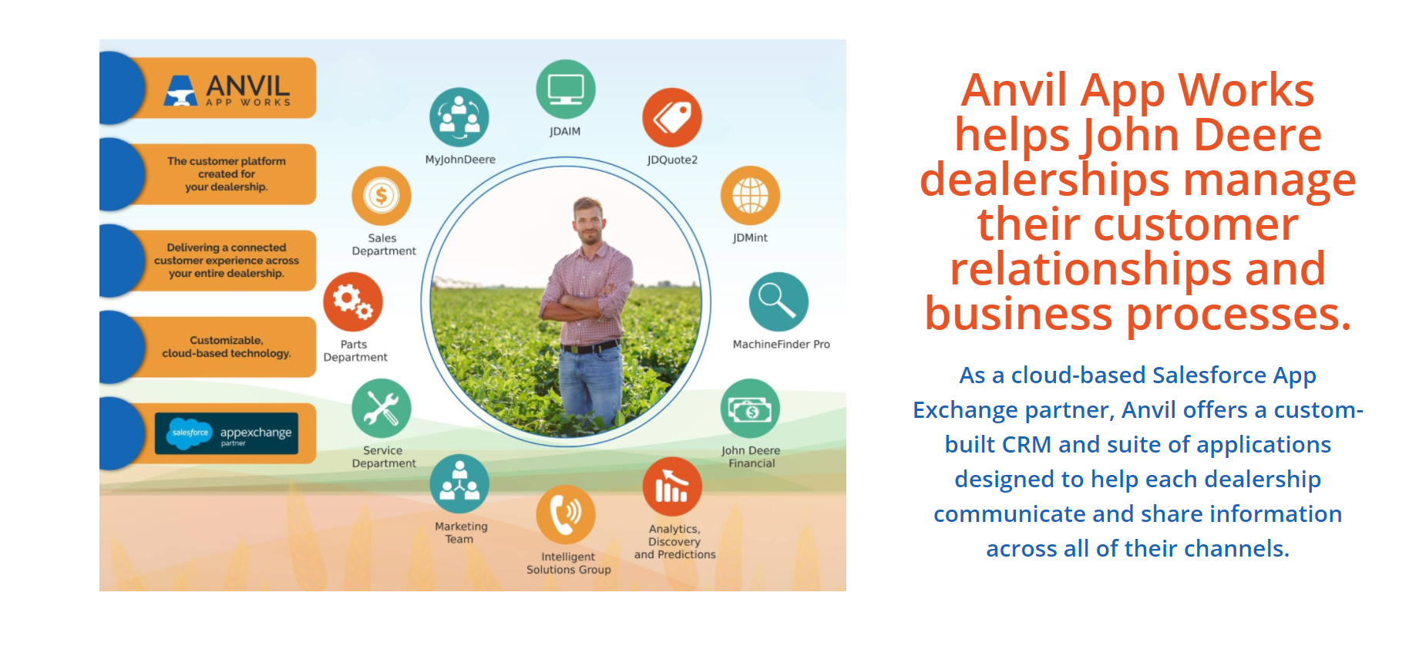
Cloud Based Software | John Deere | Dealership Platform (anvilappworks.com)
Appendix 5
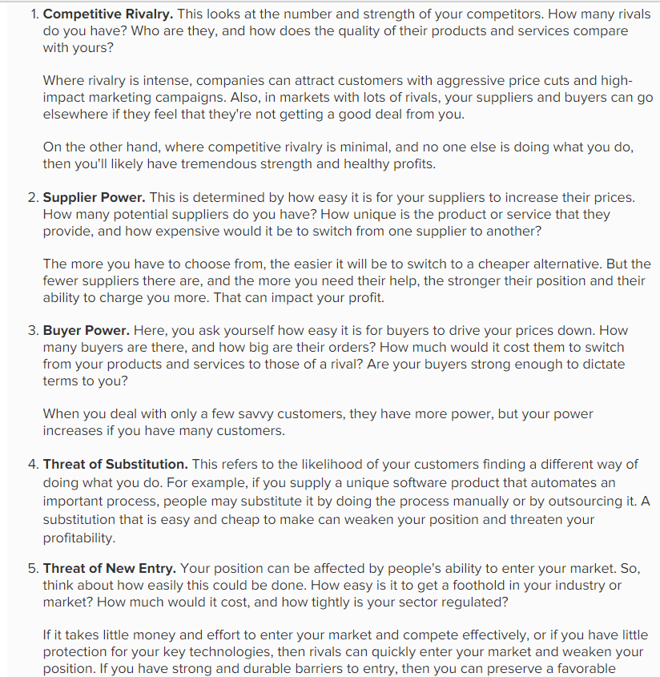

Appendix 6
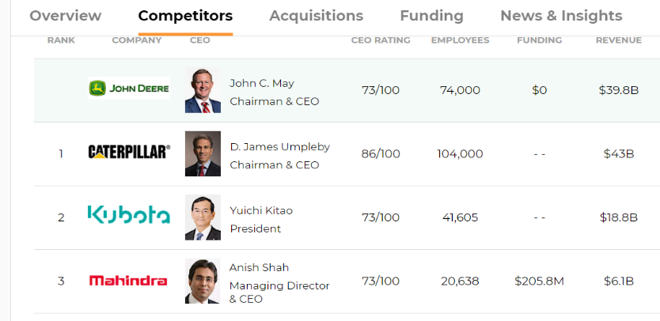

Appendix 7
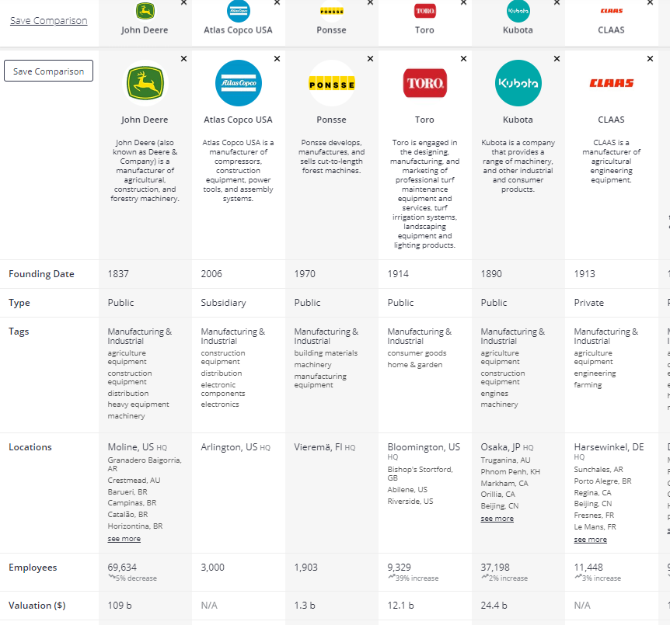
Top John Deere Competitors and Alternatives | Craft.co

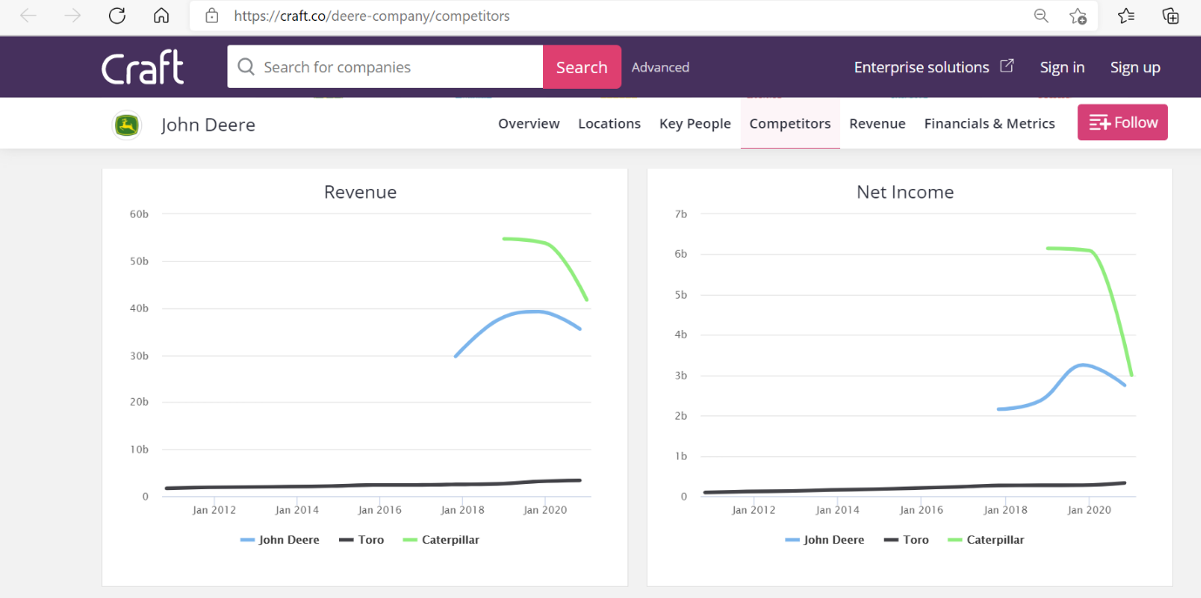
Appendix 8

Appendix 9


