
Design Thinking and Innovation
Design Thinking and Innovation through Digital Transformation BA Leadership and Management Skills in the Workplace
Sylene Angela Cedeno Pincay (2330431) | Lecture Name: Sayed Nasirpourosgoei | Module code: LCLM 6002

Contents
Design Thinking and Innovation through Digital Transformation 2
1. Introduction 2
2. Design Thinking as an Innovation Framework 3
3. Identifying Key Opportunity Areas for Innovation in the UK Market 5
3.1 E-commerce Platforms for Small and Independent Businesses 6
3.2 Digital Marketing Services 6
3.3 Integrated Digital Payment Systems 7
3.4 Retail Management Software 8
3.5 Supply Chain and Last-Mile Delivery Solutions 8
4. Applying Design Thinking to Develop a New Digital Venture 10
4.1 Introducing the New Venture Concept 10
4.2 Empathise 11
4.3 Define 12
4.4 Ideate 13
4.5 Prototype 14
4.6 Test 15
4.7 Evaluating Desirability, Feasibility and Viability 16
5. Conclusion 17
6. References 19

Design Thinking and Innovation through Digital Transformation

Introduction
Digital transformation has fundamentally changed how organisations create value, compete, and engage with customers. The COVID-19 pandemic accelerated this transformation across the United Kingdom, particularly among small and medium-sized enterprises (SMEs), forcing many businesses to adopt digital technologies to survive in an increasingly competitive environment. Traditional businesses that relied on physical interactions rapidly embraced e-commerce platforms, digital payment systems, cloud-based collaboration, online booking services and social media marketing to maintain customer relationships and business continuity. Consequently, digital innovation has become a strategic necessity rather than a competitive advantage (OECD, 2023).
Innovation within this environment requires more than simply adopting new technologies. Organisations must understand changing customer needs, identify emerging market opportunities and develop solutions that are desirable for users, technically feasible and commercially viable. Design Thinking has therefore gained significant attention as a human-centred innovation methodology that enables organisations to solve complex problems through empathy, creativity, experimentation and continuous improvement (Brown, 2008). Unlike traditional linear problem-solving approaches, Design Thinking encourages iterative learning and collaboration throughout the innovation process, allowing businesses to reduce uncertainty while developing customer-focused solutions (Liedtka, 2018).
This report critically examines the opportunities created by digital transformation within the UK market using Design Thinking perspective. The first section identifies the most promising innovation opportunities by evaluating customer pain points, market gaps, technological enablers and long-term scalability. The second section adopts the perspective of a UK entrepreneur to apply the five stages of Design Thinking-Empathise, Define, Ideate, Prototype and Test-to develop an innovative digital venture addressing challenges experienced by independent retailers and rural consumers. Throughout the report, academic theories, contemporary literature and real-world examples are critically evaluated to demonstrate how Design Thinking supports sustainable innovation and entrepreneurial success within an increasingly digital economy.

Design Thinking as an Innovation Framework
Design Thinking has become one of the most influential innovation methodologies for organisations operating in rapidly changing and uncertain environments. Rather than beginning with technology or organisational capabilities, Design Thinking starts by understanding users’ needs and experiences before developing innovative solutions. Brown (2008) defines Design Thinking as a human-centred approach to innovation that integrates customer desirability, technological feasibility and business viability. These three dimensions form the foundation of successful innovation because a solution that satisfies only one or two of these criteria is unlikely to achieve long-term commercial success. Consequently, Design Thinking has been widely adopted by organisations seeking to improve customer experiences, develop new products and respond effectively to digital transformation (Liedtka, 2018).
Unlike traditional management approaches, which frequently rely on analytical planning, forecasting and linear decision-making. Design Thinking embraces uncertainty and experimentation. Conventional problem-solving often assumes that problems are clearly defined and can be solved through logical analysis and existing organisational knowledge. However, many contemporary business challenges are characterised as “wicked problems” where customer needs continually evolve, and no single correct solution exists (Buchanan, 1992). Digital transformation presents precisely this type of challenge because technological developments, consumer behaviour and competitive pressures continuously change. Design Thinking addresses these complexities through iterative learning, allowing organisations to refine solutions based on continuous customer feedback rather relying solely on initial assumptions.
The Design Thinking process is commonly represented through five interconnected stages: Empathise, Define, Ideate, Prototype and Test (Dam and Siang, 2024).
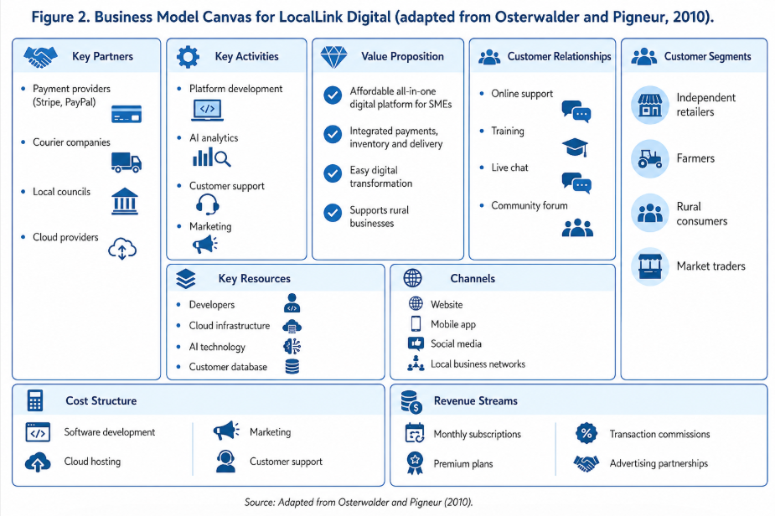
During the empathy stage, organisations seek to understand customers’ behaviours, motivations and frustrations using interviews, observation and engagement. The define stage converts these insights into a clearly articulated problem statement that focuses innovation efforts. The ideation stage encourages creative thinking and the generation of multiple possible solutions before selecting the most promising concepts. Prototyping transforms ideas into low-cost experimental models that allow rapid learning, while testing gathers user feedback to improve the solution through repeated iterations. Importantly, these stages are not strictly sequential; organisations often revisit earlier stages as new customer insights emerge, marking the process highly adaptive to uncertain environments (IDEO, 2015).
Although Design Thinking has become increasingly popular, it differs significantly from other innovation and strategic management approaches. Traditional strategic planning generally adopts a top-down perspective in which managers analyse market conditions, establish objectives and implement predetermined strategies.
This approach is valuable when operating in relatively stable environments but may limit organisational responsiveness when customer expectations change rapidly (Mintzberg, Ahlstrand and Lampel, 2009). In contrast, Design Thinking adopts a bottom-up perspective by involving users throughout the innovation process, enabling organisations to identify opportunities that may not emerge through conventional market analysis alone.
Similarly, Lean Startup methodology shares Design Thinking’s emphasis on experimentation but differs in its primary focus. Lean Startup concentrates on rapidly validating business assumptions through the Build-Measure-Learn cycle to minimise commercial risk (Ries, 2011). While this approach is particularly valuable for entrepreneurial ventures, it often begins after a product concept has already been identified. Design Thinking places greater emphasis on discovering the right problem before developing solutions, ensuring that innovation addresses genuine customer needs rather than merely improving existing products. Consequently, many successful organisations combine both methodologies, using Design Thinking to identify opportunities and Lean Startup principles to validate business models efficiently.
The UK Design Council’s Double Diamond Framework provides another complementary perspective on innovation. The framework divides innovation into four phases: Discover, Define, Develop and Deliver, encouraging organisations to alternate between divergent thinking, where multiple ideas are explored, and convergent thinking, where the most appropriate solutions are selected (Design Council, 2019). Compared with the five-stage Design Thinking process, the Double Diamond places stronger emphasis on structured exploration and decision-making while maintaining a similar user-centred philosophy. This demonstrates that Design Thinking should not be viewed as a single rigid methodology but rather as a family of human-created approaches that share common principles of empathy, collaboration and iterative learning.
Despite its advantages, Design Thinking is not without limitations. Critics argue the methodology can become overly focused on incremental customer improvements while neglecting broader organisational capabilities, financial constraints and implementation challenges (Verganti, 2009). Furthermore, excessive reliance on customer feedback may discourage radical innovation because users are often unable to artivulate future needs or imagine disruptive technologies before they exist. Therefore, successful organisations integrate Design Thinking with strategic analysis, market research and technological forecasting to ensure that innovative ideas remain commercially sustainable and strategically aligned.
Overall, Design Thinking provides a comprehensive framework for addressing complex business challenges arising from digital transformation. Its emphasis on empathy, collaboration and iterative experimentation enables organisations to develop innovative solutions that are not only technologically feasible but also desirable for customers and commercially viable. As digital technologies continue to reshape the UK business environment, Design Thinking offers organisations a valuable capability for achieving sustainable innovation and long-term competitive advantage.

Identifying Key Opportunity Areas for Innovation in the UK Market
The rapid digital transformation of the UK economy has fundamentally changed consumer expectations, business operations and competitive dynamics. While the COVID-19 pandemic acted as a catalyst for this transformation, many behavioural changes have become permanent, creating significant opportunities for innovation and entrepreneurial activity (OECD, 2023). From a Design Thinking perspective, these opportunities emerge through understanding users’ unmet needs rather than simply responding to technological change. Organisations that successfully empathise with customers, identify pain points and design solutions around real problems are more likely to achieve sustainable competitive advantage (Brown, 2008). Based on the assignment scenario, five key opportunity areas demonstrate particularly strong potential for innovation within the UK market.

3.1 E-commerce Platforms for Small and Independent Businesses
The continued growth of e-commerce represents one of the most significant opportunities for innovation. Although many large organisations have invested heavily in digital commerce, thousands of independent retailers and rural businesses still struggle to establish an effective online presence. Many SMEs face financial constraints, limited digital skills and insufficient technological expertise to develop sophisticated e-commerce systems (Department for Business and Trade, 2024). As a result, these businesses risk losing customers to larger competitors with greater digital capabilities.
From a Design Thinking perspective, the primary user pain point is not simply the absence of online technology but the complexity and cost associated with digital adoption. Business owners frequently require affordable, user-friendly platforms that allow them to manage products, payments, deliveries and customer communication without specialist technical knowledge. Understanding these needs enables entrepreneurs to design solutions that prioritise usability rather than technological sophistication alone.
Technological development, such as cloud computing, artificial intelligence (AI), software-as-a-service (SaaS) and low-code development platforms, significantly reduces barriers to innovation. These technologies enable entrepreneurs to develop scalable subscription-based services that can be continuously improved through customer feedback. Furthermore, digital platforms offer strong sustainability benefits by reducing paper-based administration, improving inventory management and enabling local businesses to reach wider markets without substantial physical expansion. Consequently, e-commerce remains one of the most commercially attractive areas for new venture creation within the UK economy.

3.2 Digital Marketing Services
Digital marketing has become essential for business growth because consumers increasingly discover products and services through online channels. Social media platforms, search engines and digital advertising allow organisations to engage customers more effectively than traditional promotional methods. However, many SMEs continue to lack the knowledge, resources and time necessary to implement effective digital marketing strategies (Office for National Statistics, 2024).
Using Design Thinking, entrepreneurs should first empathise with small business owners who often experience frustration when attempting to compete with larger organisations possessing greater marketing budgets. Their challenge extends beyond advertising costs to include content creation, campaign management, search engine optimisation (SEO) and performance analysis.
This market gap creates opportunities for innovative digital marketing platforms that automate content generation, analyse customer behaviour and provide affordable marketing support. AI-powered tools can now assist businesses with operational social media content scheduling campaigns and analysing customer engagement. Nevertheless, technological automation should complement rather than replace human creativity, as authentic customer relationships remain central to effective marketing strategies.
From a scalability perspective, digital marketing services require relatively low infrastructure investment while serving businesses across multiple sectors. Subscription-based pricing models also generate recurring revenue, improving long-term commercial sustainability.

3.3 Integrated Digital Payment Systems
Consumer expectations regarding convenience and security have transformed payment behaviour across the United Kingdom. Contactless payments, mobile wallets and QR code transactions have become standard practice for many customers. Nevertheless, numerous independent retailers continue using fragmented payment solutions that increase administrative complexity and transaction costs (UK Finance, 2024).
The principal customer pain point involves managing multiple payment systems while maintaining accurate financial records and providing convenient purchasing experiences. Through empathy research, entrepreneurs may identify the need for integrated solutions combining payments processing, accounting software, customer loyalty programmes and sales reporting within a single platform.
Cloud technology, Application Programming Interfaces (APIs) and fintech innovation provide important technological enablers for developing these integrated services. Furthermore, secure digital payment systems improve operational efficiency by reducing cash handling, enhancing financial transparency and supporting remote purchasing. As consumer demand for frictionless transactions continues to increase, integrated payment technologies represent a highly scalable innovation opportunity.
However, entrepreneurs must also recognise challenges relating to cybersecurity, regulatory compliance and customer trust. Successful innovation therefore requires balancing technological advancement with robust security and data protection measures.

3.4 Retail Management Software
Digital transformation has highlighted the importance of efficient inventory management, customer relationship management (CRM) and operational decision-making. Many SME continue to rely upon manual processes or disconnected software systems that reduce productivity and increase operational costs ( McKinsey & Company, 2023).
Design Thinking encourages organisations to observe how retailers manage daily operations before proposing technological solutions. Rather than developing software with excessive functionality, entrepreneurs should focus on simplifying routing activities that consume significant managerial time. Interviews and workplace observations frequently reveal common frustrations relating to stock management, supplier coordination, sales forecasting and employee scheduling.
Artificial intelligence, predictive analytics and cloud computing enable modern retail software to automate many of these tasks while generating valuable business insights. These capabilities improve decision-making, reduce waste and enhance customer satisfaction through improved product availability. Moreover, scalable cloud-based platforms allow SMEs to adopt advanced technologies without significant capital investment, increasing accessibility for smaller organisations.
Despite these advantages, software developers must ensure systems remain intuitive and affordable. Excessively complex digital solutions risk discouraging adoption among businesses with limited technical capabilities, highlighting the importance of use-centred design throughout software development.

3.5 Supply Chain and Last-Mile Delivery Solutions
The expansion of online commerce has placed unprecedented pressure on supply chains and last-mile delivery networks. Consumers increasingly expect rapid, flexible and reliable delivery services regardless of geographical location. Rural communities often experience longer delivery times, fewer collection points and higher transportation cost, creating significant inequalities in service provision (World Economic Forum, 2023).
Applying Design Thinking begins by understanding the experiences of multiple stakeholders, including customers, delivery drivers, retailers and logistics providers. Their needs frequently extend beyond faster deliveries to include greater flexibility, improved communication, sustainability and cost efficiency.
Technological innovations such as route optimisation software, AI-driven logistics planning, Internet of Things (IoT) tracking devices and electric delivery vehicles create significant opportunities for entrepreneurial innovation. In addition, collaborative delivery networks enabling independent retailers to share transportation resources may reduce environmental impacts while improving service quality.
From a sustainability perspective, optimised delivery routes reduce fuel consumption and carbon emissions, supporting the UK’s broader environmental objectives. Consequently, supply chain innovation satisfies both commercial and societal goals, making it particularly attractive for long-term entrepreneurial investment.
To summarise the findings from the market analysis, Table 1 compares the five opportunity areas according to user pain points, market gaps, technological enablers, scalability and sustainability potential.
Table 1: Comparative Analysis of UK Digital Innovation Opportunities
Opportunity | User Pain Point | Market Gap | Technology | Scalability | Sustainability
E-commerce | SMEs lack affordable online platforms | Easy-to-use solutions | Cloud & SaaS | High | High
Digital Marketing | Lack of digital skills | AI automation | Artificial Intelligence | High | Medium-High
Digital Payments | Multiple payments systems | Integrated platforms | FinTech | High | High
Retail Software | Manual inventory management | Affordable all-in-one software | AI & Cloud | High | High
Supply Chain | Slow rural deliveries | Local logistics | AI & IoT | Medium-High | High
Source: Author’s analysis based on Brown (2008), OECD (2023), Department for Business and Trade (2024), Office for National Statistics (2024) and UK Finance (2024).
Critical Evaluation of the Opportunity Areas
Although each opportunity demonstrates strong commercial potential, their long-term success depends upon balancing desirability, feasibility and viability, which are central principles of Design Thinking (Brown, 2008). Customer demand alone does not guarantee success if technologies are difficult to implement or business models fail to generate sustainable revenue. Likewise, technically advanced products may fail if they do not address genuine customer problems.
Among the opportunities analysed, integrated digital platforms supporting independent retailers appear particularly attractive because they combine several market needs within a single solution. By integrating online selling, digital payments, inventory management and local delivery coordination, entrepreneurs can create greater customer value while generating recurring subscription revenue. Such platforms also support digital inclusion by enabling smaller businesses to compete more effectively with larger retailers.
Overall, the UK digital economy continues to present substantial opportunities for innovation. However, sustainable competitive advantage will increasingly depend on organisations adopting a Design Thinking mindset that prioritises continuous customer engagement, iterative learning and evidence-based innovation rather than technology-led decision-making alone.

Applying Design Thinking to Develop a New Digital Venture

4.1 Introducing the New Venture Concept
Based on the opportunities identified in Task 1, this report proposes a new venture called LocalLink Digital, a cloud-based digital platform designed to support independent retailers, rural producers and local delivery partners across the United Kingdom. The platform integrates e-commerce, digital payments, inventory management and local delivery coordination within a single affordable system specifically designed for SMEs.
The business idea directly addresses the challenges highlighted in the assignment scenario, where many independent businesses rapidly adopted digital technologies during the pandemic but continue to experience difficulties managing multiple disconnected systems. Unlike larger organisations with significant financial resources, SMWs often lack the expertise and budget required to implement sophisticated digital infrastructure (Department for Business and Trade, 2024). Consequently, LocalLink Digital aims to simplify digital transformation while improving competitiveness and customer experience.
The venture applies the five stages of Design Thinking to ensure the proposed solution is desirable, feasible and commercially viable (Brown, 2008).

4.2 Empathise
The first stage of Design Thinking seeks to understand users’ experiences before developing solutions. Rather than making assumptions, entrepreneurs collect information through interviews, observations, surveys and customer journey mapping (IDEO, 2015).
For LocalLink Digital, four principal stakeholder groups have been identified.
Independent retailers often struggle to manage online orders, inventory, deliveries and digital payments using separate systems. Many owners have limited technical knowledge and spend considerable time completing administrative tasks instead of focusing on business growth.
Rural consumers, including farmers and market traders, increasingly use social media to advertise products. However, they often rely on manual ordering through Facebook Messenger or WhatsApp, creating inefficiencies and increasing the risk of errors.
Delivery partners require efficient route planning, real-time communication and improved coordination between retailers and customers to reduce unnecessary travel and delivery delays.
Empathy mapping demonstrates that despite having different responsibilities, all stakeholder groups share similar frustrations relating to fragmented digital systems, unnecessary complexity and inefficient communication. These findings reinforce the importance of designing a simple, integrated platform centred on user needs rather than technological complexity.
Empathy mapping demonstrates that despite having different responsibilities, all stakeholder groups share similar frustrations relating to fragmented digital systems, unnecessary complexity and inefficient communication.
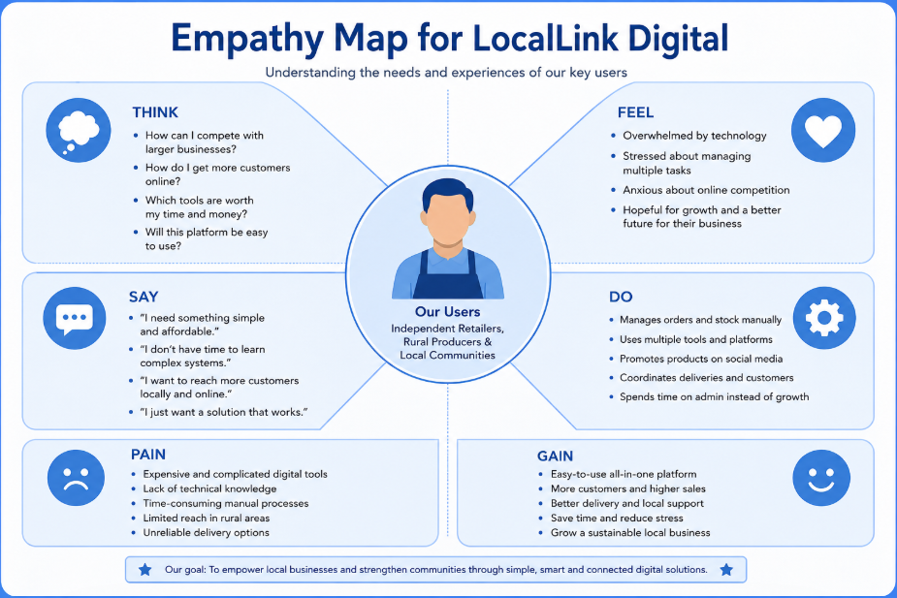Source: Adapted from IDEO (2015).
These findings reinforce the importance of designing a simple, integrated platform centred on user needs rather than technological complexity.

4.3 Define
Following the empathy stage, Design Thinking requires the information gathered to be synthesised into a clearly defined problem statement that guides innovation (Liedtka, 2018).
The central problem identified is:
Independent retailers and local producers across the United Kingdom struggle to compete in an increasingly digital marketplace because affordable digital tools remain fragmented, difficult to manage and poorly integrated, reducing operational efficiency and limiting business growth.
This problem extends beyond technology adopting alone. The issue lies in the lack of accessible digital ecosystems that combine multiple business functions within a single user-friendly platform. Existing software frequently requires multiple subscriptions, specialist knowledge and ongoing technical support, placing smaller businesses at a competitive disadvantage.
Clearly defining this challenge prevents entrepreneurs from developing technology for its own sake. Instead, innovations remain focused on solving a meaningful business problem that creates value for users.

4.4 Ideate
Once the problem has been defined, Design Thinking encourages divergent thinking by generating numerous potential solutions before selecting the strongest concept. Brainstorming sessions, SCAMPER and collaborative workshop enable participants to challenge assumptions and explore innovative alternatives (Dam and Siang, 2024).
Several ideas emerged during the ideation process:
- An online marketplace exclusively for local independent businesses;
- AI-assisted inventory forecasting;
- Integrated digital payment processing
- Customer loyalty rewards
- QR code ordering for physical shops
- Real-time communication between retailers and delivery drivers
Rather than implementing each idea independently, the strongest solution combines these features within a single cloud-based platform. This integrated approach reduces operational complexity while improving the customer experience.
The proposed platform would include:
- A personalised online storefront for each retailer
- Secure digital payment options
- Inventory management dashboards
- AI-generated demand forecasting
- Delivery scheduling and route optimisation
- Customer reviews and loyalty rewards
- Business performance analytics
Combining these functions within one affordable subscription service creates greater customer value than offering multiple disconnected applications.
Table 2 summarises how each stage of the Design Thinking process has been applied during the development of the proposed LocalLink Digital venture.

Table 2: Application of Design Thinking to LocalLink Digital
Design Thinking Stage | Purpose | Application in LocalLink Digital | Expected Outcome
Empathise | Understand users and stakeholders. | Interviews and observations of retailers, consumers, producers and delivery partners. | Identification of user needs and pain points.
Define | Clearly identify the core problem. | Fragmented and unaffordable digital business systems. | Well-defined innovation challenges.
Ideate | Generate multiple creative solutions. | Brainstorming integrated digital platform features. | Selection of the strongest business concept.
Prototype | Develop a Minimum Viable Product (MVP). | Web-based platform integrating payments, inventory and deliveries. | Early validation with users.
Test | Gather feedback and improve continuously. | Six-month pilot programme involving independent retailers. | Continuous improvement through user feedback.
Source: Adapted from Brown (2008), IDEO (2015) and Liedtka (2018).

4.5 Prototype
The prototype stage transforms ideas into a Minimum Viable Product (MVP) that enables rapid learning while minimising development cost (Ries, 2011).
The MVP for LocalLink Digital would include four core features:
- Online product catalogue
- Integrated digital payment system;
- Local delivery booking
The prototype would initially be developed as a responsive web application before expanding into dedicated Android and iOS mobile applications. Limiting the first version to essential features reduces development cost while allowing customer feedback to shape future improvements.
Additional features such as AI recommendations, automated marketing tools and predictive sales forecasting would be introduced during later development phases after validating customer demand.
Cloud computing enables rapid scaling while maintaining relatively low infrastructure costs. Furthermore, subscription pricing provides predictable recurring revenue that supports long-term financial sustainability.
Developing an MVP rather than a fully featured system reflects one of Design Thinking’s core principles: learning through experimenting instead of attempting to produce a perfect solution immediately.

4.6 Test
Testing represents a continuous process rather the final stage of innovation. Customer feedback allows organisations to identify weaknesses, improve usability and validate commercial assumptions before wider market expansion (Brown, 2008).
LocalLink Digital would initially conduct a six-month pilot involving approximately twenty independent retailers located within rural communities across the Midlands. Participants would receive training before using the platform during normal business operations.
Several performance indicators would be monitored throughout the pilot:
- Customer satisfaction
- Number of completed online orders
- Delivery time
- Retailer adoption rates
- Subscription renewals
- Inventory accuracy
- Average sale growth
Qualitative feedback would also be collected through interviews, online questionnaires and usability testing sessions. If users identified difficulties navigating the platform or requested additional features, these insights would directly inform future software updates.
The iterative nature of Design Thinking means that unsuccessful features would not necessarily represent project failure. Instead, they provide valuable learning opportunities that improve future versions of the platform. Continuous refinement, therefore, reduces business risk while increasing the likelihood of long-term commercial success.

4.7 Evaluating Desirability, Feasibility and Viability
Brown (2008) argues that successful require balancing desirability, feasibility and viability.
Table 3 evaluates the proposed LocalLink venture against the three core principles of successful innovation.
Table 3: Desirability, Feasibility and Viability Assessment of LocalLink Digital
Evaluation Dimension | Assessment | Justification
Desirability | High | Independent retailers, rural consumers and local producers require an affordable, integrated digital platform that simplifies online business operations.
Feasibility | High | The platform can be developed using existing cloud computing, AI analysis, digital payment gateways and SaaS technologies without requiring major technological breakthroughs.
Viability | High | A subscription-based revenue model, combined with premium features and delivery service partnerships, provides strong long-term commercial sustainability
Source: Adapted from Brown (2008).
Desirability is achieved because the platform directly addresses problems experienced by independent retailers, rural consumers and local producers. Extensive empathy research demonstrates genuine market demand for simplified digital business solutions.
Feasibility is supported through existing technologies, including cloud computing, AI-powered analytics, digital payment gateways and mobile application development. None of these technologies requires major scientific breakthroughs, making implementation technically realistic.
Viability is strengthened through a subscription-based business model that generates recurring revenue while maintaining affordability for SMEs. Additional income could be generated through premium features, advertising partnerships, and delivery service commissions.
Beyond commercial performance, LocalLink Digital also contributes to broader economic and social objectives by supporting local businesses, encouraging digital inclusion and promoting more sustainable local supply chains through optimised delivery routes.
Consequently, the proposed venture demonstrates not only commercial potential but also positive social and environmental impact, aligning with the growing emphasis on responsible innovation within the UK digital economy.
Figure 3: Business Model Canvas for LocalLink Digital
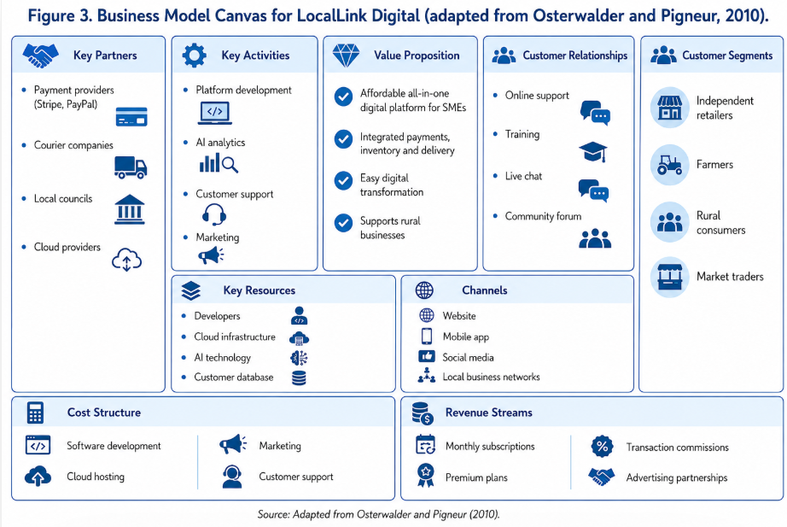
Source: Adapted from Osterwalder and Pigneur (2010).

Conclusion

Digital transformation has fundamentally reshaped the UK business environment, creating both significant challenges and substantial opportunities for innovation. As consumer expectations continue to evolve towards seamless digital experiences, organisations-particularly SMEs-must adopt more customer-centred approaches ot remain competitive. This report has demonstrated that Design Thinking provides an effective framework for addressing these challenges by placing users at the centre of innovation while balancing desirability, feasibility and commercial viability.
The analysis identified five major opportunity areas within the UK market: e-commerce platforms, digital marketing services, integrated digital payment systems, retail management software, and supply chain and last-mile delivery solutions. Although each area offers considerable growth potential, the report argued that simply introducing new technological features. This reinforces the importance of empathy and continuous user engagement throughout the innovation process.
Applying the five stages of Design Thinking led to the development of LocalLink Digital, an integrated platform designed to support independent retailers, rural producers and local consumers. Through empathy research, problem definition, ideation, prototyping and iterative testing, the proposed venture demonstrated how customer insight can be translated into a practical and scalable business solution. The evaluation further showed that the concept satisfies the three essential principles of successful innovation; it is desirable for the users, technically feasible through existing digital technologies and commercially viable through a subscription-based business model.
Overall, this report concludes that Design Thinking represents considerably more than a creative problem-solving methodology. It is a strategic capability that enables organisations to manage uncertainty, encourage continuous to reshape the UK economy. Organisations that successfully integrate customer-centred design with technological innovation will be better positioned to achieve long-term competitiveness, resilience and sustainable growth.

References
Ansoff, H.I. (1957) ‘Strategies for diversification’, Harvard Business Review, 35(5), pp. 113–124.
Brown, T. (2008) ‘Design thinking’, Harvard Business Review, 86(6), pp. 84–92.
Buchanan, R. (1992) ‘Wicked problems in design thinking’, Design Issues, 8(2), pp. 5–21.
Department for Business and Trade (2024) Small business survey 2023: businesses with employees. London: Department for Business and Trade.
Dam, R. and Siang, T. (2024) What is design thinking? Interaction Design Foundation.
Design Council (2019) Beyond the Double Diamond: A universally accessible, inclusive and sustainable framework for innovation. London: Design Council.
Design Council (2019) The Framework for Innovation: Design Council's Evolved Double Diamond. London: Design Council.
IDEO (2015) The field guide to human-centred design. San Francisco: IDEO.org.
IDEO (2015) The Field Guide to Human-Centered Design.
Kotler, P., Kartajaya, H. and Setiawan, I. (2021) Marketing 5.0: Technology for humanity. Hoboken: Wiley.
Liedtka, J. (2018) Why design thinking works. Harvard Business Review, 96(5), pp. 72–79.
McKinsey & Company (2023) The state of organisations 2023. New York: McKinsey & Company.
Mintzberg, H., Ahlstrand, B. and Lampel, J. (2009) Strategy safari: Your complete guide through the wilds of strategic management. 2nd edn. Harlow: Pearson.
OECD (2023) SME and entrepreneurship outlook 2023. Paris: OECD Publishing.
Office for National Statistics (2024) Internet sales as a percentage of total retail sales (ratio) in Great Britain. Newport: ONS.
Osterwalder, A. and Pigneur, Y. (2010) Business Model Generation. Hoboken: John Wiley & Sons.
Porter, M.E. (1985) Competitive advantage: Creating and sustaining superior performance. New York: Free Press.
Ries, E. (2011) The Lean Startup. New York: Crown Business.
Statista (2024) E-commerce in the United Kingdom. Hamburg: Statista.
UK Finance (2024) UK payment markets summary 2024. London: UK Finance.
Verganti, R. (2009) Design-driven innovation. Boston: Harvard Business Press.
World Economic Forum (2023) The future of jobs report 2023. Geneva: World Economic Forum.

