
proffessional career development
Report on professional career development

Franchesca Ann Jenkins
2114500
November 3, 2021
University of Wales Trinity Saint David

Contents
0
Introduction 2
Main Findings 3
Conclusion 13
References 14
Appendices 15

Introduction

For this assignment I will be producing a report on professional career development, understanding of self-awareness, personal development.
The importance of professional career development is to determine where you need to improve and how you will improve skills for the workplace, in order to do this, I will look at my self-awareness by being aware of different aspects of myself including my traits, skills, knowledge and feelings.
By taking advantage of professional development, continued education and planning for your career you already have a leg up on a third of peers because going for it and taking ownership of your career you’re more likely to succeed and meet your goals you are setting (web. CE Antley.T 2020)
Self-awareness refers to the capacity of becoming the object of one’s own attention, in this state oneself actively identifies, processes and stores information about the self. Key related concepts for example reflective consciousness are distinguished from the central notion of self-awareness.
The main effects of self-attention consist of amplifications of one’s subjective experiences. (self-awareness part 1. Definition and measures, Morin. A 2011).
In order to do all of this we need motivation this is when you realise something needs improving and it causes you to act upon it and rectify the situation.
In this report I will be using several models and techniques in order to identify my personal devolvement such as, SMART and SWOT analysis as well as Maslow, Johari. The 4Cs and then looking at my learning styles through VARK and honey and Mumford to develop my personal development plan which will enable me to develop employability skills I require to achieve my SMART goal.

Main Findings

I am currently on a self-awareness journey. I am currently unemployed and a stay-at-home mum to a 5-year-old.
I want to be a Learning support assistant for children ages 3-11 years and for me to do this I need to develop a SMART goal and I am going to complete my skills for the workplace university course to broaden my skills. I will measure my progress by applying what I learn in the course into applying for Learning support Assistant jobs. I will try and apply for 2 jobs for Learning support assistant every few weeks.
I know that in order to do this I need to analyse my situation and reflect on myself and my current position in self- awareness.
Self-awareness allows you to better understand yourselves, other people and how they perceive you. When we are aware that we are being watched and evaluated, we often try to behave in ways that are socially acceptable and desirable.

It is important as then we can be empowered to make changes.
In order to do this, we need motivation, this was originally published as a theory of needs, Maslow states that human needs are arranged in a series of Importance. So according to Maslow’s higher achy of needs I am currently at the self- esteem which I now need to develop my self-actualisation skills in order to succeed to my goal of becoming an Learning support assistant (Maslow 1943).
I will be looking at the 7 habits of highly effective people by Stephen covey, such as by having a plan in place as covey states making sure you prioritize and be proactive is a habit of highly effective people (Hussain 2019)
The reason I need to improve my Personal development is I have not been in work setting for a long time and I am comfortable, which has led me to being unemployed for a long period of time.

Below you will find my SMART goal.
The SMART goal technique is an acronym tool that is sometimes used to guide your goal setting.
The first known use of the SMART Goal term occurred in November 1981 issue of Management review (Doran. T 1981)

S
My goal is to become a good LSA for primary school children aged 3-11 years beginning with the end in mind (Stephen covey, 7 habits of highly effective people)

M
As Stephen covey states “first things first” I will know my progress by growing in confidence by practicing my interview techniques by doing the following steps,
- Finish my higher education course as well as applying for jobs
- Making sure I apply for at least 2 jobs
A
I will do this by being proactive, doing all my course work to the best of my ability gaining confidence as I work through the course, this will be possible with the help and support of my husband and my tutors. (Hussain 2019)

R
I believe that this goal is realistic and achievable as I am determined to do so, I have all the support and help of family and friends. With hard work this will pay off and me having experience in this field already helps my prospects.

T
The time limit will be by the end of second term I hope to have applied and secured interview for LSA jobs.

A SWOT Analysis
A SWOT analysis is useful, quick tool for taking stock of your situation it was originally done by albert Humphrey 1960 (professional academy.com)
It is based on strengths that you have, weaknesses opportunities and threats.
It is a simple way of analysing your readiness for tasks, it can take you to the core of your issue very quickly

Below is my SWOT analysis in relation to my SMART goal.

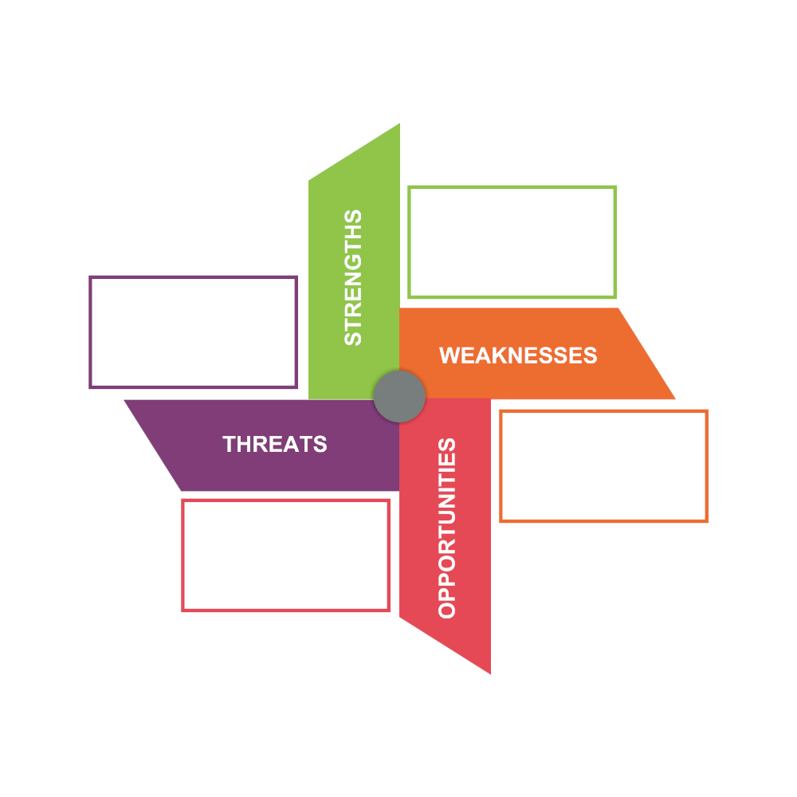
- University
- Student finance
- Chance to further my skills
- Job opportunities.
- permanent job offers

- People more qualified.
- My anxiety
- Illness
- Childcare/child unwell
- No jobs in local area.

- Lack Confidence
- Fear Of Failing
- Stubborn
- Sensitive
- Stress and anxiety

- Organised
- Time Management
- Can Drive
- Committed
- Motivated

I will now convert my SWOT analysis so you can see the conversion strategy

Strength to opportunity conversion

Employability
Employers want us to have employability skills in order to a job. It is an ability you have to do an activity or job well. (ERSI INGLIS 1994)

My Employability skills are as follows,
- RESOURCFULNESS- I am good at this as I can find resources by myself for various things by using my initiative and sometimes with the help of others.

- SELFAWARENESS- I am aware of the skills and things I need to develop my skills to further myself ready for employment.

- I.T SKILLS- I have I.T skills so I can use these in a workplace in order to complete jobs, such as word, publisher and many other it sources.

- CREATIVITY- I am a very creative person and enjoy creating new things and this will be good for the type of job I would like to be doing, workplaces of schools will look for this especially with working with children.

- ORGANISED- I am an organised person I like things done in order and things to be tidy so that I am aware of where to find them if I need them, this is good when working in a busy environment and saves time.

In order to improve other employability skills which, I have identified that need work I will be using the Johari window (LUFT & INGHAM 1955)
The Johari window is a phycological tool created by LUFT &INGHAM, it’s a simple and useful tool which is used for understanding and training. It is one of the fewer tools out there that has an emphasis on “soft skills” such as behaviour, empathy, cooperation, intergroup development and interpersonal development. It is a great model to use because it’s simple and can be applied in various situations. (Luft, J., Ingham, H. (1955). “The Johari window, a graphic model of interpersonal awareness” 2012)

Johari window

So, in this Johari window my social anxiety is in the hidden window and in order to get it into the open area I will make my lecturer aware of this and attend therapy sessions to help me get better at managing it. I will then become more confident about being in the open area with social anxiety.
In the unknown area I have referencing, in order to get this into the open area I will continue to practice referencing and asking for help from lecturers and other students this way I will be able to get it in to the open area and feel comfortable with doing it.

4C model
the 4C model is the 4 stages of competence. It is a model for learning. (Noel Burch 1970)
It is made up of 4 stages hence its name the 4C’s.
The stages are as follows:
Unconscious incompetence- which is where you don’t know about the skill or how it works.
Conscious incompetence- you know of the skill but don’t have it or know how to use the skill.
conscious competence- where you know of the skill, and you know how to use the skill.
Unconscious competence- where you are good at the skill and can now use it without thinking about it.
My 4C’s model is below.

I would bring my academic writing into unconscious competence by practicing writing and asking for feedback from my tutors.

Learning styles
There are many ways in people learn these skills and people learn differently
The 2 learning styles I will be looking at are VARK and Honey and Mumford,
Honey and Mumford’s learning questionnaire is proposed as an alternative to Kolb’s learning style (Duff & Duffy 2002).
The VARK learning style uses four preferences of learning styles such as visual, aural, read/write and kinaesthetic. (Walter et al 2009).
Using these style questionnaires, I have concluded that using the Honey and Mumford learning style the best way I learn is I am a reflector, and a reflector best learns by standing back to ponder experiences and observe from different perspectives. The philosophy is to be cautious. We are thoughtful people who like to consider all angles and implications before making a move.
I prefer to take a back seat in discussions and meetings, I like to observe others. I tend to adopt a low profile in social situations.
The downside of being a reflector learner and I learn least from being forced into the limelight, and I worry about time pressures or being rushed from one activity to another.
I tend to hold back from direct participation in activities and I am not assertive enough, nor do I like taking risks.
With VARKS learning style questionnaire I am a mixture of aural and read/write strategies,
The aural side of the VARK learning style is that I like to attend lectures, explain new ideas to others and I like to leave spaces in my notes to come back to later and fill in.
For the read/writing side of the learning preference I like to have hand books, notes and definitions.

Personal development plan

A personal development plan is an action plan of improvement used to fulfil and learn or improve skills to help advance personal or career-based goals.
It is also an ability to do an activity or job well (ERSI Inglis 1994)
Below is my personal development plan where I will identify 3 employability skills and how I will improve them I order to gain my Goal.

Development objective | Specific actions | Barriers and how they will be removed | Support required | How will I know when I have achieved the goal
- Academic writing | Practice more of it and ask for feedback from lectures, take into account what advice and support is given, also using my way of learning style from VARK I will read books on academic writing and how to improve. | I am lacking confidence on where to start and worried about what lectures may think- these will be removed by me practicing and getting better also using the advice to improve my skill | Feedback and support and tips from lectures | I will know when I achieved my goal as my writing will be better and oi won’t need to think too much on how to start or do a piece of writing.
- Research skills | Research and make notes of all research I have done on my lectures. Assignments, I can do this by using my learning as a reflector I would make notes and reflect on experiences and observe. As I am a thoughtful person, I like to consider all my angles and implications that inform my research skills. | I am unsure of how to start or get specific quotes on things I need for my lectures.  How to fid certain things on different subject matter or for assignments. | Help and support from librarian, lectures and maybe other students who already have the skill that can point me in the right direction. | I will know I have achieved this by being able to research on my own and find information needed for my assignments without having to be prompted.
- Leadership skill | I need to improve my leadership skills for taking charge of discussions, and other class activities but with being a reflector I am not confident in doing this so I need to develop it. | I am very shy and not confident in this I hate having to discuss things in class or in groups | Support from lectures and other students who feel this way and help with self-confidence. | I will know this has been achieved as I will be able to discus and present and take charge of things during lectures or even in the classroom as a learning support.

Conclusion
My conclusion of this report is that in order to learn these skills required to become a Learning support assistant I must follow my SMART goal followed by using SWOT analysis to find weaknesses and covert them to strengths.
I will also work on my employability skills and improving them so that when I apply for any jobs, I will know that I can do them.
In order to do all of these I will be using aural learning alongside read/write as these are the wo main learning strategies I have found out I learn best with as of VARK, by using these learning techniques I can take notes and then read over them to do my assignments, I need to make sure that I write down references as I go along so that I do not struggle with finding them when I need them. I will also be using aural learning style and I prefer to listen and speak with lecturers to double check that I am on the right track.
The other learning style I have found out that I am is a reflector which learns best by standing back and analysing things from a distance and thinking before acting and having time to prepare things. I believe that being a reflector may well hold be back as well because we don’t like being in the limelight or forced to do presentations which put me out of my comfort zone.
These skills are important to me becoming a learning support assistant as I need to be out of my comfort zone in order to progress and excel in the job I want. I am not always going to be comfortable with things, but I must adjust myself in order to progress.
I will be able to track the progress of my goals as I will be able to do the things I have identified as a problem and I will be able to do them better and eventually without thinking at all.
I will be working towards my end goal.

References

7 Habits of Highly Effective People [Summary & Takeaways] (hubspot.com) Originally published Jul 8, 2019, 8:13:00 PM, updated June 10 2021 accessed November 2021 Hussain. A 2019
A.H. Maslow 1943 theory of needs. Maslow's Hierarchy of Needs | Simply Psychology accessed November 2021
Albert Humphrey 1960 Marketing Theories – Swot Analysis (professionalacademy.com) assessed on 18th November 2021
Covey, S. R. & Collins, J. (2020) The 7 habits of highly effective people: powerful lessons in personal change. New York: Simon & Schuster.
Developing ‘extraordinarily realistic self-image (ERSI)’ – Inglis 1994 Undertaking Continuing Professional Development | Leap Like A Salmon accessed 18th November 2021
Duff, A., & Duffy, T. (2002). Psychometric properties of Honey & Mumford's Learning Styles Questionnaire (LSQ). Personality and Individual Differences, 33(1), 147–163. https://doi.org/10.1016/S0191-8869(01)00141-6
Leite WL, Svinicki M, Shi Y. Attempted Validation of the Scores of the VARK: Learning Styles Inventory with Multitrait–Multimethod Confirmatory Factor Analysis Models. Educational and Psychological Measurement. 2010;70(2):323-339. doi:10.1177/0013164409344507
Mind Tools https://www.mindtools.com/pages/article/smart-goals.htm March 9th, 2016, updated February 4th, 2020, accessed on 12th November 2021.
Noel Burch 1970 4 stages of competence, the 4C model. You Can't Start a Central Line? Supervising Residents at Different Stages of the Learning Cycle (nih.gov) accessed 18th November 2021
Self‐Awareness Part 1: Definition, Measures, Effects, Functions, and Antecedents - Morin - 2011 - Social and Personality Psychology Compass - Wiley Online Library
The History and Evolution of SMART Goals | AchieveIt (Doran. T. George 1981)
What Is Professional Development and Why Is It Important? (webce.com) (Antley. T 2020) accessed on 18/11/2021

Appendices

Learning Questionnaires attached

LEARNING STYLES QUESTIONNAIRE
This questionnaire aims to find out something about how you learn best. The follow up materials will then give you tips on how to use your preferred style for maximum benefit.
Choose the answer which best explains your preference and circle the letter next to it. Please circle more than one if a single answer does not match your perception. By the way, there are no ‘right’ or ‘wrong’ answers! No further information can be given as it may prejudice your responses.
When you have completed the questionnaire, use the marking guide to find your score for each of the categories, Visual, Aural, Read/Write and Kinaesthetic.

1. How many syllables are in your first name?
(a) one
(b) two
(c) three
(d) more than three

2. You are about to give directions to a person who is standing with you. They are
staying in a hotel in town and want to visit your house later. They have a rental car. You would:
(a) draw a map on paper
(b) tell them the directions
(c) write down the directions (without a map)
(d) collect them from the hotel in my car

3. You are not sure whether a word should be spelled ‘dependent’ or ‘dependant’. I would:
(a) look it up in the dictionary
(b) see the word in my mind and choose the way it looks
(c) sound it out in my mind
(d) write both versions down on paper and choose one

4. You have just received the latest copy of a magazine with an itinerary for a conference, this is of interest to someone else. You would:
(a) phone them immediately
(b) send them a copy of the printed itinerary
(c) show them on a map of the world
(d) share what I plan to do at each place I visit

5. You are going to cook something as a special treat for your family. You would:
(a) cook something familiar without the need for instructions
(b) thumb through the cookbook looking for ideas from the pictures
(c) refer to a specific cookbook where there is a good recipe

6. A group of students from another school has been assigned to you to find out about the geology of your local area. You would:
(a) drive them to a wildlife reserve or park
(b) show them slides and photographs
(c) give them pamphlets or a book on wildlife reserves or parks
(d) give them a talk on wildlife reserves or parks

7. You are about to purchase a new compass clinometer. Other than price, what would most influence your decision?
(a) the salesperson telling you what you want to know
(b) reading the details about it in a journal
(c) playing with the controls and listening to it (road testing it)
(d) it looks really smart and fashionable

8. Recall a time in your life when you learned how to do something like playing a new board game. Try to avoid choosing a very physical skill, eg. riding a bike. You learned best by:
(a) visual clues – pictures, diagrams, charts
(b) written instructions
(c) listening to somebody explaining it
(d) doing it or trying it

9. You have an eye problem. You would prefer the doctor to:
(a) tell me what is wrong
(b) show me a diagram of what is wrong
(c) use a model to show what is wrong

10. You are about to learn to use a new program on a computer. You would:
(a) sit down at the keyboard and begin to experiment with the program features
(b) read the manual which comes with the program
(c) telephone a friend and ask questions about it

11. You are staying in a hotel and have a rental car. You would like to visit friends whose address/location you do not know. You would like them to:
(a) draw a map on paper
(b) tell directions
(c) write down the directions (without a map)
(d) collect me from the hotel in their car

12. Apart from the price, what would most influence your decision to buy a particular textbook?
(a) I have used a copy before
(b) a friend talking about it
(c) quickly reading parts of it
(d) the way it looks is appealing

13. A new movie has arrived in town. What would most influence your decision to go (or not go)?
(a) I heard a radio review of it
(b) I read a review of it
(c) I saw a preview of it

14. Do you prefer a lecturer who likes to use:
(a) a textbook, handouts, readings
(b) flow diagrams, charts, graphs
(c) field trips, labs, practical sessions
(d) discussion, guest speakers

15. Ignore question 1.
THE VARK QUESTIONNAIRE SCORING CHART
Use the following scoring chart to find the VARK category that each of your answers corresponds to. Circle the letters that correspond to your answers.
Eg. if you answered b and c for question 4, circle R and V in the question 4 row
Question | a category | b category | c category | d category
4 | A | R | V | K

Scoring chart

Question | a category | b category | c category | d category
1
2 | V | A | R | K
3 | R | V | A | K
4 | A | R | V | K
5 | K | V | R
6 | K | V | R | A
7 | A | R | K | V
8 | V | R | A | K
9 | A | V | K
10 | K | R | A
11 | V | A | R | K
12 | K | A | R | V
13 | A | R | V
14 | R | V | K | A
15

Calculating your scores:
Count the number of each of the VARK letters you have circled to get your score for each VARK category

Total number of V’s circled = | 3
Total number of A’s circled = | 4
Total number of R’s circled = | 4
Total number of K’s circled = | 2

Your scores will give an indication of your preference for some of the different ways of learning
ie: V - by Visual Study Strategies
A - by Aural Study Strategies
R - by Read/Write Study Strategies
K - by Kinesthetic Study Strategies

Use the information sheets provided which give advice on how you may improve your performance.

You can also find the information on the website www.vark-learn.com

Learning Styles Questionnaire

Name: ___Franchesca Jenkins

This questionnaire is designed to find out your preferred learning style(s). Over the years you have probably developed learning "habits" that help you benefit more from some experiences than from others. Since you are probably unaware of this, this questionnaire will help you pinpoint your learning preferences so that you are in a better position to select learning experiences that suit your style and having a greater understanding of those that suit the style of others.

This is an internationally proven tool designed by Peter Honey and Alan Mumford.

There is no time limit to this questionnaire. It will probably take you 10-15 minutes. The accuracy of the results depends on how honest you can be. There are no right or wrong answers.

If you agree more than you disagree with a statement put a tick by it.
If you disagree more than you agree put a cross by it.
Be sure to mark each item with either a tick or cross.

- I have strong beliefs about what is right and wrong, good and bad.
- I often act without considering the possible consequences
- I tend to solve problems using a step-by-step approach
- I believe that formal procedures and policies restrict people
- I have a reputation for saying what I think, simply and directly
- I often find that actions based on feelings are as sound as those based on careful thought and analysis
- I like the sort of work where I have time for thorough preparation and implementation
- I regularly question people about their basic assumptions
- What matters most is whether something works in practice
- I actively seek out new experiences
- When I hear about a new idea or approach I immediately start working out how to apply it in practice
- I am keen on self discipline such as watching my diet, taking regular exercise, sticking to a fixed routine, etc.
- I take pride in doing a thorough job
- I get on best with logical, analytical people and less well with spontaneous, "irrational"
- I take care over the interpretation of data available to me and avoid jumping to conclusions
- I like to reach a decision carefully after weighing up many alternatives
- I'm attracted more to novel, unusual ideas than to practical ones
- I don't like disorganised things and prefer to fit things into a coherent pattern
- I accept and stick to laid down procedures and policies so long as I regard them as an efficient way of getting the job done
- I like to relate my actions to a general principle
- In discussions I like to get straight to the point
- 1 tend to have distant, rather formal relationships with people at work
- I thrive on the challenge of tackling something new and different
- I enjoy fun-loving, spontaneous people
- I pay meticulous attention to detail before coming to a conclusion
- I find it difficult to produce ideas on impulse
- I believe in coming to the point immediately
- I am careful not to jump to conclusions too quickly
- I prefer to have as many resources of information as possible - the more data to think over the better
- Flippant people who don't take things seriously enough usually irritate me
- I listen to other people's points of view before putting my own forward
- I tend to be open about how I'm feeling
- In discussions I enjoy watching the manoeuvrings of the other participants
- I prefer to respond to events on a spontaneous, flexible basis rather than plan things out in advance
- I tend to be attracted to techniques such as network analysis, flow charts, branching programs, contingency planning, etc.
- It worries me if I have to rush out a piece of work to meet a tight deadline
- I tend to judge people's ideas on their practical merits
- Quiet, thoughtful people tend to make me feel uneasy
- I often get irritated by people who want to rush things
- It is more important to enjoy the present moment than to think about the past or future
- I think that decisions based on a thorough analysis of all the information are sounder than those based on intuition
- I tend to be a perfectionist
- In discussions I usually produce lots of spontaneous ideas
- In meetings I put forward practical realistic ideas
- More often than not, rules are there to be broken
- I prefer to stand back from a situation
- I can often see inconsistencies and weaknesses in other people's arguments
- On balance I talk more than I listen
- I can often see better, more practical ways to get things done
- I think written reports should be short and to the point
- I believe that rational, logical thinking should win the day

- I tend to discuss specific things with people rather than engaging in social discussion
- I like people who approach things realistically rather than theoretically
- In discussions I get impatient with irrelevancies and digressions
- If I have a report to write I tend to produce lots of drafts before settling on the final version
- 1 am keen to try things out to see if they work in practice
- I am keen to reach answers via a logical approach
- I enjoy being the one that talks a lot
- In discussions I often find I am the realist, keeping people to the point and avoiding wild speculations
- I like to ponder many alternatives before making up my mind
- In discussions with people I often find I am the most dispassionate and objective
- In discussions I'm more likely to adopt a "low profile" than to take the lead and do most of the talking
- I like to be able to relate current actions to a longer term bigger picture
- When things go wrong I am happy to shrug it off and "put it down to experience"
- I tend to reject wild, spontaneous ideas as being impractical
- It's best to think carefully before taking action
- On balance I do the listening rather than the talking
- I tend to be tough on people who find it difficult to adopt a logical approach
- Most times I believe the end justifies the means
70. I don't mind hurting people's feelings so long as the job gets done
71. I find the formality of having specific objectives and plans stifling
72. I'm usually one of the people who puts life into a party
73. I do whatever is expedient to get the job done
74. I quickly get bored with methodical, detailed work
75. I am keen on exploring the basic assumptions, principles and theories underpinning things and events
76. I'm always interested to find out what people think
77. I like meetings to be run on methodical lines, sticking to laid down agenda, etc.
78. I steer clear of subjective or ambiguous topics
79. I enjoy the drama and excitement of a crisis situation
80. People often find me insensitive to their feelings

Scoring And Interpreting The Learning Styles Questionnaire
The Questionnaire is scored by awarding one point for each ticked item. There are no points for crossed items. Simply indicate on the lists below which items were ticked by circling the appropriate question number.
2 | 7 | 1 | 5
4 | 13 | 3 | 9
6 | 15 | 8 | 11
10 | 16 | 12 | 19
17 | 25 | 14 | 21
23 | 28 | 18 | 27
24 | 29 | 20 | 35
32 | 31 | 22 | 37
34 | 33 | 26 | 44
38 | 36 | 30 | 49
40 | 39 | 42 | 50
43 | 41 | 47 | 53
45 | 46 | 51 | 54
48 | 52 | 57 | 56
58 | 55 | 61 | 59
64 | 60 | 63 | 65
71 | 62 | 68 | 69
72 | 66 | 75 | 70
74 | 67 | 77 | 73
79 | 76 | 78 | 80
TOTALS
Activist Reflector Theorist Pragmatist

