

Course: BA Leadership and Management
LEVEL 5
Customer Relationship Marketing and Sustainable Customer Relationships at Marks & Spencer Food
Module code: BMSW5007
Module Lead; Gwyneth Jones
Name: MAIA VASHAKMADZE
Student number: 1816795
Date: 24/11/2025

Executive Summary
This report critically examines how Marks & Spencer (M&S) Food applies Customer Relationship Marketing (CRM) strategies to build and maintain sustainable customer relationships while enhancing organisational performance. It explores the company’s historical evolution, current market position, and mission; evaluates its use of data collection, analysis, and CRM systems; and analyses its marketing strategy through frameworks such as Segmentation, Targeting and Positioning (STP), the 7Ps, the 4Cs, and sustainability principles.
The findings reveal that M&S Food has effectively integrated CRM into its business model through data-driven personalisation, strong ethical positioning, and customer-centric marketing. These strategies have strengthened loyalty, brand trust, and long-term profitability. However, challenges remain regarding customer value perception, digital personalisation, and cyber resilience. The report concludes that while M&S’s CRM approach is robust and well-aligned with sustainability objectives, continuous innovation, enhanced communication of value, and investment in data protection are essential for maintaining competitive advantage and trust. Specially after Data privacy also remains a significant concern from the 2025 cyberattack, which disrupted loyalty systems and exposed vulnerabilities in customer data protection.

Contents

Introduction 4
Main Findings 6
Section 1: M&S Food – Organisation Overview 6
1.1 Historical Development and Evolution 6
Current Market Position 6
1.2Mission and Values 7
2.1Defining CRM and Its Strategic Role 8
2.2 Data Collection, Analysis, and Evaluation 8
2.3 Critical Evaluation of Effectiveness 8
2.4 Sustainability in Data-Driven Relationships 9
Section 3: CRM Strategy Analysis 10
3.1 Segmentation, Targeting, and Positioning (STP) 10
3.2 The Marketing Mix (7Ps) 11
3.3 The 4Cs of Customer Needs 12
3.4 Ethics and Sustainability 13
Conclusion 14
References 15

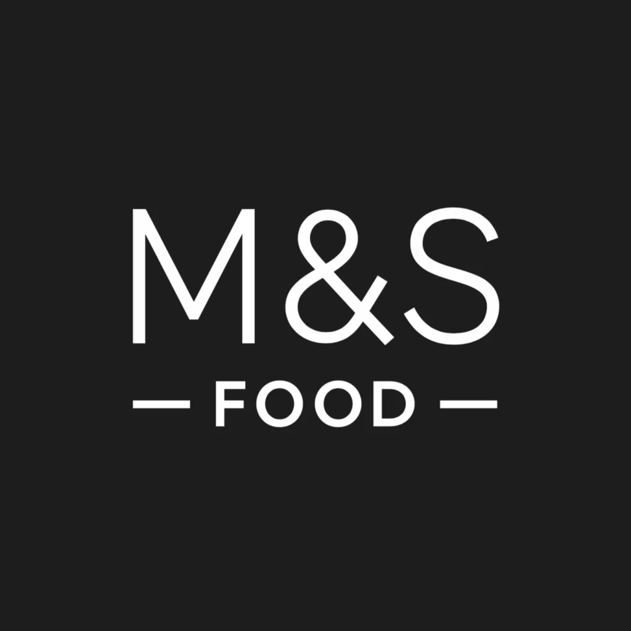

Introduction
Customer Relationship Marketing (CRM) has become a important strategic approach for organisations aiming to build long-term customer engagement, retention, and competitive advantage. In the UK grocery retail sector, where consumer expectations continue to evolve and competition is intense, CRM enables retailers to move beyond transactional exchanges and develop value-driven, relationship-based interactions. Increasing ethical consciousness, digital adoption, and personalisation demands mean that successful retailers must integrate data analytics, customer insight, and sustainability into their CRM strategies to retain loyalty in an increasingly crowded marketplace (LinkedIn, 2025).
For Marks & Spencer (M&S) Food, CRM is not just a technological tool, but a customer-centric philosophy embedded within its brand proposition of quality, trust, and responsible retailing. As a premium food retailer, M&S must work harder than mass-market competitors to justify higher prices and maintain loyalty, making strong customer relationships essential for business success (M&S, 2018). CRM therefore plays a critical role in enabling the organisation to understand customer preferences, personalise communications, and strengthen emotional and behavioural loyalty, (Marks & Spencer, 2025). This report critically evaluates how M&S Food applies CRM principles to support organisational performance and foster sustainable customer relationships. It examines the company’s historical development, current market position, and mission; analyses how data collection, analysis, and evaluation underpin its relationship-building efforts; and assesses its CRM strategy through frameworks such as Segmentation, Targeting and Positioning (STP), the 7Ps marketing mix, the 4Cs, and sustainability models. Furthermore, the report explores how M&S embeds customer centrality, placing customer needs and values at the core of strategic decision-making, to create long-term, mutually beneficial relationships that contribute to both profitability and social responsibility (M&S ESG Report, 2024)

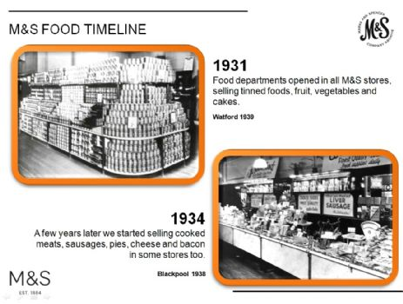

Main Findings
Section 1: M&S Food – Organisation Overview

1.1 Historical Development and Evolution
Marks & Spencer (M&S) was founded in 1884 by Michael Marks in Leeds and later joined by Thomas Spencer in 1894. Originally a general merchandise retailer, M&S expanded into food retailing during the early 20th century, focusing on freshness, quality, and innovation. By 1931, every store included a food department, and by 1947, M&S pioneered self-service food retailing (M&S Archive, 2024).
Throughout the 20th and 21st centuries, M&S Food evolved into a distinctive brand offering premium, own-label products. Partnerships such as the 2020 collaboration with Ocado facilitated entry into online grocery delivery (The Guardian, 2020). As of 2025, M&S operates over 1,100 stores globally, employs 65,000 people, and generates annual revenues exceeding £13 billion, with food accounting for approximately 60% of total sales (M&S Annual Report, 2025).

Current Market Position
M&S Food currently occupies a strong premium position within the UK grocery market, differentiated by its focus on exceptional product quality, innovation, and responsible sourcing. Its market share rose to 4.5% in early 2025, allowing it to overtake Waitrose in several regions (NielsenIQ, 2025). Despite a cyberattack that temporarily disrupted operations, the retailer reported a 9.7% increase in grocery sales during 2025, demonstrating strong customer loyalty and brand resilience (Retail Gazette, 2025).
Although M&S Food remains smaller than mass-market competitors such as Tesco and Sainsbury’s, it competes on differentiation rather than scale. Its emphasis on premium own-brand products, sustainability commitments, and a trusted reputation enables M&S to attract customers seeking higher-quality, ethically sourced alternatives to mainstream supermarkets (CMA, 2024).

1.2Mission and Values
M&S’s mission is: “to be the most trusted retailer by making exceptional quality accessible while doing the right thing for people, communities, and the planet.” The missions statement highlights its commitment to trust, quality, and responsible business practice. This mission is supported by the company’s Plan A framework, which embeds environmental, social, and governance (ESG) principles into all operational decisions (M&S Corporate, 2024, para.). Plan A initiatives include reducing carbon emissions, improving supply chain transparency, and promoting fair labour practices, demonstrating a long-term focus on ethical retailing (M&S Corporate, 2024).
According to Drummond-Dunn (2024), the mission is effective as it aligns closely with growing consumer expectations for quality, sustainability, and corporate accountability. By clearly communicating these values, M&S reinforces customer trust, strengthens emotional loyalty, and differentiates itself from competitors who focus primarily on price.

Section 2: Data and Customer Relationships

2.1Defining CRM and Its Strategic Role
CRM is a strategic process focused on fostering long-term, mutually beneficial relationships between organisations and their customers through the integration of marketing, technology, and data analytics (Kotler et al., 2022). Effective CRM transforms transactions into relationships grounded in engagement, trust, and satisfaction.
In modern retailing, sustainable customer relationships, characterised by loyalty, advocacy, and ethical alignment are critical to business success. For M&S Food, CRM underpins its value proposition by enabling data-driven decision-making and personalised customer experiences (Payne and Frow, 2017).

2.2 Data Collection, Analysis, and Evaluation
M&S collects extensive customer data from its Sparks loyalty programme, online shopping behaviour, and social media engagement. The Sparks programme delivers personalised discounts and product suggestions, leading to a 30% higher repeat-purchase rate among members (M&S, 2024).
Integration with Ocado enhances M&S’s analytical capability by capturing detailed data on demographics, purchasing patterns, and delivery preferences. These insights inform inventory planning, reduce waste, and guide product innovation, such as expanding its “Plant Kitchen” vegan range in response to sustainable diet trends (Smith, 2024).

2.3 Critical Evaluation of Effectiveness
M&S’s data-driven personalisation strategy has contributed to higher customer retention and increased average basket size, demonstrating the effectiveness of its CRM systems. For example, Sparks app users receive personalised discounts based on previous purchases, such as tailored offers on Plant Kitchen products for customers who regularly buy vegetarian items. This targeted approach encourages repeat purchases and strengthens behavioural loyalty (Smith, 2024).
However, excessive reliance on automated recommendations can create “offer fatigue,” where customers receive too many or irrelevant promotions, reducing engagement over time. Some Sparks users have reported repetitive offers or discounts on products they rarely purchase, indicating limitations in the accuracy of segmentation algorithms (Business, 2023).
Data privacy also remains a significant concern. The 2025 cyberattack, which disrupted loyalty systems and exposed vulnerabilities in customer data protection highlighted the risk associated with expanding digital CRM tools. Ensuring stronger cybersecurity measures, clearer consent processes, and transparent communication about data usage is essential for maintaining trust (Reuters, 2025),
Balancing personalisation with ethical data practices is therefore crucial. By strengthening GDPR compliance, offering greater user control over data, and improving the relevance of personalised interactions, M&S can enhance CRM effectiveness while upholding its brand promise of being a “trusted retailer.” (Sheridan, 2025).

2.4 Sustainability in Data-Driven Relationships
M&S integrates CRM with sustainability by using analytics to track progress on Plan A goals, such as reducing carbon emissions and food waste. Logistics optimisation and packaging redesign have lowered emissions by 22% since 2020. These initiatives not only improve operational efficiency but also appeal to ethically conscious consumers, reinforcing long-term loyalty (M&S Sustainability Report, 2024). Emissions falling, waste reduction improving, clear data tracking. But… M&S is not fully meeting all Plan A targets — progress is slower than promised.as a to Compared to competitors:
Tesco and Sainsbury’s have stronger public commitments to net-zero timelines. (TESCO, 2025). (Sainsbury’s accelerates its emission reduction commitments, validated by the Science Based Targets initiative (SBTi), 2025) Waitrose leads in animal welfare and plastic reduction. M&S is improving but still middle of the pack — not yet a sustainability leader. (Waitrose & Partners, no date 2024)

Section 3: CRM Strategy Analysis

3.1 Segmentation, Targeting, and Positioning (STP)
STP enables organisations to identify distinct customer groups, target profitable segments, and position offerings effectively M&S applies this framework by segmenting customers according to demographics, lifestyle, purchasing behaviour, and values, particularly focusing on shoppers who prioritise quality, freshness, and ethical sourcing (Kotler et al., 2022).
M&S targets middle- to upper-income consumers, urban professionals, ethically conscious shoppers, and families seeking convenient but premium meal solutions. Several product lines cater specifically to these segments. For example, the “Gastropub” and “Collection” ranges target affluent customers who enjoy restaurant-style meals at home, meeting their need for convenience without compromising quality. Meanwhile, the “Plant Kitchen” range appeals to health-conscious and environmentally aware consumers, offering high-quality plant-based options that align with sustainability values (M&S Gastropub, 2025).
For families, M&S targets the need for value and practicality through meal deals, ready-to-cook options, and child-friendly products, supported by Sparks offers tailored to frequent family purchases. Seasonal ranges such as Christmas party food target celebratory, experience-driven shoppers who associate M&S with special occasions (M&S Gastropub, 2025).
Its positioning statement, “quality worth paying for,” differentiates M&S from discount retailers by emphasising superior taste, ethical standards, and consistent reliability. Campaigns like “This is not just food, this is M&S Food” reinforce this premium identity and create emotional resonance (M&S Gastropub, 2025).
By tailoring products and promotions to distinct lifestyle and value-based segments, M&S meets customer needs more precisely, deepening satisfaction and strengthening long-term relationships (M&S Gastropub, 2025).

3.2 The Marketing Mix (7Ps)
M&S Food adopts a clear differentiation strategy, as defined by Porter’s generic models, competing on superior quality, innovation, and ethical standards rather than low prices. The 7Ps framework illustrates how this strategy strengthens CRM by ensuring consistent, value-enhancing customer experiences. it is about driving costs down while simultaneously driving value up for buyers. However, there are also popular authors who do believe in Porter’s idea of competitive choice as it describes in B2U (de Bruin, 2021)
Product:
M&S sells a completely own-brand food range, including its premium tiers such as Gastropub, Collection, and Plant Kitchen. These lines focus on high quality, new product innovation, and sustainable sourcing. This strengthens both emotional loyalty (trust, brand connection) and behavioural loyalty (repeat purchases).
Price:
Through its “Trusted Value” strategy, M&S aims to maintain its premium pricing position while still being seen as fair and good value for money. Personalised offers delivered through the Sparks loyalty programme give customers targeted discounts based on their preferences—without lowering the overall price image of the brand or damaging its premium reputation.Place: With more than 600 food-only stores and an established partnership with Ocado for online delivery, M&S ensures convenience and accessibility for diverse customer segments.
Promotion: Marketing relies on emotional storytelling, social media content, and personalised digital communications. The Sparks app plays a central role by offering tailored rewards and customer-specific offers.
People: Knowledgeable, well-trained staff contribute to a consistent premium service experience, supporting customer trust.
Process: Streamlined store processes, efficient supply chains, and integrated loyalty systems create seamless customer journeys.
Physical Evidence: High-quality store design, clear merchandising, and sustainable packaging communicate the brand’s premium and ethical values.
Collectively, the 7Ps create a coherent system that enhances M&S’s value proposition, strengthens CRM effectiveness, and supports long-term loyalty. However, competitors such as Tesco and Sainsbury’s challenge this advantage through lower pricing, broader ranges, and highly developed Clubcard/Nectar digital ecosystems, forcing M&S to continually justify its premium positioning and customer value.

3.3 The 4Cs of Customer Needs
The 4Cs Model shifts focus from product orientation to customer orientation (Lauterborn, 1990). Applying it to M&S Food demonstrates customer centrality:
4C Element | Application at M&S Food
Customer Value | Delivered through quality, freshness, and ethical sourcing.
Cost to Satisfy | Competitive pricing strategies enhance perceived value.
Convenience to Buy | Store proximity, online delivery, and click-and-collect enhance accessibility.
Communication | Personalised digital messaging and storytelling campaigns foster emotional connection and trust. (Akbar, Lawson and Turner, 2022)
M&S’s alignment with the 4Cs strengthens customer relationships, although competitors such as Tesco have superior data infrastructure that may allow deeper personalisation — an area for improvement in the (Hanlon, 2020).

3.4 Ethics and Sustainability
Ethical and sustainable practices have become essential components of modern Customer Relationship Marketing, as consumers increasingly expect retailers to demonstrate social and environmental responsibility. At M&S Food, the Triple Bottom Line framework people, planet, and profit form the foundation of its long-standing Plan A sustainability strategy. This framework ensures that ethical considerations are embedded across sourcing, operations, and customer engagement (M&S Sustainability Report, 2024).
Key initiatives include commitments to carbon reduction, investment in renewable energy, and a target to achieve net-zero emissions across the value chain. M&S also prioritises waste minimisation through recyclable and reduced-plastic packaging, improved forecasting to limit food waste, and customer-facing schemes such as “Too Good to Waste” produce boxes. Furthermore, the company emphasises fair-trade and responsibly sourced ingredients, supporting worker welfare and supply chain transparency (M&S Sustainability Report, 2024),
These actions strengthen customer loyalty by aligning the brand with growing consumer demand for ethical consumption. M&S effectively uses sustainability messaging within CRM communications such as in-store signage, packaging information, and Sparks app stories to reinforce its values and build emotional trust, (M&S Sustainability Report, 2024), However, M&S’s premium pricing limits accessibility for price-sensitive customers, creating tension between sustainability and inclusivity. Increasing transparency around value and expanding affordable eco-friendly options could widen appeal.
Overall, stronger recycling initiatives and clearer sustainability communication would further enhance trust, differentiation, and long-term customer relationships.

Conclusion
M&S Food demonstrates a strong and well-integrated CRM strategy that effectively supports both organisational performance and long-term customer relationships. Its use of data-driven insights through the Sparks loyalty programme, combined with a clear customer-centric philosophy, enables the company to personalise experiences, enhance satisfaction, and strengthen emotional loyalty. Premium product quality, consistent service standards, and a commitment to ethical and sustainable practices further reinforce trust and differentiate the brand within a competitive retail environment. These elements collectively contribute to sustained customer retention and positive brand equity.
However, opportunities remain for M&S Food to enhance CRM effectiveness. While its premium positioning is a core strength, the brand could improve communication around value and affordability to engage more price-sensitive customers. Expanding digital personalisation, while ensuring transparency and avoiding perceptions of intrusiveness, would enhance relevance for diverse customer segments. Additionally, recent cybersecurity challenges highlight the need for continued investment in data protection to maintain customer confidence in digital services.
By building deeper analytics capabilities, strengthening its digital ecosystem, and better integrating affordability messaging with sustainability initiatives, M&S Food can further enhance long-term loyalty. Overall, M&S’s CRM approach demonstrates that ethical, data-informed, and customer-centric strategies are essential drivers of sustainable customer relationships and competitive advantage.

References

CMA (2024) Competition and Profitability in the Groceries Sector. Available at: https://assets.publishing.service.gov.uk/media/66a3326dab418ab055592d95/Groceries_2.pdf.
de Bruin, L. (2021) Porter’s Generic Strategies: Differentiation, Cost Leadership and Focus, B2U - Business-to-you.com. Available at: https://www.business-to-you.com/porter-generic-strategies-differentiation-cost-leadership-focus/.
Drummond-Dunn, D. (2024) The Essential Customer-Centric Mission Statement for Achieving Success | CustomerThink, Customerthink.com. Available at: https://customerthink.com/the-essential-customer-centric-mission-statement-for-achieving-success/.
Drummond-Dunn, D. (2024) The Essential Customer-Centric Mission Statement for Achieving Success | CustomerThink, Customerthink.com. Available at: https://customerthink.com/the-essential-customer-centric-mission-statement-for-achieving-success/.
Easy Marketing School (2023) 7Ps in marketing mix: A Deep Dive into the 7P’s of Marketing Mix, YouTube. Available at: https://www.youtube.com/watch?v=cqikFDa1KfI.
Grönroos, C. (2017) Service Management and Marketing: Managing the Service Profit Logic. 5th edn. Chichester: Wiley.
Kotler, P., Keller, K.L., Goodman, M. and Hansen, T. (2022) Marketing Management. 16th edn. Harlow: Pearson.
Lauterborn, R. (1990) ‘New marketing litany: Four Ps passé’, Advertising Age, 61 (41), pp. 26–27.
Marks and Spencer (2024) Plan A Sustainability Report 2024. Available at: https://corporate.marksandspencer.com [Accessed 30 Oct 2025].
Marks and Spencer (2025) Annual Report and Accounts 2025. Available at: https://corporate.marksandspencer.com [Accessed 30 Oct 2025].#
NielsenIQ (2025) ‘M&S UK grocery market share’, Reuters, 5 Feb 2025.
Payne, A. and Frow, P. (2017) Strategic Customer Management: Integrating Relationship Marketing and CRM. 2nd edn. Cambridge: Cambridge University Press.
Retail Gazette (2025) ‘Grocery sales up as M&S overtakes Waitrose.’ Available at: https://www.retailgazette.co.uk [Accessed 30 Oct 2025].
The Guardian (2020) ‘M&S launches Ocado partnership for online grocery deliveries.’ Available at: https://www.theguardian.com [Accessed 30 Oct 2025].
YouGov (2024) ‘UK consumer attitudes to sustainability in food retail.’ Available at: https://yougov.co.uk [Accessed 30 Oct 2025].
Hanlon, A. (2020) The 4Cs Marketing Model, Smart Insights. Available at: https://www.smartinsights.com/marketing-planning/marketing-models/4cs-marketing-model/.
LinkedIn (2025) Linkedin.com. Available at: https://www.linkedin.com/pulse/how-crm-drives-stronger-customer-relationships-strategic-approach-vzmjc/ (Accessed: 22 November 2025).
M&S (2018) MARKS & SPENCER ANNOUNCES TECHNOLOGY TRANSFORMATION PROGRAMME. Available at: https://corporate.marksandspencer.com/media/press-releases/marks-spencer-announces-technology-transformation-programme.
M&S ESG Report (2024) Marks and Spencer Group plc ESG Report 2024. Available at: https://corporate.marksandspencer.com/sites/marksandspencer/files/2024-06/ESG_Report_2024.pdf. (Accessed: 23 November 2025).
M&S Gastropub (2025) Marksandspencer.com. Available at: https://www.marksandspencer.com/food/l/food-brands/gastropub?msockid=2c11158ba05f67a73082010ea1a46688 (Accessed: 24 November 2025).
Marks & Spencer. (2025). Newsroom. [online] Available at: https://corporate.marksandspencer.com/newsroom [Accessed 27 Nov. 2025].
Smith, R. (2024). M&S revamps its Plant Kitchen range and integrates vegan products in stores to boost appeal. [online] Vegan Food & Living. Available at: https://www.veganfoodandliving.com/news/ms-revamps-its-plant-kitchen-range-and-integrates-vegan-products-in-stores-to-boost-appeal/.
Business, in (2023). All Ease Accounting. [online] All Ease Accounting. Available at: https://www.alleaseaccounting.com/money-through-ease/046-offer-fatigue [Accessed 27 Nov. 2025].
Sheridan, N. (2025). Marks & Spencer Marketing Mix 2025: A Case Study – Latterly.org. [online] Latterly.org. Available at: https://www.latterly.org/marks-spencer-marketing-mix/.
TESCO (2025) Sustainability Report 2025, Tescoplc.com. Available at: https://www.tescoplc.com/sustainability-report-2025.
Sainsbury’s accelerates its emission reduction commitments, validated by the Science Based Targets initiative (SBTi) (2025). Available at: https://corporate.sainsburys.co.uk/news/press-releases/sainsbury-s-accelerates-its-emission-reduction-commitments-validated-by-the-science-based-targets-initiative-sbti/.
Waitrose & Partners (no date) Waitrose.com. Available at: https://www.waitrose.com/ecom/content/sustainability/plastic-reduction/plastics-and-packaging.
Akbar, M.B., Lawson, A. and Turner, N. (2022) ‘Lauterborn’s 4Cs’, The Palgrave Encyclopedia of Social Marketing, pp. 1–8. Available at: https://doi.org/10.1007/978-3-030-14449-4_12-2.

