Elliott Lewis

CPD Assignment

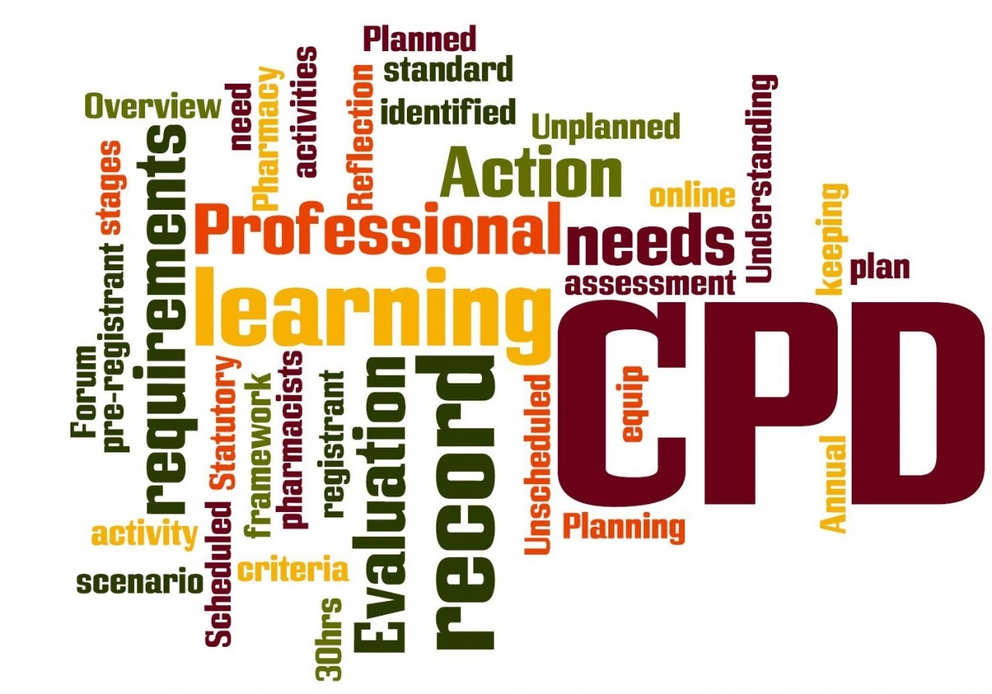
Table of Contents
Figure 1 (Nexus Education)
Introduction 3
Activity 1 – Continuous Professional Development 3
Activity 2 - Reflective Account of Experience and Learning to Date 3
Conclusion 5
Appendices 6
References 6

Introduction

Continuous Professional Development (CPD) is the method used to document learning through tracking and logging of individuals skills, knowledge and experience gain throughout a career. It has a reflective purpose too, encouraging learning experiences to be taken forward in a positive manner. Often CPD is recorded as part of a pathway to professional chartership. CIOB is the professional body for the Construction sector. Whilst currently not a member, the website is still a great learning source with many interesting and current articles for viewing.

Activity 1 – Continuous Professional Development

The attached Appendix 1 Continuous Professional Development Log provides:
- A Brief overview of past professional experience to date.
- 3 months’ worth of Professional and Personal learning events.
See Appendix 2 – Training Gap Analysis for:
- A predicted development plan for a 1 year and three-year period.

Activity 2 - Reflective Account of Experience and Learning to Date

A SWOT Analysis and Mind Map are attached as Appendix 3 & 4.
These both give some level of reflection of my strengths and weaknesses, with the mind map portraying a wider picture.
Whilst I do not yet possess the skills and knowledge of a seasoned construction professional, I do believe I have the drive and ambition to fulfil the Higher Apprenticeship role I am currently in.
Chinese philosopher Confucius once said ‘Learning without reflection is a waste. Reflection without learning is dangerous’ (The Daily Mind,2020)
The reflection table below also provides more detailed experiences over the last three months of my new career which will help shape my future growth:
Experience | Reflection
Learning from colleagues | Since October I have worked on numerous projects alongside colleagues with a wealth of knowledge and experience. Their eagerness to share this has benefited me significantly as I have had so much support and learnt so much already. Without this, especially in the working from home scenario I think my job satisfaction levels would not be so high.
Sharing knowledge with peers | As there are 5 higher apprentices within CCC we have been able to collaborate and help each other out as we all have different strengths and weaknesses. ACTION: Continue supporting one another
New tasks and activities | I have learnt to use new software such as Power BI, Total, Asset Manager plus also working on different tasks within the contacts and performance dept such as working on frameworks, T&C’s and TUPPE. ACTION: Seize similar opportunities going forward
Lessons learnt | When I first started having teams meeting, I kept quiet even when I had questions, but after settling in I have started questioning more things its really helped me understand things better and quicker. My manager has complemented me on this in my recent review. ACTION: Continue to build on this.
Gaining further knowledge | Using libraries, archives and also asking questions has really helped me improve my background knowledge.
Learning new processes and procedures | Over the last 3 months I have learnt so much about contracts and tenders and how the council procures items, services and works
Getting time from my Manager | My manager being busy has been hard to get hold of at times, so I have really made an effort to make sure we keep in contact, with me setting up meetings to maintain communication. This has also made me a lot more independent and now I am now being given more challenging projects to work on. ACTION: Continue this approach
Error Checking | When working from home there’s limited opportunity for colleagues to quickly check pieces of work as would perhaps be the case if we were in the office. So, my approach has been to ask my manager to review pieces of work via email in particular data entry to ensure accuracy before continuing. Any errors can then be identified and amended prior to completion and submission. ACTION: Continue this process
Chasing incomplete tasks | As I have been working on data performance, I have been analysing the data and chasing up jobs that are overdue. This has really improved my communication skills.
Building procurement knowledge | I have learnt so much about procurement and I continue to work on my knowledge by accessing ‘A practical guide to public procurement’
Improving networking skills | I have met many likeminded individuals and set myself up on linkedin ACTION: Continue to build on this.
Home working with a new job and starting University | Working from home has been difficult but it taught me to be more self-discipline and independent. ACTION: I know I need to work on my planning skills further, whilst I relish working under pressure, I have quickly learnt that organisation plays an important role in effectiveness.

Conclusion
Short Term:
In summary the Higher Apprenticeship with Carmarthen Council has already met my expectation since I began in October, despite a challenging ‘working from home’ start. My ability to build relationships with new colleagues, pick up tasks quickly and ask for help when I need it, have been well received by my manager and the wider team. The learning has been extensive and this alongside settling into University has been both challenging and rewarding.
I do sometimes lack self-belief but receiving a good grade for my first assignment has given me confidence that I can build on. I have enjoyed developing a peer group with the other apprentices and I am really looking forward to the variety I will get from the remaining three secondments.
Longer Term:
The ambitious decarbonisation housing plans and new eco technologies in this sector make the future exciting and I hope I can make a significant contribution to the departments success over the coming 10 year programme.
I will also be starting my NVQ level 5 too this year so that will bring further learning opportunities but most importantly how they can be applied directly to the workplace.
I am ambitious and love to learn new things so fully appreciate the qualifications and workplace opportunities I have currently been given and aim to make the most out of them.

Appendices

Appendix 1 – CPD Log – Submitted separately

Appendix 2 – Training Gap Analysis and Plan
1 Year Plan
Learning | Current Status | Target Status | Action Required | Priority | Start Date | Finish Date
Develop skills further on Microsoft packages | Competent at basic skills | Develop more enhanced skills in particular Excel | Use manager VG as mentor plus undertake any online learning at CCC | Medium term | 1.1.21 | 31.12.21
Develop skills further on Microsoft packages | Competent at basic skills | Develop more enhanced skills in particular presentation skills, graphics etc | Gower College to deliver specific training at part of NVQ level 4? | Medium term | Spring summer 21 | Spring/summer 21
Collating data | Competent at basic levels | Develop more specific skills required to produce bi weekly reports for Manager | 1-2-1 training with manager | Short term | 1.1.21 | 1.2.21
Gain more technical experience | Building on skills and knowledge via university course but need more hands-on experience | Currently seconded to Contracts and Compliance, next two secondments in 2021 will be…. | Continue academic learning supported by more hands on Secondments to …. | Medium term | 1.1.21 | 31.12.21
Gain more on site experience | Some experience gained previously on work placements at Griffiths and Swansea Council M&E depts but need to building on this in current Higher Apprenticeship position with Carmarthenshire Council | To develop on site experience including h&S, dealing with clients and customers/tenants, learning new skills and gaining more on site knowledge | Next secondments will support this development | Medium term | 18.4.21 | 31.12.21
Formalise academic and working experiences | Very new to sector but both HNC and (UWTSD) and NVQ level 4 (Coleg Sir Gar) | Continue learning the theory through University day release and begin NVQ to build up portfolio of direct work experience | University will support academic learning. Assigned a mentor for NVQ | Medium to long term | Ongoing | Ongoing
Continue to develop interpersonal skills | Some responsibilities already acquired in current apprentice role | Work with managers to further develop communication, negotiation, team working and planning skills | Review progress regularly with line manager, attend further training where applicable | Long term | 1.1.21 | 31.12.21

3 Year Plan
Learning | Current Status | Target Status | Action Required | Priority | Start Date | Finish Date
Continue professional qualifications with aim of completing the Construction Management Degree, hopefully still retained by Carmarthenshire Council beyond my apprenticeship | In first year of training | Complete degree yr 5 | Continue to deliver what is expected of me with support and regular review by line manager | Long term | 5.10.20 | 2025
Develop more skills and knowledge around subjects that interest me and those that I think will be the way forward for the construction sector over the next 10 years | Very limited knowledge | Build up a good knowledge on subjects such as decarbonisation of housing, future technologies eg battery storage, New build programmes, fuel poverty, place making. | Self development through background research, keeping up with UK and Welsh Government policies and funding, attending webinars etc. | Medium to long term | 1.1.21 | Ongoing

Appendix 3 – SWOT Analysis

Strengths  - Eager to learn  - Confident when know what to do  - Creative  - Good at problem solving  - Good team player  - Supportive  - Sharing knowledge  - Ambitious  - Good communicator  - Previous work experience  - Logical thinker  - Work well under pressure  - Not afraid to ask for help  when stuck | Weaknesses  - Sometimes lack self-belief  - English – Welsh school  - Improve IT skills  - Impatience  - Improve error checking
Opportunities  - Secondments in 4 property  maintenance sections  completing a higher  apprenticeship with a large  organisation. Opportunity to learn through university,  work and NVQ  - Learn from experienced colleagues  - Opportunity to progress with education and career  - Swimming instructor and lifeguard opportunity to develop customer service and communications skills, also working under pressure  - Networking  - Welsh government investment in affordable housing and carbon reduction strategies means buoyant sector for at least next ten years | Threats  - Government cutbacks may not offer learning through to degree level  - Current pandemic jobs market – lots of competition  - Funding for housing/retrofitting schemes cut  - Working from home due to Covid-19

Appendix 4 – Mind Map
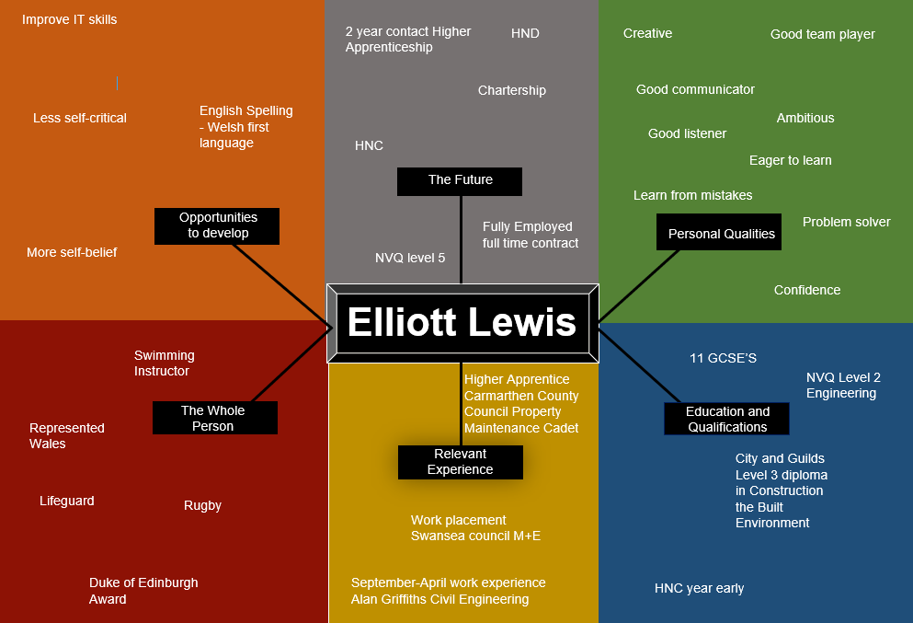

References

Nexus Education (2020) CPD. Available at: CPD (Continuing Professional Development) - Nexus Education (nexus-education.com) (Accessed December 12th)
The daily mind (2020) Mind. Available at: www.thedailymind.com (Accessed December 12th)

