

The principles of evidence-based policing

By Paul Fair

Table of Contents

Introduction | Page 3
Main body: contrast between evidence based policing and traditional policing | Page 3-4
OSARA model | Page 4
ATLAS model | Page 4-5
The NDM | Page 5
Code of Ethics | Page 5
Conclusion | Page 5-6
Bibliography | Page 7-8

Introduction
The following report will outline the principles of evidence-based policing and explain the contrast between evidence based policing and traditional policing methods, the OSARA and ATLAS models, the NDM and the Code of Ethics will be mentioned throughout relating back to my chosen case study.
Telep (2018) states that evidence-based policing is the term used to outline police strategies and tactics that are guided by scientific evidence of effectiveness. There are many different types of evidence but the most used are random experiments that can prove whether a strategy or tactic works.
The case study chosen is the rising crime rates in Adamsdown in 2023, Adamsdown is a community located in the south of Cardiff, the capital city of Wales. Ahmed (2021) states that one resident describes Adamsdown is a "no-go zone" with issues such as drugs, gangs, homelessness, fly-tipping, and stabbings.
The graph below shows that the main 3 reported crimes in the area in 2023 are violence and sexual offences, anti-social behaviour and shoplifting.
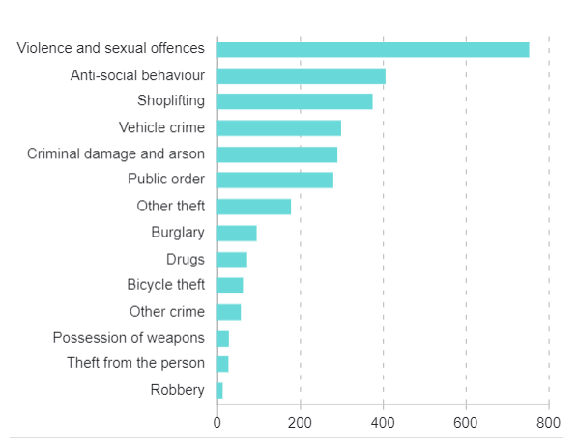

Source: Police.UK (2023)
The contrast between Evidence based policing and traditional policing methods.
At a 2022 international policing conference Sir Mark Rowley outlined the plans for the Mets approach to evidence based policing, the plans included: rebuilding trust between the policing by using data and being more open about how the Met uses and stores this data, pursuing new ways to understand and minimise high harm offences and using evidence such as public opinion surveys to uphold high standards and performance this again defies what is known as ‘traditional’ policing as before they were viewed to be private in the way they share data which concluded with a loss of trust from the public. Alfredo (no date) explains that traditional police investigations, evidence was sometimes based on hearsay which sometimes meant that for example if someone in the area had a reputation of a ‘troublemaker’ they were usually the first person they would look to for a suspect. The introduction of evidence-based policing eradicated this as it involves the use of formal academic research. This academic research is the basis of the following models discussed and has been proven effective.
OSARA model
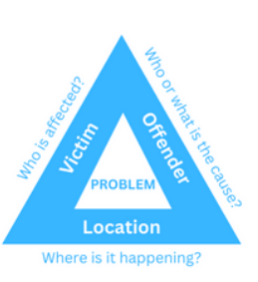
The acronym OSARA stands for: Objective, Scanning, Analysis, Response and Assessment and is the model used for problem solving within the police and identifying issues within communities and aids with developing solutions recurring problems (Healthy Surrey no date). The objective relates to what they aim to achieve with the investigation for example a Dyfed Powys (no date) case study uses the OSARA Model to present an investigation into why they issued a Criminal Behaviour Order (CBO) to tackle anti-social behaviour from a certain individual. The scanning aspect first uses the Problem Analysis Triangle (pictured to the right), this enables communities to identify and understand the problems by recognising who is causing it, who is being affected, and where is it happening. An article on College of Policing (2022) details the remaining aspects as Analysis this is the section of the report where the potential problems are identified and where the evidence is gathered to support the case. Response is the stage of implementing activities to address the causes of the problems being investigated and finally the Assessment is the way the response to the issue is decided to achieve the conclusion they desire.
In relation to the rising crime rates in Cardiff it is essential that the OSARA model is used by the local police force when investigating each individual issue identify patterns in the way these crimes are committed especially regarding the violence and shoplifting there could be an increased patrol around Adamsdown to deter offenders and help the community feel safe.
ATLAS model
Another approach used within evidence-based policing is that of “ATLAS,” which is designed to encourage the police force to:
“Ask questions that challenge current practices.
Test and critically evaluate existing research and new ideas.
Learn from existing approaches and new ideas while considering how they work in workplace practices.
Adapt practices and policies using the best evidence available.
Share the outcomes across the service.”
(Source: College of Policing, 2016)
This again is an effective and easy to remember way to implement the basis of evidence-based policing into the investigations. Adamstown police force could again benefit greatly from using this model to gain convictions of the crimes committed in the area as with a high rate of convictions and punishments being handed out in the areas could work as a deterrent to people in the future.
The National Decision Model (NDM)
The National Decision Model (NDM) as stated on the Open University (no date) website is a framework used by the police to make their decision-making process easier and standardised. It is widely believed that it should be used by everyone who is involved assess and improve all decisions. There are five stages to the NDM they are as follows: Stage 1 – find out all information about the issue, Stage 2 – understand and assess the threat, considering the full situation to make decisions. Stage 3 – this is knowing what the problem is, and what resources are available to fix this situation, Stage 4 – this is when all information has been gathered including researching the policies and other legislations to again find the conclusion to the issue, and finally Stage 5 is finding the appropriate action and performing the action to end the issue.
As areas such as violence and shoplifting have been identified as main issues in Adamsdown using the NDM the local police force need to gather more intel from the local community to understand and asses the threats they feel are most affecting them, this can also be done by liaising with local charities for help understanding which areas need more attention such as a possible large homeless community in the area or just more activities for youths to keep them safe and off the streets. As Adamstown is home to schools within a very diverse City the police should increase their presence here with regular visits and talks to the children about keeping safe and respecting others.
Code of Ethics
The College of Policing (2014) state that the “Code of Ethics are the principles and standards of behaviour that will promote, reinforce and support the highest standards from everyone” The Code helps towards preventing unprofessional behaviour from officers as it provides them with a standard that they are to always maintain especially with the modern view of evidence-based policing, as it always ensures there is a fair and extensive investigation. It is recommended that the local police force in Adamsdown carefully read and abide by the Code of Ethics to ensure they always remain professional, this will allow the local community to trust them more when reporting crimes and providing witness statements that could eventually led to the decline of crimes committed in the area. When the local community trusts the police, it is found that they will respect the local area more and businesses within the community can thrive without worrying about potential harm they may face.
Conclusion
In conclusion it is evident that when the foundations of evidence-base policing are compared to those of the traditional ways of policing it is found to far more effective especially when the OSARA model is used. This is felt to be an effective teaching method to new police officers as it provides them with a simple acronym to remember.
An evidence-based policing success story comes from Stockport, Greater Manchester Police (2024) states that Operation Rimini which was run by the Stockport Central Neighbourhood Policing Team, saw six days of action in in 2023 and secured 39 arrests and 103 charges. Rimini was a combination of policing tactics including high-visibility patrols and plain clothes officers with extra resources committed to the town centre. It is felt that Adamsdown will greatly benefit from implementing the same procedures to bring down the crime rates in the area and leave the local community feeling a lot safer, as like Stockport Adamsdown have a high rate of antisocial behaviour. Slater (2023) wrote after speaking to the police officers in the area responsible for implementing the changes stated that “one of the biggest complaints from those living and working in the town centre was anti-social behaviour. "Aggressive street begging, kids running amok, Off-road bikes, doing wheelies up and down the road,”. These changes being implemented into the city centre allowed more business to join the centre and therefore attracting more people to the area. Adamstown has the potential to become a good town centre as its proximity to the Capitol city centre is a prime location for businesses to want to open there therefore generating more income to the area.
Using these methods of evidence-based policing has been proven to help drastically reduce the crimes and keep them down in the local community as it allows officers to thoroughly investigate the main problems and allow them to find the solutions in the case of Adamsdown is violence and theft so an increase of patrols will solve a lot of the issues.

Word count: 1,511

Bibliography
Chris Slater (2023) How cops in Stockport are getting 'ahead of the game' as the town centre booms Found on: https://www.manchestereveningnews.co.uk/news/greater-manchester-news/how-cops-stockport-getting-ahead-28158950 last accessed: 15.02.2024
Cody W. Telep (2018) Evidence-Based Policing . found on: https://www.oxfordbibliographies.com/display/document/obo-9780195396607/obo-9780195396607-0255.xml last accessed 10.02.2024
College of Policing (2014) Code of Ethics A Code of Practice for the Principles and Standards of Professional Behaviour for the Policing Profession of England and Wales. found on: https://assets.publishing.service.gov.uk/media/5a7d867140f0b65084e75b94/Code_of_Ethics_2014_Web_Accessible.pdf. Last accessed 15.02.2024
David Alfredo (no date) The advantages & disadvantages of evidence-based policing. Found on: https://www.ehow.co.uk/info_8495574_advantages-disadvantages-evidencebased-policing.html. Last accessed: 15.02.2024
Dyfed Powys Police (no date) Case Study . found on: https://asbhelp.co.uk/wp-content/uploads/2021/06/Case-Study-416-Criminal-Behaviour-Order.pdf last accessed: 10.02.2024
Greater Manchester Police (2024) Stockport policing operation secures 39 arrests and 103 charges. Found on: https://www.gmp.police.uk/news/greater-manchester/news/news/2024/january/stockport-policing-operation-secures-39-arrests-and-103-charges/ last accessed 15.02.2024
Healthy Surrey (no date) Problem Solving for Communities Using the OSARA found on : https://www.healthysurrey.org.uk/__data/assets/pdf_file/0011/325919/Problem-Solving-for-Communities-Using-OSARA-accessible-document.pdf last accessed: 10.02.2024
Ian Pepper, Colin Rogers, Helen Martin (2020) Journal of Work-Applied Management Evidence based policing: a view on its development within the police service found on: https://www.emerald.com/insight/content/doi/10.1108/JWAM-01-20200001/full/html#:~:text=One%20approach%20adopted%20within%20policing%20is%20that%20of,while%20considering%20how%20they%20work%20in%20workplace%20practices last accessed: 10.02.2024
Metropolitan Police (2022) Commissioner outlines the Met’s plans for evidence-based policing. Found on: https://news.met.police.uk/news/commissioner-outlines-the-mets-plans-for-evidence-based-policing-455402 last accessed 10.02.2024
Police.UK (2023) Adamsdown found on: https://www.police.uk/pu/your-area/south-wales-police/adamsdown/?tab=Statistics last accessed: 10.02.2024
Reem Ahmed (2021) Life inside divided Cardiff community some have dubbed a 'no-go zone' found on https://www.walesonline.co.uk/news/wales-news/cardiff-adamsdown-safe-police-clifton-21431882 last accessed 10.02.2024

