Developing Wireless Charging Battery Packs For Xbox Controllers
Engineering Project Technical Report

Joe Howard
2100922

University of Wales Trinity Saint David
School of Engineering
Motorsport Engineering BEng (HONS)

28/11/22

Contents

- Introduction…………………………………………………………………….……….1
- Engineering Team Structure………………………………………..……………2
2.1 Figure 1 Evaluation………………………………………………….………….2
3. Processes to develop a Product………………………………….…………...…3
3.1 Problem Solving approaches…………………………..……………...….4
4. Issues, Legislation and Standards………………………………………......….5
4.1 Risks……………………………………………………………..………….….....…5
4.2 Environmental Impact…………………………………….……………….…5
4.3 Ethical Considerations……………………………………..…………………5
4.4 ISO Standards…………………………………………………..…………….….5
4.5 Health and safety………………………………………………………….……6
5. Personal Development……………………………………….………………………7
6. Conclusion…………………………………………………………………….……………8
7. References……………………………………………………………………………..….9
8. Appendix…………………………………………………………………………..……….10

1. Introduction

This technical report will be based on an idea for a revolutionary new product. The product is – Wireless Charging Battery Packs for Xbox Controllers. This report will cover the outline of a proposal, as well as how a CEO would structure an effective engineering team to help bring this product to the market. It will also include problem solving, and how working with different departments (non-engineering based) can help with development. There will also be research into relevant legislation and standards, to ensure the product will conform to all the correct criteria.

1
2. Engineering Team Structure

Figure 1 depicts an example departmental structure. The role of the CEO would be to set the strategy and goals of the organisation and have overall control. Managers are appointed to filter down the vision of the organisation and to lead their team. The managers will also be responsible for communicating with the CEO to give departmental updates regarding progress and to discuss issues that have been encountered that could affect deadlines. Workers for each department will be needed for operation. The departments would be Strategy and design, Planning, Prototyping, Testing, Cost Evaluation and Production. There will also be team leaders to separate the departments into 3 subgroups. A finance and marketing team will also be essential, for selling the product.

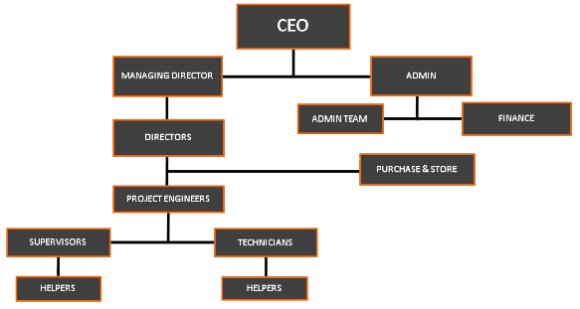
Figure 1-(Organization Hierarchy – AK Engineering, no date)

2.1 Figure 1 Evaluation

This is an effective way to organise a team. It is effective because every department must communicate to the ones next to it in the process, thus resulting in cross-functional working. They must share ideas, research, and designs to assist the next department to ensure specifications are met. It would also be advised to schedule weekly meetings with each internal department to seek progress updates and discuss bottlenecks that can be overcome. As professionalism and hardworking ethics are essential in this industry. The engineers are expected to be respectful and helpful to one another. They must also respect all individual’s beliefs and backgrounds. Any issues that develop between employees should be discussed with the departmental team leaders and/or managers.

2

3. Processes to Develop the Product

After researching team structure, figure 2 shows a well-suited structure for a product proposal. The found example is very useful for giving insight for what an organisation could look like.

In research from Sutton, Product development … (2022c)
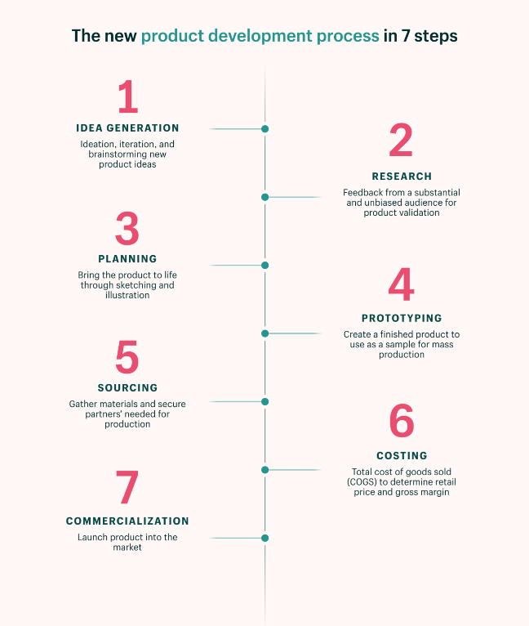
1 – Idea Generation Team – Think of a feasible design, with realistic features. For example, this product would use a plastic casing, with a 4000mah battery inside. This is on par with modern smartphones, so should last for hundreds of gaming hours. And the plastic body is a low-cost option, keeping overheads low.

2 – Research Team – Get feedback from your target market based on the initial design. They must identify the requirements from the customers. What are they looking for? What would they consider essential? How much are they willing to spend?

3 – Planning and Design Team – After being provided with the customer constraints, as well as a generic product shape, this team will design the product. Firstly, with initial sketches. The accurate sketches can be cross referenced with the research team, and with the target audience, which will ensure the design and product will meet the needs of the target audience. CAD renders will then be made, to help with prototyping.

4 – Prototyping Team – This team will be responsible for making a physical prototype, based on feedback from customers, and using the CAD models and drawings. Because the product will be made from plastic, 3D printing could be used for rapid prototyping.

5 and 6 – Sourcing and Costing Team – This team is responsible for assessing the prototype and determining what is needed for full scale production. 5 and 6 have been put together because part of liaising to manufacturers will be obtaining costs from them. These could be for materials, labour, and the cost of bills. They are responsible for talking to manufacturers to find what they can offer. Considerations into assembly of the products will have to be noted. This team is responsible for calculating profit margins based on production cost. They must also set a sensible price for the product, where it fits in with the products already out there. For example, the rechargeable batteries you can buy for gaming controllers.

7 – Launch and Promo Team – This team is responsible for getting the new product everywhere. This can be by working with retailers, or by paying for advertisements. But the costs for paying for advertising must be considered with the costing team. As overheads need to be as low as possible.

3

3.1 Problem Solving Approaches

Problem solving is a skill that every engineer needs as soon as they enter the workplace. Without problem solving, there would be no innovation, no new ideas and nothing to discuss in team meetings. Problems are encountered in every field of work. Especially when it comes to designing and making your own product. There will be problems that pop up that you hadn’t even considered in the design phase. Effective communication is essential to aid with problem solving. If a team encounters a big problem, it should be discussed with all members, to identify solutions together. This gives the best chance of finding a successful outcome.

The easiest problem-solving approach is as follows (with examples relevant to this project)

1 – Identify the problem.

A potential problem has been identified that is affecting the design and sale of the product. The problem is related to battery size and cost. A larger battery size is desired and is unlike anything else on the market. But the bigger batteries are more expensive. The problem is that the team cannot sell the product at the same price point as the existing market with the bigger battery size. It is just too expensive, and the profits would be minimal/ non-existent.

2 – Identify Potential Solutions.

As a team, brainstorm as many potential solutions as possible. And consider negatives of even the best ideas which in turn allows each idea to be evaluated fully. Both solutions have company profits in mind. The first potential solution is to minimise the battery size. This will reduce the cost of manufacturing, to bring the price in line with the market. This will give higher profits. However, without the big battery, the product will not stand out from the rest.
Another potential solution is to raise the cost of the product. The price of the product could be raised to the point that the percentage of revenue is the same as what it would have been before. This could make the product more desirable, however we could sell less units due to the price increase.

3 - Evaluate and Pick a Solution.

As a team, both solutions were discussed with their positives and negatives. It was decided to raise the price per unit, to accommodate for the battery size and cost. It is believed that it is the best idea for the benefit of revenue.

4 – Implement Solution and Evaluate.

The solution should be applied, and the performance/ outcome should be investigated. Has the solution solved the problem? Has it created any other problems? These are just some questions should be asked during the evaluation.

4

4. Issues, Legislation and Standards

4.1 Risks

There are many risks with designing any product. The biggest risk is existing patents or Copyrighted material. A patent, as defined by the ISO website, is “the granting of property right by a sovereign authority to an inventor” (ISO 9000 family — Quality management, 2021c)

This can cover materials, the way a product is assembled, mechanical or electrical devices used. It is essential to check all patents and Intellectual property before starting.

4.2 Environmental Impact

The impact that the product has on the environment will be minimal. All material choices have been considered. A fully sustainable chassis is best suited for the product. This means fully recycled materials and materials that can be recycled must be used. As plastic can now be recycled, It would be ethical to use recycled plastic as a base material. The only other consideration is regarding batteries. Lithium-Ion batteries will be used in this product. After the products lifespan is up, the hope is that the consumer will recycle the product. It will be designed in a way that when the product is end of life (EOL), the user can take the battery and metal pieces out of the shell, and then dispose of all the materials in the correct bins. This will help protect the environment.

An extract from the ISO states “Designed for any type of organisation, regardless of its activity or sector, it can provide assurance to company management and employees as well as external stakeholders that environmental impact is being measured and improved” (ISO 14000 family — Environmental management, 2022) This set of legislation is something that is very important to follow. It is important for the company’s image that this is considered.

4.3 Ethical Considerations

There are no ethical considerations needed for this product. There will be no colours or logos that are offensive to any individual from any background. The product will be black in colour with no logos.

4.4 ISO Standards

ISO standards are essentially a set of instructions for the best and most effective way of carrying out a process. ISO 9001 specifically investigates the quality of products with a significant customer focus. ISO Standards should be considered with designing and selling any product as it protects the manufacturer and customer. ISO 9001 is an essential consideration for any product design team. The customer, satisfaction and reliability of the product should be at the forefront of everyone's minds.

An extract from the ISO standards website states “Using 9001 will help to ensure that customers get consistent, good quality products and services, which in turn will bring many business benefits.” (ISO 9000 family — Quality management, 2021c)
5

4.5 Health and Safety

The product will be nontoxic, so will not cause harm to children. The batteries should be treated with care and should not be bent or squashed. The product will be manufactured using automated processes, like injection moulding. So, there will be minimal human input which in turn reduces the chances of risks developing.

Health and safety at Work act 1974-

This act is relevant to a broad range of issues in the workplace. Fines and prison sentences can be given out to any companies that do not adhere to this act. This is unless guidelines are followed by an organisation, but the individual employee refuses to follow the rules. For example, not wearing PPE, ignoring warning signs or refusing the relevant training to name but a few.

Control Of Substances Hazardous to Health 2002-

These regulations refer to the safe storing of chemicals and compounds that are dangerous to living creatures. For example, oils, solvents, fuels, paints, and cleaners. All these chemicals could be dangerous if used incorrectly, or if spilled. COSHH refers to the safe storage and use of the substances involved.

Information for HASAWA 1974 and COSHH 2002 was found at using (Health and safety legislation - overview for social care, no date)

6
5. Personal Development

My personal development is very important to me. It is something I plan on focusing on every day while studying here at UWTSD. I think the most important thing that will help me develop is listening skills. I enjoy spending time working with the race team, where I extract and absorb valuable information from experienced students. This will help me develop to become a skilful member of the race team. I always make sure I listen to all my lecturers. The information they give out is very valuable. As a first-year student, I understand and accept that my knowledge and confidence is not very high. But listening to experienced peers will assist with my development. This will help me achieve my goals. My goals are to come out with the highest grade possible in 3rd year, and to help run the race team and push for race wins. I need to develop my resilience more before I can be successful, however. I tend to give up when I have a big problem with an assignment. I do manage to get over it, but I need to keep my spirits up and stop the initial difficulties and hesitation.

7

6. Conclusion

In conclusion, being an effective team leader takes confidence and patience. An efficient team to run the departments is needed. It is important to ensure that every individual is happy and shown respect. And most importantly communication is essential. Effective communication between departments or colleagues will reduce risks and mistakes. Every individual’s opinion must be respected when it comes to decisions or idea gathering as everyone has an equal opinion. To successfully develop a product, experienced team leaders should be hired for every department to help things run smoothly. Preferably they would have experience in the required industry. Weekly meetings should also be held, to emphasise the importance of communication.

8

7. References

Organization Hierarchy – AK Engineering (no date). Available at: http://a-kengineering.com/?page_id=416

Sutton, M.-R. (2022) The 7 Step Product Development Process (2022). Available at: https://www.shopify.com/blog/product-development-process.

ISO 9000 family — Quality management (2021c). Available at: https://www.iso.org/iso-9001-quality-management.html.

ISO 14000 family — Environmental management (2022). Available at: https://www.iso.org/iso-14001-environmental-management.html.

Health and safety legislation - overview for social care (no date). Available at: Health and safety legislation | Overview for social care | SCIE

9
8. Appendix

Word count without Contents, references and Appendix : 2168

Word Count total : 2329

10

