Observational Analysis – Game U10 GIRLS RED TEAM
Physical | Technical | Tactical | Psychological
- Centre back is too small for position. | - Midfielder not moving and providing an option to receive ball. | - Played ball straight to opposition defender instead of passing it back to own defenders. | - Lack of motivation after conceding goal
 | - Ball played to opposition defender instead of teammate who was open and through on goal. |  | - Teammates don’t seem to be close to each other e.g. not celebrating with eachother, very anti-social
- Height mismatch in marking |  | - Goal scorer not marked tightly enough in box | - Poor decision making when passing
- Defender way taller than attacker, not enough strength |  | - No options for attacker to pass to when being pressed by 4 defenders  - Attacker unmarked during buildup play | - Poor decision from goalkeeper, passing to player obstructed by opposition player with plenty of better options.
Overall Review and Link to Session Planner:
Overall the biggest issue with this game was the decision making of players to pass to and the passes in general were very sloppy.

UWTSD Session Planner
Venue: |  |  | Age group:  Number Attending:
Date |  |  | Start time:  Finish time:
Equipment:

Nearest Telephone: | 1st Aid bag:
Risk Assessment completed: | Additional Hazards and actions taken:
Learning from Observational Analysis:  Passing ability needs to be improved aswell as the decision of who to pass to |  | Personal action points Observational Analysis:
Goals for the session:
Improve passing ability

Introduction and warm-up
Stuck in the mud 5 minutes

Main Content/Game  - Rondo – 5v2, 2 players in middle trying to intercept pass while players on the outside pass around them.  - Foot tennis - Play football tennis with one bounce allowed on each side, aiming for open spaces or teammates.  - 2v1 shuttle - Two attackers try to combine against one defender in a tight space, forcing quick decisions and precise passes. |  | Organisation/diagram  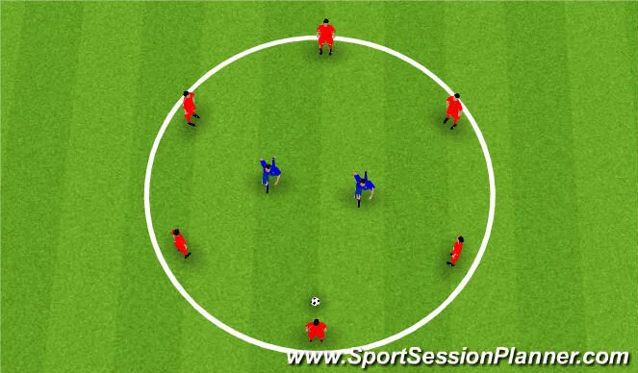  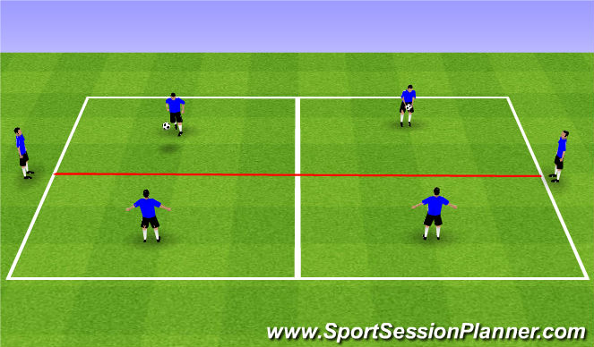  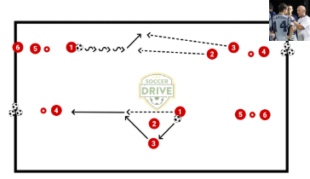
Ideas for Development (progression / regression):  - Add more defenders in the middle and close down the circle  - Add more players on each side and make it so that everyone on the team has to have a touch before hitting it over the other side |  | Diagram for activity

5Cs to be included in this session | Select 2 of the 5 and apply to session  HOW?
Competence

Confidence:

Connection:

Character and caring:

Creativity:

Cool-down:

Observational Analysis – Game SENIORS RED TEAM
Physical | Technical | Tactical | Psychological
- Number 11 lost his man after throw in
- Centre back should’ve passed to number 2 who had space and was calling for the ball.
 |  | - Pressure from number 11 onto 12 should be earlier | - BF forward has rushed the opposition keeper and powered through him, making the keeper rush his decision
- Two tall players on the goalkeeper but still the goal keeper fisted it away |  | - Number 11 leaving number 12 unmarked for the header | - Number 11 lacks good decision making he is leaving everyone run past him with no effort to get the ball.
 | - Poor attempt to play ball back to other player | - Crossed to early should’ve carried ball a bit more | - Left winger is constantly crossing to early and is not driving on to get closer to the box.
Overall Review and Link to Session Planner:

UWTSD Session Planner
Venue: |  |  | Age group:  Number Attending:
Date |  |  | Start time:  Finish time:
Equipment:

Nearest Telephone: | 1st Aid bag:
Risk Assessment completed: | Additional Hazards and actions taken:
Learning from Observational Analysis: |  | Personal action points Observational Analysis:
Goals for the session:

.
Introduction and warm-up

Main Content/Game |  | Organisation/diagram
Ideas for Development (progression / regression): |  | Diagram for activity

5Cs to be included in this session | Select 2 of the 5 and apply to session  HOW?
Competence

Confidence:

Connection:

Character and caring:

Creativity:

Cool-down:

Observational Analysis – Game BOY’S U13’S RED TEAM
Physical | Technical | Tactical | Psychological
- Bit of a height mismatch for the corner | - Headed the ball towards own goal instead of opposition goal | - Number 5 gives attacker too much space to get shot off | - Attacker felt pressured by keeper coming out when it reality he could’ve won the ball easily
- CB overpowered by ST | - Keeper should have caught it instead of palming it away | - Not challenging for the ball during header
- Opposition appear to be a lot taller and stronger in general | - Bad pass straight to opposition defence
- Another big height mismatch during defending corner  - Wide player outstrengthened in buildup to the goal | - Heavy touch on the attack led to ball being lost#  - Poor cross
Overall Review and Link to Session Planner:

UWTSD Session Planner
Venue: |  |  | Age group:  Number Attending:
Date |  |  | Start time:  Finish time:
Equipment:

Nearest Telephone: | 1st Aid bag:
Risk Assessment completed: | Additional Hazards and actions taken:
Learning from Observational Analysis: |  | Personal action points Observational Analysis:
Goals for the session:

.
Introduction and warm-up

Main Content/Game |  | Organisation/diagram
Ideas for Development (progression / regression): |  | Diagram for activity

5Cs to be included in this session | Select 2 of the 5 and apply to session  HOW?
Competence

Confidence:

Connection:

Character and caring:

Creativity:

Cool-down:

