

RE-BUILD AND MODIFICATION OF AN OLD STEAM PROVER SYSTEM, READY TO BE USED IN A RENOVATED FACTORY.
by
Chris Taylor
Supervisor: Dr Gareth Jones and Dr Garry Jones

Project submitted as part of the requirements for the award of
BEng(Hons) Electrical and Electronic Engineering

April 2017
Contents

1.0 Table of Figures 3
2.0 Declaration and Form of Consent 5
3.0 Abstract 6
4.0 Introduction and Project Overview 7
5.0 Company Background 8
6.0 Research Methodology 9
6.1 Research Philosophy 10
6.2 Research Approaches 11
6.3 Research Strategies 11
6.4 Time Horizons 12
6.5 Data Collection Methods 13
7.0 What is a Steam Prover? 15
8.0 The Problem and Desired Outcome 16
9.0 Background Research 18
9.1 PLC Systems and Types 19
9.1.0 Power Supply Module 19
9.1.1 Central Processor Unit 20
9.1.2 I/O Modules 20
9.1.3 Ladder Logic Programming 22
9.1.4 PLC Manufacturers 24
9.1.5 Operational Block Diagram 24
9.2 Inverters and Speed Control 25
9.2.0 How VFDs Work 25
9.3 Safety Systems 28
9.4 Photoelectric Sensors ^{[29]} 30
9.4.0 Photo Electric Sensor Modes/Types 31
9.5 HMI Touch Screen 37
9.6 Cables Types/Sizes 38
9.6.0 Cables Types 38
10.0 Required Parts List 41
11.0 Costing Matrix 47
12.0 Regulations 49
13.0 Time Management 51
14.0 HMI Screen 55
14.1 Designing 55
14.2 Downloading 59
15.0 Designing the Electrical Drawings 61
16.0 Designing the Panel 66
17.0 Wiring the Panel 68
18.0 Designing the Facia Plate 76
19.0 Evaluation 78
20.0 Conclusion and Recommendations 79
21.0 Reflection 80
22.0 Referencing 81

Table of Figures

Figure 1 Automated Plant at Pen-Y-Fan. ^{[1]} 8
Figure 2 Braces Logo ^{[1]} 8
Figure 3 Example of a Research Methodology Diagram ^{[3]} 9
Figure 4 Research Onion used for this project ^{[4]} 9
Figure 5 Inside of a Swing Steam Prover ^{[13]} 15
Figure 6 Interior pictures of obsolete panel 16
Figure 7 Exterior of Obsolete Panel 16
Figure 8 PLC Power Supply Module ^{[15]} 19
Figure 9 PLC Central Processor Unit ^{[16]} 20
Figure 10 PLC I/O Module ^{[17]} 20
Figure 11 Complete PLC Unit - including CPU, PSU and I/O Cards ^{[18]} 21
Figure 12 Simple Pushbutton and Light programming sequence ^{[20]} 22
Figure 13 Simple Start/Stop Circuit programming sequence ^{[21]} 22
Figure 14 A more complicated programming sequence, including: Motors and Timers ^{[22]} 23
Figure 15 Block Diagram showing sequence of events within PLC operations 24
Figure 16 Example of an Inverter Drive [25] 25
Figure 17 Variable Drive Frequency Explained 25
Figure 18 Variable drive Frequency with added Smoothing Capacitors 26
Figure 19 How adding a Smoothing Capacitor affects the Output Signal 26
Figure 20 Waveform without a Smoothing Capacitor ^{[26]} 27
Figure 21 Fluctuation smoothed out when Capacitor is introduced ^{[26]} 27
Figure 22 Sequence of events from the AC Line through to the Motor ^{[24]} 27
Figure 23 Different PILZ Systems available ^{[27]} 28
Figure 24 Interior of a Photoelectric Sensor 30
Figure 25 Different options of Sensor available ^{[30]} 31
Figure 26 Diffused Sensor ^{[31]} 31
Figure 27 Example of Barrel Sensor ^{[32]} 32
Figure 28 Diffused Convergent Beam Mode Sensor 33
Figure 29 Mechanical Suppression Sensor 34
Figure 30 Electrical Compression Sensor 34
Figure 31 Retro Reflective Sensors ^{[33]} 35
Figure 32 Type of Retro Reflective Sensor ^{[33]} 35
Figure 33 Through-Beam Type Sensor ^{[34]} 36
Figure 34 How a Through-Beam Sensor can be used to detect various products ^{[34]} 36
Figure 35 Example of a HMI Touch Screen ^{[35]} 37
Figure 36 Small round HMI Screen ^{[36]} 37
Figure 37 Available sizes of HMI Screens ^{[37]} 37
Figure 38 Single Core Cable ^{[38]} 38
Figure 39 Coaxial Cable ^{[39]} 38
Figure 40 Paired Cable ^{[40]} 38
Figure 41 Comparison of Old and New Colours ^{[41]} 39
Figure 42 Variation in sizes of Cable available ^{[42]} 39
Figure 43 Required parts: Power MCBs 41
Figure 44 Required parts: Control MCBs 42
Figure 45 Required parts: Contactors and Inverters 43
Figure 46 Required parts: Finished List 45
Figure 47 Costing Matrix 48
Figure 48 Task List with added Resources 51
Figure 49 Gantt chart: First 5 Weeks 52
Figure 50 Gantt chart: Completion Example 53
Figure 51 Gantt chart: Task Delay Example 53
Figure 52 Gantt chart: Task Delay Example 2 53
Figure 53 Gantt chart: Task Delay Completion Example 54
Figure 54 Starting a new Pro-face Project 55
Figure 55 New Project Screen Options and Specifications 55
Figure 56 New Project PLC selection 56
Figure 57 New Project Main Screen 56
Figure 58 Prover Overview Screen 57
Figure 59 Prover Monitor Screen 57
Figure 60 Screen Change Options 57
Figure 61 Screen Numeric Display 58
Figure 62 Numeric Display Options 58
Figure 63 Password Selection 58
Figure 64 Keypad to enter Password 58
Figure 65 Trending Graph - Temperature 59
Figure 66 Transferring the Project 59
Figure 67 Project Transfer Options 60
Figure 68 Desktop Screen Testing 60
Figure 69 DesignSpark Electrical 61
Figure 70 DesignSpark Regulation Selection 61
Figure 71 Drawing options 62
Figure 72 Electrical Drawing Front Page 62
Figure 73 Electrical Drawing Index page 62
Figure 74 Drawing Selection 63
Figure 75 DesignSpark Drawing Tools 63
Figure 76 DesignSpark Electrical Components Available 63
Figure 77 Drawing and Labelling the Wires 64
Figure 78 Numbering each Wire 64
Figure 79 Labelling all Components 64
Figure 80 Example of Control and Numbers 65
Figure 81 Example of Mains and Numbers 65
Figure 82 Panel Layout 66
Figure 83 Layout of Panel with Din Rail and Trunking Secured 67
Figure 84 Ferrules available ^{[43]} 68
Figure 85 Ferrules Required ^{[44]} 68
Figure 86 Wiring into PLC 69
Figure 87 PLC wiring into Terminals 69
Figure 88 Wiring into Contactors 70
Figure 89 24V+ into Terminals 70
Figure 90 Inverter Terminal Options 71
Figure 91 PILZ Relay Terminal Options 72
Figure 92 Contactor Connections 73
Figure 93 Safety Relay connections 74
Figure 94 Facia Plate design 76
Figure 95 Green Button used on Door ^{[45]} 77
Figure 96 Emergency Stop used on Door ^{[46]} 77

Declaration and Form of Consent

I, Christopher John Taylor declare that I am the sole author of this Project; that all references cited have been consulted; that I have conducted all work of which this is a record, and that the finished work lies within the prescribed word limits.
This work has not previously been accepted as part of any other degree submission.

Signed:

Date:

FORM OF CONSENT

I, Christopher John Taylor hereby consent that my Project, submitted in candidature for the B.Sc. (Hons) Electrical and Electronic Engineering degree, if successful, may be made available for inter-library loan or photocopying (subject to the law of copyright), and that the title and abstract may be made available to outside organisations.

Signed:

Date:

Abstract

The following report documents the re-designing, modification and manufacturing of an Electrical Panel that will be fitted into a newly renovated factory. The Panel will be used to operate a Steam Prover within a leading manufacturer of Bread and other Bakery products.
Research Methodologies were used which outlines the different tasks undertaken during the Background Research of the project. This was used to find the correct components for the job. The aim was to re-design the Panel to allow the end user to have complete control over the system.

Introduction and Project Overview

This report outlines the process of design of an Electrical Panel from the very initial stages, through to building a final product and programming it to suit the requirements.
The panel that was designed replaced an obsolete panel that was in an unsafe condition to be in operation. It controls a Steam Prover, which includes a 28 Swing rotating system that carries Tins around an enclosed space, an Infeed and Outfeed Pusher system, Automatic Steam Control with Air Conditioning options, Infeed and Outfeed Conveyor systems and Manual Chain Oiling.
Included in the report will be ‘Background Research’ on the different components that were needed to improve the panel such as PLC Types, Inverter Drives, Power Supply Units (PSUs) etc. and includes information that assisted with the designing of the Safety Systems, and HMI Screen later in the project, all of which are modifications to the Prover to make it easier and more efficient for the Operator to use.
Using this background research, a ‘Required Parts List’ will be shown which will show all the parts needed for the project, which became a ‘Costing Matrix’, outlining the entire cost to make the project.
Different Rules and Regulations were looked at to ensure that the Panel being built met the requirements of Health Safety and Environment, ensuring maximum safety for all the users and operators who will have to use this ProverThe report includes the designing of the HMI Screen, and how it was completed and then transferred over to the screen itself moving onto the Electrical Drawings, detailing how they were produced and adjusted through the process to fit the requirements. This allowed the panel to be designed, with the main sections of the report including the ‘Designing of the Panel’, and ‘Wiring the Panel’ which describes the steps taken to successfully complete the interior areas of the panel. After the interiors were completed, the exterior of the panel was then shown and information provided on how this was successfully completed.

Company Background

The Company funding and sponsoring the Project are Braces Bakery LTD. Braces Bakery majorly produce bread, and are major suppliers through the UK, where the product can be found in over 3,000 stores around the country.
It produces an annual turnover of £40 million, and its distribution mainly covers South/South-East Wales, and the South/South-West of England where its products are found in major leading stores such as: Tesco, Asda, Sainsbury’s and Morrison’s. They employ 280 people and have their own fleet of vehicles
Braces Bakery currently has three factories, a state of the art bread plant bakery at Pen-Y-Fan producing 6,000 loaves per hour and a bakery at Rogerstone, Newport producing bread for the sandwich industry, as well as the main stream bread range. A third bakery at Croespenmaen is in a renovation period and will reopen mid-2017. ^{[1]}
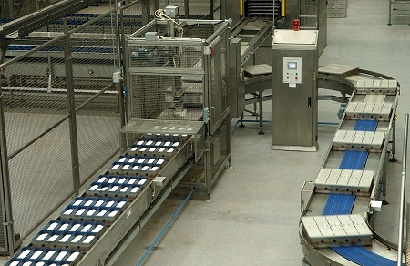
Figure 1 Automated Plant at Pen-Y-Fan. ^{[1]}



Figure 2 Braces Logo ^{[1]}

Research Methodology

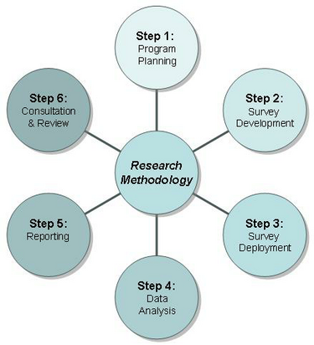
A ‘Methodology’ is the systematic, and theoretical analysis of the methods applied to a field of study. It is made up of the theoretical analysis of the different methods and principles when considering different areas of the required field. ^{[2]} It can include different techniques, some being:
- A Paradigm,
- Theoretical Model,
Figure 3 Example of a Research Methodology Diagram ^{[3]}
- Phases,
- Quantitative/Qualitative diagrams, etc.
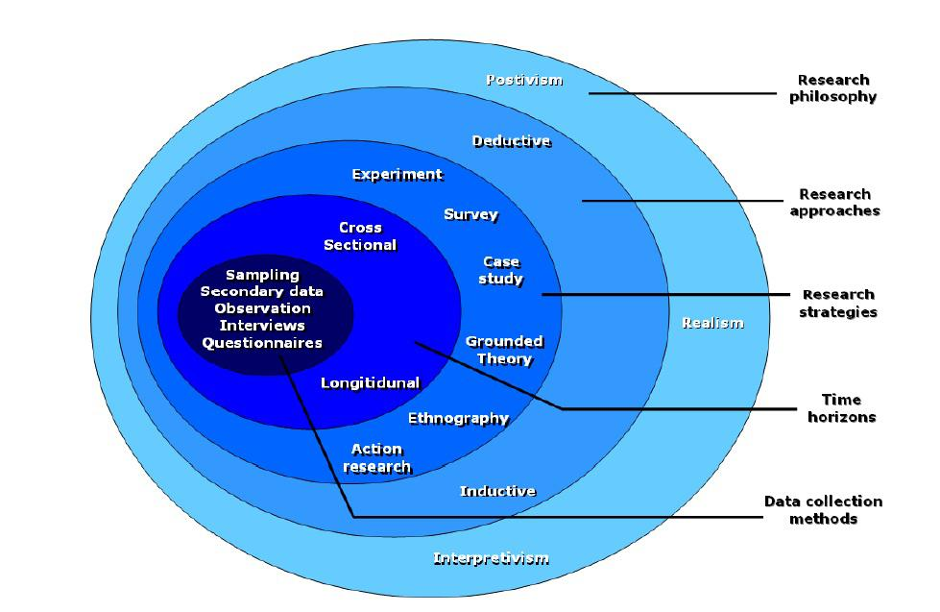
When carrying out the Research Methodology for this project, a diagram called a ‘Research Onion’ was used.
Within the Onion are five different sections, which contain smaller, more detailed sections within them. Section 6.1 to 6.5 explain each layer and how each can and were used.

Figure 4 Research Onion used for this project ^{[4]}

Research Philosophy

This first section refers to how the Research Methodology will be carried out, it creates assumptions which justify how the research will take place. The different areas of knowledge are taken into consideration, from which it is decided what needs to be looked at the most to improve the knowledge within that section. ^{[5]}
- Positivism
The view that all the factual knowledge can be gained through observation.
- Realism
The view that all factual knowledge can be gained by experiments, and scientific data collections.
- Interpretivism
The view that all factual knowledge can be gained using human interests into a study, using social options such as meetings.
When integrating this section into my project, both Positivism and Interpretivism will be used. Several observations will be carried out, using observation of current Machines to build an idea of what of what is required during the project. Interpretivism will also be used as it includes social events such as meetings, which will incorporate the human interests into the project. The final design can be adjusted to suit the requirements of those using it, and the factual knowledge gained from Observations of current factory issues can also be used to add modifications into the designs.

Research Approaches

This section covers how the research will be looked at, and approached during the process. It provides two main sections when considering which direction will be taken. ^{[6]}
- Deductive
Uses known theories and hypothesis of a machine to determine what issues to avoid. ^{[7]}
- Inductive
Uses Data Sets and Data patterns to justify a relationship with the current issues with a machine. ^{[8]}
When doing this section of the Research Methodology, the means of Deductive Research approach will be used, and it will use current theories and ideas of current operators to enable the new project to be designed around any probably issues. However, Inductive Research could be used, using an Alarm List or Breakdown Reports to build data of what issues arise the most.

Research Strategies

This is the largest section within the Research Onion, it is the general plan that helps answer questions in a systematic way. They contain clear objectives and questions, and can include data collection resources.
- Experiment
Uses small tests to prove or justify or prove a change/design that has been made.
- Survey
Uses different human interactions to gain information, can include interviews, or questionnaires.
- Case Study
Analyse specific issues with a product, or design.
- Grounded Theory
Includes a collection of data which provides grounded information and qualitative data.
- Ethnography
Includes information collected over months, or even years to provide data. ^{[9]}
- Action Research
Involves the meeting and/or the collaboration with an operator or machine user who provides feedback. ^{[10]}
When using Research Strategies for the project, several were used to obtain the required successful outcome. A Survey was carried outwith the Operators currently using the machine within the business, who provided feedback on what could be changed to improve its design. Engineers were also asked in relation to the different components used within the panel and which were the most efficient and easiest to use. Action Research was also used, which provided equivalent results to the Survey.

Time Horizons
Time Horizons, also known as Planning Horizon, is a fixed point in time in the near or distant future which states that certain processes will be evaluated or assumed to end, acting as a deadline.
- Cross Sectional
Collection of data on one occasion throughout the project process. ^{[11]}
- Longitudinal
Collection of data in one area on several occasions throughout the project process. ^{[11]}
Longitudinal studies will be carried out, in the form of a Gantt chart and interviews. It will include surveys over a prolonged period, collecting data to achieve a successful outcome.

Data Collection Methods

Data Collection is a process of collecting, gathering and measuring information on different variables set within the project, where it is carried out in an established systematic fashion allowing the results to be easy to compare to improve the project outcome. ^{[12]}
It can however be divided into two sections,
- Secondary Data Collection: Data that has already been published in books, online, newspapers etc.
- Primary Data Collection
  - Quantitative data: Include mathematical calculations in various formats, and can include questionnaire answer results and general average functions including, mean, median, mode etc.
  - Qualitative data: Doesn’t involve numbers or calculations, but more data in words using thoughts, feelings, colours etc. However, the data is less quantifiable.
Smaller section within this layer of the research onion, include:
- Sampling
Taking a small, rough numbers of results and using them as an overall conclusion as the data. For example, asking 200 people their views on the final project, and using 50 results to gauge an overall feeling.
- Observation
A means of collecting data through observation. Watching operators use equipment, observing techniques and issues that may arise.
- Interviews
A form of asking an individual specific question, then collecting and comparing the results.

- Questionnaires
Less personal interactions, but more paper based questions and answers, results can be compared like Interviews. Usually used on a much larger scale.
Within this section, several different methodologies and data collection can be used to suit what data is required. As only a small number of operators use the machine, Sampling would be inefficient, however interviews or questionnaires would be a lot more useful, and the data received would be much more accurate and understandable. Also, observations can be used, watching the operators operate the current machine, noting and watching all the problems that could occur, but also find any processes that help the operator do the job more efficiently.

What is a Steam Prover?

A Steam Prover is a custom designed enclosed space that can create an optimum environment that is required to successfully Proof the Dough or Bakery Products being made.
It incorporates this enclosed space with an air flow system, where the temperature, humidity and airflow can be monitored and adjusted throughout the system. ^{[2]}
Steam Provers can come in assorted designs dependant on the product being made. A Steam Prover used for Bread will tend to use ‘Swings’. These swings will be moved around the Prover between two drive chains and will carry as many Tins as the space can allow.
The Prover can also vary in time it takes to do a complete cycle, which is generally manually operated to suit the product. When Bread is being produced, the Prover tends to vary between 50 and 55 minute periods.
On the infeed, there will be a conveyor that carries the Tins, which will then be batched in the amount allowed. When the batch is full the conveyor stops and a pusher arm will drop and push the Tins onto a swing of the Prover.
The outfeed is similar, when the swing drops to the correct location, the pusher pushes the Tins out onto a conveyor which carries them away to the next step of the process.
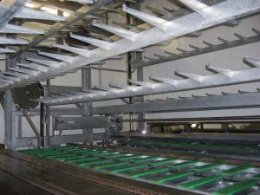
The Prover will contain temperature and humidity probes, which will send a signal back to the Panel to allow it to maintain a fixed level that has been selected. The humidity is normally set around 80%, whilst the temperature varies around 40ºC.
Figure 5 Inside of a Swing Steam Prover ^{[13]}

The Problem and Desired Outcome

The current problem within the Croespenmaen bakery is that it has two plants (B Plant and C Plant) which can be put into full operation in July 2017.However, B Plants facilities are considerably less user friendly and are more outdated than on C Plant.
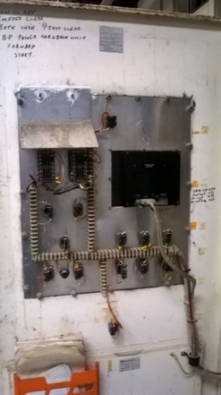
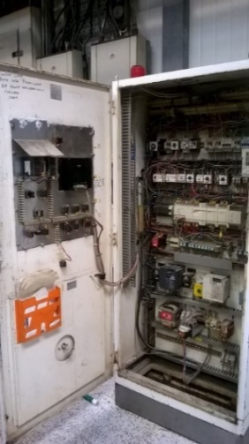
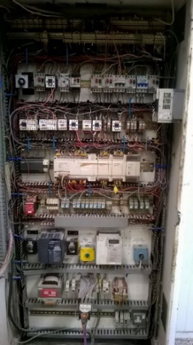
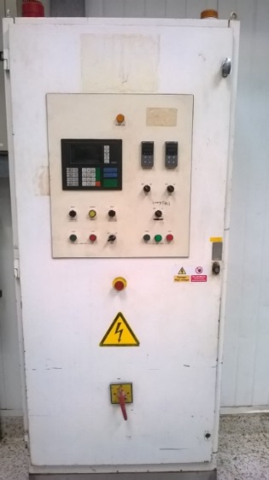
The current Panels and Operating Functions do not allow full control of B plant, and limits the amount of adjustments that can be made mid run meaning that a lot more product is wasted during a production run. When looking at the entire Plant, it was evident that the Prover was the worst plant for both Operators and Engineers to work on, as it allowed no assistance to a breakdown situation, and limited the adjustments that the Operators could make. The internals of the panel were badly organised and poorly maintained, generally created by the amount of wiring adjustments that had be made over the many years that it was in operation. Several types of inverters had been fitted, the wiring numbers had become jumbled and the wires and links had been scattered throughout the panel with no way of tracking the system. The externals were also very limiting, the screen was not touch screen, and showed very little amount of detail for the Engineers attending a breakdown, and the Operators wishing to monitor or adjust the system. There were different switches added over the years, with no proper markings making it more likely for mistakes when the Prover was in operation. Several pictures are showing the state of the Panel that was operating the Prover.
Figure 6 Interior pictures of obsolete panel
Figure 7 Exterior of Obsolete Panel

The desired outcome of the new panel was to update all the wiring within the panel, and make it a lot more user friendly for engineers that may need to work on it. It was designed to meet all wiring rules and regulations, and the new components were all supplied by the same manufacture, ensuring continuity throughout the whole panel.
The front of the panel had a new facia plate, with a brand new 5.7-inch touch screen, which would provide all users with a clear visual of the Prover operations. Included was also product tracking, easy Temperature and Humidity adjustments, and any speed adjustments that may be required during a product run. Buttons would also be properly marked, and make the Prover easy to operate, with easy START, STOP, STEAM ON/OFF, RESET buttons making it easy to be controlled.

Background Research

Background Research was carried out to obtain some extra understanding and knowledge of what was going to be used to complete the Project. It also helps as several components of the same type can be found, analysed and compared and the best can be chosen to be purchased, it ensured that the final Project will be up to a high standard.
Some of the subjects that were looked at in detail, include:
- PLC Systems,
- Sensor Types,
- Inverters,
- Steam Control,
- PILZ Safety Systems,

PLC Systems and Types

A PLC, or Programmable Logic Controller, is used to control a sequence of events, and can be programmed and adjusted to suit the process requirements. They were designed to reduce the use of Relays and Timers in older fashioned Control Panel, and a lot a lot more adjustment and control to the system that they are controlling. ^{[14]}
They are made up of three main parts:
- A Power Supply Module,
- A Central Processor Unit (CPU),
- I/O Module(s).

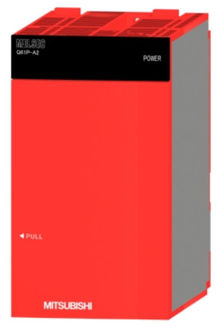
9.1.0 Power Supply Module

This module is normally attached to the CPU and I/O Modules, where it supplies the required Power to ensure the PLC runs correctly. The CPU and I/O Modules use DC power; therefore, this Power Supply Unit will convert the AC power into the required DC.
The circuitry used within the CPU uses 5V of DC power, and there is also an output of 24V which is used to supply the Sensors, Solenoids, and Actuators that are being used within the PLC programme.
Figure 8 PLC Power Supply Module ^{[15]}

Central Processor Unit
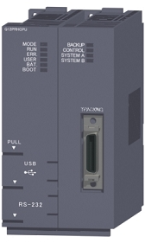
This unit is made up of a central processor that drives the PLC software, and the memory that stores the programme. The Processor part of the CPU is used and responsible for using the inputs it gets from the components being used, and doing the computations and processing the correct outputs in line with the programme in place.
The Memory part of the CPU includes both a RAM memory, and a ROM memory. The RAM is used to store the programme written by the user, and hold all the data movements required. Whereas the ROM memory contains all the driver and application programmes, and the actual operating system. The memory is a retentive memory, therefore if the Power is lost to the PLC, the memory and programme will still be stored and held in the PLC.
Figure 9 PLC Central Processor Unit ^{[16]}

I/O Modules
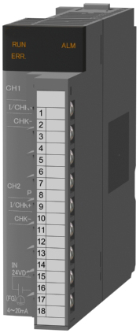
There are Input and Output modules on a PLC that are used and can be changed accordingly depending on the amount of I/O being used within the Programme. An Input card would be connected to external Sensors, these sensors would send a pulse back to the PLC signifying when it has been covered or blipped. The programme within the PLC would then use this input, and in turn send the correct output to a device, this could include a Motor to start, or a Solenoid to energise.
Figure 10 PLC I/O Module ^{[17]}
Among these Input and Output Modules, there are several types available, including:
- Digital Modules,
- Analogue Modules,
- Communication Interface Modules.

9.1.2.0 Digital I/O Modules
A Digital card would be connected to Sensors and Solenoid, where the state of the component is either ON (1) or OFF (0). They can be either AC or DC power supplied, and can come in varied sizes dependant on the user requirements.

Analogue I/O Modules
An Analogue Module would be connected to Sensors that offer a much wider range of signals, and would be used for measuring temperature or distance. However, within these modules will be an A/D Converter, where the analogue signal will be converted to a digital signal in which the processor can understand.

Communication Interface Modules
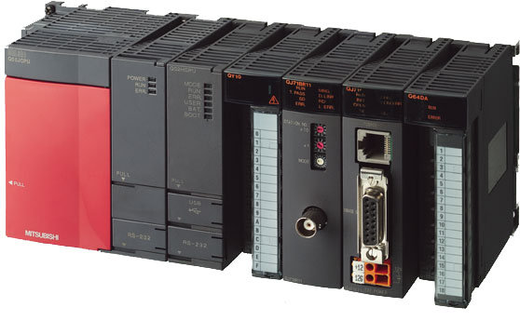
These are merely used to transfer and exchange data and information between the PLC CPU and a communication network. This could be communicating with other PLCs within a factory, or providing information to a HMI Screen within the factory.

Figure 11 Complete PLC Unit - including CPU, PSU and I/O Cards ^{[18]}

Ladder Logic Programming

Ladder Logic Programming is the name for the type of programme that is written and put into a PLC for it to operate as the user requires. ^{[19]}
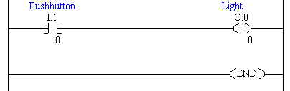
It consists of horizontal ‘rungs’ that contain contrasting functions that can be added and adjusted by the user to suit. The functions that can be added start from a simple ‘Normally Open’ (NO) or ‘Normally Closed’ (NC) contact, these will then lead to an output contact called a ‘Coil’.

Figure 12 Simple Pushbutton and Light programming sequence ^{[20]}

The picture above shows how there is a simple NO contact tagged to a pushbutton, with the output contact being a light. This shows that when the pushbutton is pressed, this contact will energize within the program and the light will come on.
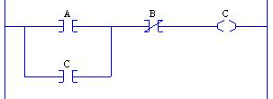

Figure 13 Simple Start/Stop Circuit programming sequence ^{[21]}

This is a slightly more technical example of Ladder Logic. It is a simple Start/Stop circuit. In this circuit, the contact tags represent the following:
- A: Start Button
- B: Stop Button
- C: Conveyor
This section of program shows that when ‘A’ is energized, ‘C’ will operate and the conveyor will start. With the output coil, ‘C’ now energized, it triggers the NO open contact ‘C’ to also energize, this then latches the system in a loop. This conveyor will now continue to run even when the pushbutton is released.
‘B’ represents the stop button, whenever this is pressed, the conveyor will stop as the NC contact will open, and break the circuit. The system can only be restarted when ‘B’ is released, and the Start button, ‘A’ is repressed.
There are several more in depth functions that can be added, mainly including Timers and Counters which uses the PLCs interface to store and compute this information. Mathematical functions can also be introduced such as, Add, Subtract, Times and Divide. These can be used to do mathematical operations within the PLC, for example, there could be a system with a sensor counting how many products are going around a system. This counter will be within the program, a Times and Divide function could then be used to calculate the efficiency or Waste figures of this product through the system.
Every contact and coil within the program must be tagged with relation to where these Input/Outputs have been wired into the PLC. The Cards will have X Input numbers, and Y Output Numbers on the cards, these must then be tagged within the program.
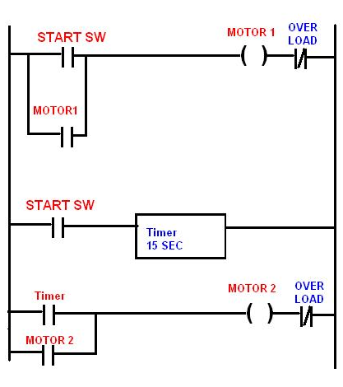

Figure 14 A more complicated programming sequence, including: Motors and Timers ^{[22]}

Above is an example of a slightly more in depth piece of Ladder Logic, it shows that when the Start Switch is on, Motor 1 will start. Once this switch has been activated, it triggers the Timer, this counts to 15 seconds. Once this reaches the 15 seconds, the Time NO contact on the bottom rung is energized which will in turn start Motor 2. Both these rungs also have the latching feature previously explained, so both Motor will continue to run until the Start Switch is turned off.

PLC Manufacturers

There are several different manufacturers of PLCs, each with their own different systems and computing devices. They all use the same idea with Ladder Logic control and I/O Card modules, but each are slightly different and suit different operations in several ways. Some of the most renowned manufacturers include:
- Allen Bradley,
- Mitsubishi,
- Siemens,
- Omron,
- Hitachi,
- Honeywell,
- Schneider,
- Bosch.

Operational Block Diagram
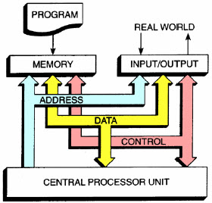
Figure 15 is a block diagram showing the sequence of events within a PLC, it involves the Memory, Input/Outputs and CPU of the PLC being operated by the Address, Data and Control within the PLC.
Figure 15 Block Diagram showing sequence of events within PLC operations

Inverters and Speed Control

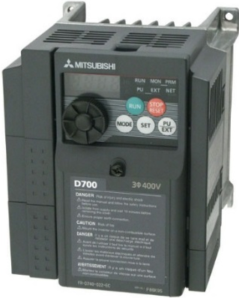
Inverters are used in line with Motors to easily change the speeds of the Motors to suit the user’s requirements.
Inverters can otherwise be known as Adjustable Frequency Drives, Micro-Drives, Adjustable Speed Drive and most commonly Variable Frequency Drive (VFD). The basic idea is that they change the frequency of the supply voltage to the Motor, doing this adjusts the RPM/Speed of the motor. A VFD can simply be turned up or down to suit the requirement of the user, and meet the requirement of the motor being used. ^{[23]}
Figure 16 Example of an Inverter Drive [25]

9.2.0 How VFDs Work
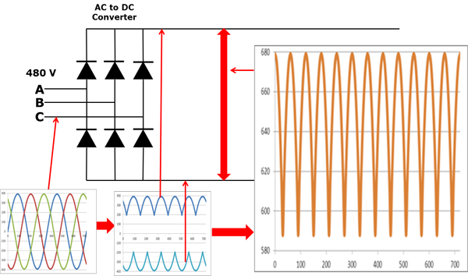
The first step of the VFD is the Converter section, these are made up of 6 diodes which allows the current to only flow in a single direction. For example, if Voltage ‘A’ is more positive than Voltage ‘B’ or ‘C’, then the diode will open and allow the current to flow. However, if ‘B’ Voltage was to become more positive, then the diodes in line with ‘A’ would shut, and ‘B’ would open. This idea is also true when it comes to the 3 diodes on the negative side. This sequence of events will always cause 6 pulses as each diode either opens or closes, therefore this is known as ‘six-pulse VFD’.
Figure 15 shows the waveforms of the three voltages previously mentioned, ‘A’, ‘B’ and ‘C’ running at 480V. As Voltage ‘A’ drops, Voltage ‘B’ takes over, until that reaches its peak and drops where ‘C’ diode then opens. The second graph shows how this effect changes the waveform for the positive and negative buses.
Figure 17 Variable Drive Frequency Explained
The final waveform shows how the signal is peaking and operating between 580V and 680V.
If this frequency was sent to the motor, then there would be a dip in motor power every time the frequency reached its peak, therefore adding a ‘Smoothing Capacitor’ can reduce/take-out this ripple effect. (see 9.2.0.0)
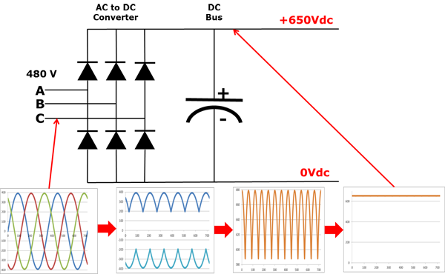

Figure 18 Variable drive Frequency with added Smoothing Capacitors
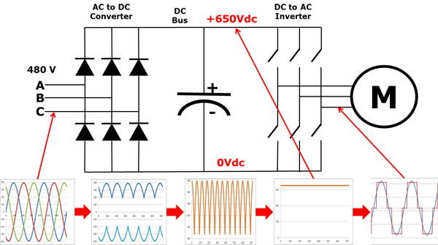
As seen above, when the Capacitor is added parallel to the diodes, the ripple that was previously active has now been reduced to a continuous, constant waveform. The Capacitor absorbs the AC ripple, and then delivers a much smoother, more controlled DC Voltage. The level of AC voltage unbalance on the system can vary, and depends on varied factors such as the motor load, and reactors or harmonic filters on the drive, and the impedance of the power system.

Figure 19 How adding a Smoothing Capacitor affects the Output Signal

Figure 19 shows how the introduction of the Motor can affect the signal. The switches on top (representing Transistors) can be operated, and when one of the switches are shut, that positive phase is then connected to the motor, similarly when one of the switches on the bottom is closed, is connects that phase to the negative side of the motor.

A Smoothing Capacitor found in Figure 19 is a capacitor that is used to reduce and limit fluctuations within a waveform. When the waveform rises, the Capacitor charges up, when the waveform decreases, the Capacitor discharges, levelling out any ripples present. Figures 20 and 21 show this.
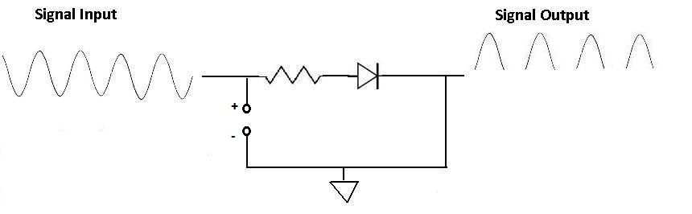
Figure 20 Waveform without a Smoothing Capacitor ^{[26]}

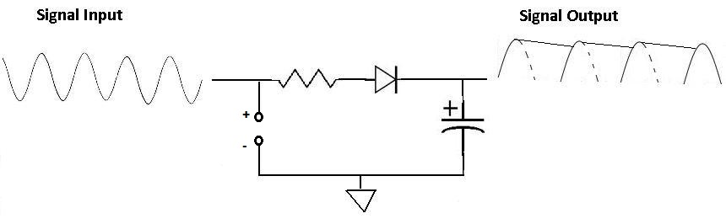
Figure 21 Fluctuation smoothed out when Capacitor is introduced ^{[26]}

Knowing this, it is possible to connect any phase on the motor become positive or negative which would then allow any frequency to be generated and delivered to the motor. ^{[24]}
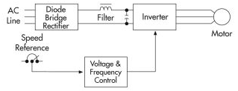
Figure 22 Sequence of events from the AC Line through to the Motor ^{[24]}

Safety Systems

Safety systems are critical when building moving machinery and equipment. It is vital to ensure that when an operator or Engineer go near the Machinery and want to enter, it stops completely and can’t be restarted until in a safe position to do so. To achieve this safety, a Safety Relay was used. ^{[28]}
If individual Safety Relays were used, there would need to be several in line to monitor all the safety features which could include:
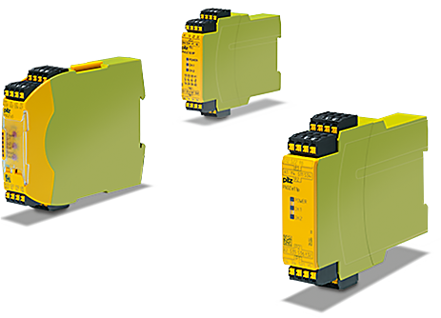
- E-Stop Circuits,
- Safety Gates,
- Light Barriers,
- Pressure Sensitive Mats,
- Speed change,
- Etc.
Figure 23 Different PILZ Systems available ^{[27]}

However, to reduce the need for several Safety Relays in the panel, a PILZ Safety Relay was used. PILZ Relays were designed in 1987 and were the first Emergency Stop Safety Relay that could protect the Machine and the User, called PILZ PNOZ. Since then, a series of several types of PILZ Relay have been introduced, and each can be used for different applications, for example:
- PNOZsigma
  - Comes in the smallest width for small Electrical Panels,
  - Operating Modes and Times are selectable,
  - Modular structure allows scalability.

- PNOZ X
  - Tailor-made safety for every function on the machine,
  - Electromechanical meaning more safety,
  - Supplied with Universal power supply.
- PNOZpower
  - Able to withstand high loads, from 8A to 16A.
  - Ability to switch motor loads directly,
  - Modular output contacts.

In this case for the electrical panel, a PILZ PNOZ X series was used as it provided the highest safety function with the electromechanical components, and can monitor every safety feature that will be on the panel and machine.
The PILZ PNOZ X series includes safety features not available on other safety relays, including the self-checking mechanism within the unit, where it checks all its components to check they are still functional. If they aren’t functional, the PILZ won’t allow itself to be reset. With every cycle that the PILZ unit goes through, it also checks the opening and closing of the contacts to ensure that they are fully operational.

Other features of the device include:

- Internal Electrical Fuse to protect itself from current spikes,
- Instantaneous safety contacts,
- Connection options for:
  - E-Stop buttons
  - Safety Gate switches
  - Reset Buttons
- LED Indicators for Channel Status and Supply Voltage

These devices also meet the required specifications in EN 60947-5-1, EN 60204-1 and VDE 0113-1.

Photoelectric Sensors ^{[29]}

There are several types of sensor that can be used, however each type of sensor requires different components for it to operate correctly. The main sensors used within product manufacturing are ‘Photoelectric electric’ sensors, also known as ‘Photo Eye’.
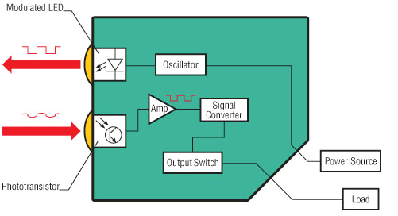
These sensors are used to discover and detect a distance, absence or presence of an object. It does this my using a light transmitter, most regularly these are infrared, and these are aimed at other photoelectric receivers. Photoelectric sensors can be found in everyday usage, they are used to control the safety during the opening and closing of garage doors, they can operate automatic sinks by the wave of a hand, control elevators and doors etc.
The basic operation of this type of sensor is that they detect a change in the light intensity, however the type of light method of which the target is detected varies depending on the sensor. They are made up of a light source (LED), a receiver (phototransistor), a signal converter and an amplifier.
Figure 24 Interior of a Photoelectric Sensor
The receiver measures and analyses the incoming light, checks that the light has been transferred from the LED, and triggers the output to suit.
Figure 24 gives the cross-sectional view of a photoelectric sensor. The LED transmits a digital square wave signal, either showing ON (1) or OFF (0), the phototransistor then receives an analogue signal depending on the varying light it receives, or distance the object is from the sensor.
Within the sensor is an amplifier and signal converter, which converters the signal back from analogue into digital to trigger the correct output.

9.4.0 Photo Electric Sensor Modes/Types

There are several diverse types of photoelectric sensors available, for example:
- Diffused,
- Through-Beam,
- Retro-Reflective.
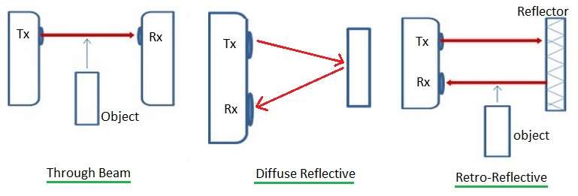
Figure 25 Different options of Sensor available ^{[30]}

9.4.0.0 Diffused Sensors
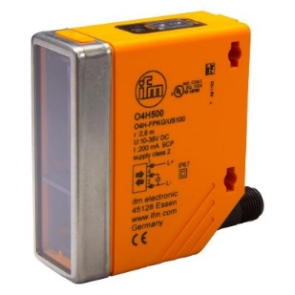
Diffused type sensors, also known as ‘Proximity Mode’, is a type where both the Transmitter and Receiver are found within the same sensor block. The Transmitter sends out a light signal, which will either strike the target, or miss it, this light reflects off the target at different and arbitrary angles.
Figure 26 Diffused Sensor ^{[31]}
The Receiver will then pick up as much of the reflected light as possible, sending a signal through the sensor to confirm that the target has been detected. This type of sensor however is normally used within small sensing ranges, due to the transmitted light energy that gets lost, they are restricted to close ranges, whereas retro-reflective and through-beam are a lot more generous with regards to sensing ranges.

Advantages | Disadvantages
Transmitter and Receiver in same Sensor housing | Short Sensing Range
No other components needed (Inc. Reflector, separate Receiver etc.) | Can be affected by Targets colour, material and size.

As mentioned in the above table, a major disadvantage is the type of Target that the sensor is being used on. Different Targets will provide different light reflections than others, and some targets may be too small or misshapen and produce too much light dispersion for the Receiver to detect the light.
Some of the best materials available for the target to be made from are metal, and some of these include Aluminium (both untreated and extruded) which will give a reflective index return of around 105% - 140%, Black Aluminium (both Anodized and extruded Anodized) which will be around 50% - 115%, and Polished Steel which has a reflectiveness of 400%.
Outside of the Target being Metal, there are many other objects which will provide a reflectiveness of over 50%, some of these include Standard White test card (90%), White Paper (80%), Newsprint (55%), Clean Pine Wood (75%), Transparent Brown Plastic (60%), Beer Foam (70%) and Opaque White Plastic (87%).
Although there’s a lot of materials that a Diffused Mode sensor would be able to detect, there are also many to avoid which can provide as little as 1.5% in Reflection. Materials to avoid include Cork (35%), Wooden Pallets (20%), Clear-Plastic Bottles (40%), Black Foam (2%), Automobile Tyres (1.5%) etc.
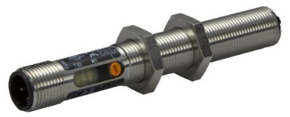

Figure 27 Example of Barrel Sensor ^{[32]}

There are several diverse types of Diffused sensor available, including:
- Diffused Convergent Beam Mode
Where the transmitter beam is focussed to an exact and specific point directly in front of the sensor, a point at which the receiver is also aiming. However, on this type, the sensing range is fixed to this exact point, but the sensor is found to be more efficient.
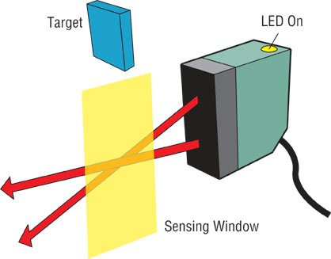
The sensor will generally offer a range in which the sensor is looking at, this is where the target and object will have to pass through for it to be detected. This is known as the ‘sensing window’. Any objects that pass directly in front of the sensor, or further than the sensing window suggests, will not be detected by the sensor. Due to all the energy being emitted is directed as a specific location, there is an ability to gain a lot of excess gain in reflectiveness, which allows this type of sensor to detect narrow or low reflectivity targets more easily.
Figure 28 Diffused Convergent Beam Mode Sensor
- Diffused Mode with Background Suppression
This type of sensor has a much more direct, and straight transmitter that can detect targets up to a certain point, known as the ‘cut-off distance’, and objects being this point will not be detected. The main advantage over this sensor is that it doesn’t allow any unwanted targets to be picked up as the cut off distance can be manually set to suit the user requirements. There are two possible ways for the background suppression to operate, either mechanically or electrically.

  - Mechanical Suppression
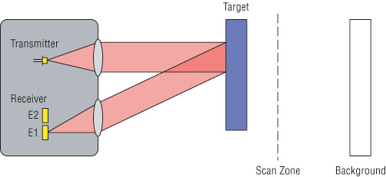
Two receiving Elements can be found within the sensor, where one will receive light from the background, and the other will receive the reflected light from the target. When the target receiver is found to have a larger or greater light input than the background receiver at any point, the target will be detected and the output activated as required. However, if the background receiver has a higher light input, the target will not be detected.
Figure 29 Mechanical Suppression Sensor
  - Electrical Suppression
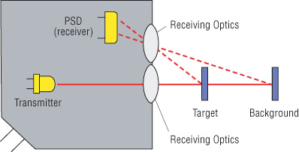
Within Diffused Mode sensors with Electrical Background Suppression, the sensor will have another internal component known as a PSD, a Position Sensitive Device. The transmitter will emit a light beam as normal which will then be reflected to the PSD in two different points, one from the target reflection and the other from the background reflection. The sensor evaluates this light input into both points on the PSD and compares the signal to a pre-set value made by the user, this will determine out the state of the output changes.
Figure 30 Electrical Compression Sensor

9.4.0.1 Retro-Reflective sensors
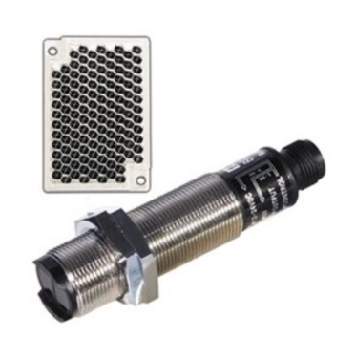
As is with Diffused Mode sensors, the Transmitter and Receiver can be found in the same sensor housing, however a reflector is now required to reflect the light back to the receiver. When the beam gets blocked and the receiver doesn’t receive a light input, the target has been detected and the output will change. This type of sensor also allows much higher sensing ranges because the efficiency of the reflector is much greater than the material on the target being picked up, with the colour, material and size also not affective the sensors response to being blocked. This type of photoelectric sensor also comes with the option of having a polarization filter or not, this filter will only allow certain light through to the receiver depending on the phase angle of the light. This allows the sensor to see shiny object as a target, and not incorrectly as a reflector. The natural shape of reflectors means that the light that hits it has a phase shift, however if light reflects off a shiny object, the phase shift doesn’t alter. A Polarized Retro Reflective Sensor will also have to be used with a corner tube reflector, as these are the only reflectors that will accurately return the light energy transmitted on a parallel axis to the sensor. However, non-polarized retro reflective sensors allow longer sensing ranges, but can be falsely identify a shiny object for the reflector.
Figure 31 Retro Reflective Sensors ^{[33]}
Advantages | Disadvantages
Longer sensing ranges | Extra component required
More efficient light return | Can be affected by shiny objects
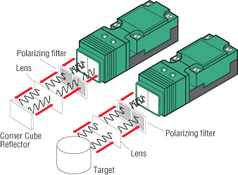
When wanting to use this type of sensor for a clear object, the correct sensor type must be chosen which have a low hysteresis circuit in line with the sensor for it to detect any slight changes in the light input. These sensors will almost definitely include polarized filters as this will reduce the risk of any light being reflected off the object and causing a false response.
Figure 32 Type of Retro Reflective Sensor ^{[33]}

9.4.0.2 Through-Beam Mode

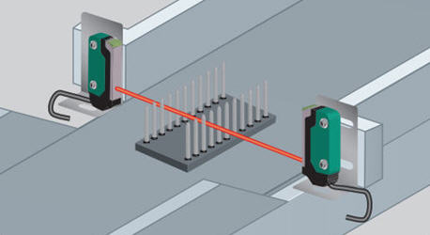
A Through Beam sensor, also known as Thru-Beam and Opposed mode are a lot simpler than the other two previously mentioned. This type of sensor has two separate components and sensor housings, the one is the Transmitter section, and the other is the Receiver. The Transmitter is aimed directly at the Receiver, and when the beam is broken, the output will change to suit. This is by far the most efficient and provides the longest sensing ranges, however requires two various parts for it to operate.
Figure 33 Through-Beam Type Sensor ^{[34]}
This type of sensor is useful for Safety features, as the sensors are available in long strips, they can look across the top of a machinery, and when the beam is broken the machine will stop instantly. This means the machinery can be more open and reduces the need to close all access via guards.
Advantages | Disadvantages
Long range sensitivity | Two components to operate
Useful safety feature | Both components need to be wired to receive output

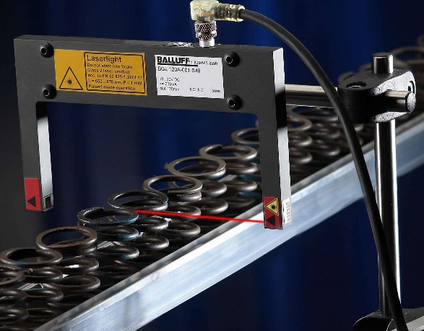

Figure 34 How a Through-Beam Sensor can be used to detect various products ^{[34]}

HMI Touch Screen
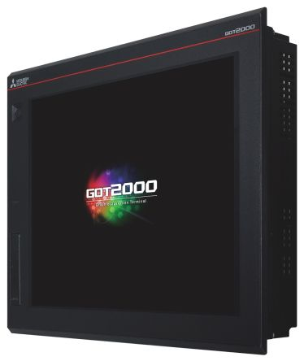
A Human Machine Interface, or HMI as they are more commonly known, is an interface that is used between a human and a machine. Although an ‘interface’ is a broad term and can include, MP3 Players, industrial computers, household appliances, office equipment etc., when the term ‘HMI’s’ is used, they are much more specific to the use of a device within Process and Control Systems. ^{[35]}
Figure 35 Example of a HMI Touch Screen ^{[35]}
The idea of a HMI in this type of system is that is provides a clear and up-to-date representation of the process, and a real-time data acquisition. The use of HMI’s in the correct manner can create productivity, and efficiency around a plant as they allow more centralised control.
Dependant on the type of PLC, and which manufacturer is going to be used, the correct HMI will be chosen to correspond with this running platform. Every manufacturer has their own selection of usable HMI screens, which all run in separate ways and require different software to design and run the screens.
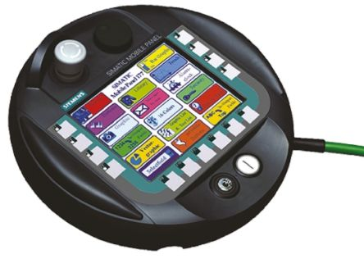
Standard display sizes can range from 1 inch – 15+ inches, and can come in varying shapes and resolutions depending on the user requirements. Some of the leading brands of a HMI Touch Screen include:
Figure 36 Small round HMI Screen ^{[36]}
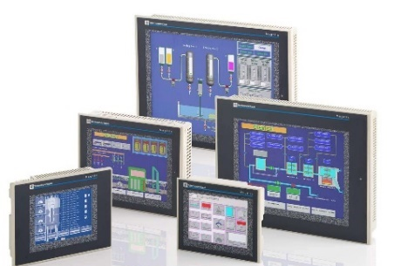
- Allen Bradley,
- Pro-Face,
- Mitsubishi,
- Siemens,
- Schneider,
- Telemechanique, etc.
Figure 37 Available sizes of HMI Screens ^{[37]}

Cables Types/Sizes

A cable is product that contains two or more copper strands twisted or braided together that are used within Electrical and Electronic wiring, and can come in a variety of sizes, shapes, termination variations and armouring strengths.

9.6.0 Cables Types

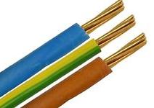
There are several types of cable available, depending on the task that needs to be carried out. Below is a list of the most widely used cables, and the tasks that they are used to carry out.
- Single Core Cable
  - Used for small Panel wiring and wiring over a short distance.
Figure 38 Single Core Cable ^{[38]}

- Multi Core Cable
  - Several single cores braided together, protected by an outer sheathing. The sheathing can either be flexible plastic, or thin metal strands wrapped together to form an armouring, which is then held tightly together by an outer plastic flexible sheathing.

- Coaxial Cable
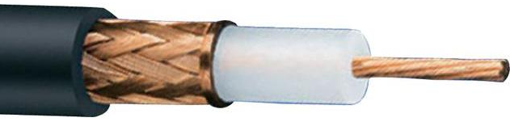
  - Widely used in radio and frequency signals. Consists of an inner conductor and metal sheathing, which is held together by an outer flexible plastic sheathing.
Figure 39 Coaxial Cable ^{[39]}

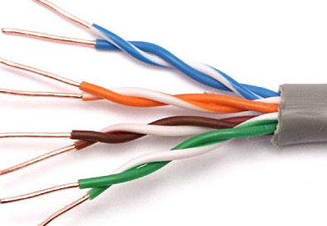
- Paired Cable
  - Made up of two individually insulated conductors, generally used within DC or low-frequency AC applications.
Figure 40 Paired Cable ^{[40]}

As well as having several types of cable available, they are also rated differently depending on the amount of Voltage required to be carried.
Within the Panel, only single core cable would be required as it easier to run, and the colour differences in the cable can help determine what each cable does, and the Voltage in which it is carrying. When running cables that will supply power around the Panel, 4mm cable was used as it provided ample carrying ability for the 400v that it would be carrying. The 400v supply would be in 3-Phase, which means that each single core cable would be assorted colours that represent each phase within the circuit. The old panel being replaced had 3-Phase colours of Red, Yellow and Blue, however these colours have recently been changed within the Wiring Regulations, to the more neutral colours, Black Brown and Grey, with the Neutral cable being Blue. A separate Earth cable was run, which has the same cross sectional area, 4mm as the power cables.
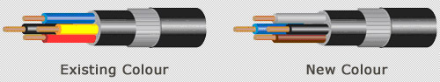
Figure 41 Comparison of Old and New Colours ^{[41]}

However, for the Control side of the panel, White cable was used at a size of 0.75mm as it would only be carrying 24v around the Panel. To easily distinguish between the 24v+, and the 24v- (Neutral), the neutral cable was a light Blue, where a separate earth cable was run, again at the same size of the control cables, 0.75mm. The earth cables of both control and power are yellow are green, stripped down the cable.
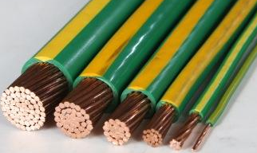

Figure 42 Variation in sizes of Cable available ^{[42]}

  - Conclusion to Background Research
Overall the background research was effective and helpful when choosing which components would be required for the task. All the information could be collected and used to effectively get all the best, and correct components available to do the task required. When deciding which components to use, it was important to keep the environment in which they would be kept in mind. When choosing the sensors, they had to be chosen to ensure that they would be able to operate under elevated temperatures and humidity, and would be able to stay efficient under these conditions. It was also important to ensure that the different PILZ relays can do the job required with regards to the safety needed within the Prover system.
When choosing the types of cable to use, the cable had to have enough protection to stop any water damage to the copper strands proving the control and power supplies within the panel.
Later in the report, a Parts List and Costing Matrix can be found, which outlines the decision of why each component was purchased, and what checks were made to ensure that each met the correct standards.

Required Parts List

Once all the main background research was complete, and the correct type of components had been selected, the parts list was created. The drawings of the original panel were sourced and each component within the panel was noted, with a comment of each parts function and operation. It was now possible to choose a new, up-to-date component capable of doing the job required, or in some cases, selecting a component which would greatly improve the operation of the Prover. For example, more powerful Inverters, and a PLC allowing a lot more opportunity of improvements and additions.
Each Motor or Fan on the Prover needed a main three pole MCB O/L switch which would supply the power required. Determining how many Overloads were needed meant that each Motor and Fan Power ratings had to be found. Below shows the table produced, showing the ratings of all the MCB’s needed.

Motor/Fan | Drawing Label | Part Required | Rating Required
Main Drive Motor | MD | MCB O/L (Three Pole) | 10A
Air Con Fan | ACF | MCB O/L (Three Pole) | 6.3A
Discharge Pusher Motor | DP | MCB O/L (Three Pole) | 10A
Oven Transfer Conveyor Motor | OTC | MCB O/L (Three Pole) | 2A
Lubricator Pump | LUB | MCB O/L (Three Pole) | 1.5A
Grouping Conveyor Inverter | GC | MCB O/L (Three Pole) | 10A
Infeed Pusher Motor | FP | MCB O/L (Three Pole) | 2.5A
Scavenger Fan | SCFC | MCB O/L (Three Pole) | 16A
Figure 43 Required parts: Power MCBs

Within the old Prover panel, there were a lot of fuses used which controlled the 24V supply to the PLC and Safety Relay Unit. However, to make it easier for the Engineer fault finding on the Panel, MCB’s were put in place instead of Fuses. In the event of an overload on the 24v circuit, the MCB would just have to be reset, as opposed to the Fuse having to be sourced and then replaced. Smaller, single pole MCBs also had to be ordered which would be used on the 24v supply throughout the panel.
This type of MCB would also be put in line of the Control circuit, which would ensure that any overload within the control circuit would take out and MCB. These were then listed, as seen below.
Operation | Drawing Label | Part Required | Rating Required
Supply | MCB | MCB O/L (Single Pole) | 1A
Supply | MCB | MCB O/L (Single Pole) | 2A
Supply | MCB | MCB O/L (Single Pole) | 4A
Control Circuit | CC | MCB O/L (Single Pole) | 4A
Figure 44 Required parts: Control MCBs
After the MCB’s within the panel there would either be a Contactor or an Inverter. An Inverter was used in places where the speed could be adjusted, which would help the Operator obtain more control over the Prover. Therefore, an Inverter was used for the Grouping Conveyor, Infeed Pusher, Outfeed Pusher and Main Drive. Where an Inverter was not used, a Contactor was put in line. This would operate as a switch controlled by an output from the PLC, which would tell the contactor to supply power to the Fan/Motor or not.
To ensure the Contactor was over the Current Rating of the unit it was supplying, a 25A was used. This ensured that it would still operate if the Fan/Motor was changed in the future, below is the updated list of whether a Contactor or Inverter was used.

Motor/Fan | Drawing Label | Part Required | Rating Required | Inverter/Con
Main Drive Motor | MD | MCB O/L (Three Pole) | 10A | 3.5 kw Inverter
Air Con Fan | ACF | MCB O/L (Three Pole) | 6.3A | 25A Contactor
Discharge Pusher Motor | DP | MCB O/L (Three Pole) | 10A | 0.75 kW Inverter
Oven Transfer Conveyor Motor | OTC | MCB O/L (Three Pole) | 2A | 25A Contactor
Lubricator Pump | LUB | MCB O/L (Three Pole) | 1.5A | 25A Contactor
Grouping Conveyor Inverter | GC | MCB O/L (Three Pole) | 10A | 0.75 kW Inverter
Infeed Pusher Motor | FP | MCB O/L (Three Pole) | 2.4A | 0.75 kW Inverter
Scavenger Fan | SCFC | MCB O/L (Three Pole) | 16A | 25A Contactor
Figure 45 Required parts: Contactors and Inverters
Once all the main components were chosen, the exact parts had to be found and the Manufacturer and Supplier resourced. When choosing the Manufacturer, a survey was taken throughout both B Plant and C Plant within the factory to try and gain some continuity to assist engineers who may have to attend future breakdowns. The most favoured manufacture of components was ‘Schneider Electric’, as they were some of the easiest to use and rarely fail. However, the Inverters within the company were all manufactured by Mitsubishi, they provided the easiest adjustments and were the easiest to change if they ever failed.
Other components needed was a PLC, the Input and Outputs required were calculated and then extra cards were added to get more I/O than was required. However, this meant that if any I/O failed during production, they could be easily changed, and if any features wanted to be added in the future, there were enough inputs and outputs to do this.

The CPU unit: FX3GE-40MR-ES is a 240v opened FX series PLC that has 24 inputs and 16 outputs. This includes a built-in Ethernet, with the possibility of two analogue inputs and one output. To achieve the correct amount of Inputs, two extra 24v input cards were ordered, this being a FX2N-16EX-ES/UL. This will add an extra 32 inputs. To achieve more outputs, an 8-way relay output card was also ordered, FX2N-8EYR-ES/UL.
A HMI touch screen was also ordered via Pro-Face, a 5.7-inch screen that can be programmed to do anything required. A FX Series cable was also required, this allowed information to be passed between the PLC and HMI screen. 24v Non-Latch Relays were also ordered, these are put inline of the 24v supply to the different outputs, and again act as switches.
To get 24V+ throughout the panel, a Power Supply Unit (PSU) was required. It was vital that all the currents (amps) of the components being supplied from this PSU were added up, this would enable the correct sized PSU to be ordered. When added up, they came to 20A, this meant that a 20A PSU was required.
To get the Voltage from 415V down to a required 24VAC for the Shutter Actuator, a Transformer was required that met the correct specifications. Finally, a 13A 24V Socket was ordered, this would be placed inside the panel as it ensures that there is always power by if required. On the following page, the full required parts list can be found.

Components | Rating | Make
MCB O/L | 9 - 14A (set at 10A) | Schneider Electric
Inverter | 3.5 kW | Schneider Electric
MCB O/L + Aux. | 4 - 6.3A (set at 6.3A) | Schneider Electric
Contactor | 25A | Schneider Electric
MCB O/L | 6 - 10A | Schneider Electric
Contactor (FWD/DSP, DSP/BRAKE) | 25A | Schneider Electric
Inverter | 0.75 kW | Schneider Electric
Contactor + Aux. | 25A | Schneider Electric
MCB O/L + Aux. | 1.6 - 2.5A (set at 2A) | Schneider Electric
Contactor | 25A | Schneider Electric
MCB O/L + Aux. | 1 - 1.6A (set at 1.5A) | Schneider Electric
Contactor | 25A | Schneider Electric
MCB O/L + Aux. | 6 - 10A | Schneider Electric
Inverter | 0.75 kW | Schneider Electric
MCB O/L + Aux. | 1.6 - 2.5A (set at 2.4A) | Schneider Electric
Inverter | 0.75 kW | Schneider Electric
MCB O/L | 16A | Schneider Electric
CC MCB O/L | 2.5 - 4A (set at 4A) | Schneider Electric
Side Mount Aux. Contact | 240V dc 690V ac | Schneider Electric
FX3GE Series - FX3GE-40MR-ES |  | Mitsubishi
FX2N Series - FX2N-16EX-ES/UL |  | Mitsubishi
FX2N Series - FX2N-8EYR-ES/UL |  | Mitsubishi
MCB Single Pole iC60H | 1A | Schneider Electric
MCB Single Pole iC60H | 2A | Schneider Electric
MCB Single Pole iC60H | 4A | Schneider Electric
5.7 inch HMI Screen - PFXGP4301TADW |  | Pro-face
FX Series Cable - CA3-CBLFX/5M-01 |  | Pro-face
MK Grey 2 Gang Socket - British 13A | 13A | MK
SITOP Switch Mode DIN Rail Power Supply | 20A | Siemens
Din Rail Mount Transformer | 100VA | Schneider Electric
PCB Mount Non-Latching Relay | 24V | Omron
Relay Base | 24V | Omron
Figure 46 Required parts: Finished List
Once the full parts list had been finished, the parts could then be sourced from the different suppliers that we use. This list was originally sent to the main component supplier, RS. They reviewed the list to see how many of the required parts they could supply, with an estimated delivery date.
RS returned and could supply many the parts, however some of the parts had a long lead time to delivery, therefore the parts had to be sourced from elsewhere. The remaining of the list, including all the Inverters and two 25A contactors was ordered from Routeco. See Appendix for complete list.
Once all parts could be ordered, the Costing Matrix was then produced.

Costing Matrix

A Costing Matrix is a spreadsheet designed to put all the project costs in one place, making a clear table to see exactly where the money has been spent. It can be added to over time, and gives a final cost of the project.
Using the parts list previously produced, the Costing Matrix was made up using the information provided by the Suppliers.
The list made included all the parts, with a Unit Cost and Quantity added. These were then multiplied which gave the overall price for each part. Discount was given on some of the parts so this was also considered on the Matrix Spreadsheet. Once all the initial costs had been calculated, it was then possible to get a final sum of the components.
Included in the final Costing Matrix:
- Components
- Rating
- Supplier
- Unit Cost
- Quantity
- Discount (%)
- Final Order Price
The most expensive unit to buy was the PLC at £997.00 which dramatically increased the overall cost, with the HMI screen costing a total of £532.80. Although these costs are high, they provide state-of-the-art control over the Prover system, and allow the complete control required.
However, the savings outweigh the spending in the project as some older parts were used. When looking to buy a new Panel the prices being supplied were more than £8000, this would have more than doubled the spending in the project. Sourcing an older Panel enabled this money to be saved and possibly spent on other parts of the project. See Appendix for full Costing Matrix. On the next page, the shortened version can be found.
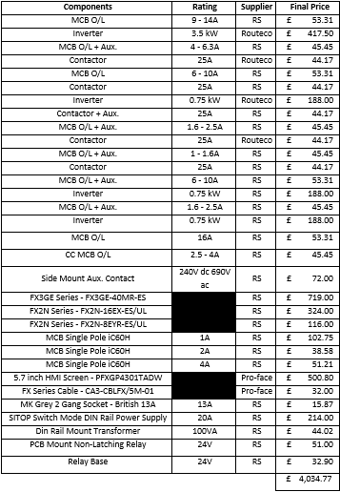
Figure 47 Costing Matrix

Regulations

Before beginning the wiring for the main panel and Prover, it was important to find all the details with regards to the Regulations that maybe involved. These were found before the design of the panel was taken place, as it allowed for any adjustments that may have to be made to suit the regulations.
The current IET/BSI Wiring Regulations available are the 17th Edition, which state an outline of the standard required for all electrical installations using mains generated electricity, which are installed in domestic and commercial environments. The initial set of wiring regulations, 1st Edition was brought out in 1882, and has been added to throughout the years, the 10th Edition being made available in 1934, and now the 17th Edition which was published in 2004.
The standards are run by BSI (British Standard Institute), which was set up to provide a standard, and overall agreed way of correctly performing electrical operations. The wiring regulations they publish include different quality management’s standards, health and safety standards, security standards, construction and energy standards, etc.
When designing the electrical aspect of the Panel, the following standards were looked at:
- BS EN 50110: 2004-2010 Operation of electrical installations.

- BS7671: 2008-2011 Requirements for electrical installations. IEE Wiring Regulations. Seventeenth Edition.

- BS EN 60529: 1992 Specification for degrees of protection provided by enclosures (IP code).

When designing how the safety aspect of the machine, the following standards were looked at:
- BS EN ISO 13850: 2008 Safety of Machinery. Emergency Stop. Principles for Design.

- BS EN 953: 1997-2009 Safety of machinery. Guards. General requirements for the design and construction of fixed and movable guards.

- BS EN 962: 2008 Safety of machinery. Safety related parts of control systems.

- BS EN 1037: 1996-2008 Safety of machinery. Prevention of unexpected start-up.

- BS EN 1088: 2008 Safety of machinery. Interlocking devices associated with guards.

- BS EN 60204 Safety of machinery. Electrical equipment of machines.

For the wiring and regulations of the 13A socket in the panel, the following standards were looked at:
- BS 1363 Parts 1 – 5: 1995-2008 13A plugs, socket-outlets and adaptors.

Time Management

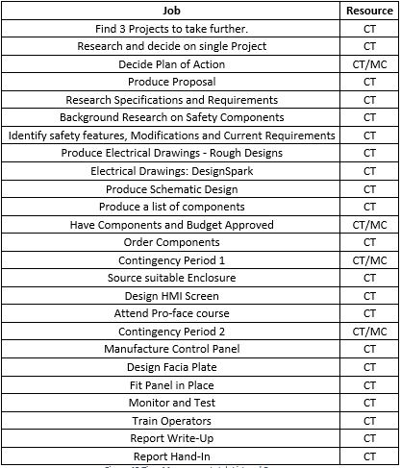
Time Management when doing a Project is important and helpful as it ensures that all tasks are completed at the correct time, for the overall project to be completed when required. It enables time and resources to be managed effectively and efficiently. For it to work correctly, a Gantt chart must be produced, stating all the activities required to be completed over the course of the project. This list can be added to at any time, providing time allows throughout the process. Once the job list was produced, the resource names were added to it.
Figure 48 Task List with added Resources

Within the list there is a Contingency Period 1 and 2, these are used as review weeks to look back over what’ has been completed. They can also be used to catch-up on any tasks that have fallen behind during that period. The next stage is to determine which resource will be required to complete that task. This is added to the list.
Where two names are stated, it means that someone of higher-level needs to confirm the actions to continue with the project. The start date was decided as week commencing 7th November 2016, with the completion week commencing 24th April 2017. Each task was allotted a date for completion.
Job | Resource | Project Timeline
 |  | 07-Nov | 14-Nov | 21-Nov | 28-Nov | 05-Dec
Find 3 Projects to take further. | CT
Research and decide on single Project | CT
Decide Plan of Action | CT/MC
Produce Proposal | CT
Research Specifications and Requirements | CT
Background Research on Safety Components | CT
Identify safety features, Modifications and Current Requirements | CT
Produce Electrical Drawings - Rough Designs | CT
Electrical Drawings: DesignSpark | CT
Produce Schematic Design | CT
Produce a list of components | CT
Have Components and Budget Approved | CT/MC
Order Components | CT
Contingency Period 1 | CT/MC
Source suitable Enclosure | CT
Design HMI Screen | CT
Attend Pro-face course | CT
Contingency Period 2 | CT/MC
Manufacture Control Panel | CT
Design Facia Plate | CT
Fit Panel in Place | CT
Monitor and Test | CT
Train Operators | CT
Report Write-Up | CT
Report Hand-In | CT
Figure 49 Gantt chart: First 5 Weeks
The yellow squares on the Gantt chart signifies the target task completion. As the task is completed these will change into green squares for example:
Job | Resource | Project Timeline
 |  | 07-Nov | 14-Nov | 21-Nov | 28-Nov | 05-Dec
Find 3 Projects to take further. | CT
Research and decide on single Project | CT
Decide Plan of Action | CT/MC
Produce Proposal | CT
Research Specifications and Requirements | CT
Figure 50 Gantt chart: Completion Example
This will be carried out on a weekly basis, and the Gantt chart will be adjusted to suit the task completion. Any red blocks added show that this task has been delayed, and a comment will be put into the box to explain the reason for the delay.
Figure 51 Gantt chart: Task Delay Example
An example shows that when the first Contingency Period came on 9th January 2017, it was found that the order on some parts would not be until late March. This meant that red blocks were added to show the date in which they were due in, and each block had a comment stating exactly the issue for the day. In this case, there was a backlog in the order, giving a much later delivery date than expected.
There was a comparable situation with regards to sourcing an enclosure. Due to the considerable amounts of money being asked for with regards to a new panel, an older panel had to be found which took longer than originally expected.
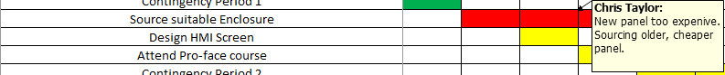
Figure 52 Gantt chart: Task Delay Example 2

When Contingency Period 2 was reached on 6th February 2017, it was known that the Pro-face course that was booked was cancelled, and was no longer available to attend, so this row was blacked out of the Gantt chart, noting this reason.
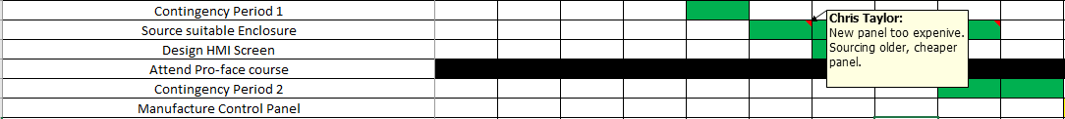
Figure 53 Gantt chart: Task Delay Completion Example
Also, by this point a panel had been sourced, this was shown by colouring in the blocks green to show its completion. However, a note was kept there to explain the reason for delays if required later in the project.
Due to the issue with components being backlogged on their delivery dates, it meant that this automatically delayed the manufacturing of the panel, the same routine was taken however with block colours and notes added.
When the parts arrived on 20th March 2017, the panel could then be started and completed, this completion was delayed however until 17th April 2017.
When the 24th April was reached, all blocks had been coloured green which confirmed that all tasks had been carried out, this led to the completion of the project being on time.
See Appendix for original and Final Gantt Chart.

HMI Screen

Designing
The HMI screen chosen for the Project door was a 5.7 inch HMI Pro-face screen. This would keep the continuity throughout the business, and the software was widely available and easy to use. The software ‘GP-Pro Ex’ was downloaded, which allowed the screen to be designed and easily adjusted at any point if the system were to change.
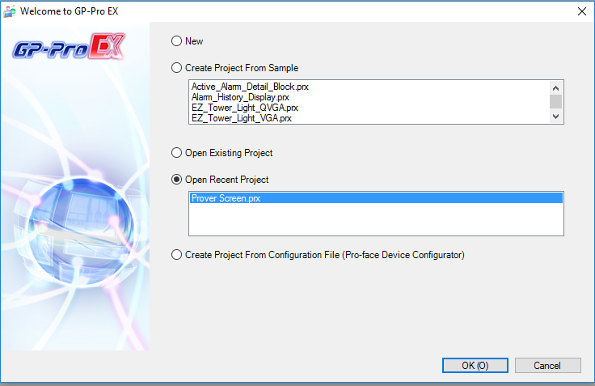

Figure 54 Starting a new Pro-face Project

When the software is opened, it offers the chance to either start a new project or open an existing. When starting a new programme, the certain parameters can be set to match the components within the panel. Below are the options available when starting a new project.
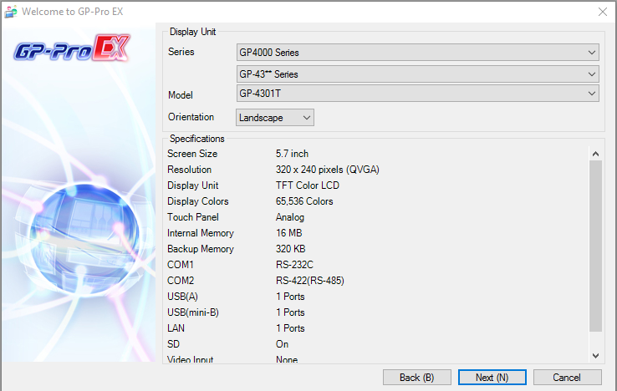

Figure 55 New Project Screen Options and Specifications

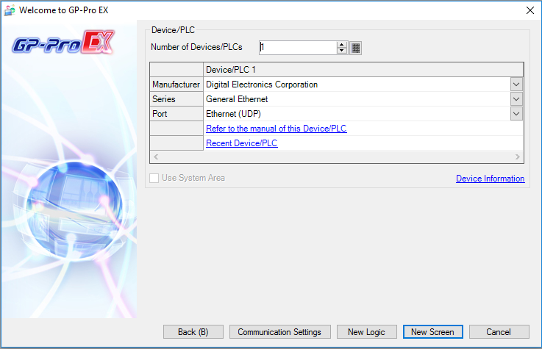
Once the series and size of screen is selected, the PLC type must be chosen, and the screen and PLC are connected via a connecting cable to transfer the information.

Figure 56 New Project PLC selection

This then brings up a completely blank screen, which can be designed to suit the requirements.
Figure 57 New Project Main Screen

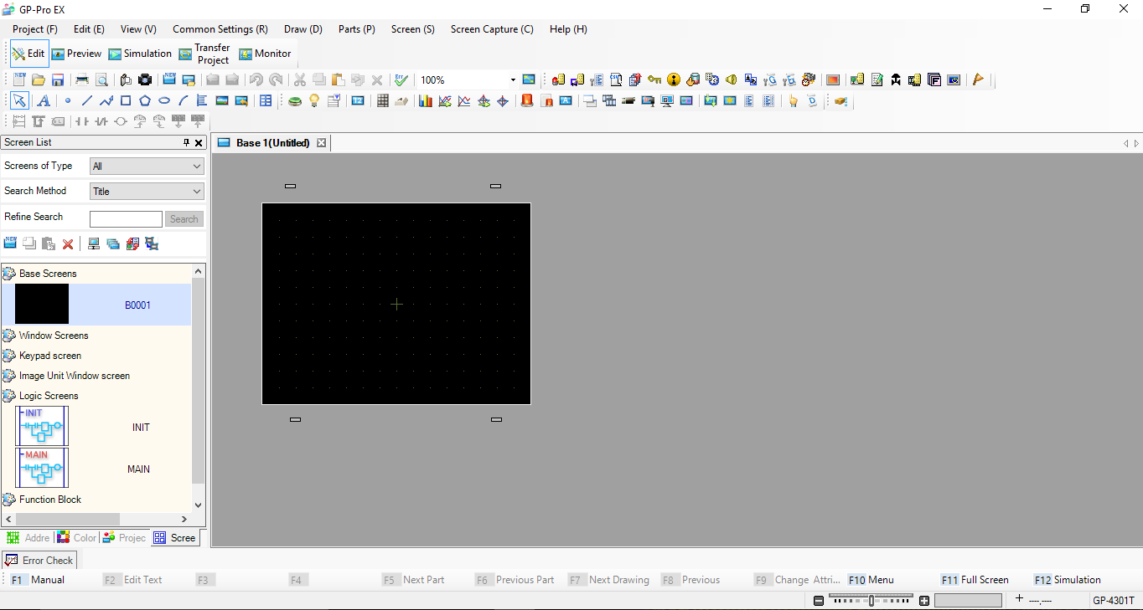
There are many contrasting functions available when designing the screen, these include:
- Buttons,
- Keyboards,
- Graphs,
- Text,
- Alarms, etc.
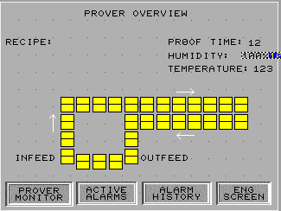
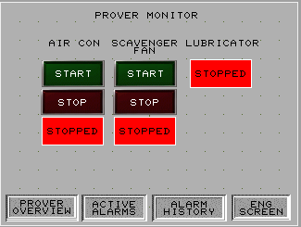
They can be drag and dropped into position on the screen, and then they are tagged to a different bit within the programme for it to perform the operation required.
Figure 58 Prover Overview Screen

Figure 59 Prover Monitor Screen

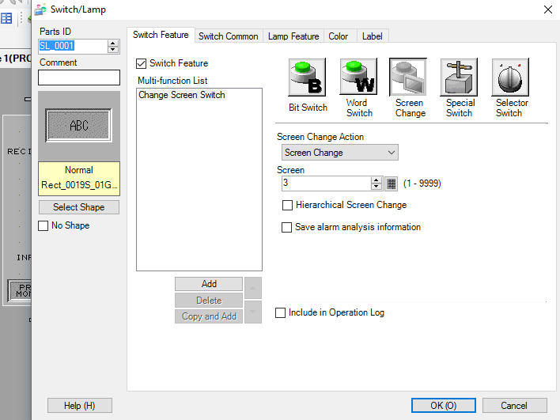
Above is an example of the different screen types available on the software. The left screen shows the Prover Monitor page, which will be for the operator to control every system involved with the Prover. The Prover Overview page shows every swing within the Prover, these boxes will change colour when that swing has Tins on it. At the bottom of the screen are buttons that are tagged as ‘Screen Change’ buttons. This means that when these buttons are pressed, the screen will change as required.

Figure 60 Screen Change Options
Also on the Prover Overview screen are bits of text that change as the PLC sends the information.
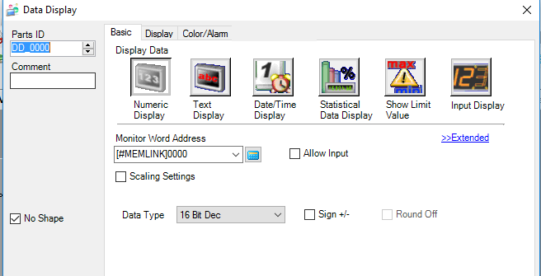

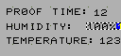

Figure 61 Screen Numeric Display

Figure 62 Numeric Display Options

The Engineers screen will be under a security lock, which means when trying to be accessed, a keyboard will pop up, this allows the Engineer to enter the correct code and get into more detailed screens.
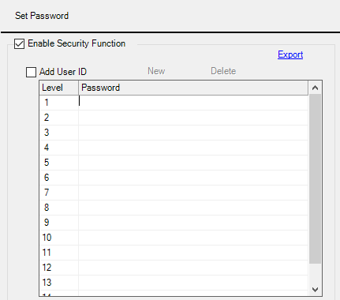
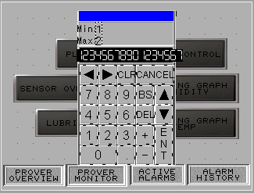
This had been locked as there are certain screen Operators can not touch as it could be unsafe without an Engineer present.
Figure 63 Password Selection

Figure 64 Keypad to enter Password

Another screen made available is a trending graph screen, this will show the live trending of both the humidity and the temperature within the Prover using the Probes inside.
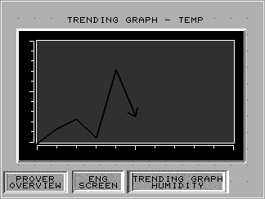

Figure 65 Trending Graph - Temperature

Downloading

Once the screen was finished on the software, it was then downloaded into the HMI screen from the laptop, which allows it to go active.
The project was transferred over to the HMI and tested, to ensure each operation was completely active and working correctly.
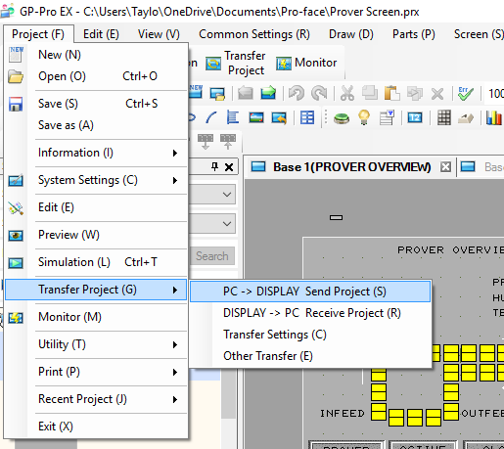

Figure 66 Transferring the Project

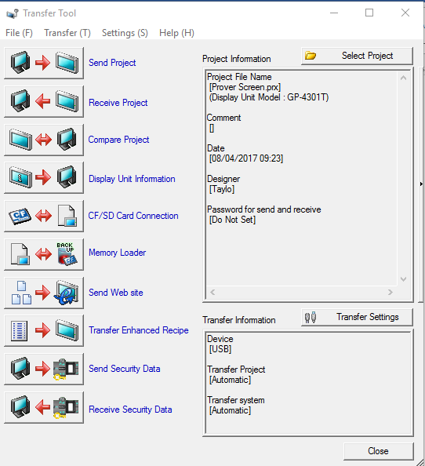

Figure 67 Project Transfer Options

To test the screen, and adjust the visuals, the screen was powered up on a desk, and the project could be transferred over as previously mentioned. The screen was attached to a temporary 24V Power Supply which was plugged into a 240V main socket. This powered the screen up and allowed any changes to be made.

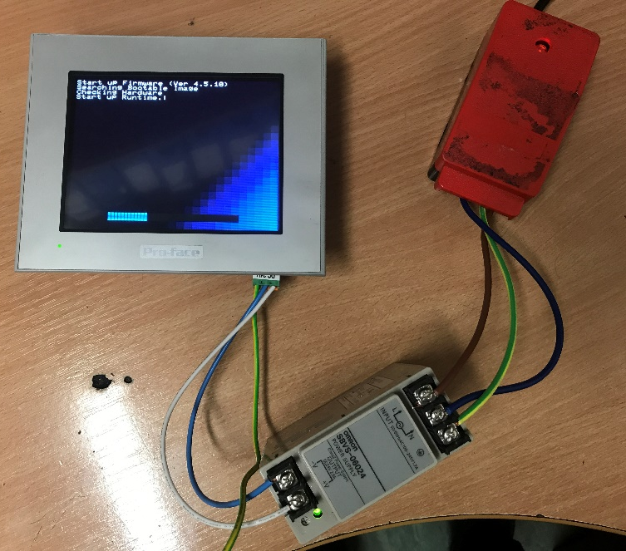

Figure 68 Desktop Screen Testing

Designing the Electrical Drawings

Using the parts list the next phase was to design the electrical drawings and ensure every component was in the correct place, and provided with the correct power supply and IO for it to operate correctly.
An electrical design software called ‘DesignSpark’ was used. This allowed an easy drag and drop system of each component, where the connecting cables could be easily drawn into place. Once all components were in place and connected, this software allowed each cable to be coloured and numbered for when the panel build took place.
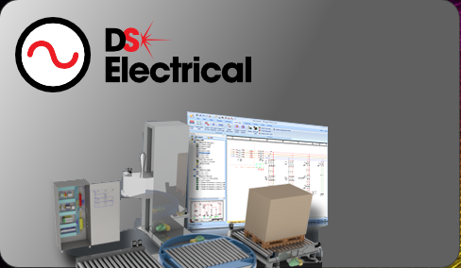

Figure 69 DesignSpark Electrical

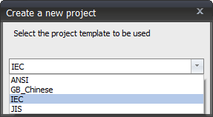
When creating a new electrical drawing, the software allows all different wiring regulations to be selected to suit where the drawings may be being carried out.

Figure 70 DesignSpark Regulation Selection

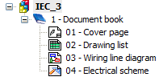
Once these have been selected, the software produces several pages that can be edited to suit.

Figure 71 Drawing options

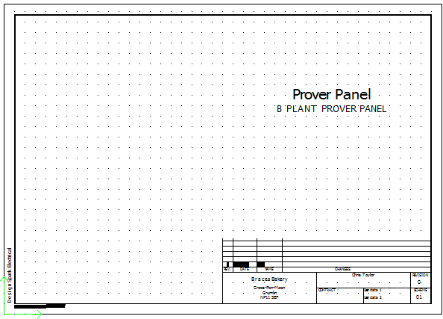
It starts with the main Document Page which includes the name of the project, location, person completing the electrical drawings, etc.

Figure 72 Electrical Drawing Front Page

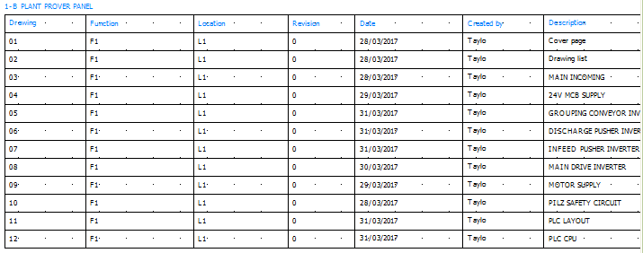
Following that is a Drawing List, which shows the order of each page and what each page includes, making it easier for anyone to follow the drawings.
Figure 73 Electrical Drawing Index page

After the Drawings page is where the main Electrical Drawings will be. Pages can be added and titled to suit what it is each page represents. This project ended with 12 pages, 10 of which were the Electrical drawings.
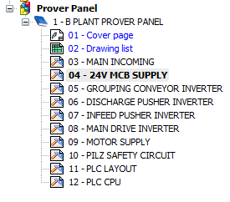

Figure 74 Drawing Selection

When selected, each page will open, allowing it to be added to and edited as required. To add components to the documents, a symbol must be added.
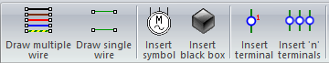
Figure 75 DesignSpark Drawing Tools

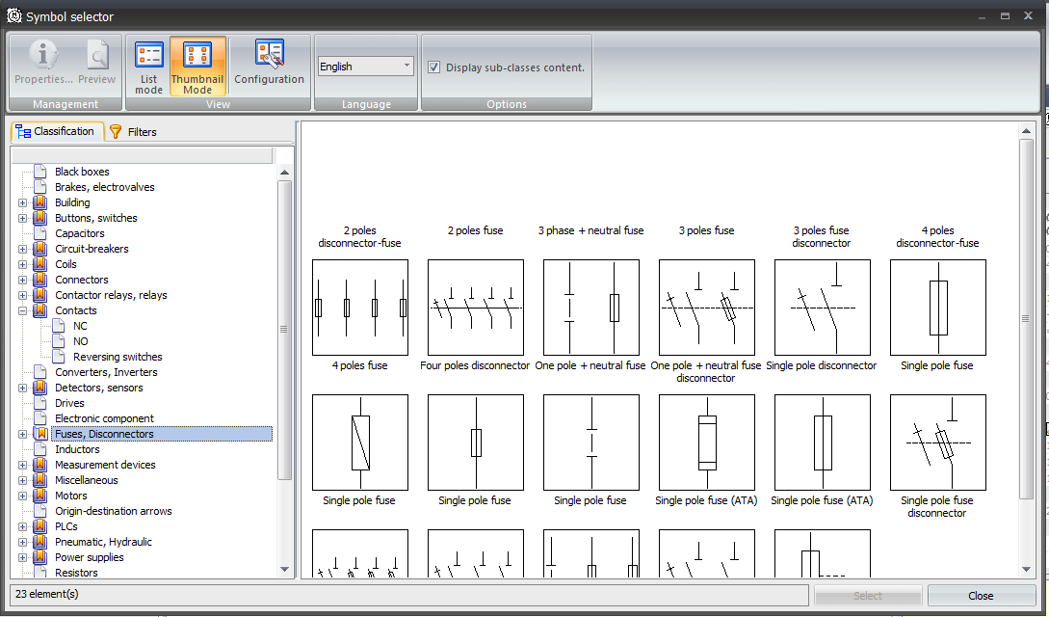
This brings up a list of every component that may be required to be used within the drawings, from here the correct symbol is added and correctly labelled to suit.

Figure 76 DesignSpark Electrical Components Available
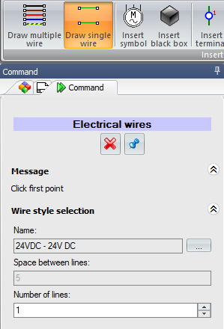
As each component is added, it automatically labels them in sequence as they appear in the drawings However this can be altered and manually entered if required. The cables were then drawn, and labelled as they would be in the panel.
The names could be changed to suit the voltage for this type of cable in the panel, depending on what it was supplying. These were then click and dragged from point to point of each component.
Figure 77 Drawing and Labelling the Wires
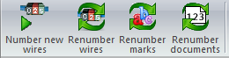
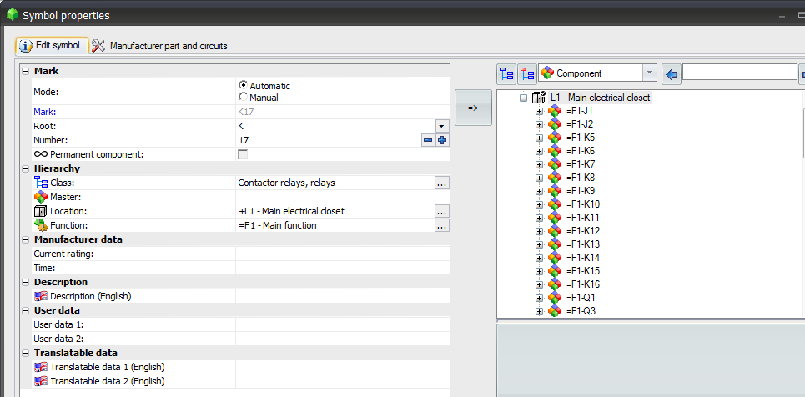
Once each component was placed in the correct place, and the wires were added and given the correct label, the software would then automatically number every wire.
Figure 78 Numbering each Wire
Figure 79 Labelling all Components

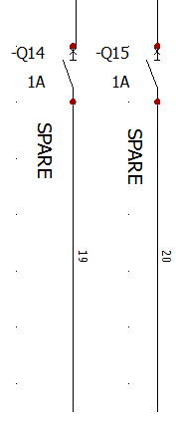
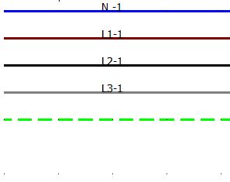
Figure 80 Example of Control and Numbers

Figure 81 Example of Mains and Numbers

Once all the pages were completed, the document was printed and the panel was now able to be wired in accordance with the drawings created. Following this meant little confusion with different cables, and provided the correct colours required for each cable. See Appendix for complete drawings.

Designing the Panel

Using the ‘Required Parts List’ and the ‘Electrical Drawings’, it was possible to design the layout of the panel, considering how each of the components had to be connected, and using the most efficient way to use the space provided on the back-chassis plate of the panel. Following wiring patterns throughout the Factory, a rough design was drawn up which showed components to flow throughout the panel. With the main incoming wires from external components going into Terminal Blocks at the top of the panel, then progressively moving through the MCB’s, Contactors and Inverters lower in the Panel, with the PLAC about ¾ of the way down the panel. In between each level of components would be plastic Trunking that would securely hold the cables in place. Knowing this, the Din Rail and Trunking could be fitted to the chassis plate.
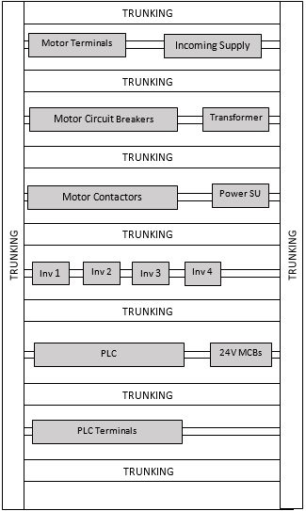

Figure 82 Panel Layout

Following on from this, it allowed the components to be fitted to the Din rail, and any adjustments to the design be made before any wiring took place.

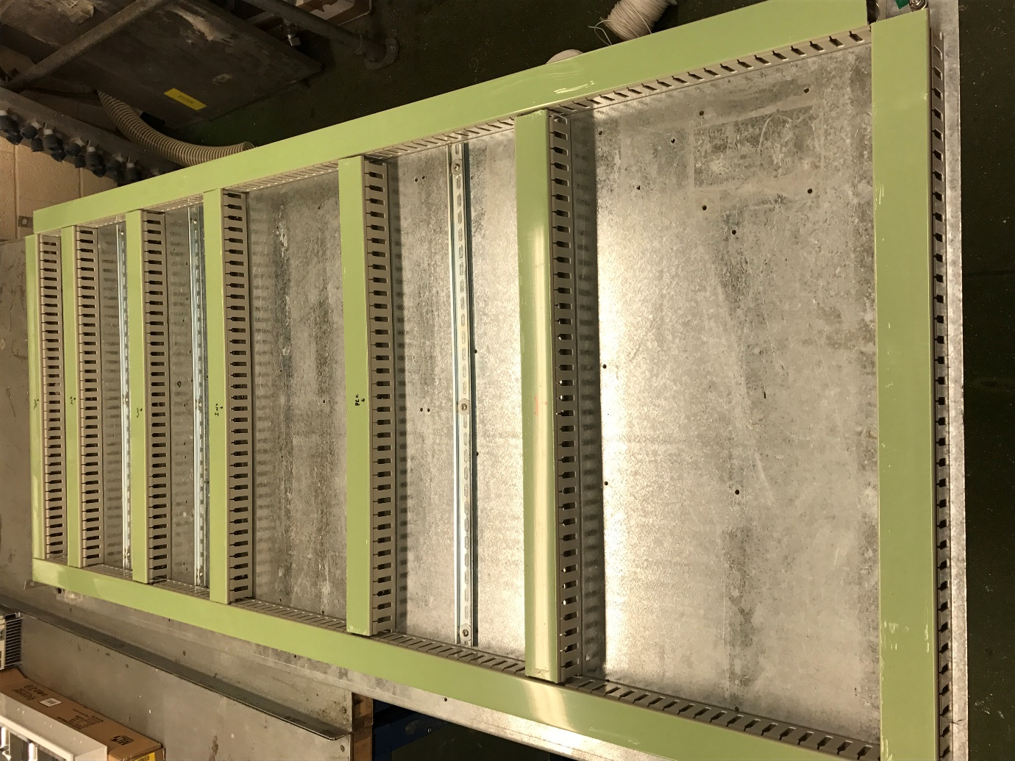
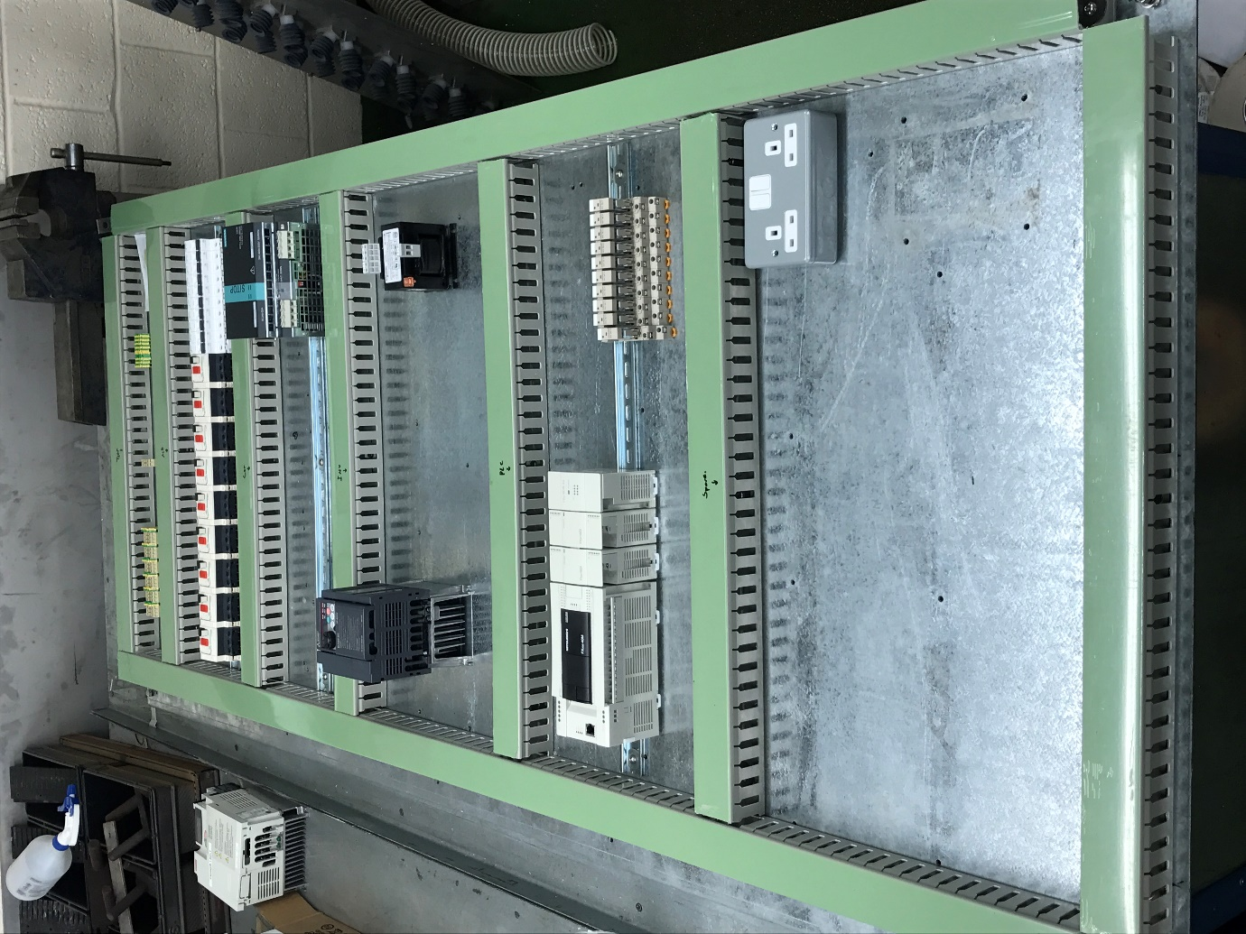

Figure 83 Layout of Panel with Din Rail and Trunking Secured

Once these components had been added, it was evident that there wasn’t any Din Rail fitted for the Terminal Blocks for each of the Inputs and Outputs of the PLC, therefore an extra Din rail and Trunking was added in the free space previously left at the bottom. Adding this terminal block would make it easier for the panel to be tested on and means that all the outgoing cables to the external components could be wired into these terminals, as opposed to straight into the PLC.

Wiring the Panel

Once all the design sections had been finished, and the Panel components were secured, it was then time to wire the panel in accordance to the drawings done in Section 12.
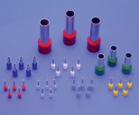
The numbers were distinguished to allow them to be easy to follow throughout the Drawings, and these labels were printed and put onto the cables. To ensure a good connection was made between the cables and the terminals on the component, each cable was fitted with a Bootlace Ferrule which was squeezed tightly to the copper strands within the sheathing. Different Ferrules are available dependant on the connection required to the components, and the size of the cable changed what Ferrules were used.
Figure 84 Ferrules available ^{[43]}

Varied sizes of Bootlace Ferrules are available, where each size is coloured differently. The main colours that were used were light blue Ferrules, for a 0.75mm cable, and Orange Ferrules for 4mm cable.
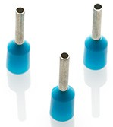
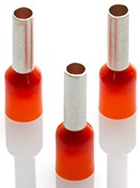

Figure 85 Ferrules Required ^{[44]}

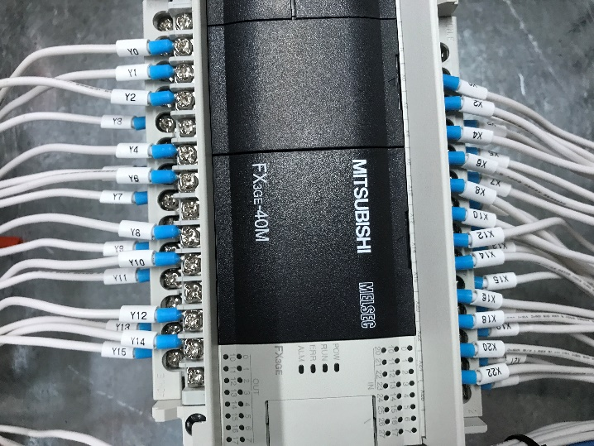
To start, the PLC was wired into terminals, which made it easier for the cables to be distributed out to the external components. They were wired in ascending order, and the terminals were split into blocks of ten. This makes it easier for any future testing to be done as it makes cables easier to locate when spread out. The PLC CPU and added cards had their own terminal numbers, including:
Figure 86 Wiring into PLC
- CPU Unit: X0 - X7, X10 - X17, X20 – X27, Y0 – Y7, Y10 – Y17.
- Input Card 1: X0 – X7, X0 – X7.
- Input Card 2: X0 – X7, X0 – X7.
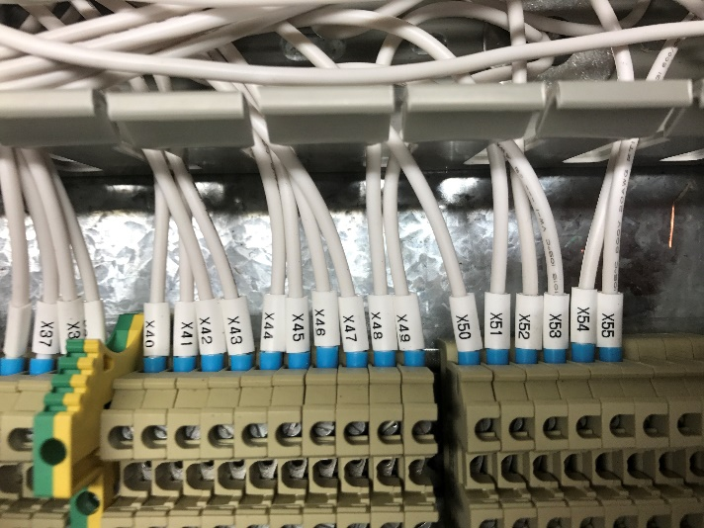
- Output Card: Y0 – Y7.
The PLC is in binary form, and these sequences follow the binary pattern (8 bits). However, if each cable was numbered the same as the PLC terminals, there would be too much repetitiveness which could easily cause confusion. Therefore, the labels added to the cables were in ascending order from X0, through to X55. Like the inputs (X), the outputs (Y) were wired from Y0 through to Y23.
Figure 87 PLC wiring into Terminals
From these terminals, wires were run through to the components as seen in the drawings.
For example, X0 was wired into the Auxiliary of the Circuit Breaker supplying the Scavenger Fan. Therefore, when the Breaker trips, the Auxiliary will send a signal to the PLC which will set off an alarm.

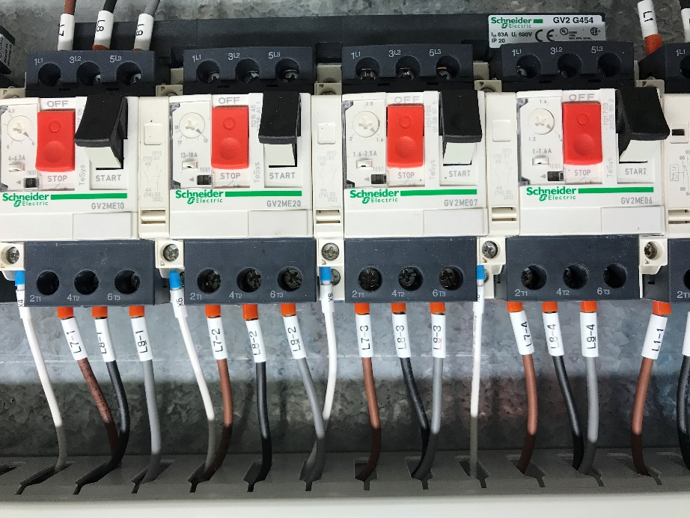
This was similar for all Motors and Fans being operated within the panel, so:
Figure 88 Wiring into Contactors
- X0: Scavenger Fan
- X1: Main Driver
- X2: Grouping Conveyor
- X3: Discharge Pusher
- X4: Air Con
- X5: Control Circuit
- X6: Oven Transfer Conveyor
- X7: Infeed Pusher
- X8: Lubricator
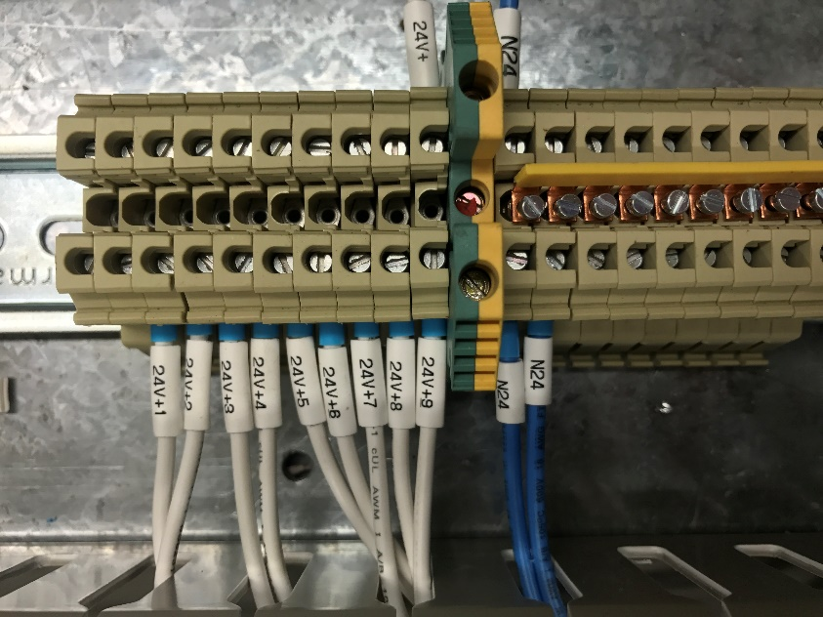
This followed for all inputs into the PLC from internal Panel components, and external components. Whilst the control was being run for the PLC, the 24V+ and 24V- were also run to the areas required. The 24V PSU in place, ran into a block of ten 24V terminal blocks that were all linked together using a small bus-bar, this allowed multiple 24V+ cables to be wired through the panel. These cables were run through the Single Pole Circuit Breakers, and then to all units requiring 24V+.
Figure 89 24V+ into Terminals
However, to ensure that each cable was specifically labelled for easy identification, each 24V+ cable was labelled 24V+1, 24V+2… etc. dependant on which component it was supplying. This including components such as:
- PLC Analogue
- PLC Cards
- HMI Screen
- PILZ Safety Unit

Some components required 24V+, but were not run through the Circuit Breakers, these included the Auxiliary Contacts on the Circuit Breakers. The same idea was used for the 24V, it was taken from the PSU and then into ten terminal blocks where the cables could be dispersed throughout the Panel, like the 24V+1 etc. With most PLC cables wired, the control cable for the Inverters was wired in accordance to the Electrical Specification supplied with each Inverter. There are many different terminals available on each Inverter, but the certain ones relevant had to be identified. In this case, the terminals use d included:
- PC: Common 24VDC Supply
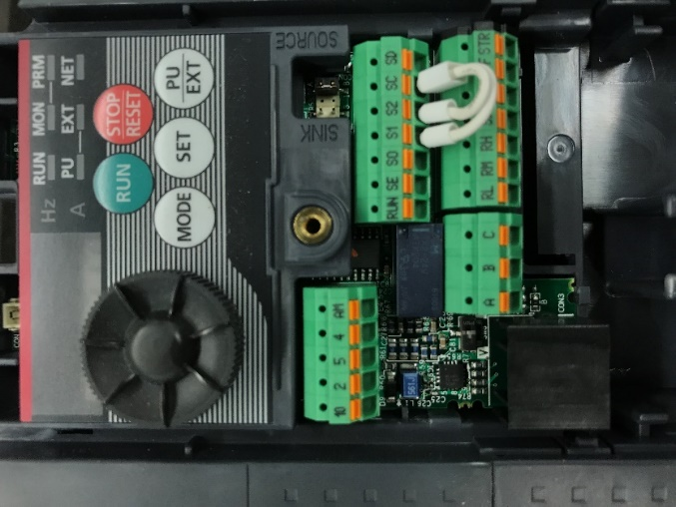
  - General 24V supply, supplying the control circuit board inside.
Figure 90 Inverter Terminal Options
- RL: Low Speed Selection
  - RH (High Speed) and RM (Middle Speed) not required as it will only be running at one speed unless Frequency is manually adjusted.
- STF: Forward Start
  - Signal telling the inverter to start in the forward direction
- STR: Reverse Start
  - Signal telling the inverter to start in the reverse direction
- SE: Open Collector Output Common
  - Wired slightly differently depending if Sink or Source is used
- RUN: Running Signal
  - Tells the PLC that the Inverter is running
- C: Fault Output
  - Relay involving A that latches if a Fault occurs, will signal to the PLC
- A: Fault Output
  - Relay involving C that latches if a Fault occurs, will signal to PLC
- 5: Output Analog Signal
  - Gives a signal out to determine the speed its running at, signal to PLC
- 4: Input Analog Signal
  - Signal from PLC telling the Inverter to change speed
Using these terminals, the Inverters were wired using the numbers represented in the Electrical drawings. Once the Inverters were completely wired, the only control cables required to be run included the PILZ unit, which was the main safety unit controlling all the Safety interlocks on the Prover. On the PILZ Safety Unit, the terminals had to be selected, like the process with the Inverters. These included:
- A1: Common 24VDC Supply
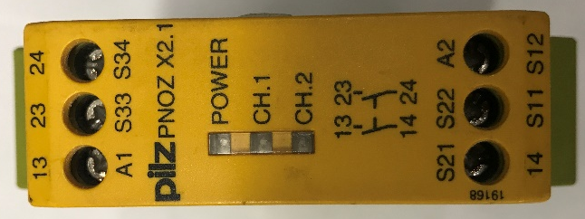
  - Common 24VDC supply fed from MCB
Figure 91 PILZ Relay Terminal Options
- A2: Common -24VDC
  - -24VDC coming from PSU
- S11: Safety Channel 1
  - Cable run to S12 via several safety interlocks, acting as the first channel
- S12: Safety Channel 1
  - Cable from S11 after being run through several safety interlocks, completing the first channel.
- S21: Safety Channel 2
  - Cable run to S22 via several safety interlocks, acting as the second channel
- S22: Safety Channel 2
  - Cable from S21 after being run through several safety interlocks, completing the second channel.
- S34: Reset
  - Signal through the Reset button back to S12
- 13: 24VDC Supply
  - Supply to other side of Safety Relay through to 14
- 14: PLC Input
  - Signal to PLC confirming when the PILZ is in fault, supplied from 13
- 23: Common 24VDC Supply
  - Supply to the other Side of Safety Relay to 24
- 24: Safety Relay Supply
  - 24VDC supply to NVRs confirming power can be restored to Motors and Fans.
These cables were run in the white 0.75mm cable, with the relevant earth cables of the same size also being run where required. To reduce cables being run throughout the factory for the safety interlocks on the main entrance doors, a Key Lock was fitted to the panel which meant that when the main key was removed, the safety would drop out and all doors could be opened. Other safety features added were E-Stops on the Panel, Infeed and Outfeed Conveyors.
Now that all the control cable had been run, the Power cables could be run. These were 4mm cables and run in Grey, Black and Brown which represented the 3-phases for 415V, a Blue cable was used for the neutral where required.
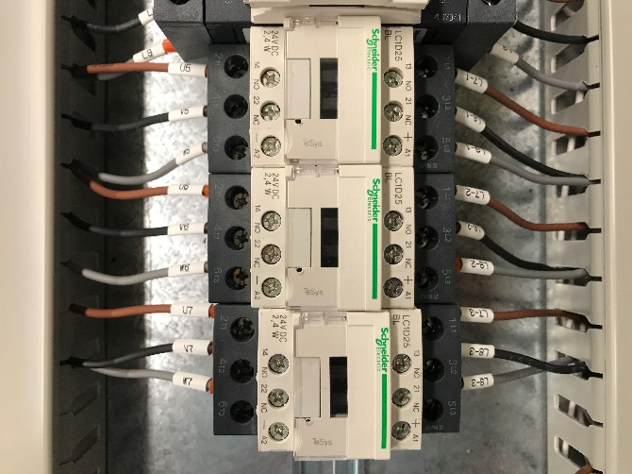
Neutral cables were distinguished by being labelled with an N followed by a number, the number increased by 1 every time the cable went through a component. For example, the main Neutral into the Isolator was called ‘N1’, coming out of the Isolator it changed to ‘N2’, then coming out of the Safety Relay it went up to ‘N3’, this was a recurring theme throughout the wiring. Following this, when the Neutral was run through a breaker then into a component, it became ‘N2-1’. For example, the Neutral cable ‘N1’ was run into a 2A Breaker supplying 240v to the PLC, once the Neutral had gone through the breaker, it then became ‘N1-2’. This increased for every component that was on a Neutral branch.
Each phase of the 415V was labelled, Brown – L1, Black – L2 and Grey – L3, the same sequence applied for the phases where the number would increase when the supply went through a component. Coming out of the Safety Relay, these number changed to L4, L5 and L6, then L7, L8 and L9 etc. When run through a Breaker, they became L4-1, L5-1 and L6-1, with the numbers increasing dependant on the number of components on that phase.
Figure 92 Contactor Connections
The drawings were worked through, putting power onto each component in turn, being careful to label each wire correctly, as per the wiring diagrams. When a 240V supply was required, for the PLC for example, only one of the phases would be used.
There were two Safety Relays put in place. SR-R1 was on the line that supplied all four inverters, then SR-R2 was in line with all the direct online motors. The 24V coils on them were controlled by the supply from the PILZ, when the PILZ was healthy all Motors and fans would be operational as the Relay/Contactor was be energised. However, if the PILZ Safety Unit was to go into Fault, the Relay/Contactor would drop out, stopping all 415v supply to everything in line with it. The only power would stay on the PLC, this could only be removed if its individual breaker was turned off or the panel was powered down.
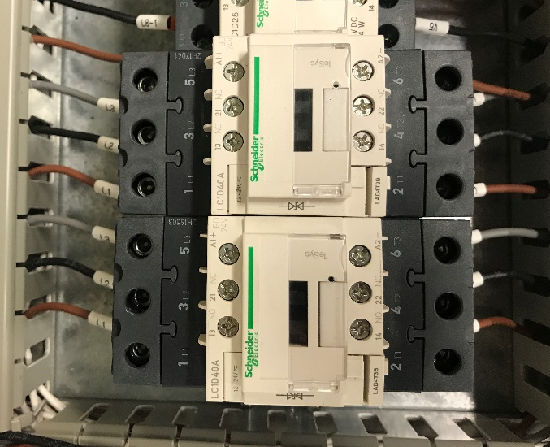
The 415V supply was run into both Safety Relays, where the supply would then follow into the breakers supplying the components. To avoid linking all the Breakers using cables, bus-bars were fitted which allowed four contactors to be connected securely. Out of four of the breakers, the supply ran through to the inverters. However, the other 5 breakers fed into Contactors, these had 24V coils that were controlled by the PLC on whether they should be energised or not. Out of both the contactors and inverters, the supply was then wired into terminal banks at the top of the Panel. Once the panel was fitted, the Motors and Fans could be wired into these terminals banks, making it a lot easier to test on if a problem every occurred.
Figure 93 Safety Relay connections
Following this pattern, all the power cables got wired and all control and power cables were neatly arranged in the trunking to ensure they were safe and had plenty of slack to rest. Once the main panel was wired, and all the work on the back-chassis plate was complete, the board was then transported to the other factory where it was fitted into the Panel.

Once completed it allowed the old panel to be taken out of use, and start wiring the external components into the new Panel. The Motors and Fans could be wired into the terminal blocks fitted at the top of the panel, whereas the smaller components acting as inputs to the PLC were wired into the bottom terminal blocks. See Appendix for Photos.

Designing the Facia Plate

The next stage was to design the Facia Plate that would be fitted to the front of the Panel. With the panel being a previously used one, the facia plate allowed for all the old markings and holes to be covered up.
PROVER PANEL

PROVER PANEL
STEAM

STEAM
START STOP ON/OFF SAFETY RESET

START STOP ON/OFF SAFETY RESET
E-STOP

E-STOP
SAFETY RESET ALARM MUTE

SAFETY RESET ALARM MUTE

1200mm

1200mm

750mm

750mm
Figure 94 Facia Plate design
Screen: 5.7 inch
All holes: 22mm
All writing: ‘Calibri Body’. Title Size 72. Other writing size 20.

Screen: 5.7 inch
All holes: 22mm
All writing: ‘Calibri Body’. Title Size 72. Other writing size 20.

This design was sent to the manufacture who used the drawings to create the Facia Plate, which could be bolted onto the front of the panel, covering any old markings and holes made from its previous use.
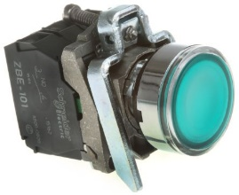
The START button was a green LED button, which would light up when pressed and the prover was in operation, The STOP button would be a red LED which would also light up when pressed by the user. When the system was stopped, the START light would flash frequently signalling that both the system was stopped, but it was ready to run if required.
Figure 95 Green Button used on Door ^{[45]}
The STEAM ON/OFF was a switch that could be operated by the user, enabling them to easily turn the steam on or off as required. When turned OFF, an alarm would signal to inform the User.
A blue SAFETY RESET LED button was also available, this would only light up when the PILZ was in fault in the panel, and would only go off or reset when the safety circuit was energised.
The ALARM MUTE button is a simple black button that can be pressed when an alarm is going off, and the User is dealing with the situation and doesn’t require assistance.
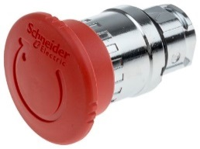
Finally, the E-STOP is a red emergency stop button that will be the largest on the panel, and easily visible. This will be wired into the safety circuit and will click into place when pressed. The only way to remove this is to twist the button and it will click back out into place. Pressing this will stop all operations within the Prover, and when returned, the SAFETY RESET button will light up as previously mentioned.
Figure 96 Emergency Stop used on Door ^{[46]}

Evaluation

There are many conclusions that can be drawn from this Project, but also a lot of lessons can be learnt.
The aim of the project was to build a Panel that was more up-to-date with the current Wiring Regulations, and used new components and touch screens which would aid the Operator when using the machine. The project met this aim, and all components were successfully implemented and operated as they should. The screen also offered good visuals for the Operator, and useful information for an Engineer when trying to fault find on the Panel. The wiring within the panel was also up to a very high standard, meeting all the Wiring Regulations previously mentioned, and was labelled well to easily identify all cables when it came to fault finding, or adjustments required in the future.
These aims were successful and were achieved to a high standard, however due to the delay in certain components delivery and certain business requirements and circumstances, the Panel, although finished couldn’t be fitted into place and tested as expected. Therefore, in this instance, the Project slightly failed to meet the expectations first set out.
A new date has been set for the Panel, with it due to be fitted and tested before 12th May 2017, ready for the new factory to start production in June 2017.
The Background Research was in enough detail to easily define which components were required for each task, and all the components ordered met the standards expected of them when bought. However, more research could have gone into Suppliers of the components, with more confirmed dates of deliveries. This would have reduced the time it took for them to arrive, and the panel would have been in place, with the project completely operational as expected when it was started in 2016.
With this being the main issue with the success of this project, it is the one task that could be changed if another Project were to begin. All other tasks and issues were completed to a high standard, and the HMI Touch Screen and Panel Wiring has been commended by the Operators and Engineers that will be using the system.

Conclusion and Recommendations

Overall the entire Project and Report was successful. Several different techniques have been learnt and improved throughout the process, which could be implemented in future projects. The only issue was that there was insufficient time for final fitting and testing in situ. However, it is the one task that could be changed if another Project were to begin. All other tasks were completed to a high standard, and the HMI Touch Screen and Panel Wiring has been commended by the Operators and Engineers that will be using the system.
The Background Research was a success, and provided good, in-detail knowledge of what was required in certain areas and conditions, and allowed the correct components to be ordered. All the components ordered met the standards required when the project first started.
There were several benefits of doing this project, which were original set out in Section 7: Desired Outcome. They were to assist and help the Operator using the machine, and make it easier for them to have complete control of the Prover and be able to visually see everything that is happening within it. The current state of the Panel, although not connected shows the potential to be able to supply the user with these facilities. By purchasing a PLC with extra I/O, means that it can also be added to and improved on in the future.
Another benefit that was set out at the start of the project, was to have a Panel that could be easily worked on by Engineers if a problem ever occurred. Follow the different wiring rules and regulations, and following a strict wiring number pattern, meant that it is in a safe working condition, and easy to follow if required.

Reflection

This Project will be used as a stepping stone to learning how to deal with different problems that can arise. Starting the Project earlier, and allowing more time to have the components delivered and built would be a major factor that would be changed if it were to be re-done.
When producing the Electrical drawings and designing the HMI Screen, new software’s were used which allowed knowledge to be built up in these areas for future projects. Producing this Panel also helped with learning about the different components available. Doing the Background Research, and looking at components in more depth meant that a greater knowledge can be built up in this area. This allows it to be taken into future Project or Panel building designs that may take place.
As a first attempt of a Major Project within the company, overall the outcome was positive. As a first time managing Suppliers and Manufacturers of components, some naivety was shown with regards to promised delivery dates and this could have been helped if the project was started earlier.

Referencing

[1]
Braces Bakery LTD. (2017). Braces Bakery: Company. Retrieved from Company Overview: http://www.bracesbakery.co.uk/company/company-overview/
[2]
Research Methodology. (2005). Methodology. Retrieved from Research Methodology: http://research-methodology.net/research-methodology/
[3]
Team CVOTER. (2017). Research Methods. Retrieved from Center for VOTING OPINION & TRENDS in ELECTION RESEARCH : http://www.cvoterindia.com/about-us/
[4]
UKESSAYS. (2015, 03 23). Research Onion - Explanation of the Concept. Retrieved from https://www.ukessays.com/essays/psychology/explanation-of-the-concept-of-research-onion-psychology-essay.php
[5]
Research Methodology. (2016). Research Philosophy. Retrieved from Research Methodology: http://research-methodology.net/research-philosophy/#_ftn1
[6]
Research Methodology. (2016). Research Approach. Retrieved from Research Methodology: http://research-methodology.net/research-methodology/research-approach/
[7]
Research Methodology. (2016). Deductive Approach (Deductive Reasoning). Retrieved from Research Methodology: http://research-methodology.net/research-methodology/research-approach/deductive-approach-2/
[8]
Research Methodology. (2016). Inductive Approach (Inductive Reasoning). Retrieved from Research Methodology : http://research-methodology.net/research-methodology/research-approach/deductive-approach-2/
[9]
Research Methodlogy. (2016). Ethnography. Retrieved from Research Methodology: http://research-methodology.net/research-methods/qualitative-research/observation/ethnography/
[10]
Research Methodology. (2016). Action Research. Retrieved from Research Methodology: http://research-methodology.net/research-methods/action-research/

[11]
Institute for Work and Health. (2009). What researchers mean by... cross-sectional vs. longitudinal studies . Retrieved from Institute for Work and Health: https://www.iwh.on.ca/wrmb/cross-sectional-vs-longitudinal-studies
[12]
Research Methodology. (2009). Data Collection Methods. Retrieved from Research Methodology: http://research-methodology.net/research-methods/data-collection/
[13]
Spooner . (2017). Spooner Provers. Retrieved from http://www.spooner.co.uk/products/provers/
[14]
El-Pro-Cus. (2017). What is a PLC System – Different Types of PLCs with Applications. Retrieved from El-Pro-Cus: https://www.elprocus.com/programmable-logic-controllers-and-types-of-plcs/
[15]
GrabCAD. (2017). Mitsubishi PLC : Power Supply Unit. Retrieved from GrabCAD: https://grabcad.com/library/q61p-mitsubishi-plc-power-supply-unit-1
[16]
NexInstrument. (2017). PLC CPU Module: Q12PRHCPU. Retrieved from NexInstrument: https://www.nexinstrument.com/Q12PRHCPU
[17]
MroSTOP. (2017). PLC. Retrieved from MroSTOP: https://www.mrostop.com/products/electrical-equipment/plc.html
[18]
Shaltz Automation. (2017). Mitsubishi Automation Platforms. Retrieved from Shaltz Automation: http://www.shaltzautomation.com/Mitsubishi.html
[19]
Ladder Logic. (2017). What is Ladder Logic? Retrieved from Ladder Logic: http://www.ladder-logic.com/hello-world/
[20]
PLCdev. (2016). Simple Ladder Logic. Retrieved from PLCdev: http://www.plcdev.com/files/plcdev/images/simple-ladder-example.png
[21]
PLCMentor. (2017, 04 24). Ladder Logic. Retrieved from PLC Mentor: http://www.plcmentor.com/Articles/Newsletters/Ladder-Logic.aspx

[22]
Electro-Tech. (2017). Ladder. Retrieved from Electro-Tech: http://www.electro-tech-online.com/attachments/ladder-jpg.31700/
[23]
VFDs. (2014, 03 20). What is a Variable Frequency Drive? Retrieved from VFDs: http://www.vfds.com/blog/what-is-a-vfd
[24]
Test and Measurement. (2016, 03 02). Basics of variable-frequency motor drives. Retrieved from Test and Measurement: http://www.testandmeasurementtips.com/basics-varible-frequency-motor-drives/
[25]
Inverter Drive Supermarket. (2017). Mitsubishi D740 - 0.37kW 400V 3ph AC Inverter Drive Speed Controller, Unfiltered. Retrieved from Inverter Drive Supermarket: https://inverterdrive.com/group/AC-Inverter-Drives-400V/Mitsubishi-Drives-370W-400V-FR-D740-012S-EC-Vector/
[26]
Learning About Electronics. (2015, 11 02). What is a Smoothing Capacitor? Retrieved from Learning about Electronics: http://www.learningaboutelectronics.com/Articles/What-is-a-smoothing-capacitor
[27]
PILZ. (2017). Safety relay/safety relays PNOZ. Retrieved from PILZ: https://www.pilz.com/en-AU/products-solutions/relay-modules/safety-relays-protection-relays
[28]
GALCO. (2017). Safety Relays - Where and How They Work. Retrieved from GALCO: http://www.galco.com/comp/prod/saftrela.htm
[29]
Automation. (2017). Fundamentals of Photoelectric Sensors. Retrieved from Automation: https://www.automation.com/library/articles-white-papers/sensors-sensing-technologies/fundamentals-of-photoelectric-sensors
[30]
RF-Wireless World. (2017). Through-Beam vs Diffuse Reflective vs Retro Reflective Sensor. Retrieved from RF-Wireless World: http://www.rfwireless-world.com/images/Through-beam-vs-diffuse-Reflective-vs-retro-reflective-sensor.jpg
[31]
Automation24. (2016). IFM Sensor. Retrieved from Automation24: http://media.automation24.com/Artikelbilder/Shop800px/100071_1.jpg

[32]
Automation24. (2016). Barrel Sensor. Retrieved from Automation24: http://media.automation24.com/Artikelbilder/Shop800px/100075_2.jpg

[33]
RackCDN. (2016). Retro Reflective Sensor. Retrieved from RackCDN: https://0f469d6f2fa468202d31-6b0d87410f7cc1525cc32b79408788c4.ssl.cf2.rackcdn.com/550/13294801_1.jpg
[34]
HubSpot. (2016). PhotoElectric Sensors. Retrieved from HubSpot: http://cdn2.hubspot.net/hub/165667/file-35865237-jpg/images/light-dark-4-resized-600.jpg?t=1431527993221
[35]
AnaheimAutomation. (2016). HMI Touchscreen Products. Retrieved from AnaheimAutomation: https://www.anaheimautomation.com/products/hmi/pages/hmi-touchscreen.php
[36]
RS. (2017). Siemens, 1, 5.7 in STN Touch Screen HMI, Colour, 320 x 240pixels, 245 (Dia.) x 123.9 mm . Retrieved from RS: http://uk.rs-online.com/web/p/touch-screen-hmi-displays/7465460/
[37]
RS. (2017). Mitsubishi GOT2000, 7 in TFT LCD Touch Screen HMI, Colour, 800 x 480pixels, 155 x 206 x 50 mm. Retrieved from RS: http://uk.rs-online.com/web/p/touch-screen-hmi-displays/8280529/
[38]
Static. (2016). Single Core Cable. Retrieved from Static: http://thumbs1.ebaystatic.com/d/l225/m/mUXabi8Og1-_YLFQLYMpr5g.jpg
[39]
Conrad-Electronic. (2015). Coaxial Cable. Retrieved from Conrad-Electronic: http://www.conrad-electronic.co.uk/medias/global/ce/6000_6999/6000/6040/6048/604869_BB_00_FB.EPS_1000.jpg
[40]
Network cabling. (2017). Paired Cable. Retrieved from Network cabling: http://www.networkcablinglosangeles.com/wp-content/themes/networkcablinglosangeles/images/unshielded_cable.jpg
[41]
Caledonian Cables. (2007). New Cable Colour Code . Retrieved from Caledonian Cables: http://www.caledonian-cables.net/product/Technical%20Lib/New%20Cable%20Colour%20Code.htm
[42]
ACL. (2007). Earth Cables. Retrieved from ACL: http://www.acl.lk/product/earth-cables
[43]
Ferrule Direct. (2017). Ferrule Variations. Retrieved from Ferrule Direct: http://www.ferrulesdirect.com/
[44]
M E I. (2017). Ferrule Variations. Retrieved from M E I : http://www.m-e-i.co.uk/shop/crimps/bootlace-wire-end-ferrules/bootlace-ferrule-blue-0-75-mm.html
[45]
RS. (2017). Schneider Electric XB4 Push Button Green NO/NC Spring Return . Retrieved from RS: http://uk.rs-online.com/web/p/push-button-complete-units/6095903/
[46]
RS. (2017). Schneider Electric Harmony Emergency Button, Twist to Reset, Red 40mm Mushroom Head . Retrieved from RS: http://uk.rs-online.com/web/p/emergency-stop-push-buttons/3309388/

