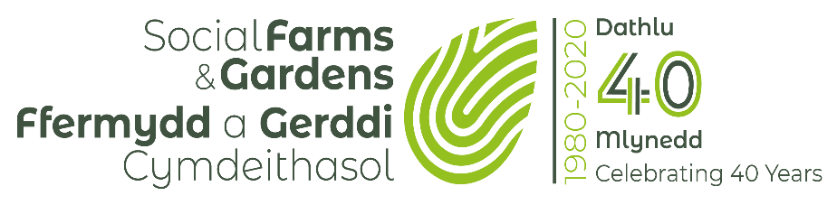

Green Space/ Community Garden Site Resilience Plan
Greenspaces include a range of vegetated land such as parks, community gardens, orchards, woodlands and hedges, informal green spaces, allotments and food growing sites, plus areas of water including rivers, canals, lakes, ponds.
At Social Farms & Gardens we aspire that all greenspaces in Wales should include an element of Food Growing, however big or small. This ranges from community gardens and allotments with food growing as their primary focus, down to incidental food growing such as a few apple trees, wild raspberries, or a hedgerow with varieties of tree suitable for foraging. Pollinators are essential to successful food growing and as such we encourage all sites to plant with pollinators in mind, leave some areas wild, and work to improve site biodiversity particularly through planting native plant varieties.
Resilience Plan Background: Green infrastructure is a network of features that are connected to each other, the surrounding countryside and urban populations. Greenspace, for example a community garden, may be seen as a feature of green infrastructure. High quality green space/ green infrastructure is multifunctional, accessible, inclusive, responds to local context, biodiverse, interactive (opportunities for play and food growing), creates habitat, contains water collection features and provision for sustainable drainage systems (SuDS). It is key that high quality green spaces are bought into urban areas close to where people live to allow maximum access and benefits to wellbeing.
Wellbeing of Future Generations: Improving access to green infrastructure and spaces contributes to increased physical activity (especially in children), improved mental well-being, reduced exposure to environmental hazards and air pollution, improved air quality, and increased social participation among older adults, whilst reducing the impact of climate change, giving protection against flooding and erosion. Examples have shown that people who live within 500 metres of accessible green space are 24% more likely to meet 30 minutes of exercise levels of physical activity.
Resilience Plan Purpose: The format of this plan has been developed with a number of key outputs in mind. These include:
1. To help community groups look to or currently managing greenspaces to focus on their purpose and what they aim to achieve through their activities, both for themselves as a group but also the wider community.
2. To put their activities in the context of the Wellbeing of Future Generations Act Wales (2015) and other policies, will in turn act as an enabler in having conversations with Local Authorities, Commissioners, Developers, Land-Owners, and Grant Funders.
3. To act as a tool to raise awareness of what the group is currently doing well and areas of site management that could be improved, with the ultimate goal of achieving a nationally recognised award such as the Green Flag Community Award which is the benchmark for parks and green spaces which are managed by volunteers, and tell the public they are visiting an exceptional place with the highest standards.

Site Information:
 | Group Name
 | Name of lead contact
 | Contact details of main contact
Where | Site address including postcode
Where | Local Authority Area
What | Site name (plus local site names)
What | Total site area
What | Any significant features (natural/physical / built)
What | Is the site of heritage/ historical or ecological value? Any valuable species living on the site?
Who | When was the Group formed?
Who | How many members does the group have?
Who | Who uses the site (public & the group) where do they come from?
Who | Other site stakeholders involved? (local groups, businesses, local authority)
How | Lease or licence? Length of agreement?
How | Site main uses (recreation, tourism, activities)
How | Who is ultimately responsible for maintaining the site?
Why | What is the main purpose or aim of the group?
Why | Any other significant information?
Site Resilience Plan: A Resilient, Healthier, Prosperous, More Equal Wales, with Cohesive Communities of Vibrant Culture, that is Globally Responsible in the decisions it makes……
A RESILIENT WALES: A nation which maintains and enhances a biodiverse natural environment with healthy functioning ecosystems that support social, economic and ecological resilience and the capacity to adapt to change.
 | Current | Future Plans
COMMUNITY GREEN SPACE: How does your site link with the wider community? Does it provide any community food growing spaces? Is the site accessible to all?
BIODIVERSITY: How do you or will you, maintain your site, and enhance the natural environment through managing land appropriately to create healthy functioning ecosystems? How will your space support pollinators and wildlife?
INTERPRETATION: How do you or will you, use signage to promote your space and its nature? How do you or will you, educate around the importance of a biodiverse natural environment with healthy functioning ecosystems?
SOIL: How does or will your work improve the soil quality? Are you working to “future proof” your site against wind (natural windbreaks) and heat (shade, tolerant vegetation) and enhancing its habitats.
DRAINAGE / FLOODING: How will you or are you, adapting to a changing environment where there is a need to use resources efficiently? Are you future proofing your site against rainfall (sustainable drainage) to reduce flood risks, and against drought (rainwater harvesting, soil mulching)?

A HEALTHIER WALES: A society in which people’s physical and mental well-being is maximised and in which choices and behaviours that benefit the future are understood.
 | Current | Future Plans
HEALTH: Does or will, your site offer opportunities for volunteers to get involved in practical activities? How do you support and thank your volunteers?
SAFETY: Do you or will you, have policies and procedures to keep volunteers and other site users safe? Does your site have handwashing / toilet facilities?
WELLBEING: Does or will, the site have a range of areas, with different themes (such as a wild, edible, play, reflection areas)? Do you or will you, have a seating area?
A MORE EQUAL WALES: A society that enables people to fulfil their potential no matter what their background or circumstances (including socio economic).
 | Current | Future Plans
COMMUNITY OWNERSHIP: Does or will your project site be owned by the community through a freehold agreement or long-term lease? Does your governance any surpluses are reinvested into the community and are the assets of the project used for public good?
RECOGNISE VALUE: How do you or will you, thank your volunteers for their work? How will or is, produce (be) divided up? Will or does your group employ anyone (or plan to)?
LEARNING: Do you or will you, run any training sessions or qualifications at your site? Is it something you would consider in the future?
PARTICIPATION: Do you or will you regularly advertise for volunteer opportunities? Do you have a public AGM? Do you or will you, consult with the community on a regular basis? Do you or will you, run public events?

A WALES OF COHESIVE COMMUNITIES: Attractive, safe, viable and well-connected.
 | Current | Future Plans
ACCESS: Is the site access safe with clear access points? Are there options to travel there by foot/ bike or public transport? Will you develop and improve these? Are there restrictions on when volunteers/ general public can access the site?
COMMUNITY INVOLVEMENT: How are you involving the wider community in the greenspace? What are your longer-term plans around creating a vibrant and viable place, where people can do the things that matter to them?
STAKEHOLDERS & PUBLIC BODIES: Have you engaged with local stakeholders and public bodies to gain support for the project? How is or will, the voice of your group be heard by them as your project develops? Do you sit on any other local or public body groups?
A WALES OF VIBRANT CULTURE AND THRIVING WELSH LANGUAGE: a society that promotes and protects culture, heritage and the Welsh Language and which encourages people to participate in the arts and sport and recreation.
 | Current | Future Plans
HERITAGE: Do you or will you, make the most of the history of your local area/ heritage assets on the site or close by?
WELSH LANGUAGE: Do you or will you, do anything to support Welsh Language? (either spoken or written)
PRODUCE: Will you grow produce known to be from the local area? Will you grow traditional and local varieties of fruits and vegetables? Will you use seeds sourced in Wales? How will you publicise this?

A GLOBALLY RESPONSIBLE WALES: A nation which, when doing anything to improve the economic, social, environmental and cultural well-being of Wales, takes into account of whether doing such a thing may make a positive contribution to global well-being.
 | Current | Future Plans
SUSTAINABILITY: How does or will, the group reduce, reuse, recycle, store water, compost?
PROTECTING OUR PLANET: Do you or will you use compost on the site? Will you peat free soil? Will you refrain from using pesticides and herbicides unless natural methods?
A PROSPEROUS WALES: An innovative, productive and low carbon society which recognises the limits of the global environment and therefore uses resources efficiently and proportionately (including acting on climate change); and which develops a skilled and well-educated population in an economy which generates wealth and provides employment opportunities, allowing people to take advantage of the wealth generated through securing decent work.
 | Current | Future Plans
SKILLS FOR THE FUTURE: Do you or will you have links to the local schools? Is there anything that you could offer them that you’re not already doing?
LOCAL ECONOMIES: Can you support your local economy by buying local? Will you sell or distribute your produce locally? How will you make the site financially sustainable? Will you create any jobs or encourage entrepreneurism?
CLIMATE CHANGE: Thinking of the bigger picture, how do you feel your group is helping people to live more sustainably (a low carbon society)?

Follow Up:
Actions | Who is responsible? | Help Needed by SF&G and others | By When?

Wider Policy Context:
As well as the Wellbeing of Future Generations Act, think about the wider policy context when trying to gain support and conversations with the Local Authority / land owner. Local, regional and national strategies and policy statements may either strengthen or impact on your site plans. Link with your Local Authority through their plans for Community, Culture, Planning, Health, Housing, Environment, Regeneration, Transport, Sustainable development, Equality of opportunity, and Education. This sustainability plan can be used as a talking tool, particularly if you are able to provide a provide a clear statement about how the plan will support and contribute to the relevant aims and objectives.
Other all Wales legislation that may be relevant (and certainly are referenced under the Future Generations Act with particular reference to green spaces) include:

The Environment (Wales) Act 2016 introduces the Sustainable Management of Natural Resources (SMNR) and sets out an approach to planning and managing natural resources to ensure that the benefits they provide for our social, economic, environmental and cultural well-being are available now and for future generations. https://gov.wales/environment-wales-act-2016-factsheets

Section 6 under Part 1 of the Environment Act introduced an enhanced biodiversity and resilience of ecosystems duty (the S6 duty) for public authorities (which includes public bodies in the WFG Act) in the exercise of functions in relation to Wales. https://gov.wales/environment-wales-act-2016-part-1-section-6-biodiversity-and-resilience-ecosystems-duty-reporting-0

The Natural Resources Policy sets out national priorities for the sustainable management of natural resources, for us all to contribute towards. The priorities are about mainstreaming action for biodiversity across our urban and rural areas and reducing the pressures on our natural resources. https://gov.wales/natural-resources-policy

Natural Resources Wales’ Area Statements will help deliver the priorities in the Natural Resources Policy in a place and will be a valuable tool to support public bodies and others delivering local actions. https://naturalresources.wales/about-us/area-statements/?lang=en

The State of Natural Resources Report (SoNaRR) 2016, sets out the national evidence base on the resilience of ecosystems in Wales so that we can understand the extent to which sustainable management of natural resources is being achieved. The building blocks of ecosystem resilience are – Diversity, Extent, Condition, Connectivity and Adaptability. https://naturalresources.wales/evidence-and-data/research-and-reports/the-state-of-natural-resources-report-assessment-of-the-sustainable-management-of-natural-resources/?lang=en

Planning Policy Wales plays a significant contribution to the improvement of well-being in all its aspects and embeds the spirit of the Well-being of Future Generations Act, through moving us towards a low carbon, resilient society with well-connected environments for everyone in Wales. The planning system can contribute to improving the resilience of ecosystems and ecological networks, halting and reversing the loss of biodiversity, maintaining and enhancing green infrastructure, ensuring resilient choices for infrastructure and built development, moving towards a more circular economy in Wales; and facilitating decarbonisation https://gov.wales/planning-policy-wales

Active Travel Act 2013 requires local authorities to map and continuously improve routes and facilities for “active travel” – defined as walking and cycling for a purpose, like accessing work or services, rather than for leisure https://gov.wales/walking-cycling

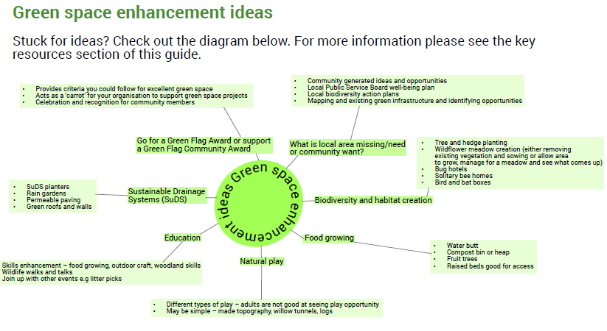

Extract from Green Space and Well-being: A good practice guide for housing associations (published by Linc Cymru, Dec 2019, in partnership with NRW)

