A STRATEGIC MANAGEMENT REVIEW
VOLKSWAGEN GROUP

Stefan Gheorghe – 2024473

Strategic Management and Sustainability – LCBB 6004
Dr. Hossein Shokri
University of Wales Trinity Saint David
16.08.2023

Table of Contents
1. Introduction 3
2. Volkswagen Group Background 4
3. Volkswagen Group's Strategies: A Five-Year Review 4
3.1 The Ansoff Growth Matrix and Volkswagen Group 5
4. Resources and Capabilities of VW Group 8
4.1 Alignment of Resources and Capabilities with Business Strategies 10
4.2 Why These Strategies Were Pursued or Changed 10
5. Volkswagen's Sustainability Initiatives and Competitive Strategy 11
6. Make Recommendations 12
7. Conclusion 13
8. References 15
9. Appendix 17

Introduction
The Volkswagen emissions scandal, also known as "Dieselgate ", came to light in September 2015 when it was revealed that Volkswagen Group (AG) had installed software in their diesel cars to manipulate emission levels during laboratory tests. As a result, these vehicles met the testing standards. They emitted nitrogen oxides (NOx) up to 40 times the permissible limit when driven in real-world conditions. This scandal affected 1.2 million cars in the UK, including brands such as Volkswagen, Audi, Seat and Skoda, particularly impacting the EA 189 diesel engines. The consequences for Volkswagen were felt worldwide. In 2020, the High Court of the United Kingdom ruled that the company had unlawfully used "defeat devices ", potentially making them responsible for compensating around 90,000 UK drivers with settlements.
The scandal's repercussions were far-reaching for Volkswagen as it experienced a decline in its stock price and underwent a change in CEO. Additionally, it cost the company billions of dollars due to fines and settlements. Moreover, VWs reputation suffered damage, leading to increased scrutiny regarding emissions testing practices across the entire automotive industry. As a result of this incident, there was increased recognition of regulations and more vigorous enforcement within the auto industry to prevent similar occurrences from happening again.
In this report, we will briefly present the company mentioned above’s profile, and then we will review some of the critical corporate strategies adopted in the past years. We will also present the resources and capabilities of VW Group and evaluate how these have been aligned with the Group’s strategies. Moreover, we will assess how VW Group has implemented environmental sustainability to become more competitive and end with a few recommendations.

2. Volkswagen Group Background
Established in 1937, Volkswagen AG is among the largest automobile manufacturers globally. The company’s headquarters are in Wolfsburg, Germany, and in 2022, Volkswagen Group had around 676,000 employees across its 119 production facilities. The company’s strong brand portfolio, which includes Audi, Skoda, SEAT, Porsche, and Bentley, is sold in over 150 countries worldwide (Volkswagen Group, 2023).
Despite the challenges presented by COVID-19 and the damaged brand image from the “Dieselgate” scandal, Volkswagen has maintained a solid financial position and recorded revenue of €279.2 billion in 2022, reflecting its resilience and adaptability during these trying times. Volkswagen AG operates in global markets with a presence in Europe, Asia, North America, and South America. China is particularly noteworthy as it contributes significantly to Volkswagen's sales (Volkswagen, 2023).
In summary, Volkswagen AG's heritage, ranging product lineup, global reach and dedication to sustainability have solidified its position as a prominent participant in the automotive industry. The company's capacity to adjust to market trends and surmount obstacles demonstrates its resilience and strategic foresight.

3. Volkswagen Group's Strategies: A Five-Year Review
In the past five years, Volkswagen Group (VW) has implemented several essential corporate strategies to navigate the opportunities and challenges within the global automotive industry. These strategies were shaped by factors, including the consequences of the 'Dieselgate' scandal, the growing focus on electric vehicles (EVs), the effects of the COVID-19 pandemic, global trends for a sustainable future, and the broader shift in mobility and technology. One noteworthy strategy adopted has been Volkswagen's move towards electric vehicles, sustainability, and digitalisation. In 2016 it introduced its "Together 2025" strategy, which included a strong commitment to become a leading electric vehicle player by 2025, as well as looking to become more customer-centric as it needed to regain the trust of its customers following the emissions scandal. This initiative was driven by growing environmental concerns, regulatory pressures, and a consumer preference for more sustainable transportation options. In 2019 the “Together 2025+” extended strategy was adopted, which reflected the company’s continual transformation and ambition to become a global leader in sustainable mobility. In 2021, Volkswagen Group adopted a 12-point “New Auto” strategy focusing on mechatronics, software, battery and charging, and mobility solutions. This strategy reflected a comprehensive and forward-looking approach to the automotive industry's evolving landscape and was driven by technological advancements, sustainability considerations, regulatory pressures, and changing consumer expectations.

3.1 The Ansoff Growth Matrix and Volkswagen Group
The Ansoff Matrix, created by the American planning expert Igor Ansoff, is a strategic planning tool that links an organisation's marketing strategy with its corporate strategic direction. It presents four growth strategies in the form of a matrix, as seen in figure 1 below. One dimension of the matrix considers the” product”, whether existing or new, and the other dimension considers operating” markets”, which can be existing or new (Kermally, 2003).
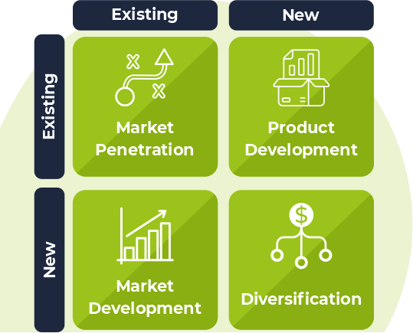
Fig.1 (Source: (Pallister, 2023))
Market Penetration in the context of Volkswagen (VW) Group's strategies involves increasing the company's share in existing markets with existing products. VW has emphasised electric and hybrid models within existing product lines, introducing variations of popular models with electric capabilities, like the VW Golf. By investing and promoting charging infrastructure in existing markets, VW has helped reduce barriers to entry for potential EV buyers, thus encouraging more sales of their electric vehicles (Volkswagen Group, 2023).
Market Development refers to strategies created to sell existing products in new markets. In the VW Group case, it involved adopting strategies which combined geographical expansion into new emerging markets, like India, Africa, and Southeast Asia, or building or expanding manufacturing capabilities in new markets, thus reducing costs, with strategic partnerships and alliances, which allowed the VW Group to navigate the uncertainties of new markets more efficiently.
Product development refers to the strategies that introduce new products for existing markets. In this regard, VW Group has launched its new ID electric vehicle line, ranging from compact to SUV models, committed to a future of electric mobility for its existing markets. It has also increased its hybrid and Plug-in hybrid range and made significant investments in the development of battery technology.
Diversification is a strategy that involves moving into new markets with new products, essentially expanding into areas outside a company's core business. Volkswagen (VW) Group's diversification strategies include investments in research and development of self-driving technologies and collaboration with technology companies that will help integrate new technologies into the Group’s products. VW has expanded its product offerings to include electric commercial vehicles such as buses and trucks, entering new market segments with specialised products.
Volkswagen Group adjusted its strategic approaches based on analysing the internal and external factors influencing its business. For instance, they have conducted a SWOT analysis to identify their strengths (such as a brand portfolio and global reach), weaknesses (including damage caused by the 'Dieselgate' scandal), opportunities (like the growth of the electric vehicle market and digital transformation) and threats (such as regulatory pressures and intense competition). The Ansoff Matrix also guided VWs expansion strategies, including market penetration through increased electric vehicle sales in existing markets and diversification by entering the services sector.
In conclusion, in the past five years, VW's business strategies have been shaped by factors and external circumstances. The company has demonstrated adaptability in response to challenges like the 'Dieselgate' scandal, the electric vehicle transition, and the digital revolution. However, it remains crucial for VW to effectively execute these strategies and adapt to an evolving automotive industry landscape for success.

4. Resources and Capabilities of VW Group
Resources and capabilities are closely linked in an organisation. While having resources is essential, how they are used and managed as capabilities is equally crucial for long-term success. This includes the effective utilisation of equipment, the efficiency of physical or financial resources, and the management systems that govern relationships, adaptability, innovation, and learning within the organisation (Whittington, 2020). As seen in Figure 2 below, resources and capabilities can be categorised as physical, financial, and human. Wittington (2020) also states the need for companies to distinguish between the threshold and distinctive resources and capabilities, the latter being necessary to achieve competitive advantage.
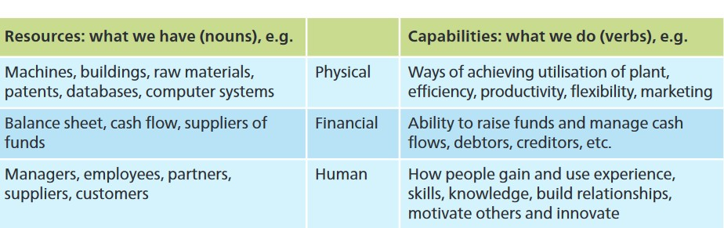
Fig.2 Source: (Whittington, 2020)
The Volkswagen Group is one of the world's leading automobile manufacturers and the largest carmaker in Europe (Appendix 1). Over the past five years, the company has strategically aligned its resources and capabilities to its business strategies. This analysis will identify these resources and capabilities and discuss the extent of their alignment with the company's strategies.
VW Group's resources and capabilities can be categorised into tangible and intangible resources. Tangible resources include the company's vast production facilities, a broad product portfolio, and substantial financial resources. Intangible resources include the company's strong brand reputation, technological capabilities, and human resources.
- Production Facilities: VW Group has a vast network of production facilities spread across the globe (Appendix 2). These facilities enable the company to produce a wide range of vehicles, from luxury cars to commercial vehicles, catering to different market segments.
- Product Portfolio: VW Group's broad product portfolio is another significant resource. The company owns several well-known car products, including Volkswagen, Audi, SEAT, ŠKODA, CUPRA, Bentley, Lamborghini, Porsche, Ducati, Volkswagen Commercial Vehicles, Scania, and MAN (Volkswagen Group, 2023).
- Financial Resources: VW Group has strong financial resources, with revenue of $279.2 billion in 2022 (Volkswagen, 2023). These financial resources enable the company to invest in research and development (R&D), marketing, and expansion into new markets.
- Brand Reputation: VW Group has a strong brand reputation, with several brands recognised for their quality and reliability. The company's brand reputation contributes to its competitive advantage and market position (Interbrand, 2023).
- Technological Capabilities: VW Group has strong technological capabilities, particularly in the area of electric vehicle (EV) technology. The company has invested heavily in R&D, $15.6 billion in 2022, to develop advanced EV technologies for vehicle portfolio, digitalisation, and platforms. The Group aims to become a global leader in these areas (Volkswagen, 2023).
- Human Resources: VW Group's human resources are another critical resource. The company has a skilled and diverse workforce that contributes to its innovation and competitiveness.

Alignment of Resources and Capabilities with Business Strategies
Over the past five years, VW Group's business strategies have primarily focused on digital transformation, sustainability, and market expansion. The company's resources and capabilities have been aligned with these strategies in several ways.
VW Group has leveraged its technological capabilities and financial resources to drive its digital transformation strategy. The company has invested heavily in R&D to develop advanced digital technologies and services, such as autonomous driving and connected car technologies.
VW Group's sustainability strategy is focused on developing and promoting EVs. The company has used its technological capabilities and financial resources to develop advanced EV technologies and expand its EV product portfolio. It also committed and invested in decarbonisation, reducing its supply chain carbon footprint (Volkswagen Group, 2023).
VW Group has used its production facilities, product portfolio, and financial resources to expand into new markets, particularly in Asia. The company has established new production facilities and launched new products to cater to the specific needs of these markets (Edward, et al., 2019).

4.2 Why These Strategies Were Pursued or Changed
VW Group's strategies were pursued or changed due to several factors, including market trends, competitive pressures, and regulatory requirements. The automotive industry's shift towards digitalisation and sustainability has driven the company's digital transformation and sustainability strategies. The growth opportunities in emerging markets, like China, have driven the company's market expansion strategy. Regulatory emissions and fuel efficiency requirements have also influenced the company's strategies.
In conclusion, VW Group has effectively aligned its resources and capabilities with its business strategies over the past five years. This alignment has enabled the company to respond effectively to market trends, competitive pressures, and regulatory requirements and to achieve its strategic objectives.

5. Volkswagen's Sustainability Initiatives and Competitive Strategy
Volkswagen Group (VW), one of the world's leading automobile manufacturers, has been making significant strides in enhancing its competitiveness while prioritising sustainability and environmental considerations. We will evaluate VW's efforts, providing evidence of its strategic initiatives and their impact on its competitive position in the global automotive industry.
VW's commitment to sustainability is evident in its shift towards electric vehicles (EVs). The company has pledged to launch approximately 70 all-electric models by 2030 and around 60 hybrid models by the next decade (Volkswagen, 2022). This strategic move was adopted in response to the increasing demand for EVs, growing consumer environmental awareness, and stringent emission regulations worldwide. VW's ID series, including ID.3 and ID.4, has been well-received in the market, demonstrating the company's competitive edge in EV technology.
Porter's Five Forces framework provides a useful lens to evaluate VW's competitive strategy. The threat of rivalry in the EV market is high, with tech companies like Tesla and traditional automakers intensifying competition. However, VW's significant investments in EV technology and infrastructure and its strong brand reputation somewhat mitigate this threat. The bargaining power of buyers, in this case, final consumers, is also high due to the availability of various EV options. VW addresses this by offering a wide range of products, from entry-level to high-quality cars, and making these affordable while providing advanced features.
VW's sustainability efforts extend beyond its product offerings. The company has invested heavily in renewable energy to power its manufacturing operations, reducing its carbon footprint. It has also implemented circular economy principles, aiming to recycle more than 90% of raw materials used in its EV batteries (Volkswagen Group, 2023). These initiatives enhance VW's environmental performance and improve its operational efficiency and cost-effectiveness, contributing to its competitiveness.
In conclusion, VW has demonstrated a solid commitment to sustainability, integrating it into its competitive strategy. Its shift towards EVs, investments in renewable energy, and implementation of circular economy principles contribute to environmental sustainability and enhance its competitiveness. However, VW must continue to innovate and adapt to the dynamic market conditions and regulatory landscape to maintain its competitive edge.

6. Make Recommendations
Based on the latest research and industry trends, recommendations can be made for Volkswagen Group, specifically in the automotive industry, to develop competitive advantages through sustainability practices. First, the circular economy model, which focuses on reducing, reusing, and recycling materials, can be a game-changer for the company. By designing products for longevity, repair, and eventual recycling, Volkswagen AG can reduce its reliance on raw materials, decrease waste, and create new revenue streams. For instance, remanufacturing parts or refurbishing used cars can save costs and meet the growing consumer demand for sustainable products.
Secondly, transitioning to renewable energy sources for operations can significantly reduce the organisation’s carbon footprint and operational costs. Companies like Volkswagen AG have already started investing in renewable energy, reducing greenhouse gas emissions, and enhancing their brand reputation.
Implementing sustainability practices across the supply chain can lead to cost savings, risk reduction, and improved stakeholder relationships. This includes working with suppliers to reduce their environmental impact, implementing fair labour practices, and ensuring transparency in sourcing.
Engaging with stakeholders, including customers, employees, investors, and local communities, can provide valuable insights into their expectations and help shape the company's sustainability strategy. It can also improve the company's reputation and customer loyalty.
While compliance with environmental regulations is necessary, going beyond compliance can offer a competitive advantage. By proactively adopting sustainable practices, Volkswagen AG can stay ahead of regulatory changes, avoid potential fines and penalties, and position itself as the industry leader.
In conclusion, sustainability is no longer a choice but a necessity for businesses. By adopting sustainable practices, organisations can contribute to environmental conservation and gain a competitive advantage in the market.

Conclusion
Over the five years, Volkswagen Group has shown an evolution that mirrors the ever-changing automotive industry and its dedication to innovation, competitiveness, and sustainability. By analysing business strategies, like "Together 2025", " Together 2025+", and "New Auto", it becomes evident that Volkswagen is actively aligning itself with global trends such as electrification, digitalisation, and customer-centricity. They have skilfully navigated pressures and capitalised on opportunities using frameworks like Porter's Five Forces and SWOT analysis. The alignment of resources and capabilities with these strategies, such as technological expertise and manufacturing capacity, highlights their adaptability and strategic consistency. Their commitment to sustainability is commendable as they carefully balance success with stewardship and social responsibility. Furthermore, the recommendations for sustainability practices provide a roadmap for Volkswagen to maintain its competitive edge through responsible leadership. In conclusion, Volkswagen's strategic journey represents an approach that positions them as a leader in a transforming industry while keeping sustainability at the forefront.

References
Edward, T., Schwartz, J. & White, J., 2019. VW ramps up China electric car factories, taking aim at Tesla. Reuters, 28 10, pp. https://www.reuters.com/article/us-volkswagen-electric-focus-idINKBN1X71RV.
Interbrand, 2023. Best Global Brands. [Online]
Available at: https://interbrand.com/best-global-brands/volkswagen/
[Accessed 14 08 2023].
Kermally, S., 2003. CHAPTER TEN: Gurus and strategic analytical tools. In: Gurus on Marketing. s.l.:Thorogood Publishing Ltd., pp. 133-150.
Pallister, B., 2023. What is the Ansoff Matrix?. [Online]
Available at: https://innovolo-group.com/innovation-en/innovation-terminology-en/what-is-the-ansoff-matrix/
[Accessed 13 08 2023].
Statista 2023, 2023. Car brand market share worldwide 2022. [Online]
Available at: https://www.statista.com/statistics/316786/global-market-share-of-the-leading-automakers/
[Accessed 14 08 2023].
Volkswagen AG, 2023. Group Management Report. [Online]
Available at: https://annualreport2022.volkswagenag.com/group-management-report/sustainable-value-enhancement/production.html
[Accessed 14 08 2023].
Volkswagen Group, 2023. Brands. [Online]
Available at: https://www.volkswagen-group.com/en/brands-15811
[Accessed 14 08 2023].
Volkswagen Group, 2023. Group Sustainability Report 2022. [Online]
Available at: https://www.volkswagen-group.com/en/publications/more/group-sustainability-report-2022-1644
[Accessed 14 08 2023].
Volkswagen Group, 2023. Newsroom. [Online]
Available at: https://www.volkswagen-newsroom.com/en/press-releases/europes-biggest-charging-network-500000-elli-charging-points-set-the-stage-for-the-transition-to-e-mobility-15732
[Accessed 13 08 2023].
Volkswagen Group, 2023. Profile. [Online]
Available at: https://www.volkswagen-group.com/en/profile-15933
[Accessed 14 08 2023].
Volkswagen, 2022. Annual Report 2021. [Online]
Available at: https://www.volkswagen-newsroom.com/en/publications/corporate/annual-report-2021-835
[Accessed 14 08 2023].
Volkswagen, 2023. Annual Report 2022. [Online]
Available at: https://www.volkswagen-newsroom.com/en/publications/corporate/annual-report-2022-1682
[Accessed 14 08 2023].
Whittington, R., 2020. Chapter 4: Resources and Capabilities Analysis. In: 1. Edition, ed. Exploring Strategy: Text and Cases. Harlow: Pearson, pp. 94-127.

Appendix

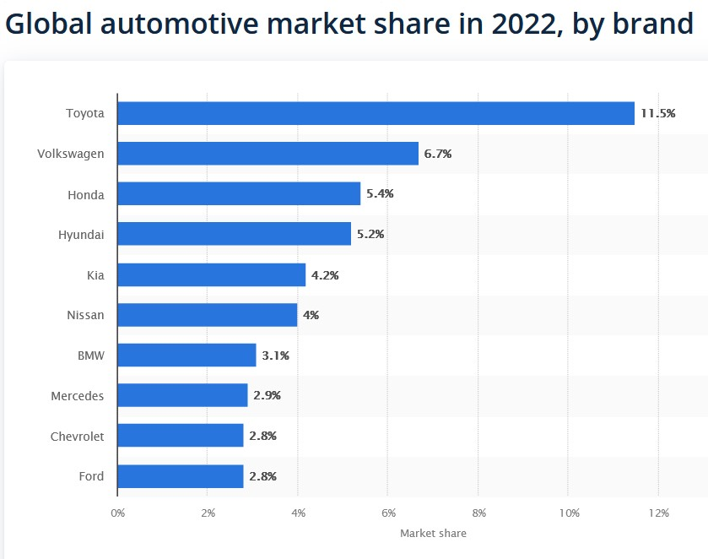
Source: (Statista 2023, 2023)
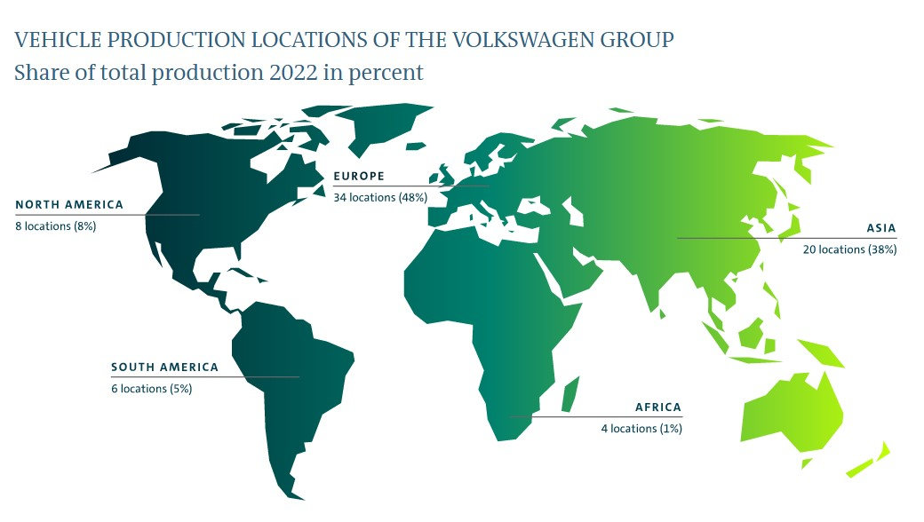
Source: (Volkswagen AG, 2023)

