1702688
William Rowlands
Data collection and Analysis of Chassis measurements
Module code M4X02198

Contents of the report:
1. Introduction.
2. Equipment
3. Research
4. Methodology.
5. Results.
6. Evaluation.
7. Referencing.

Introduction
In this assignment I will be constructing a WinGeo3 model using the data gathered from task 1 in the first assignment. Then compare the data collected from the WinGeo3 software with data collected from real car this is so that I can calculate the cars suspension frequency. The suspension geometry is one of the most important parts in a cars behaviour on the road and track. A suspension geometry is made up of several important elements that make up the handling characteristics, ride height and body roll which can be affected by many different elements of the suspension such as layout, length of arms, material used bushing and dampening ability.
Equipment.
The only equipment we shall be using is Mitchell WinGeo3 which will allow us to create a model so that we are able to dissect and examine the suspension models results. This software was designed by Bill Mitchell, WinGeo3 is used a lot throughout the motorsports industry as it’s easy to use, well-developed software and free.
Here is an example of what the software looks like.
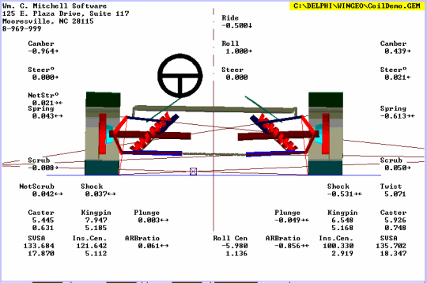
http://fastlaptimes.blogspot.com/2009/12/racing-by-numbers-programs.html
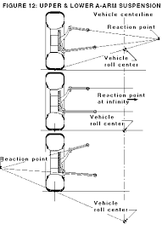
Research
- Suspension frequency
Suspension frequency is the natural frequency in which the speed a car goes upwards and downwards over bumps or different road textures. The frequency is determined by the setup of the suspension and the dampers compression and rebound rate. Suspension frequency is used to calculate the handling of a vehicle and how it will react on certain tracks. Automobile.com
- Body roll
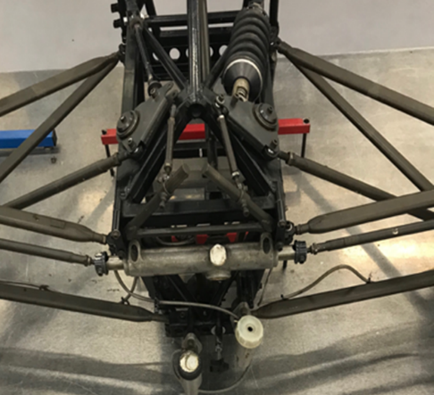
Body roll or roll centre is how the car rolls around the centre line of the car, it is effectively determined by the setup of the supensions angle and height. The roll axis is theoretically an imaginary line which lays between the fronts roll centre and rears. The position of the roll axis in relation to the centre of gravity can also determine how much chassis will roll under load or when cornering. This means the chassis will roll less the closer it is to the centre of gravity of the vehicle. Suspensionsecrets.com
Chassis.
For this task we shall be using the chassis from a Van Diemen Formula Ford car made in 1996. For our tests we shall be using the front right-hand side of the suspension setup. Image of the suspension can be found on the right. “Founded by former Lotus mechanic Ralph Firman in 1973, Van Diemen has been the world's largest volume manufacturer of racing cars for more than a decade. Revered for its integrity and engineering excellence in more than 24 countries, Van Diemen's wholehearted commitment to its worldwide customer-base has resulted in hundreds of wins and no less than 22 major championship victories last year. The first racing cars to roll out of Van Diemen's original workshops almost 30 years ago were 12 Formula Ford single seaters - and it is the Formula Ford car which has remained the centerpiece of Van Diemen's production line since that time.”
Vandiemen.com

Methodology
- Task 1
Our group had to firstly decide on who was in charge of what in terms of drawing, writing center lining, inputting data to the software and taking measurements then we discussed where we were going to take our suspension measurements this was done with accuracy in mind and using the equipment available to us. To take down the measurement’s a selection of tools were used including an engineers’ square, height gauge and Vernier calipers. Paper was used and was placed under the setup of suspension so that we were able to draw various centre lines which allowed us to to have reference points to take accurate measurements from, we then proceeded to go from point to point and then input the data into WinGeo3 at different ride heights in increments of 5mm.
- Task 2
A monoshock rod double A arm will be chosen to input the data. In order to do this, I had to select the edit function and then click on the suspension section then insert the data from the first task. The feature known as ‘GAP’ on the Wingeo3 software is used to calculate the correct data in order to compare the real and simulated suspension. The data was then taken over to the software known as Excel so that we were able to create graphs, once the graphs are created, we will compare the results from the real car in the first assignment.

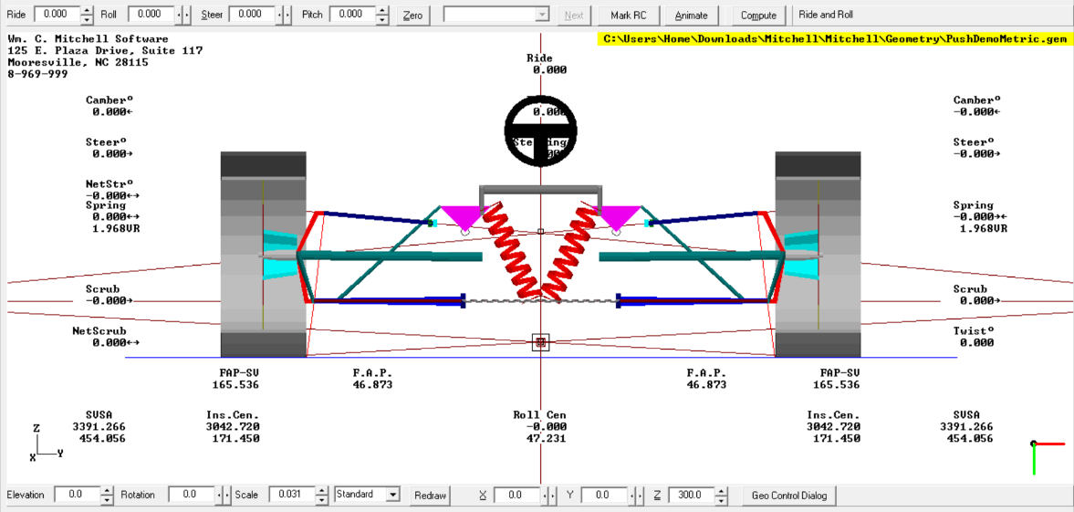
Results

Shown here is the schematic drawing we chose to use for the suspension setup which will be used for analysis, this drawing displays the many different points of movement and the angle from the front position. The software also allows you to change the different settings of the suspension (adjusting camber, toe, roll centre and ride height) and then test how it would react and record the data. This tool is useful for testing different setups prior to adjusting the vehicle.
Just like in task one with the real car I proceeded to adjust the models ride height in 5mm increments from the full rebound to the full bump, the data gathered from the testing was then taken over to excel to assess it. Two graphs were then created comparing toe and camber against the real cars results and the winGeo3 software. The data is located below alongside the table of the results.
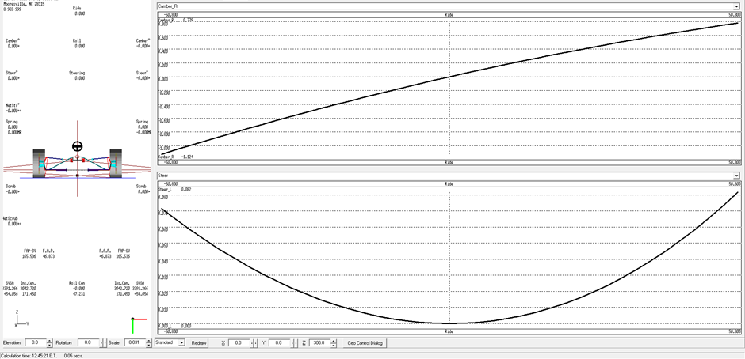
Here is the WinGeo3 software’s graph it has created for the change in camber and toe during the increment change of ride height. In this graph it shows the angle of camber is increasing from -1 compared to the toe steer which is decreasing from 0.8 until they reach the correct ride height and zero. The toe steer then goes back up as the ride height increases. This proves that camber and ride height directly impact toe steer at both extremes.

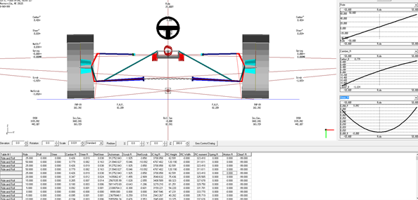

This graph from the Wingeo3 software shows the correlation between camber, ride height and toe steer altogether.

From the results in the graphs shown here we can see the that both of the graph show an opposite correlation with ride height decreasing camber seems to decrease as the toe seems to increase. However, looking at toe results there seems to be an error when transferring data from the two software’s which has caused these graphs to be inaccurate.

Top results Wingeo model

Bottom results from real car

Evaluation
In the table results I can see that ride height at its lowest will induce negative and at its highest will cause positive camber. However, toe will do the opposite and go from positive to negative when going from a low ride height upwards however there is a point of equilibrium when the ride height zeros the camber and toe at the same point. The WinGeo3 software is a very accurate tool that is very useful to a competent user.
From the results taken on the real car against the model show how inaccurate our groups dimension taking were inaccurate due to a multitude of reasons. If the for results were taken down in the correct manner maybe the data would’ve matched the data correctly. From using the WinGeo software I can see how the software can used to save time and can be much more accurate in terms of measuring from point to point and finding results. In order to gain better results when working on a real car double checking the reference point and distances between different points will allow for a more accurate results allowing for a better comparison when evaluating it against the WinGeo3 software.

References
Suspension frequency and image
https://rqriley.com/automobile-ride-handling-and-suspension-design-and-implications-for-low-mass-vehicles/
Body roll and roll centre
https://suspensionsecrets.co.uk/roll-centre-and-roll-moment/
Chassis http://www.vandiemen.registry.freeservers.com/

