Rakia 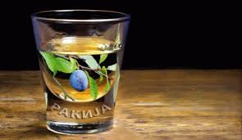
-The Taste of Balkan
Lecture Name: Tanja Nathan
Module Name: Marketing Fundamentals (LCBB4004)
Everything what You have to know about Rakia By Denitsa Encheva (1813734)
Where You can find it? By Oana Eliescu (1809525)
Rakia Promotion by Bogdan Timis (1814118)
What is the Rakia? By Geanina Bojian (1811268)
What about the Prices? Nikoletta Dudas (1814105)

Everything what you have to know about the Rakia

Rakia (Serbian and Macedonian Rakia, Romanian Tuica, Arabic arak) is a traditional strong alcoholic beverage made in the Balkans. It has a yellowish to brownish colour. It tastes similar to Japanese sake, Russian moonshine, Mexican tequila or American brandy. It is prepared by distillation of fermented fruits. The most common types are grape brandy and plum brandy. Industrial brandy (also called "bass") is usually 40%, but home-made can reach 60%. The cooking technology is not complicated, and the raw materials (fruits, sugar and water) are easily accessible and relatively inexpensive. In winter the brandy is drunk warmed. It is considered a national drink of Bulgaria, Serbia, Macedonia, Bosnia and Herzegovina, Montenegro and Croatia.

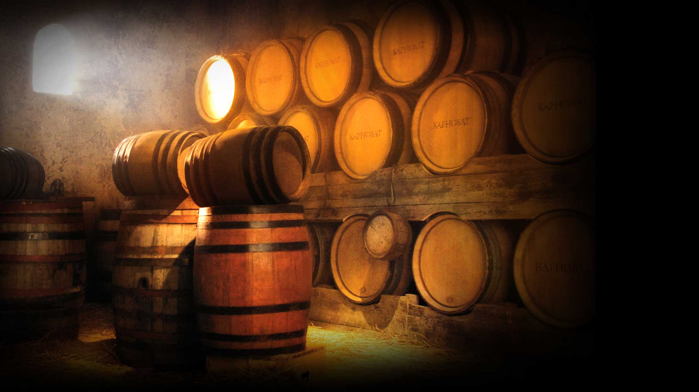
Historical data indicate that brandy production began in the 14th century. It reaches Bulgaria from the Arab world through the lands of the Ottoman Empire. In recent years, alcoholic beverage was made from wild fruits and grape marc. The history of brandy is a part of national traditions and ancestral memory, at least because brandy has been indicated for home craft since its inception. In most cases, the level of degrees in home-cooked brandy is from 30 to 50 degrees. It is a little-known fact for the society that when in 1858 the Bessarabia Bulgarians in Moldova realized that Bulgarian Nikola Bogorodi was elected prince of Moldova, their first request to him was to overthrow the state monopoly on brandy
.
The technology of brandy production has not changed for centuries, and today's craftsmen continue to follow what our grandparents did in the production of drink. It is prepared by distillation of fermented fruits. People use any type of fruit for home-made brandy, sometimes even mixing it. The most common types are grape, plum and apricot brandy. The brandy is boiled in a cauldron, from which the fumes are drawn out through a copper pipe and from there they flow into a coil. It is contained in a large container of water, thanks to which the fumes are cooled and so at the end of the chain we have a brandy ready. After the gills are boiled, the masters of the brandy maintain a moderate fire, thanks to which the brandy runs on a thin and even stream.

The strongest degree is the brandy that flows in the beginning. The degree meter may then reach levels of 60 ° - 80 °. Under no circumstances should fresh boiled brandy be drunk, as there is a real risk of poisoning. If the resulting brandy is boiled once more, a brandy known as "toast" is obtained. Its degrees are about 55 ° - 65 °. In these cases, it is necessary to dilute the alcohol with water. There is also the so-called. brandy 'double toast', which reaches over 90 °. According to the Bulgarian State Standard / BDS / the minimum alcohol content in ordinary, aged and special brandy should be at least 36 °.

The RAKIA is a very strong alcohol,
CONSUME IN MODERATION!!!
Source: (Simply Sashes, 2019)
Where You can find It?
Source: (Drink, 2019)
Rakija is very popular fruit brandy in Serbia, Bulgaria, Croatia, Bosnia & Herzegovina, Macedonia and Montenegro, however it found its way to the hearts of non-Slavic nations in Balkans as well, like Romania, Albania. We talk here about home-produced rakija (not something commercial) and homemade rakija alcohol content is typically 50% ABV to 80% ABV but many people like to produce it as high as 90% ABV at times. (Slavorum,2019)
Many Bulgarians produce their own homemade rakija, especially in towns and villages, most in western Bulgaria. They use diversity of fruits as, plums, grapes, figs, apricots, quinces, apples and pears. It’s all depending on what you prefer. It about self-respect for the host to offer a good-quality homemade rakija to their guests. The season for making the most common rakija is between August-September made out from grapes, meanwhile the time for the plum-rakija is September to the end of November. (When in Bulgaria,2019)
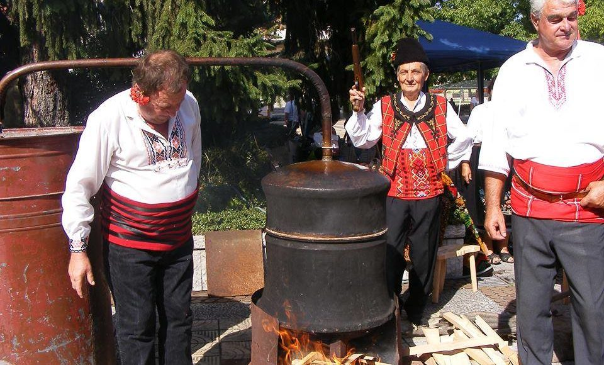
Homemade Rakija is part of Bulgaria’s nation culture and traditions. Ask any self-respecting Bulgarian who makes his own Rakia, “Who makes the best Rakia?” and he’ll tell you he does. The soil, the fruit trees and humidity have an important role to produce a very good Rakija. Beyond these important “ingredients”, there are also cylindrical container where the fruits are left to ferment. The people who are making this alcoholic drink said that the best cylinders are made its from oak, lightly burnt, which allow extremely subtle scent for Rakija. And for aging they say that as much long as the fruits stand in these cylinders, the more alcohol can produce.

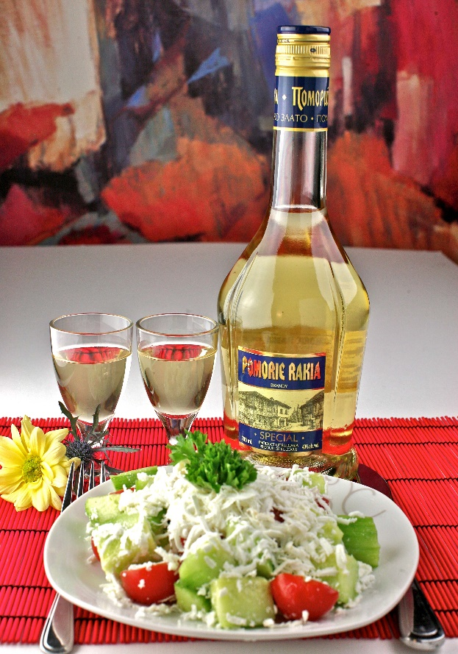

In summertime, Rakija must be chilled, because is served with a very popular Bulgarian salad, called “Shopska salata”. In summertime, Rakija must be chilled, because is served with a very popular Bulgarian salad, called “Shopska salata”.

On the other side, during the wedding ceremonies, the groom’s father must to walk around the guests and to offer them one glass or small bottle of a home-made rakija. Bulgarian people also considerate Rakia has curative power as if you drink one glass of rakija daily it will keep you healthy, in good condition. (Foreigner.bg: Best info for expats, 2019)
As a tourist, you should visit Raketa rakia bar based in Capital of Bulgaria, Sofia, is just across Zaimov park’s main alley and when you see the old ‘Balkanche’ bikes in front of the entrance, you’ll know you’re there. This restaurant/bar is very popular in that area because is known for its wide selection of Rakia which they can offer with many local dishes.

Rakia Promotions

Within the globalisation marketing process of products and services, the famous Balkan’s side spirit product Rakia can be found at online markets, at traditional events and restaurants.
Events
Discover the Rakija in Eastern Europe, in Serbia, in Belgrade Rakija distillery. In their two tours the events consist in tasting the famous drink Rakija among some nice mezze dishes. You will find interesting stories about the Rakija history and the manufacturing process. The full information about the tours, prices and content, can be found on http://belgrade-distillery.com/en/rakija-tour/

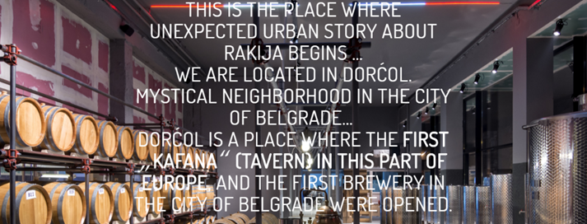
Source: Belgrade-distillery.com, 2019
Balkan Rakia & Spirit Fest Sofia – a well-known at their six-edition festival offer a rare occasion to taste from a variety of 250 brands of spirits including the famous Rakia. The Master of Rakia Mehmet Bashka, introduce the Rakia concept in his event “Discover the world of RAKI” (2018) with a great tasting of Rakia. Please find more information about the event on http://balkanrakiafest.com/.
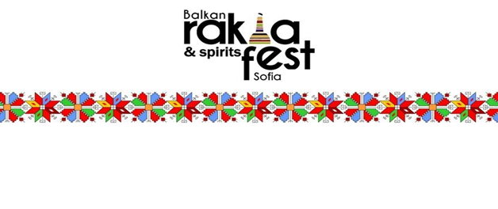 Source: Balkanrakiafest.com, 2019
RAKIA BAR
One of the best and fancy ideas about the product of the Rakia drink can be found at Rakia Bar, Zemun, Serbia. Among the types of product here you will enjoy the Etno collection, Brandy in the tube, the Fairy Grass or Rakia chocolate.
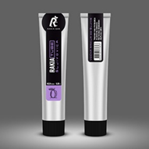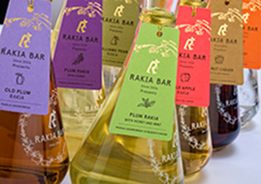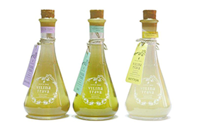
Source: https://www.rakiabar.com/products/rakija-.212.html

Special Offers of Rakia can come with the shot’s glasses like Yeni Raki promotions.

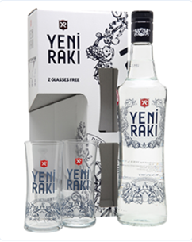

Source: https://www.sid-shop.com/products/yeni-raki-2-glasses-pack

The concept of Rakia and the obsession of many, transform the name of Rakia in even a name brand for the fashion. Through the printed Rakia name products, you can find T-shirts and key rings.

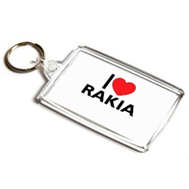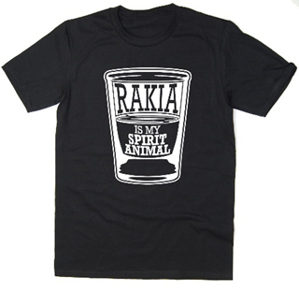
Traditional gifts – Rakia can be found in Airport Duty- Free as a gift in different bottles shapes.
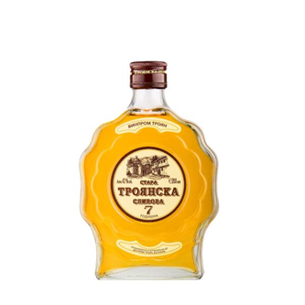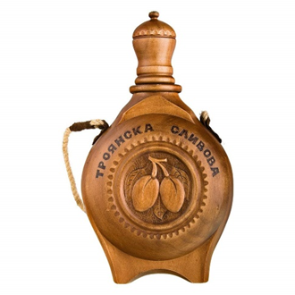
Rakia in Supermarkets – apart the homemade Rakia, the Rakia manufacturer are available in supermarkets in many parts of Bulgaria. The captivating part of Rakia is the unusual and bottles design. Also, you can find different varieties, the most known to be grape and plum Rakia on the supermarkets shelfs.
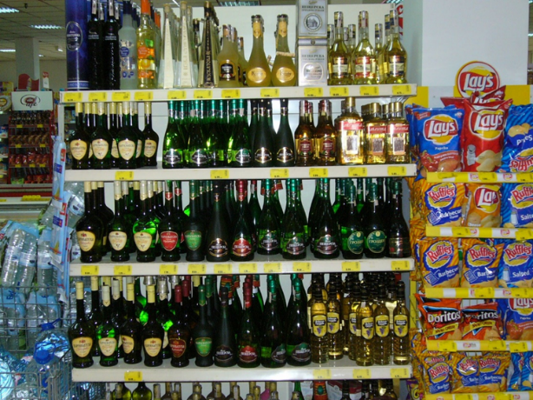
Source: http://therakiasite.blogspot.com/2008/12/commercial-supermarket-rakia.html
Join Ambar restaurant for a little while of pleasure in their Rakia Tasting room, every Wednesday from 8 pm and find the greatest taste of fine spirits. Find the world Bulgarian tradition with a craft plum Rakijas and another special herbs spirits.
Next to some nice dishes, this is a unique food experience and tasting craft and traditional Rakia.
Please find more info at https://www.ambarrestaurant.com/belgrade-specials/.

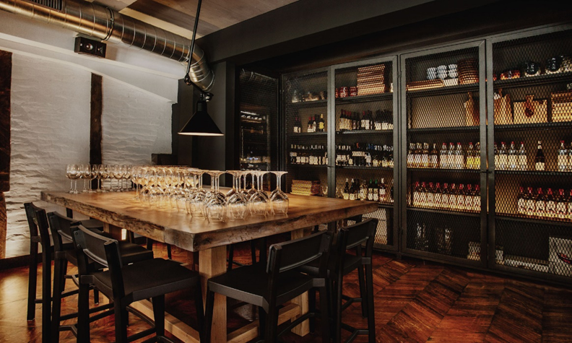
Source: Ambarrestaurant.com, 2019

In Serbia, people drink and use rakija as a medicine. In some villages the people drink Rakija with coffee in the morning. This can be new method to come up to reality in the morning. 😊 Even to treat the fevers, the people put rakija on chest and the they found the famous drink pull out high temperatures (Wine Enthusiast Magazine, 2019).
Please let us know about the content of this page. Leaving your comment help us to improve the information about the Taste of Balkans drink RAKIA.

What is the Rakia?
To begin with the first element of marketing mix is the product offers to the consumer for sale. Under the product part of the marketing mix it is seen that what is the feasibility of the product and that the current product served is appropriate and suitable for the market of the present time's consumers. The product to be launched in the market is RAKI, which is an alcoholic drink mostly served in the East European countries including Albania, turkey, Greek Island and in the countries of Balkan.
RAKI is a sweetened drink which generally have anise flavour and is an alcoholic drink which is generally served with the sea food and Maze. The product is generally made with grape pomace and Aniseeds. RAKI is traditional product which is produced through raisin or grape spirit and is quite a strong alcoholic drink thus it has a separate consumers segment who have desire to have it purposely as this it has its own acquired taste. The production of this drink takes almost 30 days where the flavours are distillate with diluting and sweetening the RAKI and then rested for minimum 30 days to give it a particulate taste (Raki- A Cure for Everything, 2019). So, the process of making the product is not too high and it is not a lengthy process to give it flavours.

The product is high in demand and famous in eastern countries of Europe and it is national drink of Turkey which is traditionally consumed chilled water as per the preferences of the drink. This gives RAKI an upper hand in the European market amongst the alcoholic drinks which is generally served with maze, seafood and some exotic fruits. This make is product feasible for the coastal area and where there is high demand and consumption of seafood and as both make an exquisite combination that can give a good market share of RAKI. This product contains 45% on concentrate alcohol which is made from figs, grapes or raisins and other key ingredient of making it is aniseeds (The 7 Ps of Marketing, 2019). RAKI is also consumed on the festivals of certain countries which is a tradition, so the product has a tradition backing which as well automatically raises a market share for the RAKI in other countries of Europe specially in the eastern region. The product RAKI also serves a purpose of making another alcoholic drink such as Rekomelo with the use cinnamon and honey.
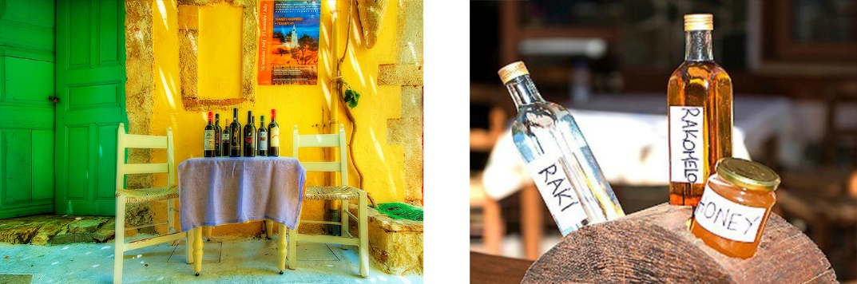
Source: (Thenewgreece.com, 2019)

With completing the product element of marketing mix RAKI it can be stated that this product has feasibility of being launched in European countries. As this have a potential to grab a market shares effectively and with faster pace as this is traditional drink and contains certain traditional values as well. The costing of production is also not too high as it required two or three ingredients for its preparation namely grapes/raising/figs and aniseeds. Furthermore, this product allows to make another drink form it which gives an opportunity of development of a product line related to it.

What about the Prices? 

The Rakia is a very popular drink, with a long history. To this end, over the years, has become available with chipper prices and also luxury form, and of course the homemade Rakia is still available. The prices are shows huge different, the different between the homemade and the most expensive Rakia in Bulgaria can be more than £90/ liter. The visitors in Bulgaria, can enjoy the classical homemade Rakia’s taste. The amount will make everyone very happy, because one bottle of handcrafted alcohol usually is 10 leva. One lev is around £0.5, that means the £5 cost for one bottle of Rakia, more than friendly.

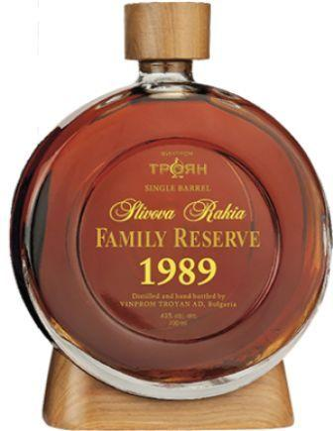
The most famous and luxury Rakia is the Troyanka Slivova Vinprom, which can cost more than 240 levs, which is around £110. The price can be acceptable in point of the fruit content and that Rakia is 30 years old, what is makes it even more special.
Source: (sommelier.bg, 2019)

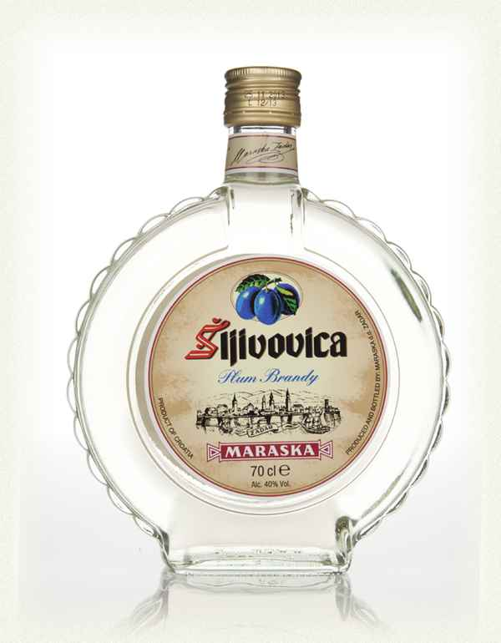
Rakia can be made out of any fruit, and each fruit has an own specific Rakia name.
The Slivovice is the plum Rakia. This is the most popular, strongest and the good news, the CHEAPEST as well.
The price for one bottle of Plum Rakia is cost around £ 10-12.
Of Course, we can find about the Slivovice some very special edition with a much higher price. For example, that Slivovice in the picture can cost £30.
Source: (Contributor, 2019)

Usually the popular Rakia’s are accessible between 13-40 levs, which is around £6-20. (Rakiashop.eu,2019) For obvious reasons, not everyone would like to buy a full bottle of Rakia, some people want only to taste it, for them is the easiest way to try this traditional alcohol are the restaurants and bars. The prices in the Bulgarian bars are nearly the same, one shot of Rakia is around 5 leva, which is cost £2.3. In the restaurants are have more friendly costs for the Rakia, it is less than 4 leva, that cost is less then £2. That is a very competitive price, because usually in the bars have the higher prices for the alcohol drinks.
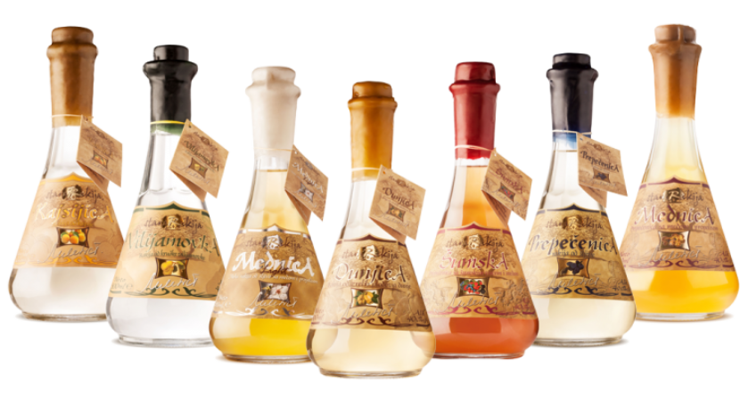
Source: (Worldlyspirits.com, 2019)
Luckily, if anyone planning to taste the Rakia, not necessary to travel to Bulgaria or any other Balkan country, because some restaurant can bring it to the UK the special Bulgarian tastes. One of the best-know restaurants is the Sunny Beach in London. The prices are nearly the same as in the Bulgarian restaurants, which is nearly £4, so we can enjoy it the Balkan feeling without long travel.
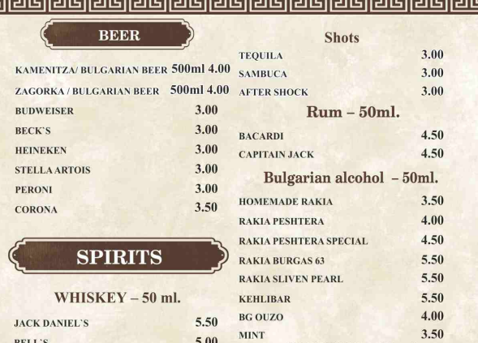

Source: (Sunnybeachrestaurant.co.uk, 2019)
Not least, that prices are cheaper as any alcohol drink in London’s any pub. For example, usually the whisky shot’s price can start from £4.20.
The Rakia’s taste cannot be the same as other drinks in the world, but in terms of alcohol content, which is around 50%, can be the same as vodka, gin, whisky or other most popular drinks. For example, 1 bottle of middle category gin price is around £18, whisky nearly the same price, vodka is around £15, while one bottle of Rakia is available from £13 ( The prices was checked in ASDA website, Please find here: https://www.asda.com/). So, the classic Bulgarian traditional drink is a good choice in value for money.


Хайде наздраве! (Cheers!)

References:

Ambarrestaurant.com. (2019). Specials – Ambar Restaurant. [online] Available at: https://www.ambarrestaurant.com/belgrade-specials/ [Accessed 22 Aug. 2019].
Angelova, M. (2019). A Brief History of Rakia, Bulgaria's National Drink. [online] Culture Trip. Available at: https://theculturetrip.com/europe/bulgaria/articles/a-brief-history-of-rakia-bulgarias-national-drink/ [Accessed 28 Aug. 2019].
Asda.com. (2019). Asda.com - Online Food Shopping, George, & more. [online] Available at: https://www.asda.com/ [Accessed 28 Aug. 2019].
Balkanrakiafest.com. (2019). BALKAN RAKIA FEST – Балкански фестивал на ракията и спиртните напитки. [online] Available at: http://balkanrakiafest.com/ [Accessed 20 Aug. 2019].
Belgrade-distillery.com. (2019). ABOUT – Belgrade Urban Distillery. [online] Available at: http://belgrade-distillery.com/en/about/ [Accessed 20 Aug. 2019].
Contributor, G. (2019). Serbian Rakija: A Strong Drink with Good Spirit. [online] Europe Up Close. Available at: https://europeupclose.com/article/serbian-rakija-a-strong-drink-with-good-spirit/ [Accessed 27 Aug. 2019].
Contributor, G. (2019). Serbian Rakija: A Strong Drink With Good Spirit. [online] Europe Up Close. Available at: https://europeupclose.com/article/serbian-rakija-a-strong-drink-with-good-spirit/ [Accessed 27 Aug. 2019].
Drink, A. (2019). Apron - 2052 Wheres My Drink - Sale & Seasonal | Barbeques Galore. [online] Bbqgalore.com. Available at: https://www.bbqgalore.com/clearance-promos/big-game/attitude-apron-by-la-imprint-apron-design-2052-wheres-my-drink.html [Accessed 27 Aug. 2019].
En.wikipedia.org. (2019). Rakia. [online] Available at: https://en.wikipedia.org/wiki/Rakia [Accessed 27 Aug. 2019].
Foreigner.bg: Best info for expats. (2019). The History of The Bulgarian Rakia. [online] Available at: https://www.foreigner.bg/the-history-of-the-bulgarian-rakia [Accessed 17 Aug. 2019].
Raki- A Cure For Everything. 2019. [online]. Available through :<http://thebalkanista.com/2018/09/19/raki-a-cure-for-everything/>.
RakiaShop.eu. (2019). Du hast nach rakia gesucht - RakiaShop.eu. [online] Available at: https://rakiashop.eu/en/?s=rakia&post_type=product) [Accessed 22 Aug. 2019].
Simply Sashes. (2019). Warning May Contain Alcohol - Hen Party Sash | Simply Sashes. [online] Available at: https://simplysashes.co.uk/warning-may-contain-alcohol-yellow-sash [Accessed 27 Aug. 2019].
Slavorum 2019, Rakia – Everything you wanted to know about this drink [Online], Available at : https://www.slavorum.org/rakia-everything-you-wanted-to-know-about-this-drink/ (Accessed on 17Aug.2019)
sommelier.bg. (2019). [online] Available at: https://sommelier.bg/bg/blog/item/ [Accessed 27 Aug. 2019].
Sunnybeachrestaurant.co.uk. (2019). [online] Available at: https://www.sunnybeachrestaurant.co.uk/ [Accessed 27 Aug. 2019].
The 7 Ps of Marketing. 2019. [online]. Available through :<https://www.entrepreneur.com/article/70824>.
Thenewgreece.com. (2019). Cretan alcoholic beverages – TheNewCrete. [online] Available at: https://thenewgreece.com/en/kitchen/cretan-alcoholic-beverages/ [Accessed 27 Aug. 2019].
When in Bulgaria. (2019). The world of Rakija. [online] Available at: https://wheninbulgaria.wordpress.com/2016/01/23/the-world-of-rakija/ [Accessed 17 Aug. 2019].
Wine Enthusiast Magazine. (2019). Rakija-Hopping Through Belgrade. [online] Available at: https://www.winemag.com/2017/08/04/rakija-hopping-through-belgrade/ [Accessed 20 Aug. 2019].
Worldlyspirits.com. (2019). All You Need to Know About Rakia – Wordly Spirits. [online] Available at: http://www.worldlyspirits.com/all-you-need-to-know-about-rakija/ [Accessed 27 Aug. 2019].

