LEADING AND IMPLEMENTING WORKPLACE CHANGE
STUDENT NUMBER: 1916036

Tesla’s Change Management in Post-Pandemic Era

Executive Summary
The paper’s critical examination of business operations in post-pandemic period showed that COVID-19 pandemic disrupted operations across the world. The effects did not die with the end of this pandemic since businesses continue to experience the aftermath effects, and they are required to make necessary changes in the workplaces to help restore their operations. In Tesla’s case, it is evident that COVID-19 adversely affected the company’s operations, and effective change management will help it to restore and improve its operations accordingly. Effective change management will require the involvement of the organization, workers, buyers, and other important stakeholders as it will help ensure they are all committed towards improved functioning. Further, by implementing the suggested change plan, Tesla may experience notable cultural changes. Therefore, if the changes are to help this organization to continue with its global reputation in the automotive industry, it needs to make sure its resources are focused on addressing various degrees of change. The recommended steps to do so include: navigating the changing cultural landscape fast, mitigating the prevalence of deep emergent changes to reduce disruptions and embracing a leadership style that results in a comprehensive and integrated transformation that will help grow its competitive advantage.

Table of Contents
Executive Summary 2
1.0: Introduction 6
2.0: Critical Evaluation of The Adopted Change Management Process and Identification Of The Suitable Strategic Change Option 7
2.1: Brief Overview of The Chosen Company with Its Existing History of Dealing with Changes 7
2.2: The External Factors During and Post-Covid Time That Acted as Change Drivers (PESTEL Analysis) 8
2.2.1: Political Change 9
2.2.2: Economic Change 9
2.2.3: Social Change 10
2.2.4: Technological Change 10
2.2.5: Legal Changes 11
2.2.6: Environmental Changes 11
2.3: Leadership Styles Used to Manage the Change 11
2.4: How Organisational Culture Was Impacted Due to The Development and Implementation of Change 12
2.5: Areas That the Organisation Could Have Done Better in The Process of Change Management 13
2.6: A Suitable Area (Organisational Culture) That May Need to Be Changed in The Future 13
3.0: Critical Evaluation of the Change Management Models 14
3.1 Incorporating Issues Related to Strategic Change 14
3.1.1 Strategy Map 15
3.2: SWOT Analysis 17
3.2.1: Strengths 17
3.2.2: Weaknesses 18
3.2.3: Opportunity 18
3.2.4: Threats 19
3.3: Porter’s Five Forces Industry and Competition Analysis 19
3.4: Critical Evaluation of Change Management Models 20
3.4.1: Lewin’s Change Management Model 21
3.4.2: ADKAR model 22
3.4.3: Kotter’s Eight-Step Change Model 23
3.5: The Suitable Change Management Model That May Be of Use to Implement the Identified Suitable Strategic Change for The Chosen Organisation 24
4.0: Section 3- Proposal and Implementation of Change Strategy 25
4.1: Based on The Identified Suitable Change Management Model, Propose A Change Management Plan 25
4.2: Leadership Approaches/Styles Suitable for Initiating and Implementing Identified Strategic Change 27
4.2.1: Leadership Style Before COVID-19 27
4.2.2: New Leadership Style Following the Pandemic 27
4.3: Step-by-Step Process to Implement the Change Strategy 28
4.3.1: Identify the Area to be improved 29
4.3.2 Present Proposed Changes to Relevant Stakeholders 29
4.3.3 Plan for the Change 29
4.3.4 An Evaluation of Resources 29
4.3.5 Communication 30
4.3.6 Monitor and Manage Resistance 30
4.3.7 Celebrate Success 30
4.3.8 Review, Revise and Improve 31
4.4: The Probable Impact of The Implementation of Change Strategy on The Culture of The Chosen Organisation 31
5.0: Conclusion and Recommendations 31
References 33

1.0: Introduction
The paper acknowledges that the COVID-19 pandemic disrupted operations across the world. Specifically, the effects were most prevalent among businesses since they had to deal with disrupted operations. The effects did not die with the end of this pandemic since businesses continue to experience the aftermath effects, and they are required to make necessary changes in the workplaces to help restore their operations (Gursoy & Chi, 2020). Primarily, most organizations, such as Tesla Inc., have had to make the crucial decision for them to navigate the ever-changing uncertainty as part of reinventing themselves for continued and better business operations. I have chosen this organization for examination because despite the adverse effects of the COVID-19 pandemic, it has embraced change management strategies, which have transformed its operations. The significance of change management in this organization is evident in that Tesla has improved its overall management of systems, hence improving workers' well-being, and it continues to be a profitable business entity.
In an attempt to understand this organization’s change management post-COVID-19 era, the paper will utilize business analytical tools, such as Balanced Scorecard, Strategy Map, SWOT Analysis, PESTLE Model, and Porter’s Five Forces. It will also use ADKAR, Lewin’s, and Kotter’s change management models to ensure change implementation is effective. A more elaborate approach to how the paper plans to explore the topic of change management at Tesla post-COVID-19 era is apparent in the paper’s sectioning. The main segments of this paper are the critical evaluation of the adopted change management process and identification of the suitable strategic change option, proposal and implementation of change strategy, as well as conclusion and recommendations. Based on this approach, it is expected that the change management strategy utilized by Tesla will entail planning according to the ever-changing business environment and integrating change management plans that will improve its competitiveness in the automobile market.

2.0: Critical Evaluation of The Adopted Change Management Process and Identification Of The Suitable Strategic Change Option

2.1: Brief Overview of The Chosen Company with Its Existing History of Dealing with Changes
Tesla company is described as a relatively new automobile company compared to others, such as Citroens and Renaults, among other motoring companies. The organization was established in 2003 by Marc Tarpenning and Martin Eberhard (Mann, 2022). When the two founded Tesla Company, they wanted to prove that electric vehicles were a game changer and were out to replace diesel and petrol-powered automobiles. The approach has been significant in the company’s progress as it has completely refined the world’s perception of electric cars. In particular, despite having a shaky start, Tesla has established itself as one of the forefront companies in the electric vehicle market because of its innovativeness. According to research, the company’s focus on renewable energy is ascribed to its name Tesla as it was branded after a famous inventor Nikola Tesla, which meant creating cars that depended on alternating current electricity as the source of power.
Based on its history, it is evident that Tesla’s continued success is because it has always focused on effective change management. Although the organization was founded by the aforementioned individuals, its most significant milestones were after Elon Musk became part of the company as an investor in 2004. Having invested roughly $6.5 million in Tesla Series A, Elon Musk became an essential part of the company to the extent of becoming the chairman of the board of directors. Such changes in management are a notable part of the company’s ability to deal with transitions. For instance, after Tarpenning and Eberhard left Tesla in 2009 in search of greener pastures, Musk took over management to become the CEO and product architect (Homburg et al., 2012). Since then, the organization has had a culture of constant change. For instance, in the post-COVID-19 era, the organization has made significant changes in management in an attempt to restore its glory and expansion. Most of the changes are internal, such as filling some responsibilities in various departments following employees’ departure (Carnall, 2007). Additionally, Tesla’s ability to deal with changes is apparent in its response to the rapidly changing automobile market. In the recent past, as an electric carmaker, Tesla has gained a global reputation to the extent that it has grown from being a niche premium brand to a mass manufacturer. Nonetheless, the growth process is not without challenges, as the organization has to deal with competition from other established automobile manufacturers.

2.2: The External Factors During and Post-Covid Time That Acted as Change Drivers (PESTEL Analysis)
An organization’s environment is classified as either internal or external. The external environment influences the operations of a business significantly as they are factors beyond a company’s control. These most common factors are political, economic, social, technological, environmental, and legal. Therefore, according to Perera (2017), a PESTEL analysis is necessary for identifying a company’s external environment and how it affects its operations. In this case, a PESTEL analysis will help understand external factors that acted as the change drivers at Tesla during the post-COVID-19 period and how it managed pertinent changes.
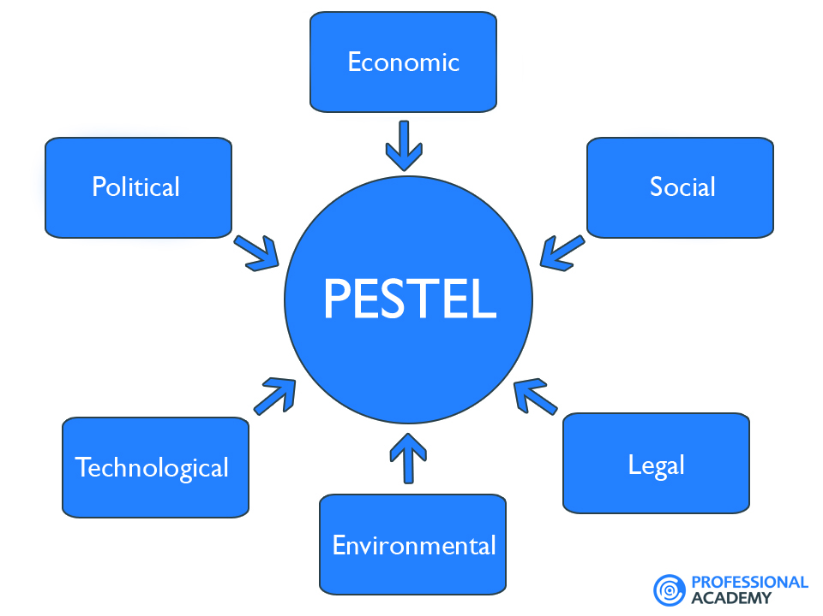
Figure 1: Elements of PESTEL analysis

2.2.1: Political Change
During the post-COVID-19 pandemic period, the government’s responsiveness and dedication to helping companies had a significant effect on businesses’ ability to bounce back. In the United Kingdom, the government was keen to ensure businesses had an easy time restoring their operations (Chehertma, 2022). Specifically, the government took the initiative to minimize losses in different areas of business as a way of keeping them alive. Tesla benefited from this since the government’s fast responsiveness helped to plan its processes for an easier restoration of operations despite the lockdown.

2.2.2: Economic Change
The effects of the COVID-19 pandemic on businesses may be construed as a type of serious gambling. This interpretation is linked to the fact that almost all businesses were affected since economies were stuck following the global lockdown (Xinyi et al., 2022). The adverse economic effects on a company like Tesla included a shortage of raw material supply. Consequently, after the world restored operations, companies, including Tesla, were struggling to address the possible global recession. The economic conditions drove Tesla to adopt change strategies that would mitigate the downward effects as a result of a bad economy.

2.2.3: Social Change
Social changes were most significant during the COVID-19 pandemic since most people stayed at their homes, and businesses needed to observe social distancing (Xinyi et al., 2022). The social effects did not die immediately with the restoration of global operations during the post-pandemic era. Rather, people’s movement was still limited, and this affected the number of customers visiting Tesla retail outlets. Such hindrances drove Tesla to reinvent its sales and marketing process by embracing more digital operations.

2.2.4: Technological Change
Tesla as an electric car manufacturer is a highly technology-based organization. Therefore, during the post-pandemic period, the organization had to focus on more technologically-appropriate approaches to help boost its manufacturing and marketing processes (Chehertma, 2022). Considering the technological aspect of its manufacturing process had not been significantly affected, the organization’s approach was on how to grow its marketing by using its website and apps. The changes were part of the company’s cost-cutting strategies, so they could attract more buyers.

2.2.5: Legal Changes
The legal factors that contributed to Tesla’s change during the post-covid era included third-party dealerships and being the world’s best employer. A report by Forbes ranked Tesla as one of the best employers in the world. Therefore, after the pandemic, the company utilized this feature to create the impression of an ideal place for young graduates, fresh talents, and job seekers. Secondly, third-party dealerships helped Tesla to continue its global operations even in nations that do not allow foreign companies to directly sell their products.

2.2.6: Environmental Changes
Tesla’s primary goal and objective is to produce eco-friendly cars. Specifically, by producing fuel-efficient and environmentally friendly automobiles, Tesla enjoyed an enhanced competitive advantage, more so because people were more than sensitized about environmental protection (Chehertma, 2022). Tesla capitalized on this to maintain a positive image of being the best company with reduced carbon emissions.

2.3: Leadership Styles Used to Manage the Change
The leadership style at Tesla Company is associated with that of Elon Musk. According to Khan (2021), Elon practices a transformational leadership style. His focus on this leadership is because it focuses on creating real positive changes. The bigger picture about this leadership style is that it is action-oriented, and instead of a leader just sitting around, they outline and execute strategies that helped to realize the stipulated visions. A clear representation of this approach at Tesla is evident in that its management is centered on realizing goals that entail staying alive, growing, and fulfilling the dream of electric cars being better automobiles than diesel-and petrol-powered ones. However, despite Tesla following a transformational leadership style in its process, the adverse effects on its operations during COVID-19 called for a revitalized approach.
As a result, Elon Musk adopted a transactional leadership style to help it navigate the aftermath of the 18 months of suffering due to the pandemic. The significance of this style was that transactional leadership occurs between leaders and followers, and it involves rewards and punishment as motivation to complete the job (Odumeru & Ogbonna, 2013). This strategy was successful since Tesla provided its employees with special healthcare benefits and training facilities, which contributed significantly to their working efficiency. Secondly, a transactional leadership style was vital as it revitalized Tesla’s operations by emphasizing motivation and productivity. The style was also commendable since the system adopted by Tesla during the post-pandemic era helped it to focus more on workers following the leader’s command. This strategy resulted in strategic management of operations in the organization.

2.4: How Organizational Culture Was Impacted Due to The Development and Implementation of Change
The organization culture of Tesla Inc. is characterized by unifying workers into a team, which works towards improving business operations. This cultural feature helps reduce conflicts in the workplace since most employees work in teams. Apparently, teamwork in this organization helps develop synergy in its human resource management practices. Therefore, this type of corporate culture is beneficial as it helps maximize benefits related to workers’ talents and skills. During the post-pandemic era, this culture played a crucial role in the company’s development and implementation of changes (Shiddiq, 2020). Primarily, synergetic teamwork is vital at Tesla since it has grown its competitiveness in the international car market. Further examination shows that a unifying cultural approach facilitated corporate management and strategy management, which encouraged innovation and enhanced growth rate. Besides, Tesla utilized the approach where its culture embodies and empowers workers to think creatively and find solutions that continuously improve operations and set the company apart from its competitors.

2.5: Areas That the Organization Could Have Done Better in The Process of Change Management
Throughout its change management process, Tesla made significant progress; during and after the COVID-19 pandemic. Considering the pandemic affected businesses across the world, the global market faced possible crashes and recession. Most companies, including Tesla, countered this by switching to e-commerce for better requisitions and infrastructure (Wen et al., 2021). The organization made a good impression out of this by ensuring the overall digitalization of its processes helped mitigate issues concerning border rules and other regulations on close contact. The outcome of this approach was productivity growth. Precisely, statistical evidence concerning Tesla’s operations after the COVID-19 pandemic affirms that, regardless of shortages in the market, the organization m made notable advancements in technology that helped it stay afloat. Therefore, a critical examination of Tesla’s operations during change management implies that the organization was comprehensive during the entire process.

2.6: A Suitable Area (Organizational Culture) That May Need to Be Changed in The Future
The current volatility, complexity, uncertainty, and ambiguity of the international business environment requires an organization to pay attention to its culture in terms of its ability to address possible future issues, as witnessed during the COVID-19 pandemic (Cameron & Green, 2019). On close reflection, Tesla’s organization culture may be disruptive in nature. Being disruptive means that Tesla is founded on loose tech startups, which invites workers to be imaginative as possible (Grover et al., 2022). Such an approach cultivates a loose culture, which may be detrimental to the organization if such an occurrence is repeated. Thus, if Tesla is to address this, it needs to “remake” itself by attempting to balance the loose and tight cultures. A tight culture may benefit the organization, and it involves embracing organization norms (Henderson at al., 2015) similar to those adopted by companies such as Toyota, as they will help it to produce quality electric vehicles on a large scale.

3.0: Critical Evaluation of the Change Management Models

3.1 Incorporating Issues Related to Strategic Change
For a clear understanding of how Tesla should manage changes during the post-pandemic era, the organization needs to conduct a thorough examination of how COVID-19 affected its operations. As of this approach, scholars purport that a complete analysis of Tesla’s business process should focus on suitable and effective leadership styles and strategic plans (Benn et al., 2014). This approach requires the organization to focus on the balanced scorecard and the strategic map. First, the balanced score is vital in this case as it allows Tesla to reflect on its objectives and how it can fix them. By embracing the right objective, the organization will be better positioned to make critical decisions that are meaningful to its continued excellence. However, to avoid making unnecessary choices, it also needs to measure current conditions, particularly how the external and internal environment was affected by the pandemic and how to mitigate the effects (Bencivenga, 2002). A crystal-clear concept will be unparalleled as Tesla will focus on key action programs.

3.1.1 Strategy Map
A strategy map is an important tool in an organization’s change management. According to Hu et al. (2017), the significance of a strategy map is that it provides businesses with a simple, visual, and clean pathway towards improvement. Besides, the strategy map helps identify the key goals and how the objectives affect each other. A more elaborate examination of the strategy map shows that it consists of features such as the financial perspective. At this point, the organization will examine its profit increase strategies, especially how to grow its revenue and manage costs. Another notable feature in the strategy map is the customer perspective. This section is vital since it will help Tesla to focus on whether it has identified the best way to serve its customers. In doing so, the company will focus on strategies, such as setting competitive prices and quality offerings. The other area of the strategy map is internal perspective innovation, and it will help Tesla with better customer management practices that will ensure operational excellence. Lastly, Tesla will need to focus on the learning and growth perspective. The significance of this area is that it will help Tesla to engineer talents as part of its growth process. Moreover, this will help ensure proper learning and growth that involve being more accountable.
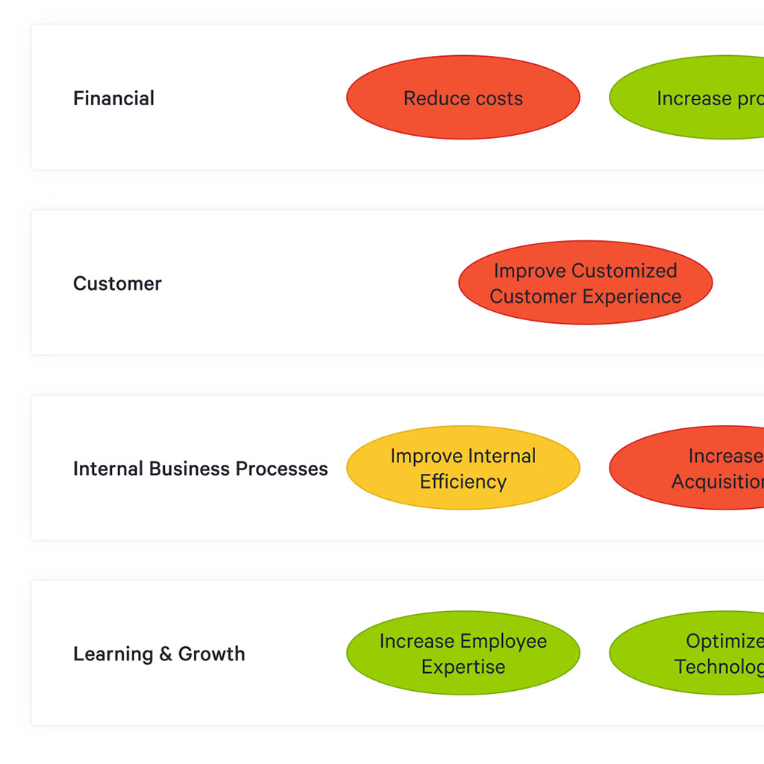
Figure 2: An illustration of four elements of a strategy map

3.2: SWOT Analysis
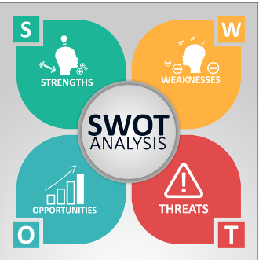
Figure 3: Graphical representation of the four segments of SWOT analysis

3.2.1: Strengths
For Tesla to have a better change management approach, understanding its strengths, weaknesses, threats, and opportunities is mandatory. The organization’s strengths during the post-pandemic era include being a leading company in the automotive market, innovation, and being the best employer (Dobrev, 2020). The strength of the automotive market leader is ascribed to the fact that despite the shutdown and lockdown during the COVID-19 pandemic across the world, Tesla still experiences notable growth, as evidenced by its sales. The reason behind such success is inherent to Tesla’s commitment to research and development. The organization is also ranked as the best employer. Ranking by Forbes affirms that Tesla is one of the ideal workplaces highly sought by young graduates and innovative job seekers. The company is also commendable because of its innovativeness. Regardless of whether it is a semi-electric truck or a sports car, Tesla has a reputation for launching innovative designs.

3.2.2: Weaknesses
During the post-pandemic period, most manufacturing organizations are struggling with not meeting demand, manufacturing issues, and less production volume. With increased sensitization about environmental sustainability, most buyers now prefer electric cars (Dobrev, 2020). As a result, this has increased the demand for Tesla automobiles, and the company is unable to meet this demand. The inability to meet the demand is linked to manufacturing issues and reduced production volume. During the COVID-19 pandemic, government regulations and restrictions caused problems in most manufacturing companies, such as Tesla, since they were incapable of having the entire workforce present at work. The outcome of this occurrence was that the production volume decreased significantly.

3.2.3: Opportunity
The opportunities that Tesla needs to seize include expanding its market and reclaiming market confidence. The effects of COVID-19 on most companies were devastating, and some may have shut down operations or are incapable of producing as they used to. Tesla can view this as a great opportunity to venture into new markets, such as the Asian continent, since the automotive industry in this region is yet to realize the full growth of renewable energy cars (Dobrev, 2020). Secondly, during the pandemic period, Tesla’s reputation among customers may have been tarnished. The company can approach this by attempting to reclaim its market confidence by ensuring it gives customers value for their money.

3.2.4: Threats
The global automotive industry is dominated by companies of all sizes, which increases competition between rivalling companies. For instance, the electric car segment is a newly introduced area, and most cars are competing with purely electric cars by producing hybrids (Dobrev, 2020). Specifically, economical automobile brands, such as Mercedes, Lexus, BMW, and Audi, are front-line competitors of Tesla cars. Secondly, the organization is threatened by customer adaptation. Compared to the aforementioned brands, Tesla cars are relatively costlier, which drives customers to prefer other brands because of affordability. This aspect of customers’ unwillingness is detrimental as it may grow their rejection of Tesla’s products regardless of their innovativeness.

3.3: Porter’s Five Forces Industry and Competition Analysis
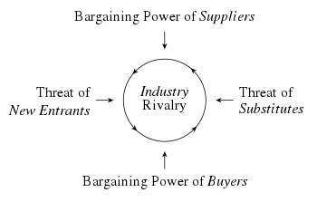
Figure 4: A diagram showing the specifics of Porter’s five forces
First, the customers’ power is measured based on buyers’ bargaining power, and it is moderate. Besides, the switching cost is relatively low since buyers of Tesla cars treasure them because of the high-quality standards (Majoul et al., 2023). The second feature is the suppliers’ power, it is also moderate. The moderation is linked to the company’s forward integration. The threat of substitution is high. Tesla is known for producing purely electric cars, which sell at higher prices. During the post-pandemic era, most people are not doing well financially and prefer to buy more economical hybrid cars. The threat of new entrants is also high. The electric car segment is new, and most dominant automobile companies are venturing into this area. Lastly, the company’s competitive rivalry is a major concern to Tesla since other manufacturers, such as Ford and Volkswagen, are big rivals and focused on producing environmentally sustainable cars.

3.4: Critical Evaluation of Change Management Models
An examination of Tesla’s internal and external environment shows that the organization must be keen on change management during this post-pandemic era if it will continue to be successful. In that case, embracing the right change management model is unparalleled. By description, change management models refer to concepts, methodologies, and theories that help organizations to have an in-depth understanding of how to approach organizational transitions. Therefore, an effective change management model, in Tesla’s case, is one that helps it to understand the basic principles and frameworks that enables it to leverage best tactics, practices, and strategies to lean on. Besides, change management models have a great impact on a company since they may cause ripple effects across its production potential. Based on this understanding, the paper will examine three change management models, ADKAR, Lewin’s, and Kotter’s, to determine which one is suitable for Tesla’s case.

3.4.1: Lewin’s Change Management Model
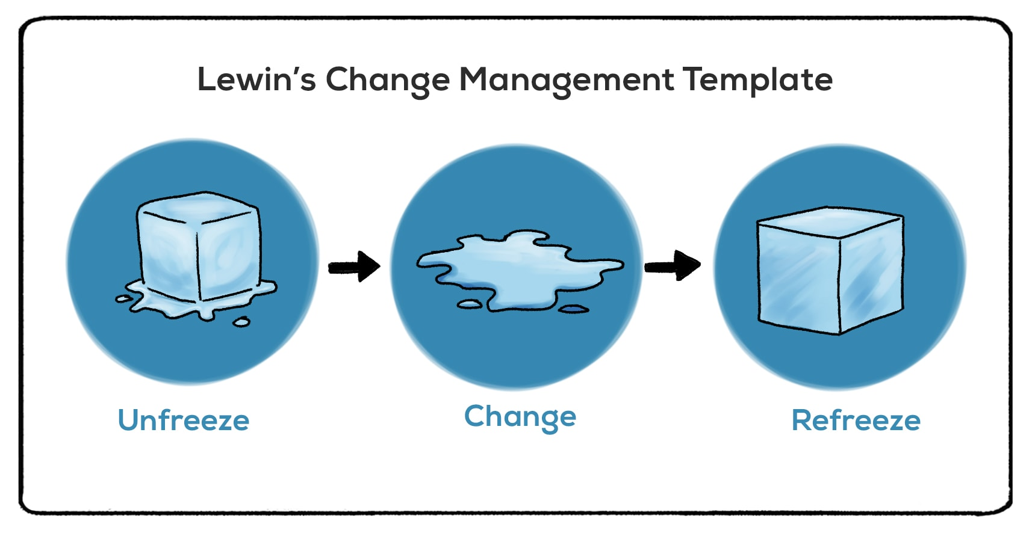
Figure 5: The Lewin’s change management template
This change management model was founded in the 1940s by Kurt Lewin. The model is relevant in modern-day society because of its simplicity. According to Hussain et al. (2018), the model is broken down into three manageable stages, which are unfrozen, change, and re-freeze. An organization undergoing changes needs to first unfreeze their current processes and perception to help them prepare for upcoming transitions. The step is important since it helps businesses to approach changes without any form of biasing (Kotter, 2012). Next is the implementation phase, which requires clear and constant communication between affected departments. Lastly, the model requires an organization to “re-freeze,” which is about reflecting on the feedback as it helps them to move away from old models into new ones (Kotter, 2012).

3.4.2: ADKAR model
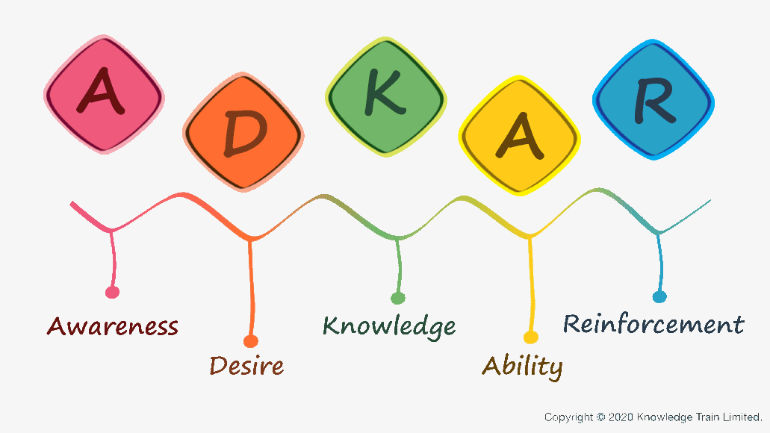
Figure 6: The ADKAR model of change management
The model is popular among organizations because of the people-focused approach to change. The model was founded by Jeffrey Hiatt, and it focuses on the individual level of change (Joseph Galli, 2018). This approach is based on the understanding that changes are not much about themselves; rather, they are more about how people react to them. As such, the model suggests specific steps that include awareness of why changes are needed, the desire to participate in transitions and support them, knowledge about changes, the ability to implement them, and the reinforcement necessary to sustain changes. These steps suppose that since organizational changes are directly influenced by employees’ successful implementation, then individuals need to have a clear understanding of the changes occurring in an organization.

3.4.3: Kotter’s Eight-Step Change Model
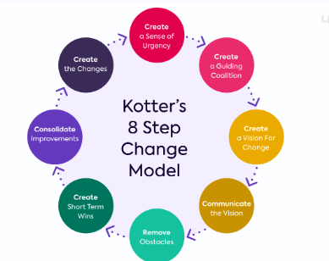
Figure 7: The Kotter’s 8-step change model
This change management model was developed by John Kotter. Kotter came up with the model after analyzing changes in 100 organizations. Based on his findings, Kotter suggested eight steps necessary in change management and they include creating a sense of urgency, building a strong coalition, forming a strategic vision, getting everyone’s buy-in, enabling action by removing barriers, generating short-term wins, sustaining acceleration, and instituting changes (Rajan & Ganesan, 2017). The eight steps imply that the change management process should be about turning resistance into reception, which is achieved through transparency, trust, and teamwork. Therefore, change management needs to be inclusive since everyone should be involved in executing the changes together.

3.5: The Suitable Change Management Model That May Be of Use to Implement the Identified Suitable Strategic Change for The Chosen Organization
From all three change management models, Kotter’s eight-step process is arguably a more effective tool for strategic changes at Tesla Company (Rajan & Ganesan, 2017). The first step will help Tesla to establish a sense of urgency in transforming its operations in the post-pandemic era to restore its operations. In this step, Tesla will ensure its workers understand the need for change so they can support the entire process. Considering that the COVID-19 period was a tough time for everyone, Tesla can use the model to ensure it creates a guiding coalition that builds on the right team. People are aware of the issues that transpired during the pandemic, and empowering them to help with the changes will be the right move for Tesla and its stakeholders. However, the organization will need to develop a vision and strategy that suits it best. That is, ensuring everybody is on the same page and is committed to changing the organization’s operations will help Tesla to figure out an effective change plan (Rajan & Ganesan, 2017). The step that follows includes involving everyone. For the company to achieve this, it will need to communicate with relevant parties and talk about the change vision to help everyone to know how the changes will be realized.
The model further illustrates the need for Tesla to remove or reduce barriers during change management. Barriers can be mitigated by ensuring that everybody has a clear understanding of their responsibilities. In this phase, rewarding those that perform well on the changes will help motivate effective transitioning. Establishing a focus on short-term wins will also help Tesla to identify its progress and be equipped to tackle bigger changes and tasks (Rajan & Ganesan, 2017). This step requires a progressive approach, such as starting small and simple to help people get comfortable with the changes and work out a plan that helps with effective implementation. The organization will also need to keep the momentum going. Lastly, anchoring new approaches to Tesla’s organizational culture will help it to create a clear connection between the desired new habits and the company’s success.

4.0: Section 3- Proposal and Implementation of Change Strategy
A change management plan is vital in Tesla’s case since it helps manage the external and internal environments and ensures every resource is dedicated towards successful implementation. In particular, a change management plan helps the business, workers, customers, and other stakeholders to be on the same page and ensure the transitioning process is smooth. With everybody onboard, change management minimizes the cost and also helps ensure control of crucial resources needed in the transformation. On that note, Wheelen et al. (2017) theorize that a good change management strategy helps with all degrees of transition if a company has a leading personality that helps everything to materialize.

4.1: Based on The Identified Suitable Change Management Model, Propose A Change Management Plan
The above-mentioned analysis identified Kotter’s eight-step model as the best management model. From this, the paper advances further by suggesting that the Plan-Do-Study-Act (PDSA) cycle is vital in Tesla’s change process as it helps with quality improvements and leverages a straightforward method of implementing necessary changes. According to Braithwaite (2022), the PDSA cycle will help Tesla by ensuring that it starts with small-to-larger practices, which are not necessarily impacted by staffing or the level of IT sophistication. Based on the specifics of the PDSA cycle, Tesla can enact necessary changes by focusing on the four steps of PDSA cycle:
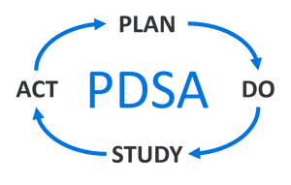
Figure 8: The four steps of the PDSA cycle
In relation to designing a management plan, the organization will need to embrace proper strategies, which will be compatible with the changes resulting from COVID-19's effect on organizations. Secondly, the step of doing will require Tesla to execute a plan in all areas of operations. By doing so, the organization will benefit by splitting out plans that work well with the employees to motivate them to ensure the changes are effective. The third step entails studying the situation. In that case, Tesla will gather vast information about its competitors, consumers, employees, and other stakeholders as part of ensuring that change management is comprehensive. The last step is acting, and Tesla’s change management plan should focus on creating an environment that allows effective management of the existing management team.

4.2: Leadership Approaches/Styles Suitable for Initiating and Implementing Identified Strategic Change

4.2.1: Leadership Style Before COVID-19
Tesla is closely associated with its CEO Elon Musk. Hence, in understanding the organization’s leadership style, Rajaram (2023) suggests that Musk’s approach is a true reflection of that of Tesla. As the manager of Tesla Motors, Twitter, and Space X, Elon Musk's management style is notable for the innovative ideas seen in each company. A critical examination of Musk’s leadership, therefore, suggests that he is an innovative individual whose most prevalent style is that of a transformational leader. As a transformational leader, Musk works with his followers to ensure they get a higher level of morality and motivation to work on more innovative projects. According to Gang Wang et al. (2011), this is possible because the transformational leadership style is associated with fairness and integrity. As a result, Musk has high expectations of his followers, and he motivates them to achieve stipulated goals by being the best of themselves. This understanding implies that a transformational leader needs to formulate inspiring visions and share them with the people. By doing so, they create a strong and trust-based connection with the workers (Anderson & Anderson, 2010).

4.2.2: New Leadership Style Following the Pandemic
Over the years, Musk’s transformational leadership has always been his identity. Specifically, he tries to execute every task in a better way that allows improvements. The significance of this style is that it has helped Musk to come up with great ideas and concepts, and their successful implementation is influenced by his ability to create teams around the objectives and visions he sets. Nonetheless, following the COVID-19 effects on organizations, Musk needed to come up with a new leadership style that would help address the situation and still maintain the company’s innovativeness. Khan (2021) posits that the changes were necessary since the pandemic forced businesses across the world to remain closed, and this caused drastic effects on their financial performance. To mitigate this, Musk adopted the participative leadership style. By definition, this style refers to an approach which involves a leader listening to workers and involving them in the decision-making process. Apparently, this leadership style has been quite prevalent, but its adoption by organizations was accelerated by the COVID-19 pandemic.
This leadership is necessary for implementing the identified strategic changes at Tesla. Its significance is attributed to the fact that it allows companies to get back to the new abnormal. The pandemic was a devastating occurrence for everybody, and the question that lingers among most organizations is how they can move beyond these effects. The answer to such questions is leaders need to be more strategic by taking breaks, giving breaks, operationalizing the abnormal, and re-strategize the future. In this case, Tesla must stop and recognize how the pandemic caused changes and what they have accomplished since then. This approach will help the leader, together with the workers, to have a relaxed approach that entails taking rests to help them to take on the future re-energized. Operationalizing the new abnormal is interpreted as the need for leaders and workers to reconcile and work together (Anderson & Anderson, 2010). The step will help them to re-strategize the future by trying to restore operations as they used to before the pandemic and make them better.

4.3: Step-by-Step Process to Implement the Change Strategy
A complete change management process at Tesla will follow the eight steps outlined in Kotter’s change management model. These steps are as outlined below:

4.3.1: Identify the Area to be improved
The organization will start by being very critical in identifying and focusing on the specific goal. This portion is about Tesla formulating organizational and individual goals. For Tesla to accomplish this, it will need to reflect on its internal and external environment. This process will help find the main focal point for initiating necessary changes (Ahrne & Brunsson 2011).

4.3.2 Present Proposed Changes to Relevant Stakeholders
An organization that is as massive as Tesla Company is associated with several layers of stakeholders. Therefore, when implementing the changes, these individuals need to be familiar with the steps Tesla will take in their implementation. Considering that the levels of stakeholders vary, the company will need to give a clear description of the change framework that matches the specific level.

4.3.3 Plan for the Change
Having a clear roadmap is crucial since it helps identify the start, the route taken, and the destination. As aforementioned in the strategy map, Tesla needs to have a clear map that helps with the integration of necessary resources to leverage objective-focused plans.

4.3.4 An Evaluation of Resources
Besides the planning process, Tesla will need to critically examine the resources to ascertain whether the equipment and infrastructure are all geared towards a common objective, which is effective changes to help the organization in this post-pandemic period. A critical evaluation of resources will help understand if they are sufficient to help with retraining and rethinking company goals for a successful change management plan.

4.3.5 Communication
The right communication channel is priceless, especially in organizations experiencing changes. This step of implementation will require Tesla to focus on an effective and efficient communication framework that assists in communicating the message of change to workers, customers, and other stakeholders. Additionally, a good communication plan will help in planning, onboarding, and executing an effective change plan.

4.3.6 Monitor and Manage Resistance
Kotter’s change management model supposes that resistance is common in the transition process. Therefore, with the right measures in place, Tesla will focus on possible factors that may increase resistance from workers. Bearing this in mind, proper planning will help to monitor resistance and manage it before it gets out of hand.

4.3.7 Celebrate Success
Change implementation has its challenges, and this understanding requires pertinent organizations to recognize milestone achievements. Tesla Company will approach this by ensuring it has a clear picture of what it intends to achieve at the end of this process. This recognition will assist in making sense of every process and how to progress further (Ahrne & Brunsson 2011).

4.3.8 Review, Revise and Improve
Lastly, effective implementation of the changes will help Tesla to overcome challenges to organizations following the COVID-19 pandemic. However, the organization needs to understand that effective implementation of these changes is just but a starting point. It will need to review its operations, revise the changes accordingly, and make necessary improvements.

4.4: The Probable Impact of The Implementation of Change Strategy on The Culture of The Chosen Organization
Tesla’s current organizational culture is characterized by being focused on its vision. COVID-19 affected this culture further, and as per the current situation, the organization has been experiencing high executive turnover, internal sabotage, and reduced profits. An examination of the company’s culture suggests that the varying types of values and devalued behaviors have been the major contributory factors to this situation (Sackmann, 2022). Therefore, since the suggested change management will be centered on the people and how their collaborated efforts can help restore the company’s operation before the COVID-19 pandemic, such changes will result in Elon Musk emphasizing organizational citizenship behaviors. This strategy will help increase employee performance since it will involve developing improved coordination skills that will enhance coworker and leadership productivity.

5.0: Conclusion and Recommendations
An effective change management plan is crucial in an organization as it helps understand a company’s internal and external environment. In Tesla’s case, it is evident that COVID-19 adversely affected the company’s operations, and effective change management will help it to restore and improve its operations accordingly. More precisely, the change management will involve the organization, workers, buyers, and other important stakeholders and ensure they are all committed towards improved functioning. Further, by implementing the suggested change plan, Tesla may experience notable cultural changes. Therefore, if the changes are to help this organization to continue with its global reputation in the automotive industry, it needs to make sure its resources are focused on addressing various degrees of change. The recommended steps to do so include: navigating the changing cultural landscape fast, mitigating the prevalence of deep emergent changes to reduce disruptions and embracing a leadership style that results in a comprehensive and integrated transformation that will help grow its competitive advantage.

References
Ahrne, G. and Brunsson, N. (2011) Organization outside organizations: The significance of partial organization. Organization, 18(1), pp.83-104.
Anderson, D. and Anderson, L.A. (2010) Beyond change management: How to achieve breakthrough results through conscious change leadership (Vol. 36). John Wiley & Sons.
Bencivenga, J. (2002) John Kotter on Leadership, Management and Change. School Administrator, 59(2), pp.36-40.
Benn, S., Edwards, M., & Williams, T. (2014). Organizational change for corporate sustainability. Routledge.
Braithwaite, J. (2022). Plan, do, study, act (PDSA). In Implementation Science (pp. 83-84). Routledge.
Cameron, E. and Green, M. (2019) Making sense of change management: A complete guide to the models, tools and techniques of organizational change. Kogan Page Publishers.
Carnall, C.A. (2007) Managing change in organizations. Pearson Education.
Chehertma, B. (2022). International competitiveness management of Tesla, Inc. during the COVID-19 pandemic (Doctoral dissertation, Private Higher Educational Establishment-Institute “Ukrainian-American Concordia University”).
Dobrev, I. (2020). Tesla’s current state and brand potential. How to derive a brand meaning and create a future that inspires. GRIN Verlag.
Gang Wang, Oh, I., Courtright, S. H., & Colbert, A. E. (2011). Transformational leadership and performance across criteria and levels: A meta-analytic review of 25 years of research. Group & Organization Management, 36(2), 223-270.
Grover, V., Tseng, S., & Pu, W. (2022). A theoretical perspective on organizational culture and digitalization. Information & Management, 59(4), 103639.
Gursoy, D., & Chi, C. G. (2020). Effects of COVID-19 pandemic on hospitality industry: Review of the current situations and a research agenda. Journal of Hospitality Marketing & Management, 29(5), 527-529.
Henderson, R., Gulati, R. and Tushman, M. eds. (2015) Leading sustainable change: An organizational perspective. OUP Oxford.
Homburg, C., Kuester, S., & Krohmer, H. (2012). EBOOK: Marketing management. McGraw Hill.
Hu, B., Leopold-Wildburger, U., & Strohhecker, J. (2017). Strategy map concepts in a balanced scorecard cockpit improve performance. European Journal of Operational Research, 258(2), 664-676.
Hussain, S. T., Lei, S., Akram, T., Haider, M. J., Hussain, S. H., & Ali, M. (2018). Kurt Lewin's change model: A critical review of the role of leadership and employee involvement in organizational change. Journal of Innovation & Knowledge, 3(3), 123-127.
Joseph Galli, B. (2018). Change management models: A comparative analysis and concerns. IEEE Engineering Management Review, 46(3), 124-132.
Kotter, J.P. (2012) Leading change. Harvard business press.
Khan, M. R. (2021). A critical analysis of Elon Musk’s leadership in Tesla Motors. Journal of Global Entrepreneurship Research, 11(1), 213-222.
Majoul, B., Pandya, D., & Wang, L. (2023). Proceedings of the 2022 4th International Conference on literature, art and human development (ICLAHD 2022). Springer Nature.
Mann, D. L. (2022). The genius of Tesla: How Elon Musk and electric cars changed the world. Lerner Publications TM.
Odumeru, J. A., & Ogbonna, I. G. (2013). Transformational vs. transactional leadership theories: Evidence in literature. International review of management and business research, 2(2), 355-361.
Perera, R. (2017). The PESTLE analysis. Nerdynaut.
Rajan, R., & Ganesan, R. (2017). A critical analysis of John P. Kotter's change management framework. Asian Journal of Research in Business Economics and Management, 7(7), 181.
Rajaram, K. (2023). Leading and transforming organizations: Navigating the future. Taylor & Francis.
Sackmann, S. A. (2022). Culture in organizations: Development, impact and culture-mindful leadership.
Shiddiq, M. (2020). Case Study of Tesla, Inc. as Dynamic Organization in Automotive Industry and How It Acts Amidst COVID-19 Epidemic. Inc. as Dynamic Organization in Automotive Industry and How It Acts Amidst COVID-19 Epidemic (April 30, 2020).
Wen, W., Yang, S., Zhou, P., & Gao, S. (2021). Impacts of COVID-19 on the electric vehicle industry: Evidence from China. Renewable and Sustainable Energy Reviews, 144, 111024.
Wheelen, T. L., Hunger, J. D., Hoffman, A. N., & Bamford, C. E. (2017). Strategic management and business policy (Vol. 55). Boston: pearson.
Xinyi, L., Chen, Z., & Bai, C. (2022). Case Study Research in Tesla (China) Marketing Strategy Application During Covid-19.

