Build, and deploy, a Type 2 Hypervisor platform based Virtualised network

Farley Staines
2204098
Contents
1. Understanding Hypervisors in Virtualization 3
Types of Hypervisors: 3
Features: 3
Advantages: 3
Scalability: 4
Security: 4
Compatibility: 4
Use Cases: 4
2. Hypervisor choice 4
3. IP Addresses 5
Data Transmission on the Internet: 5
Protocols: 5
IP Addressing: 5
IPv4 and IPv6 Addressing: 6
Subnetting: 6
Routers and Switches: 6
Web Servers: 7
4. Network testing 7
Connectivity Tests: 7
Ping Test: 7
Traceroute: 7
Telnet/SSH: 7
Netcat: 7
Troubleshooting techniques 7
Identify Symptoms: 7
Check Physical Connections: 7
Verify Network Configuration: 7
Check Firewall and Security Settings: 8
Update Firmware and Drivers: 8
Bandwidth Testing: 8
Internet Speed Tests: 8
iperf: 8
Packet Loss Testing: 8
Ping Test with Packet Loss: 8
Packet Capture Tools: 8
Types of Security Testing: 8
Vulnerability scanning 8
Penetration testing 8
Application security testing 9
Web applications security testing 9
API testing 9
Security auditing 9
Risk assessment 9
Security posture assessments 9
5. Testing the network 9
Pinging between SW-DC and SW-PC 9
SW-DC (10.1.0.1) pinging SW-PC (10.1.0.2) 10
SW-PC (10.1.0.2) pinging SW-DC (10.1.0.1) 10
Pinging between SW-DC and LD-DC 11
SW-DC (192.1.1.1) pinging LD-DC (192.1.1.2) 11
LD-DC (192.1.1.2) pinging SW-DC (192.1.1.1) 12
Pinging between LD-DC and LD-PC 12
LD-DC (10.2.0.1) pinging LD-PC (10.2.0.2) 13
LD-PC (10.2.0.2) pinging LD-DC (10.2.0.1) 13
6. References 14

Understanding Hypervisors in Virtualization
A hypervisor, also known as a virtual machine monitor (VMM), is a software application that facilitates the creation and management of virtual machines (VMs) on a single physical host machine. By effectively sharing the host's resources among multiple guest VMs, hypervisors enable the link of workloads and enhance resource utilization. [1]

Types of Hypervisors:
Type 1 hypervisors, also known as bare-metal hypervisors, operate directly on the host's physical hardware. They have a thin layer of software that interacts directly with the hardware to manage virtual machines. With minimal hardware requirements, Type 1 hypervisors offer high performance, scalability, and security. They efficiently allocate hardware resources and isolate virtual machines from each other and the host system, making them ideal for enterprise-level virtualization deployments. Type 1 hypervisors are compatible with a wide range of hardware platforms and operating systems, making them suitable for diverse environments such as server virtualization, cloud computing, and data centres.
Examples include VMware vSphere/ESXi, Microsoft Hyper-V, and XenServer.
Type 2 hypervisors, known as hosted hypervisors, run on top of an operating system. They utilize the resources of the host operating system to create and manage virtual machines. With moderate hardware requirements, Type 2 hypervisors offer ease of use, flexibility, and cost-effectiveness. They are ideal for desktop virtualization, allowing users to run multiple operating systems and applications on a single physical machine. While less scalable than Type 1 hypervisors, Type 2 hypervisors are versatile and compatible with various hardware platforms and operating systems, making them suitable for development, testing, and educational environments.
Examples include VMware Workstation, Oracle VirtualBox, and Parallels Desktop.

Features:
Resource Allocation: Hypervisors allocate resources (CPU, memory, storage) to VMs and manage resource scheduling.
Isolation: VMs are isolated from each other and the host system, ensuring that one VM's actions do not affect others.
Instant Provisioning: VMs can be created, cloned, and deployed rapidly, facilitating dynamic workload provisioning.
Portability: VMs can be moved across different physical hosts, providing flexibility and resilience. [2]

Advantages:
Speed: Instant VM creation enables rapid deployment of resources, improving agility.
Efficiency: Consolidating multiple VMs on a single physical server optimizes resource utilization, reducing costs and energy consumption.
Flexibility: Bare-metal hypervisors abstract the hardware, enabling VMs to run on diverse hardware platforms.
Portability: VMs are independent of the underlying hardware, allowing seamless migration between hosts.

Scalability:
Hypervisors offer scalability by dynamically allocating resources to VMs based on workload demands. They support the scaling of virtualized environments to accommodate growing or fluctuating workloads.

Security:
While VM isolation enhances security by containing compromises within individual VMs, the hypervisor layer must be adequately secured to prevent vulnerabilities. Regular patching, access control, and encryption mechanisms help mitigate security risks.

Compatibility:
Hypervisors are compatible with various operating systems, applications, and hardware platforms, offering broad interoperability across heterogeneous environments.

Use Cases:
Server Virtualization: Type 1 hypervisors are commonly used for consolidating multiple servers onto a single physical host, reducing hardware costs, and simplifying management.
Desktop Virtualization: Type 2 hypervisors facilitate running multiple operating systems or applications on a single desktop or laptop, enhancing productivity and flexibility.
Development/Testing: Hypervisors provide isolated environments for software development, testing, and debugging, enabling rapid prototyping and deployment.

Hypervisor choice
The chosen hypervisor for the coursework is the type 2 hypervisor Oracle VirtualBox, for completing this coursework as it offers several advantages. Firstly, it is incredibly user-friendly and easy to set up, making it ideal for environments where simplicity and convenience are vital. The straightforward installation process and intuitive user interface of Oracle VirtualBox ensure that I can quickly start creating and managing virtual machines without requiring in-depth technical knowledge.
Additionally, Oracle VirtualBox provide a high degree of flexibility, allowing me to run multiple operating systems and applications simultaneously on a single physical machine. This versatility is particularly helpful for coursework that involves testing software across different platforms, experimenting with various operating systems or configurating various networks. The ability to seamlessly switch between virtual environments within the same host operating system enhances productivity and efficiency.
Overall, the user-friendly interface, flexibility, and cost-effectiveness of Oracle VirtualBox makes it an excellent choice for completing this coursework, it provides a practical and accessible platform to learn about virtualization technology and conducting experiments in various computing environments.

IP Addresses

Data Transmission on the Internet:
Data transmission on the Internet involves breaking down messages into packets, each containing 1500 bytes of data which encompass information about the message. These packets are then routed across the Internet through various devices, such as switches and routers. The packets are reassembled at the destination, ensuring the integrity and order of the transmitted data. [3]
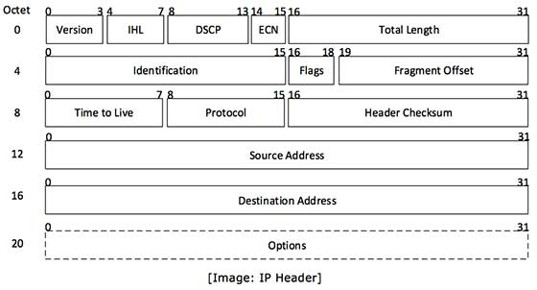
Figure 1 - structure of a TCP packet
[4]

Protocols:
Protocols are standardized ways of performing actions and formatting data. They play a pivotal role in the Internet's functionality. Different protocols govern actions such as communication between devices on the same network, sending packets from one network to another, ensuring the arrival of packets in order, and formatting data for websites and applications.

IP Addressing:
IP, or Internet Protocol, is a set of rules governing the format of data sent over the Internet or local networks. IP addresses serve as identifiers, enabling information to be sent between devices on a network by providing location information. When a device connects to the Internet, it first connects to a network that is already connected to the Internet, typically the Internet Service Provider (ISP). The ISP assigns an IP address to the device, and all internet activity is routed through the ISP, using the assigned IP address.

IPv4 and IPv6 Addressing:
IPv4 and IPv6 are the two main versions of the Internet Protocol, each with distinct addressing formats. IPv4 addresses are 32-bit numerical labels, represented in dotted-decimal format (e.g., 192.168.0.1). Due to the limited number of IPv4 addresses, IPv6 was introduced with a 128-bit addressing format, allowing for a vastly increased number of unique addresses. [5]
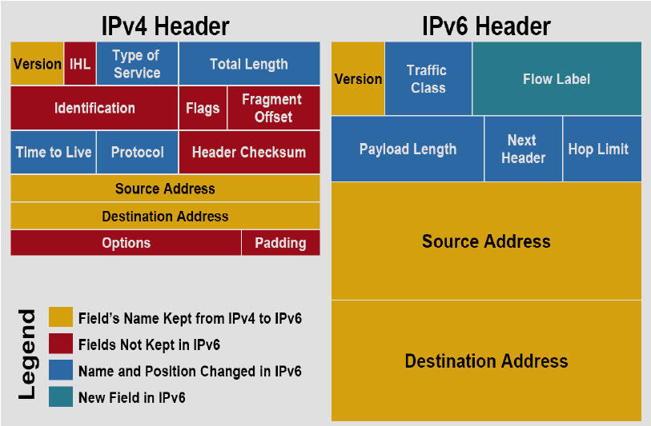
Figure 2 - structure of IPv4 and IPv6
[6]

Subnetting:
Subnetting is a technique that allows for the efficient utilization of IP addresses. It involves dividing a larger network into smaller, more manageable sub-networks. This not only aids in optimizing address space but also enhances network security and performance.

Routers and Switches:
Routers and switches are critical components in the Internet's infrastructure. Routers forward packets to different networks based on destination addresses, ensuring efficient data flow. Switches, on the other hand, connect devices within a single network, utilizing packet switching to direct packets to the correct devices.

Web Servers:
Web servers play a crucial role in storing and serving content to users. Additionally, they host applications and databases, contributing to the overall functionality and effectiveness of the Internet.

Network testing

Connectivity Tests:

Ping Test:
The ping command will send internet control message protocol (ICMP) echo requests to a target device and measures the round-trip time for responses. It verifies connectivity between devices and helps identify network latency.

Traceroute:
Traceroute traces the path packets take from the source to the destination, showing each hop along the way. It can help identify routing issues and network congestion.

Telnet/SSH:
Telnet or secure shell (SSH) can be used to establish a connection to a specific port on a remote device, verifying whether the port is open and accessible.

Netcat:
Netcat can test connectivity and port availability between devices by establishing transmission control protocol (TCP) or user datagram protocol (UDP) connections.

Troubleshooting techniques

Identify Symptoms:
Start off by gathering information about the issue. This can includes noting any error messages, symptoms, or changes in network behaviour reported by users or observed firsthand. [7]

Check Physical Connections:
Ensure all cables, connectors, and network devices are properly connected and powered on. Physical connectivity issues, such as loose cables or faulty hardware, can often cause network problems.

Verify Network Configuration:
Review network configurations, including IP addresses, subnet masks, gateways, and DNS settings, to ensure they are correct and consistent across devices. Configuration mismatches can lead to connectivity issues.

Check Firewall and Security Settings:
Review firewall configurations and security policies to ensure they are not blocking desired traffic. Adjust firewall rules as necessary to allow traffic to pass through.

Update Firmware and Drivers:
Ensure network devices, including routers, switches, and network interface cards (NICs), have the latest firmware and drivers installed. Outdated firmware or drivers can cause compatibility issues and performance problems. [7]

Bandwidth Testing:

Internet Speed Tests:
Perform several online internet speed tests to test your internet bandwidth along with download and uploads speeds, latency, and packet loss information.

iperf:
iperf is a command-line tool for measuring network performance by generating TCP or UDP traffic between two hosts. It provides detailed bandwidth metrics and can help identify network bottlenecks.

Packet Loss Testing:

Ping Test with Packet Loss:
Using the ping command with a large number of packets (-n option) can reveal packet loss issues. Consistent packet loss indicates network congestion or hardware problems.

Packet Capture Tools:
Wireshark or tcpdump can capture and analyse network packets, helping to diagnose packet loss, retransmissions, and other network issues.

Types of Security Testing:

Vulnerability scanning
Vulnerability scanning utilizes automated tools to detect security vulnerabilities within software applications or networks. Its main aim is to identify potential threats and suggest improvement measures. This method establishes a security baseline by focusing on known risks. [8]

Penetration testing
Penetration testing, a subset of ethical hacking, simulates real-world attacks to uncover vulnerabilities in software applications. Conducted manually or with automated tools, it includes techniques like social engineering and network scanning to locate potential threats and recommend solutions. [8]

Application security testing
Application security testing (AST) evaluates software security, combining automated and manual techniques like code analysis and penetration testing to detect and address vulnerabilities. It is vital for identifying both external and internal threats.

Web applications security testing
Web application security testing specializes in identifying vulnerabilities in web-based applications, using methods like structures query language (SQL) injection and cross site scripting (XSS) tests to ensure security.

API testing
Application programming interface (API) security testing assesses the security of an application's APIs, protecting them against threats like DoS attacks and API injection.

Security auditing
Security auditing evaluates software or network security to ensure compliance with standards and best practices, using methods like code review and vulnerability scanning.

Risk assessment
Risk assessments prioritize security risks based on their potential impact, helping develop plans to mitigate them.

Security posture assessments
Security posture assessments evaluate an organization's overall security strategy and implementation, recommending improvements to enhance security.

Testing the network

Pinging between SW-DC and SW-PC
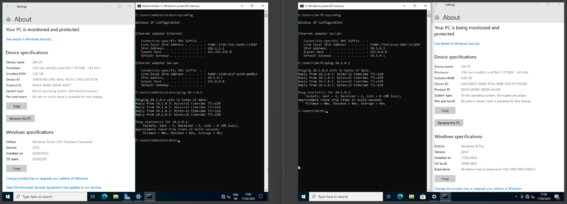
Checking the IP on the LAN for SW-PC shows it as 10.1.0.2 which is expected and checking the IP for SW-DC on the LAN shows it as 10.1.0.1. On the SW-PC device you can ping the server, SW-DC, without issue. This also works the other way round with SW-DC being able to ping SW-PC. Both devices are also appropriately named based on the topology.

SW-DC (10.1.0.1) pinging SW-PC (10.1.0.2)
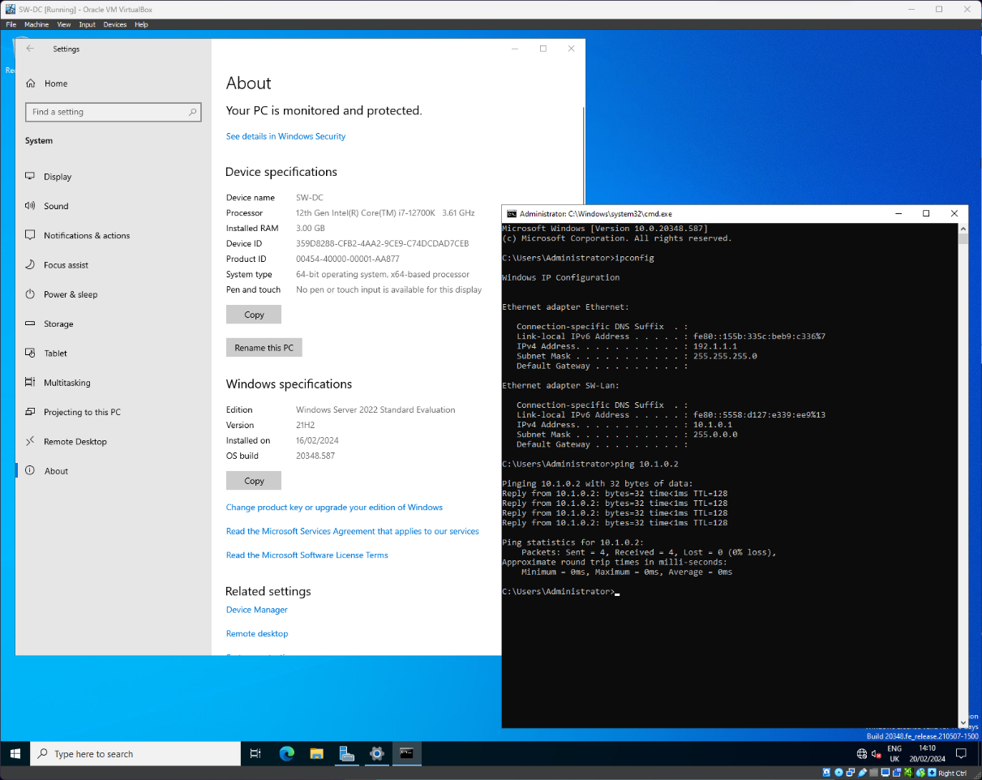

SW-PC (10.1.0.2) pinging SW-DC (10.1.0.1)
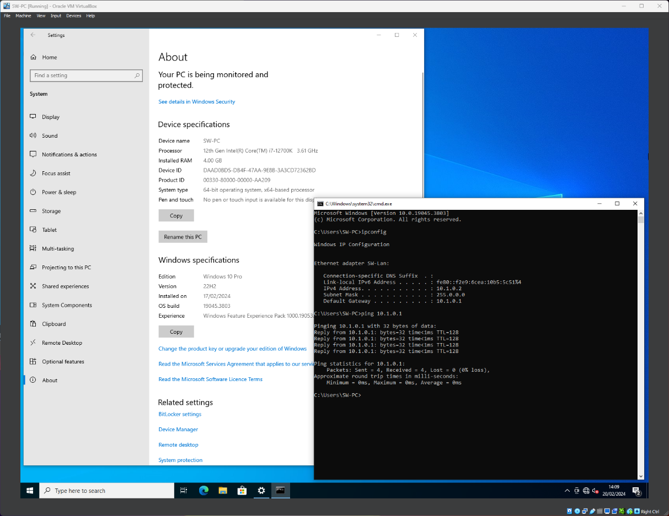

Pinging between SW-DC and LD-DC
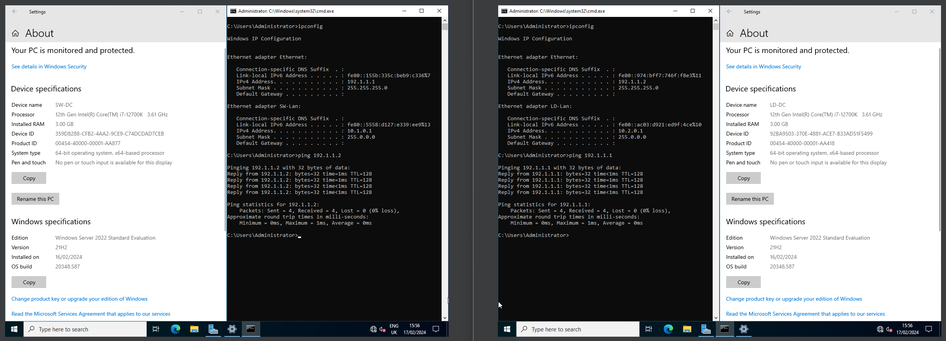
Checking the IP on the ethernet adapter for SW-DC shows it as 192.1.1.1 which is expected and checking the IP for LD-DC on the ethernet adapter shows it as 192.1.1.2. On the SW-DC server you can ping the server, LD-DC, without issue. This also works the other way round with LD-DC being able to ping SW-DC. Both devices are also appropriately named based on the topology.

SW-DC (192.1.1.1) pinging LD-DC (192.1.1.2)
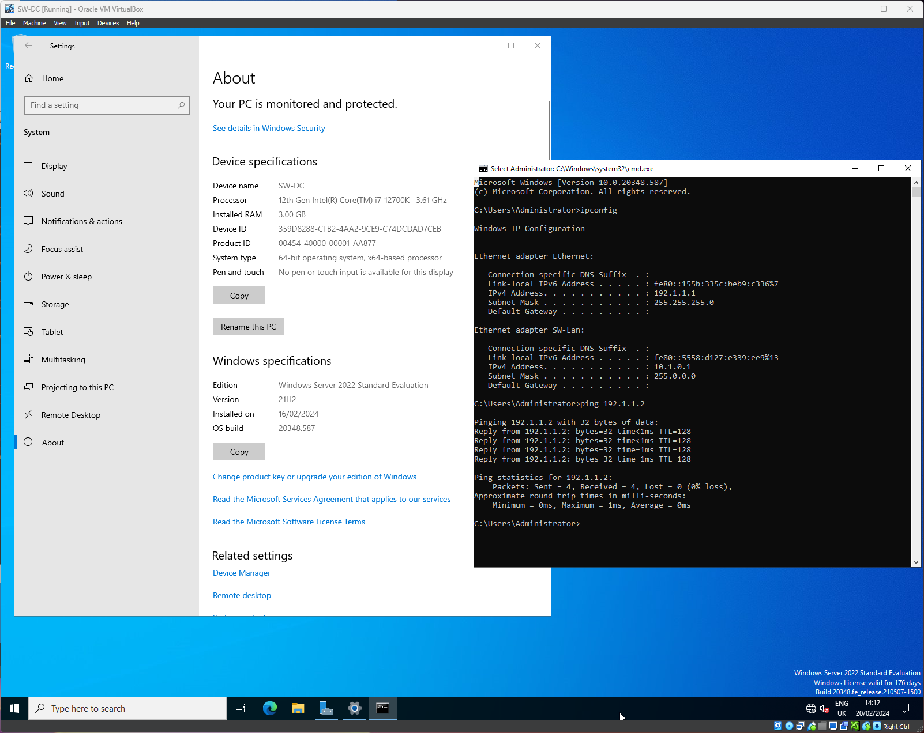

LD-DC (192.1.1.2) pinging SW-DC (192.1.1.1)
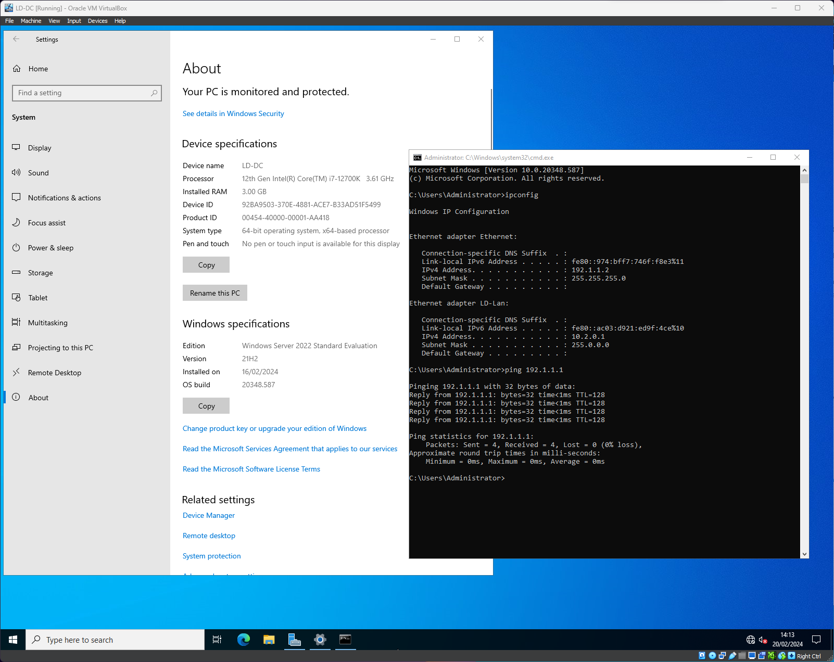

Pinging between LD-DC and LD-PC
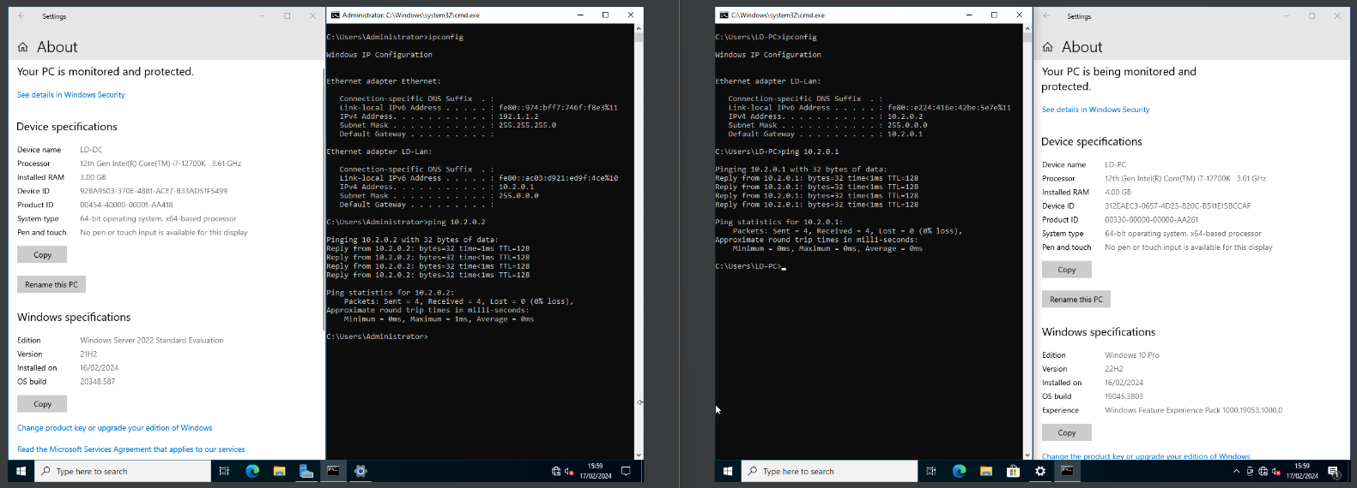
Checking the IP on the LD-LAN for LD-PC shows it as 10.2.0.2 which is expected and checking the IP for LD-DC on the LD-LAN shows it as 10.2.0.1. On the LD-PC device you can ping the server, LD-DC, without issue. This also works the other way round with LD-DC being able to ping LD-PC. Both devices are also appropriately named based on the topology.

LD-DC (10.2.0.1) pinging LD-PC (10.2.0.2)
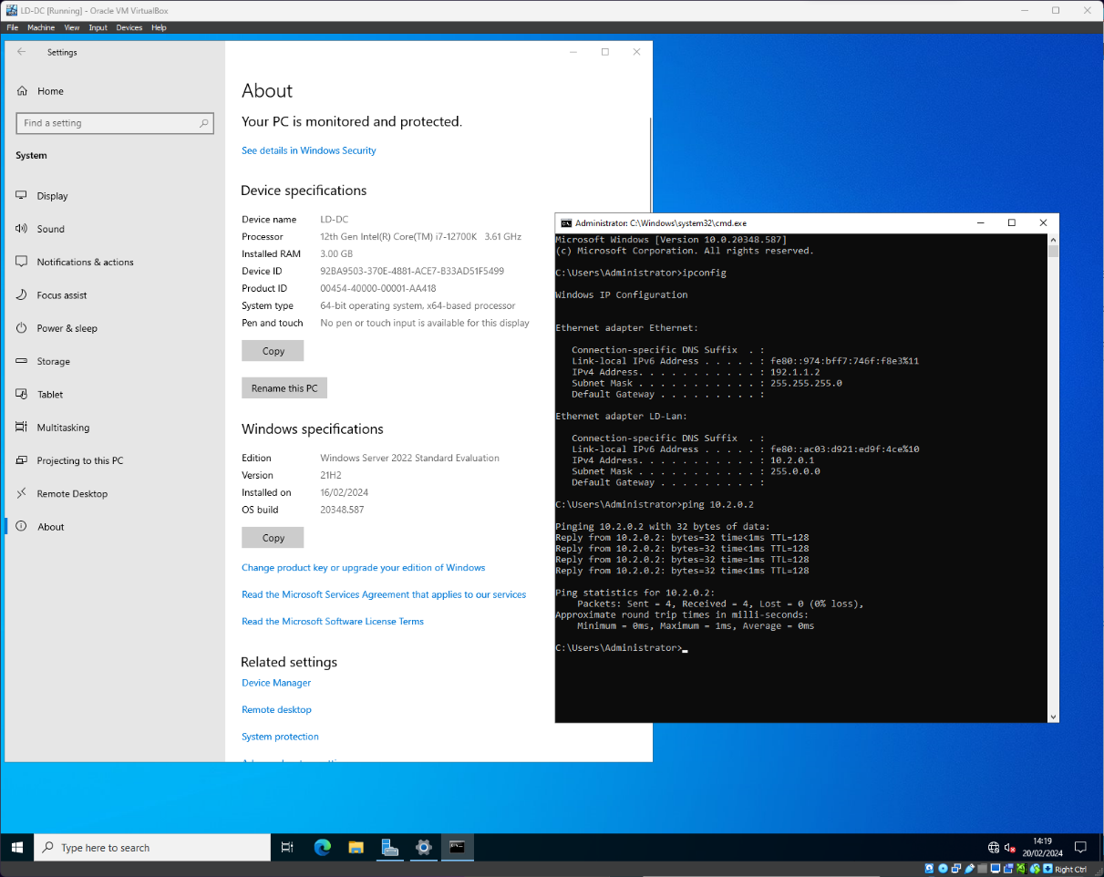

LD-PC (10.2.0.2) pinging LD-DC (10.2.0.1)
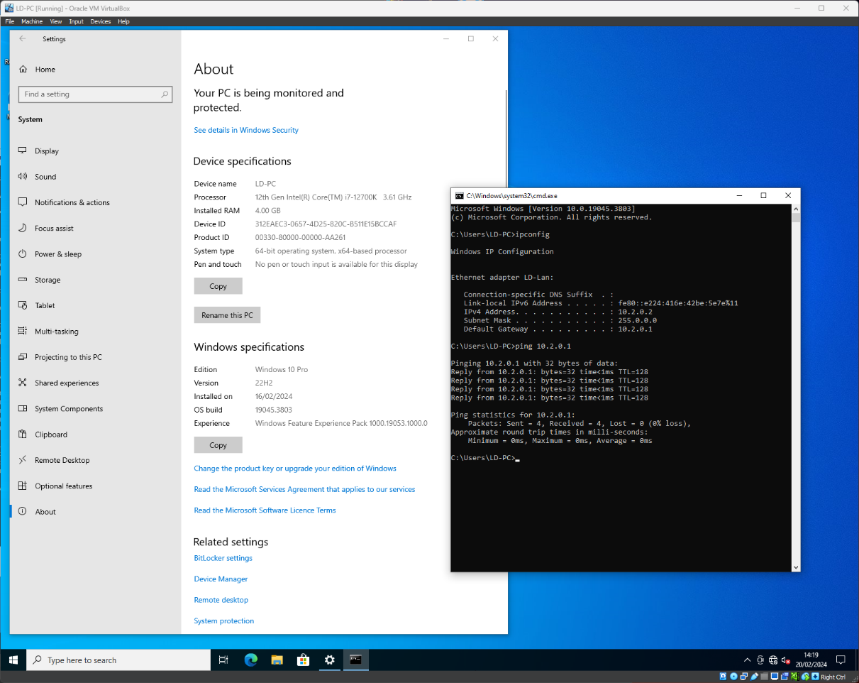

References

[1] | RedHat, “What is a hypervisor?,” 3 January 2023. [Online]. Available: https://www.redhat.com/en/topics/virtualization/what-is-a-hypervisor. [Accessed 9 February 2024].
[2] | VMWare, “What is a hypervisor?,” [Online]. Available: https://www.vmware.com/uk/topics/glossary/content/hypervisor.html. [Accessed 9 February 2024].
[3] | CloudFlare, “What is the Internet?,” [Online]. Available: https://www.cloudflare.com/en-gb/learning/network-layer/how-does-the-internet-work/. [Accessed 5 January 2024].
[4] | M. Mackenty, “IP Header,” 7 November 2017. [Online]. Available: https://computersciencewiki.org/index.php?title=File:Ip_header.jpg. [Accessed 18 February 2024].
[5] | Kaspersky, “What is an IP Address – Definition and Explanation,” [Online]. Available: https://www.kaspersky.com/resource-center/definitions/what-is-an-ip-address. [Accessed 5 February 2024].
[6] | M. Al-Ani, “Comparison of IPv4 and IPv6 headers’ structures,” December 2012. [Online]. Available: https://www.researchgate.net/figure/Comparison-of-IPv4-and-IPv6-headers-structures-15_fig1_269810379. [Accessed 17 February 2024].
[7] | Cloud 7 IT Services Inc, “Network Troubleshooting: A Step-by-Step Guide,” 8 September 2023. [Online]. Available: https://www.linkedin.com/pulse/network-troubleshooting-step-by-step-guide-cloud-7-i-t-services/. [Accessed 16 February 2024].
[8] | hackerone, “What Is Security Testing?,” [Online]. Available: https://www.hackerone.com/knowledge-center/what-security-testing. [Accessed 18 February 2024].

Figure 1 - structure of a TCP packet 5
Figure 2 - structure of IPv4 and IPv6 6

