

Student name: Minchi C. Chandler
Student ID: 2532181

Module name: Introduction to Health & Social Care
Module code: LCHS4003
Lecturer name Umma Sileiman
Content Page:
Task 1: Poster
- Introduction
- Brief History
- How Ambulance Services Function
- Response Team Target by Category
- Two Modern Day Challenges
- Conclusion
- Refences

Task 2: Essay
Title: Domiciliary Care Services Within the Community
1.Introduction
2.Historical Origin and Development
3. Critical Evaluation and Contemporary Practice
4.Significance for Quality Life
5. Conclusion
6. References

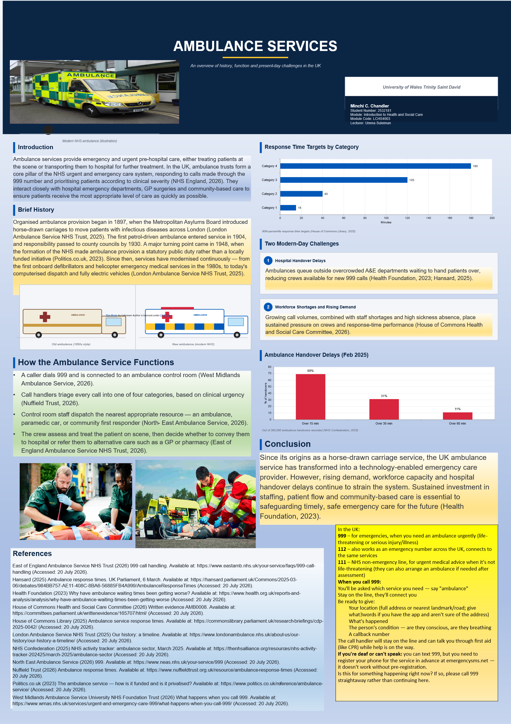

Domiciliary Care Services within the Community in the UK: Origins, Development, and Contemporary Significance
Introduction
With the UK population growing older and more people living with long-term conditions, being able to stay in one's own home while receiving support has become a key focus of health and social care policy. Domiciliary care — the provision of personal, practical, and at times nursing support to people within their own homes — has grown from fragmented charitable efforts into a major strand of community-based provision. This essay examines where domiciliary care in the UK originated, considers the historical context that shaped its growth, critically assesses how the service works today, and discusses its importance in improving the quality of life of those who use it, before offering a concluding evaluation.
Historical Origins and Development
Organised, home-based support for vulnerable people in Britain can be traced back to nineteenth-century charitable visiting, when religious and philanthropic bodies attended to the sick and elderly poor in their own homes rather than sending them to the workhouse (Hygea Homecare, 2025). A more solid institutional basis was established with the founding of the National Health Service in 1948, which was structured around three distinct strands: hospital treatment, general practice, and community and domiciliary services — a division that positioned home-based support as its own category from the very start (myHSN, 2025).
The most significant period of development, though, came in the 1980s, set against a backdrop of mounting criticism of long-stay institutional care and a number of scandals involving abuse in long-stay hospitals, which reinforced the case for supporting people within their own communities (Community Care, 2025). The Audit Commission's 1986 report, *Making a Reality of Community Care*, made the practical and financial argument for redirecting resources away from institutions and towards domiciliary provision (Audit Commission, 1986, cited in Langan, 1990). Building on this, Margaret Thatcher's government asked Sir Roy Griffiths to review the community care system; his 1988 report, *Community Care: Agenda for Action*, concluded that the sector lacked clear management accountability and recommended that local authorities take charge of assessing need and organising a "mixed economy" of care drawing on private and voluntary providers (Griffiths, 1988, cited in Jones, n.d.). These recommendations fed into the 1989 White Paper *Caring for People*, which underpinned the NHS and Community Care Act 1990, obliging local authorities to assess individual needs and give priority to support delivered within people's own homes wherever this was appropriate (Langan, 1990; homecare.co.uk, 2025).
Critical Evaluation of Contemporary Practice
Domiciliary care today covers everything from short visits to full live-in support, including personal care, help with medication, household assistance, and companionship, provided through a mix of local authority staff, commissioned independent agencies, and services paid for directly or arranged through direct payments (Wikipedia, 2026b). Regulators such as the Care Quality Commission in England now inspect providers in an attempt to bring greater consistency to what remains a fragmented market (homecare.co.uk, 2025). Yet despite this regulatory framework, there are signs that local-authority provision has not kept pace with demand: research shows that even as the population has aged and policy has continued to favour home-based support, the number of households receiving council-funded home care actually fell over a fifteen-year period, even though the average number of hours provided per household increased (Jones, n.d.). The sector also continues to struggle with serious workforce shortages and high staff turnover, which undermine the consistency and reliability the 1990 reforms were designed to secure (Wikipedia, 2026b).
Significance for Quality of Life
Despite these structural pressures, domiciliary care remains vital to the wellbeing of the people who use it. It allows individuals to keep their independence, routines, and control over daily life in a way institutional settings often cannot match, while helping them stay connected to family and familiar surroundings. For older and disabled people in particular, being able to remain at home with support tailored to their needs is strongly linked to greater dignity and personal wellbeing (Helping Hands, 2026).
Conclusion
Domiciliary care in the UK has developed from nineteenth-century charitable visiting into a regulated, though still uneven, part of the welfare state, shaped decisively by the Griffiths reforms and the Community Care Act 1990. Although funding and workforce pressures remain, its continuing ability to protect independence and dignity for people in their own homes confirms just how much it matters, both to individuals and to the wider community.
References
Community Care (2025) *Social work across the decades: the birth of the adults'/children's divide
Helping Hands (2026) *Domiciliary care services at home
homecare.co.uk (2025) *History of home care in the UK.
Hygea Homecare (2025) *The history of domiciliary care in the UK
Jones, R. (n.d.) *The history of English social care policy*. Ageing Horizons, 6. Oxford Institute of Population Ageing.
Langan, M. (1990) 'Community care in the 1990s: the community care White Paper: "Caring for People"', Critical Social Policy, 10(2), pp. 58–70.
myHSN (2025) *A short history of the NHS
.

