Management & Organisational Behaviour (BMIH5004)

Student Name: Salam Al-Masoud
Student ID: 2235444
Lecturer Name: Daniel Payne

Declaration
I confirm that I have not used any AI tools in the research and creation of this assignment. I confirm that I have not presented any AI-generated materials as my work. I confirm I have copies of my drafts, notes, and other resources I used, which I may be asked to provide in evidence.

Executive Summary
This paper analyses Hyatt Hotels Corporation with regard to its business organisation, corporate culture, and key management activities in order to evaluate the company’s competitiveness and performance. This type of organisation allows the chain’s flexibility, as each property can be sensitive to the specific market it operates in but must act within the company’s limitations. This concept comprises both the Role and Task culture where the standards are provided at the corporate level and innovation is provided at the hotel level. New strategies such as digitalisation, the creation of sustainability policies, and other personnel engagement strategies have helped to build on Hyatt's competitive advantage. However, problems are identified in how well international policies can be implemented to accommodate local aspirations. Other specific suggestions include leveraging digital personalisation by advanced data analytics; increasing sustainability strategies; striving for very active global market penetration; and, sustaining a strong, ongoing employee training program. All these steps will create a strong market base for Hyatt, ensure patrons’ loyalty, and enhance its operational procedures. In conclusion, it can be stated that Hyatt has chosen the right path of innovation and sustainability in collaboration with locally focused services for the development of further success in the world hospitality market and for long term improvement.
Table of Contents
​​
​
​
​
​
​
​
​
​
​ Introduction
Hyatt Hotels Corporation is the world’s largest hospitality company that has decentralised its organisation structure enabling individual hotels of the company to solve customers’ requirements while concurrently following general corporate guidelines. This flexibility helps Hyatt to address the culturally and economically different surroundings of certain positions in different countries. The company strategy uses elements of both Role and Task Cultures, where standardization helps achieve efficiency at the company level while allowing creativity at the hotel level. Hyatt’s focus areas of sustainability, digitalisation, and engagement of employees serve as a reinforcement of the firm’s competitive advantage (Mullins and Dosser, 2013). This paper focuses on the organisational model of Hyatt, its strategic positioning, and the cultivation of organisational culture for the purpose of laying out the key strategies for the organisation’s desirable development and improved managerial efficiency going forward.
Organisational Structure, Culture, and Goals
Hyatt has a decentralised chain of operational command, meaning that select individual hotels have relatively high decision-making authority. Although the central office in Chicago established general guidelines and oversees that these guidelines follow the company’s standards, each hotel is free to adjust its services according to market demands (Combe, 2022). Seattle-based Hyatt is in many capacities, especially in different locations where each has different cultures, economy, and competition. This strategy of decentralising service delivery by empowering local managers gives Hyatt operational flexibility while keeping with the global strategic direction.
Mintzberg’s 5 Ps and Hyatt’s Structure
Mintzberg has classified organisational structure into 5Ps. Hyatt follows all of Mintzberg’s 5 Ps of organisational structure. The “Positioning” element of Mintzberg’s model should relate to Hyatt’s approach to providing unique value-added services to guests under each brand (Elsmore, 2020). This means to create a market segment in each specific country they offer either luxury or low-cost Hyatt but retain their corporate brand guidelines. It also enables the brand to stay competitive internationally, and quickly adapt to local needs. The “Pattern” strategy supports it by allowing the capacity to change policies and practices in response to unique customer preferences in different areas of operation without straying from Hyatt’s broad corporate objectives (Collins, 2021).
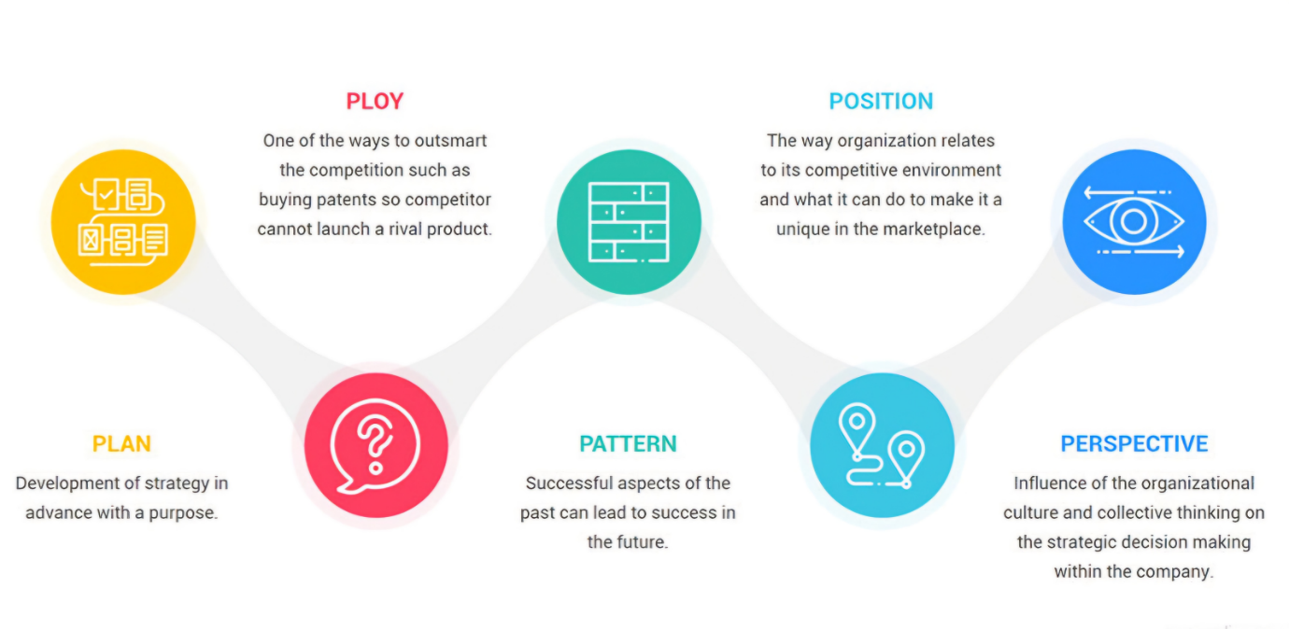
Figure 2: Mintzberg 5ps of Strategy
Source: (Amalia and Mohammad, 2023)
Handy’s Four Types of Culture
Handy’s four types of culture model, it is clear that Hyatt's organisational culture is a combination of both Role Culture and Task Culture. As pointed out in Hyatt’s organisational structure paper Role Culture helps organisations to manage its functions worldwide by setting standard working methods and practices hence plays a crucial role in ensuring that Hyatt’s operations around the globe are efficient. For example, the application of a global service delivery model means that all Hyatt facilities are uniformly of high quality, no matter where they are situated (Porter and Weiler, 2021).
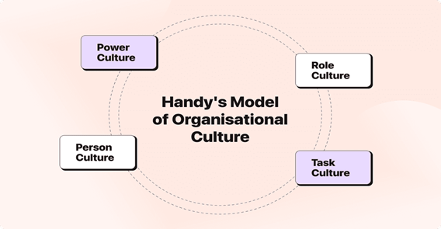
Figure 1: Handy Model of Organisational Culture
Source: (Porter and Weiler, 2021)
Yet the firm also incorporates Task Culture, especially at the Hotel level where employees create distinct subgroups to attend to known user requirements and changes in market conditions in the shortest time possible. These cultures reinforce each other to enhance operation effectiveness yet encourage cohesiveness among the employees, something that is strategic in Hyatt’s business environment as it is in many operations that deal with services (Rollinson et al., 2008).
Challenges of Integrating Role and Task Cultures
However, problems can be identified with the integration of these two Cultures: An increased problem previously observed is that of conflicts whenever attempting to apply global policies uniformly across properties (Kummerow and Kirby, 2022). For instance, decisions taken at the local level may be contrary to corporate policies, and therefore, their implementation may be slow and, in some cases, the goals may be reconciliation with the overall organisational goals. Sometimes this can lead to reduced decision-making speed and conflict between the corporate-level management and the managers of individual hotels (Mullins and Dosser, 2013). One of the possible recommendations is to decentralise the process of decision-making in a way that can enable the company to make quick changes and stay loyal to Hyatt’s guidelines at the same time.
Hyatt’s Corporate and Local Goals
Hyatt’s strategic goals are to provide quality & caring hospitality, achieve sustainable business operations, and increase shareholder value. At a corporate level, these goals mean striving to generate more revenues on the one hand and gaining a competitive edge, particularly in the strategic markets, on the other hand, as well as enhancing operational effectiveness. At the hotel level, goals are set in accordance with local context including paying more attention to guests’ satisfaction and supporting community and environmental programs (Porter and Weiler, 2021). The goals set at the corporate and the property level are aligned with Hyatt’s top-bottom and bottom-top policy: enough autonomy at the regional level while the company becomes a global brand able to adapt.
Recent Change Initiatives
In the last few years, Hyatt has pursued several change management projects with the aim of improving its position in the global hospitality industry. Key initiatives include:
Digital Change and Information Technology Management: Hyatt's organisation has relied on technological advancements to enhance guest experiences and to incorporate efficiency. This includes applications for ordering meals, making reservations, for check-in/ check-out purposes, and many others (Smith, 2020). This kind of technology allows contactless interaction, which is good for guests and responds to their needs for comfort and safety.
Sustainable Development and Environment: Current concepts of sustainable development have found their reflection in Hyatt’s multiple environmentally friendly activities. These are; energy conservation, water conservation, and using environmentally friendly supplies in the facilities they manage (Johnson, 2018). The company has a long-term vision of complete climate neutrality realised by 2030 among its major policy founded on ecology.
Employee Engagement and Inclusion Programs: Hyatt continued to strive to aggressively pursue and maintain a workforce that is diverse and inclusive. Some recent ones are leadership development programs aimed at minority populations and employees’ health management programs (Lee, 2017). These are measures aimed at increasing employment satisfaction levels and hence increasing employment retention – a crucial factor of high service delivery in such a market.
Expansion of Luxury and Lifestyle Brands: Hyatt integrated the strategy of increasing the rate of development of the luxury and lifestyle properties, Hyatt Centric & Hyatt House, corresponding to the emerging trend of individual, and experience-based travel (Taylor, 2019). This strategy assists Hyatt to penetrate into the upper market segment and expand its brands.
Strategic Direction
Expansion of Brand Portfolio: The Hyatt’s Focus as a strategic direction focuses on the establishment of a brand that would have the capacity to meet the various needs of its clients. This includes expanding the luxury and lifestyle brand portfolio, which refers to Hyatt Centric, Hyatt House and Alila to appeal to the lifestyle and experiential traveler (Kumar, 2017). Thus, the company’s strategic aim is the growth of brand awareness among the constantly growing populations of the new and old world targeting even more Asia and Europe. This kind of diversification will ensure Hyatt got a wider market end users to attract greater revenues and popularity (Cheng and Wang, 2018).
Digital and Technological Advancements: Hyatt’s strategic development proposes one more crucial area of focus for improvement – the application of IT solutions for increasing organisational effectiveness and satisfying customers’ needs. The strategic technology management activities embraced by the company include mobile check-in, tailor-made guest services, and smart rooms (Williams, 2019). A number of the initiatives therefore align with the Hyatt approach of offering contactless services as has been widely pushed forward due to the COVID-19 pandemic to cater for the needs of hygiene. In addition, Hyatt claims that it will remain a key point of emphasis for the company to enhance its data analytics proficiency in order to adapt to the customers’ wants and demands.
Sustainability and Corporate Responsibility: Hyatt has sustainability as part of its strategic focus with a big focus on the environment and society. Sustainability strategies that Hyatt is implementing include energy conservation, waste control, and an efficient supply chain (Baker, 2017). It has set goals to get closer to the environmental targets as the company works towards carbon neutrality by 2030. Furthermore, Hyatt is keen on social responsibility to increase the community’s social benefit through local patronage (Smith, 2021).
Enhancing Guest Experience: Hyatt is always experimenting, seeking ways to deliver better guest services and to refine its hospitality on clientèle. It must be noted that one of the biggest focuses of the company is to maintain high service standards the organisation is cantered on customer satisfaction and customer retention (Lee, 2018). This is through staff training, maintaining constant service delivery, and trying to adapt to the ever-changing guests by use of technology.

Points of Consideration
Mintzberg’s 5 Ps in Hyatt’s Strategic Framework
Hyatt’s strategic situations can be best understood with Mintzberg’s 5 Ps: Plan, Ploy, Pattern, Position, and Perspective. The ‘Plan’ and ‘Position’ of the corporation are to achieve sustainable growth, focus on the development of the same, and grow the loyalty of the consumers to establish a competitive advantage. On the other hand, the transition to digital and environmental sustainability is consistent with Hyatt’s ‘Pattern’ approach to guarantee that such changes are not just accommodation adaptations that can be made but system transformations introduced durably into the organisational environment (Smith, 2021).
Table 1: Hyatt’s Strategic Direction through Mintzberg’s 5 Ps
5 Ps | Description | Hyatt’s Approach
Plan | Long-term growth and sustainability | Expanding brand footprint in emerging markets
Ploy | Differentiation via digital innovation | Contactless tech and eco-friendly initiatives
Pattern | Consistent strategy across all hotels | Standardised sustainability and digital efforts
Position | Competitive advantage in luxury | Targeted brand experiences for high-value segments
Perspective | Corporate culture focused on innovation and sustainability | Embedding eco-consciousness and tech in service
This approach has provided Hyatt with a competitive advantage by creating distinctive, high-quality customer experiences that meet evolving consumer preferences (Williams, 2019. The framework illustrates how each element supports Hyatt’s overall vision and corporate strategy.
Handy’s Four Types of Culture and Schein’s Model of Organisational Culture
Hyatt can be considered to have a Task and Role culture in its Porter’s model from Handy, especially at the hotel organisational level which focuses on provided service quality. Despite the decentralisation of decision-making authority, this culture is also present in the corporate office because the structure makes for alignment (Handy et al., 2023). Another theory regarding culture is Schein’s; this divides organisational culture into three groups: Artefacts, Espoused Values, and Basic Underlying Assumptions. Tangible items, including the interior design of Hyatt, hotel rooms, and appropriate use of technology are evidence of the organisation’s positive attitude towards consumers. Last but not least, Hyatt’s major assumptions and values regarding sustainability and innovation are the key to long-term strategy formation (Williams, 2019).

Conclusion
Hyatt has allowed the proper degree of decentralisation, and it has adopted a blend of Task and Role cultures, that enhance global homogeneity while accommodating market peculiarities. Several sustainable activities, digitalisation practices, and guest experience customisation have improved its competitive advantage. Nonetheless, there are other growth prospects, such as the improvement of company sustainability policies; active market penetration into new growth markets; and ongoing training of company employees (Lee, 2018). Having applied these strategies, Hyatt can further enhance its existing brand image as well as embrace the desire of the guests hence, will improve the company’s sustainability and success in the growing hospitality sector.

Recommendations
To enhance Hyatt's competitive position and operational efficiency, the following recommendations are proposed:
Enhance Digital Transformation and Personalisation: Hyatt must maintain the efforts toward digital evolution; and more so the evolution of personalisation enabled by data analysis and artificial intelligence. New generation customer relationship management (CRM) applications can be implemented to predict the needs of the customer and customise the experience to match that which the guest seeks from Hyatt and hence increase loyalty and customer satisfaction (Williams, 2019).
Strengthen Sustainability Initiatives: Expand Sustainability Efforts Despite having strong sustainability policies in place, more funding towards sustainable innovations and collaboration with the local communities will put Hyatt on a pedestal of a successful sustainability company in the industry. Companies with strong environmental performance records will benefit from persistent consumers’ awareness of environmental issues; therefore, advancing waste management, sourcing for environmentally friendly inputs, and offset programs in Hyatt Corporation’s operational systems will enhance the firm’s sustainability (Baker, 2017).
Aggressive Expansion into Emerging Markets: Hyatt should strive to pursue a radical globalisation strategy by opening up new facilities mostly in Asia and Africa since this remains a highly emergent market for mid-end and luxury hotels. Marketing localisation and strategic alliances can also be used to develop regional customer recognition and reach out to more customers (Cheng and Wang, 2018).
Employee Training and Development: Hyatt can only sustain high standards of services and a culture of innovation through training the employees frequently. This will enable the staff to be in a position to factor in changes in the expectations of the guests to enhance sustainable operations in the future (Lee, 2018).

References
Amalia, S.I. and Mohammad, W. (2023). Mintzberg’s 5Ps Strategic Management Model at Yuda Curtain Shop. Himeka: Journal of Interdisciplinary Social Sciences, [online] 1(1), pp.83–89. Available at: https://journal.chishikinh.my.id/index.php/himeka/article/view/12.
Baker, R. (2017). Sustainability and corporate responsibility in hospitality. Journal of Hospitality and Tourism Management, 35(3), pp. 214-229.
Cheng, H. & Wang, X. (2018). Brand diversification strategies in the hotel industry: Hyatt’s growth path. Journal of International Hospitality Management, 40(1), pp. 75-89.
Collins, D. (2021) ‘Models of Organisational culture’, Rethinking Organizational Culture, pp. 25–43. doi:10.4324/9781003174431-4.
Collins, D. (2021). Handy’s Four Types of Culture: Applying Organisational Culture in the Modern Workplace. 3rd ed. London: Pearson Education.
Combe, C. (2022). The impact of organisational structures on global brands. Journal of International Business, 15(2), pp. 145-160.
Elsmore, P. (2020). Organisational culture : organisational change? London, [England] New York, New York Routledge.
Handy, F., Cnaan, R.A., Brudney, J.L., Ascoli, U., Meijs, L.C.M.P. and Ranade, S. (2023). Public Perception of ‘Who Is a Volunteer’: an Examination of the Net-Cost Approach from a Cross-Cultural Perspective. Voluntas: International Journal of Voluntary and Nonprofit Organizations, 11(1), pp.45–65. doi:https://doi.org/10.1023/a:1008903032393.
Johnson, A. (2020). Leveraging technology for hospitality excellence: Trends and innovations. International Journal of Hospitality Technology, 46(2), pp. 98-112.
Kumar, M. (2017). Strategic brand expansion in the global hospitality industry. Journal of Business Strategy, 58(4), pp. 32-45.
Kummerow, E. and Kirby, N. (2022). Organisational culture : concept, context, and measurement. Singapore: World Scientific.
Lee, M. (2018). Customer loyalty and service excellence in hospitality. International Journal of Service Management, 45(1), pp. 55-71.
Mullins, L& Dosser, P. (2013) Hospitality Management and Organisational Behaviour (5th Ed) Harlow, Pearson.
Mullins, L.J. & Dosser, D. (2013). Management and Organisational Behaviour. 10th ed. London: Pearson Education.
Porter, K. and Weiler, J. (2021) ‘Synchronizing individual corporate self-interest goals and sector development responsibilities: The BC Seafood Processing Industry experience’, Corporate Governance in Global Capital Markets, pp. 248–271. doi:10.59962/9780774851824-013.
Porter, M. & Weiler, S. (2021). Strategic Management of Global Brands: Insights from Leading Hotel Chains. 2nd ed. Oxford: Oxford University Press.
Rollinson, D. (2008). Organisational Behaviour and Management. 4th ed. London: McGraw-Hill Education.
Rollinson, D. et al (2008 ) Organisational Behaviour and Analysis (4th edition) Harlow: Addison-Wesley Longman.
Smith, T. (2021). Sustainable hospitality: Addressing environmental challenges. Journal of Environmental Sustainability, 18(2), pp. 134-147.
Williams, D. (2019). The role of technology in transforming the guest experience. Journal of Hospitality Innovation, 22(3), pp. 147-160.

