Leading and Managing Projects

Project Initiation Document

STUDENT NAME: Huizhi Zeng
STUDENT NUMBER: 1904106
CONTENTS
Executive summary 3
1. Project Description with Business Case 3
1.1 Aims and objectives 3
1.2 Rationale 4
1.3 Resources 6
1.4 Possible Constraints 7
2. Environmental Analysis 8
2.1 SWOT Analysis 8
2.2 Stakeholder Analysis 9
3. Operational Requirement 11
3.1 List of required resources 11
3.2 Project Task Schedule 12
4. Financial Projections 14
5. Recommendations＆Findings 17
Reference List 18

Executive summary
"Ordinary life needs a sense of ceremony"，based on this concept, our company has prepared "Graduation Time Capsules" online or offline for graduates, so that they can write their expectations or what they say to their loved ones into a letter and put them in a capsule or save it in the "Time Capsules" app, get their own special "Time Password". Then receive this letter or email within a week or three years later. The first event of this project will be held in conjunction with the Student Union at UWTSD.
The proposal of the project takes into account some feasible case studies, and discusses the opportunities and challenges that the project may face through SWOT and Stakeholder analysis. Then list the resources needed for the project, including people, facilities, time, and funding. Based on the above analysis, the conclusion is that the project can be propagandized and surveyed for the number of people who may participate in some schools. The research is based on literature review, market feasibility survey, questionnaire, and case studies.

1. Project Description with Business Case

1.1 Aims and objectives
The purpose of this project is to introduce the "Time Capsule" project into the graduation ceremonies of various universities in the UK, and encourage graduates to use the "Time Capsule" to record the important moment of life in graduation, making graduation more ritual. The company will plan and organize the first reunion after graduation for graduates who buy online or offline "time capsules" and participate in activities. Project goals are what the project organization expects to deliver at the end of the project (wit,1988).The goal of this project are：
- Evaluate：Analyze the data on various universities in the UK, including the number of graduates and the time of the school's graduation ceremony, and statistics about the graduates' willingness to meet for the first time after graduation.
- Recommend the “Time Capsule” project to more students who have graduated from university and get them involved before June of each year. Reached a 10% increase in the number of participants per year within three years.
- Make sure that personal information such as address and email left by graduates are sorted online and offline and archived in a database From June to September each year.
- The company's turnover in the first year reached 90,000 pounds, and with the expenditure of publicity expenses, the annual turnover increased by at least 7%.

1.2 Rationale
The Sense of Ritual in Life
Anthropologist Victor Turner (1967) originally defined ritual as a “prescribed formal behavior for occasions not given over to technological routine, having reference to beliefs in mystical beings or powers”(Cheal, 1988).Conducted by the Time Post Joint Social Survey Center for 2001 people showed that 79.8% of the respondents said that the sense of ritual in life is important for growth, of which 18.3% thought it was very important and 15.9% of the respondents The interviewer said it was not important(Giovagnoli,2018).
The Oxford Headington campus once hosted the University time capsule event, which introduces Year 5 students to higher education and shows what it is like to be a student at university. The event required students to write down what they might want to study at university and do as a career on a 'Time Capsule Card' and put it in the capsule, the school principal keeps these "time capsules" and distributes them to students after they graduate(Giovagnoli,2018). This activity at The Oxford Headington campus has achieved a good response among students and has also provided guidance for students' career planning. It can be seen that expected planning and expectations can play a very important role in a person's growth(Viere,2001).
The introduction of the "Time Capsule" activity into the graduation ceremony in the project is also to make graduation an important event in life more ritualistic, and to cater to the concept of contemporary youth.
The Slow Delivery
"Combining the concept of time capsule and traditional letters, slow delivery is a service that sends a letter to a designated person at some time in the future(Wang,2017). " There are business cases for gaining profits through "Time Capsules". Panda Slow Delivery, the first of its kind worldwide, is from 2009, based in Beijing’s buzzing art hub the 798 district. Panda Slow Delivery resembles a normal post office but the letters sent here can take up to a year, even decades, to reach the addressees and the senders choose their own delivery date(Wang,2017). The charge for "Panda Slow Delivery Post Office" to help customers save letters is like this, it is 10 pounds a year, and each additional year costs 1 pound. So far, almost 10,000 letters have been commissioned to be mailed in this slow post office(Chen,2016).Therefore, the same model may be feasible in the UK.
In the market survey questionnaire designed according to this project, 60% of the students who participated in the survey expressed interest in this project because they thought the activity would make the graduation ceremony fun and maintain the relationship between students after graduation. Secondly, they really need to seriously consider their career plans when they graduate, and this project is a good opportunity. However, some students do not think this is necessary, because they are more willing to be based on the present, rather than spend a lot of time thinking about the future, which is contrary to the situation of Chinese students, Chinese students are more willing to make plans for future life (Wang,2017).
Contemporary youth are paying more and more attention to ritual sense(Giovagnoli,2018). In general, according to market research, as the majority of students support the inclusion of the "Graduation Time Capsule" activity in the graduation ceremony process, this activity is feasible, and it is possible to try the first activity at the graduation ceremony of UWTSD.

1.3 Resources
Resources in project operations include a stock or supply of money, materials, staff, and other assets that can be drawn on by a person or organization in order to function effectively(Fuller,2017).Resource allocation on a project planning network is modelled as a minimax convex program. A limited budget is to be distributed over the activities of a project so as to minimize the duration of the project or critical path(Scott,1995).
The project of "Graduation Time Capsule" is divided into online and offline. The most needed resource in offline activities is a "capsule". During the process of demanding potential cooperation companies, I found The Original Time Capsule Company started operating the "Time Capsule" retail business very early. The Original Time Capsule Company is a retail company selling "time capsules" in the United States, found in 1992 by jeff mccarty, officially started selling "DIY TIME CAPSULE" products in 2005. Currently it mainly sells "BABY TIME CAPSULE" and "WEDDING TIME CAPSULE" series products (The Original Time Capsule Company sustainability report, 2016). So the company can help students buy the required number of capsules from this company. If the quantity is large, they can buy it at a lower retail price.
In the online activities, my plan in the project is that graduates can write what they want to say or letters in a file, and then upload it to the "Time Capsule" app. In the process of seeking potential cooperation companies, I found that there is an application in the IOS system called "Time Capsule". Download this and you can send a letter in the form of an email on a certain day in the future, and able to insert treasured photos, such as graduation photos. But this app is not free. Downloading this app requires paying 99p in the Apple Store and the same user after payment can use the app indefinitely.
The student union can play a important role in project operation. Because this project can strengthen the cohesion of students and encourage students to plan after graduation, these can improve the student experience in the university, the project is able to work in conjunction with the student union and utilise their resours.

1.4 Possible Constraints
An industry from appearing to being recognized by the market need a natural process, so that the emergence of new industry will make potential customers have a lot of worries and concerns(Chen,2016). The potential constraints in the project are as follows.
Potential cooperation failure —Companies that plan to collaborate are The Original Time Capsule Company. The Original Time Capsule Company has a better profitability on the current retail "Baby Time Capsule" and "Marriage Time Capsule" products. It needs sufficient persuasiveness to cooperate in developing "Graduation Time Capsules", but the current market survey only Limited to universities hosting events for the first time, and thus may face cooperation failure. Once the cooperation fails, it can only be purchased at low prices through promotional activities, such as buying capsules during boxing day.
Lack of funding — The source of funding for the project is mainly through collecting fees from those students who want to participate in the "Time Capsule" activities, and then purchase the "capsules" from the company uniformly and hand them over to the Student Union for distribution. When the number of students participating in the event is sufficient, the company can buy Time Capsules at a relatively low retail price and make a profit from it to pay the staff responsible for the project. Once there are fewer students participating in the event, company cannot pay for project promotion costs，then the company will face insufficient funding and it will be difficult to run the project.
Potentially unsuccessful business start — Because many students have little knowledge about the “Time Capsule” activity, if the promotion is not done well, it will directly lead to a small number of people participating in the activity. If there are not enough people to participate in the first activity at UWTSD, then other Promotion of university activities is also difficult to achieve. As a result, the company will face the risk of potential project startup failure.

2. Environmental Analysis

2.1 SWOT Analysis
Griffin (2004) says that the strengths of an organization are the advantages or skills that enable the company to carry out its own strategies. A SWOT analysis revealed that the project has several strengths. The first is that the project focuses on graduates and can provide better services to graduates in cooperation with schools. Secondly, it is more attractive to attract graduates to participate in the "Time Capsule" event by organizing the first reunion for graduates after graduation. Then, Researchers have started to study methods of preserving digital data in forms that will still be usable in the distant future ( Petrelli,2013) .So, online “time capsule” activities can save costs and maintain user loyalty to the project through social media.
The weaknesses of a firm are the skills that make the firm fail to carry out and choose its own strategies to fulfill the mission (Griffin,2004). The SWOT analysis also revealed that the project has several weaknesses. Firstly, preserving students' "Time Capsules" requires a certain amount of space, and these spaces will be occupied for a long time. Therefore, obtaining this storage space is a big problem. Secondly, students set their own mail collection time within three or five years. If their address and contact information change, they may not be able to contact them and send them a "Time Capsule".
Opportunities mainly lie in cooperation with companies and some UK schools. According to the survey, there is currently no company specializing in the "Graduation Time Capsule" project. This project has great market potential and development space. In addition, in cooperation with The Original Time Capsule Company, it can obtain capsule purchase channels.
The threat is mainly due to lack of funds. Without funds to start, staff cannot be hired and raw materials purchased, and projects cannot be carried out. Another threat is that the level of recognition for this activity is not high, and market feasibility still needs further research. According to the questionnaire survey, only 60% of the students support the "Time Capsule" activity at the graduation ceremony and are willing to participate in the activity. It also shows that the project has not been accepted by most students. If the project does not have a large commercial market, it may not be able to run the project.

2.2 Stakeholder Analysis
Today almost every project takes place in a context where stakeholders play a major role in the accomplishment of the tasks. Projects are often sensitive to actions and decisions taken by stakeholders. Project stakeholders can include customers, unions, industry organizations, public institutions, financial institutions, control organizations, media, third parties, and competitors(Karlsen,2002). Stakeholder identification, management and engagement are recognized as key project management skills; however, this is a soft skill that requires both intuition and a strong capacity for analysis(Atkin,2008). In this project, the following stakeholders are involved in the project:
1) For graduates. The graduated students write their expectations for the future into a letter and put them in capsules. When students open these letters, they can recall a lot of things and compare their current situation. Increased stakeholder engagement can help manage their expectations, reduce unforeseen risks, unleash positive energy or reduce negative actions or reactions that could potentially impact project success(Karlsen,2002). In this project, the participation of graduates is crucial.
2) For partner universities. Stakeholders can be divided into internal and external (Gibson, 2000), internal stakeholders being those directly involved in an organization's decision‐making process (e.g. owners, customers, suppliers, employees) and external stakeholders being those affected by the organization's activities in a significant way (e.g. local universities). As the written content can be used as a promise, it also has a certain stimulating effect on the future development of students. Schools can also increase visibility in collaborations.
3) The Time Capsule app. This app can send a letter in the form of an email on a certain day in the future specified by the user, and can also be accompanied by a photo and the like. It should be available on the Apple Store iOS system, with an average monthly download volume of 10,000 times (The Original Time Capsule Company sustainability report, 2016). This app can meet the content storage and delivery needs of the project online. It is learned that the app is priced at 99 pence and started a three-month free download and use campaign on September 28, 2019. Therefore, I think that the company can discuss cooperation with the "Time Capsule" app. Our company will open up the graduate market for this app, and this app provides our company with free downloads and practical app places, and supports graduates in Class groups are built in the "Graduation Wish Wall" section.
4) The Original Time Capsule Company. A time capsule is a historic cache of goods or information, usually intended as a deliberate method of communication with future people, and to help future archaeologists, anthropologists, or historians (Guzman,2015). The company's aim is to provide words or items that can be reserved for each important stage of life. It mainly sells "Baby Time Capsules" and "Wedding Time Capsules" to record the mood of the child's birth and marriage, and the annual sales amount. It's around $ 500,000. Although the company sells "DIY graduation time capsules", it is not popular as a new product. Therefore, through the cooperation between our company and schools, it may have great market prospects.
Stakeholder management has emerged as an important function in projects, particularly with the current focus on sustainability in project delivery and use as noted above(Atkin,2008).The recognition and support of this activity by the graduates and their schools will directly determine whether there is market demand for the products launched in the project. In addition, the company intends to cooperate with The Original Time Capsule Company in offline activities and The Time Capsule app in online activities. If the company can reach cooperation, it will bring great benefits to the sustainable development of the project.

3. Operational Requirement
Projects that belong to different categories have different characteristics and life cycles and require different management approaches(Archibald,2016). Traditional project management methods are suitable for managing well-structured projects in a project environment with clear requirements and project scope. This approach accepts actions that can be foreseen to affect the project and makes good assumptions about tools, techniques, and actions. Royce (1987) defined the traditional approach, that was later named “Waterfall” by Bell and Thayer(Bell,1976). This approach includes managing a sequential, non-repeatable series of phases, where the phases in the life cycle follows one another.
Traditional methods have both advantages and limitations. These advantages are reflected in the importance of having a well-structured set of project lifecycle phases and clear requirements(Petrovic,2017). The traditional approach is suitable for well-managed projects with clear needs and project scope in the project environment (Keegan, 2001). However, stakeholders cannot always specify all requirements at the beginning of a project, and can expect changes throughout the project life cycle.
This Project Initiation Document will be based on a Deductive method. The deductive method is an approach to reasoning that is based on deduction, or starting from a general case and, from that general case, drawing a conclusion about something more specific(Gardiner,2005). Some elements of the project will be researched using induction, so that the research results collected during the project will be used to express new theories and assumptions(Müller,2014). For example, using a questionnaire to obtain data on the number of people who want to participate in this project, and then use it to develop a more efficient project strategy.

3.1 List of required resources
The project management organizations would need to muster and allocate resources to build up capabilities to improve the way relationships are managed with greater consistency on projects and across them without harming stakeholder interests(Atkin,2008) .The first activity of this project was carried out at UWTSD, the purpose is to test the feasibility of the project for later promotion.
- People: The project requires 4 people to form a department to provide services to graduates each year, publicize the project, and encourage students to participate in the "Time Capsule" project.
- Time: As the graduates graduate in June each year, the campaign will start in January of each year and will end in September of each year.
- Place: A garage or office is needed in the project as a space for storing letters. This place must be moisture-proof and cannot be easily accessed by non-project personnel due to the privacy of the letters.
- Cash: Advocates need to charge students for funds to participate in the event to promote the "Time Capsule" project. They need to buy uniform capsules to store letters, pay project staff salaries to maintain the project and pay for courier for letters.
- Technology: project management is a complex team-based activity where various types of technologies are an inherent part of the project management process(Fuller,2017).The project requires the classification of electronic files, record the time required for express delivery by each student, and send letters on time. Master the technology to develop and maintain the online operation of the "Time Capsules" App.
- Data: Detailed address and contact information for each graduate student participating in the event, annual statistics on the number of graduates from various universities in the UK, and the number of people who eventually get a "Time Capsules".

3.2 Project Task Schedule
The project uses schedules for time management in the project. Timetable is a way to manage time. It is a form to clearly record and indicate the clear tasks in a certain period of time. It is a reminder to users and related people to act in accordance with the schedule and effectively manage time and guarantee Simple way to accomplish the task. Compared to Gantt charts, timetables provide more accurate time period data. In addition, users can also update task progress directly in the schedule(Petrovic,2017). Therefore, a monthly schedule is used for project management in this project.
Project Task Schedule
Time | Task
January  （Market survey period） | ·Design a questionnaire on graduates' perceptions and acceptance of the "Time Capsule".  ·Issue questionnaires to UWTSD graduates to count how many people want to participate in offline and online activities
February  (Offline partner negotiation period) | ·Negotiate specific events with UWTSD student union.  ·Negotiate with The Original Time Capsule Company.  ·Co-developed the "Graduation Time Capsule" product with The Original Time Capsule Company and engraved the school name on the capsule.  ·Reached an agreement with an offline partner company to try to buy "Graduation Time" capsules in large quantities at a lower retail price.
March  (Online partner negotiation period) | ·Negotiate cooperation with the "Time Capsule" app.  ·Obtain a certain amount of free trial papers. When the number of people participating in offline activities in a class exceeds half of the total number of class members, all graduates in this class will be eligible to download the app for free.
April  (Promotion period) | ·Post event information (such as instagram, facebook, twitter, etc.) on social networking sites.  ·Placing print ads in schools.
May  (Material preparation) | ·The purchased "Time Capsules" will be stored in a unified place and handed over to the student union for distribution to participating graduates during the event.  ·Collect the free trial papers of the "Time Capsule" app and count which classes can get these free trial places.
June  (Activity starts) | ·Arrange department staff to organize events.  ·Charge the time capsule for offline storage. The longer the time, the more expensive the fee (1 pounds a week, 5 pounds a year, five pounds for each additional year).  ·Online "Time Capsule" APP participation fee is uniformly £ 1.
July  (Customer Information Statistics) | ·Establish a database to organize information.  ·Count the class information and organize the student information of the same class into a file to facilitate the planning of class gatherings in the future.
August ＆  September  (Activity ends) | ·Collect experience feedback from participating graduates.  ·Calculate the revenue and expenditure of the "Time Capsule" app online, compared with the revenue and expenditure of offline Store and mail. And make an event plan for the second year.

4. Financial Projections
Chapman and Ward explore the impact of risk and uncertainty management methods on contracting methods. A key function is to use a balanced incentive and risk sharing (BIARS) framework to consider all specific forms of contract options, such as fixed price, design, construction, finance, and operations (DBFO). In BIARS, "balance" means aligning the goals of clients and contractors (Atkin,2008). In order to identify when the project will break even on costs, The project needs to know the following specific data in advance.
1) About the number of participants. According to official website data, there are currently 11,320 students at University of Wales Trinity Saint David including 9,280 undergraduate students and 2040 graduate and doctoral students. The school has about 10,000 graduates each year, and it is estimated that about 6,000 people will participate in the "Time Capsule" event.
2) About sales price. Questionnaire indicated that Students are willing to spend £ 2 to £ 5 to participate in the "Time Capsule" project online. For offline activities, 60% of graduates are willing to participate when the amount does not exceed £ 20.
3) Retail quotes from offline partner companies. The Original Time Capsule Company sells Time Capsules for $ 20, or about £ 15 each. In discount seasons such as boxing day, the retail price of online stores will be 40% off, which is about 10 pounds per "capsule".
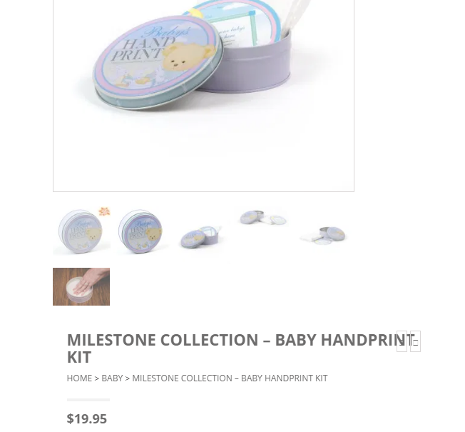
(The Original Time Capsule Company retail price)

4) Retail quotes from offline partner companies. The "Time Capsule" app is available for download in the Apple Store iOS system and costs 99 pence. Some special "Remembrance Day Capsules" in it cost extra and sell for 1 to 3 pounds.
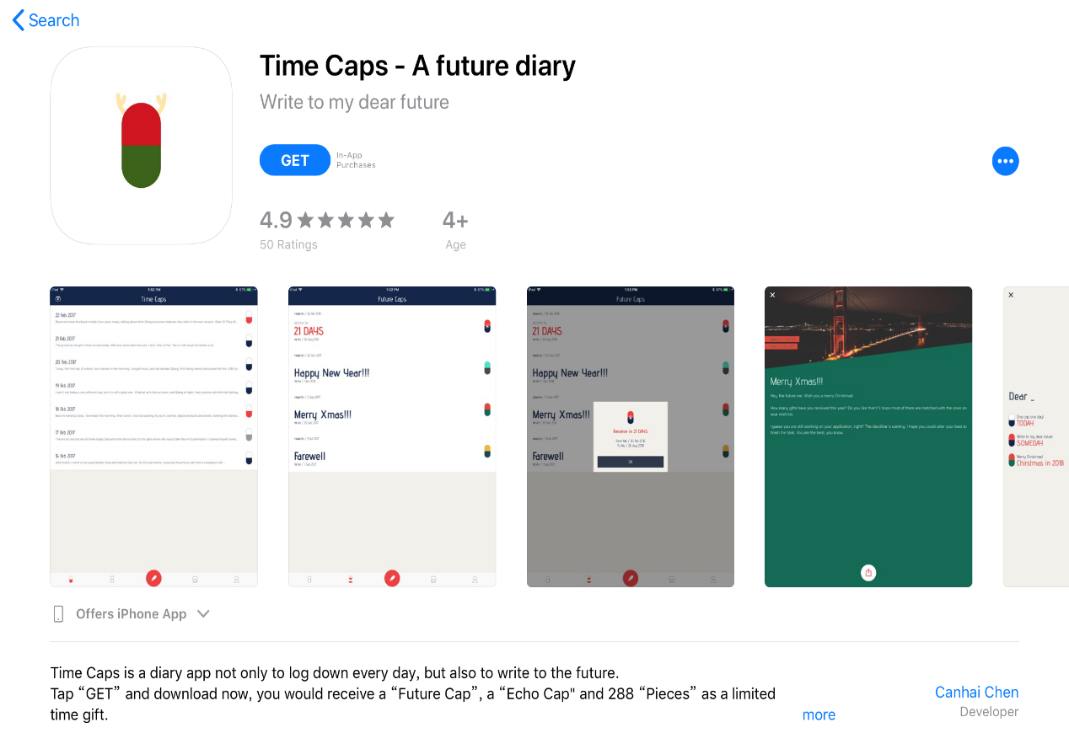
("Time Capsule" app download interface)
5) Advertising costs for social media. Researchers collected relevant data from 15 different sources to compare how much the average cost of posting an ad on different social platforms (Facebook, Instagram, Twitter, and LinkedIn) was. On Facebook, most advertising costs are measured in terms of clicks (CPC) or impressions (CPM). Most advertising campaigns that target user traffic are usually billed based on clicks, while marketing campaigns that target brand awareness are usually billed based on impressions(Kasemsap,2017).
If our company want the project to reach 50,000 impressions on a certain social media, using Facebook as an example, the media cost per 1,000 impressions is $ 9 (approximately £ 7). The cost of advertising on Facebook during the project promotion period is 350 pounds. If I want to run on instagram, facebook, twitter three social media platforms at the same time, the advertising budget is about 700 pounds.
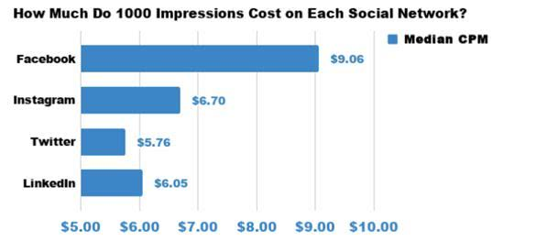
(CPM on social networks)

Project Process | Required resources | Costs
Market survey period | Personnel issuing and collecting questionnaires (4 persons) | Budget £40
Promotion period | Post event information (such as instagram, facebook, twitter, etc.) on social networking sites | Budget £700
Material preparation | Purchase of 6000 "Time Capsules" from The Original Time Capsule Company | Budget £60,000  (£10 each)
Offline activity costs | Store and mail "Time Capsules" | Budget £1,000  For slow delivery  (£10 each)
Activity ends | Collect experience feedback from participating graduates  (4 persons) | Budget £40  Total expenses:  £61,780

Project Process | Profitable point | Projected income
During the activity | Charge 6,000 students who participated in offline "Time Capsule" activities to purchase Time Capsules | Budget £90,000  (£15 each)
During the activity | 10% of graduates expressed willingness to pay for offline storage of "Time Capsules" | Budget £15,000  (£5 per year, £5 per additional year, up to 3 years of storage)
During the activity | Charges for downloading and using the online "Time Capsule" app | Budget £2,000  (£1 each)  Estimated income: £ 107,000

Fully integrating contract selection decisions with other aspects of best practice methods for risk and uncertainty management is feasible and beneficial, and a logical next step in the evolution of best practices (Atkin, 2008). Therefore, the above financial plan combines the process of project implementation, and estimates expenditures and benefits in each step of the process, which can more accurately reach the balance of payments. Considering the salary of the person in charge of the activity and the cost of advertising, when the number of participants reached 1,000, the project started to be profitable. The larger the number of people, the more profitable the project will be.

5. Recommendations＆Findings
The success of the project management is measurable from the project start to the project closure, because it is important whether the objectives are met in terms of time, budget and quality, while the project success is focused on long-term effects and results that are related to stakeholder satisfaction. (Archibald,2016). The scope of the project is set in UWTSD to test the feasibility of the project in universities. According to the data obtained from the project planning and questionnaire survey, we can find that this project is feasible in UWTSD.
However, both in the project and in the business environment, increased uncertainty and complexity make project management difficult and complex (Petrovic,2017). For the success of project management, it is important to choose a method based on the characteristics of the project and its life cycle, while taking into account the special nature of the environment. Slow delivery business has a large market in China, which is based on China's unique cultural environment. In the UK, it takes a long time for slow delivery to become widely accepted among British students.

Reference List
Archibald, R. D., & Archibald, S. (2016). Leading and Managing Innovation: What Every Executive Team Must Know about Project, Program, and Portfolio Management. Auerbach Publications.
Atkin, B., & Skitmore, M. (2008). Stakeholder management in construction. Construction Management and Economics, 26(6), 549-552.
Bell, T.E. and Thayer, T.A., 1976, October. Software requirements: Are they really a problem?. In Proceedings of the 2nd international conference on Software engineering (pp. 61-68). IEEE Computer Society Press.
Boyle, G. (2017). Design project management. Routledge.
Cheal, D. (1988). The ritualization of family ties. American Behavioral Scientist, 31(6), 632-643.
Chen, W. (2016, January). Competitive analysis of Mandy industry in China. In 2016 2nd International Conference on Education Technology, Management and Humanities Science. Atlantis Press.
Chen, S.M. (2014). Introduction analysis of the feasibility and prospects of slow delivery. Industrial Economy (in China), 303.
Duhigg, C. (2013). The Power of Habit: Why we do what we do and how to change. Random House.
Fuller, M. A., Valacich, J. S., George, J. F., & Schneider, C. (2017). Information Systems Project Management: A Process and Team Approach, Edition 1.1. Prospect Press.
Gardiner, P. (2005). Project management : A strategic planning approach. Basingstoke: Palgrave Macmillan
Giovagnoli, R. (2018, June). Rituals as “Social Habits”. In Handbook of the 6th World Congress and School on Universal Logic (p. 217).
Griffin(2004),Management, Boston: Houghton Miffin co,2004, Chapter5,p142
Guzman, M., Hein, A. M., & Welch, C. (2015, October). Eternal memory: long-duration storage concepts for space.
Johansson, J. K. (2003). Global marketing. McGraw Hill.
Kasemsap, K. (2017). The role of social media in international advertising. In Advertising and Branding: Concepts, Methodologies, Tools, and Applications (pp. 804-831). IGI Global.
Karlsen, J. T. (2002). Project stakeholder management. Engineering Management Journal, 14(4), 19-24.
Keegan, A. and Turner, J.R., 2001. Quantity versus quality in project-based learning practices. Management learning, 32(1), pp.77-98.
Kerzner, H. (2017). Project management: a systems approach to planning, scheduling, and controlling. John Wiley & Sons.
McNeil, A. J., Frey, R., & Embrechts, P. (2015). Quantitative Risk Management: Concepts, Techniques and Tools-revised edition. Princeton university press.
Newton, R. (2016). Project management step by step: how to plan and manage a highly successful project. Pearson UK.
Müller, R., Rolstadås, A., Tommelein, I., Schiefloe, P. M., & Ballard, G. (2014). Understanding project success through analysis of project management approach. International journal of managing projects in business.
Petrelli, D. (2013). There is more in personal heritage than data. interactions, 20(3), 16-19.
Royce, W.W., 1987, March. Managing the development of large software systems: concepts and techniques. In Proceedings of the 9th international conference on Software Engineering (pp. 328-338). IEEE Computer Society Press.
Scheff, T. J. (1979). Catharsis in healing, ritual, and drama. Univ of California Press.
Scott, C. H., & Jefferson, T. R. (1995). Allocation of resources in project management. International Journal of Systems Science, 26(2), 413-420.
Toljaga-Nikolic, D., Petrovic, D., & Mihic, M. (2017). How to choose the appropriate project management approach? 2017 12th International Scientific and Technical
Viere, G. M. (2001). Examining family rituals. The family journal, 9(3), 285-288.
Wang, J. (2017). FOOLISH MOON (Master's thesis).
Wysocki, R. K. (2011). Effective project management: traditional, agile, extreme. John Wiley & Sons.

