BA Foreign Languages & Cultural Awareness Business
Name: Elza Soares
Student Number: 1815430
Lecturer: Dr. Olu Adegbite
Module code: M5X01923

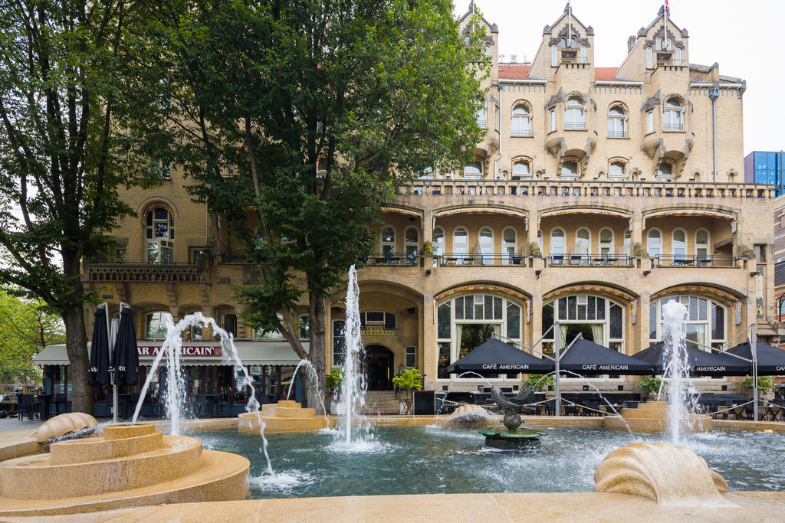
Introduction ………………………………………………………………………………………………. 1
Culture ---------------------------------------------------------------------------------------------2
Guest service -------------------------------------------------------------------------------------3
The cultures Characteristics of Guests from different Cultures and Nationalities
Describe the cultures and characteristics ------------------------------------------------4
Conclusion---------------------------------------------------------------------------------------- 5
References----------------------------------------------------------------------------------------6



Introduction

As hotel employee, it is essential to be part of the culture of your guest, the first impression that guest have is to provide excellent service.
Indeed, it can be said that negotiation is inherent to human beings. Negotiating for relationships, jobs, products and others theory of cultural dimensions. (Geer Hofstede)
There is a need to analyse what makes people from all over the world take leisure trips abroad and “what attributes of destination they most desire” can hardly be debated (Baloglu & Uysal, 1996; Muller, 1989, 1991; Mok & Armstrong, 1998; Reisinger & Turner, 1998; Sussmann & Raschovsky, 1997; You, O'Leary, Morrison & Hong, 2000). Nowadays and at the international level in business there is a lot of competition, tourism products must be designed, promoted and delivered, to meet the needs, expectations and interests of real and potential customers (Mattila, 2000; Middleton, 1994; Reid & Reid, 1997; Uysal and Hagan, 1993) Middleton (1994, p. 71) the more information you know about your customers
Their wants and needs, behaviors and attitudes will better be able to design and implement the marketing efforts necessary to stimulate their customers. in this way, customers can make a better decision when buying travel motivations and the search patterns of travellers’ attributes offer useful information on the understanding of their decision making (Uysal and Hagan, 1993). appropriate clientele for a specific destination country, given the physical and cultural limitations examining the differences in motivation for vacationing among travellers.

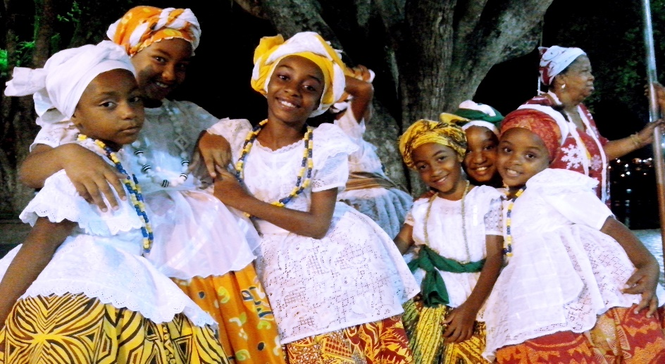

Culture
Culture and all knowledge, which we acquire through art, beliefs, law, morals, customs and all habits and skills, society and family are part of society. Each country is individual because it is influenced by its environment, believes in its own customs cultural complexity can be explicit and implicit for behaviors acquired and transmitted by symbols. The traditional is part of this essence considering as a unique product. (p. 357) (Kroeber and Kluckhohn, 1952)
It is a symbol of the nation itself, history indicating and telling its symbology, its past, developing its knowledge and attitudes towards life. (p.89) Clifford Geertz (1966).

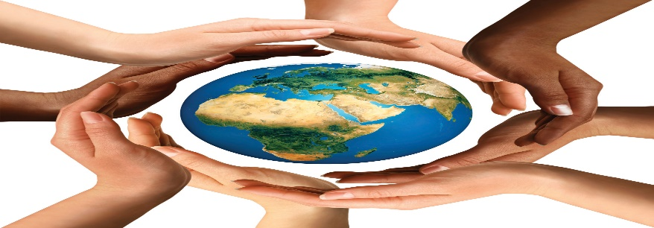

Guest service
To satisfy a customer it is necessary to bet on the quality of the service to obtain satisfaction from customers and their loyalty. (Bowen and Chen, 2001).
When receiving a reservation from foreign customers, it is important to do a brief survey about your place of origin and the main cultural traits that must be not be as maintained. Things that can be quite common here, like shaking hands or making eye contact, may welcome elsewhere. Try to find a middle ground to maximize the reception of these guests.

The cultures Characteristics of Guests from and Nationalities
Differences between cultures are often numerous and can be much less subtle than you thinking England, it is customary to have a barbecue and it may not be a good idea to suggest it to someone from Chinese culture.
Having Chinese customers on the 4th floor may seem like a common thing, right? The number 4, for them, is a symbol of bad luck; important to know and understand the main customs of customers, offering personalized services.
How to receive an Arab guest? What do you like to eat? How they should be treated, cultural, religious and social habits and customs. Muslims pray five times a day, even when they are abroad. It is very important to have an arrow in the rooms towards the Mecca, Koran, carpet and, in the month of Ramadan, to have flexible times for meals
Portuguese American and African guest a smile is essential to be friendly, playful and good-natured. the Asian, a slight smile, the Turks do not look in the eyes, smile and respect; Italian, smile and good humour,
Describe the cultures and characteristics


South Africa
what characterizes South Africa and its vast and mixed culture. They were colonized by the Inglese’s and the Dutch and their native and unique indigenous culture. (UC Press E-Books Collection, 1982-2004) formerly eScholarship Editions)
Racism and discrimination are still felt in this great country.
Due to explicit racism they are an intolerant people (Wikipedia)

LANGUAGES AND CULTURE
This country has two official languages ​​which are English and Afrikaner, and in addition to its 9 dialects, Zulu being the most spoken among the population.
It has a vast and unique cuisine derived from the various cultures existing in the country, over time it has been gaining influences from Oriental, French, Dutch and other flavors of many different external cultural influences. the variety of taste and texture with unique aromas continues to betray many people and they want to come back and delight themselves. UISINE OF SOUTH AFRICA. (South Africa.Explore. Experience. Stay)
Religion
The dominant religion and Christianity, according to Protestants being the largest denomination. and there are other non-Christians Islam, Hinduism, Judaism and Buddhism. 
How to greet
A South African label gently opens someone else's hand and waits until they release yours. The style of compliance can vary widely from region to region; in some cities there are very specific techniques associated with local traditions. (Ben1183/Thinkstock)
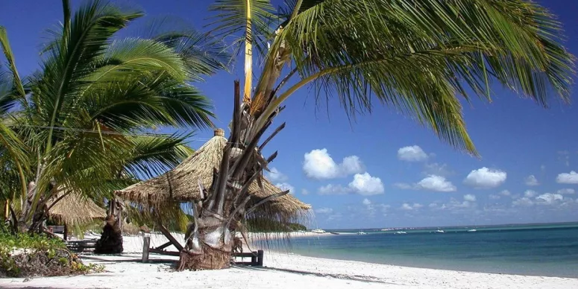
Mozambique
Mozambique has a great cultural diversity but speaking of Africa and normal, African countries have this in common a lot of cultural wealth which makes it difficult to define a unique identity without mentioning other countries.
Very musical society likes music, poetry, cinema.
They are peaceful and have a lot of respect when the eldest speaks, everyone is silent to listen to him and obey.
Loyalty and basic unity of the society's family greet yourself with 2 kisses on the cheek, and everyone greets each other on the street, always smiling.
languages
There are 43 languages, of which Macua, Tsonga (Shangaan), Sena, Lomwe, Chuwabu and Nianja stand out. Tsonga, for example, is spoken by the ethnic group of the same name, which is spread across Mozambique, South Africa, Zimbabwe and Swaziland. (Emerson Santiago)
Religion
As for religion, 50% follow traditional cults, 28% declare themselves Catholic and 20% Muslim.
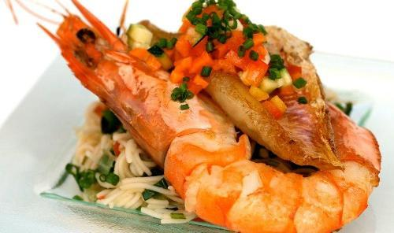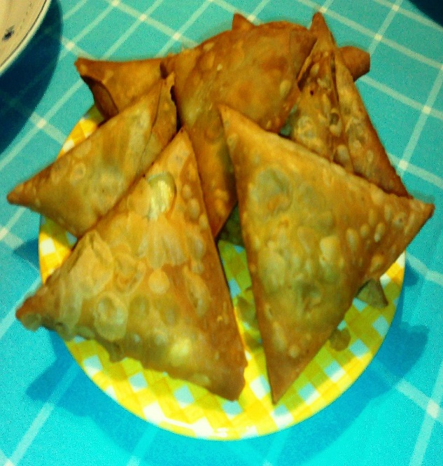Gastronomy

Fish and seafood, such as lobster, shrimp, mussels, are delicious and occupy a prominent place in Mozambican gastronomy. And then, there are the traditional spices of Indian food that make it delicious for many palates.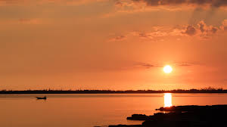
Cuba
It is a country where democracy does not exist, let alone freedom of expression, human rights. The government itself modified the law so that there were no gay marriages in the country.
Those who do not obey the laws of the country are in danger of being arrested, all international comic strips are controlled by the government itself. (antonio luiz fontela)
Religion
The Catholic religion, and atheism. (antonio luiz fontela)
Gastronomy
The cuisine is influenced, Spanish and African. (www.Viajar barato.com)


Nigeria
Nigeria is a hierarchical society. Being the oldest and having a great social status where the family before making any decision will consult you because they believe that age is equal to wisdom, there is a lot of respect for the older person. Being the oldest gives the right to be received and served first, in case of conflicts and in making the most important decisions they are consulted, and their decision is respected.
The most common greetings are a handshake, when a woman is expected to reach out first, it is also very important to ask about the person's general condition.
Looking down when you meet an older person and synonymous with respect, the titles have their importance both academic or honorary, if someone has that title it is worth mentioning so the person feels honoured.
Language
As they were colonized by the English, the official language became English It has over 250 individual tribal languages,
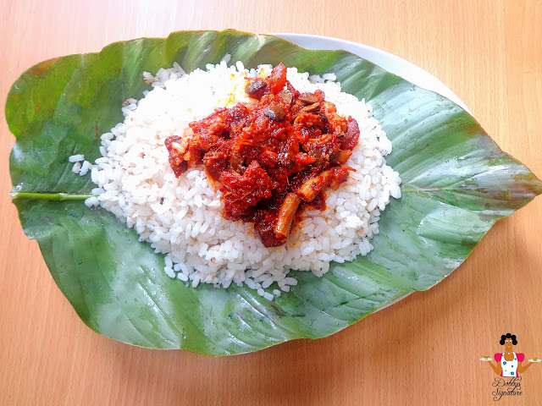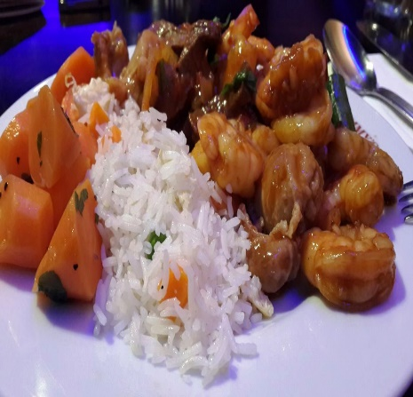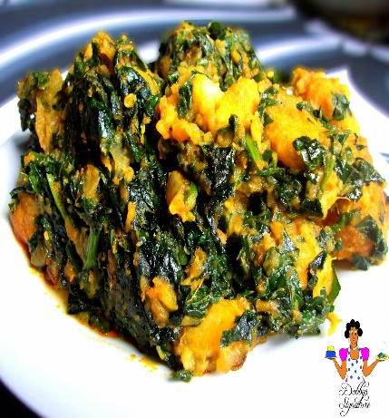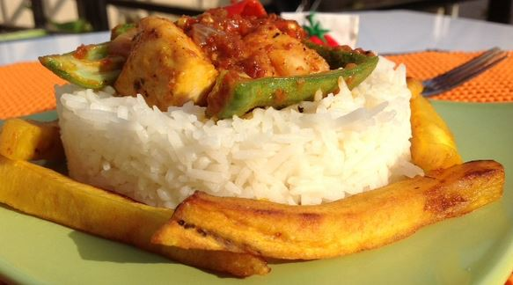Gastronomy
Gastronomy is known for its variety and richness, they use herbs from different origins that add flavors to food, palm oil in the creation of salads with an intense flavour. spicy that can be made with fish or goat meat. info@commisceo-global.com)
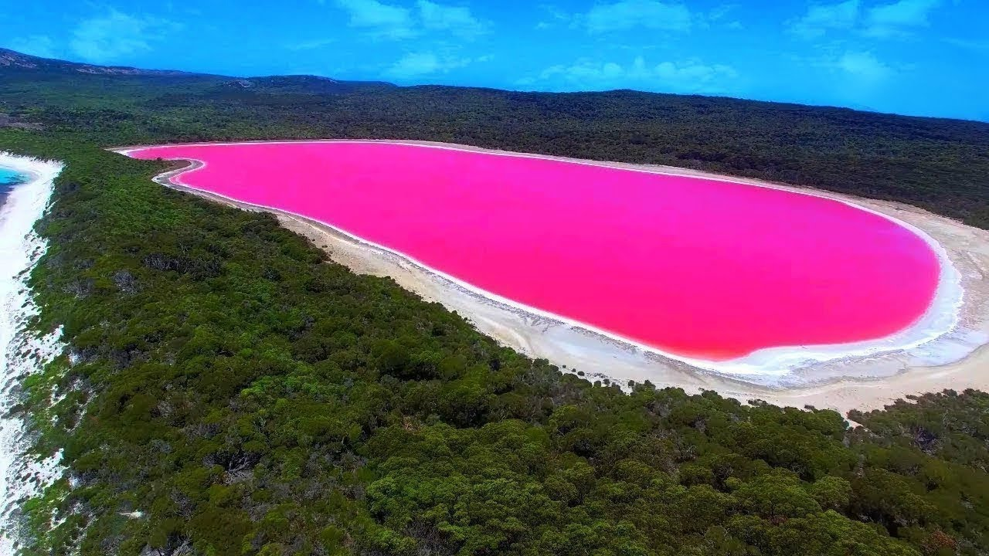
Australia
The Australian people prefer modernism, they appreciate humility and a sense of humour.
they do not feel the need to say their academic titles and do not like whoever do it, they do not give much importance to their own success. (Globalwww.commisceo)
Is multicultural country, but the most dominant and well-known groups are the Australian Anglo-Irish peoples and the Australian Aborigines. (https://quora.com)
Religion
Christianity and the most popular, two main denominations, Anglican and Catholic.
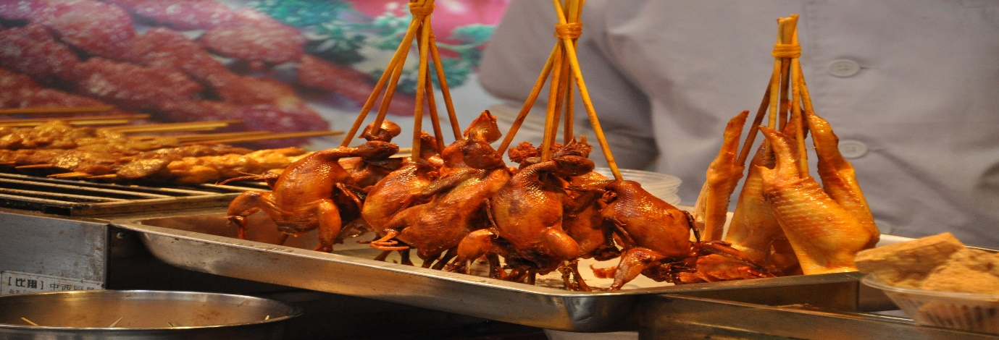

Food
British and Irish eating habits strongly influenced Australian cuisine, healthy puddings and a taste for tea and beer came from our Anglo-Celtic ancestors.


Mauritania
Mauritania has external indigenous influences that greatly influence its way of life, hence this unique mix (iExplorewww.iexplore.com)
Is a predominantly desert country, covering Arab Maghreb, the Arab-Berber population. Slavery and racism are a very old phenomenon, but they cannot speak the color of their skin and determine everything. (Pierre Daum)
Religion
Most Mauritians are part of the Sunni Muslims, although there are many Christian churches in the country.
To unite the population, they made an Islamic declaration of independence.
They identify themselves first with their true roots.
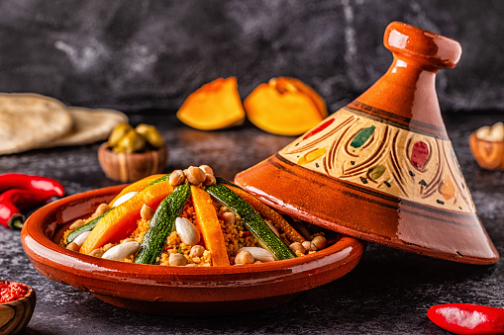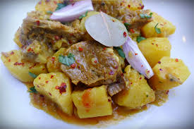
Gastronomy
Is generally simple and repetitive. The basis of the diet is sheep meat and dromedary meat, which is usually accompanied by rice or corn. At the end of the meal a tea with mint is taken.
On the coast, the diet is quite different because the main food is fish, tuna and seafood, lobster. The most recommended dishes are couscous, tayines, rice dishes with chicken, lamb, camel or dried fish. The desserts are varied.
The most common drink is tea. You can also drink dill liqueur or curdled milk.
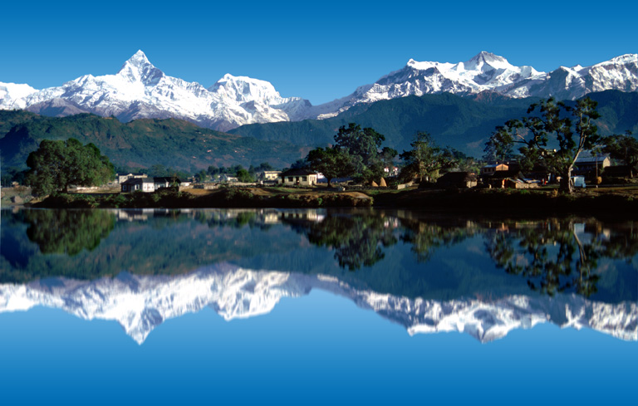
Nepal
The culture is very varied, reflected by the different ethnic origins of its people. a Nepalese culture has many Hindu clothing, beliefs and traditions. However, the influence of Buddhism, which covers about 10% of the population, is great.
Religion
How two religions coexist and rite Hindus and Buddhists.
Music
These people are very fond of the folklore that is integrated within society, and they hold the tradition of stories that are told by the elders with the fallacy around them, stories of war, love, fairies.
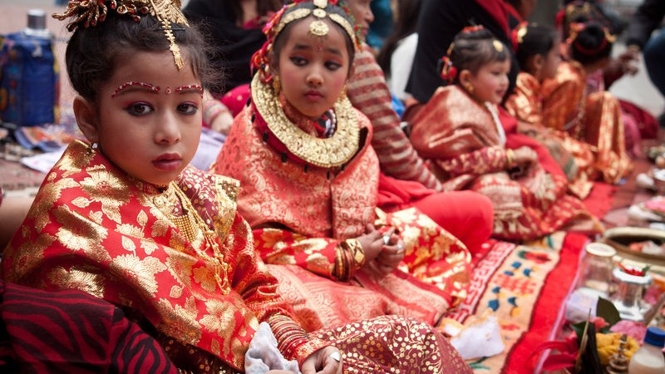

Marriage
Many families deliver their daughters between the ages of 11 and 13 in marriage, because the older, the greater or more requested by the groom. Nepal, where more than half of the 30 million people live on less than $ 1.25 a day. (https://envolverde.cartacapital.com.br/)

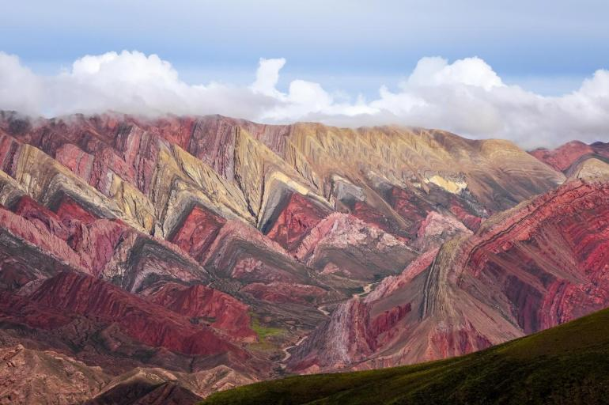
Argentina
The culture of Argentina is highlighted by many immigrants who have settled in the country with European influences, American as well as from neighboring countries, they have a unique modern mix, thus giving Argentina a distinctive cultural touch. Unique and sensual. Its lifestyle and characteristics have spread around the country's multiculturalism. (Juliana Fazenda)
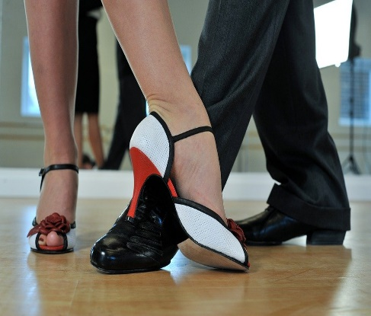
Dance
Tango is the symbol of Argentina. This dance is so sensual that everyone who wants to learn is considered a world heritage site. And a way of expressing yourself using all sensuality.

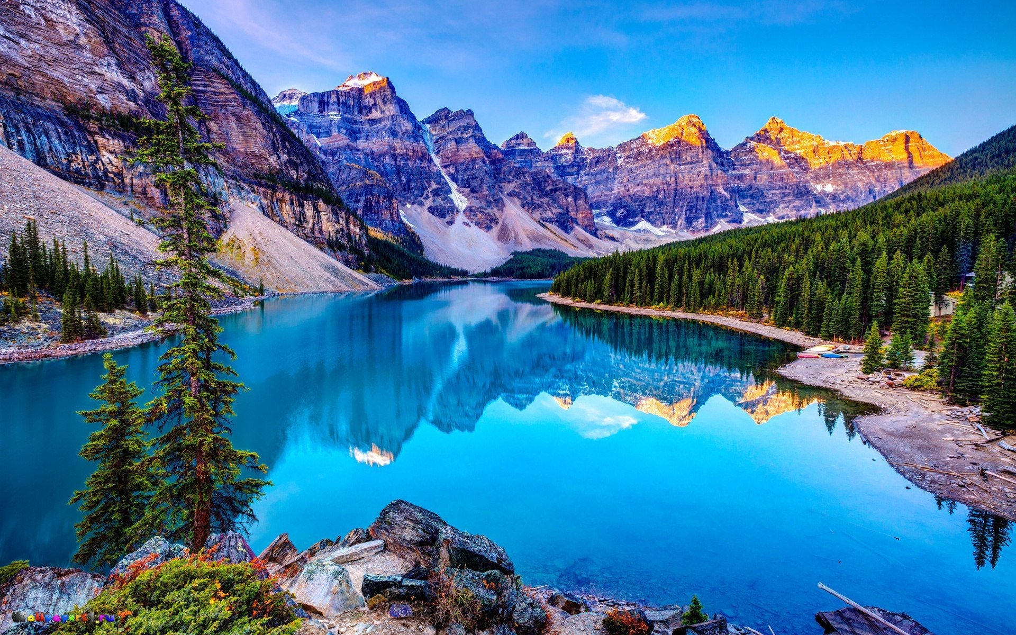
Greenland
Greenland culture has a lot in common with Groneland's Inuit tradition, as most are descendants of Inuit. Many people still fish on the ice and there are annual dog sled races in which everyone participates in a team. Greenland has become a tourist attraction.
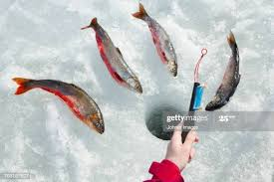  The greeting called kunik
The person should press part of the nose and upper lip under the other's face. started with the Eskimos.

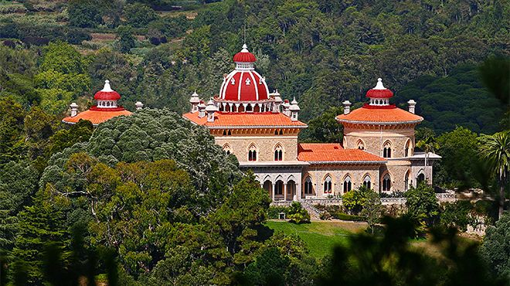
Portuga
Culture is everything that defines the character and personality of a people, it has a rich and varied culture. In such a small country, there is such a wide variety of cultural events. It includes several aspects that include music, gastronomy, wine, pilgrimages, etc. and a more erudite part of the theatre, cinema, art, literature etc. (VxMag - Jun 2, 2018)

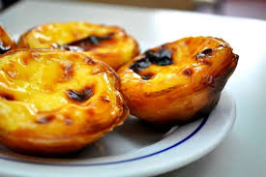
 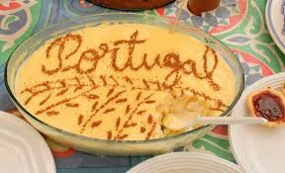They have the habit of giving 2 kisses on the cheek, in addition to the handshake which is also one of the most popular.

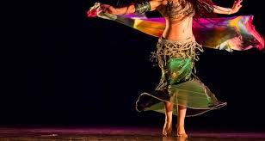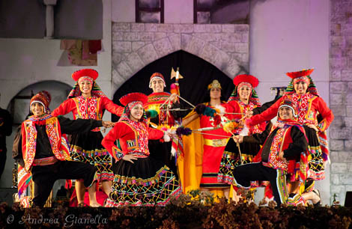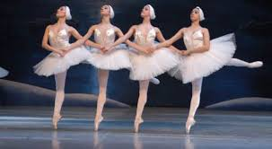

Conclusion

This work took me to travel a little and concludes that culture is inserted in all the habits that humanity has been acquiring since then until now.
The music, the theatre, the dance, a simple painting on the wall, all told tells us a story.
It is concluded that the concept of culture is based life what we are, where we come from and what will be the future of our children, culture and a rotation in constant motion

References

Antonio luiz fontela
Baloglu & Uysal, 1996
Ben1183/Thinkstock
Bowen and Chen, 2001
Clifford Geertz (1966)
Emerson Santiago
Geer Hofstede 1991
Globalwww.commisceo
https://envolverde.cartacapital.com.br
https://quora.com
iExplorewww.iexplore.com
info@commisceo-global.com
Juliana Bezerra
Mattila, 2000
Middleton, 1994
Mok & Armstrong,
Mok, C., & Armstrong, W. R. (1998
Middleton (1994, p. 71)
Muller, 1989, 1991
Politica e cidadenia
Pierre Daum
Reid & Reid, 1997
Reisinger & Turner, 1998
Sussmann & Raschovsky, 1997
South Africa.Explore. Experience. Stay
UC Press E-Books Collection, 1982-2004
Uysal and Hagan, 1993
VxMag - Jun 2, 2018 (p.89)
Wikipedia
www.Viajar barato.com
You, O'Leary, Morrison & Hong, 2000).

