
ACDB 4011: Calorimetry Lab Report
Cameron Lane- OME Apprentice

Table of Contents
List of Tables 1
Introduction 2
Results 2
Heat Capacity of Water 2
Specific Heat Capacity of Metal 3
Enthalpy of an endothermic reaction 4
Discussion 4
Sources of Error 5
OME Applications 5
Conclusions 6
Appendix 8
Appendix A – Method 8
Appendix B- Results Page 10
References 13

List of Tables
Table 1 – Variables of the Experiment 2
Table 2 – Results of the First Experiment 2
Table 3 – Energy of the First Experiment 3
Table 4 – Temperatures of the Second Experiment 3
Table 5 – Masses of the Second Experiment 3
Table 6 – Variables of the Third Experiment 4
Table 7 – Temperatures of the Third Experiment 4

Introduction
Calorimetry is a scientific method used to measure the change in energy of a system when a change is affected upon the system. This could be either a physical change to the system, such as the experiment conducted on the heat capacity of metal, or a chemical reaction, as was conducted in the lab on the reaction of hydrochloric acid and sodium hydroxide. The purpose of these experiments was to study the use of a calorimeter in measuring the change in heat of three different scenarios. There were three hypotheses that this purpose relied upon. Firstly, that a calorimeter can be used to calculate the heat capacity of a body of water and of the calorimeter. Secondly, that the specific heat capacity of a sample of metal can be calculated through the use of calorimetry. Finally, that the heat produced in a chemical reaction can be measured through calorimetry. The variables present in these three experiments are listed in Table 1 below.

Experiment | Heat Capacity of Water | Heat Capacity of Metal | Heat of the Reaction
Independent Variable | The Temperature of Hot Water Added | The Temperature and Mass of Metal | The Volume of reactants added
Dependent Variable | The Temperature the System Reached | The Temperature the System Reached | The Temperature the System Reached
Control Variables | The Temperature of the Cold Water  The Mass of the Cold Water | The Heat Capacity of the Calorimeter  The Mass of Water in the System | The Heat Capacity of the Calorimeter
Table 1 – Variables of the Experiment

Results

Heat Capacity of Water
The results from the first experiment measuring the change in temperature of water and of the calorimeter when hot water is added are visible below, in Table 2. In this experiment, the temperature of both the hot and cold water were measured before being combined in the calorimeter, and the highest temperature reached were recorded, to give the change in temperature. In total, the hot water added decreased by 48.8$℃$ from 95.0$℃$ to 46.2$℃$, while the cold water increased in temperature by 22.2$℃$ from 24.0$℃$ to 46.2$℃$. The calculations based off these results can be seen below.
Temperature | ºC | Volume | mL | Change in Temperature | ºC
T_{cold} | 24.0 | V_{cold} | 50 | $$ΔT_{cold}$$ | 22.2
T_{hot} | 95.0 | V_{hot} | 50 | $$ΔT_{hot}$$ | -48.8
T_{max} | 46.2 | V_{combined} | 100 | $$ΔT_{calorimeter}$$ | 22.2
Table 2 – Results of the First Experiment
Table 3, shown below, shows the calculated values of energy change in each part of the system. This is calculated through two equations, where m is the volume, c is the heat capacity of the material, and $ΔT$ the change in temperature of the water. For the calculation of water, c is given as 4.186 $J/{g℃}$:

$$Q=m ×c × ΔT$$
$$-{Q }_{hot water}=Q_{ cold water }× Q_{ calorimeter}$$

From these two equations, using the information listed in table 2 above, the heat lost by the hot water can be calculated, Q = 50.0 x 4.186 x -48.8, giving a heat change of -10213.94 J. The minus sign in this figure indicates that it is energy lost from the water. The heat gain of the cold water can be calculated from the same equation, 50.0 x 4.186 x 22.2, for a change of 4646.46 J. Putting these calculations into the second equation allows for the change in the energy of the calorimeter to be calculated:

$$10213.94=4646.46+ Q_{calorimeter}$$
$$10213.94=4646.46+5567.38$$

Q_{cold-water} | Q_{hot-water} | Q_{calorimeter}
-10213.94 J | 4646.46 J | 5567.38 J
Table 3 – Energy of the First Experiment
Putting the value for the heat change of the calorimeter into the equation $Q=HC × ΔT$ to work out the heat capacity of the calorimeter gives the equation ${5567.38}/{22.2}=250.78 J/℃$.

Specific Heat Capacity of Metal
The second experiment conducted was to calculate the specific heat capacity of a sample of metal. The results obtained from the experiment are listed below, in Tables 4 & 5.

Temperature of Metal | Temperature of Water | Temperature of Equilibrium
95.0 | 23.6 | 31.6
Table 4 – Temperatures of the Second Experiment
Mass of Metal Sample- Grams (g) | Volume of Water- mL
18.6 | 30.0
Table 5 – Masses of the Second Experiment
Equation 2, used in the first experiment is reused for this experiment, giving the calculations listed below for the energy gained by the water when the heated metal sample is added to the calorimeter:

$$Q_{Water}=30.0 ×4.186 × 8=1004.6 J$$

From this calculation, and by knowing the mass of the metal, the specific heat capacity can be calculated by rearranging equation 1 as show below:

$$c=\frac{Q}{m × ∆T}$$

$$c=\frac{1004.6 J}{18.6 g × 63.4 ℃}=0.852 J/g℃$$

This gives a specific heat capacity of the metal sample as 0.852 J/g$℃$. Comparing this result to specific heat capacities of common metals, it can be seen that the metal sample used in this experiment was aluminium, which has a value of $0.9 J/g℃$, just slightly off from the result measured.

Enthalpy of an endothermic reaction

The third experiment covered the exothermic reaction of sodium hydroxide and hydrochloric acid. The table below, Tables 6 & 7 , shows the data of the reactants and the measurements made from the experiment.
Volume | mL | Concentration | Mol/L | Moles of Reactant | Moles
V _{HCL} | 50.0 | c _{HCL} | 1.0 mol/L | n _{HCL} | 0.05
V _{NaOH} | 52.0 | c _{NaOH} | 1.0 mol/L | n _{NaOH} | 0.052
Table 6 – Variables of the Third Experiment
Temperature of at the Start | Temperature at the End
28.5 | 33.1
Table 7 – Temperatures of the Third Experiment
The data listed above can then be put into a modified version of the equation used in the first experiment:
$${-Q}_{Reaction}=m_{water} ×c_{water} × ΔT_{water}+{HC}_{calorimeter} × {∆T}_{calorimeter}$$

This results in the calculation for Q_{Reaction} of:
$${-Q}_{Reaction}=102.0 ×4.186 ×4.6+250.78 ×4.6$$
$$102 ×4.186 ×4.6+250.78 ×4.6=-3117.66$$

This result is based off the reaction between half a mole of hydrochloric acid and half a mole of sodium hydroxide, as the limiting reactant for the experiment was the hydrochloric acid, and the reaction used 1 mole of each reactant. As the energy change of a reaction is normally measured per mole of reactants, the result is adjusted to get a per mole value. To do this, the equation below is used, where $Q_{reaction}$ is the calculated energy of the reaction, $n_{reaction}$ is the volume of the limiting reactant of the reaction, which in this case is hydrochloric acid, and $q_{reaction}$ is the calculated energy of the reaction per mole:
$$q_{Reaction}=\frac{Q_{Reaction}}{n_{Reactant}}$$
$$\frac{-3117.66}{0.05}=-62353 J/mol$$
This gives the final answer for the energy change of the reaction as being -62.35 kJ/mol.

Discussion
These experiments highlighted the range of uses that calorimetry can be used for. Each of the three experiments conducted utilised different measurements and calculations to get the required results. The first used known volumes of water, from which the energy input and output can be measured, to work out the unknown heat capacity of the calorimeter. The second experiment was working out an unknown amount of energy being added to the system, and calculating the energy and specific heat capacity using the known values for water and the calorimeter. Whilst the last experiment took a known reaction with an unknown enthalpy, and used the known values of water to calculate the energy produced during the reaction. This highlights the versatility of calorimetry as a scientific method, as the unknown value being investigated can be any part of the experiment, in these cases both as the system and as the energy input to the system.
Furthermore, the second experiment highlighted the vast differences in specific heat capacities between water and aluminium. Liquids normally have a higher specific heat capacity than solids do, as the energy in a solid is going into vibrating a rigid structure, while in a liquid the energy is going into free-flowing molecules in movement and vibration. Water however also has a particularly high heat capacity. This is down to its atomic structure. The hydrogen bonds that make up water molecules require significantly more energy to break than other forms of atomic bonds do, meaning more energy can be stored within them before breaking [3][10].

Sources of Error
There are a number of sources of potential error across all three experiments conducted. There are a number that common across all three experiments conducted, and some that are individual to each experiment. In common across all three experiments is the calorimeter used. While the setup used worked for the accuracy of measurements made, all of the calculations done across the three experiments relied on an initial calculation estimating the heat capacity of the calorimeter. A specialised calorimeter with a known calibrated heat capacity will significantly reduce the impact on all the following calculations. A further source of error across all experiments was in the measuring out of the various liquids needed in these experiments. These measurements were made with a graduated cylinder, which gives an accuracy to the nearest mL, compared to a pipette that can be accurate to 5 hundredths of a mL. This would most probably have the greatest impact of all potential sources of error on these three experiments. Consistent being off by one millilitre in each measurement will cause significant errors across all calculations, when other readings are accurate to one or two decimal places. Another source of error potentially impacting all of the calculations is the temperature readings. The readings done for these experiments were conducted to one decimal place in some cases, but to the nearest degree for others. Recording temperatures all temperatures to at least one decimal place, if not two would greatly increase the accuracy of the readings taken, and the calculations that they depend upon. Related to the error in temperatures is the error in the initial measurement of the temperatures for the water and metal in the first two examples. In both of these cases, the sample was heated, before being removed from the heat and added to the calorimeter. While every effort was made to move the sample across as quickly as possible, in both cases the samples will have cooled down slightly, which will cause a difference between the recorded starting temperature and the actual starting temperature, impacting the calculations made.

OME Applications
Calorimetry sees a significant amount of use across the OME industry. In both the confirmation of new compounds, and in the measurement of known materials and methods. Through the use of a variety of modifications of bomb calorimeters, a wide variety of statistics can be measured. Firstly, the role of calorimetry in synthesis. While the properties of compounds and materials can be estimated from the atomic makeup of the compounds, these properties still require lab testing to confirm these estimates [9]. The development of N-guanylurea-dinitramide, or FOX-12, is a prime example of this. The heat of formation of the compound was calculated through the use of a bomb calorimeter, giving a result of −355 kJ/mol [12]. Also measured using a differential scanning calorimeter was the thermal sensitivity of FOX-12. Through slowly heating the sample, an ignition temperature of 214.8 °C was identified. Calculating ignition and decomposition temperatures is highly important for the OME field, as these temperatures influence the safety and conditions required in its manufacture and storage, to prevent accidental ignition or detonation [4]. Calorimetry has been used to calculate these temperatures in numerous different explosives, ranging from synthetic polymers to aluminized mixtures of RDX [8]. In the latter, calorimetry was used to measure the impact that different sized particles of aluminium had on the energy released by the detonation of RDX/Al mixtures, compared to control samples mixed with lithium fluoride as an inert material [5]. This revealed only slight difference in the energy of detonation in air between the two aluminized samples, the smaller particles at 16965 Jg^{–1} compared to 16905 for the larger particles. By comparison, the lithium fluoride samples had far less energy released during detonation, only 7747 Jg^{–1}.
Calorimetry has also been used to calculate a range of measures for already known compounds, either to confirm safety measures, or to study the safety of new production methods [2] [11]. The US Army utilised calorimetry as part of its evidence for the building of a new plant for the production of RDX/HMX. While the various different figures for RDX and HMX were already known, new production methods involved new chemical reactions, for which the enthalpy of the reactions needs to be measured [13]. After calculating this, the feasibility of production can be decided upon, and safety margins for sizes of batches and conditions can be established, improving the safety of production. Similarly, a study was conducted on the thermal decomposition of graphene oxide, to evaluate the safety of common methods used in production [6]. This found that common drying methods even at low temperatures were close to the thermal decomposition temperatures identified using calorimeters, especially as decomposition negatively corelates to the mass. Measurements of calorimetry also identified variation in the thermal decomposition temperatures based on the purity of the samples, ranging from commercial to lab produced graphene oxide. This is another highly relevant role of calorimetry in OME, to establish the purity of a sample. By measuring the thermal decomposition point of the sample against an established pure value, it is possible to identify contamination, as the temperature will vary depending on impurities against the known value [5]. In this role, the calculation of the energy output of the detonation of an explosive can also be used as a tool for the identification of explosives. Similarly to establishing the purity, comparing the measured energy of a detonation against known energies for explosives can give an estimate for what the explosive sample is, in situations where this is unknown, such as unexploded ordnance [7].

Conclusions
From the results listed for the three experiments, and the corresponding calculations based upon them, it can be seen that the hypotheses that were being tested in these experiments were all proven. Firstly, it was found to be possible to calculate the energy change of a body of water, and using this result calculate the heat capacity of the calorimeter used in the experiment. Second, it was found that the specific heat capacity of a sample of metal can be calculated using the measurements made with a calorimeter. And finally, it was found that the energy change of a reaction can be calculated using a calorimeter. The effectiveness of this method of measurement was clear from the ease of conducting the experiment, as well as the ease of the calculations based upon the measurements. The relevance of this technique to OME and the potential benefits of the data gained were clear from conducting these experiments.
There are a number of areas for potential further study in the use of calorimeters. Firstly, would be the use of more refined tools for measurements in the experiment. This would include both in measuring out the water and reactants, as well as the thermometers and calorimeters. One of the sources of error in this experiment is this measuring, so making it more accurate will result in more accurate calculations. The second area of interest for investigation would be the use of different calorimeters [1]. The research into the application of calorimetry to the OME field revealed numerous different variations to the calorimeter, all working in the same method by measuring the energy released, however having different ways of starting the thermal decomposition of the sample tested. The testing of the graphene oxide, and testing of the purity of a sample, utilise a calorimeter than heats the sample up, until it reaches the point of thermal decomposition. Similarly, calorimeters designed to test the reactions of chemicals can include methods to store chemicals separately, and mix them in the sealed calorimeter, preventing the potential energy loss that would have been present in the method used in the experiment conducted.

Appendix

Appendix A – Method

Materials:
- 2 Styrofoam cups
- 1 lid
- 1 thermometer
- 1 stirring rod
- 1 Stand with clamp
- 130mL water
- Bunsen Burner
- Metal Sample
- Metal tongs
- Graduated cylinder
- 50mL Hydrochloric acid, 1.0 mol
- 52mL Sodium Hydroxide, 1.0 mol
Set up the calorimeter as shown, with one Styrofoam cup inside the other, held in the clamp on the stand. Cover the top of the cup with the lid, with the thermometer and stirring rod going through the lid.
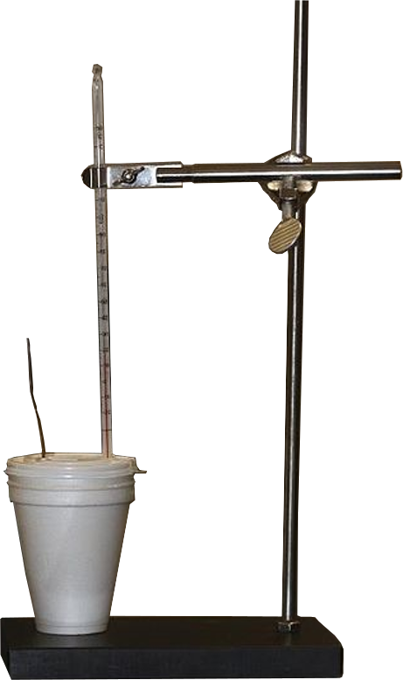

Experiment 1
- Add 50mL of water to the cup, and close the lid
- Add 50mL of water to a beaker, and heat to 80ºC. Remove from heat and allow to cool down to 60oC
- Measure the temperature of the water in the cup
- Add the hot water to the cup, close the lid and mix thoroughly. Record the maximum equilibrium temperature that the water reaches
- Use the recorded figures to calculate the energy of the reaction, as shown in the results

Experiment 2
Use the same setup of Styrofoam cups in the clamp. Empty out from the first experiment
- Weigh the metal sample, and record this.
- Heat the metal sample in a water bath of boiling water for 5 minutes, to allow the metal to reach the temperature of the boiling water. Remove from the heat, to allow the metal and water to reach thermal equilibrium
- Add 30mL of water to the cup, measuring the temperature of this after adding, and record this
- When the metal and water bath reach thermal equilibrium, measure and record the temperature as T_{hot.} Add the metal sample to the cup, using the metal tongs
- Stir the water, recording the temperature every 10 seconds. Repeat recordings until the temperature has reached its highest, and dropped again by 2ºC
- Use the recorded figures to calculate the energy of the reaction, as shown in the results

Experiment 3
Use the same setup of Styrofoam cups in the clamp. Empty out from the second experiment
- Add 52mL of Sodium Hydroxide, NaOH, to the calorimeter and 50mL of Hydrochloric Acid, HCl, to a separate beaker
- Allow these to reach thermal equilibrium, recording this temperature as T_{start}
- Quickly add the HCl to the NaOH, and record the maximum temperature reached as T_{end}
- Use the recorded figures to calculate the energy of the reaction, as shown in the results
Appendix B- Results Page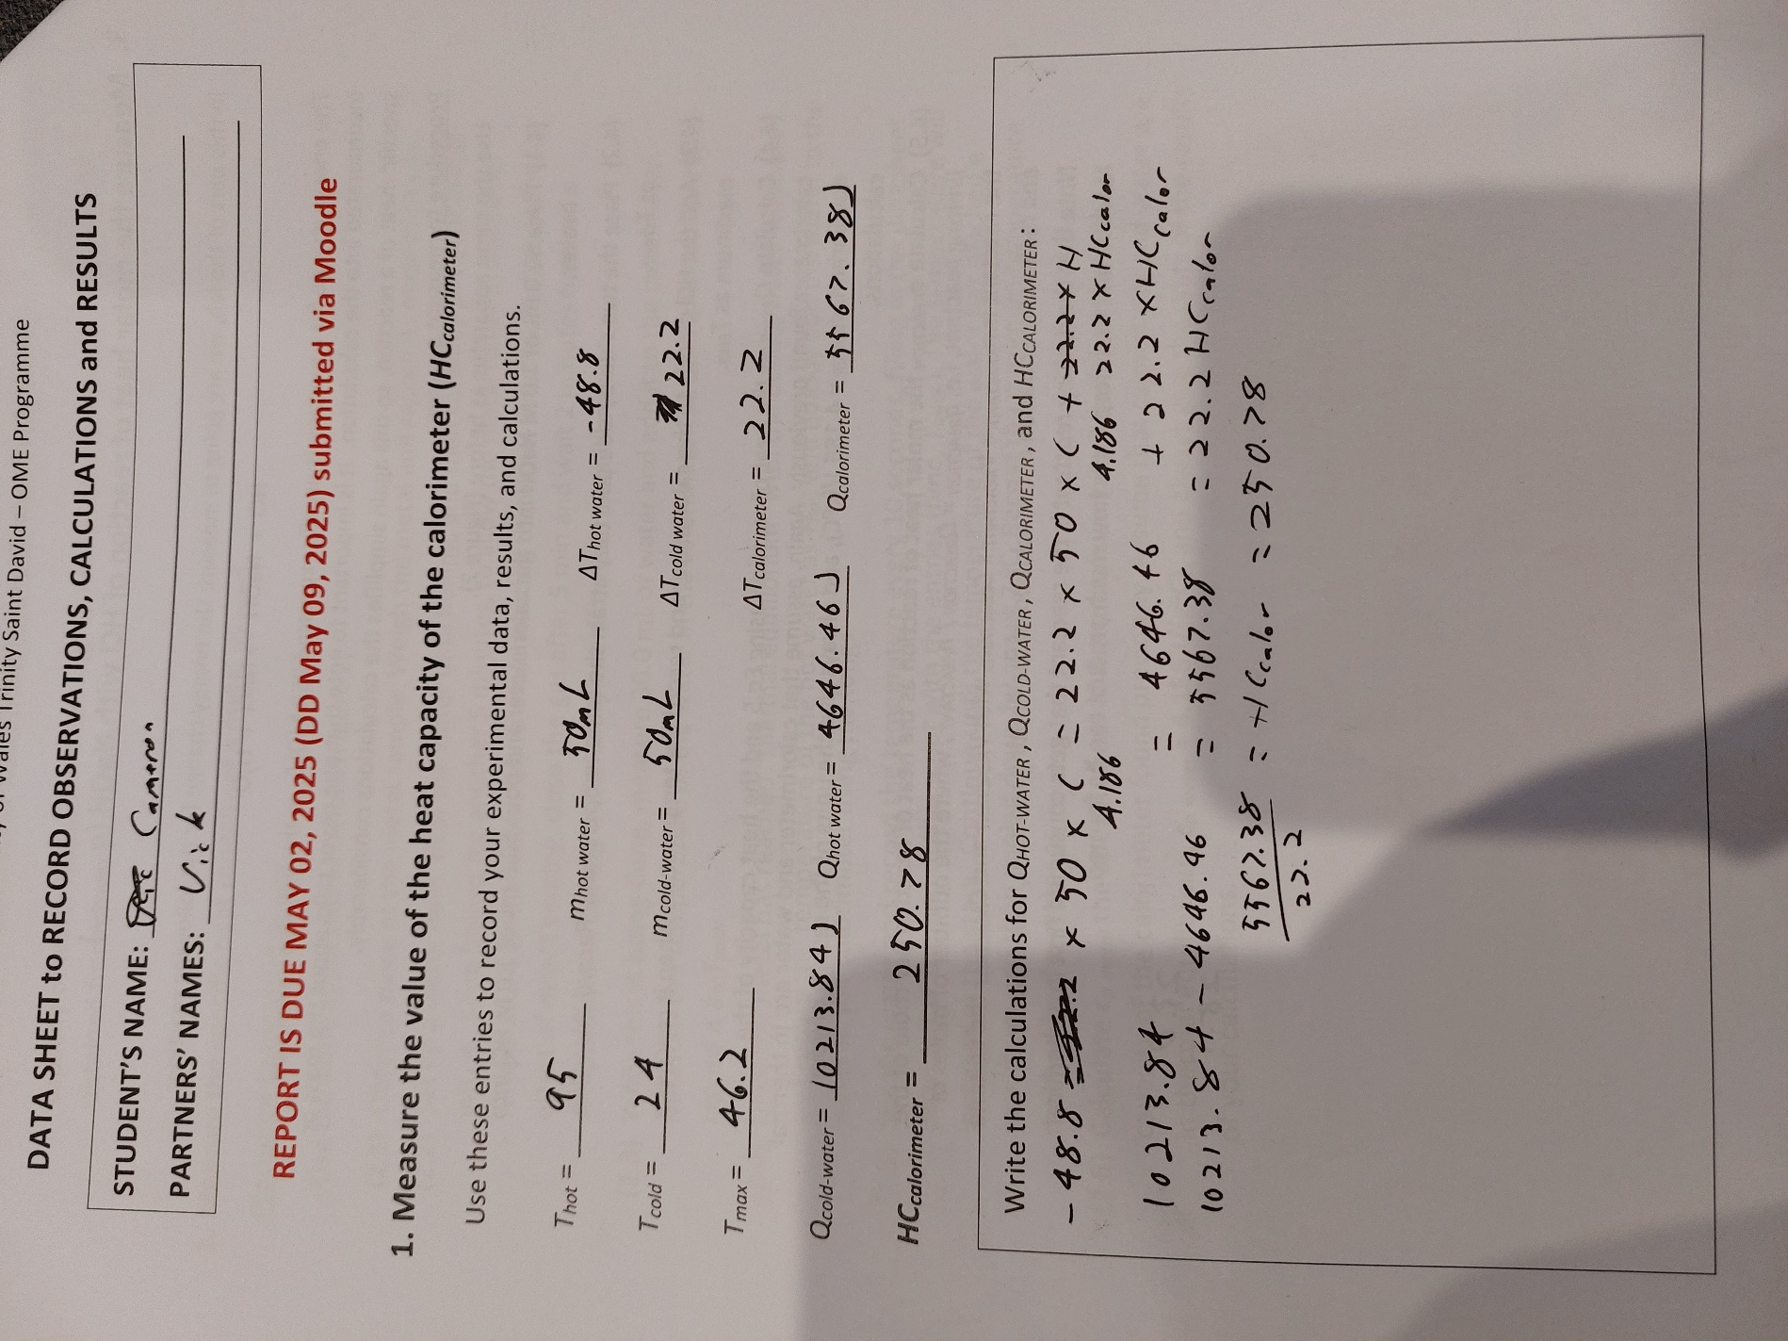
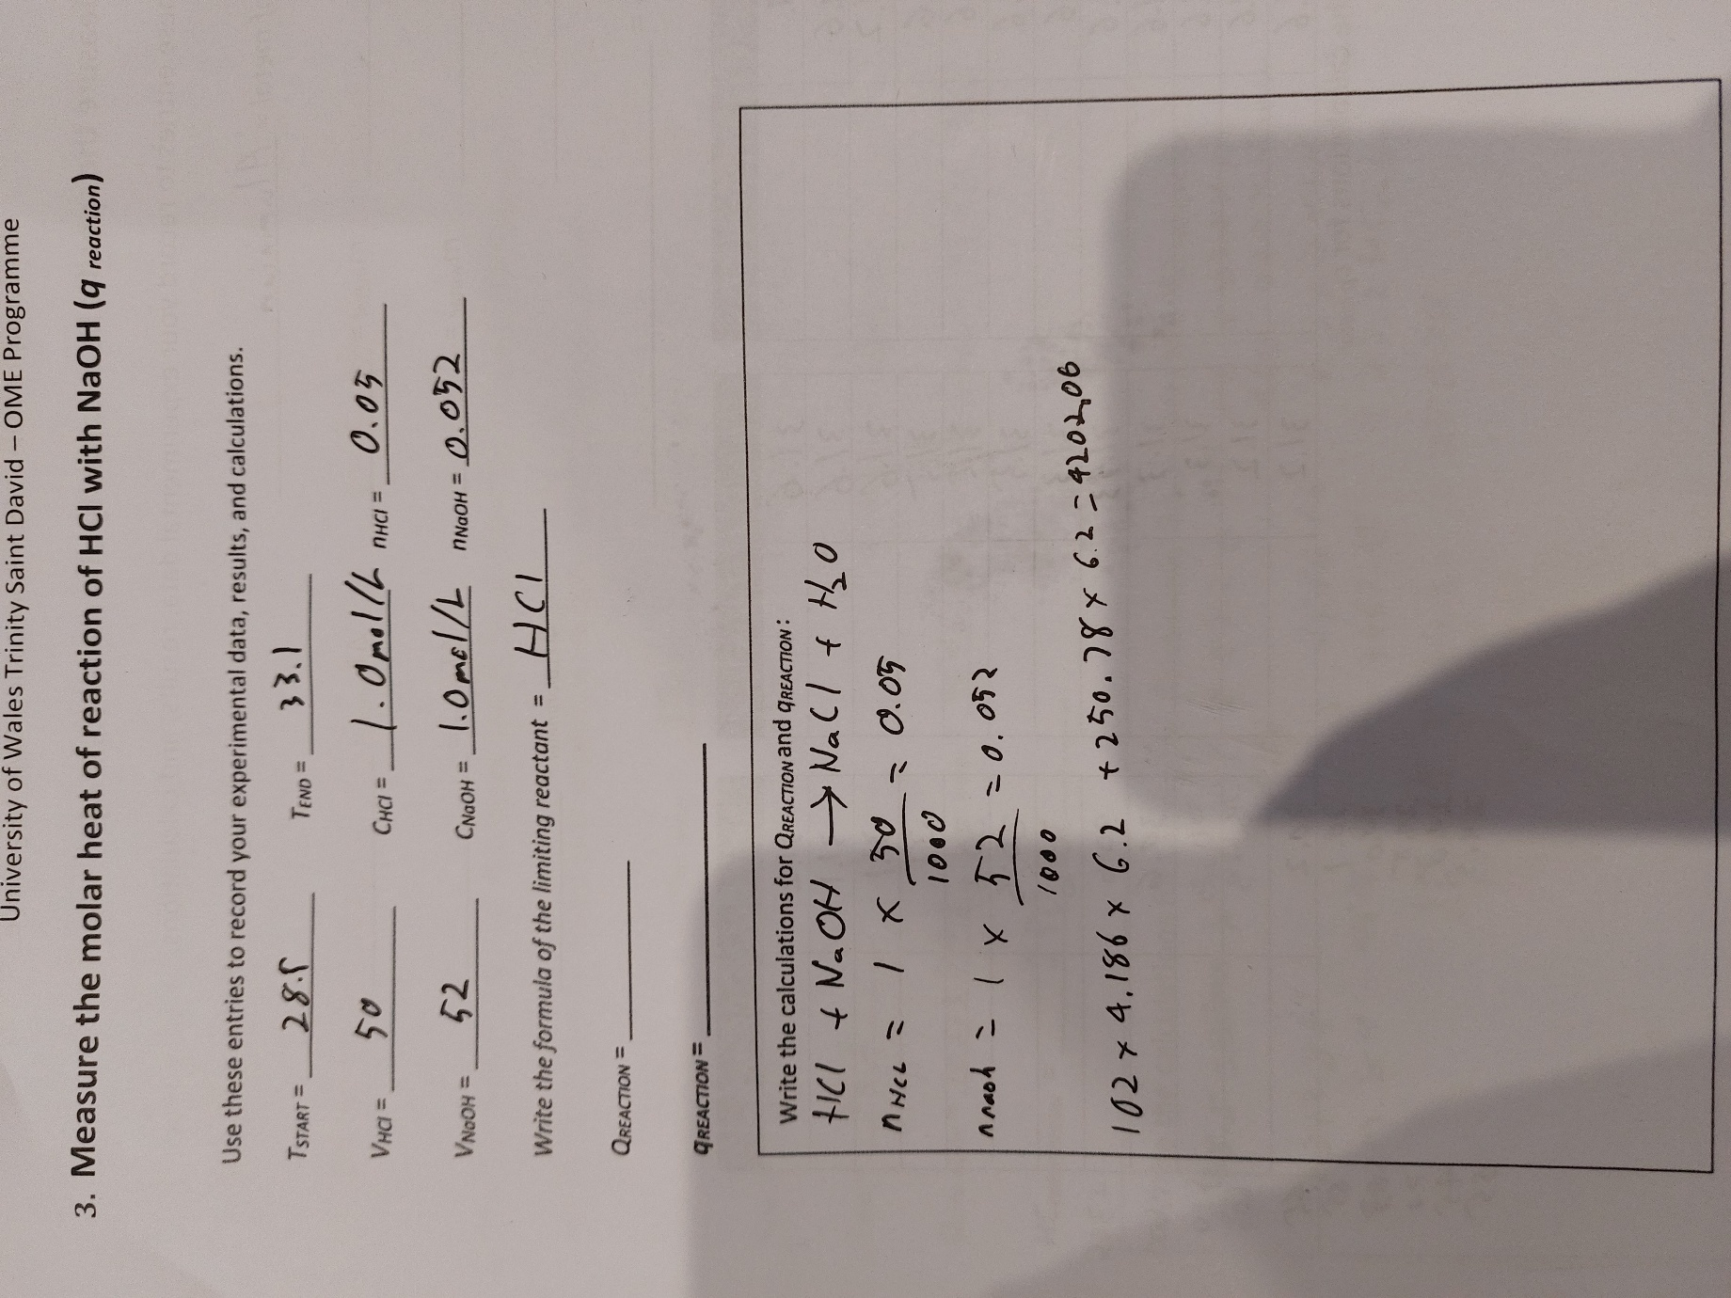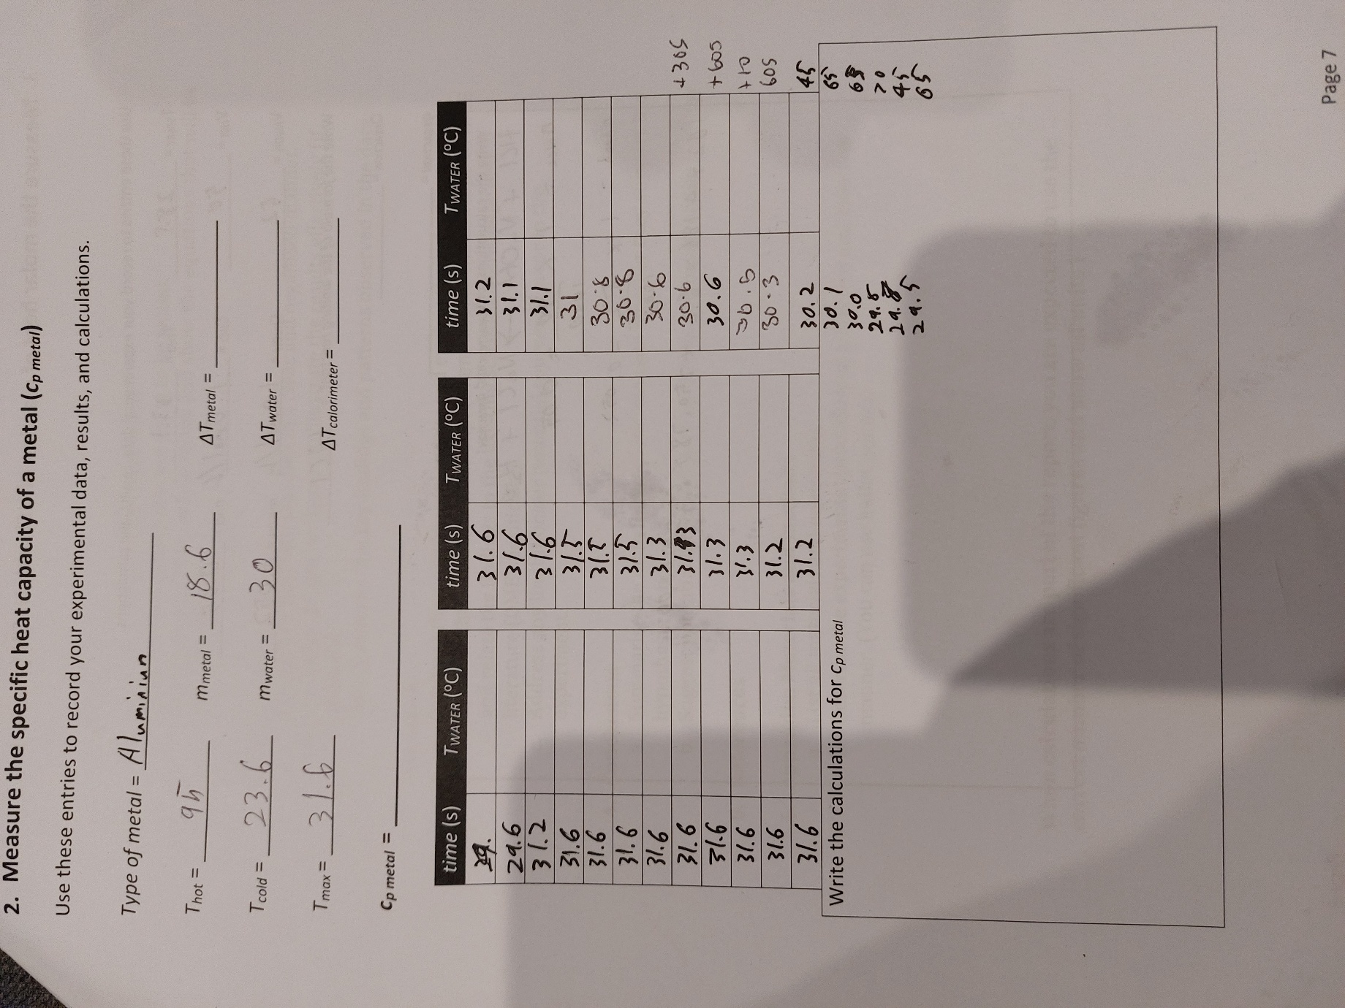

References
[1] J. Akhavan. The Chemistry of Explosives (4th ed.) 2022Available: https://www.perlego.com/book/3286318/the-chemistry-of-explosives-pdf.
[2] W. P. De Klerk. Thermal analysis of some propellants and explosives with DSC and TG/DTA. 1996. Available: https://apps.dtic.mil/sti/citations/ADA320678.
[3] L. Gunkel, A. A. Ehrhard, C. S. Krevert, B. A. Marekha, M. Bonn, M. Grechko and J. Hunger. Dynamic anti-correlations of water hydrogen bonds. Nature Communications 1515(1), pp. 10453. pp. 10453. 2024. Available: https://www.nature.com/articles/s41467-024-54804-y. DOI: 10.1038/s41467-024-54804-y.
[4] J. L. Johnston and M. P. Flores. Hazard analysis of explosives by accelerating rate calorimetry. 1986. Available: https://apps.dtic.mil/sti/citations/ADP005388.
[5] W. Kiciński and W. A. Trzciński. Calorimetry studies of explosion heat of non-ideal explosives. J Therm Anal Calorim 9696(2), pp. 623–630. pp. 623–630. 2009. Available: https://doi.org/10.1007/s10973-008-9100-5. DOI: 10.1007/s10973-008-9100-5.
[6]. P. Lakhe, D. L. Kulhanek, W. Sun, B. Zhang, M. J. Green and M. S. Mannan. Calorimetry of explosive thermal decomposition of graphite oxide. Journal of Hazardous Materials 366366pp. 275–281. pp. 275–281. 2019. Available: https://www.sciencedirect.com/science/article/pii/S0304389418311294. DOI: 10.1016/j.jhazmat.2018.11.100.
[7] Y. Liu, V. M. Ugaz, S. W. North, W. J. Rogers and M. S. Mannan. Development of a miniature calorimeter for identification and detection of explosives and other energetic compounds Journal of Hazardous Materials 142142(3), pp. 662–668. pp. 662–668. 2007. Available: https://www.sciencedirect.com/science/article/pii/S0304389406009940. DOI: 10.1016/j.jhazmat.2006.08.050.
[8] N/A. Services textbook of explosives. Ministry of Defence. 2020Available: https://moodle.uwtsd.ac.uk/pluginfile.php/627974/mod_resource/content/0/JSP%20333%20Service%20Textbook%20of%20Explosives.pdf.
[9] M. C. Neveu. A search for new fuel components in explosive mixtures with ammonium nitrate.. 1981. Available: https://apps.dtic.mil/sti/html/tr/ADA104881/index.html.
[10] E. T. Peltzer and P. G. Brewer. The molecular basis for the heat capacity and thermal expansion of natural waters Geophysical Research Letters 4646(22), 2019. Available: https://agupubs.onlinelibrary.wiley.com/doi/10.1029/2019GL085117. DOI: 10.1029/2019GL085117.
[11] J. D. Wilcox. Differential scanning calorimetry methods in the determination of thermal properties of explosives. 1967. Available: https://apps.dtic.mil/sti/citations/AD0818369.
[12] H. Östmark, U. Bemm, H. Bergman and A. Langlet. N-guanylurea-dinitramide: A new energetic material with low sensitivity for propellants and explosives applications. applications. Thermochimica Acta 384384(1), pp. 253–259. pp. 253–259. 2002. Available: https://www.sciencedirect.com/science/article/pii/S0040603101008000. DOI: 10.1016/S0040-6031(01)00800-0.
[13] R. T. Rewick and B. J. Gikix. R. T. Rewick and B. J. Gikix. Calorimetry studies of ammonia, nitric acid, and ammonium nitrate. Available: https://apps.dtic.mil/sti/tr/pdf/ADA078229.pdf

