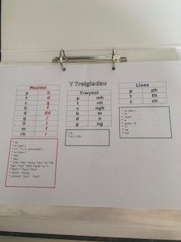
Notes and Lessons Learnt from Welsh Language lessons at UWTSD with Eleri.

Within this picture, the Welsh teacher supplied a document in which would help with Welsh mutations. Throughout my education, mutations within the Welsh language have been a difficult element that I have faced and therefore this table was useful for overcoming my problems.

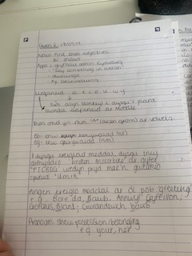
This picture to the left, is the notes I took within the lesson to understand the mutations, and how in which they are used. From the document also, it can be noted I was recapping on the role of Welsh vowels in mutations.

The below two pictures are the notes used to recap the months and dates of the year. Through going over this basic element of the language I was able to feel more confident in preparation for its teachings.

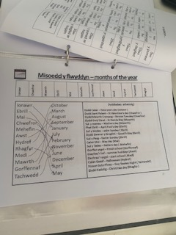
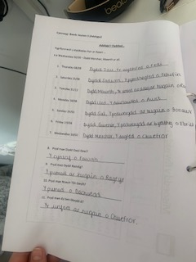
The picture to the below of this of my work during Welsh lessons, is that of the work used to understand the role of mutations with adjectives with the female and male forms of words. To understand this further, I downloaded the app on my phone to translate words and differentiated between female and male words.

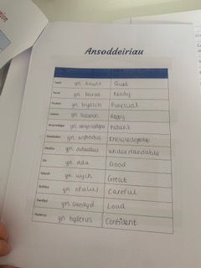

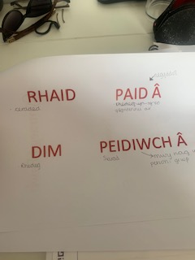
Within the Welsh lesson, we also did a large amount of work on the commands in Welsh and how in which they should be taught and said correctly to model good Welsh to a class of learners. As noted below in the pictures the lessons were targeted towards my personal primary classroom and were used throughout my teaching practice.

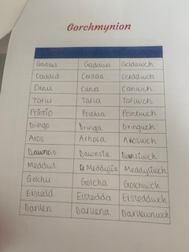

As noted below, the female and male version of vocabulary, commands, sentences, and objects for example were discussed to a high extent during the Welsh language lessons. The pictures below indicate the activities that were used in sorting a range of different words into the correct categories.

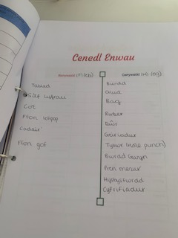
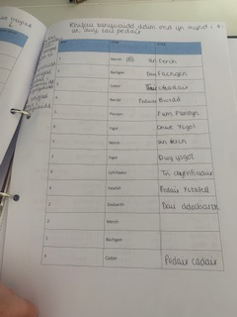

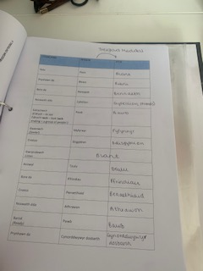
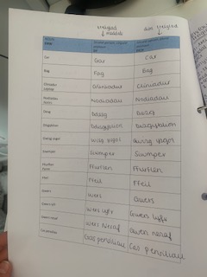
Within these lessons we were also able to complete a range of tasks to boost confidence and efficiency with mutations. Below are examples of the activities we used to complete this.

