Is the current explosive safety distance calculator in place on Porton range a viable tool for explosive fragmenting charges?

Major Project Proposal

Luke Penny 1810352

Table of Contents
- Research Title 3
a. Aims & Objectives 3
b. Outcomes / Deliverables 3
2. Introduction 3
3. Literature Review 3/4
4. Project Design 4/5
a. Outline of Project Design 4
b. Data Collection Methods 5
c. Risks & Limitations 5
5. Resources & Planning 5
6. Gantt chart 5
7. References 6

- Research Question
Is the current explosive safety distance calculator in place on Porton range a viable tool for explosive fragmenting charges?

Aims & Objectives

The aims and objectives of the project are to define the current safety distance system in place and exploit the algorithm using modelling techniques to design the charge and understand its limitations using simulation software. This will be backed up with trials work to gather real time data of fragment capture using various instrumentation techniques.
Background research will be used to gather more information on data capture for fragment velocity and safety distances and how this is used to extrapolate the correct safety distance. This will be used alongside a live explosive trial with an array of instrumentation methods to collect data of the fragments. This will give real-time data that can be analysed and inform if the current safety distance system in place is viable.

Outcomes / Deliverables

In order for this project to be successful;
- A safety assessment needs to be carried out to ensure all potential hazards/risks are captured and mitigated as low as reasonably practicable.
- A SSoW needs to be created for the trial phase and all relevant paperwork must be signed off by relevant subject matter experts.
- The results gathered must be sufficient for analysis with the current algorithm in place.

Introduction

When developing new and novel explosive articles, they need to undergo a series of testing to understand many different aspects, from performance to safety. There are many considerations when choosing where you can trial a new explosive article. The limit of the certain range needs to be taken into account. The explosive article will let off a considerable amount of noise and gaseous products, this needs to be done in an environment that is designed for such activities.
There are systems in place to aid the overall safety of the explosive activity such as a safety distance calculator for informing you, based on an algorithm whether or not your explosive article is within the limits of the range. It will give you an overall distance either in a radial format from the detonation zone, or a directional cover area. This will give you an idea of how far any fragments of material will be projected from your chosen article.

Literature Review

Harris KG, Static Trial Sites – Danger Areas.

- This is the current document used by RTO Range for explosive trials, the formula is within the document and states the change in weight (lb) and the weight of explosive fill will give you a safety distance in which the fragmentation for the device will fall within, in turn this formula allows you to plot a safe distance cover area on your trials site. The current algorithm is for Unconfined charges = 130 x W^{1/3}, Light cased charges = 446.3 x W^{1/5} & Heavy cased charges = 634 x W^{1/6}. [1]

International Ammunition Technical guideline – formulae for ammunition management.

- This IATG introduces and summarises scientifically proven and sound formulae that may be used to support the decision-making and risk management processes essential for the safe and effective stockpile management of conventional ammunition. Guidance on their appropriate use is either contained within this IATG, the complementary IATG software or in other more specific technical IATG. [2]

Project Design

Outline of Project Design

The project will focus on the safe delivery of conducting an explosive fragmenting trial and all risks associated with explosive trials – a HAZID will take place to identify any potential hazards with performing the trial phase
All Risk Assessments and Trials plan will be produced to mitigate any risks – these will be signed off by relevant management prior to the trial taking place.
Modelling will be used prior to the trial phase to understand the limitations of the designed charge and explosive fill – this will give an idea of the velocity of fragments.
Testing/Trial phase will consist of the designed explosive charge undergoing repeated testing in the live environment and instrumentation techniques will be used to capture the fragments. These fragments can then be analysed.
The results can be compared to the original safety system in place and see if any improvements/changes can be made.

Data collection methods

During the planning phase of the explosive trial, the HAZID will inform of the main hazards and risks associated with the task, involving subject matter experts will improve the chance of gathering the most from the project. Data collection is key to this project so ensuring the correct data collection techniques are implemented is vital
Instrumentation will be used to gather data on the velocity of the fragments and the initial velocity of detonation. Blast screens will be used to capture fragments for analysis.

Risks & Limitations

Health and Safety – All personnel involved with the trial will be training and competent to carry out the task.
The testing/trial phase must be in-line with all safety documentation.
Financial limitations – The research will assist with the current safety system in place, either improving the system or highlighting any issues that can be implemented. There will be a maximum budget for this project, this could influence the scale of the live trial.
The explosive range will have limits to follow for NEQ limits and noise limits, these must be adhered to at all times.
Any technical issues arriving from the trial will be discussed in detail with the trials team and any technical members involved. All trials members will be briefed on all tasks and be suitably trained and qualified to perform the tasks described.

Resources & Planning

Manpower; Lead researcher for the project, Modelling team, H&S, Management (for approval of documentation). Trials team (up to 6 people), competent to handle explosives.
Welfare; Energetic process facility that is licensed to stem charges with plastic explosive, suitable trials site for the arena setup and explosive firings. Welfare facilities for all staff present on the trial.
Energetics; Various quantities of plastic explosive for stemming into the charges. High voltage detonators, High voltage firing system and all other consumables.
Instrumentation; High speed videography, Blast/Velocity screens, Straw packs for fragment collection.

Gantt chart
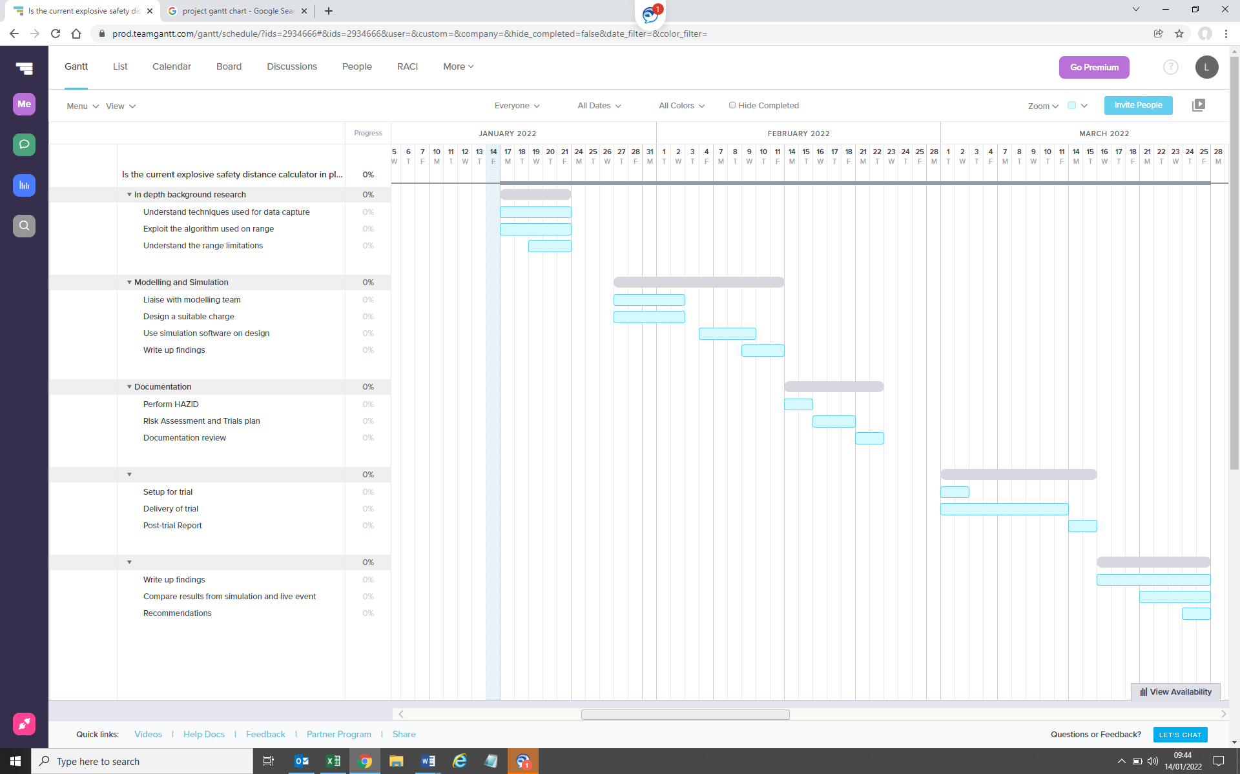
Figure 1 - Project Gantt chart

References

[1] Harris KG, Static Trial Sites – Danger Areas
[2] IATG (International Ammunition Technical Guidelines) https://unsaferguard.org/un-saferguard/guide-lines
- Ethics form has already been submitted.

