Programme title: BA Business Management
Module Code and title: The Global Business Environment (LCBB4005)
Assignment title: Impact of COVID 19 pandemic on fashion industry
Student name: Soner Bedri Halmi
ID: 1908827

The COVID-19 Pandemic affects the global fashion industry as governments close -down manufacturing plants, and through store closures, and event cancellations to slow the spread of the virus. The coronavirus pandemic has had a major impact on fashion brands worldwide. At the same time, the fashion industry faces challenges in consumer demand. New opportunities are also presenting themselves as fashion brands shift to making fashionable coronavirus face masks.
The Covid-19 pandemic has had a colossal effect on almost every industry, whether that be unprecedented pressure on health services, non-essential businesses shuttering, or supermarkets needing to consider their re-stocking tactics and opening hours. And so it follows that the fashion industry has also been experiencing the effects of a global health crisis.
Though it has been dismissed as frivolous - if compared directly with the front line service industries fighting to keep people alive and fed - the fashion industry is both a creative mecca and one of the world's most significant fiscal heavyweights. The fashion industry's deterioration would see a serious impact on the global economy, not to mention the furloughing or unemployment status of millions of artists, designers, seamstresses and more.
The virus has moved at different rates through, and had varying impact on different countries. The latest lockdown measures in the UK still encourage those who can work from home to do so, but those who cannot are 'actively encouraged to go back to work (alongside relaxed rules around exercise and outside leisure time).
Despite some of the more severe lockdown relaxing (or even being lifted in places like France) the Covid-19 pandemic rages on, and the fashion industry's fate still hangs in the balance.
From the potential for a humanitarian crisis in Bangladesh, to billions of pounds donated by luxury fashion groups, here are all the ways the fashion industry is adapting under the strain of the coronavirus.
While many of us non-'essential workers' may feel like sitting ducks during this pandemic, influencers and fashion-focussed celebrities have taken it upon themselves to find ways to contribute.
Stylists Anna Rosa Vitiello and Bettina Looney, for example, co-ordinated a wardrobe clear out on their respective Instagram stories, to raise money for both Doctors Without Borders and Help Them Help Us charities.
'We wanted to create a fun and interactive way to help raise funds for charities who need our help during this time,' Looney told ELLE UK.
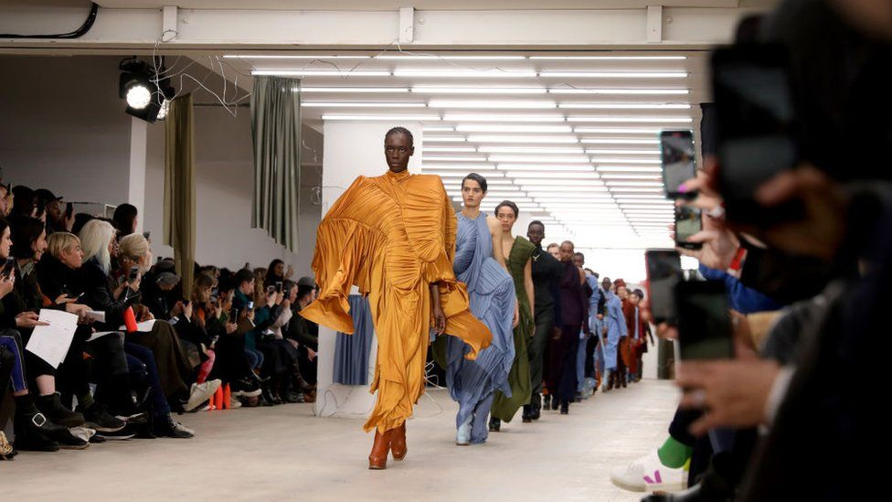
‘Fashion is what we love and can also be the perfect vehicle for giving back so we found a way to combine the two and the response has been phenomenal. We will continue to host a sale each week on Mondays, for as long as we can, to continue to raise money and awareness and will also be working with some wonderful small brands to aid this.'
While luxury resale site Vestiaire Collective garnered clothing donations from the likes of Kate Moss, Thandie Newton, and Camille Charriere, to resell in aid of local charities including Fondation Hôpitaux de France-Paris, the World Health Organisation and Lombardy Regional Fundraising.
Due to store closures and sale downturns, Forbes claims western fashion brands have cancelled over $2.8 (£2.26) billion in orders from Bangladeshi suppliers, potentially sparking a humanitarian crisis.
At least 1.2 million workers in Bangladesh are said to have been directly impacted by order cancellations, and of the thousands of factories and suppliers who have lost their contracts: '72.4% said they were unable to provide their workers with some income when furloughed (sent home temporarily), and 80.4% said they were unable to provide severance pay when order cancellations resulted in worker dismissals.'
Thankfully, campaigners have already successfully urged companies (such as H&M) to extend some sort of compensation to their suppliers, and there is hope more will follow.
Despite the extensive impact Covid-19 is predicted to have on the global luxury goods market, fashion houses are stepping up to donate in this time of crisis.
'During this global health crisis, we must all be responsive to the urgent needs of our global communities,' the Chairman and President of the Tiffany & Co. Foundation, Anisa Kamadoli Costa, revealed in a statement announcing the company would be allocating $750,000 (£606,350) to the COVID-19 Solidarity Response Fund for the World Health Organisation, powered by the UN Foundation and $250,000 (£202,120) to The New York Community Trust’s NYC COVID-19 Response & Impact Fund.
'We are proud to support organisations providing immediate relief for communities impacted by COVID-19, including our hometown of New York,' Kamadoli Costa concluded.
The Tiffany & Co. also declared they will be matching 'employee donations to any qualified nonprofit organisation supporting COVID-19 relief.'
LVMH initially donated $2.2 (£1.78) million dollars to The Red Cross China and subsequently retooled their perfume and cosmetics units to manufacture large quantities of hydroalcoholic gel and pledged 40 million medical masks.
Kering and its houses donated to Hubei Red Cross Foundation in China and have since made donations to four major foundation hospitals in Italy. They are also joining LVMH in providing medical masks.
Prada's co-CEOs and chairman have donated intensive care and resuscitation units to three hospitals in Milan, including Vittore Buzzi, Sacco and San Raffaele
Dolce & Gabbana have donated to the Humanitas University for a research project hoping to help against the fight against coronavirus: 'We felt we had to do something to fight this devastating virus, which started from China but is threatening all mankind,' Domenico Dolce and Stefano Gabbana announced.
'In these cases, it is important to make the right choice. This is why we thought Humanitas University would be the ideal partner, whose excellence and humanity make it a special entity, with which we have already cooperated on a scholarship project.'
Moncler have donated to support the construction of a hospital in Italy. The €10 (£8.77) million donation will help towards the construction of 400 intensive care units.
Versace has also made a substantial donation to The Chinese Red Cross Foundation to help with shortage of medical supplies. Since their initial donation, Donatella Versace and daughter Allegra Versace have announced that they will be donating €200,000 to the intensive care unit of the San Raffaele Hospital in Milan.
Giorgio Armani similarly has donated €1.25 million to numerous Italian hospitals and institutions.
Since mid-March, Lacoste’s French factories have seen nearly a hundred of their employees volunteer in manufacturing 145,000 washable and reusable masks. The brand explained these masks are intended for those who work for essential businesses to protect themselves in their daily life. The brands Argentinian factory has also seen dozens of volunteers help in the production of gowns and masks which are being donated to local hospitals.
While Maison Valentino's parent company donated €1 million to an emergency field hospital in Madrid, Spain.
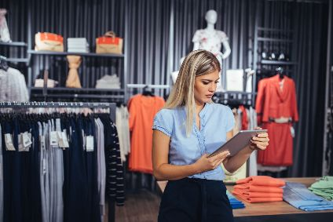
PESTEL Analysis of the fashion retail industry in the UK
This detailed PESTEL Analysis of the fashion retail industry in the UK aims to explore how some of the political, economic, social, technological, environmental, and legal factors influence the UK fashion retail industry. Clothing has always been a big business for the UK. In fact, the fashion industry contributes approximately £32 billion to the country’s economy.
Political factors affecting the fashion retail industry in the UK

The fashion retail industry in the UK has a global reputation. However, the recent lockdown and economic challenges have hit it very hard. Therefore, the industry has called for more financial support from the government. Without substantial support from the government, half of the industry may risk of walking into an unsustainable future.
Political stability in the UK has impacted on its fashion industry very positively. However, Brexit uncertainty has been a cause of concerns for many. The UK imports approximately £10 billion worth of clothes and shoes from Europe. Therefore, if the country’s existing trade relations with the EU disappear, the fashion industry may have to pay £1 billion more in each year, potentially causing a price hike for many clothing items (Tobin, 2019).
Many politicians and political figures impact on the UK’s fashion industry. What they wear and how they wear influence on the behaviour of many consumers. However, it is worth noting that clothing may sometimes go beyond the idea of ‘fashion’ and be used to express political statements.

Economic factors affecting the fashion retail industry in the UK
Clothing manufacturing is expensive in the UK. Therefore, many retail giants produce their fashion items in countries e.g. Bangladesh, India, Sri Lanka, Turkey, and China. Producing aboard helps them reduce the production cost and sell the end products at affordable prices. However, it does not mean that all the retailers sell their products cheap.
Armani, Next, Gap, Gucci, and Zara are expensive compared to Peacocks and Primark. This shows that the UK customers have a variety of options depending on their economic circumstances, when it comes to addressing their fashion needs and desires. In fact, fast-fashion retail chain Primark is doing fantastic as it caters for the needs of people who have budget limitations.
Fashion products are entirely different from food products. Therefore, recession and similar economic difficulties affect fashion retailers badly. However, it is also true that the fashion industry adapts quickly to any change of circumstance.

Social factors affecting the fashion retail industry in the UK
There are a good number of colleges and universities in the UK that prepare the fashion designers for tomorrow. Unsurprising, British nationals are in the leading positions of some of the most famous brands in the world. Likewise, a number of fashion events e.g. London Fashion Week, the Curve Fashion Festival, Glamour Beauty Festival London, and Manchester Fashion Week attract thousands of people from all over the world for shopping, catwalks, celebrity talks and much more.
Many people in the UK are heavy buyers of fashion products. No doubt that fast fashion dominates their buying habits. According to Wolstenholme (2018) more than 80% buyers buy clothes that they never wear. While it is fantastic for fashion companies, it is not good for the environment. It should be mentioned that brands endorsed by celebrities do really well in the UK.

Technological factors affecting the fashion retail industry in the UK
There is no doubt that more and more people are shopping online. Most of the fashion giants now have their e-commerce sites. Amazon, eBay, Debenhams, and Next are doing great online, while
boohoo.com, misguided.co.uk, prettylittlething.com, and many others are steadily becoming household names.
While it is difficult to establish a fashion brand name in the UK, e-commerce sites such as Amazon and eBay provide anyone with open opportunities to sell anything online. Many people have achieved financial freedoms by trading on Amazon and eBay. However, it is worth mentioning that competition is extremely fierce in the online segment of the UK fashion industry.

Environmental factors affecting the fashion retail industry in the UK
According to the UN (cited in Paton, 2019) the fashion industry is responsible for around 10% of global greenhouse gas emissions. This industry consumes more energy than the combined consumption of international aviation and shipping industries. This is really concerning for the UK, as 80% buyers buy clothes that they never wear. The UK shoppers purchase more clothes than any other country in Europe. They are also responsible for sending around 300,000 tons of clothes a year to burning or landfills. Therefore, campaign groups are urging the government to put pressure on fashion companies to take more responsibility and contribute to environmental sustainability.

Legal factors affecting the fashion retail industry in the UK
The UK fashion retail industry must adhere to the country’s rules and regulations set for the industry. Due to strict rules and costs, many companies have outsourced some of their operations abroad. While this saves costs for companies, many customers do not like it at all.
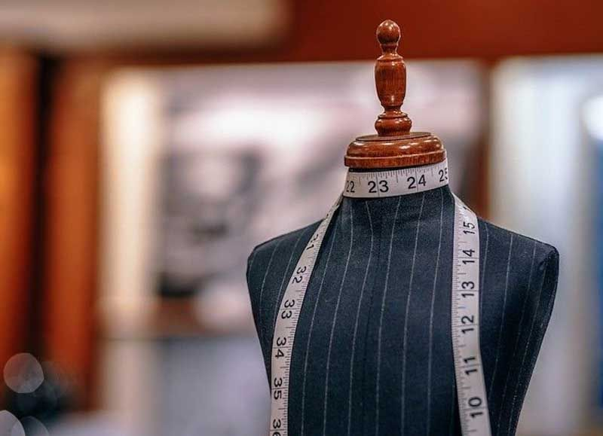
Resources:
- https://en.wikipedia.org/wiki/Impact_of_the_COVID-19_pandemic_on_the_fashion_industry
- https://howandwhat.net/pestel-analysis-fashion-retail-industry-uk/
- https://www.elle.com/uk/fashion/g32015646/coronavirus-fashion-brands/
- https://www.openaccessgovernment.org/covid-19-fashion-industry/89851/
- https://bntnews.bg/news/kak-koronavirusat-promeni-sveta-na-modata-1076987news.html

