
Christmas spirit flavored Introduction

John Lewis & Partners also known as John Lewis is a chain of department stores all over Britain, Ireland, and Australia. Unlike many other big store chains around the world John Lewis is an employee-owned mutual organization, hence the name John Lewis & Partners. They are all owners and partners. The secret to their success is simple - partnership, trust, professionalism, and responsibility. All these people and their teams with their brilliant ideas take shopping to a whole new level:



John Lewis & Partners has been focused on Christmas and especially their Christmas adverts for years now. It became a tradition many of us look forward to every year.


So, if you are anywhere on this island, you must have seen this year’s John Lewis Christmas advert. A schoolboy, noticing a strange object falling from the sky. The boy follows it and meets an alien named Skye. They become friends. The alien leaves and gives him a kiss on the cheek goodbye. So simple, yet watching it, like most of the previous John Lewis adverts gives you the feeling of a warm hug, a friendly smile, or just… hope. In this time of pandemic, lockdowns, and general panic it feels good to have moments like this, moments full of smiles and Christmas spirit. John Lewis once more is trying to make our lives a bit better, a bit fuller, and to leave us with a smile and a feeling of something good coming our way.

Beginnings and Partnerships
More than 150 years ago in 1864, they appeared on the market with the first of many stores in Oxford Street, London. It has been originally a drapery store. In 1905 the second store was a fact, this time in Sloan Square, again in London, followed by stores in Nottingham, Sheffield, Liverpool, and many more. The Irish and Australian stores were founded fairly recently in 2016.

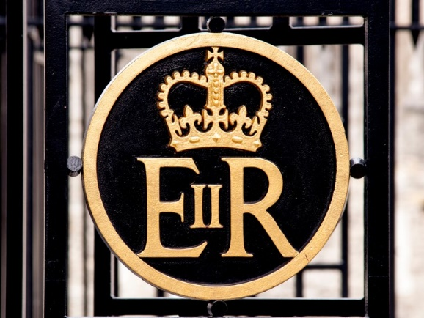
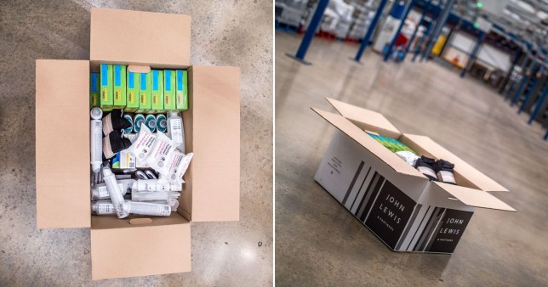
The company is very socially active. In Critical and Intensive units from a different 500 NHS hospitals was provided nearly 2000 boxes of essential products were. Their charity work and the help they provide to the NHS, the countless jobs they create - 80 900 employees in the period ending January 2021, set footprint. Their involvement in Britain’s everyday life, customer satisfaction, and environment-friendly ideas hasn’t gone unnoticed.
That very first store, the Oxford Street one has been honored in 2008 with one of the highest possible awards in their field: a Royal Warrant from the Queen as "suppliers of haberdashery and household goods". Only a year before this John Lewis officially became the holder of a Royal Warrant as a supplier of household and fancy goods. Anyone who manages to stay relevant and successful for over 150 years deserves a stand innovation.
You have probably heard of Duchy Originals, founded by Prince Charles himself. In 2009 Duchy appeared at Waitrose as Waitrose Duchy Organic. That is not the only royal fact Waitrose prides itself with. Her Majesty Queen Elizabeth II visited the store as well, the first time in 1984 and then again in 2008.

There is no doubt that the team is working hard, and their efforts are not without results. Waitrose farm located in Leckford Estate in Hampshire, property of John Lewis since 1929, is a place providing the store with all sorts of products amongst which vegetables, eggs, fish, and grapevines for wine production. The ethical part of it is also priority number one. Animals are treated with the utmost respect and care and the farming is environmentally friendly. Waitrose realizes that to be up-to-date and provide the best possible service and products to its customers at a good price, to stay relevant and successful, they created "Essential Waitrose '' for their loyal customers. Affordable yet adequate to the quality they provide and always focused on the customer's best interest.

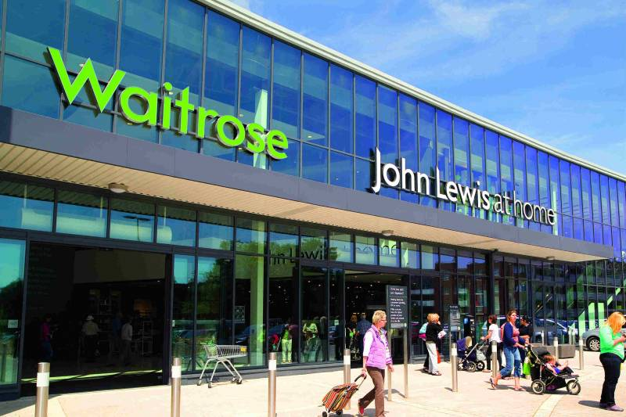
Waitrose

Part of John Lewis & Partnership is Waitrose & Partners. One of the stores of choice for most of Britain, which constantly competes for the first place in the business. So, let’s take a minute and look at what Waitrose has been doing lately. At John Lewis, our opinion as customers is not just important it matters. There has been more than one survey and the results are giving me personally hope.
About three-quarters of the people who took part in the survey have put an effort to minimize their food waste in 2021 and over half of them say they will continue doing it in the future. 77% of the customers worry about the plastic stores use to package everything and 71% of the customers refuse to use plastic packaging options when shopping so the amount of plastic packaging they bring home has been strongly reduced.
Caring about our planet is a team effort. No store chain can do it on its own, no matter how big or powerful. We all need to chip in and do our part.
Waitrose has a very ambitious goal I hope they can reach by 2023, as stated on their website. They plan on having all their food labels completely recyclable and reusable. That on its own would be a giant step in the right direction. For those of you who have heard of the Greenpeace annual plastic reduction league, well Waitrose got 1st place there this year. They have been using over 100 tons of plastic intercepted before it could reach the ocean. And it doesn’t stop there, their new DuraBag is a great alternative to the regular plastic bag. It is so much more durable and of course reusable and made entirely of recycled materials.
Zero waste has been an important part of the company policy for quite a while and even though it is not easy, they are not giving up. Every bit of food waste from every store has been used to make natural fertilizers and renewable energy.
John Lewis & Partners are specifically trying to target mostly the Gen Z or the so-called young people born between 1997 and 2015 since these are going to be their future customers – another clever move it may add. Caring about the planet is not a project with an expiration date, it is a never-ending job. Yes, there is still so much more to be done but by the looks of it, John Lewis & Partners plan to keep up the good work and the focus on environment-friendly projects.
As a company so firmly focused on innovation and constantly striving to make our lives better. Customer satisfaction is and always has been a priority. A brilliant move on their part was getting Paul Coby on board. The ex-CEO of British Airways brought a unique set of skills and endless experience which he then put to good use and the results followed shortly after.
John Lewis prides itself with a great tracking system operating and exercising control over every single customer order onsite in an actual store, just as well as the online ones. A well-oiled “machine” that connects your phone calls and e-mail requests with the right people, perfectly trained to help you at any given time with anything you need.
We are living or have been living for the past two years in a very unfortunate and far from perfect reality, not just in Britain but all over the world. Covid 19 forced us to limit our time outside the home and our social interactions in general. In a time like this, John Lewis’s online platform and its delivery system made shopping significantly easier and much safer for all of us. You have the choice to get all your purchases delivered right to your doorstep or to any given location of your choosing. For example, any given Waitrose store as well as over 500 branches of the Co-Op stores, which John Lewis signed a partnership contract to make shopping and delivery for us, customers, even easier.
The platform is extremely user-friendly. The whole online shop is focused not only on items you are interested in buying but also provides you with beauty tips and professional designer’s advice in multiple areas.
Anyone who ever stepped foot in Waitrose would confirm that the quality of the products as well as the variety and the customer service are indeed exquisite. Naturally, when a customer is treated like royalty and is completely satisfied with the quality of his purchases, they are more likely to come back.

Rooftop Magic

Right at the top of John Lewis Oxford Street’s building is where great ideas and a need to create beauty all around meet and present us with something unique. The boring concrete roof has been turned into a beautiful almost magical place, where we get to escape the madness of our fast lane London life full of work, responsibilities, bills, and chores, and just enjoy the relaxing atmosphere of the cocktail bar “Willows on the Roof”.
Whether with friends or by yourself after a long shopping spree, the rooftop bar with its welcoming and rather chilled vibe is a perfect way to finish the day or just to spend a few hours relaxing before you take on the next chapter of your busy day.
Take a minute on your day and visit “Willows on the roof”. Treat yourself to a delicious drink or any of the mouth-watering offerings they are offering. You won’t regret it.

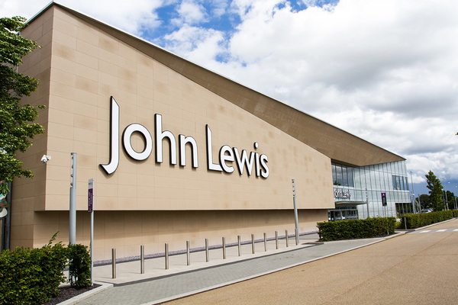
Welcome home
Another interesting strategic move is the fund’s John Lewis is currently investing in building homes in south-east England. The flats or houses will
be positioned on a land already owned by the company, tastefully furnished with their merchandise. Of course, near those apartment buildings, they will create more stores. What better way to provoke people to shop than building stores near their homes? You can’t help but shop. Smart move, John Lewis!
In conclusion, there is one thing we all can learn from John Lewis & Partners. The world we live in is our world and it is up to us to make it better for us and our loved ones. From the way we live, zero waste focused, to the way we shop and the way we treat others, whether it’s customers, friends, or strangers on the bus, to the way we treat ourselves. Teamwork, straight-up priorities, crystal clear goals, and hard work are what get results in life.

References:

Brignall, M. (2021) John Lewis plans to build 10,000 rental homes on its land.
Available at: https://www.theguardian.com/business/2021/jul/04/john-lewis-plans-to-build-10000-rental-homes-on-its-land-waitrose
(Accessed: 28th November 2021).

Curtin, A. (2021)
A ‘Willows On The Roof’ Winter Terrace Has Opened On Oxford Street And It Looks Magical.
Available at: https://secretldn.com/willows-on-the-roof/
(Accessed: 1st December 2021).

John Lewis Partnership (2021) Unexpected Guest (Extended Version) [video].
Available: https://www.youtube.com/watch?v=4LEHJob-kjQ
(Accessed: 02nd December 2021).
John Lewis Partnership (2021). who we are
Available at: https://www.johnlewispartnership.co.uk/about/who-we-are.html
( Accessed: 30th November 2021).
Love Money (2019) Waitrose: the story of how it started and why it's become a British high street favorite.
Available at: https://www.lovemoney.com/gallerylist/80196/waitrose-the-story-of-how-it-started-and-why-its-become-a-british-high-st
(Accessed: 01st December 2021).

Statista Research Department (2021) John Lewis Partnership - statistics & facts.
Available at: https://www.statista.com/topics/8716/john-lewis-partnership/
(Accessed: 1st December 2021).

Statista Research Department (2021) Number of employees at John Lewis Partnership plc in the United Kingdom (UK) from 2009 to 2021.
Available at: https://www.statista.com/statistics/420213/john-lewis-partnership-employees-united-kingdom-uk/
(Accessed: 30th November 2021).

