April 1, 2024
Cheng Chen (2305261)
University of Wales Trinity Saint David
BSc Applied Computing
Analyse the networks and discuss its security postures
L4 - Network and Cybersecurity Essentials (ACCA4024)
Contents
Abstract: 2
Introduction: 2
Part 1: 3
a) The Vital Role of the NIST Cybersecurity Framework in Safeguarding Digital Assets and Personal Data. 3
b) As stated in the introduction, Reconnaissance is the first stage in the “cyber kill chain” used by cybercriminals to gather pertinent information about their target. 4
c) Cyber – Attacks and Mitigations strategies 7
i) WannaCry and TeleRAT Malware: Operation and Mitigation 7
ii) Whaling and Pharming Phishing Attacks: Implementation and Mitigation 8
Part 2: 10
a) Using a network diagram (topology) or illustrations, create a secure network design 10
b) The software and hardware technologies can be implemented to enhance network security during its operation 12
Complete “Introduction to Packet Tracer” 13
Complete all the 5 Module Exams and Final Exam for Palo Alto Network Security Fundamentals 13
Conclusion: 15
Recommendations: 15
Future Work: 16
References 17

Abstract:
This paper delves into the realm of cybersecurity, focusing on the imperative task of safeguarding digital assets and personal data today. It begins by elucidating the evolving challenges and opportunities within the field, emphasizing the necessity of possessing essential knowledge and skills. The National Institute of Standards and Technology (NIST) Cybersecurity Framework emerges as a crucial tool in achieving the overarching objective of safeguarding digital assets and personal data. Further, the paper explores the reconnaissance stage of cyber-attacks, highlighting the utilization of tools such as Nmap and Wireshark to gather pertinent information about targets. Additionally, it examines prevalent cyber-attacks like WannaCry and TeleRAT, elucidating their operational mechanisms and proposing effective mitigation strategies. Furthermore, the implementation of phishing attacks known as Whaling and Pharming is discussed alongside mitigation strategies. In the latter part, a secure network design is presented, incorporating design principles focused on achieving high availability. Finally, software and hardware technologies aimed at enhancing network security during operation are detailed, ensuring comprehensive protection against cyber threats.

Introduction:
Safeguarding digital assets and personal data has become paramount in contemporary society. With the proliferation of cyber threats, understanding cybersecurity and its multifaceted challenges is crucial. This paper aims to explore various aspects of cybersecurity, from the utilization of the NIST Cybersecurity Framework to the implementation of reconnaissance tools like Nmap and Wireshark. Additionally, it delves into prevalent cyber-attacks such as WannaCry and TeleRAT, elucidating mitigation strategies. Furthermore, phishing attacks, including Whaling and Pharming, are examined alongside effective countermeasures. The paper also presents a secure network design, emphasizing high availability through the elimination of single points of failure and reliable crossover. Finally, it discusses software and hardware technologies aimed at bolstering network security during operation.

Part 1:

a) The Vital Role of the NIST Cybersecurity Framework in Safeguarding Digital Assets and Personal Data.
The NIST cybersecurity framework is a powerful tool to organize and improve your cybersecurity program. [1] The National Institute of Standards and Technology (NIST) Cybersecurity Framework plays a pivotal role in the contemporary landscape of cybersecurity, particularly in the safeguarding of digital assets and personal data. In an era characterized by evolving cyber threats and rapid technological advancements, the NIST framework serves as a comprehensive guide and roadmap for organizations to enhance their cybersecurity posture effectively.

The NIST Cybersecurity Framework provides a standardized approach to cybersecurity risk management. It offers a common language and set of best practices that enable organizations, regardless of size or industry, to assess and mitigate cyber risks systematically. By following the framework's guidelines, organizations can identify and prioritize their cybersecurity needs, thus facilitating the development of tailored strategies to safeguard their digital assets and personal data.
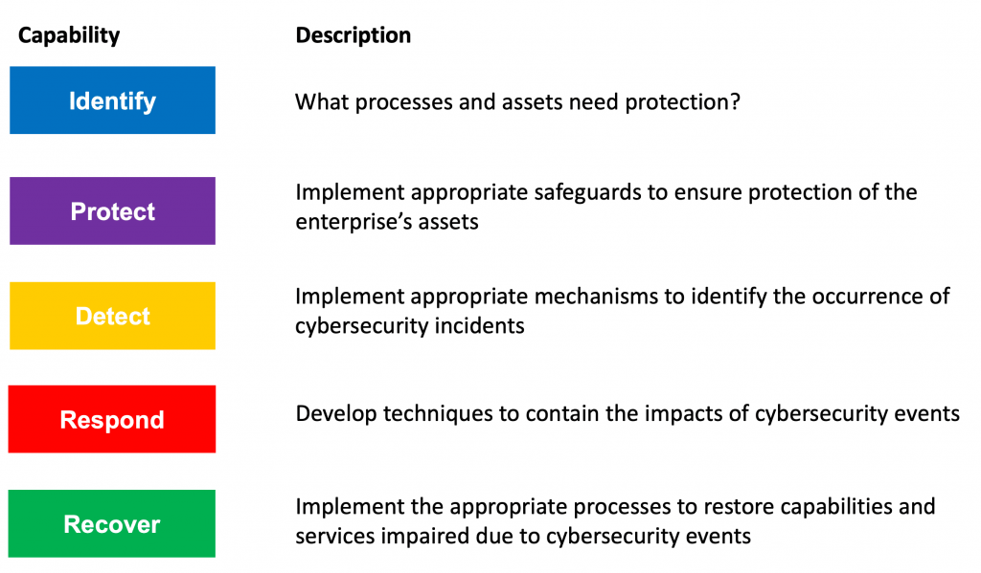
NIST Cybersecurity Framework [2]
The NIST framework emphasizes the importance of risk-based decision-making. In today's dynamic threat landscape, where cyber threats are constantly evolving and becoming more sophisticated, organizations must adopt a proactive approach to cybersecurity. The framework encourages organizations to conduct regular risk assessments, identify potential vulnerabilities, and implement appropriate controls to mitigate risks effectively. By aligning cybersecurity efforts with the organization's overall risk management strategy, the NIST framework enables organizations to make informed decisions about resource allocation and risk prioritization, thereby enhancing their ability to safeguard digital assets and personal data.

Another key aspect of the NIST Cybersecurity Framework is its emphasis on collaboration and information sharing. In today's interconnected world, cyber threats often transcend organizational boundaries, necessitating collaboration among various stakeholders, including government agencies, industry partners, and cybersecurity professionals. The framework promotes collaboration by providing a common set of cybersecurity principles and guidelines that facilitate communication and information sharing among stakeholders. By fostering collaboration, the NIST framework enables organizations to leverage collective expertise and resources to address cybersecurity challenges more effectively, thereby enhancing the overall security posture of the ecosystem.

The NIST framework promotes continuous improvement and adaptation to evolving threats and challenges. Cybersecurity is a constantly evolving field, with new threats emerging regularly and existing threats evolving in sophistication. The framework emphasizes the importance of ongoing monitoring, evaluation, and adjustment of cybersecurity strategies and controls to address emerging threats effectively. By adopting a continuous improvement mindset, organizations can stay ahead of cyber threats and adapt their cybersecurity measures to mitigate new risks effectively.

The NIST Cybersecurity Framework plays a vital role in achieving the dominant objective of safeguarding digital assets and personal data today by providing a standardized approach to cybersecurity risk management, promoting risk-based decision-making, fostering collaboration and information sharing, and emphasizing continuous improvement and adaptation to evolving threats. By following the guidelines outlined in the framework, organizations can enhance their cybersecurity posture and effectively mitigate cyber risks, thereby safeguarding their digital assets and personal data against potential threats.

b) As stated in the introduction, Reconnaissance is the first stage in the “cyber kill chain” used by cybercriminals to gather pertinent information about their target.
Nmap and Wireshark are powerful tools commonly used by cybercriminals during the reconnaissance stage of a cyber-attack to gather crucial information about their target.

Nmap is a network scanning tool—an open-source Linux command-line tool—used for network exploration, host discovery, and security auditing. [3] Nmap, short for Network Mapper, enables cybercriminals to discover hosts and services on a computer network, thus providing valuable insights into the network topology and potential vulnerabilities. One example of how Nmap can contribute to reconnaissance is by conducting a port scan. Cybercriminals can use Nmap to scan a target network for open ports, which can indicate the presence of running services and potentially vulnerable entry points.

- Example: 1
TCP SYN scanning is a network scanning technique used to determine open ports on a target host.
sudo nmap -sS <<Target_computer_ip_address>>
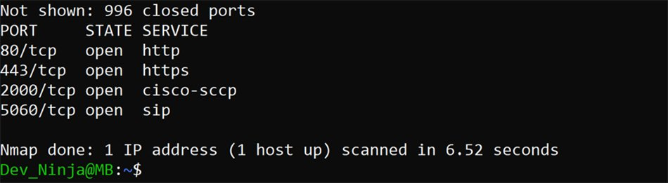
A TCP SYN scan shows results about the port, state and services. [4]

- Example 2
Version detection scanning is a network scanning technique designed to determine the specific version information of network services running on a target host.
sudo nmap -sV <<Target_computer_ip address>>
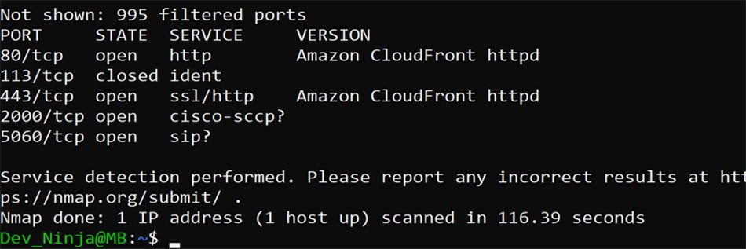
A version detection scan shows results about services running on open ports. [4]

Wireshark will help you capture network packets and display them at a granular level. [5] On the other hand, is a network protocol analyser that allows cybercriminals to capture and analyse the traffic flowing through a network in real-time. By intercepting and inspecting network packets, Wireshark enables cybercriminals to gather detailed information about network communications, including the types of protocols being used, the source and destination addresses of packets, and even the contents of unencrypted data. Cybercriminals can use Wireshark to capture network traffic during a reconnaissance phase, allowing them to identify patterns of communication between devices and potentially uncover sensitive information such as usernames, passwords, or system configurations.

- Example
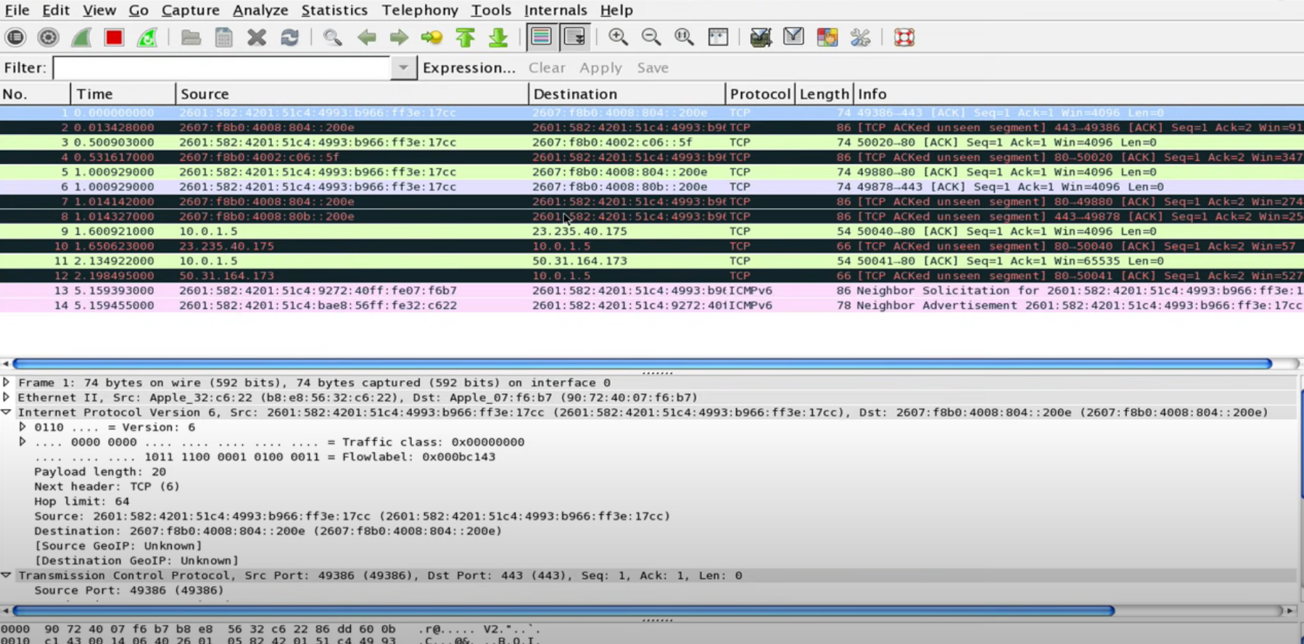
Viewing Packet Captures in Wireshark

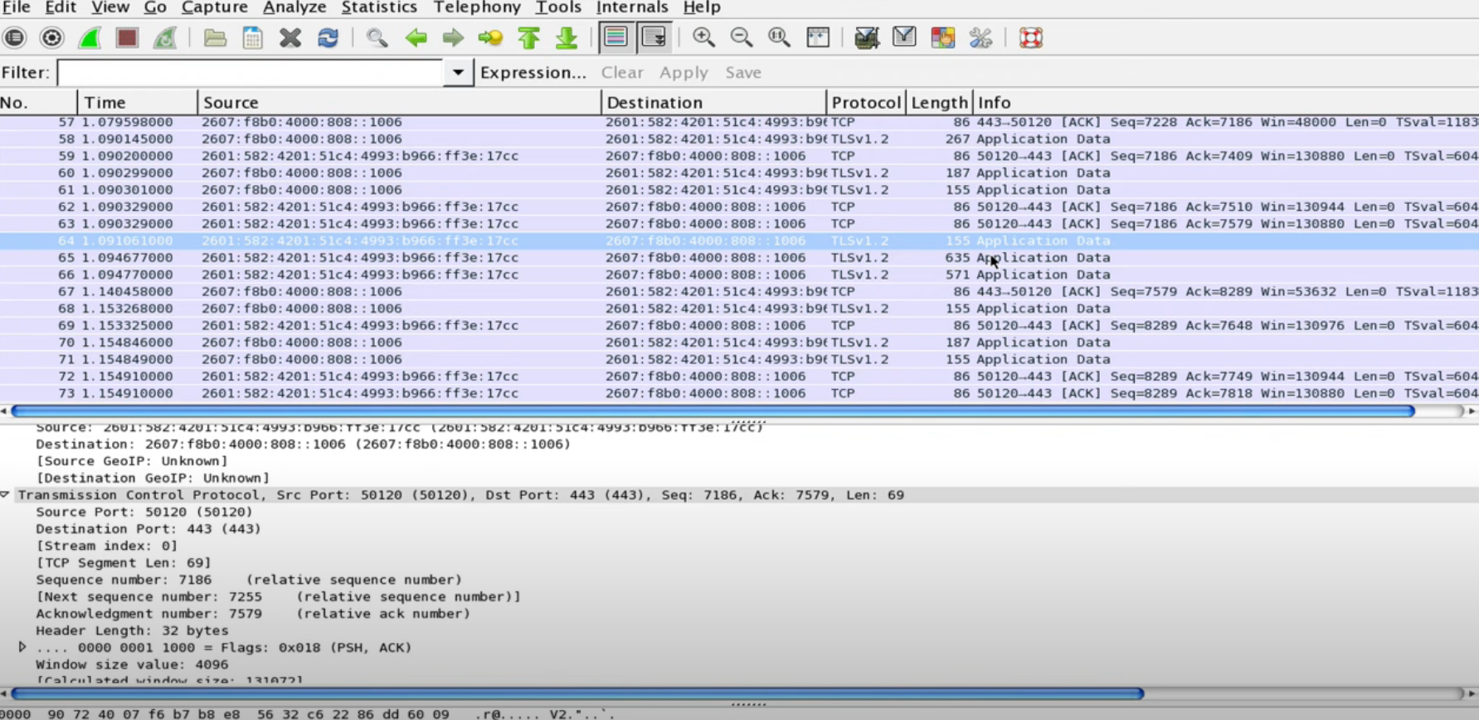
Finding what application / process is sending packets:

Nmap is for scouting and knowing the landscape, while Wireshark is for stealthily collecting what could be interesting data and bringing them back to camp for analysis. [6] Nmap and Wireshark are essential tools in the reconnaissance stage of a cyber-attack, allowing cybercriminals to gather pertinent information about their target network and potential vulnerabilities. Nmap facilitates the discovery of hosts and services by conducting port scans, while Wireshark enables the capture and analysis of network traffic to uncover valuable insights into network communications and potential security weaknesses.

c) Cyber – Attacks and Mitigations strategies

i) WannaCry and TeleRAT Malware: Operation and Mitigation
- WannaCry:
WannaCry, a notorious ransomware, Ransomware does this by either encrypting valuable files, so you are unable to read them, or by locking you out of your computer, so you are not able to use it. [7] spread rapidly in May 2017, infecting countless computers worldwide. It exploited a vulnerability in the Windows operating system, particularly targeting the Server Message Block (SMB) protocol. WannaCry encrypted files on compromised computers and demanded Bitcoin ransom for decryption. It spread laterally through networks using the EternalBlue exploit leaked from the NSA.

Mitigation Strategies:
1. Patch Management: Prioritize patching systems to address known vulnerabilities, especially the one exploited by WannaCry. Regularly applying security patches prevents vulnerability exploitation and mitigates infection risks.

2. Network Segmentation: Implement network segmentation to restrict WannaCry spread within the organization. Isolate critical systems from less secure areas to contain ransomware impact and prevent lateral movement.

3. Backup and Recovery: Maintain regular backups of essential data to mitigate WannaCry impact. Ensure backup integrity to restore encrypted files, minimizing data loss, and reducing ransom payment incentives.

- TeleRAT:
TeleRAT, a remote access trojan (RAT), Telegram's Bot API was already being employed by attackers to steal information ranging from SMS and call history to file listings from infected Android devices. [8] Grants cybercriminals unauthorized access to compromised systems. It commonly spreads via phishing emails or malicious downloads, disguising as legitimate software or documents. TeleRAT enables remote control over infected devices, data exfiltration, and various malicious activities without user awareness.
Mitigation Strategies:
1. Employee Training: Educate employees on phishing email risks and the importance of cautious behaviour regarding attachments or links. By raising awareness about phishing tactics, employees can recognize and report suspicious emails, mitigating TeleRAT threats.

2. Endpoint Security Solutions: Deploy endpoint security solutions like antivirus and intrusion detection to detect and block TeleRAT infections. These solutions identify and isolate malicious files or processes, preventing endpoint compromise and data access.

3. Network Monitoring: Implement robust network monitoring tools and intrusion detection systems to detect unauthorized access and suspicious activity associated with TeleRAT. By monitoring traffic and analysing logs, organizations can identify and respond to security breaches promptly.

These mitigation strategies aim to reduce the impact of WannaCry and TeleRAT attacks, safeguarding organizations against data loss, financial damage, and reputational harm.

ii) Whaling and Pharming Phishing Attacks: Implementation and Mitigation
- Whaling:
Whaling attacks, targeting high-level executives to gain access to sensitive financial information or execute fraudulent transactions. With the aim of stealing money or sensitive information or gaining access to their computer systems for criminal purposes. [9]

Mitigation strategies:
1. Employee Awareness Training: Regular and comprehensive training programs should educate all employees, especially those in leadership positions, about the risks associated with whaling attacks. Training sessions should cover common phishing tactics, including email spoofing and social engineering techniques. Employees must be encouraged to exercise caution and scepticism, verifying the authenticity of email requests, especially those involving financial transactions or sensitive data.

2. Multi-Factor Authentication (MFA): Implementing MFA solutions adds an additional layer of security to critical accounts and transactions. By requiring multiple forms of authentication, such as passwords, biometrics, or one-time passcodes, MFA mitigates the risk of unauthorized access, even if attackers obtain login credentials through a whaling attack.

3. Email Filtering and Authentication: Deploy advanced email filtering technologies and authentication mechanisms to detect and block spoofed, or fraudulent emails associated with whaling attacks. Utilize Sender Policy Framework (SPF), DomainKeys Identified Mail (DKIM), and Domain-based Message Authentication, Reporting, and Conformance (DMARC) to verify email authenticity. Configure email filters to flag suspicious emails for review by IT security personnel, preventing them from reaching employees' inboxes.

- Pharming:
Pharming attacks manipulate DNS records to redirect users to fraudulent websites, posing significant security risks. Is an online scam similar to phishing, where a website's traffic is manipulated, and confidential information is stolen. [10]

Mitigation strategies:
1. Secure DNS Configuration: Maintain up-to-date DNS software and patches to address vulnerabilities and enhance DNS security. Implement strong encryption protocols and enable DNSSEC to protect against DNS hijacking and manipulation, reducing the risk of unauthorized redirection to malicious websites.

2. Website Authentication: Employ advanced website authentication mechanisms such as Extended Validation (EV) SSL/TLS certificates and HTTP Strict Transport Security (HSTS) to validate website authenticity. EV SSL/TLS certificates provide visual cues, indicating a website's legitimacy, while HSTS ensures secure connections. These measures make it challenging for cybercriminals to impersonate legitimate sites and conduct pharming attacks.

3. Network Monitoring and Analysis: Deploy comprehensive network monitoring and analysis tools to detect anomalous DNS traffic patterns indicative of pharming attacks. Continuously monitor DNS requests and analyse network traffic for signs of unauthorized redirection or manipulation, enabling prompt identification and mitigation of suspicious activities.

By implementing these proactive measures, organizations can effectively mitigate the risks associated with Whaling and Pharming attacks, safeguarding their assets, data, and reputation against cyber threats.

Part 2:

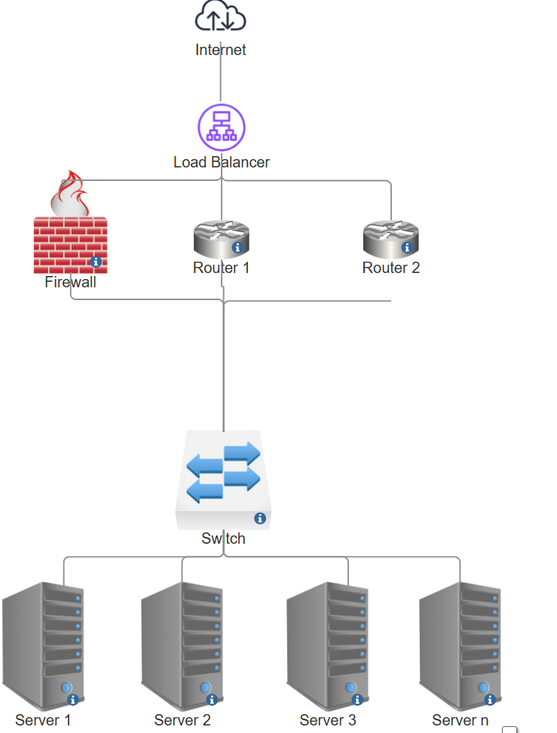
Using a network diagram (topology) or illustrations, create a secure network design.
In this design we have the following components:
- Internet: represents the external Internet.
- Load Balancer: responsible for distributing incoming traffic to multiple backend servers to improve performance and availability. Load balancers also monitor the health of servers and divert traffic from failed servers to healthy servers when necessary.
- Firewall: Used to protect the network from malicious traffic and attacks.
- Routers (Router 1 and Router 2): are responsible for forwarding traffic from the internal network to the external network (Internet) and back. By using dynamic routing protocols such as OSPF (Open Shortest Path First) or BGP (Border Gateway Protocol), it is possible to ensure that traffic can be forwarded between different paths for reliable crossover.
- Switch Layer: Provides LAN connectivity between devices in the internal network.
- Servers (Server 1 to Server n): host network services and applications, such as Web servers, database servers, and so on.

High Availability Explained
Elimination of Single Point of Failure: In this design, we have eliminated single point of failure by using load balancer, multiple routers, and firewalls. If one of these components fails, the others can take over their functions, thus ensuring network connectivity and service availability.
Provides reliable crossover: By using multiple routers and dynamic routing protocols, we can achieve reliable crossover. If a router fails or a link goes down, the dynamic routing protocol will automatically select an alternate path to ensure that traffic can continue to be forwarded normally, thus ensuring network connectivity and availability.

Packet Tracer Topology and Basic Configuration
In this network topology, we can use packet tracer to simulate the path of traffic and verify the dynamic routing protocols between routers. We can also configure basic rules for load balancers and firewalls to ensure that traffic is transmitted securely and efficiently.
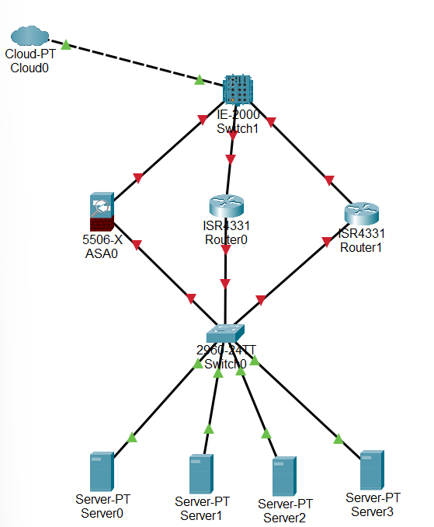

The software and hardware technologies can be implemented to enhance network security during its operation.
To enhance network security during its operation, several software and hardware technologies can be implemented:
1. Next-Generation Firewalls (NGFW): NGFW is a security appliance that processes network traffic and applies rules to block potentially dangerous traffic. [11] NGFWs provide advanced features such as deep packet inspection and intrusion prevention, allowing organizations to enforce granular security policies based on application, user, and content. They block malicious traffic and identify threats in real-time, enhancing network security.

2. Intrusion Detection and Prevention Systems (IDPS): An intrusion detection and prevention system (IDPS) is a solution that monitors a network for threats and then takes action to stop any threats that are detected. [12] IDPS monitor network traffic for suspicious activity and known attack patterns, automatically blocking or mitigating threats. They protect against unauthorized access and data breaches by detecting and responding to potential security incidents.

3. Endpoint Security Solutions: These protect devices from malware and cyber threats. They include antivirus software, anti-malware tools, and endpoint detection and response capabilities, ensuring the security of individual devices and sensitive data.

4. Network Access Control (NAC) Systems: NAC ensures only authorized devices and users access the network by assessing device security posture before granting access. This prevents unauthorized access and reduces the risk of insider threats.

5. Virtual Private Networks (VPNs): Which stands for virtual private network, establishes a digital connection between your computer and a remote server owned by a VPN provider. [13] VPNs create encrypted tunnels for remote users to securely access the network. They protect data transmitted over untrusted networks, ensuring confidentiality and integrity.

Implementing NGFWs, IDPS, endpoint security, NAC systems, and VPNs enhances network security by enforcing policies, detecting threats, and securing access, ensuring data confidentiality and integrity.

Complete “Introduction to Packet Tracer”
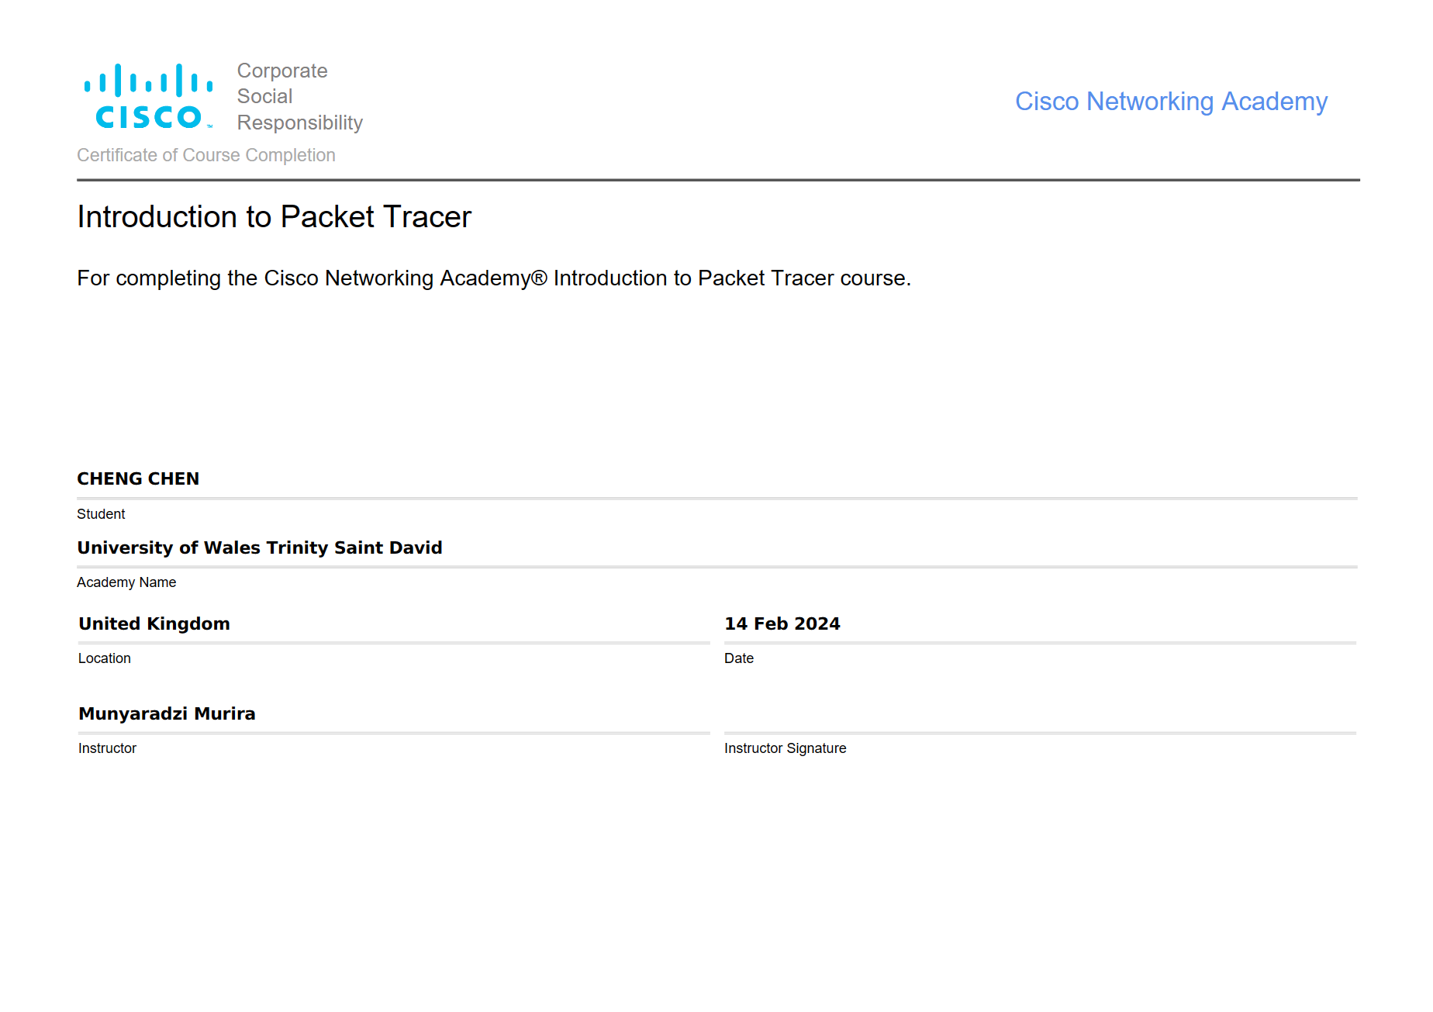

Complete all the 5 Module Exams and Final Exam for Palo Alto Network Security Fundamentals
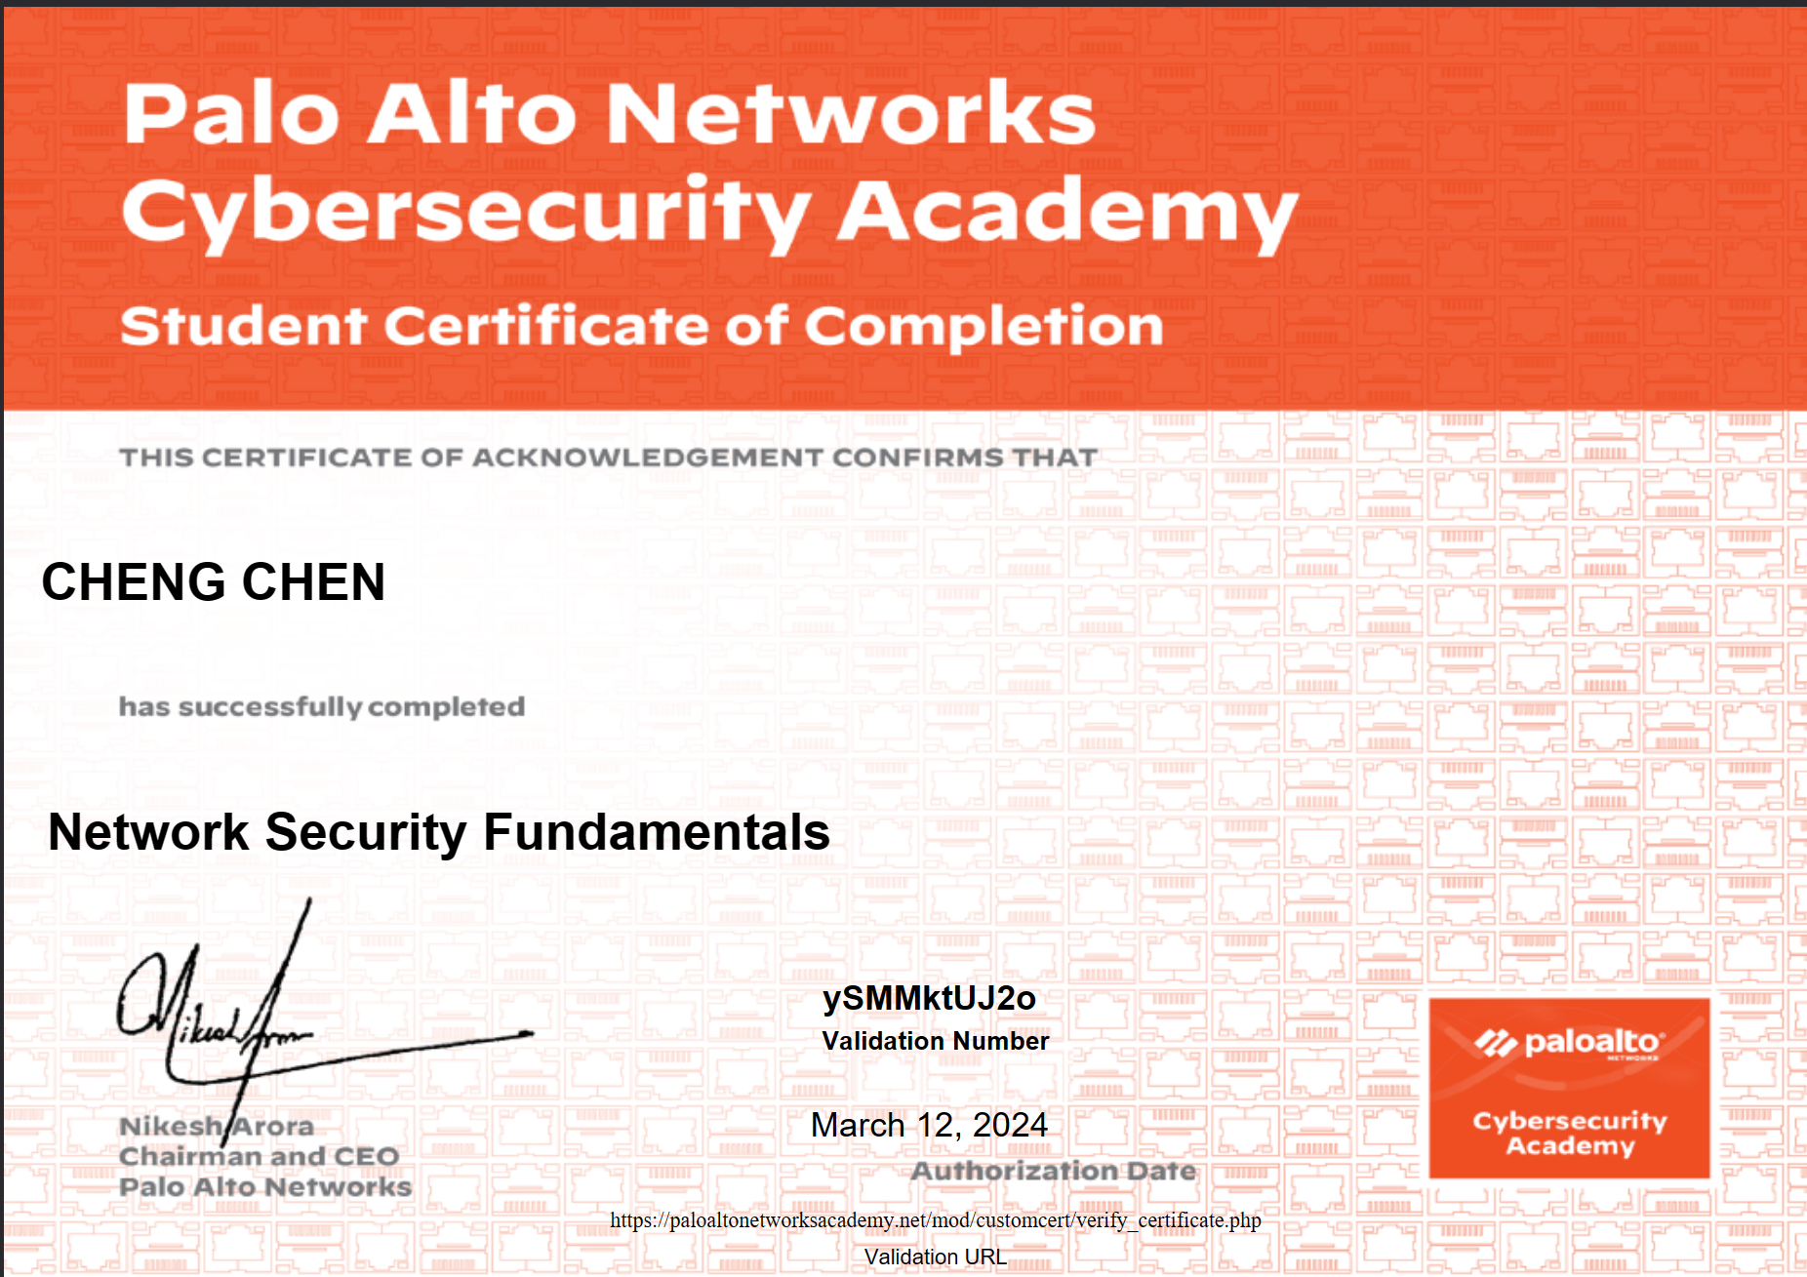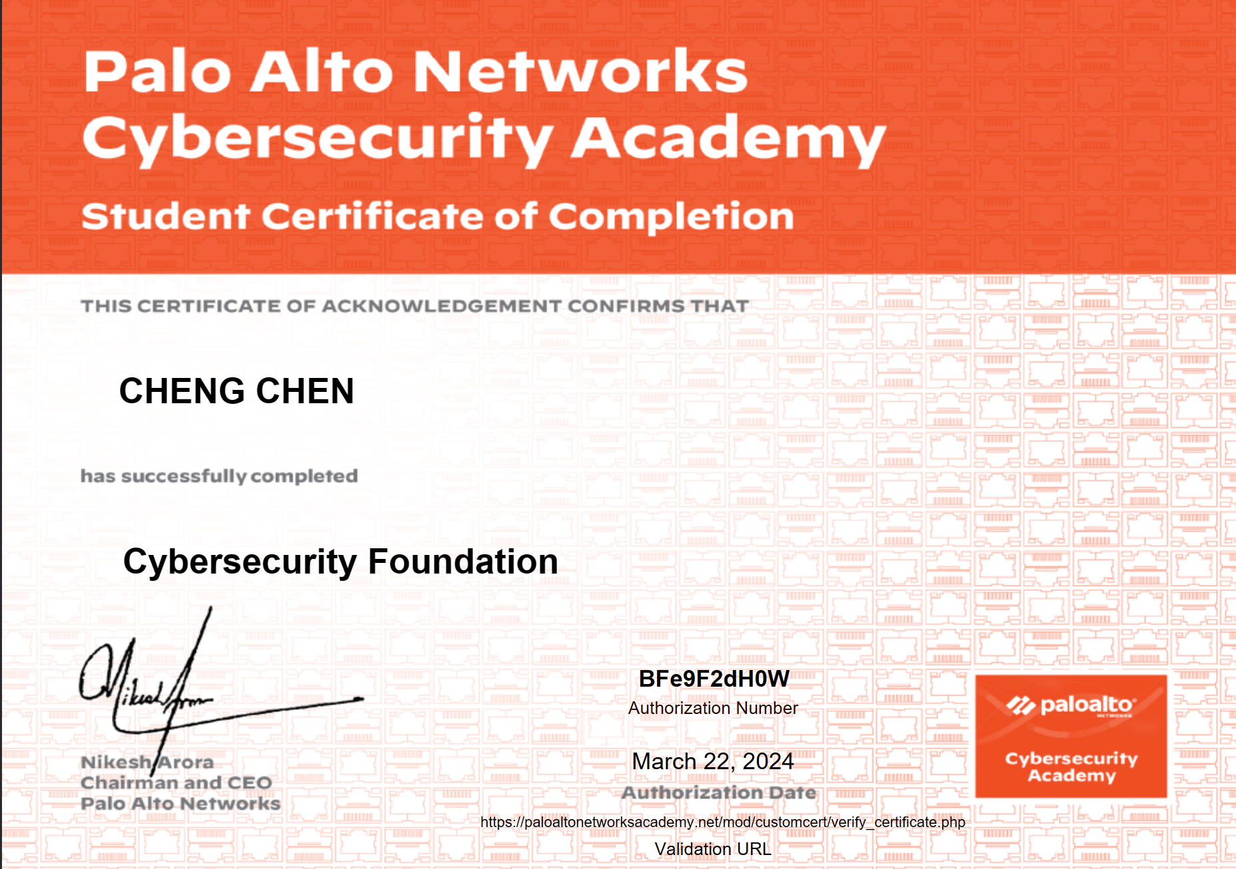

Conclusion:
In conclusion, the analysis of Whaling, Pharming, WannaCry, and TeleRAT underscores the critical importance of robust cybersecurity measures in safeguarding organizations against evolving cyber threats. Whaling and Pharming attacks exploit human vulnerabilities and weaknesses in DNS infrastructure, posing significant risks to data integrity and financial security. Meanwhile, WannaCry and TeleRAT represent formidable threats with their capabilities to infiltrate and compromise systems, leading to data encryption, unauthorized access, and potential financial losses.

Recommendations:
Based on the findings, several recommendations emerge:
1. Investment in Cybersecurity Training: Organizations should prioritize cybersecurity awareness training for employees, particularly focusing on phishing email recognition, safe browsing practices, and adherence to security protocols.

2. Implementation of Multi-Layered Defence: Deploying a multi-layered defence approach, including advanced endpoint security solutions, network monitoring tools, and robust access controls, can effectively mitigate the risk of cyber-attacks like Whaling, Pharming, WannaCry, and TeleRAT.

3. Regular Patch Management and Vulnerability Assessments: Organizations must maintain up-to-date patch management practices and conduct regular vulnerability assessments to address known vulnerabilities promptly and prevent exploitation by ransomware and remote access trojans.

4. Enhanced Backup and Recovery Strategies: Strengthening backup and recovery strategies, including regular backups of critical data and rigorous testing of recovery processes, is essential for minimizing the impact of ransomware attacks and ensuring business continuity.

Future Work:
For future work, further research and development efforts could focus on:
1. Advanced Threat Detection Technologies: Exploring emerging technologies such as artificial intelligence and machine learning for advanced threat detection and response capabilities to combat evolving cyber threats effectively.

2. Behavioural Analysis and Anomaly Detection: Investigating behavioural analysis techniques and anomaly detection algorithms to identify suspicious activities and malicious behaviours associated with sophisticated cyber-attacks like Whaling, Pharming, and TeleRAT.

3. Collaborative Defence Strategies: Encouraging collaboration among organizations, industry stakeholders, and government agencies to share threat intelligence, best practices, and cybersecurity resources for collective defence against cyber threats on a broader scale.

4. Regulatory Compliance and Cybersecurity Standards: Adhering to regulatory compliance requirements and industry cybersecurity standards to ensure robust security posture and resilience against cyber-attacks, while also promoting a culture of cybersecurity awareness and accountability within organizations.

By implementing these recommendations and focusing on future work areas, organizations can strengthen their cybersecurity posture, mitigate cyber risks effectively, and better protect their digital assets and sensitive information from evolving threats in the dynamic cyber landscape.

References
[1] “What is the NIST Cybersecurity Framework?,” 2020. https://www.balbix.com/insights/nist-cybersecurity-framework/ (accessed Apr. 25, 2024).
[2] “What is the NIST Cybersecurity Framework?,” 2020. NIST-cybersecurity-framework-1024x599.png (1024×599) (balbix.com) (accessed Apr. 25, 2024).
[3] “How to Use Nmap | UpGuard.” https://www.upguard.com/blog/how-to-use-nmap (accessed Apr. 25, 2024).
[4] “Types of Nmap scans and best practices | TechTarget.” https://www.techtarget.com/searchnetworking/tip/Types-of-Nmap-scans-and-best-practices (accessed Apr. 16, 2024).
[5] “What Is Wireshark and How to Use It | Cybersecurity.” https://www.comptia.org/content/articles/what-is-wireshark-and-how-to-use-it (accessed Apr. 25, 2024).
[6] “Nmap vs Wireshark: 2024 Comparison,” 2023. https://www.stationx.net/nmap-vs-wireshark/ (accessed Apr. 25, 2024).
[7] “What is WannaCry ransomware?,” 2024. https://www.kaspersky.com/resource-center/threats/ransomware-wannacry (accessed Apr. 25, 2024).
[8] W. Kyle Ruchna Nigam, “TeleRAT: Another Android Trojan Leveraging Telegram’s Bot API to Target Iranian Users,” 2018. https://unit42.paloaltonetworks.com/unit42-telerat-another-android-trojan-leveraging-telegrams-bot-api-to-target-iranian-users/ (accessed Apr. 25, 2024).
[9] “What is a Whaling Attack?,” 2023. https://www.kaspersky.com/resource-center/definitions/what-is-a-whaling-attack (accessed Apr. 25, 2024).
[10] “What Is Pharming and How to Protect Yourself,” 2023. https://www.kaspersky.com/resource-center/definitions/pharming (accessed Apr. 25, 2024).
[11] “What is a next-generation firewall (NGFW)?” https://www.cloudflare.com/learning/security/what-is-next-generation-firewall-ngfw/ (accessed Apr. 25, 2024).
[12] “What is an intrusion detection and prevention system (IDPS)?” https://www.redhat.com/en/topics/security/what-is-an-IDPS
[13]“What is a VPN? Why Should I Use a VPN? | Microsoft Azure.” https://azure.microsoft.com/en-us/resources/cloud-computing-dictionary/what-is-vpn (accessed Apr. 25, 2024).

