Chapter 3: Methodology
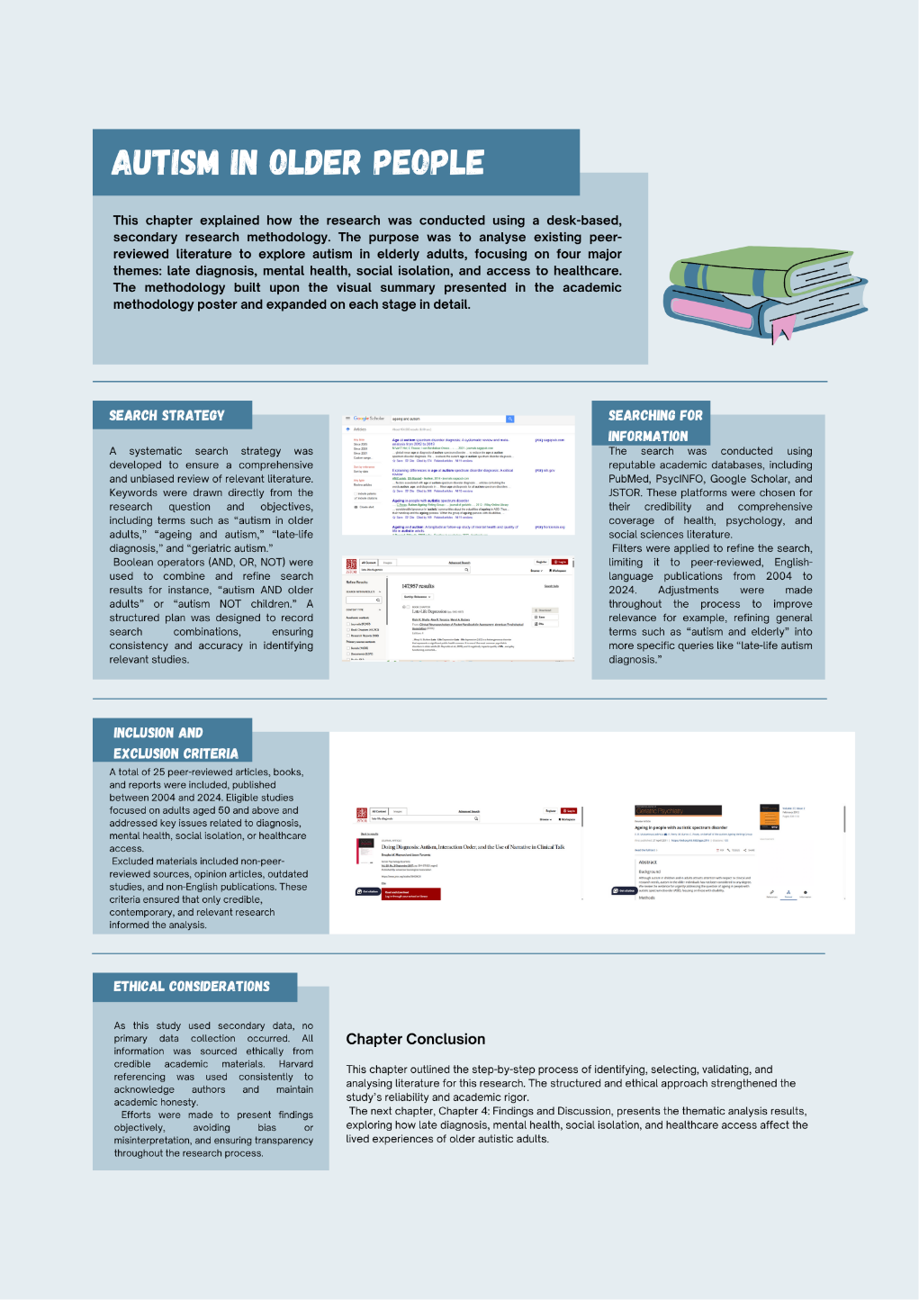

3.1 Introduction

In this chapter, the methodological approach used in conducting the research is explained. It has elaborated on the academic methodology poster, providing a detailed description of the desk-based and literature-based methods used. As the research employed only secondary research, the available peer-reviewed articles, books, and reports were critically examined to examine autism in older adults. This approach enabled the synthesis of a comprehensive range of scholarly evidence without requiring the collection of primary data. The aim of the research process described in this chapter was to identify, review, and analyze pertinent sources that informed the thematic findings presented in Chapter 4.

3.2 Search Strategy

Keywords were formulated according to the research title and objectives and included autism in older adults, ageing and autism, late-life autism diagnosis, and geriatric autism. Similar technical synonyms like autism spectrum disorder, neurodiversity, and older adults with autism were also employed. Search terms were combined using Boolean operators (AND, OR, NOT) to narrow the search, e.g., adult autism and older adults or adult autism and children. A scheduled search plan has been developed to document pertinent search combinations systematically, ensuring consistency and accuracy throughout the research process.

3.3 Searching for Information

Peer-reviewed sources were found in the academic databases of PubMed, PsycINFO, Google Scholar, and JSTOR. These databases were selected as they are credible, accessible, and cover a wide range of the psychological, medical, and social research literature. Search filters were used to narrow the search to English-language articles that were peer-reviewed and published between 2004 and 2024, so that the findings were based on more recent research.
The search was conducted iteratively, and further modifications were made to enhance relevance and coverage. As an example, an initial search with the terms autism and elderly was further narrowed down to late diagnosis of autism in older adults to filter for more precise results. A source-tracking table was created to capture important information, including author, year, methodology, and key findings. This systematic arrangement facilitated systematic analysis and helped identify emerging themes in the reviewed literature.

3.4 Research Validation

To verify the sources, the articles were initially filtered using the titles, abstracts, introductions, and conclusions to determine their relevance. The quality of each source was evaluated using the CRAAP test, which assesses Currency, Relevance, Authority, Accuracy, and Purpose. The search studies were given priority to those that exhibited good currency (within the last 10 years), relevance, and authority as determined by reputable journals or institutions.
Not all studies were included as required, but preference was given to peer-reviewed studies that offered an empirical or theoretical perspective. Indicatively, older previous studies were included solely because they presented critical theoretical knowledge that remains relevant to the current research. This ensured the final selection was reliable and scholarly.

3.5 Inclusion and Exclusion Criteria

The inclusion and exclusion criteria were well formulated to facilitate the quality, relevance, and credibility of the research sources that were selected to be used in this study. The number of peer-reviewed articles, books, and reports (2004-2024) was chosen as 25 articles were reviewed. These sources were specifically on autism in adults aged 50 years and older, and this is where the study concentrates on ageing and neurodiversity. Both qualitative and quantitative studies were included, which have provided an opportunity to gain a clear picture of the life experiences, diagnosis, and disease burden of older adults with autism. The studies were incorporated in case they focused on major themes such as late diagnosis, mental health and emotional well-being, social isolation, and access to healthcare services.

However, non-peer-reviewed materials like blogs, opinion pieces, and magazine articles were excluded as non-academic and lacking in verifiable information. Studies that involved only children, adolescents, or young adults were also eliminated to ensure that the study remained on the elderly autistic population. Also, articles that were not written in English and those that were not published since 2004 were excluded so that only recent and pertinent results were used in the analysis.

Using these inclusion and exclusion parameters, the research was well-focused on high-quality and evidence-based literature. This method improved the trustworthiness and dependability of the results and ensured that the study would represent the latest information and comprehension of autism in the elderly over the past twenty years.

3.6 Analysing Research

A thematic coding methodology was employed to facilitate a systematic analysis of the 25 selected sources. All the articles were carefully read to identify common ideas, concepts, and patterns associated with the four key themes of the study: late diagnosis, mental health, social isolation, and access to healthcare. In the first stage, open coding was used to identify key phrases, common findings, and theoretical insights that were recurrently found in the literature. These early codes were then narrowed down and made under larger thematic headings, which were directly connected with the research objectives.

Spreadsheets, tables, and colour-coded highlights, among others, were also used to document emergent themes and patterns, ensuring that the entire process was well-organized and accurate. This made it easy to compare studies, and there was uniformity in cross-cutting issues. After finalizing the themes, they were subjected to critical scrutiny to ensure that the themes accurately reflected the key discussions and gaps in the literature.

This is a systematic analytical procedure that has enabled the incorporation of results from various materials to adopt a broader and more descriptive approach to autism in elderly individuals. Chapter 4: Findings and Discussion presents an evidence-based discussion and interpretation, grounded in the last thematic framework.

3.7 Ethical Considerations

This study employed only secondary research, so no primary data were collected, and therefore, no participant consent or ethical approval was required. There was also ethical integrity, as the authors' findings were properly represented, academic honesty was upheld, and the Harvard referencing style was consistently used throughout the report.
The references were made transparently to ensure credibility and prevent plagiarism. The researcher was objective in his choice and presentation of the literature, ensuring that interpretations were not biased or distorted by personal interests.

3.8 Chapter Conclusion

The chapter describes the secondary research process, which involved formulating keywords, conducting a systematic search of databases, and validating, selecting, and analyzing the literature thematically. A systematic approach was employed to ensure that only valid and relevant studies were incorporated, thereby enhancing the reliability of the findings.

