DIGITAL ENTREPRENEURSHIP

Moodle: BMMB7002D

Date: 27 July 2020

Student Name: Nathaniel Odoi

Student number: 1810442
https://youtu.be/kRzZfjxxIzg - link for Part A



Table of Contents
Introduction ………………………………………………………………………………... 3
Business strategy …………………………………………………………………………... 4
Understanding Amazons Virtuous Cycle ………………………………………………….. 5
Amazon’s Strengths on Porter’s Value chain Model ……………………………………… 5
Weaknesses of Porter’s Value chain in the case of Amazon ………………………………. 6
SWOT Analysis of Amazon ……………………………………………………………….. 7
How Amazon has infused digital technologies into its growth strategy …………………… 9
Conclusion …………………………………………………………………………………. 10
References …………………………………………………………………………………. 11

INTRODUCTION
Digital disruption in businesses is a new trend instigated by innovative and fresh technologies. These fresh technologies are not only impacting the business models but drive innovation, organisational change and new cultural behaviours. It has caused businesses to rethink about the way they do businesses and re-evaluate their goods and services (Oxford College of Marketing, 2020).
Amazon which is in the league of digital companies in 1994 commenced online bookstore trading and has significantly expanded meaningfully, now the company is extensively offering product catalogue which includes electronics, software, digital music, video on-demand, food, clothing and furniture. The company which was established by Jeff Bezos has an active employer base of almost 250 million and records net sales of around $70 billion annually, Amazon, undoubtedly is among the largest digital companies globally. The company functions under a ‘growth first’ approach and ploughs back all of its income in enlarging the company, no wonder Amazon is trading in over ten countries currently (Amazon.com).
Historical disruption in the retail sector
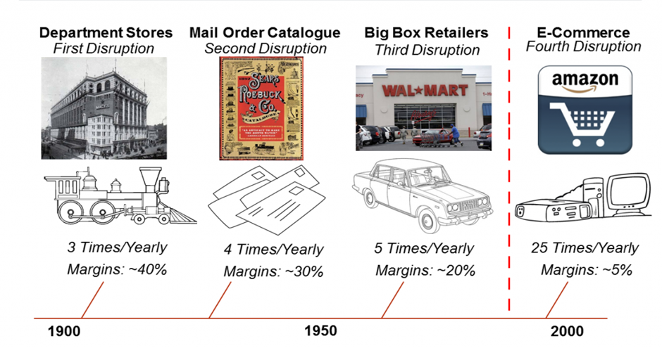
Significantly, Amazon interrupted the retail segment by not just making shopping from home stress-free but the ability in having variety of product to shop from, the company also bid its personal inner abilities as a service. Fulfilment, cloud computing warehouse space and e-commerce are examples of their internal capabilities which they provide to other firms, further stimulating the disruption of bricks-and-mortar trade. The physical and digital marketplaces are becoming increasingly intertwined, which makes the deployment of digital tools such as RFID chips, predictive analytics, AI or block chain a powerful instrument to keep a competitive edge in the retail industry.

Business Strategy
A corporation can adopt one or more of three basic strategies: cost leadership, differentiation or focus (Porter,1985). Equally, it is the vision of Amazon.com to offer product variations and fulfilment facilities in conjunction with reasonable prices that entails to attain economy of scope and economy of scale together with customer satisfaction. Besides, the owner’s (Jeff Bezos’s) borrowed the renowned flywheel drawing which demonstrates Amazon’s core corporate strategy as the growth tactic and Amazon.com’s virtuous cycle.
This concept is significant to understand how e-commerce leader controls its processes. The low prices encouraged more customer participation and that led to massive sales which fascinated further commission-paying third-party retailers to the site. That permitted Amazon to get extra out of fixed costs like the fulfilment centres and the servers required to run the website. This larger efficiency then empowered it to reduce prices further. Feed any part of this flywheel, they reasoned, and it should quicken the loop.

Amazon Flywheel: Understanding Amazons Virtuous Cycle

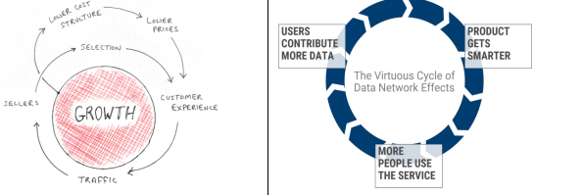
Source: Amazon Flywheel / Virtuous Cycle the key to Amazons success

This similar clue of motion applies to the business correspondence as well. Each enhancement Amazon's workers make to fuel the flywheel helps fast-track the company's cycle of progress. The flywheel model is continuing which demonstrate that technologies and services that Amazon delivers are subject to change over several periods, but the principal views, such as low prices, entrenched in the flywheel model should constantly reverberate with Amazon's customers, irrespective of the situation (Chaffey, 2018).

Amazon’s Strengths on Porter’s Value chain Model
The internal analysis of Amazon company will be covered using Porter’s Value Chain model. This will highlight the strengths and weakness of the company and how to curb the weakness in a form of recommendations. The approach has customers as the focal point. These are done in a set of activities done internally to gain competitive urge over competitors. In addition, as a part of Amazon customer centric policies, its value creation & proposition begins with Amazon sign that signifies a grin for the clients and also endures with product accessibility and variation together with lower prices to produce and deliver value (Zenger, 2013). The chart below is formed to depict that Amazon value chain drives to offer low prices and astonishing customer involvement which distinguishes Amazon by building loyalty and exceptional competitive superiority amid its rivals (Porter, 1980). Also, Amazon increases customer’s experiences together with its Amazon Prime retention program that also facilitates personalised services which are far appreciated by all ‘the Amazonians’ (Chaffey, 2018).

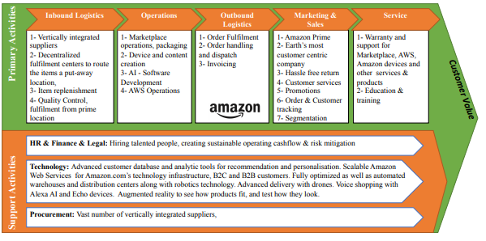
Source: value chain of Amazon

Weaknesses of Porter’s Value chain in the case of Amazon
There are enormous advantages of the Value chain Model but there is the risk of missing out the strategic assessment of the internal affairs of the organisation. This is because not all the set activities will be inter-related at all times and the focus could be one sided whilst other strategic planning could be missed out leading to failed approaches as enumerated below.
Failed approaches: Amazon failed by trying to build an organic travel and hotel retailing product (Called destinations) in 2015. This was the wrong approach because of the complexities in gaining access to travel inventory and lack of expertise in managing travel industry relationships. Despite of all its retailing prowess and innovation. The company had no idea on how to manage travel inventory unlike books or stocks. This appears too niche and a business that involves a lot of distinct sales support, which isn't really Amazon's style (Dennis, 2020).

SWOT Analysis of Amazon
SWOT tool is used by managers in various decision making and strategic planning of an organisation, is also interpreted as 2x2 Matrix (BusinessBalls.com, 2020). This Matrix will be used to assess the internal variance of Amazon focussing on the Strength and weaknesses (SW) for this report.
Amazon, the largest online retailer has gained competitive advantage over its cohorts because their strengths have been identified and utilised in the right way. Also, there are some few weaknesses that has been assessed internally that needs work on so that their rivals will not use to their advantage.

Strengths
The constant and cumulative existence of digital, social and mobile technologies in retail is pushing massive gravity on businesses in the division to certify they can deliver a fully unified knowledge across online and in-store platforms. The public is progressively digitally knowledgeable, and as such consumer embracing of these channels will continue to grow (Resca and Spagnoletti, 2014).

- The manifestation effect of Amazon is the unending consumer swing to shopping online. Online retail makes it likely for customers to shop from home or anyplace where there is internet access. They can purchase the precise product they are seek for without going through hassle and can go ahead and buy and arrange for delivery with just some clicks (Resca and Spagnoletti, 2014).
- Amazon Go, an e-commerce mobile application which allow consumers to purchase products in store without having to wait in long queues or checking out with registers. It uses machine learning, sensor technology, machine image and Artificial Intelligence (AI) to track items that customers pick up.
- Click and collect is also a hybrid e-commerce model which allows customers to purchase or select items online and collect them.
- Proximity beacon technology is alternative conversion of the retail setting. Beacons positioned in stores interconnect with customers mobile devices to assist them trace products and service.
- Low cost structure: Online selling helps Amazon to cut costs as compared to running a massive retail store physically. This in turn lower the cost of their products and reducing marginal costs whilst selling more units.

Weaknesses
- Online Streaming - As the digital marketing is booming, Amazon faces huge competition from a major rival in the likes of Netflix. The later has a cheaper monthly subscription to customers which may see most customers switching to subscribe with Netflix instead (Holt, 2019).
Recommendation on this is, amazon needs to have a basic account so the average customer can still subscribe using the basic account.
- Distribution – Amazon faces enormous risks at their distribution centres from safety, remunerations and treatment which has even attracted lawmakers. Workers are poorly paid and they also face several hazards in their work places especially with the current COVID-19 pandemic. Recommendation for this is, proper pay structure as well as other benefits should be awarded to the workers.
- Another Amazon consequence is how non e-commerce retailers and malls are striving to make shopping in person persuasive and lively experience for consumers. Fun and play areas have been established by many malls for children, in addition, lounge areas and salons as well as restaurants have been made accessible whilst shopping. Some have gone to the extent of building aquarium and dinosaur walk museum and Amusement park. Inspiring destination shopping is one achievement, enticing customers to a place because it delivers something in precise that makes it worth the outing. Providing a convincing atmosphere and encouraging shopping itself as the experience (Resca and Spagnoletti, 2014).

How Amazon has permeated digital technologies into its growth strategy

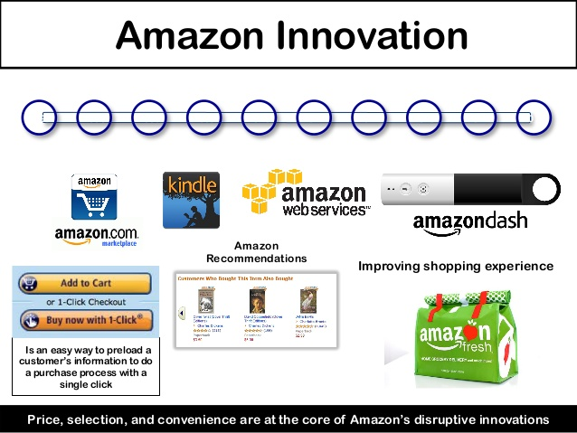
Digital technologies of Amazon are consistently evolving and growing regularly. The initial step Amazon took was to disrupt the book selling business, paving the way for customers to purchase their books online and get them received vial the mail. Leveraging physical products like movies, books and music getting digitised through aids like downloadable books, Amazon Prime Music, and Amazon Instant Video (Berg and Knights, 2019). This has permitted Amazon to offer wide array of assortment for customers while constantly reducing costs, like inventory and warehouses. The company has raid into bricks and mortar settings with fresh technologies;

CONCLUSION
Competitiveness is not mainly driven by Technology and many organisations trail by not been able to transform their management scheme and corporate cultures in line with the new digital economy when they try to match Amazon (Furth, 2019). Meanwhile, Amazon is not just part of the new economy, but rather forming the new economy - the economy of cyber-physical value networks and digital capabilities. This is the most remarkable feature about Amazon’s digital supply chain and for Amazon, every day, is Day One. While technology remains to be a driver for modification, retailers mustn’t get swivel with what others are doing but rather form a long-term strategy that allows each business model to grow uninterruptedly. The company has attained accomplishment through persistent customer passion and attention on long term progress by leveraging technology into its growth strategy.

REFRENCES

Almirante, S.M.D.S., 2018. “Alexa, what should we buy next?”: the proposed acquisition of Ulta by Amazon (Doctoral dissertation).

Amazon Is Pulling Way Ahead of Other Retailers in E-Commerce. Fortune, 11 May
2016. Web. 17 May 2017.

Berg, N. and Knights, M., 2019. Amazon: how the world’s most relentless retailer will continue to revolutionize commerce. Kogan Page Publishers.

Bezos, Jeff. “1997 Letter to Shareholders.” http://media.corporate-ir.net/media_files/irol/97/97664/reports/Shareholderletter97.pdf
Businessballs.com. 2020. SWOT: Strengths, Weaknesses, Opportunities, Threats – Businessballs.Com. [online] Available at: <https://www.businessballs.com/strategy-innovation/swot-analysis/> [Accessed 23 July 2020].

Cronin, M.J., 2014. Amazon fast tracks transformation. In Top down Innovation (pp. 49-60). Springer, Cham. Wahba, Phil. "In Two Charts, How Amazon Is Killing Its Traditional Competitors."

Dennis, S., 2020. Remarkable Retail: How to Win & Keep Customers in the Age of Digital Disruption. LifeTree Media.

Finley, Klint. “Amazon Giving Away The AI Behind Its Product Recommendations.” https://www.wired.com/2016/05/amazons-giving-away-ai-behind-product-recommendations/
Furth, J.F., 2019. Why Amazon and Jeff Bezos Are So Successful at Disruption.

Prince, Marcelo and Slobin, Sarah. “How 20 Years of Amazon Changed Retail.” http://www.wsj.com/articles/how-20-years-of-amazon-changed-retail-1436998020
Ansari et al., 2016
Resca, A. and Spagnoletti, P., 2014. Business development through digital transformation: The evolution of Amazon. com. In Information Systems, Management, Organization and Control (pp. 163-177). Springer, Cham.

Ritala, P., Golnam, A. and Wegmann, A., 2014. Coopetition-based business models: The case of Amazon. com. Industrial marketing management, 43(2), pp.236-249.

Rossman, J., 2016. The Amazon Way on IoT: 10 Principles for Every Leader from the World's Leading Internet of Things Strategies (Vol. 2). Clyde Hill Publishing.

S. Ansari, R. Garud, A. Kumaraswamy The disruptor’s dilemma: TiVo and the US television ecosystem Strategic Management Journal, 37 (9) (2016), pp. 1829-1853 CrossRefView Record in ScopusGoogle Scholar Ansoff, 1957 H.I. Ansoff

Wahba, P., 2016. In Two Charts, How Amazon Is Killing Its Traditional Competitors. Fortune.

Zhu, F. and Liu, Q., 2018. Competing with complementors: An empirical look at Amazon. com. Strategic management journal, 39(10), pp.2618-2642.

URL Link for Part a of Assignment
https://youtu.be/kRzZfjxxIzg

