
Workplace Culture and its Impact on Organizational Efficiency
(BMSW5105_LON)

Assignment Title: How do broader external environmental factors along with COVID-19 and ethical dilemmas affect organisational culture and its performance?

Ivanovitch Bumba Girao Paiva (1916038)
Rexon Nting


Table of Contents
Executive summary 2
Introduction 3
1- Background of the Organization 4
2- Environmental Tools and Techniques Analysis 5
2.1- Porter’s Five Forces 5
2.2- Pestel Analysis 7
2.3- Swot Analysis 8
2.4- Culture Web 10
3- Critical Evaluation of External Environment Analysis and Key Drivers of Change in The Workplace Context 11
4- Critical Evaluation of Industry Analysis and Key Drivers of Change 13
5- Organization Present Culture and the Relationship Between the Organization financial and non-financial 14
6- Evaluation of Ethical Dilemma in the Workplace Context 15
7- Recommendations 16
8- Conclusion 17
9- References 18
Bibliography 18

Executive summary

This report will be a discussion about the external factors that can contribute to change the organization culture, what can directly affect the organization objectives and how can we predict those activities and prevent, which tools can be effective and how can we use, what is the importance of the company culture and how can we identify, I will explain each of them regarding my company in the covid-19 scenario.
I will present the tools and techniques and explain both concepts and why we use and when we need to use it, and what it can prevent in the business environment and at the end I will critically assess my company culture and present the culture dilemma, finishing with recommendation and conclusion.

Introduction

This report will be covering the main external factors of the organization culture that my company faced during the covid-19, how it affected the ethical dilemma and performance.
The aim of this report is to discuss and identify the organizational culture that my company used during the pandemic, analysing the performance how they could do better giving example to sustain my argument with theories and critically assess those theories showing what could be the best culture to adapt during those internal and external environment factors and the possible outcomes.
Gail’s bakery is the company that has been chosen to be critically analysed the main reason is because I have been working in this company for 3 years and I could see all the changes that they have been implementing among with the culture and strategy. I will use techniques to help analyse the external factors that made impact during the pandemic using PESTEL and SWOT Analyses, and theories model to evaluate the most important reason that caused external and internal changes using Porter’s Five Forces and other model to help understand all the process and decisions.
I will be covering in the main body the background of my organization explaining the mission and vison and identify the organizational culture and present more theories applying in the reality of my workplace in the covid-19 environment, also explain how the company overcome the competitors, the entry barriers the determinants of supplier power the buyer’s power and the substitutions threats.
This report will also cover the environment analyse techniques and critically evaluate each of them giving example and applying them in my workplace reality in the covid-19 scenario showing the possible outcomes this report will finish with a conclusion and recommendation.
The main outcome of this report is to be able to understand how we can identify the possible environment threats and how to deal with them, using theories and techniques and make them practical to use and implement in all case scenarios, and be aware about the organizational culture how it can influence internally and externally the company mission and vision how we can identify and compare and see the benefits, it is to be able to transform the theories in practical situations.

Background of the Organization

Gail’s Bakery is a company based in London founded in 1990 with the mission to be the best artisan bakery around London and expand in England with the vision to start serving in different neighbourhoods adding more products to satisfy the customer expectations and needs, The idea started with the owner of a bread factory Gail Mejia that wanted to introduce artisan breads that started to be called sourdough, but she find herself struggling financially it is when Tom Molnar and his business partner Ran Avidan saw the opportunity to start a bakery business buying the idea from Gail Mejia introducing In 2005 with the opening from the first bakery in Hampstead named Gail’s Bakery choosing this name to honour Gail Mejia and like that started history of Gail’s that now has more than 70 shops in England. The main idea was to sell only bread (sourdough) but with the high demand and to face their competitors they increase the menu and transformed the bakery into a coffee shop as well, selling morning goods and savouries but all of them ready to eat. The market share is with Waitrose, Ocado, and Amazon that sell Gail’s products as well, the main idea was to become only a bakery but the mission to become something bigger transformed into a coffee shop.

Environmental Tools and Techniques Analysis

2.1- Porter’s Five Forces

Porter’s five forces is a tool used to realise the competition on your business environment helping you know your position in the market and see who are your strongest competition and identify strategies that can lead to profit knowing if the product that you are choosing can become profitable, and is very useful because when you understand your business environment and what can affect your profitability you can create the right plan to solve accordingly, this tool was developed by Michael Porter in 1979. (Team, 2010)
Michael Porter developed this tool to watch closely what your competition can impact on your organization profit and in the business environment so he created five forces that any business can use to make up the competitive environment and lead the company to profit.

1-Competetive rivalry, this force is to help you understand how strong your competition is, how many rivals you have, and if their products can affect yours comparing the quality, because your competition can make your customers go against you, because they might have good suppliers and lower price on their product, and it will force you lower your price, or your customers will go somewhere else.
2- Supplier power, this force is to help you see if your supplier is good as you think makes you question yourself about what if they increase their prices, how easier can I switch the supplier, how good is their product and how expensive will be if I want to change the supplier. That can help you realise that more suppliers you have easier will be to change if they change their prices and have this ability you can prevent impacts on your profit.
3-Buyer Power, this is the stage of the force that you can see if your customer can make you lower your price and realise how many customers you have and if they are profitable or not, and to see how easy they can switch you for your competitor, if you have a lot of customers your power will increase.
4-Threat of Substitution, here in this force is to make you aware what if your customer can make what you do in a cheaper way, example if sell cakes what if your customer finds out a cheaper way to make the same, that can impact your position in the market.
5-Threat of New Entry, this force is to make you see how easy is for you to have competitors on what you do, how your strategies are secure and unique and if your barriers to entry are strong enough to protect your business.
These forces can help you be aware about your business environment, thinking how each force can affect you will save your company and identify your strength and lead you to assess your position.

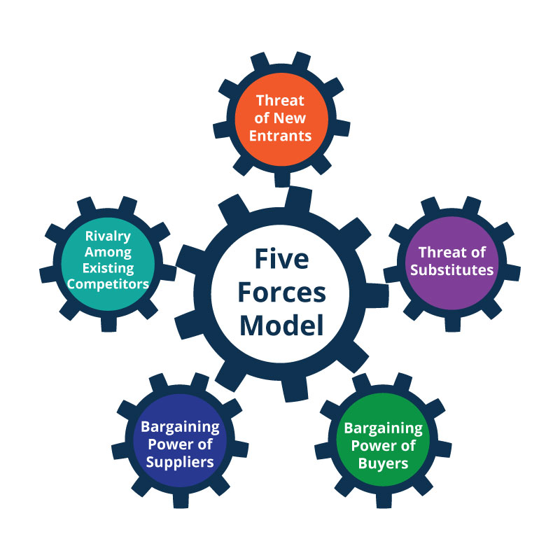
(Team, 2010)

2.2- Pestel Analysis

Pestel is a strategic tool to evaluate the external environment of a business, by identifying the risk and opportunities that can affect the company dividing by breaking down the stages, Political, Economic, Social, Technological, Environmental. Pestel analysis is an effective way to protect your business by anticipating what can affect you externally and from them finding the opportunities as well, by breaking down the word PESTEL you can find each meaning of the factors.

Political Factors, this factor is to help you understand what can impact your business politically, looking by government policy that can affect your business financially or with the changes of rules, and that can be tax policy, tariffs, bureaucracy, change of law of the consumer health and safety policy.

Economic Factors, this factor is to make you aware of what can affect your company economically, when you analyse this factor, it will make you understand what if the economic conditions change such as interest rate, inflations rate, unemployment rate, or economic growth rate, it will help you to prepare your company to go through these changes.

Social Factors, society are constantly changing the trends, by analysing this factor will help you understand what is happen related to the culture of general environment and that include population size, age, beliefs, consumer activism, behaviour, it will make you understand better what the consumer is are looking for what are they willing to spend and what is going to be their reaction.

Technological Factors, this factor is to help you realize what kind of improvement of products and service the science is providing and understand what if it can help you or not, what type of technology you can apply for your business and how it can help you and realising why is your competitor is one step ahead.

Environmental Factors, this factor is concern about the ecological impacts on the business, as the climate change is becoming common. And these factors will put you one step ahead to make plans to how adapt to this change such as, weather conditions, temperature, natural disaster, and pandemics.

Legal Factors, this factor is to make you aware about what the business can and cannot do, intersecting by government entities, legislature and policy that can affect how business operate like industry regulation, licence and permit is to understand how court can influence your business activity. (Institute, 2015)
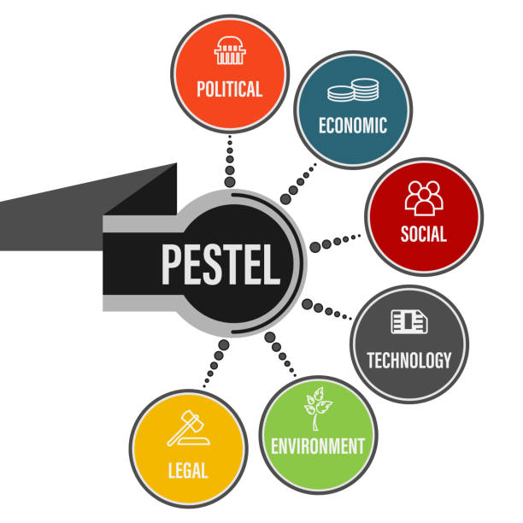
(Institute, 2015)

2.3- Swot Analysis

Swot analysis is the most common tool used for evaluating internal and external the business environments and is used to implement strategies in the company it can be used for product, company, and person. Swot helps with decision making it increases the awareness of the business.
This tool was developed by Albert Humphrey 1970 the tool was introduced as strategic tool to evaluate and helping with decision making to identify opportunities, breaking the word Swot you can find out what each letter stand for.(Pratt, 2019)

S- Strength, this step is to understand what your company is strong at, knowing what advantages your company has, what is the unique service or product you provide, which unique suppliers do you have, All the attributes and resources.
W- Weakness, what is going bad internally and what is the consumer perspective, what is the company not doing right, what are de bad aspects that your consumer spot in your service, what is contributing to make your company weaker.
O- Opportunities, this step is to spot the opportunities that can make your company grow, like what are the opportunities to expand your business, social responsibility, what can be the good opportunities in the marketplace, what can be capitalize.
T- Threats, this is the step that helps the company see the threats externally preventing them, threats like what obstacles can the company face, is my competitors better than me, if I do some changes in my strategy will a lose customers, is this consequence a big risk for the company, is the social behave affecting my sales, is this trend a threat for my company.

To help understand better and make you clear when you conduct this tool to evaluate your business environment you need to separate in two categories:
Internal factors – Strength and weakness, because the strength will give you the vision what is your competition advantage and weakness what you need to improve to make your performance better.
External factors- opportunities and threats, because spot the opportunities will make you analyse the external environment and identify what can you have from your present attitude, and threat will make you identify what can stop your company to achieve the goal or the mission. (Nickel, 2020)

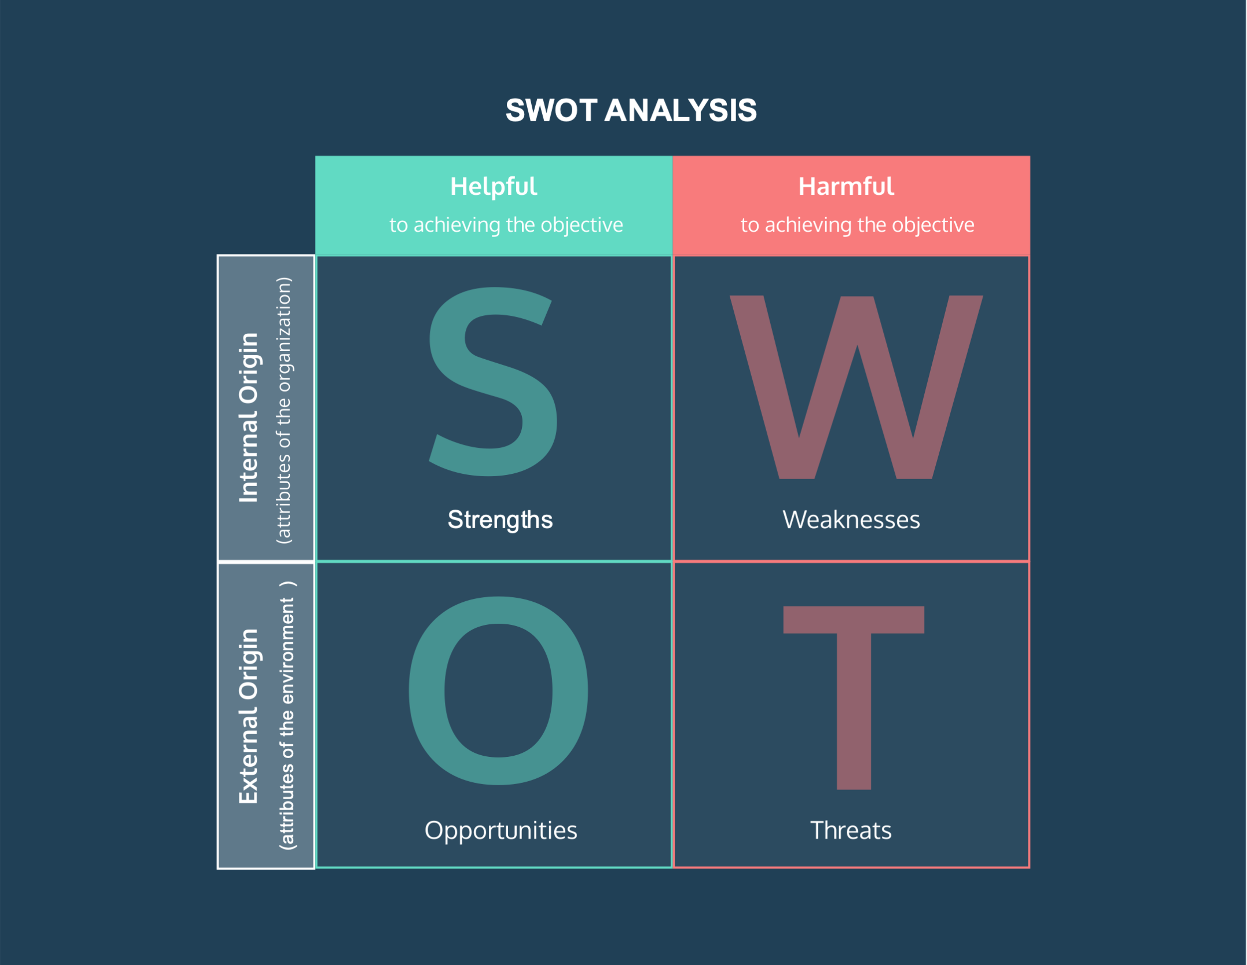
(Nickel, 2020)

2.4- Culture Web

The cultural web was developed by Gerry Johnson, and Keven Scholes in 1992 with the goal to understand the change that your company is making towards the organization culture, this approach exposes the assumptions and activities to align the work with the new strategy that you are trying to implement. Johnson and Scholes create this model to help analyse the activities of your culture identifying what is working, what is not and how it can be changed so they develop six steps:
1-Stories, this element is to understand what the people talk about the company, what do they know about the company and what do they stories tell about the company, is to make you aware what people think about your organization.
2-Rituals and Routine, this element is to analyse the actions and behaviour of the employees with the company to create awareness of what to expect from each employee, and what is the customer experience and expectations.
3-Symbols are what represent the company what the people can see and take their conclusions what kind of picture is associated with the company in others point of view.
4-Control system is the system that report how is the organization has been controlled including the financial management and employee’s behaviour.
5-Organization Structures, this element is to understand how the organization Is divided regarding the hierarchy who has the authority and how the competences are distributed.
6- Power Structures, here is where you understand how the power is distributed and the responsibilities of everyone who can influence and make the final decision. (BusinessBall, 2018)

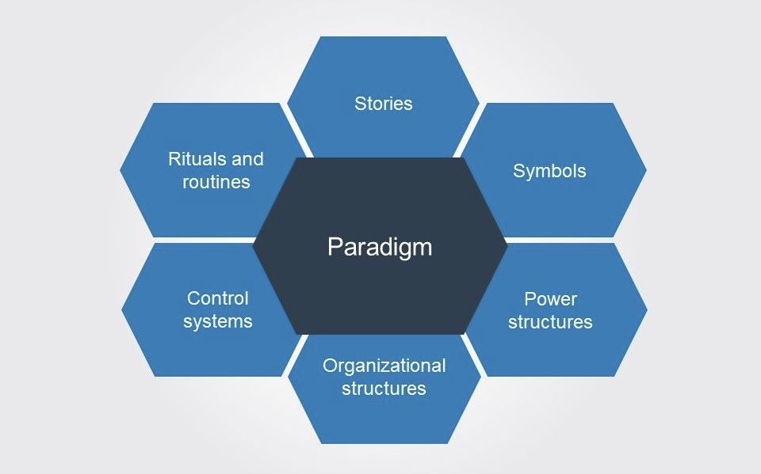
(BusinessBall, 2018)

Critical Evaluation of External Environment Analysis and Key Drivers of Change in The Workplace Context

PESTEL

Pestel stand for political, Economic, Social, Technological, Legal and Environmental this tool is used to understand what is going on in your external business environment, the environment influence and for decision making, and is very useful because if you can understand what is going on externally and internally in your business you will be more prepared to react, correct and change with efficiency.
This tool is very useful in my company especially when we needed to prevent against the covid-19 pandemic, it gave us the opportunity to see the consequences in the big picture identify the risk and how we could change the risk assessment to keep the staff and customer safe, with this tool my company could prevent the shortage if the staff giving redundancy to the employees, cut some products due the suppliers problem, and the low quality of service due the situation and the most important see the advantages they could take from that, increasing the sales 26% than the last few years.
Identifying the drivers that can make change in a company is very important it will prevent the company to get fine or to be legal prosecuted or even to get bank corrupt, with the pandemic the government stablish rules and guidance and those rules could affect the business and was important to identify them because my company was able to react quick transforming the bakery in an essential shop so we could remain open during the lockdown selling products that can be considerate first necessity with this strategy we could keep 35 stores open around London giving the company advantages of the competitors, and pestle analysis is a key tool to identify those drivers of change.
To apply this tool, you need to understand differences between the organizations can affect the way you can apply, because in a microenvironment you have less influence and impact and in the macro is where you have no control just time to react and prevent, pestle is there to understand the opportunities and threats to minimize and maximize the consequences in the company and allow you to adapt with the change of the external forces.
To identify the key drivers of change in the covid-19 pandemic and how it could impact my company, they needed to conduct the pestle analysis understanding step by step what could affect the organization. Political the company needed to understand how the government rules and guidelines could affect the business environment the restrictions about the openings and closing hours the social distance the risk assessment the forecast the ordering how many hours they could give to the employees all those aspects needed to be changed and assessed to decrease the impact.
Economic, we needed to look in the inflation and the interest rates, the unemployment status and the company knew it that they could afford paying the full salary and invest keep all the stores open they prevent with the strategy of given redundancy to some employees, cutting the hours in the contracts, changing the hieratical structure of the company to protect the economy of the business.
Social, the principal concern about this stage was the consumer behaviour and lifestyle choices because the company needed to act in the way to make the costumers safe and analysing those aspects was crucial helping the company react quick providing rules of social distance, policy about payment, online service and provide online orders and delivery.
Technological, innovations they knew it that the only option to survive this crisis was to innovate the technology providing more safety and easy access to everyone accessing the consumer behaviour they could see the costumers needs and expectations and the best option was to invest in the technology.
Legal, this step is one of the most important because will make you aware about the new employment law, consumer protection and environment regulation, for the company that is very important to prevent fines and the company to be prosecuted, taking caution about the employee’s contract and the risk assessment of health and safety.
Environmental, the organization culture and the employee morale and attitude to don’t offend those who care about the environment and my company regarding those aspects we made changes implementing the exchange of some products, going paperless, showing the care about the environment.

Critical Evaluation of Industry Analysis and Key Drivers of Change

Porter’s Five Forces

Porter’s five forces is a competitive framework that help you analyse your position in the market and helps you see the advantages that you have of your competitors, I will evaluate my company “Gail’s Bakery” using the porter’s five forces method to find out the advantages that the company has over their competitors and how they could secure their position during the covid-19 pandemic.
Intensity of competitive rivalry, this method is to understand the strength of the competitors, during the covid my company knew it about the competitors that they could face so the strategy was to sell only what is necessary serving in the neighbourhood for almost 7 years made the company understand what the customers really need and identifying this they could keep their loyal customers.
Bargaining Power of Suppliers, with the restrictions some of the suppliers could not provide their products but having more than one supplier helped a lot in my company we work with three different suppliers we lost some products, but we could replace them maintaining the quality.
Bargaining power of buyers, during the pandemic restrictions just essential shops were allowed to open and knowing our customer base we understood that large grocery could impact our customer because of their power of suppliers they could decrease the prices and put products on sale and being aware of this the company was focusing on the quality and in the customer needs to maintain our profitable buyers and the loyal buyers.
Threat of substitutes, understand our buyers in deep level made us increase the profit during the pandemic, because even with the problem with the suppliers we could substitute some products ensuring that those products maintain the demand among the customers and happened with the service we needed to reduce the staff replacing some service, but the key was understood what the buyers want and need.
Threat of new entrance is important to know how new companies can become your rival during the lockdown my company was doing deliver and, in that time, as appearing a lot of deliveries company studying those company, they could analyse that would be better work among with then because of their system and efficiency.
Analysing and identifying all those key drivers of change understanding the steps you can see and prevent external environmental impacts.

Organization Present Culture and the Relationship Between the Organization financial and non-financial

The present culture in my company is Hierarchal who everyone respects the formality following the structure respecting who takes the final decision. This culture brings to the company clarity of the roles and responsibilities the efficiency is very high among with the coordination, the roles are well structured with the description of what are your responsibilities with this culture everything Is planned in my company the priority is to growth and increase the stability in the business. Hierarchy gives clear direction and a calm work environment because everyone knows that more, they work more chances they must be promoted and that brings motivation to the team, perhaps the employees feel controlled, and they work with pressure because they need to work like robots is no space for creativity is just following the company policy.
The relationship between hierarchical culture with the financial organization is that the structure of this culture will help improve the financial achievement bringing more organization and stability because in the financial organization is important that everyone knows about their roles and responsibilities and fowling the coordination in this culture will define the success.
The non-financial organization they will need this structure to be more organized and work among coordination helping the organization gain clarity about their goals and core values and recruit the right employees to work in this kind of organization will bring more advantages because in one organization that the motivation is not the money keep well-structured and organize is the goal.

Evaluation of Ethical Dilemma in the Workplace Context

Ethical Dilemma is when something goes against your personal ethics morals and value that can put you pressure to choose between being honest or dishonest, or what you know that is right or wrong. (Davis, 2021)
Working in my company I could face situation that involved some ethical dilemma, we have a list of product that we can have on our breakfast and the list of what we cannot have and taking this products you can face actions of disciplinary, and sometimes I see my colleges taking but I know if I report they will be against me and if I don’t report the company will ask what is happen with the missing products I was in facing an ethical challenge between say the truth and being loyal and me as team leader knowing the right and wrong to keep everyone safe and work with ethic my option was to speak with them to stop telling the consequences and the position that they are putting me and making them aware that the next time I would report.

Recommendations

My recommendations is to understand all the tools of external and internal business environment, is important for the organization, being able to assess your company and evaluate the threats will contribute to the long term success, by solving the problem and prevent you are giving huge steps to put your organization in the right path, apply pestle analysis to make your company aware of the external threats this tool is crucial, and if you are facing problem with your competitors you can use porter’s five forces it will give you a lot of benefits such knowing how you can avoid lose your position in the market and maintain your customers with you.

Conclusion

With this report I can conclude that this tools have an extreme importance to the organizations, and I structured this report in the way that the reader can understand step by step all the explanation during the read, and making clear that the assessment might change if you have a micro or macro environment the approach will be different but the benefits will be fantastic, understand all these theories and models will change the way you face your problems in your workplace, be aware about the ethical dilemma understand how it can be avoided

References

Bibliography
BusinessBall, 2018. BussinessBall. [Online]
Available at: https://www.businessballs.com/strategy-innovation/cultural-web-johnson-scholes/
[Accessed 6 September 2021].
Davis, B., 2021. Mvorganizing.org. [Online]
Available at: https://www.mvorganizing.org/what-are-the-big-four-ethical-dilemmas/
[Accessed 6 September 2021].
Institute, C. F., 2015. CFI. [Online]
Available at: https://corporatefinanceinstitute.com/resources/knowledge/strategy/pestel-analysis/
[Accessed 3 September 2021].
McLean, L. M. a. J. E., 2019. Mullins: Organisational Behaviour in the Workplace. 12th Edition ed. Harlow: Pearson Education, Limited.
Nickel, T., 2020. ToughNickel. [Online]
Available at: https://toughnickel.com/business/What-is-PESTLE-analysis
[Accessed 6 September 2021].
Pratt, M. K., 2019. SearchCio. [Online]
Available at: https://searchcio.techtarget.com/definition/SWOT-analysis-strengths-weaknesses-opportunities-and-threats-analysis
[Accessed 4 September 2021].
Team, M. S. T., 2019. Mars Startup Toolkit. [Online]
Available at: https://learn.marsdd.com/article/industry-analysis-and-competition-using-porters-five-forces/
[Accessed 6 September 2021].
Team, M. T. C., 2010. MindTools. [Online]
Available at: https://www.mindtools.com/pages/article/newTMC_08.htm
[Accessed 3 September 2021].

Task 2 – Reflective Essay

Learning the workplace culture and its impact on organization made me realise the complexity of the problems that an organization can face, and the steps to solve it is even more complicated than it looks, my vision among of organization changed a lot it made me understand how this machine works and why it needs to work as a machine because every concept is important every peace needs to be in place to make everything work. The tools to identify the external problems understand how it can be applied and the benefits are unreal it has an extreme importance being able to understand what an organization is the elements the culture the strategy to implement and reinforce the strategy all this complexity made me understand how everything works internally and why organizations needs to work like a machine.
The learnings of this module increased my skills as employee giving me an understanding about the companies and how they work, it increased my capability to solve and understand the problem that happen in my workplace and understanding the culture web that they are implementing in my company made me respect more their decision and support, now I can see more opportunity and room to improve, understand hierarchal culture I could see why my organization don’t give me room to by creative and give ideas, understand this concept you start to accept and criticize less because you already know why we ned to follow, why we need to be controlled, and why to have a voice you need to be in certain role, you will face this in another perspective understand that they want efficiency centralizing the power to maintain the company organize and precise with the policy and guidelines.
Ethical dilemma is a very important topic knowing how to deal with this ethical challenge brings you the wisdom to avoid them, is very important to understand how to deal with this in your workplace it will change your vision about doing wrong and right and from there it will be easy to take actions.
The vision that I have now is completely different even my decision making process has changed now I can look to the companies with a different perspective it will help me a lot when I finish my degree and look for better opportunities, I will be able to look through the job description and now the work culture if is suitable for me or not, the process and the way they implement their strategy understand all of this will have a massive impact on my decisions.

