
Assignment 2:
Operating Systems
CertHE Computing Skills for Workplace

Computer Architecture and Operating Systems. ACCA4022_LON
DR. Redhwan Al-Amri (Lecturer)
University of Wales Trinity Saint David
(London Campus)
Student Name: Dolapo Farouk Owolabi
Student Number:2518096
Group: 2
Date: 29/04/2026

Table of Contents
Introduction 1
1. Key functions of general Operating Systems 1
Systems 1
1.1 Process and Processor Management 1
1.2 Memory Management 3
1.3 File System Management 4
1.4 Security and Protection 5
2. Use of Windows OS CLI commands. 7
3. Use of Linux OS CLI commands. 15
4. Use of Windows OS scripts. 20
Script: System Health Check 20
Key Features Demonstrated 22
5. Use of Linux OS scripts. 23
Script: Log File Analyzer 23
Key Features Demonstrated 25
Conclusion 26
References 27
Appendices 29
Tutorial Activity on OS Types from OS Tutorial 1 29
1. LinkedIn Learning course: 29
2. Cisco Network Academy: 30
3. Cisco Network Academy : Operating Systems Basics 32

Introduction

1. Key functions of general Operating Systems

1.1 Process and Processor Management
Process and processor management is a fundamental role of any operating system, responsible for controlling the execution of programs and allocating central processing unit (CPU) time among them to enable multitasking. The OS schedules tasks, manages the creation and termination of processes, and ensures that each application receives the necessary resources to run efficiently without causing conflicts. This function allows multiple programs to operate simultaneously by rapidly switching the processor between different tasks, maintaining system responsiveness and overall performance. [1]

1.2 Memory Management
Memory management is a core function of the operating system that controls and organizes the computer's main memory (RAM). It involves allocating specific memory space to active programs and data, ensuring that each process has enough resources to operate while preventing them from interfering with one another. The OS also tracks which parts of memory are in use, reclaims space when tasks are finished, and uses techniques such as virtual memory to extend available capacity by utilizing hard disk space, ultimately optimizing system performance and stability. [2]

1.3 File System Management
File System Management is a fundamental function of general-purpose operating systems (such as Windows, macOS, and Linux) that provides a logical, organized structure for storing and accessing data on secondary storage devices, hiding the physical complexities of data location from users. Key functions include creating, deleting, renaming, and manipulating files and folders (directories) within a hierarchical structure. Additionally, it manages file access permissions to ensure data security, tracks free space to enable efficient allocation, and maintains metadata—such as file size, creation date, and type—to optimize data retrieval and integrity. By utilizing mechanisms like journaling or logging, these systems ensure data integrity and facilitate recovery following crashes or unexpected shutdowns. [3]
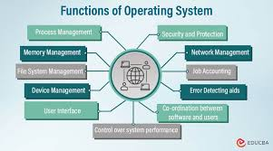

1.4 Security and Protection

Security and protection are essential functions of an operating system that safeguard the system and data from unauthorized access, damage, and malicious threats. The OS implements various mechanisms such as user authentication, password protection, and access permissions to ensure that only authorized users can view or modify specific files and resources. It also isolates processes from one another to prevent interference and uses tools like firewalls, encryption, and antivirus integration to defend against external attacks and malware. These measures work together to maintain the integrity, confidentiality, and availability of information, ensuring a safe and reliable computing environment [2]

2. Use of Windows OS CLI commands.
The Command Line Interface (CLI) in Windows, including Command Prompt and PowerShell, allows users to perform administrative tasks efficiently by typing text commands. This method is often faster than using the graphical interface and is essential for system management and automation. Below is a documentation of key commands covering process control, file handling, network checks, user administration, and task scheduling.

Process Management
This command displays a complete list of all processes currently running on the system, showing their names, Process IDs (PID), and memory usage. It is useful for monitoring what programs are active and identifying which ones are consuming resources.
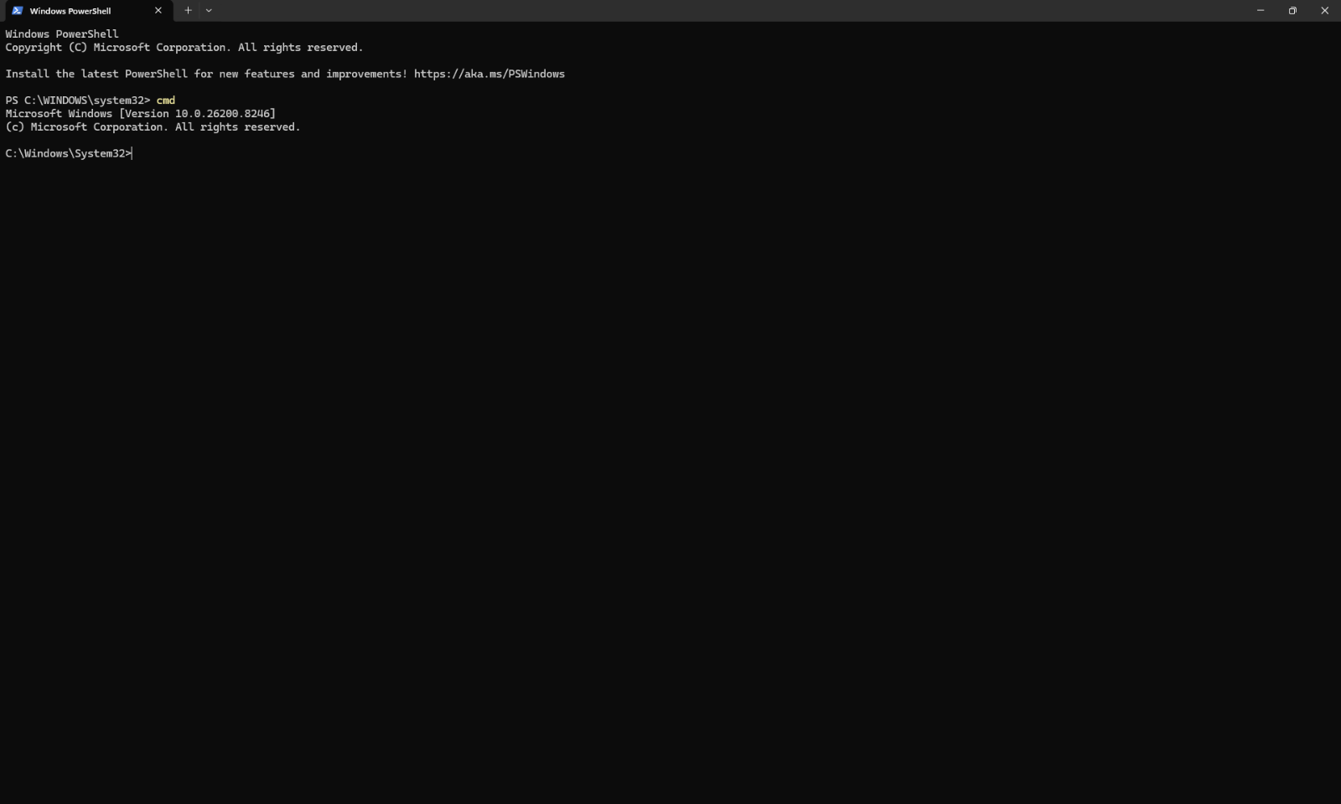
This command displays a complete list of all processes currently running on the system, showing their names, Process IDs (PID), and memory usage. It is useful for monitoring what programs are active and identifying which ones are consuming resources.
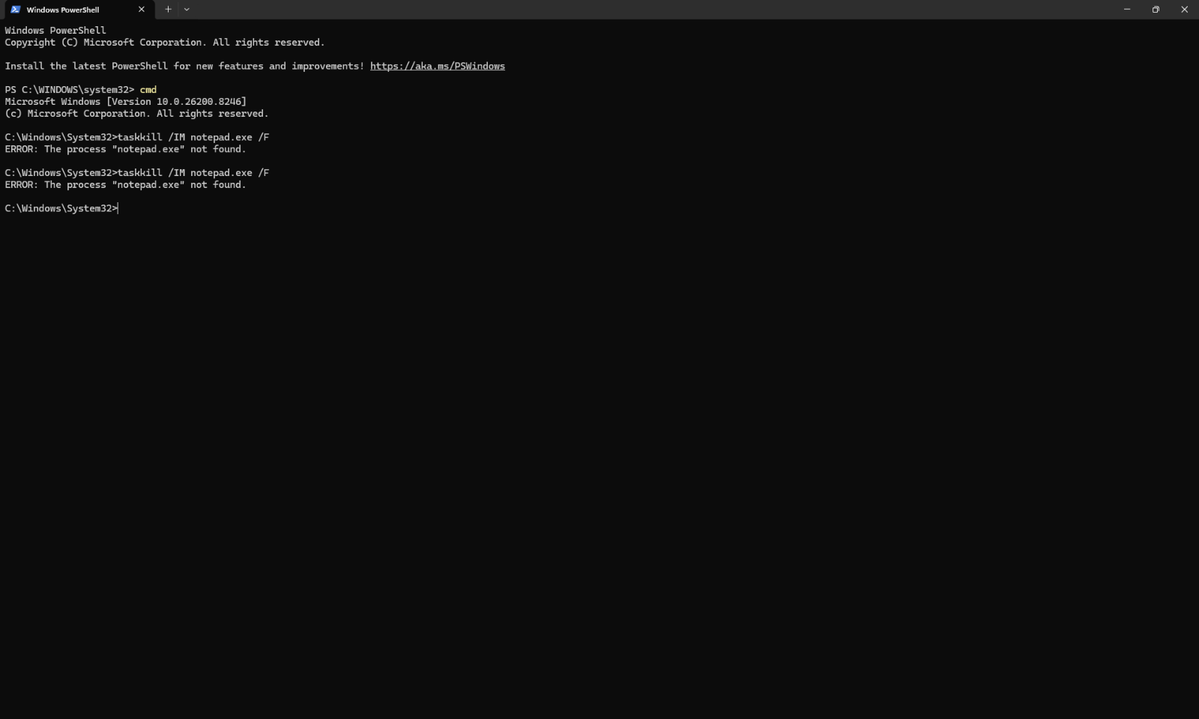
This command is used to stop or terminate running processes immediately. You can target a process by its name using the /IM switch or by its ID using /PID. The /F switch forces the process to close.

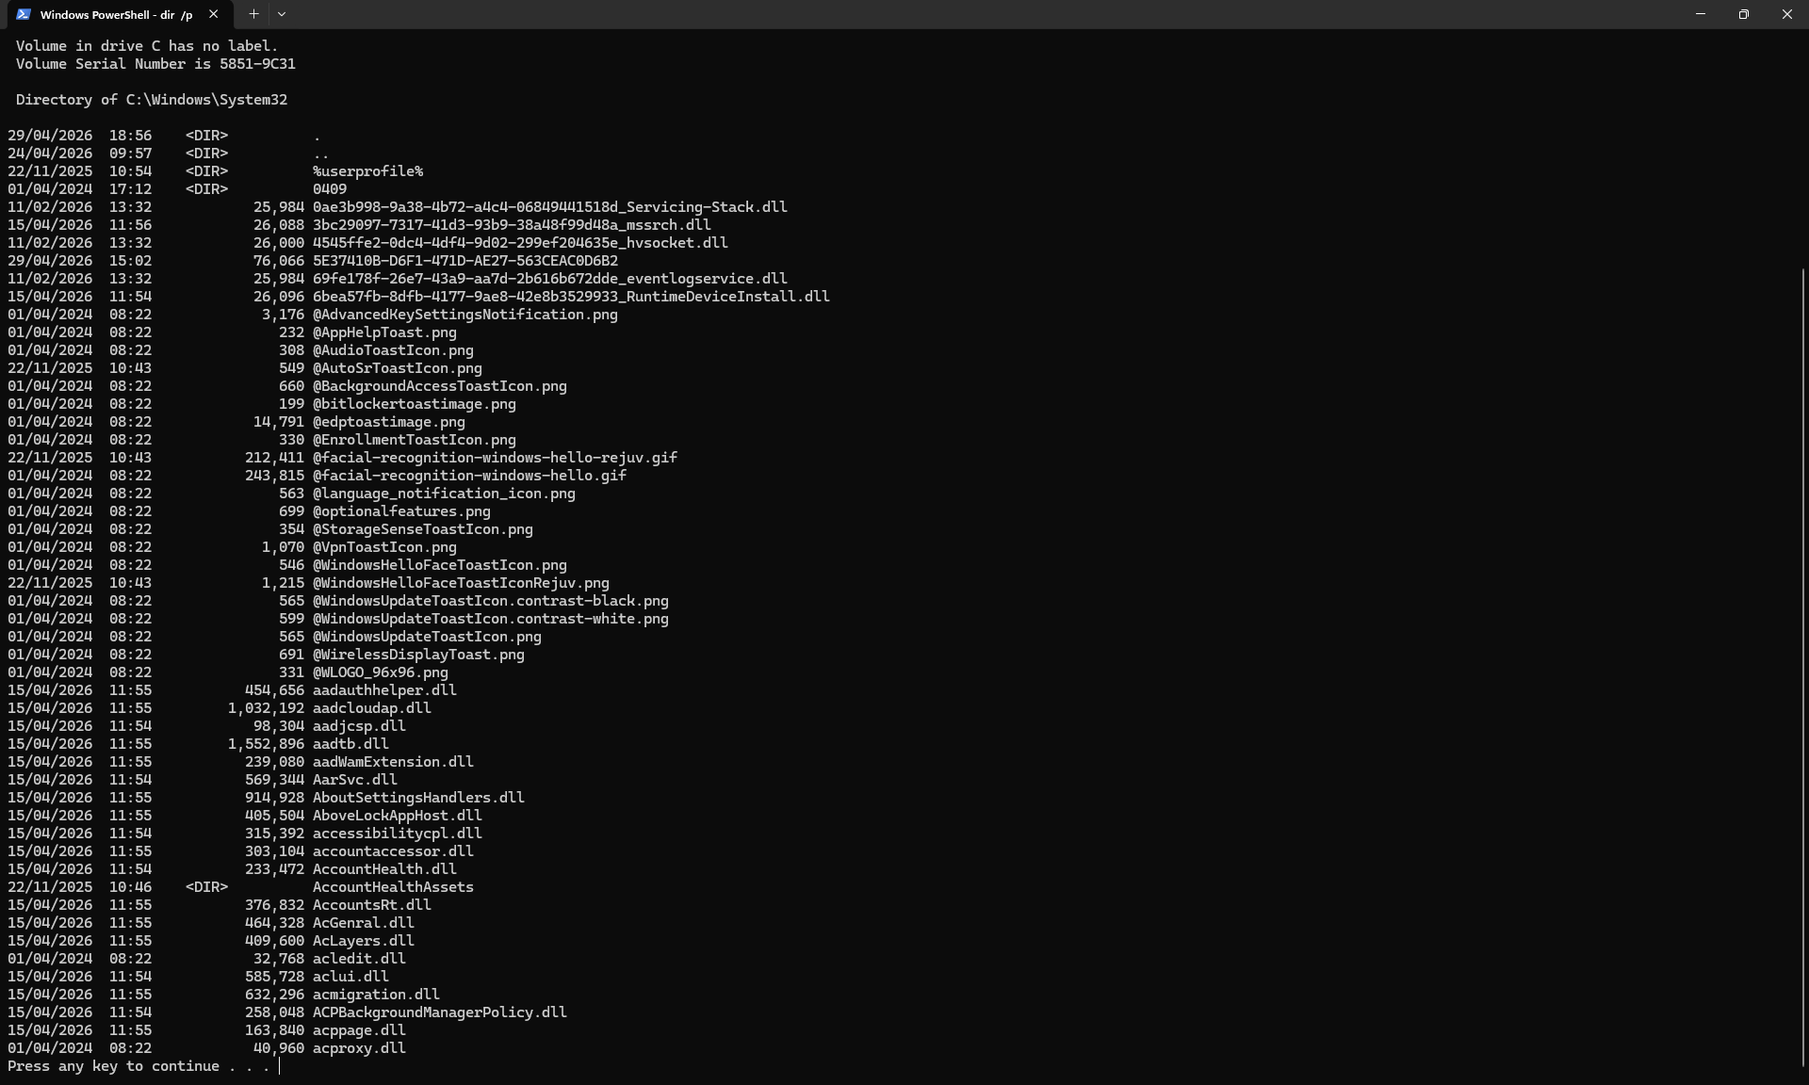
The directory command lists all files and folders contained within the current location, along with details like file size and date modified. Adding the /p switch pauses the output when the screen is full, making it easier to read.
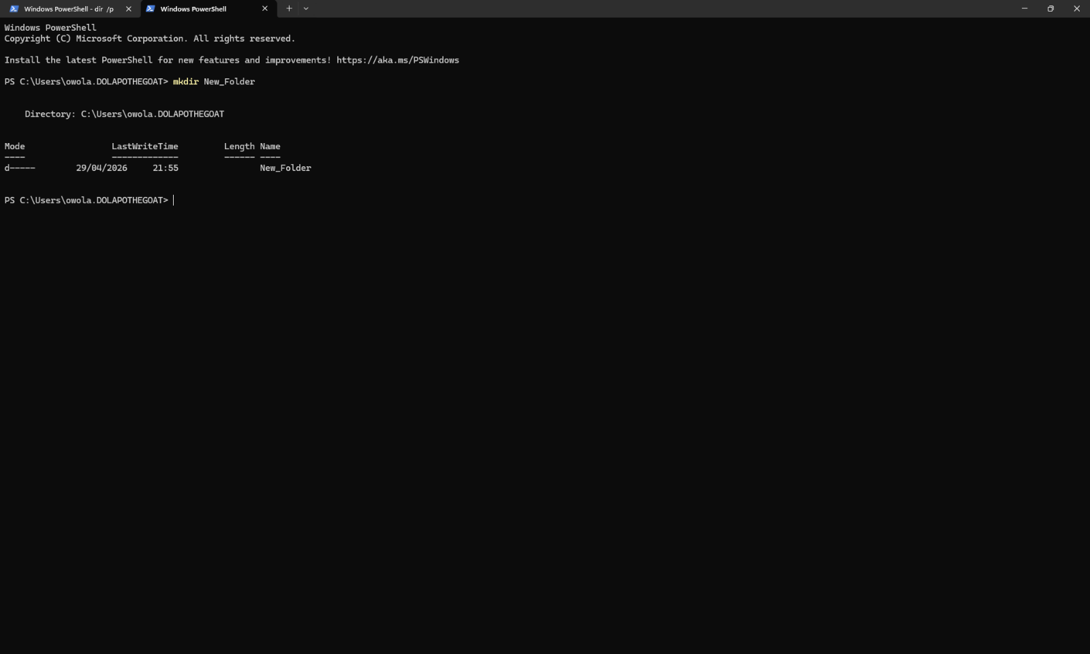

Short for "make directory", this command creates a new folder at the current path. It is a quick way to organize storage without needing to open File Explorer.

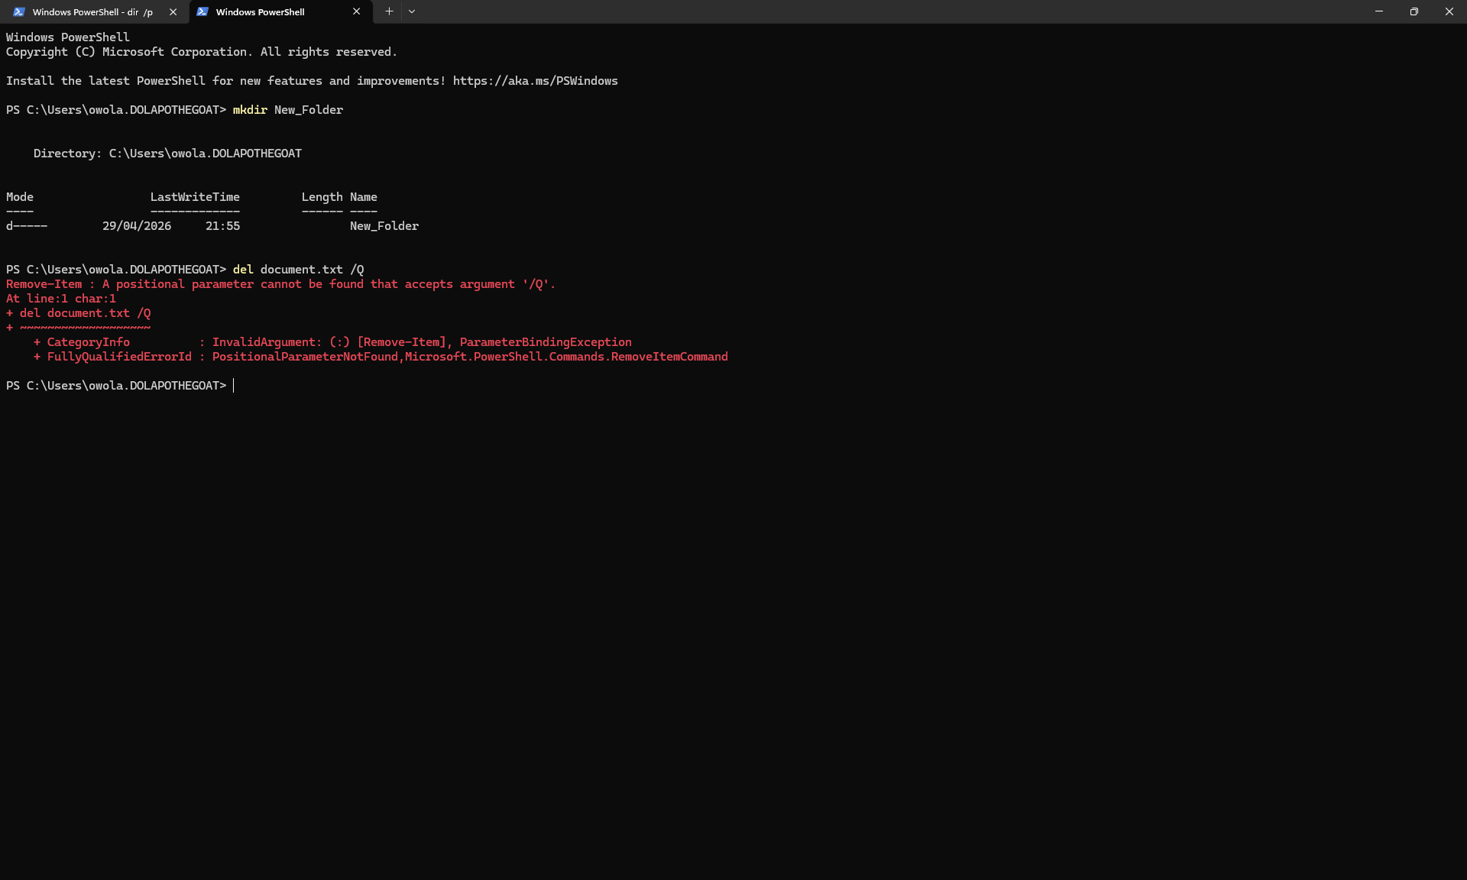
This command is used to delete one or more files from the system. The /Q switch runs it in quiet mode, meaning it will not ask for confirmation before deleting files.
This command displays the current network configuration of the computer, including the IP address, subnet mask, and default gateway. Using the /all switch provides detailed information including the MAC address and DNS servers.
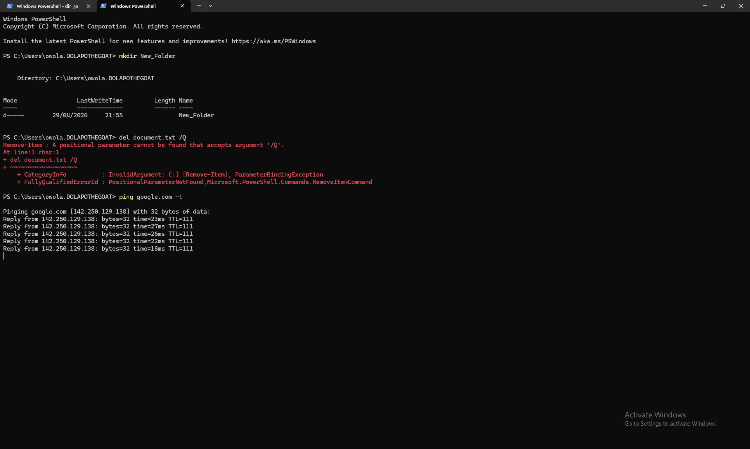

This command allows administrators to view, add, modify, or delete user accounts on the system. Typing the command alone lists all existing users, while adding parameters allows changing passwords or account settings.
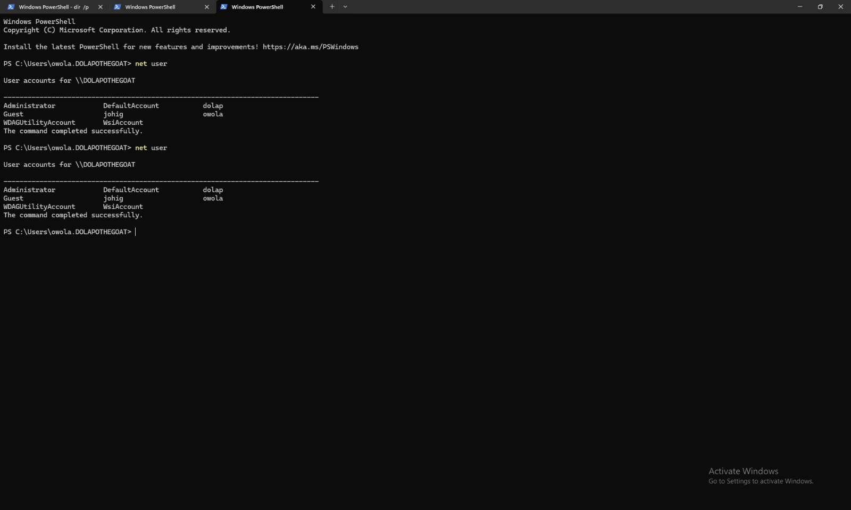
This command is used to manage security groups and permissions. Adding a user to the "administrators" group gives them full control over the computer settings and files.
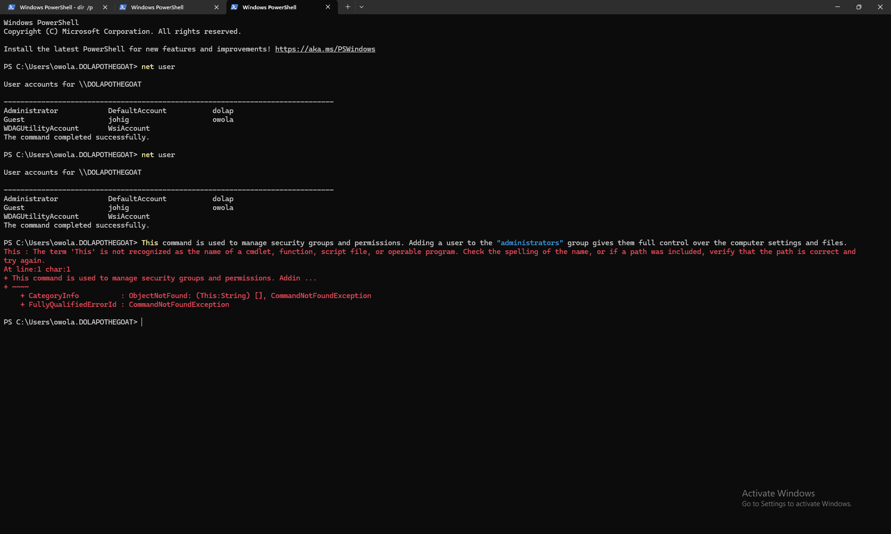
Schtasks is used to create and manage scheduled tasks that run automatically at specific times or events. The /create switch makes a new task, /tn names it, /tr specifies the program to run, and /sc sets the schedule frequency.
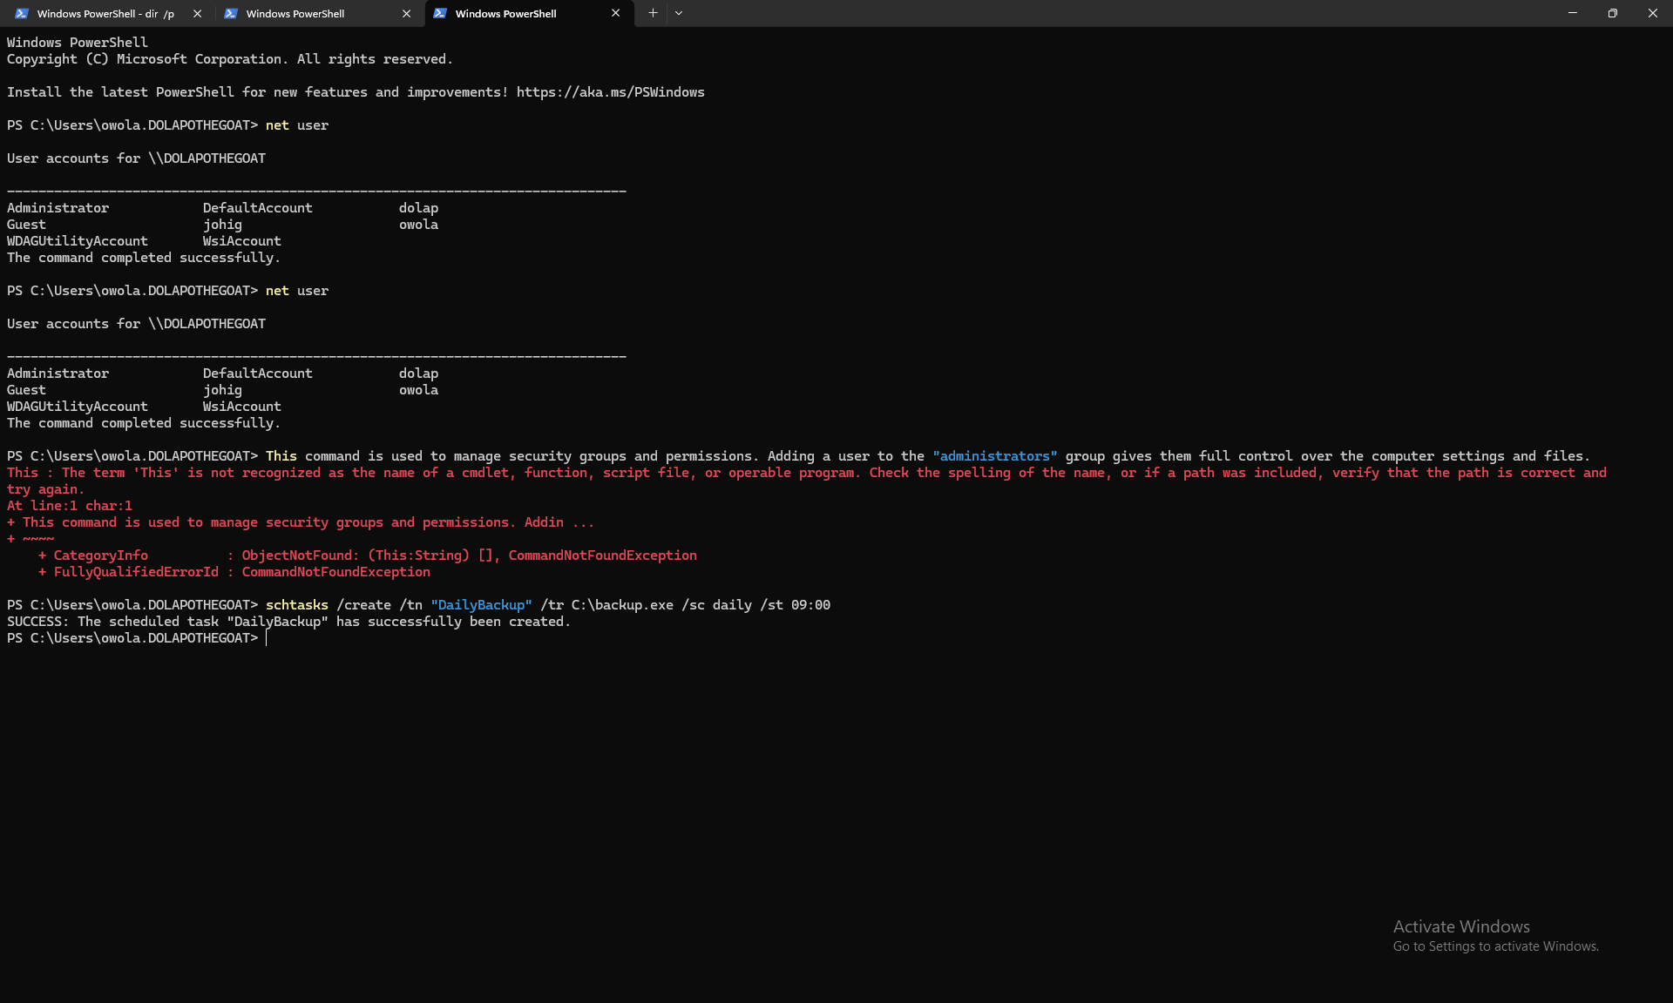
Schtasks is used to create and manage scheduled tasks that run automatically at specific times or events. The /create switch makes a new task, /tn names it, /tr specifies the program to run, and /sc sets the schedule frequency.
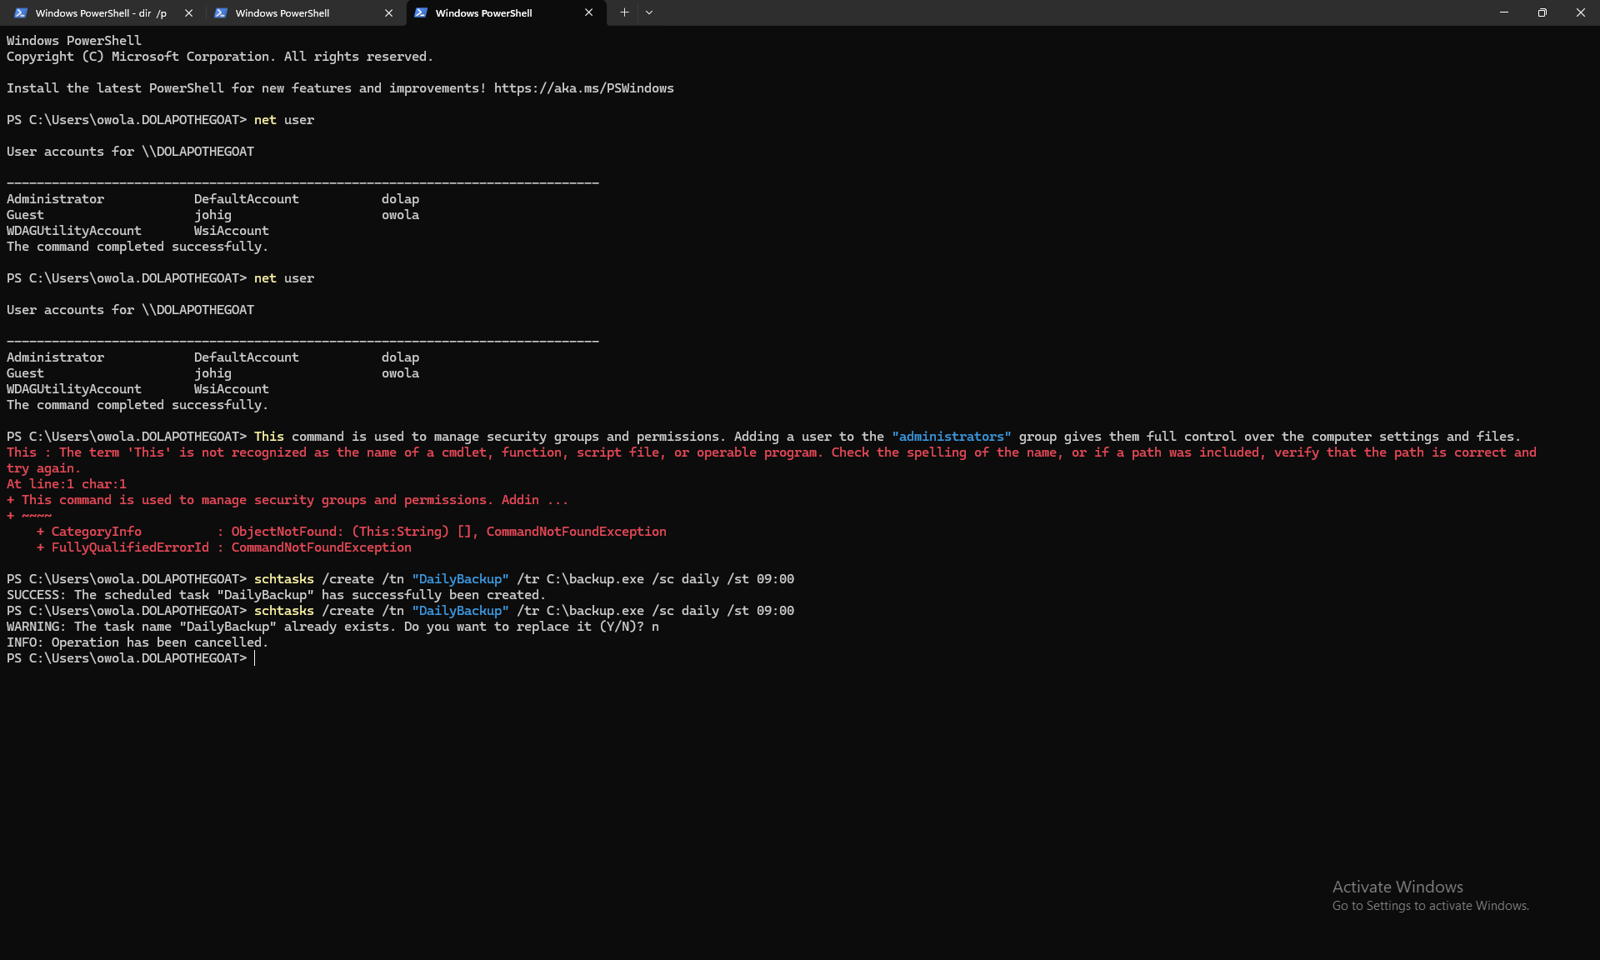

3. Use of Linux OS CLI commands.
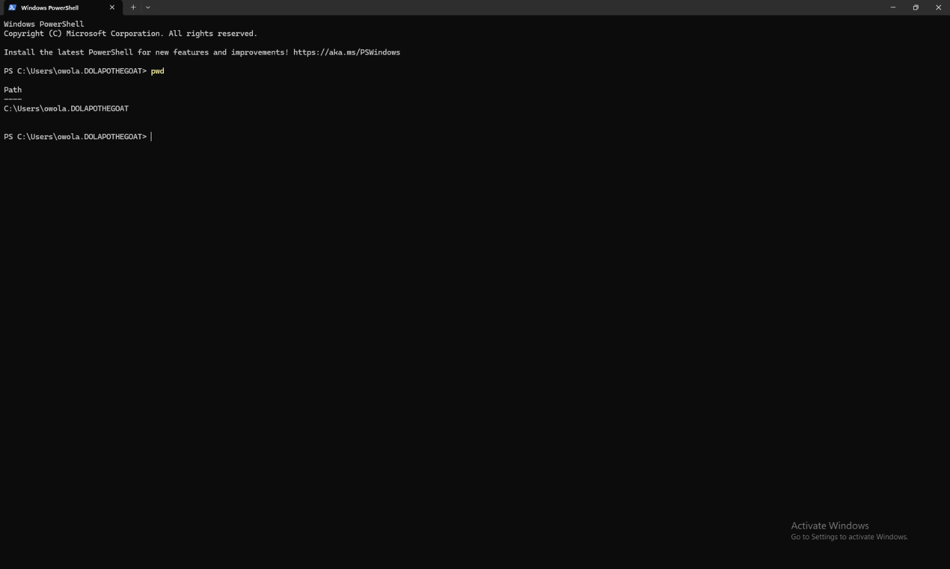
File & Directory Management
Command: pwd
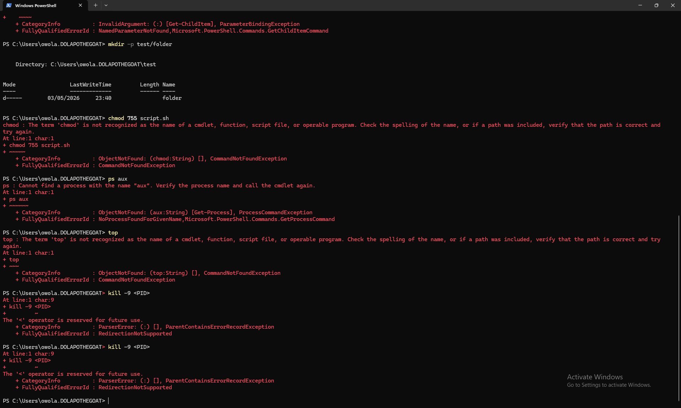
Process Management

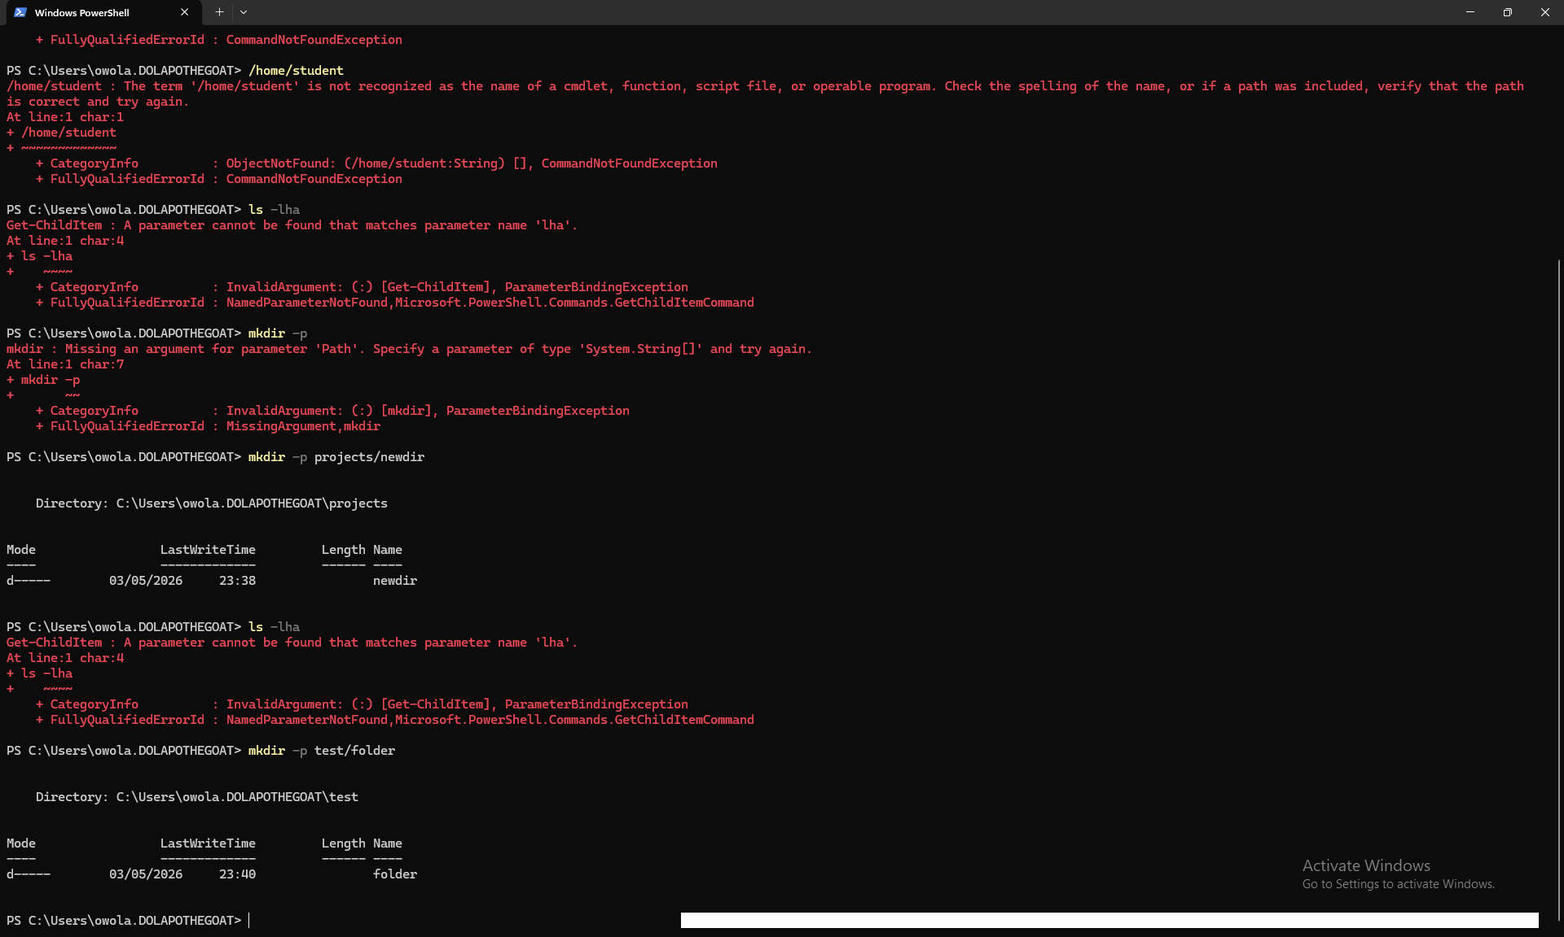
Network Testing & Monitoring
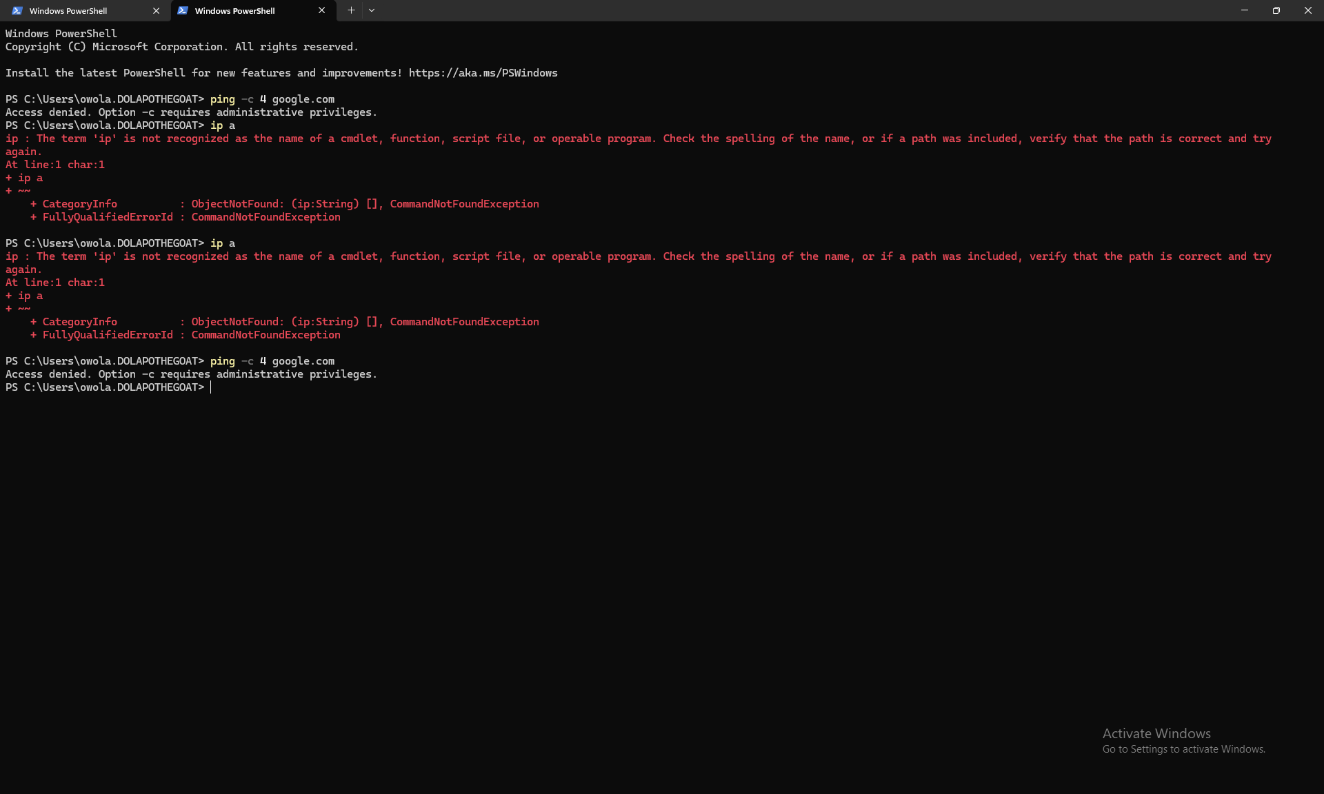
Tests if your computer can connect to the internet or another machine.
User Management
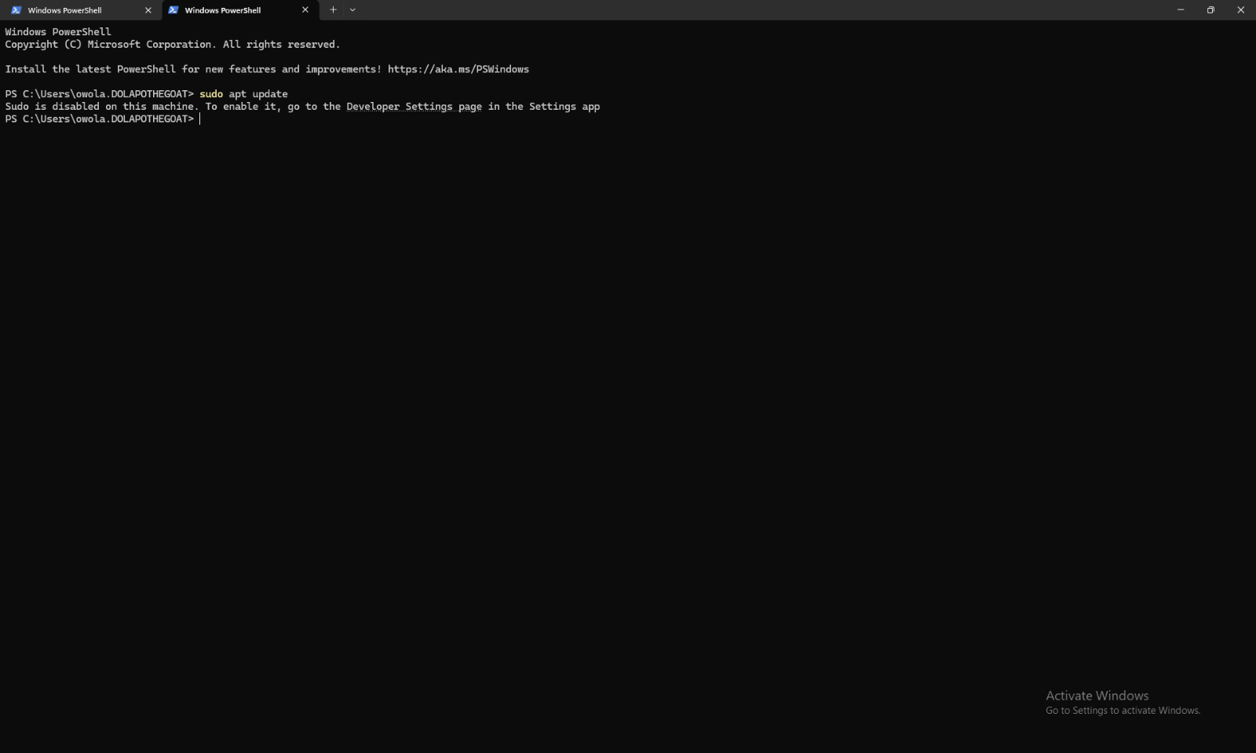
Shotts, W. (2019). The Linux Command Line. 2nd Edition. No Starch Press.
Linux Manual Pages. (n.d.). Retrieved from man ls, man ps, man crontab.
Ubuntu Documentation. (2024). Command Line Usage.
Runs a command with administrator privileges.

4. Use of Windows OS scripts.
Windows Batch scripting allows us to automate repetitive computer tasks. Instead of clicking buttons or typing commands manually, we can write a list of instructions in a text file saved as .bat or.cmd. When running, the computer follows these steps automatically. This saves time and reduces human error.

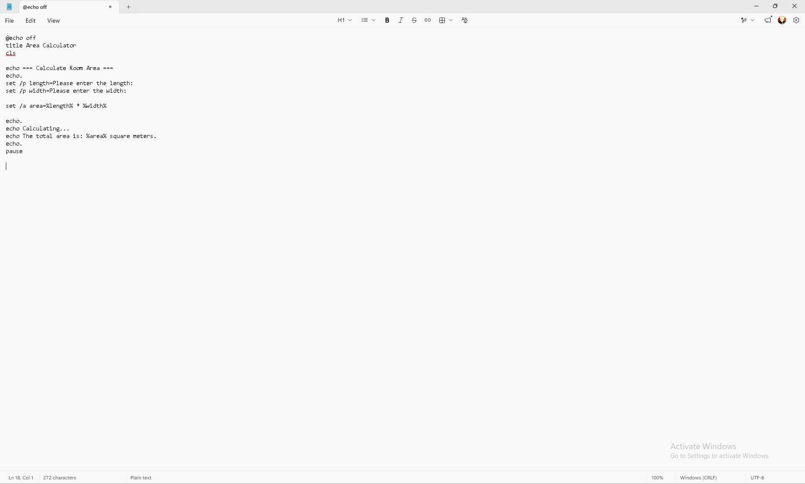
This script asks the user for the length and width of a room, calculates the total area, and displays the result. It shows how to use variables, get input, and perform math operations.
How it works:
- @echo off hides the commands so the screen looks clean.
- set /p is used to get input typed by the user and store it in a variable.

- set /a allows us to do mathematical calculations (in this case, multiplication *).
- We use %variablename% to display the stored data.

This script checks if a folder called "Documents" exists. If it doesn't, it creates one automatically. Then it moves all text files into that folder. It demonstrates loops and conditional logic (IF statements).
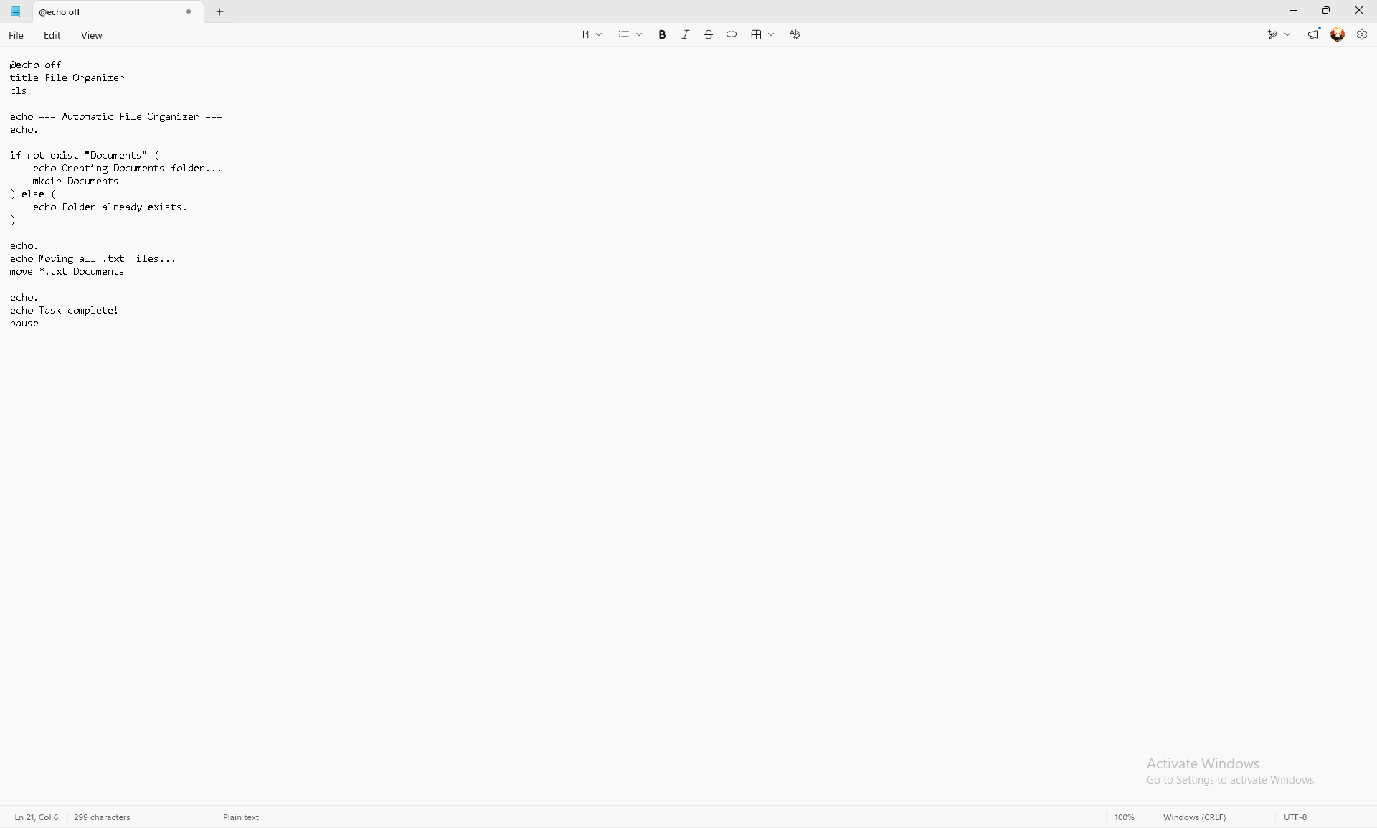
How it works:
if not exist checks to see if something is already there. This is a conditional statement.
mkdir creates a new directory (folder).
move *.txt Documents uses a wildcard * to move all files ending with .txt into the new folder in one go.
This is very useful for cleaning up downloads folders automatically.

Batch scripts are powerful tools for system administration. As shown in the examples, they can handle calculations and manage files. By using variables and logic, we can build tools that make daily computer work much faster and easier.

5. Use of Linux OS scripts.
In Linux, we can write scripts to automate tasks. A Bash script is a text file containing a series of commands that the computer can run automatically. This is very useful because it saves time and ensures tasks are done the same way every time.
Below are two examples of simple scripts that use variables, accept input from the user, perform calculations, and use logic to make decisions.
This script asks the user to enter two numbers, adds them together, and displays the result. It shows how to use variables and perform arithmetic operations.
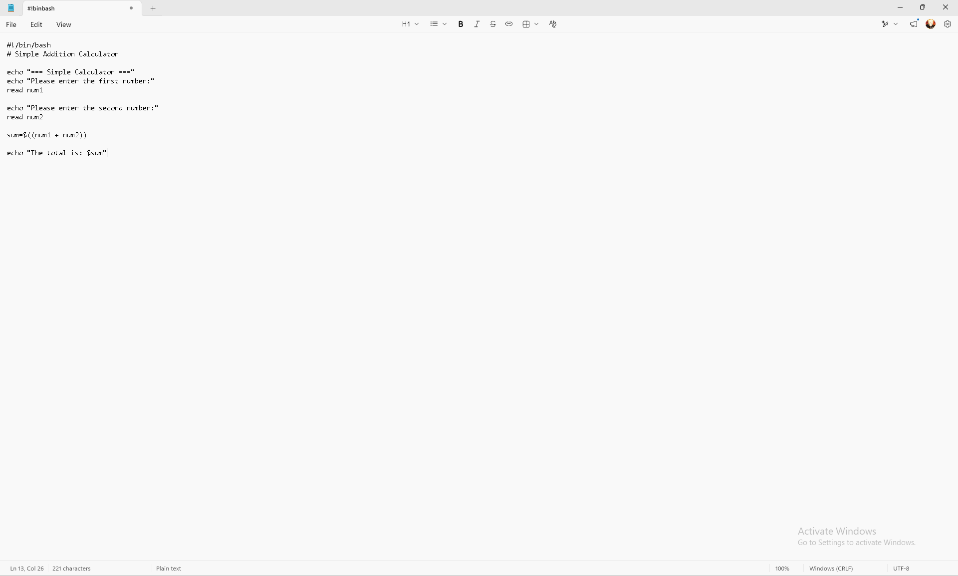
How it works:
- #!/bin/bash tells the system this is a Bash script.
- read is used to get input typed by the user and store it in a variable.
- $(( )) is used to perform mathematical calculations.
- We use $variable_name to display the stored data or results.

This script checks if a specific folder exists. If it does not exist, it creates it automatically. It demonstrates the use of conditional statements (if statements).
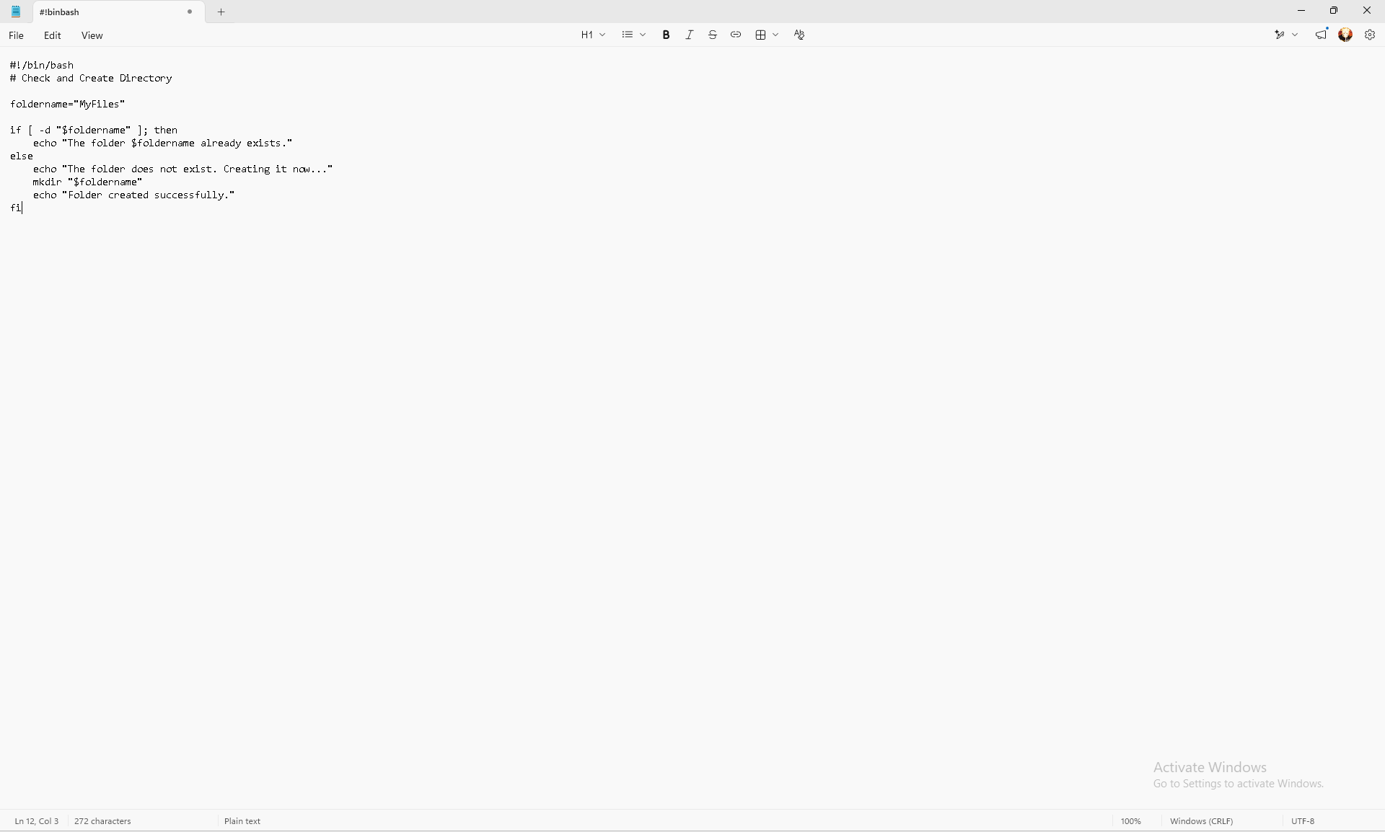
How it works:
- We store the name "MyFiles" in a variable called foldername.
- if [ -d ... ] checks if a directory already exists.
- If it exists, it prints a message. If not, it runs the mkdir command to make the folder.
- This is a good example of automation where the script makes decisions based on the current situation.

Bash scripting is a powerful way to control the Linux system. As shown in these examples, we can create tools that handle data input, do maths, and make decisions automatically. This makes system administration much easier and more efficient.

Conclusion
In this assignment, I have explored and demonstrated the use of command-line interfaces and scripting for both Linux and Windows operating systems. Through practical examples, I have learned how powerful the CLI (Command Line Interface) can be for managing a computer system efficiently.
One of the main findings is that using commands directly in the terminal is often faster and more powerful than using a graphical interface. In Linux, commands like ls, ps, ping, and crontab allow users to manage files, monitor processes, test networks, and schedule tasks easily. Similarly, on Windows, the command prompt provides access to system functions that can be automated.
Furthermore, I discovered that writing scripts is an excellent way to automate routine work. Both Bash scripts (Linux) and Batch files (Windows) allow us to store instructions in a file so they can be run automatically whenever needed. I learned how to use variables to store data, accept input from users, perform mathematical calculations, and use conditional statements (like IF statements) so the program can make decisions. This shows that scripting is very useful for reducing manual work and preventing mistakes.
Overall, understanding how to use the command line and write scripts is an essential skill for IT. It allows users to control the system deeply, save time, and create tools that make complex tasks simple.

References

References

[1] | A. G. P. B. a. G. G. Silberschatz, Operating System Concepts, Hoboken: (John Wiley & Sons, 2018.
[2] | P. B. G. a. G. G. A. Silberschatz, Operating System Concepts, Hoboken: John Wiley & Sons, 2018.
[3] | P. K. Singh, Operating System Management, Delhi, India: Khanna Book Publishing, 2024.
[4] | AITS-TPT, "UNIT-I Operating Systems Functions," 26 August 2025. [Online]. Available: https://aits-tpt.edu.in/wp-content/uploads/2022/06/Operating_System-min.pdf.
[5] | Britannica, "Operating system (OS) | Definition, Examples, & Concepts," 26 August 2025. [Online]. Available: https://www.britannica.com/technology/operating-system.
[6] | UTC, "Chapter 8: Memory Management," [Online]. Available: https://www.utc.edu/sites/default/files/2021-04/2800-lecture8-memeory-management.pdf. [Accessed 26 August 2025].
[7] | University of Bologna (cs.unibo.it), "File Systems," [Online]. Available: http://www.cs.unibo.it/~sangio/SO_currentAA/Luc_SO/FileSystem/File_Systems1.pdf. [Accessed 26 August 2025].
[8] | MBIT, "Operating System Concepts, 8th Edition," [Online]. Available: https://www.mbit.edu.in/wp-content/uploads/2020/05/Operating_System_Concepts_8th_EditionA4.pdf. [Accessed 26 August 2025].
[9] | GeeksforGeeks, "How to Monitor System Activity in Linux | top Command," [Online]. Available: https://www.geeksforgeeks.org/linux-unix/top-command-in-linux-with-examples/. [Accessed 26 August 2025].
[10] | OpenStax, "6.4 Memory Management - Introduction to Computer Science," [Online]. Available: https://openstax.org/books/introduction-computer-science/pages/6-4-memory-management. [Accessed 27 August 2025].
[11] | TechRepublic, "How to use Windows 10's Resource Monitor to track memory usage," [Online]. Available: https://www.techrepublic.com/article/how-to-use-windows-10s-resource-monitor-to-track-memory-usage/. [Accessed 27 August 2025].
[12] | Testbook, "Process Management in Operating System - Learn Details Here!," [Online]. Available: https://testbook.com/operating-system/process-management-in-operating-system. [Accessed 27 August 2025].
[13] | Turing, "How to Use the Linux Free Command," [Online]. Available: https://www.turing.com/kb/how-to-use-the-linux-free-command. [Accessed 27 August 2025].
[14] | OpenStax, "6.5 File Systems - Introduction to Computer Science," [Online]. Available: https://openstax.org/books/introduction-computer-science/pages/6-5-file-systems. [Accessed 27 August 2025].
[15] | GeeksforGeeks, "df command in Linux with Examples," [Online]. Available: https://www.geeksforgeeks.org/linux-unix/df-command-linux-examples/. [Accessed 27 August 2025].
[16] | man7.org, "top(1) - Linux manual page," [Online]. Available: https://man7.org/linux/man-pages/man1/top.1.html. [Accessed 27 August 2025].
[17] | GeeksforGeeks, "System Protection in Operating System," [Online]. Available: https://www.geeksforgeeks.org/operating-systems/system-protection-in-operating-system/. [Accessed 27 August 2025].
[18] | Fiveable, "OS Security and Access Control | Cybersecurity and Cryptography Class Notes," [Online]. Available: https://library.fiveable.me/cybersecurity-and-cryptography/unit-5. [Accessed 28 August 2025].
[19] | PDQ, "10 PowerShell commands every sysadmin should know," [Online]. Available: https://www.pdq.com/blog/top-powershell-commands-to-know/. [Accessed 28 August 2025].
[20] | Active Directory Pro, "50 Basic Windows Commands with Examples," [Online]. Available: https://activedirectorypro.com/windows-cmd-commands/. [Accessed 28 August 2025].
[21] | Varonis, "Windows PowerShell Scripting Tutorial For Beginners," [Online]. Available: https://www.varonis.com/blog/windows-powershell-tutorials. [Accessed 28 August 2025].
[22] | NinjaOne, " How to Automate Repetitive Tasks with PowerShell," [Online]. Available: https://www.ninjaone.com/blog/how-to-automate-tasks-with-powershell/. [Accessed 28 August 2025].
[23] | Tom, " Essential PowerShell Commands for Beginners," [Online]. Available: https://medium.com/tomtalkspowershell/essential-powershell-commands-for-beginners-613bfa9cef82. [Accessed 29 August 2025].
[24] | Hostinger, " Bash Scripting for Beginners + Downloadable Free Cheat Sheet," [Online]. Available: https://www.hostinger.com/tutorials/bash-scripting-tutorial. [Accessed 29 August 2025].
[25] | It's FOSS, "Bash Scripting Tutorial for Beginners," [Online]. Available: https://itsfoss.com/bash-scripting-tutorial/. [Accessed 29 August 2025].
[26] | DataCamp, "How to Write a Bash Script: A Simple Bash Scripting Tutorial," [Online]. Available: https://www.datacamp.com/tutorial/how-to-write-bash-script-tutorial. [Accessed 29 August 2025].

Appendices

