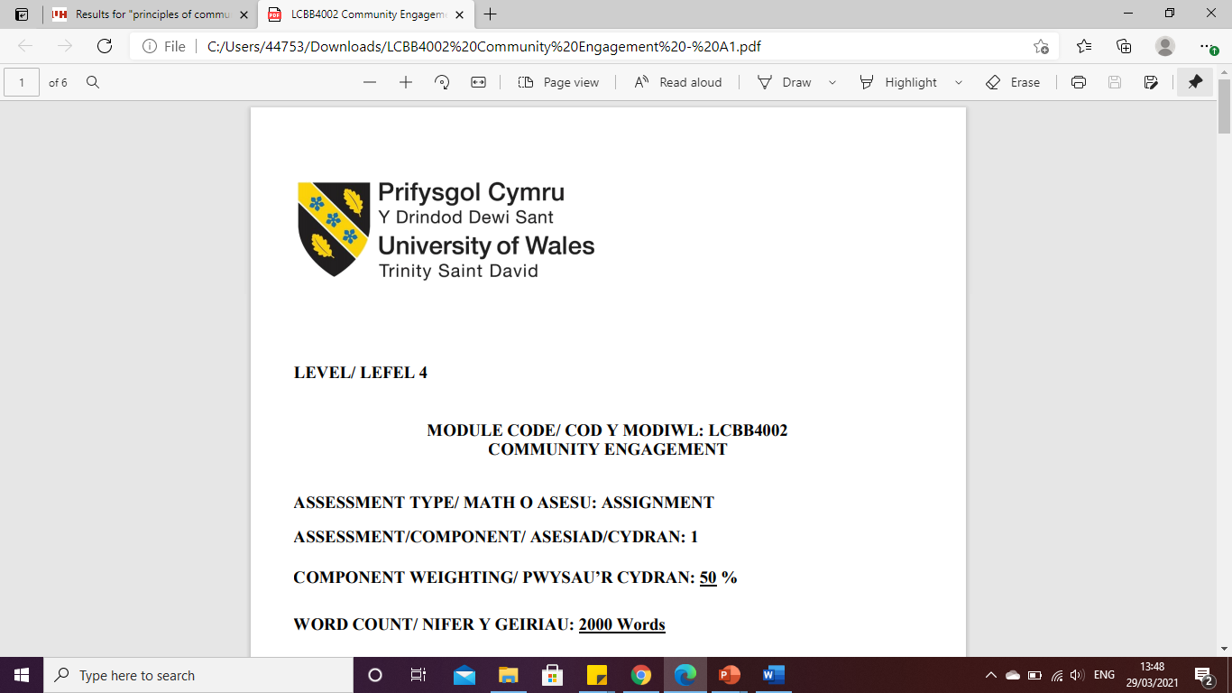

LEVEL 6

ASSIGNMENT 1- COCA-COLA
MODULE CODE: LCBB6002
INTERNATIONAL FINANCIAL MANAGEMENT

ASSESSMENT TYPE: ASSIGNMENT
ASSESSMENT/COMPONENT: 1
COMPONENT WEIGHTING: 30 %
WORD COUNT: 1516 Words
SUBMISSION DETAILS:
Name: Cosmin Adrian Mitu
Student Number: 2021613

Table of Content

1. Introduction: 3
2. Importance of international finance management of Coca-Cola: 3
2.1. Maximise the wealth of shareholders: 3
2.2. Manage international finances: 3
2.3. Dealing with international clients: 3
3. Evaluate the dividend distribution policy of the business organisation of Coca-Cola: 3
4. Analyse the efficient market hypothesis theory in the context of the operations of the business organisation of Coca-Cola: 4
5. Challenges of Coca-Cola in different financial markets internationally: 5
5.1. The suffering of damage to the brand image to quality problems in China: 5
5.2. Supply chain problems in the UK: 5
5.3. Ethical crisis in the US market: 6
6. Evaluate the methods of appraising projects in the business organisation of Coca-Cola: 6
7. Conclusion: 6
References: 7

Introduction:
The key objective of the report is to make a brief discussion in a critical way on the dividend distribution policy in the business organisation of Coca-Cola. Other than that, another objective of the study is to make a brief analysis in a critical way of the efficient market hypothesis theory in the context of the operations of the business organisation of Coca-Cola. Along with that, another purpose of the study is to make a brief evaluation as well as analyse the methods of appraising projects in the business organisation of Coca-Cola.

Importance of international finance management of Coca-Cola:
  - Maximise the wealth of shareholders:
The business organisation of Coca-Cola gives so much importance to international financial management as managing international financial management in the business helps the organisation to increase the worth of the company and that helps to do wealth maximisation which means increasing the share price of the shareholders of the company (Study Corgi, 2023).
  - Manage international finances:
With the help of managing international financial management, the business organisation of Coca-Cola was able to manage all kinds of international finances in the business in an effective as well as efficient way (Study Corgi, 2023).
  - Dealing with international clients:
The business organisation of Coca-Cola managing international financial management helps the company deal with international clients by giving proper and transparent financial records (Study Corgi, 2023).

Evaluate the dividend distribution policy of the business organisation of Coca-Cola:
A dividend distribution policy is some principle that helps to ascertain the amounts for distributing to every equity shareholder as dividend by a business organisation as well as enable the business organisation to strike a balance between retained earnings and pay-out for addressing the future needs of the business organisation (Barros et al. 2020). With that, the business organisation of Coca-Cola is one of the most popular companies in the area of consumer non-durables in the world that has a market capitalization of 27, 6234.6 million dollars. Other than that, the share price of the business organisation of Coca-Cola is 64.15 dollars in the month of May 2023. In the last year, the dividend price of the business organisation of Coca-Cola was 2.24 dollars in the whole year. With that, the current dividend yield ratio of the business organisation of Coca-Cola is 3.49 per cent. Other than that, the company has a huge capacity for paying dividends to the shareholders of the business organisation. As the business organisation of Coca-Cola grew by 4.66 per cent on a year-on-year basis and the profit of the company grew by almost 11.72 per cent on a year-on-year basis. Almost all companies in the area of consumer non-durable do not pay dividends to their shareholders but the business organisation of Coca-Cola does pay dividends to its shareholders (Coke Consolidated, 2022). Not only that, the business organisation of Coca-Cola with the help of the optimum currency area theory has a dividend policy of regular dividend policy for paying dividends to its shareholders. Under this policy, the business organisation of Coca-Cola pays out dividends to its shareholders every year. Along with that, the business organisation of Coca-Cola also has a dividend reinvestment plan. Under this dividend reinvestment plan, the business organisation of Coca-Cola provide a service to their shareholders that allow all the shareholders of the business organisation to increase their holdings in an easy as well as effective way while incurring lower the cost of brokerage as well as realises all the full privileges and rights on the reinvested shares (Dividends Diversify, 2023). Not only that, but the shareholders of the business organisation also can benefit from the robust dividend yield where the business organisation of Coca-Cola prioritises both the reinvestment as well as the growth of the dividend into the business organisation for the growth of long-term earnings of business of Coca-Cola (Coca-Cola Company, 2023).

Analyse the efficient market hypothesis theory in the context of the operations of the business organisation of Coca-Cola:
An efficient market hypothesis theory is the price of the share that reflects all kinds of information about the business organisation. The efficient market hypothesis is the trading of stock at the fair market value on the exchanges. Other than that, the efficient market hypothesis theory talks about the accurate market price that reflects the true value of a share of the business. The prime focus of the efficient market hypothesis is on every impossibility of the market being wrong about the worth of a stock of a business organisation. With that, the collaboration accomplishment of Coca-Cola with their shareholders undermines the efficient market hypothesis (Study Corgi, 2023). Through a market stock analysis, there is an understanding of the efficient market hypothesis theory of the business organisation of Coca-Cola. Warren Buffet at the time of the crash of the stock market supported the business organisation of Coca-Cola in a financial way. Not only that, the decision of supporting the company gave a huge chance to get huge revenues as well as the company has gained an increase of almost twenty times in the price of the shares of the company. One year after the crash of the stock market, the price of one share of Coca-Cola cost 2.45 dollars and after thirty years in the stock market, the price of one share of the company grew to 42.7 dollars. Other than that, the investors, as well as shareholders of the business organisation of Coca-Cola, earned a lot of money from the investments in this company (NCBI, 2020). But it is a fact that the business organisation of Coca-Cola was worth more than the only estimation of the price of one stock of the company. Along with that, the business organisation of Coca-Cola is a successful one in the global market and the company not only just benefited the shareholders of the business organisation but also approves the long-term investment position in the shares of the company. With that, the brand name of the business organisation of Coca-Cola is so powerful in recent times in the market that the business organisation is able to support twenty different kinds of brands. The share price of the company grows in a continuous manner and the share price of the company has become 60.1 dollars from 7 dollars in the past.

Challenges of Coca-Cola in different financial markets internationally:
  - The suffering of damage to the brand image to quality problems in China:
Coca-Cola has suffered damage to the name of the brand of the business organisation due to the problems in the quality of the products of the company in the market China. As the company scored the lowest of 63.9 in a survey of CACNCC among the twelve main beverage brands in the China market (Chen, 2022).
  - Supply chain problems in the UK:
The business organisation of Coca-Cola has gained huge pressure for the crisis in the supply chain for the shortage of aluminium cans in the UK market. So, consumers lack the availability of Coke Zero and Diet Coke in various places in the UK (The Guardian, 2021).

  - Ethical crisis in the US market:
The company faced different kinds of ethical crises in the US market in different kinds of areas such as distributor conflicts, channel stuffing, depletion of natural resources, intimidation of union workers, health concerns, and racial discrimination (Auburn, 2020).

Evaluate the methods of appraising projects in the business organisation of Coca-Cola:
Coca-Cola concentrates primarily on the sales of financial assets and collection of contractual cash flow for appraising projects in the business organisation. Other than that, the business organisation of Coca-Cola analyses the impairment as well as the exchange rate fluctuations to appraise the projects of the company. Along with that, the business organisation of Coca-Cola uses the internal rate of return methods in their business organisation to appraise different kinds of projects in the organisation. Not only that, the business organisation of Coca-Cola uses the IRR method for getting numerous kinds of benefits as well as the simplicity of the method for calculating any kind of thing in the business organisation. With the help of the IRR method, the business organisation of Coca-Cola is able to calculate the profitability ratio on the opportunities in possible investments for increasing the revenue rate of the business organisation. Not only that, with the help of the internal rate of return method, but the business organisation of Coca-Cola also evaluates any kind of opportunities for investment based on the time value of the money (Study Corgi, 2023). By following the IRR method, the business organisation of Coca-Cola is able to increase its revenue as well as new kinds of collaborations.

Conclusion:
The business organisation of Coca-Cola faces the challenge of damaging the brand image of the company in the market of China. As the company scores the lowest with a number of 63.9 among the twelve prime main beverage companies in the China market in a survey of CACNCC. Other than that, the company also faced the challenge of different kinds of ethical crises in the US market.

References:
Auburn (2020) The Coca-Cola Company struggles with ethical crises, auburn. Available at: https://harbert.auburn.edu/binaries/documents/center-for-ethical-organizational-cultures/cases/coca-cola.pdf (Accessed: 03 May 2023).
Barros, V., Matos, P.V. and Sarmento, J.M., (2020). What firm’s characteristics drive the dividend policy? A mixed-method study on the Euronext stock exchange. Journal of Business Research, 115, pp.365-377.
Chen, S. (2022) Coca-Cola suffers brand damage due to quality problems in China: Marketing, Campaign Asia. Available at: https://www.campaignasia.com/article/coca-cola-suffers-brand-damage-due-to-quality-problems-in-china/312888 (Accessed: 03 May 2023).
Coca-Cola Company (2023) FAQs, The Coca-Cola Company. Available at: https://investors.coca-colacompany.com/shareowners/faqs (Accessed: May 3, 2023).
Coke Consolidated (2022) Investor FAQ, Coca-Cola Consolidated, Inc. Available at: https://investor.cokeconsolidated.com/shareholder-services/investor-faqs#:~:text. (Accessed: May 3, 2023).
Dividends Diversify. (2023) Coca-Cola Stock Analysis (KO) & Dividend Review, Dividends Diversify. Available at: https://dividendsdiversify.com/coke-dividend/ (Accessed: May 3, 2023).
NCBI. (2020) An analysis of the stock market reaction to the announcements of the UK Soft Drinks Industry levy, Economics and human biology. U.S. National Library of Medicine. Available at: https://www.ncbi.nlm.nih.gov/pmc/articles/PMC7397522/ (Accessed: May 3, 2023).
StudyCorgi (2023) Coca-Cola Company's International Financial Management: Free Essay example, StudyCorgi.com. Available at: https://studycorgi.com/coca-cola-companys-international-financial-management/#:~:text. (Accessed: May 3, 2023).
The Guardian. (2021) The Guardian. Available at: https://www.theguardian.com/business/2021/sep/02/coca-colas-supply-chain-under-pressure-due-to-shortage-of-cans (Accessed: 03 May 2023).

