

Student name: JAYANTHI SAGANTI
Student ID: 2532228

Module name: Intoduction of Health and Social Care
Module code: LCHS4003
Lecturer name: Ping Wu

Content page

Element 1 …………………………………………………………….. page 1
Element 2 …………………………………………………………….. page 3
References …………………………………………………………… page 6

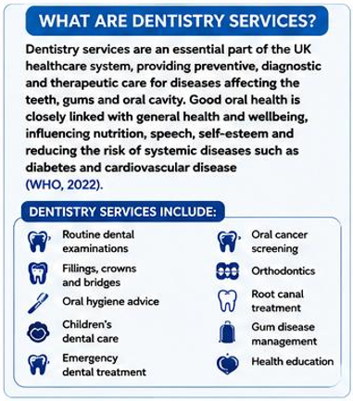 | 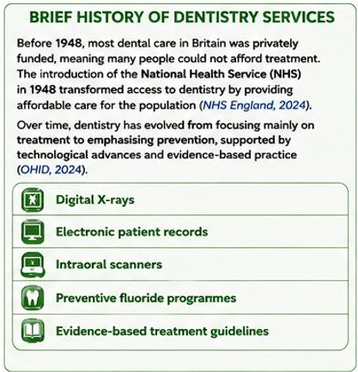 | 
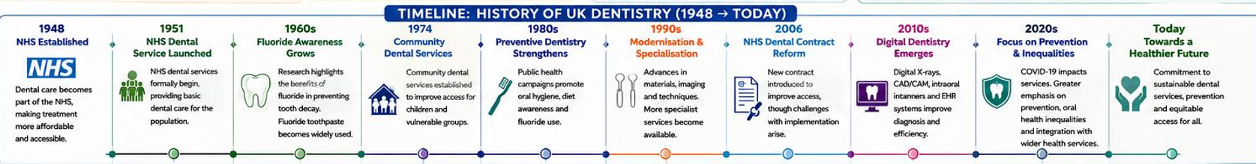

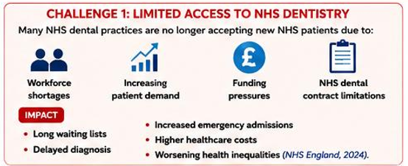 | 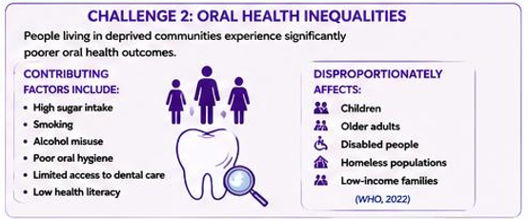

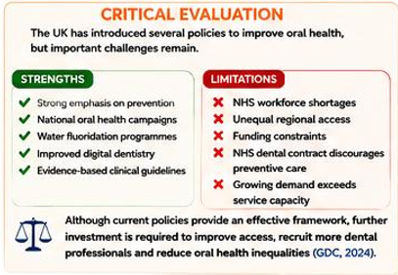 |  | 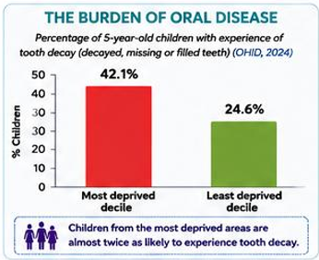 | 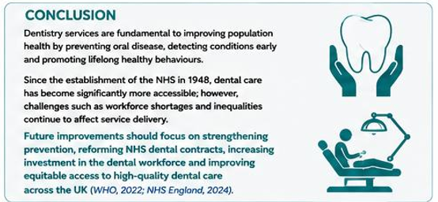

Element 2

Community Mental Health Services

Introduction
Mental health shapes how people think, feel and behave across the lifespan. The World Health Organization (2022) estimates that one in eight people worldwide lives with a mental health condition, underlining the need for accessible and effective care. In the United Kingdom, Community Mental Health Services (CMHS) provide assessment, treatment, rehabilitation and recovery support while enabling people to remain in their own communities (NHS England, 2024). This assignment investigates the origins of the service and the historical context that shaped it, critically evaluates how it functions today, and discusses its significance in enhancing service users' quality of life.

Origins and Historical Context
Before the 1950s, people with severe mental illness in the UK were largely housed in large psychiatric hospitals, or asylums. While these institutions offered shelter and treatment, they produced prolonged institutionalisation, social isolation and limited rehabilitation (Mental Health Foundation, 2024). Several converging pressures then drove reform. Advances in psychiatric medication from the 1950s made symptoms manageable outside hospital; public attitudes towards mental illness began to soften; and growing concern for patients' rights exposed the custodial character of asylum care (Mental Health Foundation, 2024). Underpinning this was a broader conceptual shift towards a biopsychosocial understanding, recognising that mental health is shaped by biological, psychological and social factors and that treatment is most effective in a person's everyday environment (World Health Organization, 2022).
The Care in the Community policy of the 1980s and early 1990s marked the decisive turning point, closing long-stay hospitals and replacing them with local services offering personalised care, housing support and multidisciplinary treatment (The King's Fund, 2024). The National Health Service and Community Care Act 1990 consolidated this by placing statutory responsibility on local authorities and NHS organisations for community-based provision. Policy has since prioritised recovery, early intervention, social inclusion and stigma reduction (Department of Health and Social Care, 2022). Critics have noted, however, that deinstitutionalisation was driven partly by cost containment, and that community infrastructure did not always expand at the pace hospital beds closed (The King's Fund, 2024).

Critical Evaluation of Current Functioning
CMHS today are delivered by multidisciplinary teams of psychiatrists, mental health nurses, psychologists, occupational therapists, social workers, support workers and peer support practitioners (NHS England, 2024). Provision spans Community Mental Health Teams, Crisis Resolution and Home Treatment Teams, Early Intervention in Psychosis Services, Child and Adolescent Mental Health Services, Older Adult Mental Health Services and community rehabilitation. Service users access psychological therapies, medication management, crisis intervention, employment support and social care locally (NHS England, 2024).
The model's strengths are evident: care is holistic, needs-led and delivered in context, and the inclusion of peer support practitioners embeds lived experience within professional teams. Yet delivery falls short of design in important respects. Rising demand has generated long waiting times and workforce shortages, and access varies markedly between regions, producing a postcode lottery that undermines the equity the model promises (The King's Fund, 2024). Funding constraints delay assessment and treatment, particularly for anxiety, depression and severe mental illness. Because effective care depends on collaboration between NHS organisations, local authorities, housing providers and voluntary organisations, fragmentation across these boundaries is a structural weakness rather than an incidental failure; The King's Fund (2024) notes such collaboration is inconsistently achieved. The result is discontinuity of care, with people falling between services at precisely the transition points where risk is highest. Arguably, then, the limitation lies less in the community model itself than in chronic under-resourcing of its implementation.

Significance for Quality of Life
The significance of CMHS lies in treating people within the settings that give their lives meaning. Receiving care at home allows service users to sustain family relationships, continue education or employment and participate in everyday activities, preserving the social roles that institutional care historically stripped away (World Health Organization, 2022). This matters for dignity and autonomy as much as for clinical outcomes: encouraging service users to participate actively in decisions about their own treatment reframes them as agents rather than recipients, and community care reduces avoidable hospital admissions. Early intervention services are associated with lower relapse rates, better medication adherence and stronger long-term recovery (NHS England, 2024).
The benefits extend further. Good mental health supports better physical health, stronger social relationships and greater economic participation (World Health Organization, 2022). Community services also sustain carers and families, whose own wellbeing is closely bound to that of the service user, and reduce stigma through education and awareness work — contributing to healthier communities and improved public health (Department of Health and Social Care, 2022).

Conclusion
CMHS have reshaped UK mental healthcare, replacing institutional care with a recovery-focused, person-centred model delivered locally (NHS England, 2024). The Care in the Community policy and the National Health Service and Community Care Act 1990 were pivotal in promoting independence, dignity and social inclusion (Mental Health Foundation, 2024). Workforce shortages, rising demand, funding pressures and regional inequalities nonetheless continue to constrain delivery (The King's Fund, 2024). Sustained investment, genuine integration across health and social care, and greater emphasis on early intervention and prevention will be essential if these services are to remain effective, equitable and sustainable (Department of Health and Social Care, 2022).

References
Department of Health and Social Care (2022) Mental Health and Wellbeing Strategy. London: Department of Health and Social Care.
Mental Health Foundation (2024) Community Mental Health. Available at: https://www.mentalhealth.org.uk (Accessed: 17 July 2026).
National Health Service and Community Care Act 1990. London: HMSO.
NHS England (2024) Community Mental Health Services. Available at: https://www.england.nhs.uk (Accessed: 17 July 2026).
The King's Fund (2024) Mental Health Policy and Community Care. Available at: https://www.kingsfund.org.uk (Accessed: 17 July 2026).
World Health Organization (2022) World Mental Health Report: Transforming Mental Health for All. Geneva: World Health Organization. Available at: https://www.who.int/publications/i/item/9789240049338 (Accessed: 17 July 2026

