Amelia Molloy
1801342

Content

P.3) Introduction
p.4) Evidence
p.5)Evidence
p.6)Evidence
p.7)Evidence
p.8)Evidence
p.9)Evidence
p.10) placements and previous jobs
p.11-15) Placements and previous jobs
P.16-17) Action plan for the future
P.18) Reference list.

Introduction
I am currently a Student in the University of Wales Trinity St David’s studying Nursing and Health level 4. During my year at University of Wales Trinity St David’s my studies have progressed. I have progressed so much academically and the lectures have taught me more in depth on the subjects that I have been attending. This year has helped me progress as a person and learn so many new skills and helped me for the future. During this year many skills have been progressed, skills in the assignments have developed, through doing assignments through different formats like a report, an essay, presentations and even recorded sessions and learning how to do them properly and efficiently.

Progression is the process of developing or moving gradually towards a more advanced state, (English Oxford Living Dictionary, 2019).Progression is important as it shows how far you’ve become and how much your skills and knowledge has developed over time. . My preparation for my exams and Anatomy and physiology lectures helped me progress so much academically and know more in depth information on parts of the body. Health research also Taught me an introduction to Harvard reverencing and how to use it sufficiently during my assignment as this was new to me this was a challenge and was very new to me be eventually I started to get the hang of it.

The lectures during health research and also PAD taught me where to reference and how to efficiently. Hopkins and Reid (2018) They state the importance of acknowledging where your information has come from . My Attendance in PAD lessons also helped to improve my assignments and my vocabulary .This assignment has taught me how to evaluate information by using relevance, currency , authority, accuracy and purpose and also more Knowledge on health research. During the counselling lessons I felt like I had developed as a person and learnt many different skills to do with communication including different types of communication skills by discussing learning outcomes and active listening skills.

During lessons we discussed the importance of communication skills and it will benefit me in my further studies within nursing this . SOLER was also used in the video as this felt like an essential skill that needed to be used in the video, SOLER is a non verbal way of communication it stands for sit squarely, open posture, lean towards the other, eye contact and also relax (Research Gate, 2018).

Evidence
During my times in workplace practice lectures I learnt many skills and new information. Although I couldn’t do workplace practice due to my DBS arriving in the middle of April and also applying for many job applications but not being successful due to experience, not driving or no DBS. I have however I done previous work experience in a primary school and also worked in a children's play area. I participated in many job interviews and also telephone interviews.

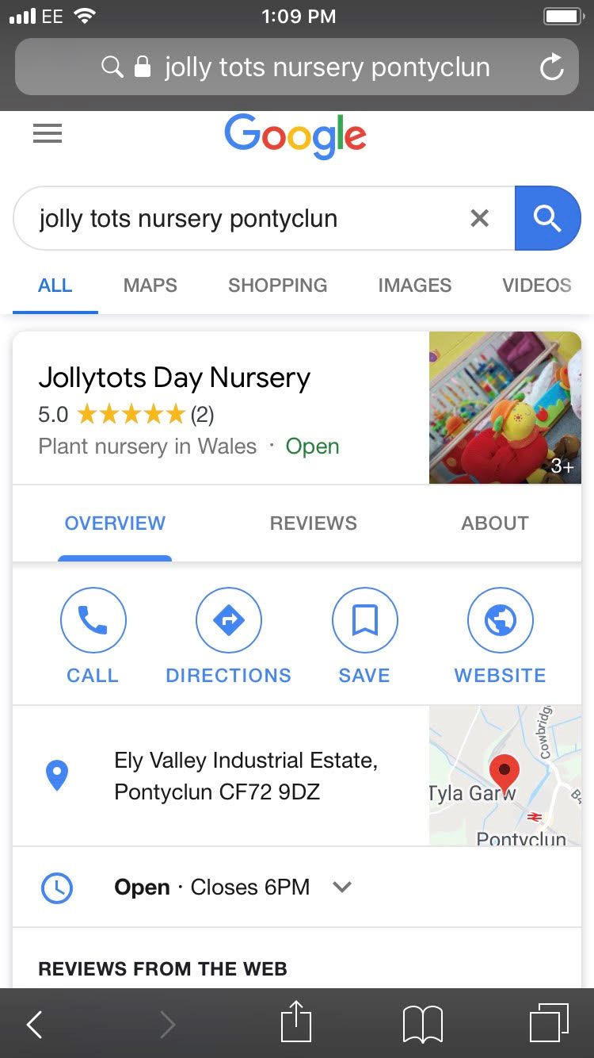

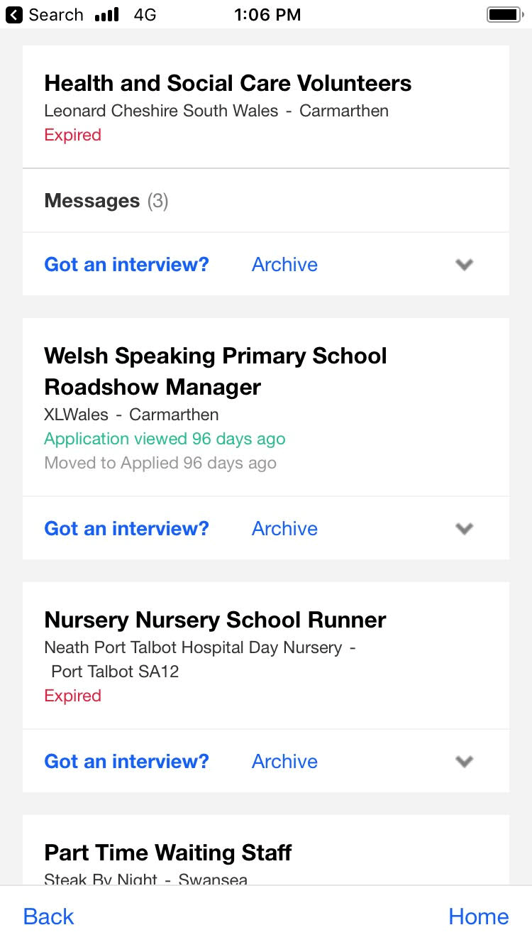
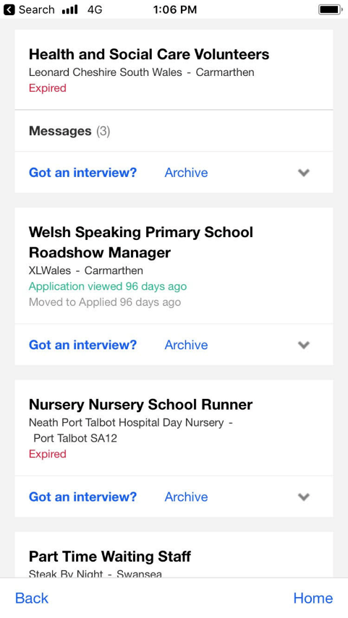

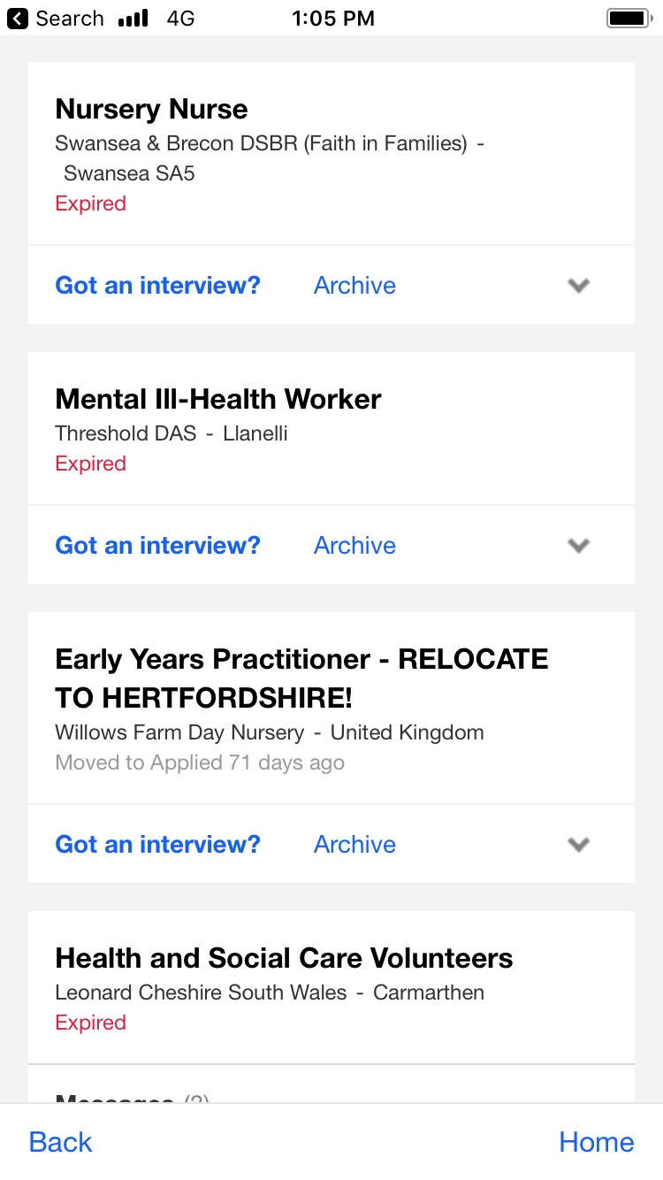

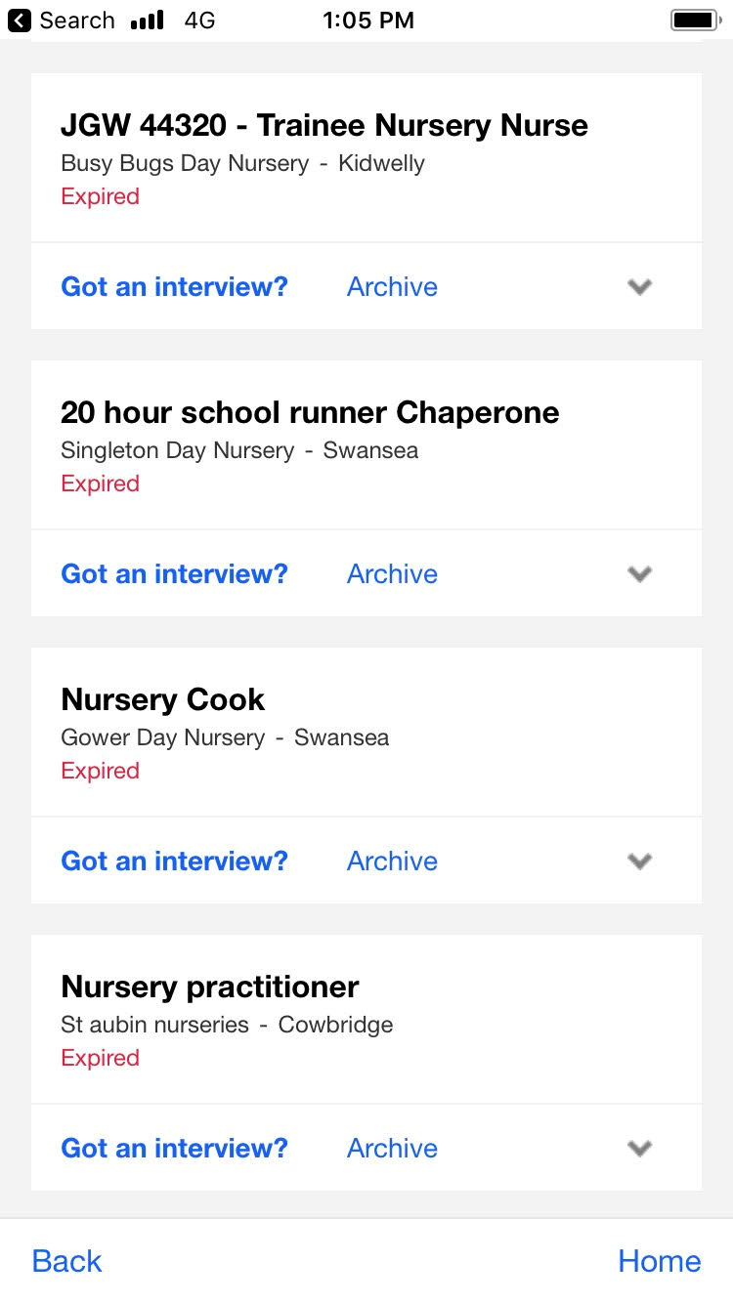

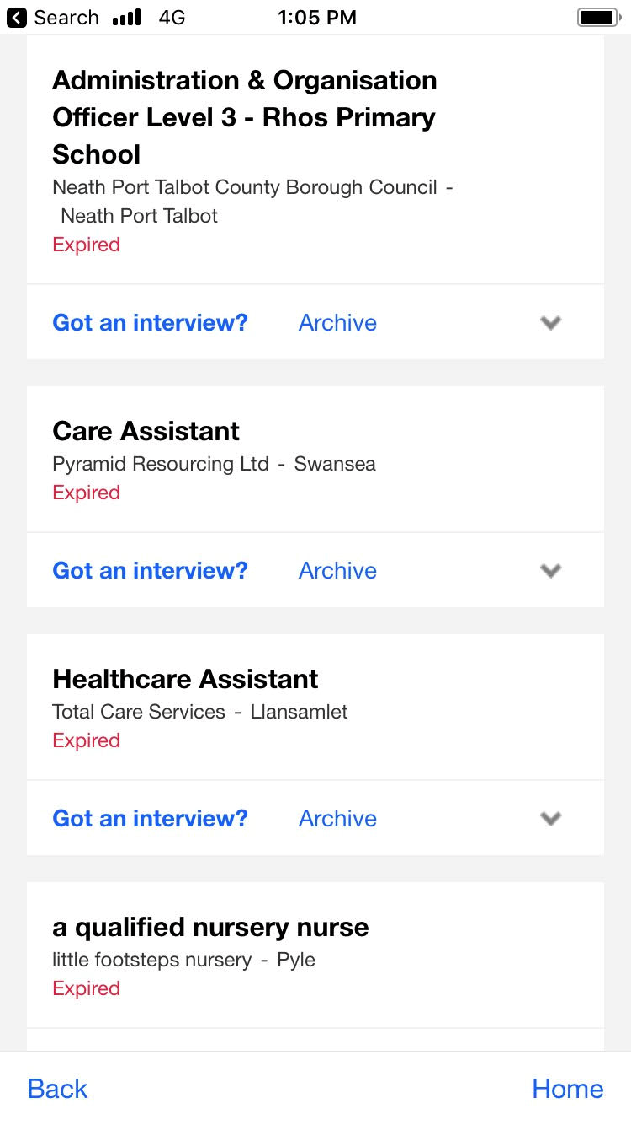

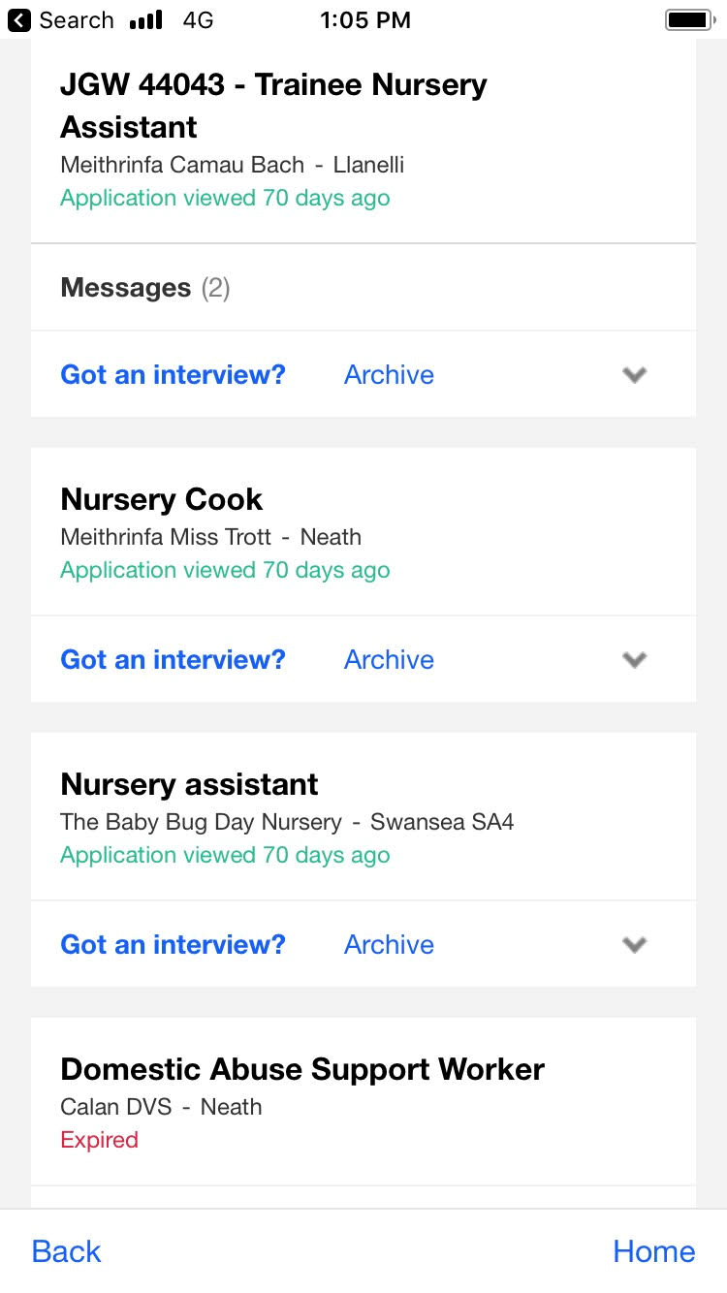

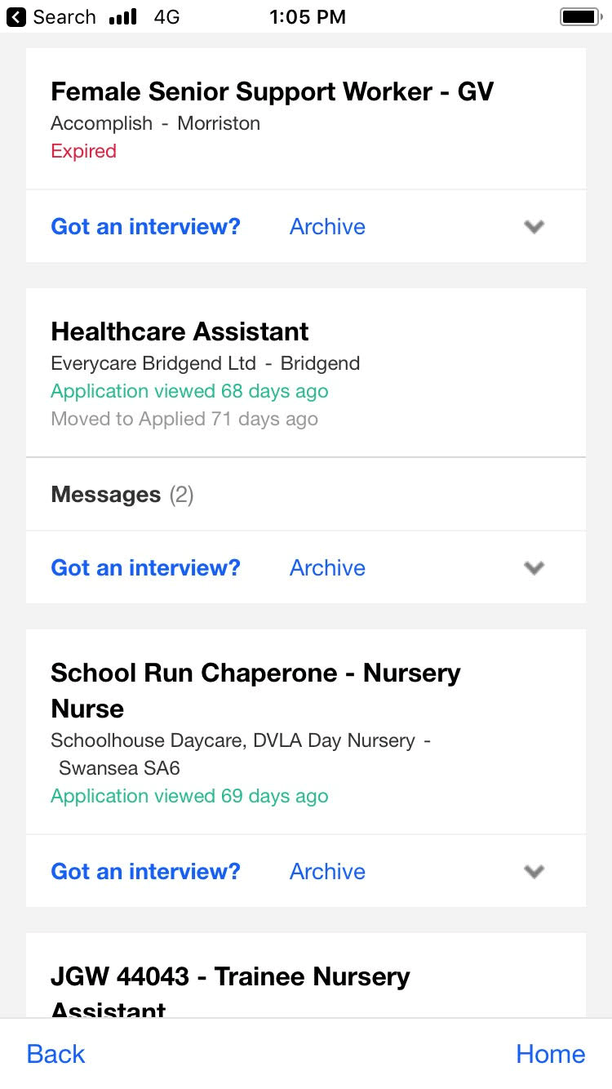

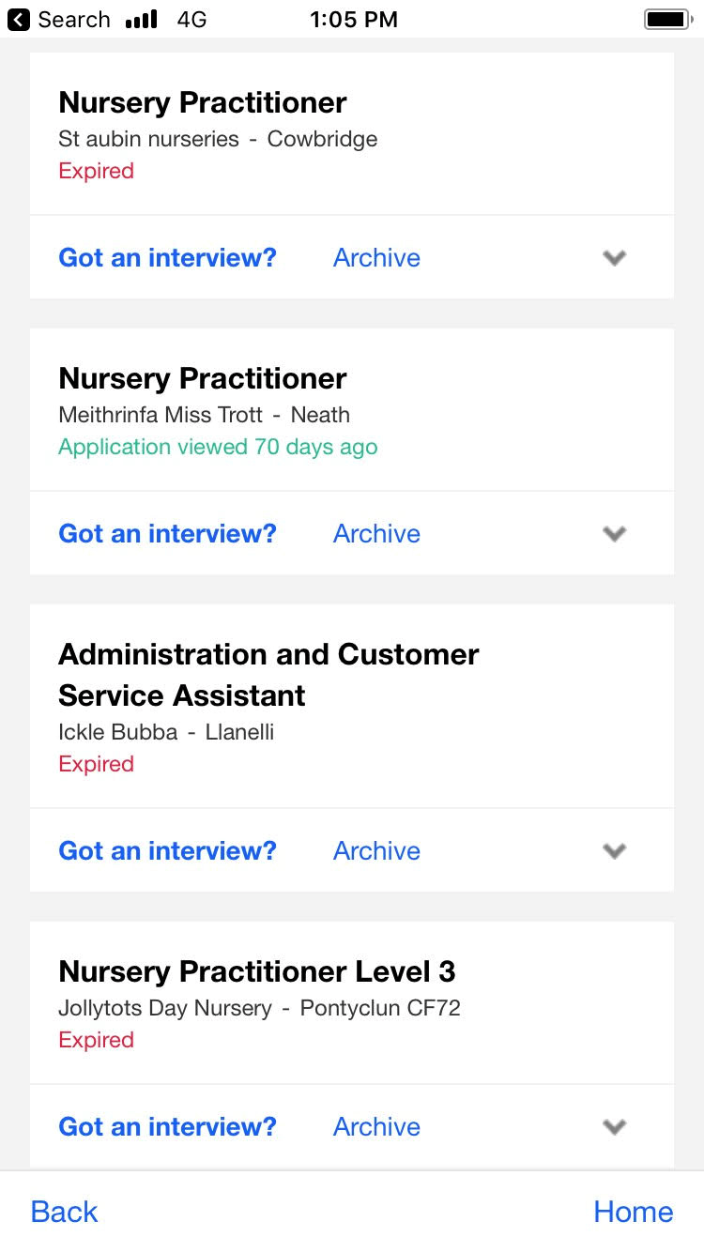

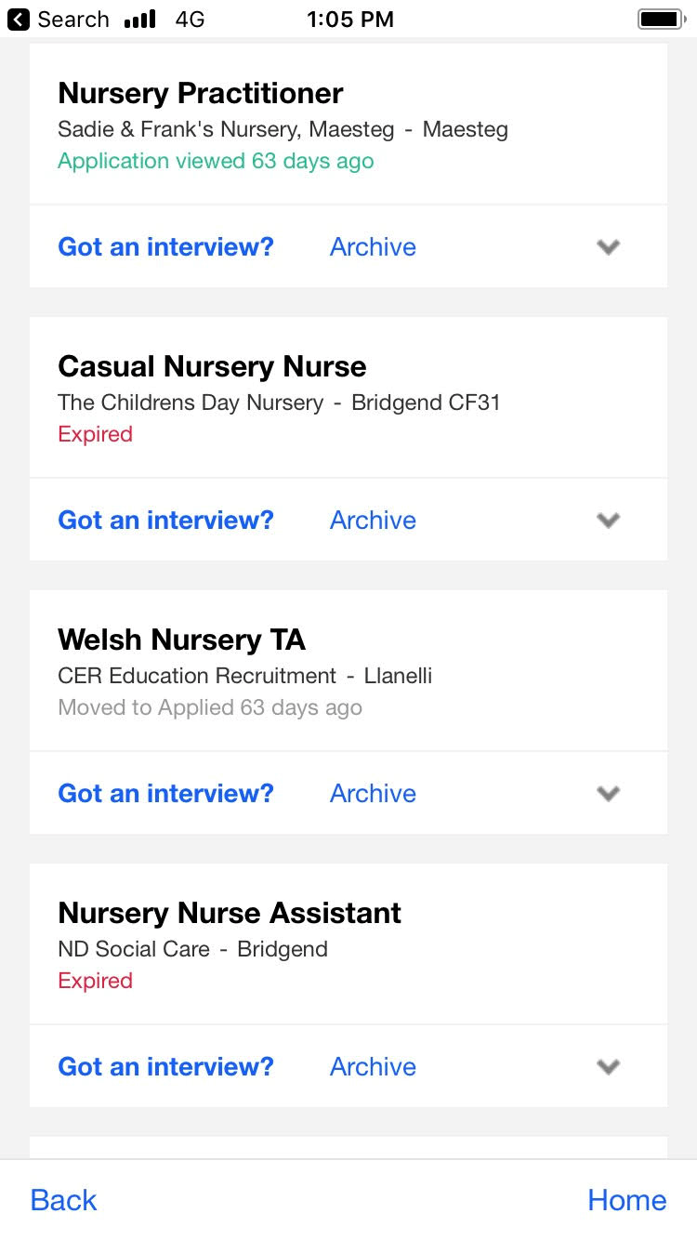

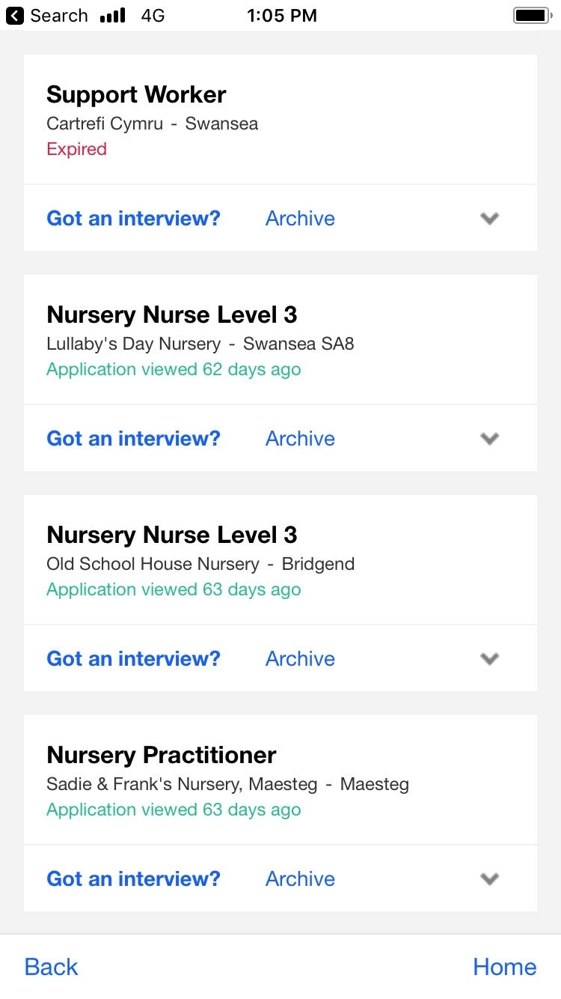

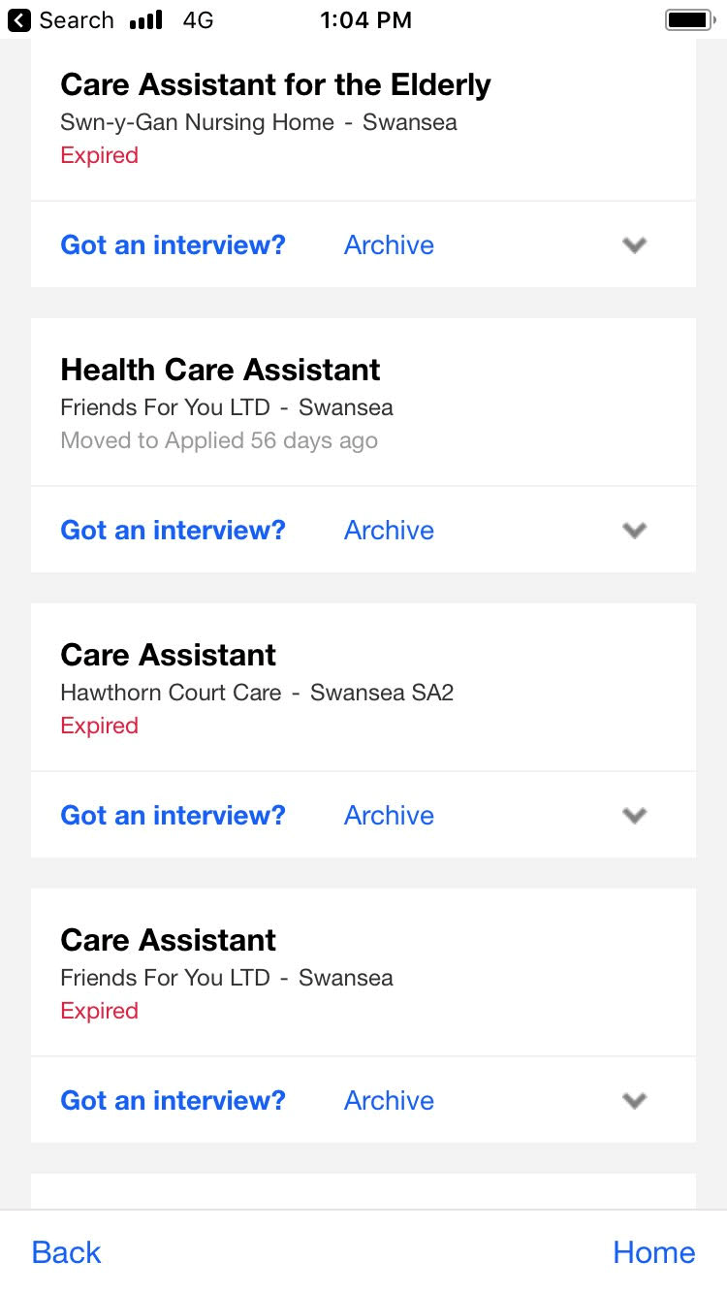

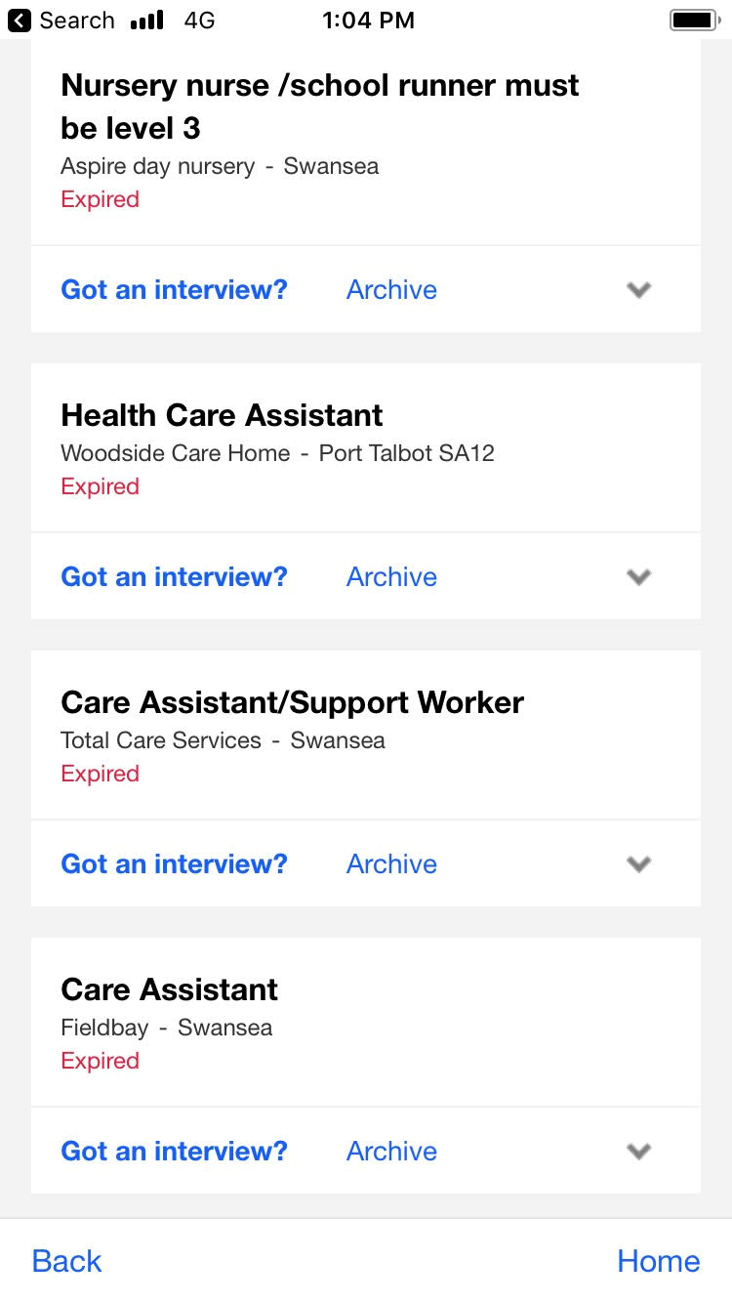
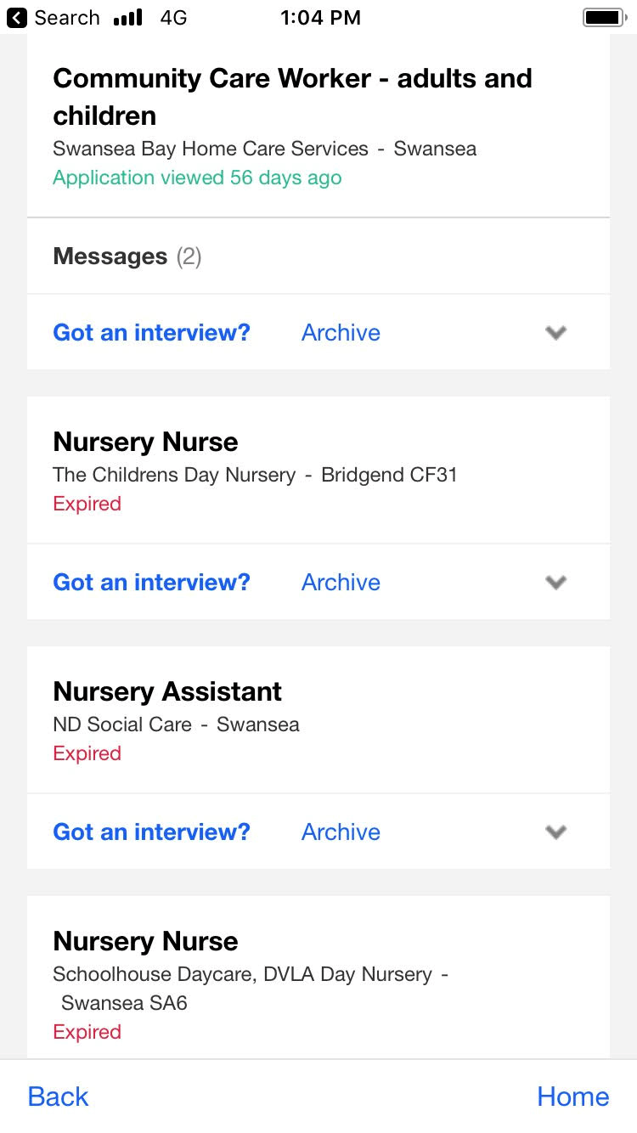

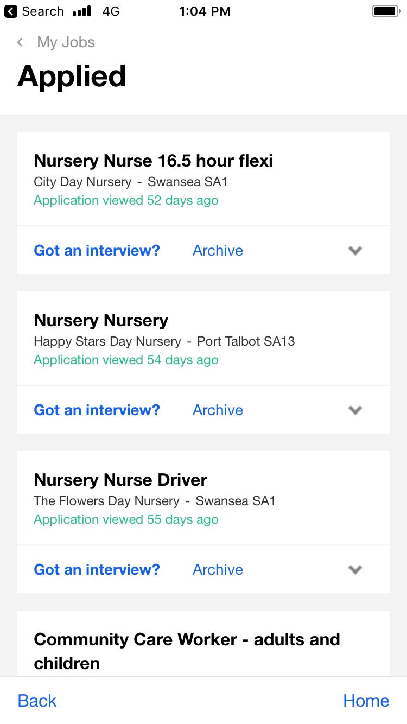

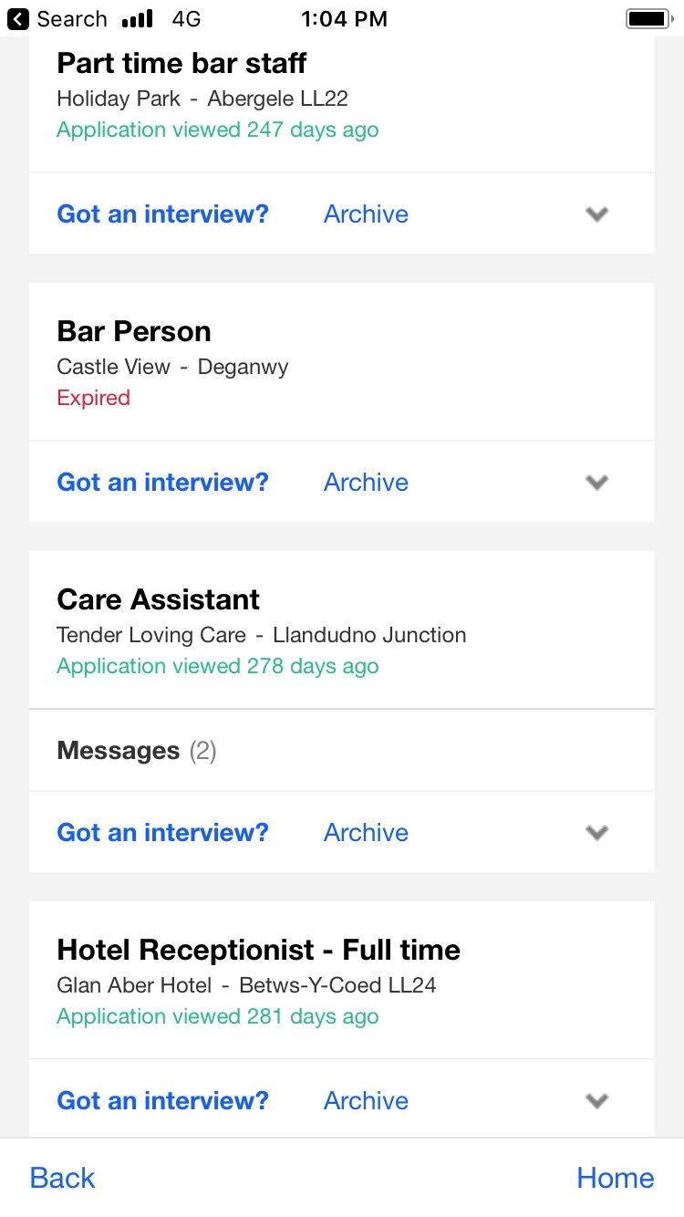

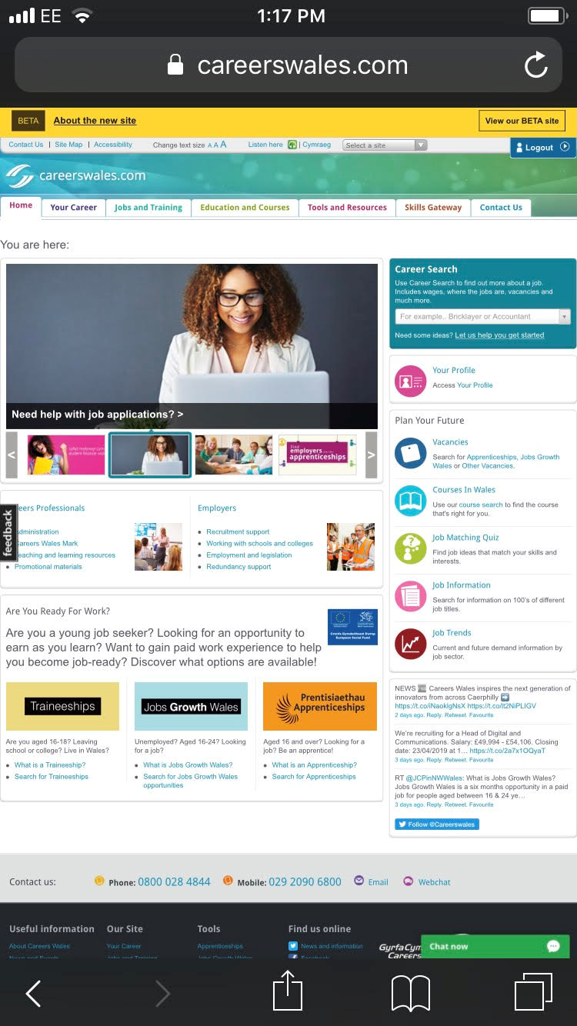

During my time at NWC venues I learnt many new skills. The main type of skills I learnt was communication skills, communication skills is the process by which we share and understand information (Kids Link, 2019). The different types of communication skills are verbal, visual, non-verbal and also written communication (Kids link, 2019).The are different types of methods for communication including verbal communication, non-verbal communication and also effective listening these are all essential with communication(Kids link, 2019).

I learnt these communication skills by observing the children and helping them with their need whether they lost their parents or had any problems. During my time in the play area I had to deal with behavioural problems including bullying or breaking the rules by making sure the rules where kept and the children where safe and no bullying was tolerated .

I also dealt with first aid so when a child used to cut themselves I used to clean it and an put a plaster or if more severe a bandage on their leg while making sure their needs are met to by talking too them or even giving them a lolly. I also dealt with bangs and bruises by giving the children an ice pack and making sure that their ok. During my times in NWC venues I also worked behind the bar dealing with people my communication skills developed during this time and also I had to deal with a busy and stressful work environment this taught me to keep calm and to do the best I can during this time. I worked at this busy Holiday venue for seven months before going to university.

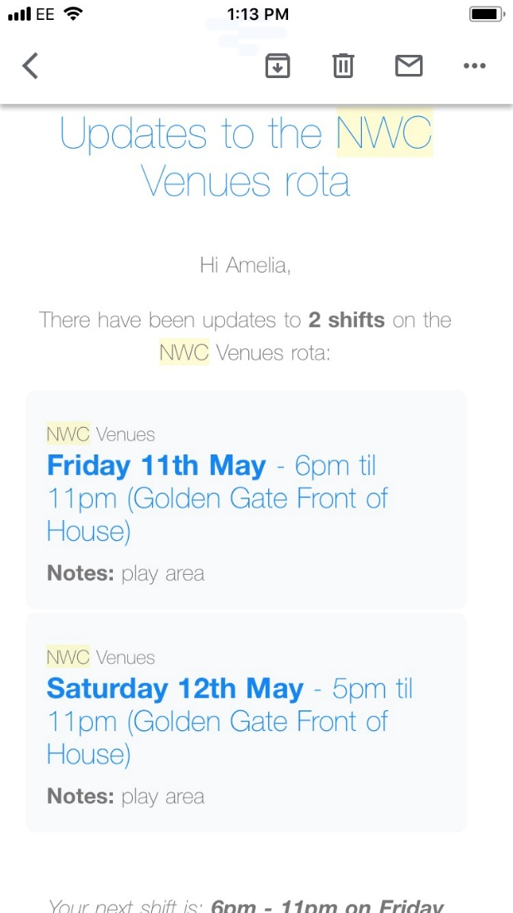

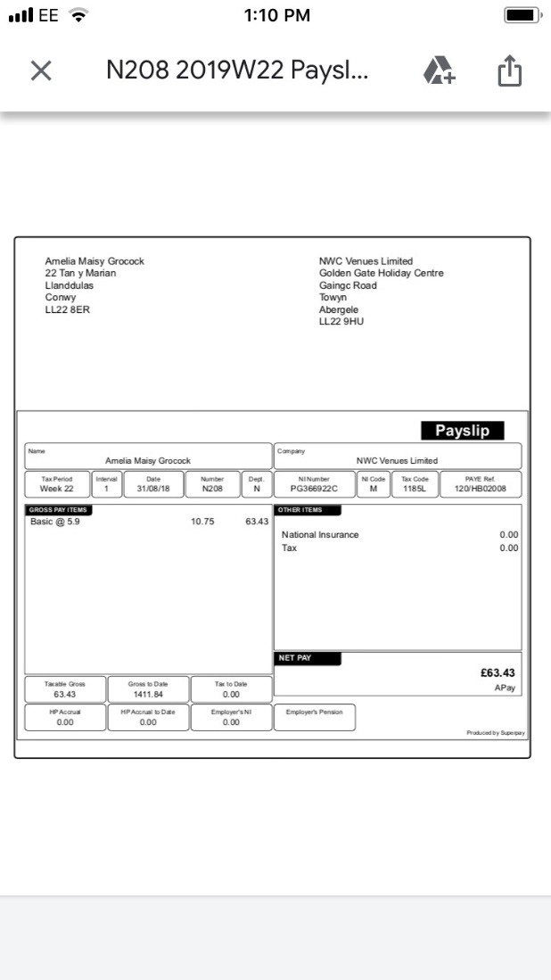

During my years in school I also did placement at Ysgol Glan Wydden where I participated in classes of all different ages from four too eleven. I also participated in a school trip that involved going bowling with the children this was a very important pay at the children where in our care i learnt many new skills like communication skills, helping the children with bowling and also making sure that they where safe and secure during the day out.
During my time at Ysgol Glan Wydden I participated in many classes including year Meithryn with in the youngest group of children, during this time I built a strong relationship with the children while still keeping it professional. Being able to network and build a relationship at an early stage is fundamental to building a long term career (Enactus, 2016). I participated in tasks like reading too them, building things, and also observing the children when outside. Communication skills during in this my time in this class is important . I also participated in Derbynfa with infants this involved good communication skills with the children, good communication skills are important . (CFI, 2019) Having strong communication skills aids in all aspects of life from personal life to professional life and everything in-between.
During my time here I participated in many tasks like reading, building communication and participated in many tasks with the children. I also participated in year 3 and fours history classes although history isn’t my strong point I managed to help the children with their work and helped to explain their work to them when some individuals dont understand.
I also participated in physical education with year five and six this was my favourite as sports is a big interest to me. Sports is an important role in everybody’s live mentally and physically, sports helps children develop character and to learn important social and brain skills (Sompting Abbots Preparatory School, 2019).

Action plan for the future
Realistic learning objectives
Using SMART technique for 3 of them.
The Smart technique is a goal technique which stands for specific, measurable, agreed upon, realistic and time based (Smart goals, 1981).My first specific long term goal is to become a Nurse the specific Nurse is a paediatric nurse the reason behind this is that I love children and that I love helping peoples lives change for the better. Ive known that ive wanted to be a Nurse ever since I was in sixth form I used to always look after my siblings and also help my friend with her granny that had dementia I also enjoyed my placement in a children’s primary school and working in a children’s paly area has also gave me an insight on what i wanted to do .
All of these experience have led up to me wanting to be a nurse as I feel as if its important to give back to others. The measurable step I did next was knowing what I needed to do to get there as i had the motivation and so I did my A levels and decided to do a foundation year in Nursing and health in UWTSD while I try and pass my maths qualification which has then led me up to an offer for a nursing course. The next step I plan on taking is trying my very best in university to reach my goal as a nurse and appreciate every experience I get and learn from along the way during my time in university. This Goal is a realistic long term goal which is time based as I’m aware of as long as I keep my head focused that ill be a qualified Nurse within three years.
The act that I need to take to achieve my goal is to pass my maths GCSE maths has been a struggle for me as I have tried passing the exam for the past two years but I am determined to pass the exam in June. This is because I need to pass my maths to become a nurse. It is important for me to get this and I'm going to achieve my goal. The measurable (smart goals, 1981) step I did next was knowing what I needed to do to get there as I had the motivation and so I did my A levels and decided to do a foundation year in Nursing and health in UWTSD while I try and pass my maths I hired a tutor for the last few weeks to make sure that I was up to date with my maths and for me to ask about anything I’m unsure of, i also attend night class in Ty Coch college one a week where ill attend my exam, I also have been revising and doing work in maths to achieve my goals. The action (Smart goals, 1981) I proceeded to do to pass my maths is revise a couple of times a week during my year at university and go over the stuff I was unaware of .
I will be able to achieve my goals by making sure I try my very hardest to revise and concentrate on the exam. I also have help off my personal tutor for a few weeks before the exam which is beneficial as its helped me to develop my skills in maths. I also attend college night classes for maths once a week .I will achieve my goal by going through past papers and going over the stuff I find difficult to achieve my goals. The goal is relevant as it is vital that i pass it for my further studies. I have set myself an achievable time frame to achieve my goals by making a revision schedule for maths to achieve my goals in my time that I have.

I also I need to pass my certificate to nursing and health to achieve my goals in nursing. So far I have passed all my exams and modules so I should pass the foundation year by trying my best and working hard , although I'm unaware of the grade .I have also got good A level results in which boosted my UCAS points also, I should pass my foundation course by making sure I revise for Anatomy and physiology, doing my assignment properly and efficiently and getting them in on time and also on time.
Time management is important as balancing everything out to make sure there’s time for everything is important I did this by creating a work schedule . This achievable if I have passed all my modules. The goal is relevant as it will help me get into nursing and a lot has been learnt over the past year that will benefit me for future studies.

Conclusion
This assignment has discussed the skills that have been progressed during the placement and the experiences I have had during my placements and previous work. This assignment includes clear evidence on my placements and where I applied for trying to get my placement. The assignment includes how much I have progressed during my placements. The assignment includes an action plan for futire goals in which I disgussed three long term goals that I have for the future.

Reference list
English Oxford Living Dictionary(2019)Progression. Available at: https://en.oxforddictionaries.com/definition/progression.
Hopkins and Reid (2018) The academic Skills Handbook, London, Sage.
Research Gate (2018) From Soler to Surety for effective non-verbal communication. Available at: https://www.researchgate.net/publication/51048314_From_SOLER_to_SURETY_for_effective_non-verbal_communication.
Enactus(2016)Importance of building professional relationships. Available at http://enactus.ca/importance-of-building-professional-relationships/ .
CFI(2019)Communication. Available at https://corporatefinanceinstitute.com/resources/careers/soft-skills/communication/ .
Sompting Abbots Preparatory School(2019)10 Reasons why learning sports for children is more than one big game.
Project smart(1981)SMART goals .Available at: https://www.projectsmart.co.uk/smart-goals.php.
Ranade, W.(1997)A future for the NHS? 2nd ed. London.
Powell, M.(1997)Evaluation The National Health Service. Buckingham.
Levitt R, Wall A, Appleby J(1997)National health service 6 ed. Cheltenham.

