Critically Evaluate And Explain The Role And Activities Of The Marketing Department Within Your Own Organisation

BMMB7012D

Robert Davies 1805256

Contents
Report Title 1
Contents 2
Introduction 3
Organisational Structure 4
Key Target Markets 5
Marketing Channels 9
Conclusion 10
Bibliography 12

Introduction
Admiral Group plc (AGP) launched in January 1993 under a single motor insurance brand, Admiral. Since then AGP has gone through a number of different phases of development. Firstly was the launching of different motor insurance brands within the UK, including Diamond, Bell and Elephant. A second phase saw the creation of the UK’s first insurance aggregator site, Confused.com. This was followed by expansion into international markets with motor insurance and aggregator sites and most recently the creation of home insurance and loans businesses (Admiralgroup.co.uk, 2019). Admiral is currently one of the largest car insurance providers in the UK, with a market share in excess of 11% (Directorate, 2018).
AGP has always operated with the intention of employing a strong understanding of its customers and attempts to use this understanding to help create and subsequently target its brands and products at these customers accordingly. In relation to its UK motor insurance brands Admiral was initially targeted at city dwellers, often driving premium vehicles, Diamond for female drivers, Bell for young drivers and Elephant for those wishing to engage with their insurer online, rather than by phone. As the product range has grown in breadth so has the need to widen the activities of the marketing department to cover such things as home insurance, loans and an insurance aggregator, Confused.com. Kotler and Keller (Open University, undated) defined brand positioning as ‘the act of designing the company’s offering and image to occupy a distinctive place in the mind of the target market’, whereas Marion (2017), writing for thebrandingjournal.com focuses more on the extent to which a customer’s perception of a brand is positive. The inclusion of design in Kotler and Keller’s definition is, it could be argued, particularly relevant definition when it comes to insurance; most general lines insurance products are very similar in nature, meaning that subtle differences in the design of the product and the brand can become an important differentiator.
We can relate this point back to AGP in more detail by using the example of the UK motor insurance brand, Diamond, which at the point of launch was designed and marketed exclusively towards female customers. Whilst is was possible for male drivers to obtain motor insurance from Diamond its pricing for males was prohibitively expensive resulting in the customer base being made up almost exclusively of females. However, the release of the EU Gender Directive in 2012 made it illegal for insurers to used gender as a factor in pricing and benefits (Financial Services Authority, 2012). This change triggered a period of consultation between the marketing and product design teams within AGP in order to establish how they would continue to position the brand towards the desired female customer base without the ability to use gender-specific price as a differentiator. A visit to the Diamond website reveals the strategy of using exclusively female models in the visual imagery, female only testimonials and product benefits that are designed to appeal more to female customers, such as handbag cover (Diamond.co.uk). A second example can be found in AGP’s home insurance product which is split into three tiers, Admiral, Gold and Platinum. The tiers contain different levels of cover and features that are aimed at customers with different needs of cover from the more basic with the Admiral level of cover to the far more comprehensive Platinum tier (Admiral.com, 2019).
Organisational Structure
Within AGP the UK marketing function sits as a standalone department that is responsible for all marketing activities across the spectrum of UK brands and products that is mentioned above. Given the variance of products, brands and customers that the marketing department has to service it could be suggested that the department operates within a structure that supports a high degree of market segmentation where this segmentation can be described as:

‘where there are differences in customer needs and wants, or in their attitudes and predispositions towards the offerings on the market, then there are opportunities to segment the market, i.e. to subdivide the larger market into smaller groups that provide market segments’ (Hooley, Piercy & Nicolaud, 2008).

Whilst it could be suggested that such a structure provides benefits in the sense that it allows for a better understanding of the population and therefore a marketing mix that can be better tailored to each segment (Bhasin, 2018) Davis suggests that it can result in a duplication of functional expertise (2018). Perhaps AGP could overcome some of the issues with a segmented structure by adopting an elastic organisational structure for its marketing area which ‘allows for adding headcount and/or functions seamlessly as the company’s product mix evolves’ (Modernmarketingpartners.com, 2014). It could be argued that adopting such an elastic approach would suit AGP particularly well given the way that its structure is organised in the wider sense.

AGP employs product managers and executives who are responsible for the design of new products as well as the continued development of features for existing products. In addition to this there are separate sales (inbound and outbound), customer service, renewals and claims departments all of whom are responsible for interacting with customers and discussing the products, either in the act of selling policies or maintaining and using existing ones. In this sense it could suggested that these frontline members of AGP’s staff are well placed to gauge the customer’s reactions to the market offering. Whilst there is already a close link between AGP’s marketing and product departments perhaps an area for improvement would be in forging closer links between marketing and the frontline staff in order to better create conditions where a customer value-driven marketing strategy can be pursued by using their experiences with customers day in, day out to inform the value proposition, which Kotler & Armstrong defined as ‘the set of benefits or values’ a company commits to delivering for its customers (2018). An elastic marketing structure would provide for the ability to recruit and deploy marketers into these positions with relative ease.

Ability to Identify Key Target Markets

As discussed above, AGP is required by its product range to deliver a number of different market offerings, where market offerings can be defined as a ‘combination of products, services, information, or experiences offered to a market to satisfy a need or a want’ (Kotler & Armstrong, 2018). Linton makes a useful addition to this definition by specifically referencing elements that represent additional value to the customer such as availability and quality of service (2018); it could be argued that these are of particular relevance when considering the marketing of insurance products, indeed Soloman, writing for Forbes suggests that good customer service is essential for success in the insurance business (2017).

When attempting to critically evaluate the performance of AGP’s marketing department in its ability to identify key target markets it could be that a broad approach is taken such as referencing AGP’s growth in customer numbers, turnover or profitability on the basis that these are measures directly impacted by AGP’s ability to market to the correct customer base. In taking this broad view we could look to AGP’s 2018 full year results and infer that performance has been good:

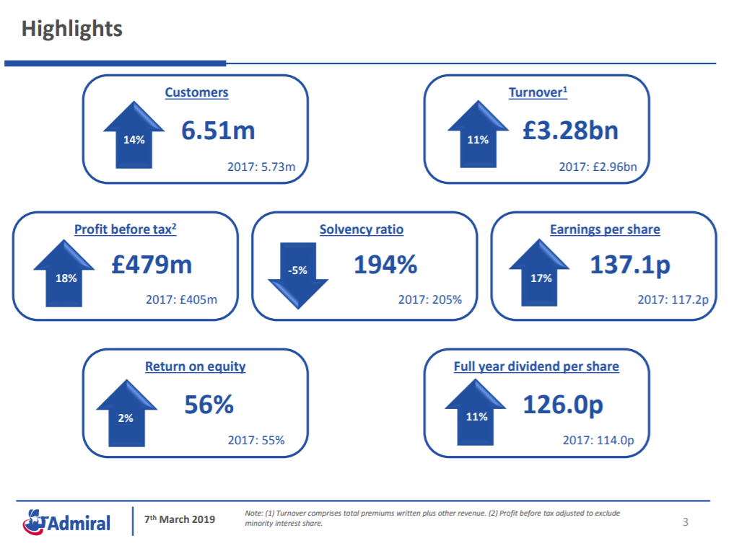
(Directorate, 2019)

Support for the notion that broad company measures such as those outlined above can be found from Marson, quoted by 4C Associates, who argues that revenue growth is the only reliable way of measuring marketing performance (2013). However it could be argued that such a broad approach does not reflect the granularity of information required in the more nuanced sense required to assess AGP’s ability and performance in identifying target markets.

Insurance is sometimes referred to as a ‘grudge purchase’ in an attempt to reflect the fact that it is a product that people generally don’t want to buy, rather they do so out of a desire to protect themselves and their assets from suffering a loss, or in the case of motor insurance are legally obliged to purchase. With that in mind it could be suggested that traditional notions of target markets, where a broad definition such as ‘a group of potential customers to whom a company wants to its products and services’ (Kenton, 2019) are less relevant as in the case of motor insurance the target market can be identified by assessing the number of vehicles licensed for driving on the UK roads, which according to the UK government is 37.9 million as of March 2018 (Gov.uk, 2018). Where a target market is so broad perhaps it is appropriate to take a broad measure of performance in AGP’s ability to identify it, indeed AGP does so in its annual report:
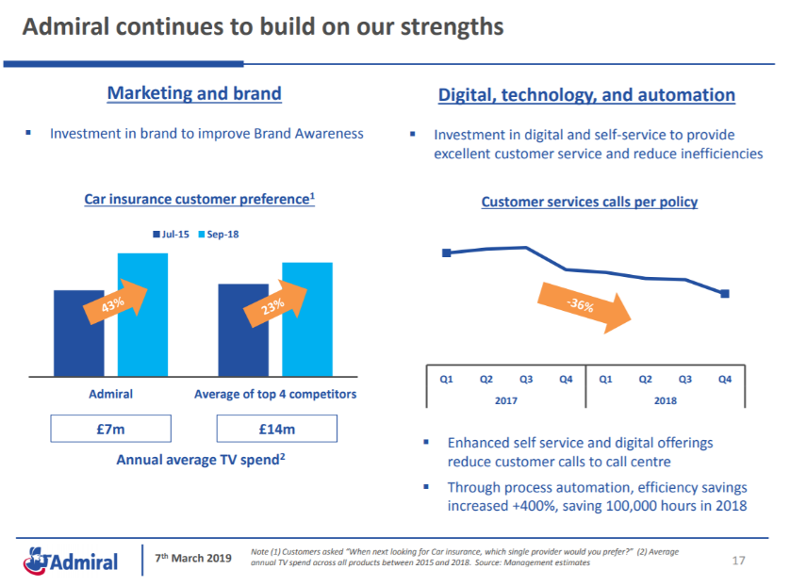

(Directorate, 2019)
The figures in the graph above suggest that AGP has outperformed its market competitors by 20% in improving its rating as the insurer of choice despite an average annual TV marketing spent that sits at 50% of the market. These figures suggest that AGP’s ability to engage with its target market is more efficient than its competitors and is achieving greater results.

The above chart relates only to AGPs insurance business, therefore in order to provide a more rounded critique of its ability to identify target markets it seems sensible to widen the scope of the review to include at least one other area of AGP’s business, in this case I have chosen its UK-based aggregator site, Confused.com.

Confused.com was the UK’s first insurance aggregator site and as such was the market leader for a number of years, however since then it has experienced a decline in popularity that could be attributed to the extent to which it lacked both a strong brand campaign when its competitors were performing well in that regard, and not really differentiating itself from its competitors in terms of its marketing offering, suggesting that its performance in identifying key target markets was poor. A good operative example of this can be found in the performance of one of Confused.com’s competitors, Comparethemarket.com. Comparethemarket.com were, at one point the smallest of the ‘big four’ aggregator sites (Confused.com, Comparethemarket.com, Gocompare.com & Moneysupermarket.com), however following the launch in 2009 of their incredibly successful marketing campaign that features Alexsandr Orlov, the anthropormorphic meerkat they have experienced a remarkable reversal of fortunes and one that shares a broadly inversely proportional relationship with those of Confused.com, as illustrated by the chart below:

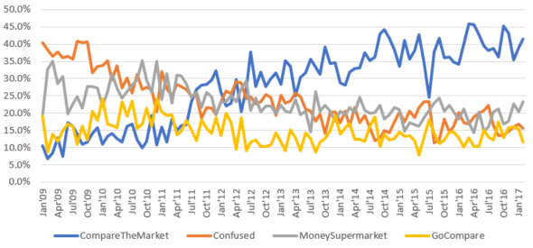
(Paterson-Fox, 2017)
The graph above depicts the aggregator sites that customers used when purchasing their insurance (rather than simply gathering quotes that were not acted upon) and clearly illustrates an upward trajectory for Comparethemarket.com and a downwards trend for Confused.com.

Whilst Confused.com continued to suffer with poor performance in the period immediately following the timeframe shown in the graph above they have continued to push through changes of marketing approach with a view to turning things around and have recently experienced some improvement. AGP’s 2018 full year results reported a market share increase for Confused.com across both home and motor insurance and made specific reference to ‘efficient marketing spend’ leading to a 41.5% year on year increase in profit (Directorate, 2019)

There is also evidence to suggest that Confused.com has improved upon its ability to differentiate itself from its competitors, thereby improving is market targeting. Confused.com offers a narrower band of products to customers looking to use the comparison services of an aggregator site, rather than attempt to compete by broadening this offering past its competitors Confused.com has instead begun to position itself as a provider of consumer advice, something that is again referenced in the AGP full year results report

‘We prefer to call ourselves ‘Customer Portals’ rather than Price Comparison, as the future requires us to not only compare prices, but also to give advice on the individual fit between consumer and service/product. We expect insights based on data analysis and AI will enable us to achieve this’ (Directorate, 2019).

The potential benefit of adopting such a strategy can be assessed using the 3 circles model put forward by Urbany & Davies and their framework for defining customer value. Urbany & Davis suggest that when considering customer value we must realise that we sell more when customers choose us over other brands and the reason that customers will choose our brand is they believe it creates better value for money (2010). This is relevant to aggregators as they are free for customers to access, and perhaps more importantly, all have access to an almost identical panel of insurers from which to generate prices with the resultant prices often being very similar. It could therefore be argued that aggregators are not differentiated by their ability to provide value for money, rather the provision of value for the customer’s time or a more valuable experience; through that lens the delivery of an advisory element would appear to be a shrewd move on Confused.com’s part.

Perhaps reinforcing the suggestion that these activities are having a beneficial impact is the increased turnover achieved by Confused.com of 9.5% year on year. With that in mind we may conclude that Confused.com represents an area of poor performance but one that is also improving, achieved at least in part by increasing its ability to target key markets.

Selection of Marketing Channels

As mentioned above there is evidence that both Confused.com and AGP as a whole rely upon advertising, and more specifically television advertising as a large part of its marketing channel selection. Insurance aggregators have traditionally been big spenders when it comes to television advertising and have achieved a great deal of success through that channel, as evidenced by the success of the aforementioned meerkat campaign. This reliance upon television advertising was recently acknowledged by Confused.com’s CMO Samuel Day, along with signalling a departure from this approach, when Day was quoted as stating that whilst Confused.com’s previous strategy was to ‘go big on a limited number of channels", namely TV, digital display and search’ that ‘Fundamentally, I believe in a much more integrated media mix…We’re bringing in VOD, radio and much more work directly with Facebook, YouTube and Twitter’ (Gwynn, 2018).

It is my view that AGP’s wider marketing department has not signalled any such intention to embrace digital marketing in the same way as Confused.com. I think there is an opportunity for AGP’s insurer brands to work more closely with it’s frontline departments, particularly the claims area as having purchased an insurance policy a customer will only find out if the product is a good one, or lives up to how it was marketed, when coming to make a claim. With the rise in digital functionality in the claims world it is possible to extract significantly more data that is relevant to the customer experience (Bruggemann et al, 2018); this information can be fed back to the product design and marketing departments in order to improve the product and use these improvements to better market the policy to customers in an authentic way, possibly through the use of social media marketing, by making these campaigns fun insurers could use social media channels to gain followers who may otherwise not have engaged with them at all (Fien-Schmalzbauer, 2017)
Conclusion
The use of broad, objective measures such as profit and turnover, allow us to paint a picture of AGP’s marketing activities as being successful. The company has experienced consistent and significant growth since its launch in 1993 and is now in a position where it enjoys a significant share of the UK motor insurance market, whilst growing its home insurance market share. It could be argued that AGP laid the foundation for this success via the use of a comprehensive market segmentation and targeting strategy that sees its provision of insurance brands and products aligned to the needs of different customer strata.
However, a closer look at the situation suggests that there are a number of areas where improvement could be sought. AGP’s insurance aggregator, Confused.com, has faced a challenging few years where its competitors out-performed it with stronger advertising strategies, particularly the television campaign run by Comparethemarket.com. The resultant impact of this has seen Confused.com fall from being the top performing of the four largest UK aggregators to the worst performer. There are recent signs that Confused.com has taken steps to address this, and that by re-targeting its offering it is seeing the green shoots of recovery. Perhaps there is a lesson to be learned by the marketing department for the wider AGP business who have relied heavily upon traditional advertising channels and are therefore in a position where they may benefit from exploring more up to date approaches, such as social media marketing.

Bibliography
Admiral.com (2019), Home Insurance Available at: https://www.admiral.com/home-insurance (Accessed: 01/06/2019)
Admiralgroup.co.uk, (2019) Our Story Available at: https://admiralgroup.co.uk/our-story (Accessed: 10/07/2019)

Bhasin, H (2018) 6 Advantages of Segmentation Available at: https://www.marketing91.com/6-advantages-segmentation/ (Accessed: 02/06/2019)

Bruggemann, P et al (2018) Claims in the digital age: How insurers can get started Available at: https://www.mckinsey.com/industries/financial-services/our-insights/claims-in-the-digital-age (Accessed: 04/05/2019)

Davis, B (2018) The Six Types of Marketing Structure Available at: https://econsultancy.com/the-six-types-of-marketing-org-structure/ (Accessed: 13/07/2019)

Diamond.co.uk (undated) Main Website Available at: https://www.diamond.co.uk/car-insurance-for-women/ (Accessed: 13/07/2019)

Directorate (2019) Admiral 2018 Full Year Results Available at: https://admiralgroup.co.uk/sites/default/files_public/slides/2019/03/2018-full-year-results-slides.pdf (Accessed: 13/07/2019)

Directorate (undated) Our Business / Our Operations Available at: https://admiralgroup.co.uk/our-business/our-operations (Accessed: 13th July 2019).

Fien-Schmalzbauer, B (2017) Social Media In Insurance Marketing Today Available at: https://www.digitalistmag.com/customer-experience/2017/04/13/social-media-in-insurance-marketing-today-05030403 (Accessed: 13/07/2019)

Financial Services Authority (2012), Gender Directive Available at: https://www.fca.org.uk/publication/archive/fsa-gender-directive.pdf (Accessed: 28/06/2019)

Gov.uk (2018) Vehicle Licensing Statistics: January to March 2018 Available at: https://www.gov.uk/government/statistics/vehicle-licensing-statistics-january-to-march-2018 (Accessed: 13/07/2019)

Gwynn, S (2018) James Corden Makes Way As Confused.com Advertising Returns To ‘Tackling Confusion’ Available at: https://www.campaignlive.co.uk/article/james-corden-makes-confusedcom-advertising-returns-tackling-confusion/1490597 (Accessed: 13/07/2019)

Hooley, G; Piercy, N; Nicoulaud, B (2008) Market Strategy And Competitive Positioning, 4th Ed, Pearson Education Limited, Harlow

Kenton, W (2019) Target Market Available at: https://www.investopedia.com/terms/t/target-market.asp (Accessed: 13/07/2019)

Kotler, P; Armstrong, G (2018) Principles of Marketing 17th Ed, Pearson Higher Education, Hoboken

Linton, I (2018) What is an Offering in Marketing? Available at: https://yourbusiness.azcentral.com/offering-marketing-7598.html (Accessed: 13/07/2019)

Open University (undated) Positioning My Brand Available at: https://www.open.edu/openlearn/ocw/mod/oucontent/view.php?id=78689&section=5 (Accessed: 11/07/2019)

Marion, (2017) A Simple Definition of Brand Positioning, Available at: https://www.thebrandingjournal.com/2016/11/brand-positioning-definition/ (Accessed: 10/07/2019)
Marson, P (2013) The only worthwhile measure of marketing performance is revenue growth Available at: https://www.4cassociates.com/the-only-worthwhile-measure-of-marketing-performance-is-revenue-growth/ (Accessed: 13/07/2019)

Modernmarketingpartners.com (2014) 7 Types of Marketing Organization Structure Available at: https://www.modernmarketingpartners.com/7-types-of-marketing-organization-structures/ (Accessed: 05/06/2019)

Paterson-Fox, P (2017) Twerking, James Corden And The Frozen Meerkats. Which Was The PCW Winner In 2016? Available at: https://www.consumerintelligence.com/articles/twerking-james-corden-and-frozen-meerkats.-which-was-the-pcw-winner-in-2016 (Accessed: 13/07/2019)

Soloman, M (2017) Customer Service And The Insurance Industry: Best Practices We Can All Learn From Available at: https://www.forbes.com/sites/micahsolomon/2017/06/02/what-the-insurance-industry-can-teach-you-about-customer-service-and-client-focus/#d43bf015f086 (Accessed: 13/07/2019)

Urbany, J & Davis, J, (2010) Grow By Focusing On What Matters: Competitive Strategy in 3 Circles Available at: https://www.scribd.com/doc/50234350/Introduction-to-3-Circle-Analysis-Urbany-Davis-2010 (Accessed: 19.06.2019)

