2018/19
A Reflection on Academic and Employability Skills
ACCA4016 ASSESMENT
Morgan Norbury
Contents
Introduction 2
Section 1: Presentation 2
Myself, an Overview 2
Screen Shots 2
Improvements and Evaluation 4
Section 2: Research into Skills Evaluation 4
Key skills for Employment 4
Required skills for HE 5
Self-Evaluation 5
Tests 5
Evaluation 6
Section 3: Action Plans 6
Short-term and long-term Goals 6
S.M.A.R.T 6
Section 4: Application 7
Looking after Data 7
Time management & self-organisation 8
Section 5: Conclusion & Evaluation 9
Section 6: Appendices 10
References 12
Bibliography 13

Introduction
This document, titled “A Reflection on Academic and Employability Skills”, will be used to detail my own recent development towards jobs, skills and HE; Skills required for both work and study; the different ways to secure information; and my future goals and prospects. It will serve as both an informative piece and a stepping stone to my future career/on my life path.

Section 1: Presentation

Myself, an Overview
My name is Morgan Norbury, I’m an IT student currently studying for an HND in applied computing with Pembrokeshire College. I was born in London on the 21st of August 1997, however I was only there for 2 weeks before my family moved down to the area I was raised in. I grew up in Neyland and went to both the infants and junior school that were here. Neyland is a small town, more of a hamlet, that has been around for many (many) years. After I attended Neyland junior school (primary school) I went to STP, Sir Thomas Picton School. I have worked in the past, only one job though. This was at Specsavers Haverfordwest as an Optical technician, which is just a fancy way of saying “glasses maker”. I have two main hobbies being gaming and photography. The main games I play are MMOs, ARPGs and Shooters. Photography is an expensive hobby of mine, but as shown in my photographs, an enjoyable one nonetheless. My strengths and weaknesses are weird to talk about, I’d never considered myself good at anything but talking, however after some reflection I’ve added a good memory and knowledge on computers onto the list of strengths. Weaknesses? I’ve got too many to count, but a few of my most noticeable ones are second guessing myself, indecisiveness and fretting over every detail before decisions, and procrastination. In the near future I really would like to finish this course with a good grade, it’ll take hard work but it would be worthwhile. In the further future, probably in the next 5-10 years, I’d like to get into the IT industry in a good area, maybe SysAdmin or even in game design. I’d also like to move out of Wales, as much as I love the country side, I prefer the city and moving to somewhere like London would be a great move for any future career.
This was a rough transcript of my presentation that I held in class. I used mostly minimal text and imagery on the slides as a sort of visual cue to move on.

Screen Shots


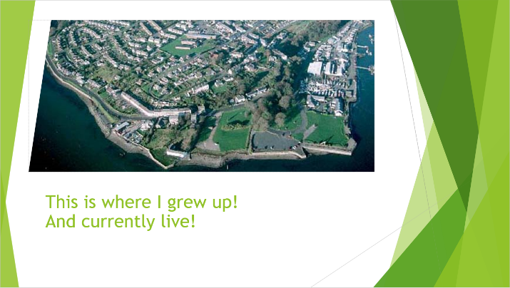
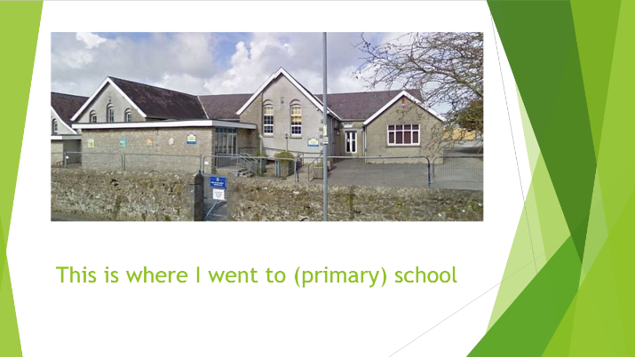
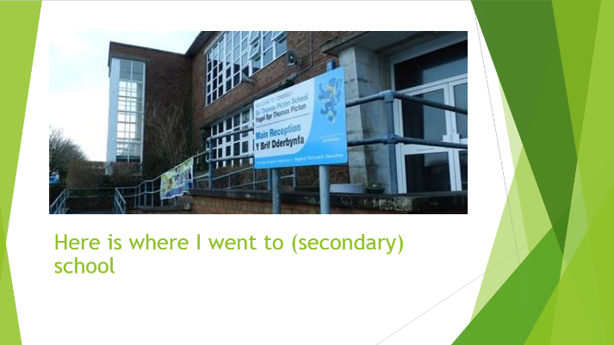
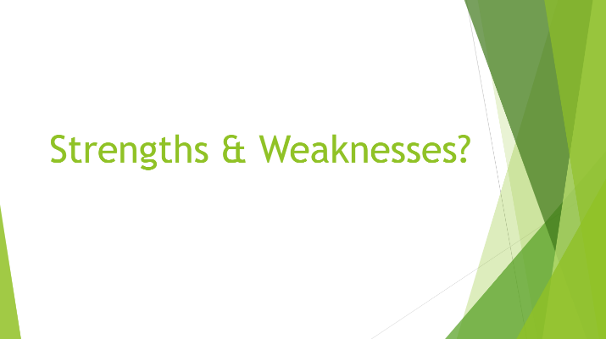
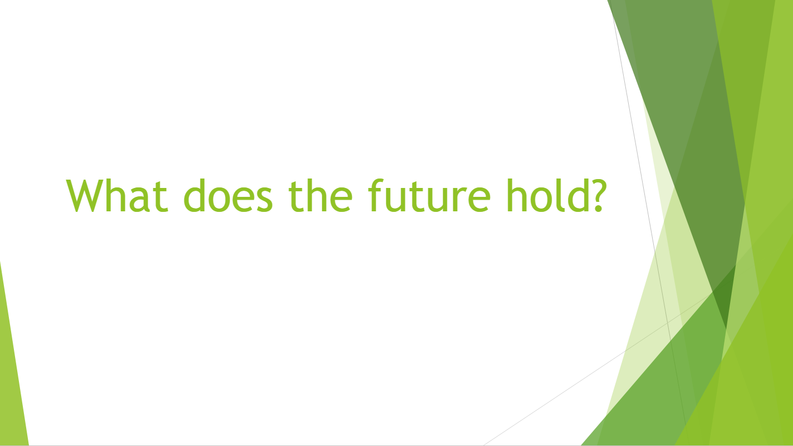

Improvements and Evaluation
At the end of my presentation I was given feedback by several people in my class and have worked towards evaluating my performance based on the feedback and feeling of how the presentation went.
“The presentation was very informative and gave great insight into Morgan’s life, his hobbies and dislikes. There was some occasional amusement throughout the presentation, so it wasn’t dull. This presentation showed that there had been a good amount of preparation, judging from the confidence shown. There were no visible nerves. Overall, it was a good presentation, the only thing I would recommend working on would be "Ummm" “ [1]
This and many pieces of feedback like it were received by me after my presentation. I agree with the constructive feedback, in-between long sentences and major points of the presentation I would often use “Ummm”. This was clearly a way that shows my lack of practise with timing of my presentation and could easily be worked upon in future. I did work a fair amount on the content of the presentation and I thought through the humour and imagery used as well to try and create a good atmosphere, this has worked well in my favour and the feedback shows it. I wouldn’t say that the presentation was perfect because I could have done more work in varies areas but with the feedback and my personal feel of how my speaking went I would say that I have done very well.
I think that some of the ways that I could’ve improved are very cliché. More practice and more time put into the presentation would give a greater result than that which I already had. “Don’t you just love dramatic pauses? That moment of silence right before the presenter delivers a punchline? You can practically feel the anticipation building up inside you, and your thoughts turn towards guessing what the presenter is going to say.” [2] Working proper pausing into the way that I gave my presentation would have made a significant improvement. Due to the pacing problems that I had there were not many well placed pauses and as stated above, lots of Ummm’s were used. At the end of certain topics as well pauses could have been very effective as a dramatic stop before I moved on.
Watching others give presentations would also have helped in the build up to giving mine. It would have helped me with speaking patterns, pauses and engagement with the audience.

Section 2: Research into Skills Evaluation

Key skills for Employment
Organizational skills
“Organizational skills are essential for multitasking and keeping a business running smoothly and successfully.” [3]
After extensive searching, the following skills were found to be the most commonly occurring as the best/most useful skills for employment. Most of these skills are now used in practically all employment in modern times and have been dubbed as “Soft skills”. These so called “Soft skills” are used in day-to-day use along with the knowledge of the task at hand to flawlessly work within any job environment.
Communication
There are many parts that make up communication and these can include; body language, paying attention, showing interest in topics discussed and being assertive.
The ability to communication clearly and accurately is one of, if not the most important, skill in many jobs nowadays. Being able to convey to others how something works or what something is and being able to listen to others and analyzing the information they have given you, both verbal and non-verbal is very much sought after.
Communicating with others improves other skills as well for example; problem solving, teamwork, organizing and management. All these interpersonal skills benefit from improved communication with others, even if it is just one person, and planning and implementing projects requires social skill to succeed. [4]
How to improve upon your communication skills varies from person to person, however; preparation, more contributions to meetings, debates and speaking arrangements, and discussions of your own ideas has been shown to give improvement.

Teamwork
Teamwork is a very important skill for any employee to have. Working with and helping others as part of a group, be it on a project or not, is crucial to succeed. You need to be able to get along with teammates no matter who they are, what they are like or where they are from. Teams must be organized; they must have people communicating within them about the task at hand and any future work. This lets you avoid confusion and keep within time limits. Conflict isn’t always negative in a team, being able to communicate and disagree on topics and choices is a good thing to have. But being able to tell whether a conflict is good or bad is highly sought after by employers

Commercial awareness
“Commercial awareness can be simply defined as staying up-to-date on daily happenings and developments in the business and commercial world.” [5]
Understanding how a business works or how your preferred field of work “works” is a great skill to have. Often employers are looking for people who are actively engaging with the knowledge of the sector that the job is in.

Experience
Some would argue that experience isn’t a skill. Many would disagree. A skill is defined as “the ability to do something well; expertise” and when you work within an industry you will pick up the experience, or expertise, needed to often stay within that industry. This is something that employers will value or pay for, so it can be considered a skill. [6] Compared to the other skills listed here, this can be considered a “hard skill” due to it being taught or learned through working.

Required skills for HE
In addition to the previous skills listed for employment independent learning skills and various other studying skills. “Effective studying requires not only the knowledge and application of skills, but volition as well” [7]
Study skills are skills that can be learned in a short amount of time and can apply to most, if not all area of study. Skills like Rote learning, flashcard training and environmental choice.
Rote learning is a continuous technique of going over topics or material to get every piece of information memorized.
Visual cue cards with imagery or small amounts of text are called flashcards. They are often used to learn via random selection because of their ability to be re-ordered.
Environmental choices can sometimes give an increased learning experience by having the mind almost tricked into thinking that you are doing something new and must retain the information.

Self-Evaluation

Tests
As part of the Academic and Employability skills unit we were tasked with finding and undertaking various tests to see what our personalities and employment prospects were like based on the scenarios/questions proposed. Personality tests commonly have lists of questions that, depending on your choices of answers, will give you a general idea of what type of personality you have. [8] Employability skills tests work similarly but are more orientated to questions about positions within work places that would suit you and your skills. [9] Additionally, I undertook a VARK [10] test to find how best I would learn from various styles and techniques as it could potentially help with my studies.

Evaluation
From my VARK [10] test I found out that I had a combination of all of the different learning styles with the most prominent one being aural (14), with similarly high scores in visual (13), read/write (13) and kinaesthetic (11). I can use a multitude of techniques; including reading, condensing notes, discussions, talks, demonstrations and others to learn and feel that the VARK test is right in regard to my multimodal learning. I undertook two other similar tests to find out my personality and career pathways based on my personality. I completed both the Jung personality test and the Myers Briggs personality test and came away with a personality described as Introvert-intuitive-thinker-perceiver for both. For a career test I came away with various creative and computer-based jobs. I agree with the choices that were made from the employability tests that I undertook, and they quite accurately showed my preferred areas when selecting types of work. I similarly agree with the personality tests as well and I think there are very informative of who I am as a person.

Section 3: Action Plans

Short-term and long-term Goals
Short-term goals
- Submit assignment work before/on submission date
- Develop soft & hard skills while working in class
- Research during class topics for further study
- Revision for exams in the next 2 months
Long-term goals
- Turn up for every lesson (excluding illness)
- Finish studying at Pembrokeshire College
- Move to a city for better job prospects within 2 years

S.M.A.R.T
Specific
My goals are specific to myself; they include my study and prospects I can have later this year, and I would be the only one these pertain to. The majority of these would be done at Pembrokeshire College within a 3-4-month time frame, with long term goals stretching into next year and the year after that.

Measurable
I will know when these goals have been completed by the outcomes they will give. Tests and assignments are assessed pieces of work and can easily be measured based on how well I do, my study should be able to provide me with ample information to be able to do well with tests and assignments in future.

Attainable
Lots of these are easily attainable due to the time frames I have set and the progress I have already started making towards them, this includes both study and everyday life.

Realistic
These goals are all realistic. They can be accomplished by me with enough focus and drive. With the way that the goals are currently going I am getting closer and will be achieving some of them soon.

Timely
I have been vague with some of the goals due to them being an ongoing or continuous goal. But for goals that I have given a time frame for I am confident that I can complete them within the time set. Goals such as moving to a city are simple once I have completed other goals of mine such as finishing my studies, due to having qualifications.

Section 4: Application

Looking after Data
Data Backup Types
Backups have two purposes that make them such useful tools. Data recovery in the case of loss and data recovery to restore data from a previous point in time. Neither of these can be considered a complete solution but are still useful to mitigate the damage that any crisis can cause. There are many different types of backups that you can do across many media configurations.

Storage Medias
Physical technology used in the storage and accessing of digital data. This includes cloud-based services as they still count as a physical storage type, while also being fully integrated for online storage APIs to allow for remote accessing and storage of data.

Paper Based
Paper based storage is always going to be used within backups. Commonly referred to as a “Hard copy” by businesses it is used to keep information on hand or on file for access without the need of computers. There are ways to take machine printed or written words from a paper-based copy into text manipulation software or PDF formats; this act is normally done with OCR (Optical Character Recognition). [11]

Magnetic Tape
One of the most cost-effective types of storage media, with some of the highest data speeds and largest storage capacities. Magnetic tape is an ideal form of backup storage due to its impressively high capacities of up to 330TB [12]. It’s a useful medium for taking offsite to either restore other locations data or keeping securely. Modern tape units (tape library) can store immense amounts of data up to 2.1 Exabyte of data. [13] Slower initial speeds make random access of data difficult compared to hard disks but the amount of data transferable per with all tapes can be 58TB/h depending on model of tape library.

Hard Disk & Solid-State Drives
Most modern data stores are often hard drives and solid-state drives. These are often tens of terabytes bigger than the ones we would normally have in our own computers. These drives are used in racks that are interchangeable and are often setup in configurations to account for redundancy. RAID has many configurations that are usable for storing data securely; RAID 0, for example, splits the data across any number of drives to allow for faster access and read/write speeds, but this often leads to problems if one of the drives fail as you can lose chunks of data. RAID 1 is one of the most used by businesses as it has the data mirrored across drives, this means that any data is retained if you lose any of the drives and you can just replace the drive that is lost and resume. It is often expensive as you need twice the hard drives but the addition redundancy is worth it.
RAID 5 & 6 are very similar in how they work. They store data much like RAID 0 but also saves “parity” information, which is small amounts of data accurately detailing the large amounts of data in the rest of the drives. This data is used to quickly rebuild the lost data on new drives. It’s gives both speed and redundancy but gives less performance if you are working with continuously changing data, it is best used in large file storage servers. RAID 5 stores one copy of small data while RAID 6 stores two. [14]

The Cloud
The cloud is a very fancy way of saying “off-site fully online back-up”. The cloud is often used for automatic saving of files and additional backing up of documents. It is a server dedicated to an API such as one drive or google drive that integrates document editing flawlessly with file storage. Cloud storage is a more recent and well received technology and is being developed and integrated into lots of companies worldwide as an alternative to physical onsite backups.

My own backup strategy would include RAID 1, 5 and 6; Flash drive or portable HDD/SSD copy and Cloud saving. Cloud saving being an automatic feature is an easily workable backup strategy, from these automatic saves I can keep copies online that can be accessed anywhere I want, including at home or within a work environment. RAID 1, 5 and 6 would be used within the computer systems I use to allow for data to not be lost in any event due to drive failure. Keeping a copy on a flash drive or portable hard drive would also be a perfect way to keep my data safe, this would let me bring a physical copy anywhere I went even if I didn’t have access to the internet for a cloud copy. Synchronizing the files would be easy as it is a simple copy and paste.

Disaster scenarios
- Water logged computer systems (via leaks)
- Fires & overheating
- Electrical surges & power cuts
- Theft of property
- Corruption of data

With the strategy I proposed above I could minimize all risks in these scenarios. Water logged computer systems are an easy problem to resolve as I have two additional copies on both portable and cloud-based storage. Fires and overheating are not a problem even if both the computer and portable storage are gone, I still have redundancy due to online backups. The same could be said to electrical surges and power cuts and theft of property. Corruption of data can occur if you remove devices from a computer prematurely or if bits are interrupted while transferring data from one device to another. With the RAID 5 & 6 formats I have discussed above I could easily circumvent this by having multiple copies and buildable copies from data I already have obtained. Restoring any of the media I have chosen for backups is a simple task as the files I use are mainly document files and are small enough in size to copy and paste to each drive/the cloud.

Time management & self-organisation
Desire, decisiveness, determination and discipline are considered the four Ds of time management. These refer to your drive to have better time management, your decisions towards better time management, and your determination towards the goal of effective time management and your self discipline in the face of lack of effective time management. [15]
By following these, almost like a mantra you can become a very effective time manager and can shift the balance of high and low performance with projected work.
There is a lot of psychology that goes into time management, from decisions based on subconscious to attitude with certain tasks, but that shouldn’t stop me from trying and successfully developing better time management. Rigorous work is involved with getting the right mindset and acting on it and often it takes lots of time. It is best not to rush anything, and I intend on taking it at my own pace.
I intend to work within the mindset that I can finish my work on time and will submit it on time. I will work on assignments and revision as much as possible to improve my quality of work.
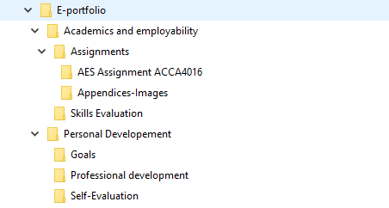
Here I have used a templated version of an E-portfolio to store and work on my work. I will continue using this structure for many years to come and will keep up to date with goals and evaluations.

Section 5: Conclusion & Evaluation
In this assignment I detailed my presentation skills, my evaluations of my skills and my personality; my researching abilities; my goals and work ethics and decisions about various problems that could be faced by myself or others regarding data loss. I have explained various skills and techniques that are desirable for both a working environment and for study. I believe that I have made good judgement with my backup strategies and selection of skills. I will continue to use the techniques discussed within the assignment and will work towards furthering my goals.

Section 6: Appendices
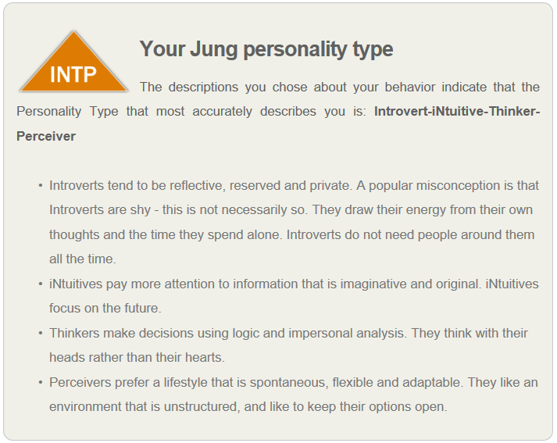
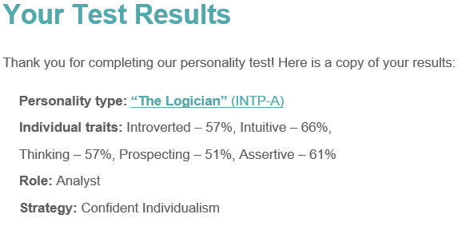
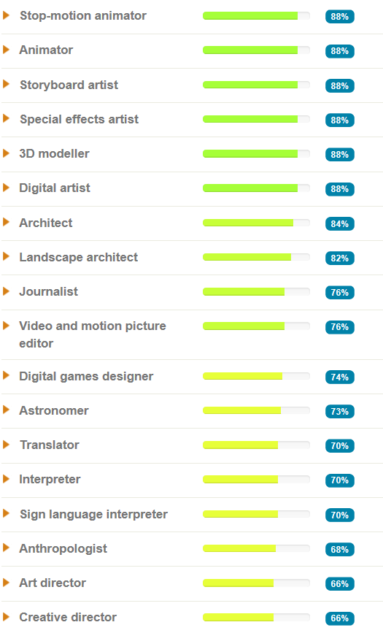

References

[1] | G. Davies, Presentation Feedback, Haverfordwest, 2019.
[2] | Emergingedtech, “15-simple-tricks-to-improve-your-presentation-skills,” 2018. [Online]. Available: https://www.emergingedtech.com/2018/10/15-simple-tricks-to-improve-your-presentation-skills/. [Accessed March 2019].
[3] | the balanced careers, “organizational-skills-list,” [Online]. Available: https://www.thebalancecareers.com/organizational-skills-list-2063762. [Accessed March 2019].
[4] | O. Hargie, The Handbook of Communication Skills, Routledge, 2006.
[5] | P. Harris, “what-is-commercial-awareness,” AllAboutLaw, 12 August 2016. [Online]. Available: https://www.allaboutlaw.co.uk/law-careers/commercial-awareness/what-is-commercial-awareness.
[6] | J. L. Kennedy, Resumes For Dummies, John Wiley & Sons, 2007.
[7] | M. a. J. K. S. Gettinger, “"Contributions of study skills to academic competence.",” vol. School Psychology Review 31(3), no. 2013., pp. 350-365, 2002.
[8] | 123test, “jung-personality-test,” 2018-19. [Online]. Available: https://www.123test.com/jung-personality-test/. [Accessed February 2019].
[9] | 123test, “Career-Test,” 2018-19. [Online]. Available: https://www.123test.com/career-test/. [Accessed February 2019].
[10] | N. Fleming, “VARK,” [Online]. Available: http://vark-learn.com/the-vark-questionnaire/. [Accessed October 2018].
[11] | G. N. T. A. N. Stephen V. Rice, Optical Character Recognition: An Illustrated Guide to the Frontier, Springer Science & Business Media, 2012.
[12] | Sony Corporation, Sony Storage Media Solutions Corporation, 2nd August 2017. [Online]. Available: https://www.sony.net/SonyInfo/News/Press/201708/17-070E/index.html.
[13] | Oracle Corporation, “sl8500-modular-library-system,” [Online]. Available: https://www.oracle.com/storage/tape-storage/sl8500-modular-library-system/. [Accessed March 2019].
[14] | IBM, IBM DS8880 Architecture and Implementation (Release 8.51), IBM Redbooks, 2019.
[15] | B. Tracy, Time Management (The Brian Tracy Success Library), AMACOM, 2014.
[16] | T. Dean, CompTIA Network+ 2009 In Depth, Cengage Learning, 2014.
[17] | A. Leon, Software Configuration Management Handbook, Third Edition, Artech House, 2015.

Bibliography
https://targetjobs.co.uk/careers-advice/career-planning/273051-the-top-10-skills-thatll-get-you-a-job-when-you-graduate
https://www.jobs.ac.uk/careers-advice/interview-tips/1337/what-are-employers-looking-for-skills-and-qualifications
https://www.prospects.ac.uk/careers-advice/applying-for-jobs/what-skills-do-employers-want
https://www.overlandstorage.com/blog/?p=323
https://www.emergingedtech.com/2018/10/15-simple-tricks-to-improve-your-presentation-skills/
https://www.seagate.com/gb/en/do-more/everything-you-wanted-to-know-about-hard-drives-master-dm/

