International Business Communications AS1 and AS2

Slide 1
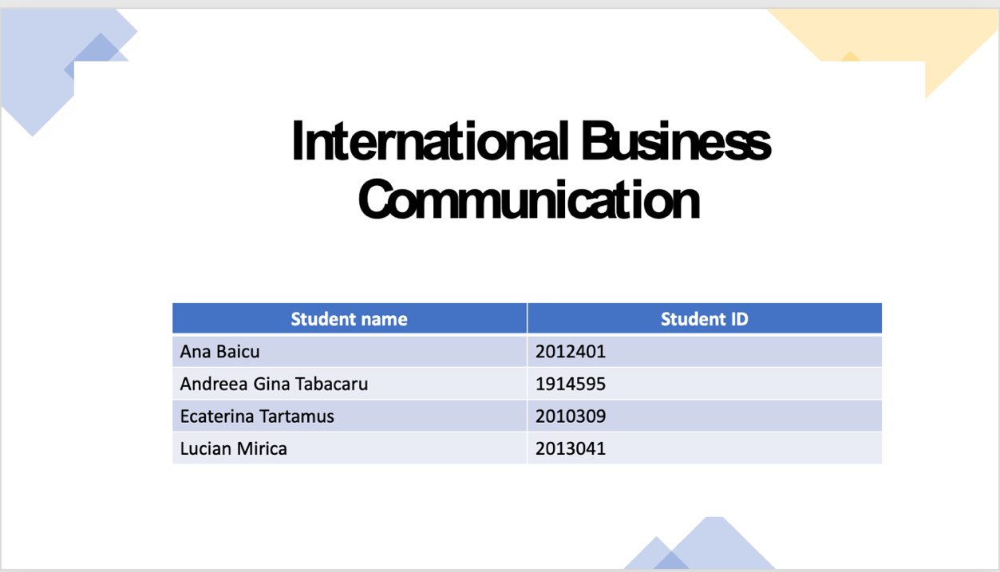

Slide 2

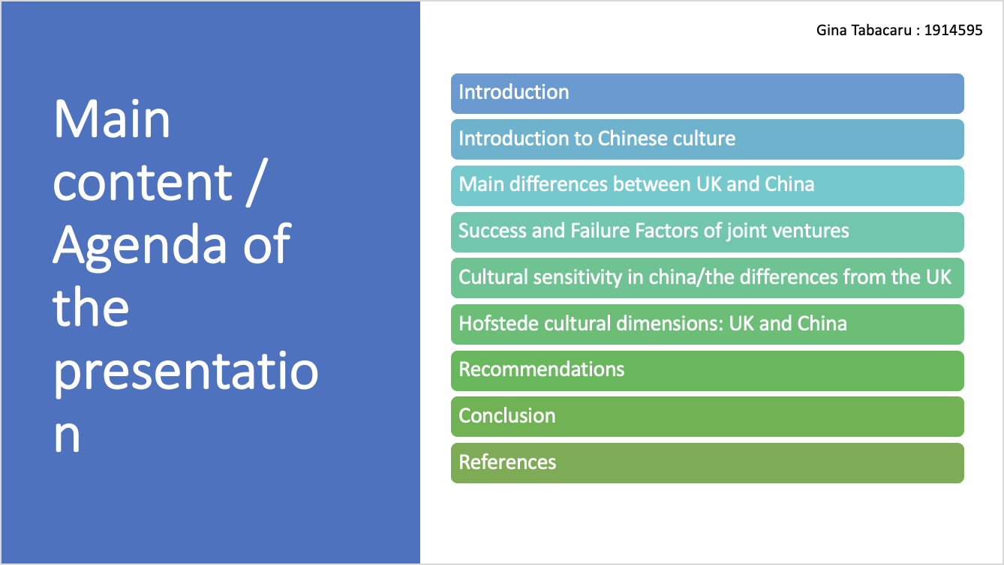

Slide 3
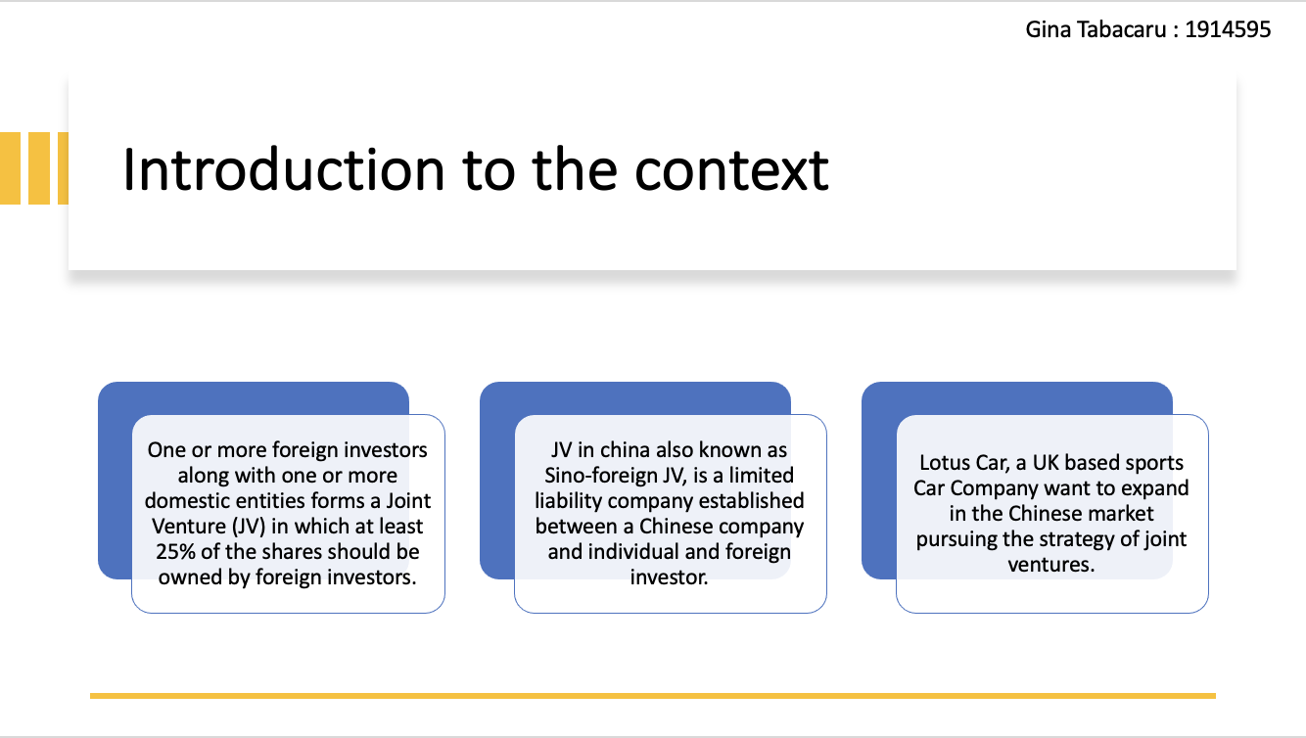

One or more foreign investors along with one or more domestic entities forms a Joint Venture (JV) in which at least 25% of the shares should be owned by foreign investors. JV in china also known as Sino-foreign JV, is a limited liability company established between a Chinese company and individual and foreign investor. Restricted industries only allows JVs which is the reason behind foreign investor’s interest in investment alongside their strategic preference in using of existing sales networks and channels (Guo, 2022). Lotus Car, a UK based sports Car Company want to expand in the Chinese market pursuing the strategy of joint ventures.

Slide 4
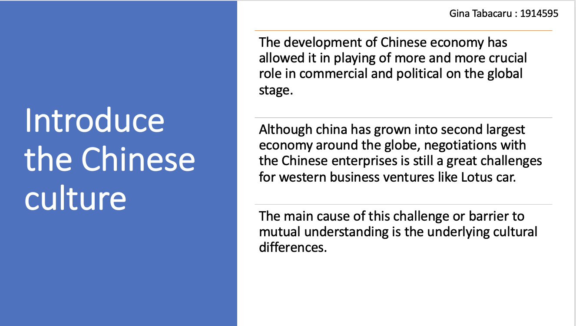

The development of Chinese economy has allowed it in playing of more and more crucial role in commercial and political on the global stage. Although china has grown into second largest economy around the globe, negotiations with the Chinese enterprises is still a great challenges for western business ventures like Lotus car. The main cause of this challenge or barrier to mutual understanding is the underlying cultural differences.

Slide 5

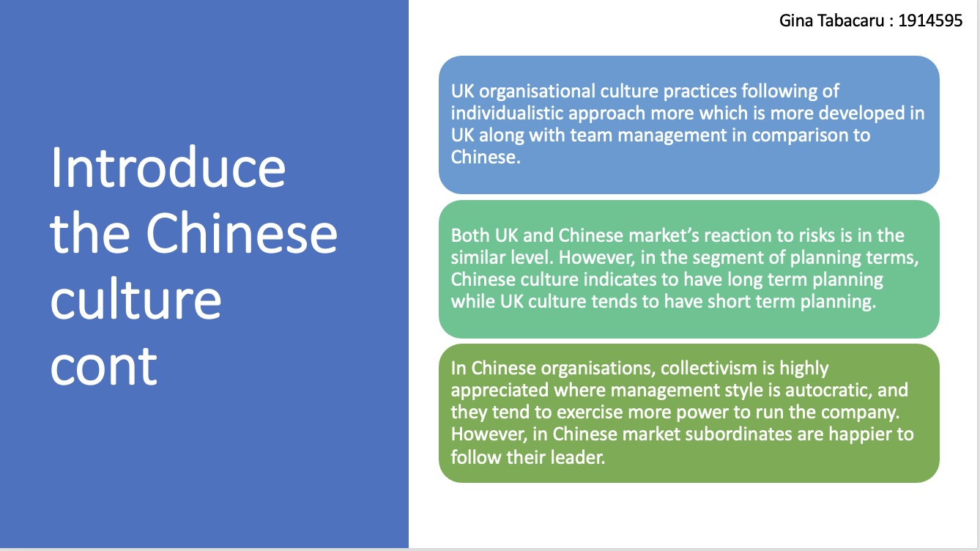

Main difference between UK and China
Considering UK expectations, Chinese understanding of inequality and power distribution is two times higher. This indicates the Chinese management team styles for inclination to one person to be in high position and higher power.
UK organisational culture practices following of individualistic approach more which is more developed in UK along with team management in comparison to Chinese (Guo, 2022).
Both UK and Chinese market’s reaction to risks is in the similar level. However, in the segment of planning terms, Chinese culture indicates to have long term planning while UK culture tends to have short term planning.
In Chinese organisations, collectivism is highly appreciated where management style is autocratic and they tend to exercise more power to run the company. However, in Chinese market subordinates are happier to follow their leader.
In terms of managements planning skills, Chinese management with long term planning goal is found appropriate where employee thinks well into future (Shaukat, 2011).
In both countries, same level of approach is followed for gender based diversification.
So, in the Chinese market a managerial position requires a person who is aware of risks, works more challengingly in comparison to others and collectively works with others. Without any difficulty, foreign firm can find persons with these skill-set very easily. However, Lotus Car may hire British personnel with working experience in China.

Slide 6
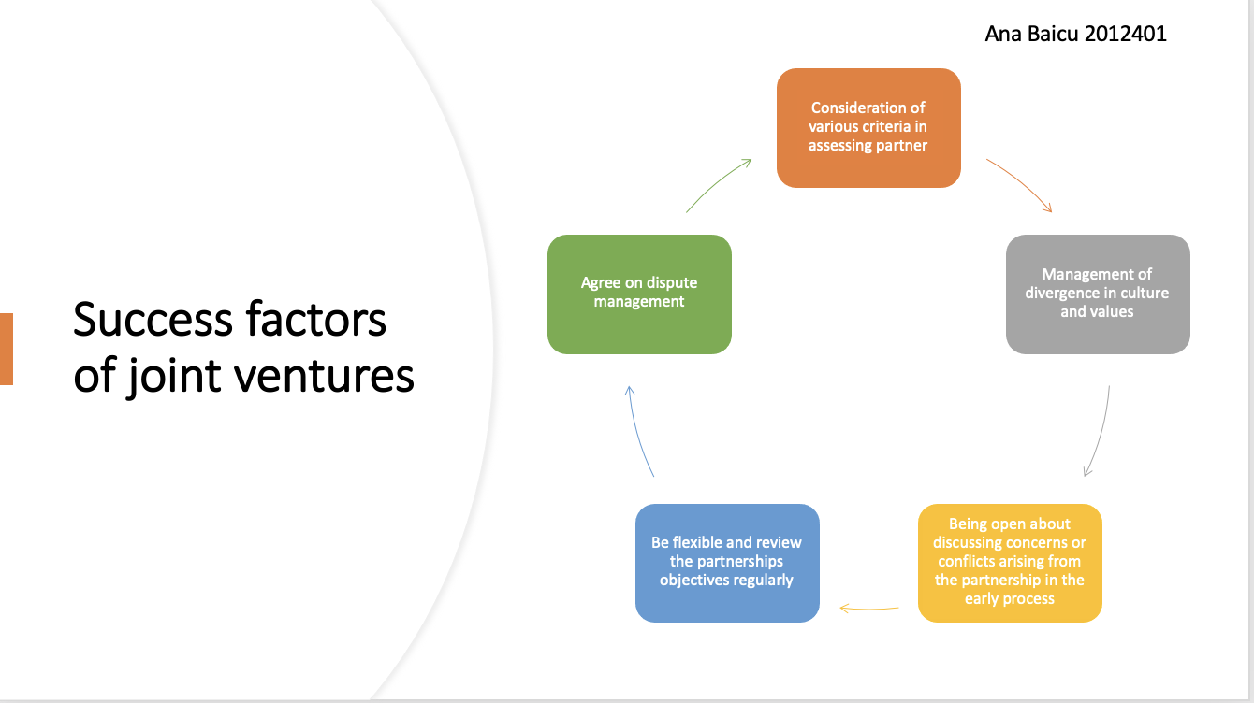

Success factors of JVs
Consideration of various criteria in assessing partner: The Chinese partners possessed relational and transactional competence need to look into by foreign companies. An open-minded culture, strategic leadership, learning effectiveness, entrepreneurial orientation, organisations brand image, market response and innovation skills are encountered here (Shaukat, 2011).
Management of divergence in culture and values: Organisations having different teams from different culture face complexity but found it as opportunity. This involves in seeing the same reality with different eyes.
Being open about discussing concerns or conflicts arising from the partnership in the early process: Considering the roles of different parties, clarity is maintained by JVs in china.
Be flexible and review the partnerships objectives regularly: Organisations taking lesson from the history of Chinese joint ventures strengthens their strategic pathways to success (Shaukat, 2011).
Agree on dispute management: In order to put everything on table, regular meeting with the general management and partners proved its essence.

Slide 7

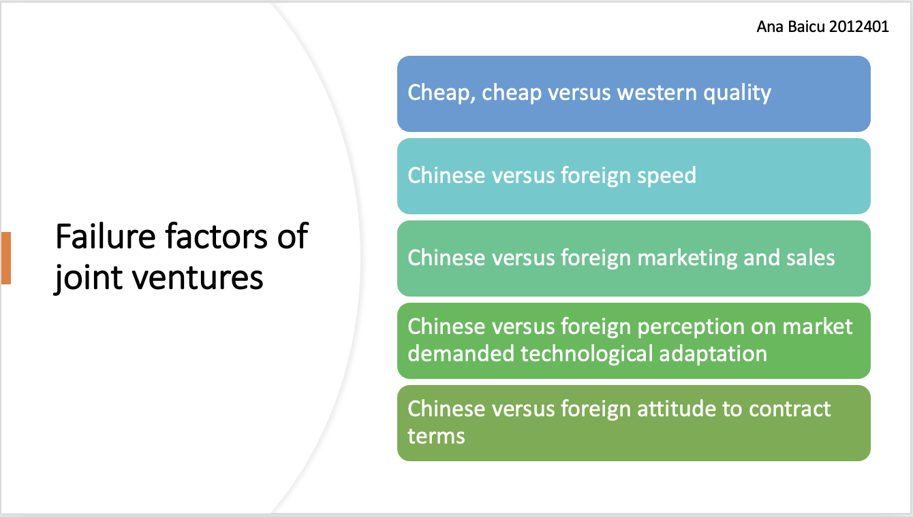

Cheap, cheap versus western quality: In china, quality doesn’t mean to be perfect rather they practice fast replacements which contradicts with UK based firms practices.
Chinese versus foreign speed: Speed is the king in the Chinese market and they easily forgives flawed newly product offerings and ensures the fast repairing (Needham & Hotson, 2020).
Chinese versus foreign marketing and sales: In the Chinese market, foreigner being naïve and refusal to set a competitive price results in failure of JVs.
Chinese versus foreign perception on market demanded technological adaptation: Foreigners refusal to product according to market needs and pursuing old technology results in failure in Chinese market.
Chinese versus foreign attitude to contract terms: If foreign company fails to grab an opportunity, it will be grabbed by local competitors immediately (Needham & Hotson, 2020). So, foreign companies should formulate venture contracts reflecting the actual situation of the market.

Slide 8

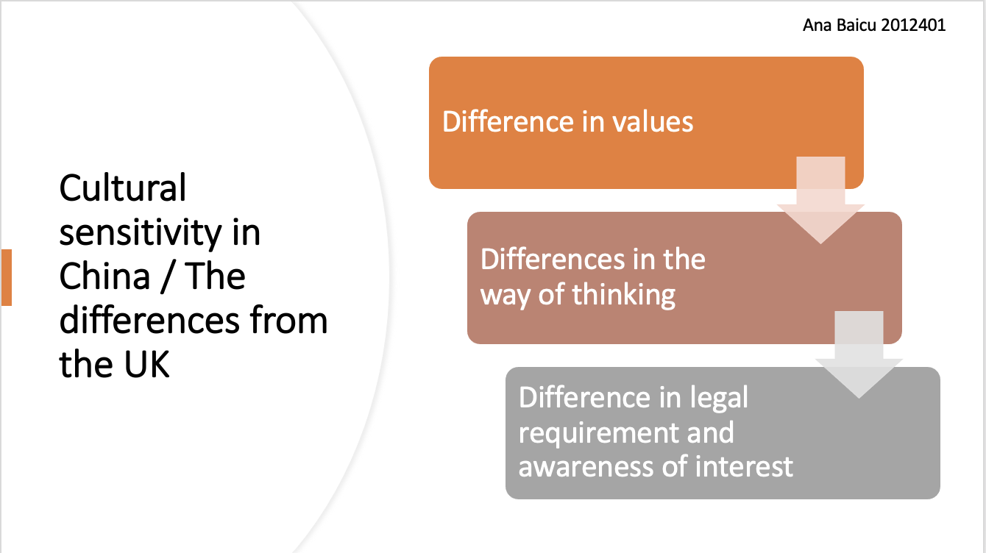

Differentiation of distinct cultures can be conducting through awareness of interest and legal requirements, ways of thinking and values.
Difference in values: Cultural differences between UK and China can be narrowed down into individual and collective consciousness. Chinese cultural tradition is impacted by Confucianism for over two millennium which cultural objective is achievement of social harmony that advocates the humbleness and less focus on individual interest (Mort, 2019). But the British culture both industrial revolution and religious reformation influenced British individualisms formation greatly.
Differences in the way of thinking: In this dimension, holistic thinking and individual thinking reflects the differences between UK and China. Unity of man and nature is the centre for concentration of Confucianism. The living environment is regarded as separated piece and treats each of the segment individually by British negotiators. Most Chinese negotiators intends to focus on overall situation and tends establishment of long term cooperative relationships (Mort, 2019). On the other hands, current situation is a focus point by British negotiators who also inclined to use of logical reasoning for expressing of ideas and value facts.
Difference in legal requirement and awareness of interest: Chinese societies are more related to humanities in which an important role is played by interpersonal networks in negotiations. Chinese people mostly believes in relationships and they are inclined to high power distance. On the other hand, UK scores low on power distance and seeks maximisation of interests. Brits put all divergence into law and pays great attention to fairness.

Slide 9

Major bipolar dimensions is introduced by Hofstede which involves in short versus long orientation, collectivism versus individualism, weak versus strong uncertainty avoidance, femininity versus masculinity and weak versus small uncertainty avoidance. This figure shows comparison between UK and China and provides right overview of Chinese culture’s deep drivers.
Power distance: Inequality amongst society people is indicated through this dimension and China’s highest score indicates Chinese people’s higher inequality accepting practice which is beneficial for a company for the development of leaderships and undertaking of initiatives. UK’s low score indicates the unacceptance of inequalities (Khaire, 2017). So, equality concept will be a cultural barrier in the decision making process and daily communication.
Individualism: This dimension presents people’s looking after them and their home only while a deeper recognition for teams or groups is recognised in collectivist society. Scoring 20, it indicates high collectivist culture of Chinese people who acts for the interest of the groups instead of theirs. However, UK has highest individualistic score and that represent huge difference in the workplace of UK-Sino joint ventures.

Slide 10

Masculinity: High score in this dimension means that achievement and competition drives the society which low score indicates caring for other factors like quality of life. Having same score in this dimension, UK and China belongs to masculine society which argues on their spending of time on working instead of family and leisure (Khaire, 2017).
Uncertainty audience: Uncertainty audience meant fact for society’s future it tough to predict and control which can be resulted in people’s anxiety. Both the country scored close in this dimension which meant their comfort in ambiguous situations.
Long term orientation: Societies keeping relations with the past in dealing with both present and future challenges is indicated by this dimension. With 87 score, Chinese culture becomes a pragmatic culture and its people believe truths dependency on time, context and situation. Having 51 score, British culture belongs to the intermediate level in which dominant preference can’t be determined.
The diagram shows a big gap in scores of both these country which meant prevailing cultural difference from different aspects. Chinese people accepts the situation of inequalities, polarised relationships between superior and subordinate and no barrier against superiors power abuse.

Slide 11

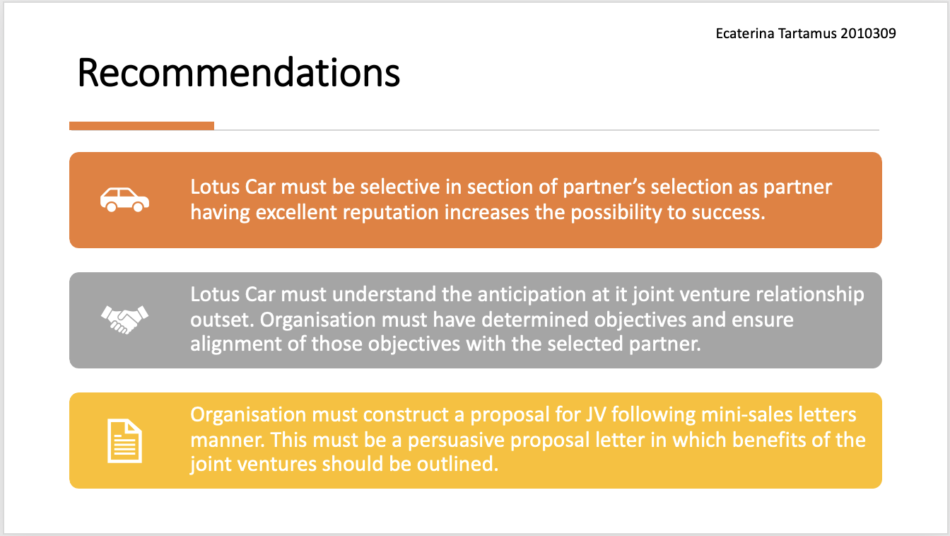

In order to make a successful joint ventures in the Chinese market, Lotus Car should consider following recommendations:
Lotus Car must be selective in section of partner’s selection as partner having excellent reputation increases the possibility to success. Ensuring effective team building is very critical component where partners must be dependable and possess integrity to a higher degree.
Lotus Car must understand the anticipation at it joint venture relationship outset. Organisation must have determined objectives and ensure alignment of those objectives with the selected partner.
Organisation must construct a proposal for JV following mini-sales letters manner. This must be a persuasive proposal letter in which benefits of the joint ventures should be outlined.
Lotus Car must avoid setting of too high offers and even if you are large company, you must not pursue a large company from your destinations. In order to draw the attention of powerful and large companies, organisation should form successful joint ventures with the smaller companies.
In all of the business dealings, organisation must maintain transparency and truthfulness. For a successful ongoing team building, both parties require a high level of understanding, trust and expertise.

Slide 12

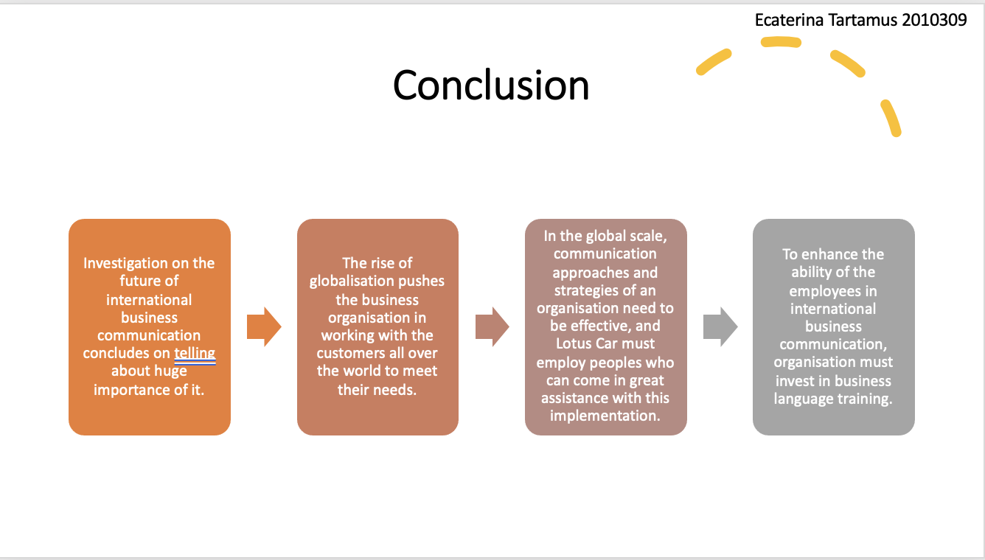

Slide 13

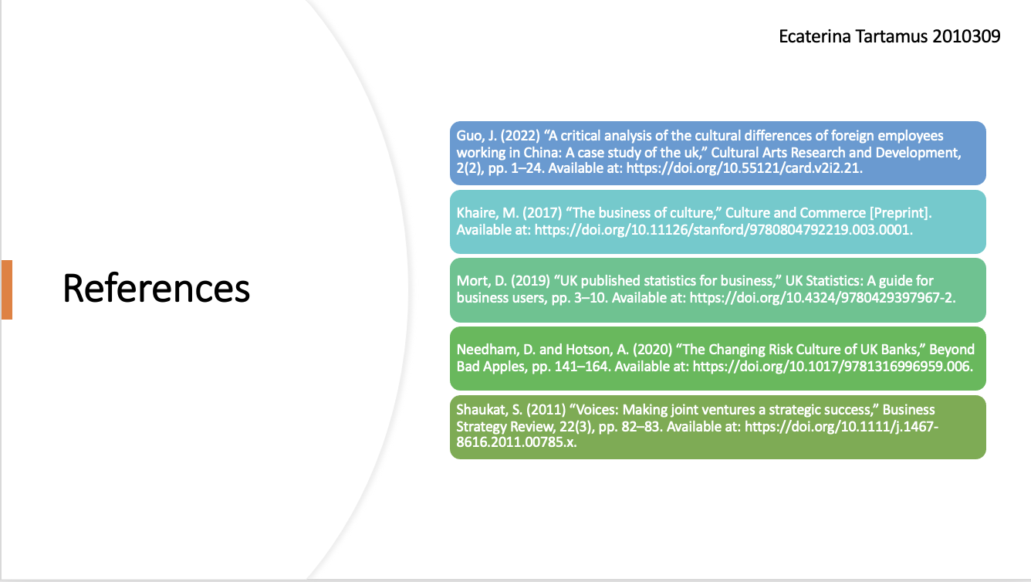

Slide 14


International Business Communications AS2

Table of Contents
Contents
Table of Contents 2
Introduction 3
Introduction to the developing country 4
Cultural differences 5
Cultural sensitivity 7
Communication barrier and challenges (UK VS China) 9
Communication strategies VS recommendations 11
Conclusion 13
References 14

Introduction
International business communication is involved in exchanging of information, creation of relationships and building trust across cultures. A huge challenge appearing before the organisation is varying cultural expectations and norms from country to country. The uses of technological advancements, different practices of businesses and language barriers complicates the international communication to a further level. Studies suggests that around one fourth of the total employees face the needs to interact with people from other countries (Andrews, 2022). Realising the importance of understanding international business communication¸ Lotus Car, a British Sports car producer has decided to conduct a study to develop a clear understanding on it.

Introduction to the developing country
China is one of the fastest growing developing nation which is also believed to have oldest continuing civilisation. The capital of Chinese nation is Beijing and standard Chinese is its official language which is derived from the dialect of mandarin. China is ruled by a government which is communist formed and guarantees freedom of religion although atheism is promoted by this country. Being the mostly densely populated country Chinese nation has approximately 1.4 billion people which made this country as one of the desired destination for the multinational organisations (Naidoo & Dulek, 2018).
The people’s republic of china has as developing upper middle income market economy which is mixed socialist that pursues five years strategic plans and industrial policies. Chinese economy has been foremost economic powers in most of the time over past two millennium. The economy is consists of state owned enterprises, large domestic private sector organisation as well as mixed ownership enterprises (Andrews, 2022). But one of the most important aspects of the Chinese economy is its openness to foreign organisation. In the measurement of GDP, China has second largest GDP in the world which is US$17.7 trillion in 2021 and considering the purchasing power parity, it is the largest. There is a forecast that Chinese economy will grow into largest economy in the world by 2028.

Cultural differences
Hofstede’s five cultural dimensions can be pursued for clarifying cultural differences between UK and China as it was him who adopted a pragmatic problem-solving approach. He also discussed a relation between management and cultures. Culture is defined as mind’s collective programming that distinguishes between one category people with another by Hofstede. Culture based values systems comprised of short/long term orientation, uncertainty avoidance, masculinity/femininity, collectivism/individualism and power distance.
Power distance: There is inequality in a societies and it expresses a culture’s attitude towards this inequalities. Less powerful members of organisations and institutions expectance and acceptance of powers unequal distribution’s extent is termed as power distance. China sits highest ranking in power distance index at 80 that meant a societies belied in acceptability inequalities amongst people (Ceil, 2012). Superiors power abusing is not prevented and polarisation superior-subordinate relationship. Sanctions and formal authority influences individuals who are optimistic about their capacity for initiative and leadership.
Individualism: A societies maintained degree of independence amongst members if addressed in this where people’s self-image can be defined as we or I. While people are supposed to look after their families alongside themselves in the individualistic societies, people take care of them in groups in exchange of loyalty according to collectivist societies. Chinese culture is highly collectivist where people acts for the interest of groups (Naidoo & Dulek, 2018). People may cooperative with the colleagues in groups and vice versa. Personal relationship prevails over institutions and tasks.
Masculinity: Success, achievement and competition drives the society where winning is defined as success according to high score of this dimension. This value system continues to the organisational life starting form value systems at school. Chinese society is success driven and oriented where people sacrifices leisure and family over work (Ayyash-Abdo et al., 2016). Families are left behind by migrated farmers by traveling to distant places in quest of better work and pay.
Uncertainty avoidance: The extent of a societies members feeling about cultures threatened by unknown and ambiguous situations is known as uncertainty avoidance dimensions which created institutions beliefs for avoiding these. Chinese economy has low score on this dimension. Truth is concerned about immediate social circles and not necessarily laws and there is flexibility to the suiting of pragmatism and actual situation (Ayyash-Abdo et al., 2016). The ambiguity of Chinese people can be difficult to be followed by UK people but they are highly entrepreneurial and adaptable.
Long term orientation: This dimension represents every societies maintenance of links with own past for efficiently dealing with the present and future. Scored low in this dimension, normative societies prefers the maintenance of time-honoured norms and traditions in viewing change in the society with suspicion. Enough effort and thrifty nature in modern education is believed to be a way for the future in the culture which scores is high (Ceil, 2012). Chinese cultures score in this dimension states its cultural pragmatism. Pragmatic society people believes that truths largely depends on time context and situation. Chinese people have high ability for adaptation of changes in its tradition along with strong propensity for perseverance, thriftiness, invest and save to achieve results.

Cultural sensitivity
For conducting daily business in China, western business leaders like UK need to be concerned about cultural values and norms. Considering attitudes to time, Chinese people prefer slow negotiations while UK people hurries to make a deal as they values time as money. Instant gratification and quick negotiations are preferred in UK which culture is biased towards short term end. In the pre-negotiating phase, British team member’s attempts to shorten the process which may be presumed by Chinese team as an effort for concealing something. These cultural differences may grow mistrusts and results in negotiations of breakdown.
Particularism v Universalism: This describes the extent of societal belief on importance of values codes and rules. Human relationships are considered with utmost importance in the particularistic societies while values codes and rules are seen as important in universalistic society. Being culturally particularistic, Chinese people gives importance to friendships roles in negotiation of a business and negotiation for expansion may go in vain for Lotus Car if they don’t display trust and friendship (Root, 2019). For avoiding offense to Chinese people, the management of Lotus Car need to present them as friendly and trustworthy.
Specific versus diffuse: In culture of diffusion, during negotiation the idea for saving face is important. Having face is the mark for personal dignity which are meant for having high status in the eyes of his peers. A more hierarchical and structural form is preferred by Chinese people which they rarely shows emotion in times of negotiation and concerned highly about saving face and maintenance of composure (Zhai & Brunstrom, 2022). UK people generally speaks out of their mind even if it embarrasses its counterparts but business prospects with Chinese people could be lost even recrimination may be invited if their action results in losing of face of Chinese people.
Neutral versus affective: Neutral culture practices the subduing and controlling of feelings but affective culture practices like Chinese are more open with their feelings. The highly neutral style of UK people can be misinterpreted as boredom or disinterest by the most affective Chinese which British counterparts may found indirect communication style of Chinese people as ambiguous and vague. Smile can be commonly meant as media of communication during their interaction but it can be viewed as mask for having different meaning (Root, 2019). As Chinese people feel discomfort in looking straight into people’s eyes, direct eye contact should be avoided by the management of Lotus Car.
Cross culture negotiations: The negotiation between Lotus Car and Chinese people, management must concern about prioritising creation of interpersonal relations. The negotiation processes encompassing unconscious forces driven by cultural norms, complicates the negotiation process and thus effective communication may be undermined. The cross cultural complications in the Chinese economy encompasses the interpretation of cultural expectations, language and behaviour which are influenced by the business norms (Moula, 2021). These business norms includes government policies, level of bureaucracy, power and influence centres and stage for economic development. European negotiators like Lotus Car may helped in discovering the reasons for Chinese way of behaving and unveiling the homocentric characters of theirs, through understanding these features.

Communication barrier and challenges (UK VS China)
Following 30 years of growth, Chinese economy has become an ever greater player which attracts large market player for investments who wants to capture a market share. However, for foreign firm Chinese economy is still a challenging prospects. In entering China, biggest hurdles be effective communication and lack of good language skills which prevention may cost Lotus Car huge time and money (Sanders, 2013). This may made the brand difficult to find its feet in the Chinese market, but understanding the challenges and way to approach them will potentially enable Lotus Car success in the market.
The need for localised knowledge: It is the good market who tells the essence for establishment of emotional connection with the potential customers and speaking to them pursuing ways for driving action. The base language is not only a barrier to meaningful interaction in the market but also linked to the culture inextricably. To make Lotus Car compete in the Chinese market and become successful they must remain unrest unless they know what to say and how to say along with speaking the correct languages (Safdar et al., 2020). In the localisation marketing industry, development of a website of Chinese version should be absolute minimum. As Chinese culture consists of different customs, dialects and cultures, Lotus Car must speaking each of these groups’ unique approaches for catching their attention and gain the competition.
Understanding Chinese negotiation tactics: In business communication aspects, negotiations is an essential aspects and a series of unique challenges will be before Lotus Car when they expands in the Chinese market.
- In the Chinese culture, blatant emotional displays are looked down upon which may cause the business negotiating more favourably (Sanders, 2013).
- The negotiation phase of the Chinese takes longer time which is many cases can be deliberate testing of entrant’s patience.
- To ensure saving face of the negotiator, some concession may need to make by the management of Lotus Car (Safdar et al., 2020).
In some form of visual aid, communication can be very effective so at least video meeting should be arranged if you can’t get into an in-person meeting.
The limitation of translation app: Lack of precision in the translation app is another barrier to accessible communication. Although passed a long way, translation app can’t be relied on for delicate conversations. Although Chinese translation is around 90% accurate on Google translate, this can’t be of any degree of confidence for an advertising campaign (Kale & Nirmal, 2012). The translation of Mandarin to Chinese is very difficult as a result of which, Lotus Car must take time to develop their translation abilities through hiring locals even if they need to revise HRM policies.

Communication strategies VS recommendations
Organisations are enabled in building strong relationships inside and outside of the organisation through effective communication and thus contributes to the overall growth and company culture positively.
Focus on clarity and conciseness: This strategy aims at building a communication with customer to sort out minimal misunderstanding and confusion. This facilitates the assurance of planned landing of message by avoiding any misunderstanding and confusion (Morrell & Sterling, 2006).
Keep communications consistent: This strategy ensures alignment across all communication channel of the organisation to build a focused brand image and shaping the expecting experience of the customer from the organisation. Organisational brand strategy is reinforced through this which also ensures consistent design and content by providing rules (Pandit et al., 2019).
Humanising of brand: This aims at fostering of long term relationships with the customers by connecting the brand emotionally with the audience through showing empathy and friendliness to the appropriate level. Transparency and trust is enforced by this along with improvement of the ability in establishing and maintaining meaningful external and internal relationships (Morrell & Sterling, 2006).
Practice active listening: This strategy aims at gaining further insights of the organisation’s audience and it shapes the implementation changes based on their feedback. Employees and customers felt appreciated and heard and organisation gets better understanding about the target audience’s needs.
Use asynchronous communication: This aims at embracing of a more flexible workflow that takes customers and employees into accounts through their preferred communication medium and in different geographical regions. Dynamic work environments are supported in this and both the customers and employees are to choose a way to communicate with (Pandit et al., 2019). More opportunities for collaboration and communication are created through giving the employees and customers enough space and time to craft their optimum response.
Communication strategy is for communication with the target audience which can be made efficient:
- If the purpose of the communication strategy or plan is well defined. Clear purpose of a communication plan helps brining everyone on board (Tao & Kim, 2017).
- The management of the organisation must know about the target audience and messages which must be delivered to the target audience.
- A framework for the outreach activities of the company must be provided through the communication strategy of the organisation but selection of effective communication channel is crucial.
- To ensure strategic implementation of communication strategy and making it successful, determination of timing is very essential (Tao & Kim, 2017). Based on the customers’ needs and wants, organisation must determine time and location of letting the communication plan to implement.

Conclusion
Investigation on the future of international business communication concludes on telling about huge importance of it. The rise of globalisation pushes the business organisation in working with the customers all over the world to meet their needs. In the global scale, communication approaches and strategies of an organisation need to be effective and Lotus Car must employ peoples who can come in great assistance with this implementation (Kale & Nirmal, 2012). To enhance the ability of the employees in international business communication, organisation must invest in business language training.

References
- Andrews, D.C. (2022) “Commentary: A space for place in business communication research updated,” International Journal of Business Communication, p. 232948842211264. Available at: https://doi.org/10.1177/23294884221126491.
- Ayyash-Abdo, H., Tayara, R. and Sasagawa, S. (2016) “Social anxiety symptoms: A cross-cultural study between Lebanon and the UK,” Personality and Individual Differences, 96, pp. 100–105. Available at: https://doi.org/10.1016/j.paid.2016.02.079.
- Ceil, C. (2012) “Discuss the similarities and differences between China and UK TV industries,” SSRN Electronic Journal [Preprint]. Available at: https://doi.org/10.2139/ssrn.2051483.
- Kale, E. and Nirmal, B. (2012) “Challenges in healthcare in multi-ethnic societies: Communication as a barrier to achieving health equity,” Public Health - Social and Behavioral Health [Preprint]. Available at: https://doi.org/10.5772/38259.
- Moula, Z. (2021) “Academic perceptions of barriers and facilitators of creative pedagogies in higher education: A cross-cultural study between the UK and China.,” Thinking Skills and Creativity, 41, p. 100923. Available at: https://doi.org/10.1016/j.tsc.2021.100923.
- Morrell, C. and Sterling, R. (2006) “ICT strategies for Gender Empowerment: Actionable Approaches and recommendations,” 2006 International Conference on Information and Communication Technologies and Development [Preprint]. Available at: https://doi.org/10.1109/ictd.2006.301871.
- Naidoo, J. and Dulek, R.E. (2018) “Artificial Intelligence in business communication: A Snapshot,” International Journal of Business Communication, 59(1), pp. 126–147. Available at: https://doi.org/10.1177/2329488418819139.
- Pandit, V.N. et al. (2019) “Pricing in ride sharing platforms: Static vs dynamic strategies,” 2019 11th International Conference on Communication Systems &amp; Networks (COMSNETS) [Preprint]. Available at: https://doi.org/10.1109/comsnets.2019.8711391.
- Sanders, K. (2013) “The strategic shift of UK Government Communication,” Government Communication, pp. 79–98. Available at: https://doi.org/10.5040/9781472544629.ch-005.
- Safdar, G.A., Kalsoom, T. and Ramzan, N. (2020) “Security challenges in Cyber Systems,” 2020 International Conference on UK-China Emerging Technologies (UCET) [Preprint]. Available at: https://doi.org/10.1109/ucet51115.2020.9205388.
- Root, S. (2019) “The relationship between language, emotional intelligence, and cultural sensitivity.” Available at: https://doi.org/10.33015/dominican.edu/2019.honors.st.14.
- Tao, W. and Kim, S. (2017) “Application of two under-researched typologies in crisis communication: Ethics of justice vs. care and Public Relations vs. legal strategies,” Public Relations Review, 43(4), pp. 690–699. Available at: https://doi.org/10.1016/j.pubrev.2017.06.003.
- Zhai, Y. and Brunstrom, J.M. (2022) “Associations between energy density and preference in fruits and vegetables: A cross-cultural comparison in the UK and China,” Appetite, 179, p. 106198. Available at: https://doi.org/10.1016/j.appet.2022.106198.

