

LOCATION: Swansea | LLEOLIAD: abertawe
LEVEL 4 | LEFEL 4
EXAMINATION PERIOD | CYFNOD ARHOLIADAU
MAY 2026 | 2026

MODULE CODE: ACMA4031
Electrical Prinicples

TIME: 2 HOURS
Maximum Marks: 100
answer ALL the questions

Equipment or materials required – Calculator, formula sheet
Adnoddau neu ddefnyddiau sydd eu hangen - Cyfrifiannell
ANSWER ALL THE QUESTIONS

Question 1 [25 Marks]
- For the circuit shown in fig1, Calculate the following
- Total resistance in the circuit [4 Marks]
- Total current in the circuit. [2 Marks]
- Current across each resistor [8 Marks]
- The voltage across $R_{7}$ resistor [2 Marks]
- Power delivered by the battery [2 Marks]
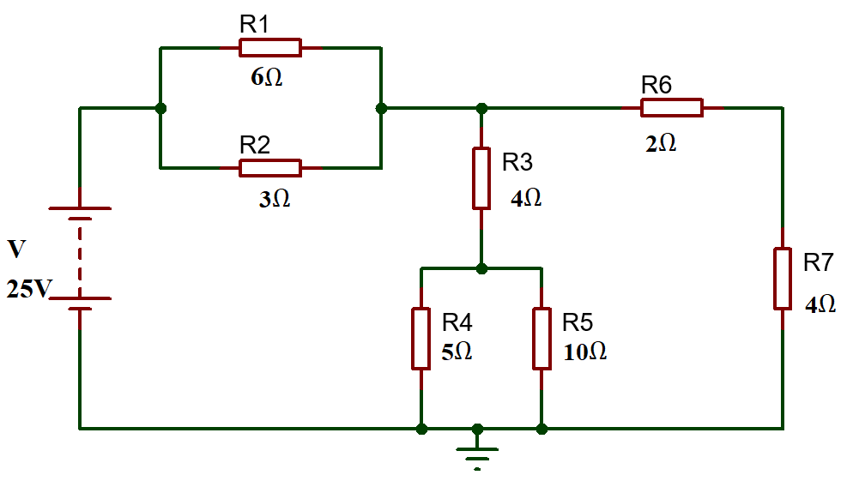
Fig: 1
- A solar yard light has a solar collector that can provide 1.0W of power for charging the 3.0V batteries. What is the maximum charging current the solar collector could supply to the fully discharged 3.0V batteries? [2 Marks]
- Calculate the potential difference across the bulb if 2kJ of work is required to push a charge of 250C through the bulb. [2 Marks]
- What length of German silver wire, diameter 0.050 cm, is needed to make a 28 resistor, if the resistivity of German silver is $2.2×{10}^{-7}$ m? [3 Marks]
Question 2 [25 Marks]
- Calculate the current flowing when a charge of 60C flows past a point over a period of 2 minutes. [2 Marks]
- Determine the current across each resistor in the circuit shown in fig.2, using mesh analysis (Kirchhoff’s Voltage Law) [13 Marks]
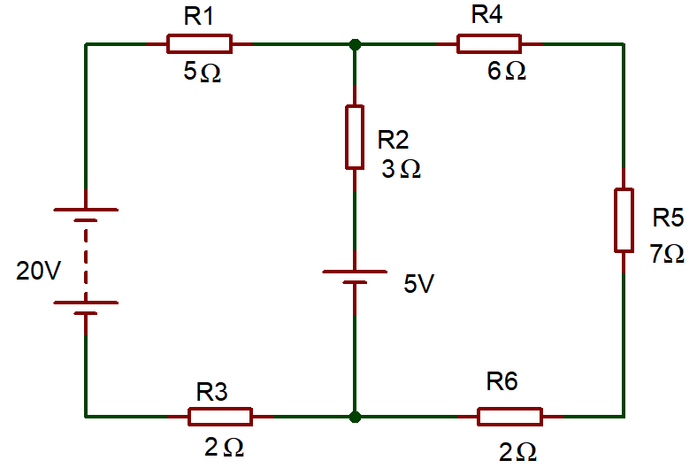
Fig.2
- Differentiate Step- up Transformer and Step-Down Transformer (minimum of two differences) [4 Marks]
- Explain the following terms:
- Resistance [2 Marks]
- Reactance [2 Marks]
- Impedance [2 Marks]
Question 3 [25 Marks]
- The alternating current is given by $i=40 sin314t A$. Determine the following
- Peak Value of current [1 Mark]
- RMS Value of Current [2 Marks]
- Frequency [2 Marks]
- Time period [1 Mark]
- An oscilloscope display shows the below voltage waveform. The oscilloscope settings are shown in the box next to the waveform.
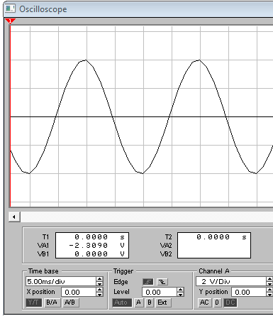
Oscilloscope settings:
2V/div
10ms/div

Fig:3
- Estimate the period of the waveform. [1 mark]
- From the estimated period, determine its frequency. [2 marks]
- Determine its peak-peak amplitude [2 marks]
- Determine the r.m.s. value of the waveform. [2 marks]
- An RLC circuit is shown in figure 4 below. Calculate the following
- The total circuit impedance [4 Marks]
- Total current flowing in the circuit. [2 Marks]
- Determine the voltage drop across each component in the circuits. [6 Marks]
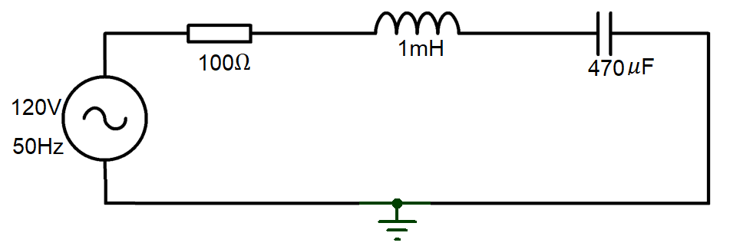
Fig: 4
Question 4 [25 Marks]
- State Maximum power transfer theorem. [2 Marks]
- A transformer has 300 turns in its secondary coil and is used to step up a 12v AC voltage to 200V.
  - How many turns would there be in the primary coil. [3 Marks]
  - Under full load conditions, the current demand in the secondary circuit is 2.5A. Determine the Power output rating of this transformer. [2 Marks]
  - Determine the maximum load resistance that this transformer could supply. [2 Marks]
  - we assume that the transformer is 97.5% efficient, estimate the current flow in the primary circuit for the conditions present in part b). [2 Marks]
- Describe the functions of the following components used in DC machines
- Field System [2 Marks]
- Armature [2 Marks]
- In the transient circuit, a Capacitor of Value $1μF$ and a resistor of 5.45M$Ω$ are connected in series across a $220V$ power supply through a switch. Calculate the time by which the capacitor will be charged to $60$percentage of the supply voltage. [10 Marks]

