Aphrodite and Pan
National Archaeological Museum, Athens
Hellenistic
ca 100 BCE
From Delos, House of the Poseidoniasts of Beirut
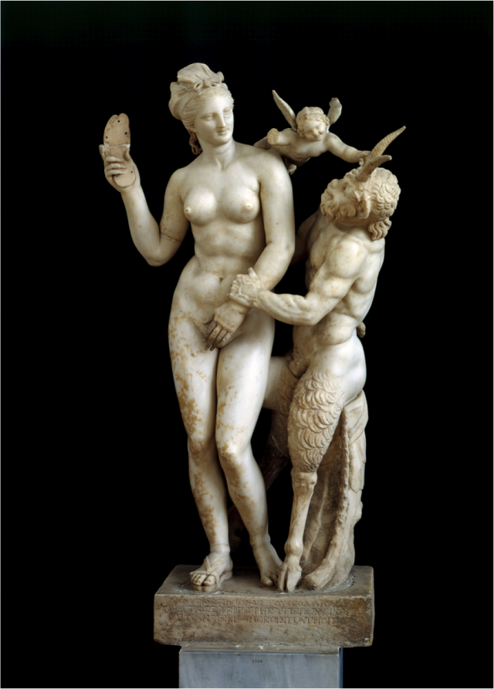

The statue depicts Aphrodite, Eros and Pan quarrelling. How can we identify the three figures in the statue though? Beginning with Aphrodite, Aphrodite is almost always depicted as naked in any form of art from example (painting) and (statue). Next is the little winged figure; who is Eros, we know this because Aphrodite is often depicted in the company of Eros a small winged figure. The final figure in the statue is a fawn/satyr we know this because of the goat legs and the horns atop his head but how what makes this figure Pan? The inscription on the base of the statue pertains to Dionysus, Pan and Dionysus are often pictured together so it would be a logical assumption that the figure in the statue is Pan. Pan is also the god of hunters and resting on the stump he’s sitting on is a lagobolon, which is a hunters stick used for striking hares, and an animal skin which would be another indication to the identity of the figure being Pan.

In the statue Pan is depicted as attempting to sleep with Aphrodite however she is rejecting his advances. There are multiple aspects of the statue which portray this; firstly the most obvious sign is Aphrodite covering her genitals with her hand indicating her unwillingness. Next is the positioning of her legs, her left leg is bent inward denying Pan entry. There is also the sandal in her left hand raised above her head as if she is about to strike Pan.
We gain a sense of the way Pan is forcefully move Aphrodite’s hand from the detail of his muscles, they appear to be tensed and defined which implies the force he is exerting. Finally Eros is pushing on Pans horn to move them apart and although the other hand is missing we can infer that it would be raised in a palm to stop Aphrodite from striking Pan with the sandal. Also Eros is the god of love and with him pushing Pan away it is clear that he does not approve as it is not an act of consensual love.
The statue could be a representation of the myth of Pan and the Nymph Syrinx in which Pan gets his pipes. There are many parallels that can be drawn between the two such as the implied lack of love, Aphrodite denying Pan in the same way that Syrinx ran from him and the obvious of Pan pursuing failing to attain the women.
I could also be a visual representation of the conflict between Aphrodite and Pan which resulted from Akhilleus, Pans lust for Aphrodite representing the love she placed in his heart for Ekho and the ugliness of the act he’s committing represents her turning Akhilleus from beautiful to ugly.

Bibliography
Modern Sources
Atsma, Aphrodite Wrath 2 ,http://www.theoi.com/Olympios/AphroditeWrath2.html#Pan, 04/01/2018.
Atsma, Aphrodite, http://www.theoi.com/Olympios/Aphrodite.html 04/01/2018.
Atsma, Eros, http://www.theoi.com/Ouranios/Eros.html 04/01/2018.
Marble group of Aphrodite with Pan and Eros, http://www.namuseum.gr/object-month/2010/jun/jun10-en.html, 04/01/2018.

Ancient Sources
Ovid, Metamorphoses, M. Innes, B. Radice, London, the Penguin Group, P47-48.
Ptolemy Hephaestion, New History Book 6, Pearse, summary from Photius, Myriobiblon 190.

Atsma, 04/01/2018
Ovid, Metamorphoses, M. Innes, London, Penguin Books.
Ptolemy Hephaestion, New History Book 6, Pearse, summary from Photius, Myriobiblon 190.

