Social media, does honesty exist online?
Can we believe everything we see from both individual and commercial users?

Katie Jones P151513

BA Hons Graphic Design

Submitted in partial fulfilment of the requirements for the degree of BA (Hons) University of Wales Trinity Saint David, Swansea, and the 12th December 2018

Word Count: 5864

Tutor: Mark Cocks

Table of Content

List of Illustrations 3

Introduction 4

Chapter 1 : Identity and the Internet 6
Chapter 2 : When the Internet Reacts 13
Conclusion 22
Bibliography 23

List of Illustrations

Fig 1 : Steiner P (1993) [ Screenshot] on the internet, nobody knows you're a dog, available at :
https://condenaststore.com/featured/on-the-internet-peter-steiner.html (Accessed at 8/12/2018)

Fig 2 : BBC Three (2017) [Tweet] #4in1 Campaign Available at https://twitter.com/bbcthree/status/854688537710477312 (Accessed at 8/12/2018)

Fig 3 : Make a Wish (2018) [Tweet] #Shareyourears campagin. Available at https://twitter.com/MakeAWish/status/1068574190012293120 (accessed at 8/12/2018)

Fig 4 Sauer (2014) [ Screenshot ] Lester Oreo Advert Available at :
https://www.brandchannel.com/2014/12/03/youtube-product-placement-and-oreo-take-a-licking-in-the-uk/
(Accessed at 8/12/2018)

Fig 5 MacIntyre, M (2018) [Screenshot] Logan Paul Thumbnail for Suicide Forest Available at https://www.thedrum.com/opinion/2018/01/09/what-brands-should-learn-logan-paul-s-suicide-forest-video
(Accessed at 8/12/2018)

Fig 6 :Ghoshal, A (2017) [ Image ] Pewdiepie Anti-Semitic Joke available at https://thenextweb.com/insider/2017/02/14/pewdiepie-dropped-disney-anti-semitic-joke-videos/
(Accessed at 8/12/2018)

Fig 7 : Annear, S (2018) [Image] Adidas apologizes for ‘insensitive’ Boston Marathon marketing e-mail
available at https://www.boston.com/sports/boston-marathon/2017/04/19/adidas-apologizes-for-insensitive-boston-marathon-marketing-e-mail (Accessed at 8/12/2018)

Fig 8: Abad-Santo(2018) [Image ] Nike advert featuring Colin Kapernik Available at https://www.vox.com/2018/9/4/17818148/nike-boycott-kaepernick (Accessed at 8/12/2018)

Fig 9 : Abad-Santo(2018) [Image ] Sean Clancy Tweet of him burning his Nike shoes Available at https://www.vox.com/2018/9/4/17818148/nike-boycott-kaepernick (Accessed at 8/12/2018)

Fig 10 : Abad-Santo(2018) [Image ] John Rick Tweet about Nike Available athttps://www.vox.com/2018/9/4/17818148/nike-boycott-kaepernick

Introduction

The focus of this dissertation, will be an investigation into the notions of 'the self' online; Does honesty exist online, can we trust what we see and read? I decided to research this topic as I have always found internet culture very interesting. The internet has allowed people to connect on a global scale, we are able to see, post and view what we like without censorship commonly found in traditional media. With the evolution and the increasing popularity of social media, we are now presenting ourselves constantly online in the form of selfies and other means. We are forced to compare ourselves to others posts and are encouraged to share more to increase our followings. In the past few years, social media has raised serious ethical questions with scandal becoming an almost daily occurrence.
In my first chapter, I will explore the impact of social media sites such as Instagram and Facebook etc. I will investigate the idea of 'the self' and question what the word identity means when referring to our 'online self'.
Is our online 'self' a true depiction of the person we are in real life? I will explore how we as individuals compose and express our identities online and determine if our personality types affect the way we share information. I will define what narcissism is and explore if social media causes an increase in narcissistic tendencies. What happens when we abuse the anonymity of the internet? I will explore what selfies are and how they can be used online.
In my second chapter, I will explore various social media campaigns and scandals which have taken place in the recent past. I will investigate the public response to these campaigns. I will analyse the campaign or scandal and investigate the consequences. I will question if the public response was justified. I will explore how social media influencers with a large following are affected when the content they have uploaded is seen as controversial, I will predominantly focus on the YouTube social media influencers for this section. I will analyse the content the influencer has uploaded and investigated the public and media response. I will question who is to blame when the content uploaded is not well received, do we blame the uploader or the distributor? I will see how large-scale companies like Nike are using social media campaigns to increase their business. I will explore the impact of the campaign and the effect of when a campaign is taken out of content? Does this affect the business?
I will conclude my dissertation using the research I have collected from previous chapters. I will try to answer the following questions “Social media, does honesty exist online? Can we believe everything we see from both individual and commercial users? “

Chapter 1 : Identity and the Internet

Early in my study, a college senior warned me not to be fooled by 'anyone you interview who tells you that his Facebook page is 'the real me'. It's like being in a play. You make a character.' Eric, a college-bound senior at Hadley, a boys' preparatory school rural New Jersey, describes himself as savvy about how you 'mild a Facebook page'. (Turkle 2017 :183)

In this chapter, I will define what identity is and investigate the different theories of identity. With the rapid growth of social media platforms, I explore how an individual might use the internet and question whether an online profile is a true representation of one's self. I will explore the notions of selfies and try to see if our personality type affect the way we upload online.

Erik Erikson was one of the first psychologists to investigate the idea of identity; by defining identity as a consistent set of attitudes and values an individual hold about themselves. (Whitty, 2016) Erikson proposed that in order to achieve a clear and strong identity one must develop a specific ideology of personal values and goals. He states the formation of one's identity must begin with knowing the orientation of past, present and future (Whitty, 2016). Erikson theory of 'psychophysical development' explores the impact of social interaction and relationships on the development of human identity. (Cherry, 2018) The theory is broken down into 8 stages;

Stage 1 - Trust vs. Mistrust
Stage 2 - Autonomy vs. Shame and Doubt
Stage 3 - Initiative vs. Guilt
Stage 4 - Industry vs. Inferiority
Stage 5 - Identity vs. Confusion
Stage 6 - Intimacy vs. Isolation,
Stage 7 - Generativity vs. Stagnation
Stage 8 - Integrity vs. Despair. (Cherry, 2018)

Erikson believed that each psychological stage would lend to the individual to experience conflict. This conflict would serve as a turning point in the development of the ego. (Cherry, 2016). Stage 5, takes place during adolescence where typically children begin exploring their independence and develop a sense of self. This is influenced by outside forces such as friends, family, trends and popular culture. This becomes a crisis of identity, those who complete this stage feel a strong sense of independence whilst those who don't remain unsure of their own desires and can remain insecure and confused about themselves. (Cherry, 2016)
Erikson claims “that identity play is the work of adolescence.” (Turkle, 2017: 179) but in a world dominated by the internet how do adolescences form identity online? Sherry Turkle (2017) explains that some adolescents used online simulations like 'The Sims Online' to act out these scenarios;

Trish, a timid and anxious thirteen-year-old, has been harshly beaten by her alcoholic father. She creates an abusive family on The Sims Online, but in the game her character, also thirteen, is physically and emotionally strong. In the simulation, she plays and replays the experience of fighting off her aggressor. (Turkle, 2017 .179)
Sherry Turkle (2017) suggests that this type of identity work can only occur whenever an avatar is created. She suggests “Teenagers make it clear that games, worlds and social-networking sites ( on the surface, rather different) have much in common. They all ask you to compose and project an identity.” (Turkle, 2017: 180) The internet gives teenagers the ability to edit, delete and perform to an audience. Many studies have taken inspiration from Erikson's idea of identity. E.T Higgins (1987) expanded on the idea of identity and proposed three aspects of the self. Firstly 'The 'Actual self', the representation of attributes an individual beliefs to have. The 'Ideal Self', the representation of attributes the individual would or wishes to process and the 'Ought to be Self', is the representation of attributes an individual wants to have.

Since the internet became accessible in the early 1990s, the numbers of users have been growing rapidly, In 2018 the number of internet users passed 4 billion users and the average user spends 6 hours a day online (We Are Social,2018). Matt Haig (2018) also comments on the growth of internet users since 1995, he writes;

It's wild to think that back in 1995 comparatively no one was on the internet: 16 million people, 0.4 per cent of the world population. A decade later, in 2005, it was up to a billion people, which meant 15 per cent of the world's population was online. And by 2017 those digits flipped to 51 per cent. (Haig: 87)

This is a rapid amount of change in a considerably short period of time. Which can be linked with the creation of mobile technologies such as wireless connectivity, smartphones, and tablets all of which makes accessing the internet easier compared to the dial-up methods of 1995.

Eric Schmidt stated at the Internet World Trade Show;

In many ways the Internet is the world's largest experiment in anarchy.
commonly quoted in the extended form ‘The Internet is the first thing that humanity has built that humanity doesn't understand, the largest experiment in anarchy that we have ever had’ ( Schmidit, 1999)

But in a world so connect how do we decide if the posts we are seeing are fake or fiction? Does honesty exist on the internet?

According to Kurt Vonnegut, 'We are what we pretend to be, so we must be careful who we pretend to be' (Vonnegut, 1966: 3) Though Vonnegut did not experience social media, humans however have felt the need to present themselves to the world through the choices they have made e.g. fashion, make up etc. Social media has enhanced the act of presenting to a new level. It could be argued that our online selves are detached from our actual self. Social media has become a huge part of our daily interactions, in 2018 the largest social media networks are Facebook, Twitter, and Instagram. In 2013, Twitter admitted that five percent of all accounts are fake (D’Onfro, 2013). These fake accounts have lent to other users being subjected to fraud e.g. stolen images, detail etc. How do we know if the person we are interacting with are who they say they are? What happens when we discover the person we are interacting with is detached from the profile we are viewing online?

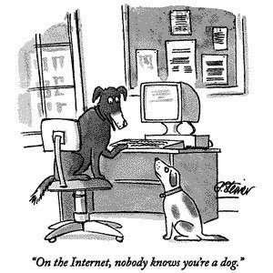
Fig 1: On the internet, nobody knows you're a dog
The term 'Catfish' was first used in the 2010 MTV documentary in which Nev Schulman discovered the woman who he met and had fallen in love with online, was in fact a middle-aged married mother. In the Sun Newspaper article based on the documentary by Ellie Flynn (2018) explain how the term catfish came to be;

At the end he tells a story about how live cod were shipped along with catfish to keep the cod active and ensure the quality of the fish. He uses the metaphor to describe Angela, saying there are always "catfishes" in our lives who keep us alert, active and on our toes. (Flynn, 2018)

The web has given us a place where anonymity is allowed. Social media requires the user to create a profile which begins to build the character profile. Over a period of time, the interactions and activities shared begins to paint a picture of who that user is. “We become walking merchandise” (Haig, 2018: 109)
As internet users it is easy to forget that others are able to view and pass judgement on our identity from these profiles. It is important to consider that these activities and actions shared online do not represent a full picture. It is a snapshot of what has been chosen to be shared. A catfish uses this to manipulate their target into seeing the desired character. Krystal D'costa explains;

Catfish are successful because their actions mirror offline behaviours. We choose what we believe to be the best of ourselves to share with others. We highlight knowledge, skills, and tendencies that help establish our connection to particular social groups—and hopefully the person in front of us well. (D'costa, 2014)

The act of catfishing is not only for romantic gain. In 2016 Texas Tech coach Kliff Kingsbury admitted to encouraging Red Raiders coaching staff to set up fake social media accounts using "cute girls" photos as avatars to spy on their players. (Kercheval, 2016) This raises some ethical questions in regards to the impersonation of an online character to track a person's activity. As of 2018 catfishing is not illegal in the UK. (Flynn, 2018) Can we link the act of catfishing or other internet-based activities to narcissism or narcissist traits? Narcissism is defined in the Oxford directory as;

“selfishness, involving a sense of entitlement, a lack of empathy, and a need for admiration, as characterizing a personality type.” (Oxford Dictionary, 2016).

With the ability of anonymity online it is arguable that narcissism or narcissist traits are easily displayed on a social media profile. Social Media users are able to gain instant gratification from small interactions posted online. The ability to write posts on Facebook or Twitter and the expectation to receive comments or likes can cause a positive or encouraging behaviour for both the user and online audience. Many users will go to great lengths to broadcast the perfect version of themselves. An individual with narcissist traits will use the internet as a stage. (Firestone, 2012)

But has Facebook created a generation of narcissists? Lisa Firestone notes that according to Shawn Bergam "There is a significant amount of psychological research that shows that one's personality is fairly well-established by age 7," (Firestone, 2012) As of 2018, Facebook's policy doesn't allow users to register under the age of 13. Bergam goes onto explain that social media cannot be blamed for the formation of narcissist traits which can be showcased online. Bergam explains that a person's personality is already well formed at the recommended age for most social media sites. Firestone goes on to explain that she believes the increase in narcissism among millennials is due to the 'self-esteem' movement used by parents which see children receiving praise for a completed task which have been completed correctly or incorrectly. Empty praise leads children to feel entitled, while lacking the confidence to feel good about themselves. The shift towards instant gratification appears to have a negative effect on children. (Firestone 2014)

In 2013, the word of the year according to the Oxford English Dictionary's was 'selfie'. Christopher Barry, et Al., (2017) explains 'selfies' have shown some relevance for self-perception e.g. highlighting one's physical appearance which correlates with vulnerable narcissism. Sorokowski, A. et al., (2015) explain that gender could possibly play a role in selfie posting behaviours. A series of studies showed that female selfies posting behaviours were unrelated or associated with overall narcissism. Male selfie posting behaviour were linked with an overall narcissism, as well as vanity, leadership, and admiration. Daniel E Re and colleagues argue against this (Re et al., 2016) Re undertook a study which found the more selfies their participants reported taking in the past week were more favourable in being photographed by the lab. The participants which displayed more narcissistic had their selfies and non-selfies judged by an external team. The findings found that the external judges deemed their selfies less likeable and less attractive compared to the non-selfies taken by the experimenters.

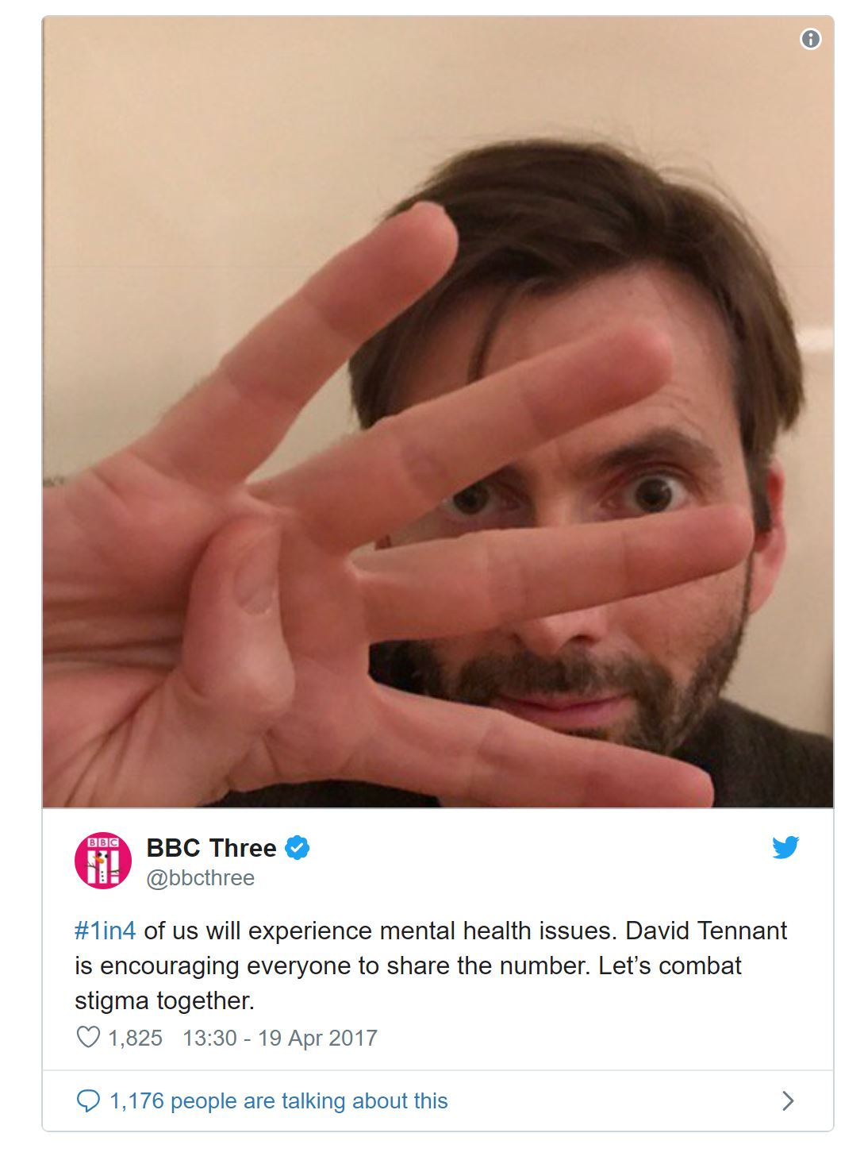
Overall it was deemed that the finding indicates a self-favouring bias and there were no differences in self-reported narcissism between regular and non-regular selfie takers. The indicative of narcissism may only be relevant to the viewers. If not for our own profiles how else can a selfie be used online?

Fig 2. #4in1 Campaign

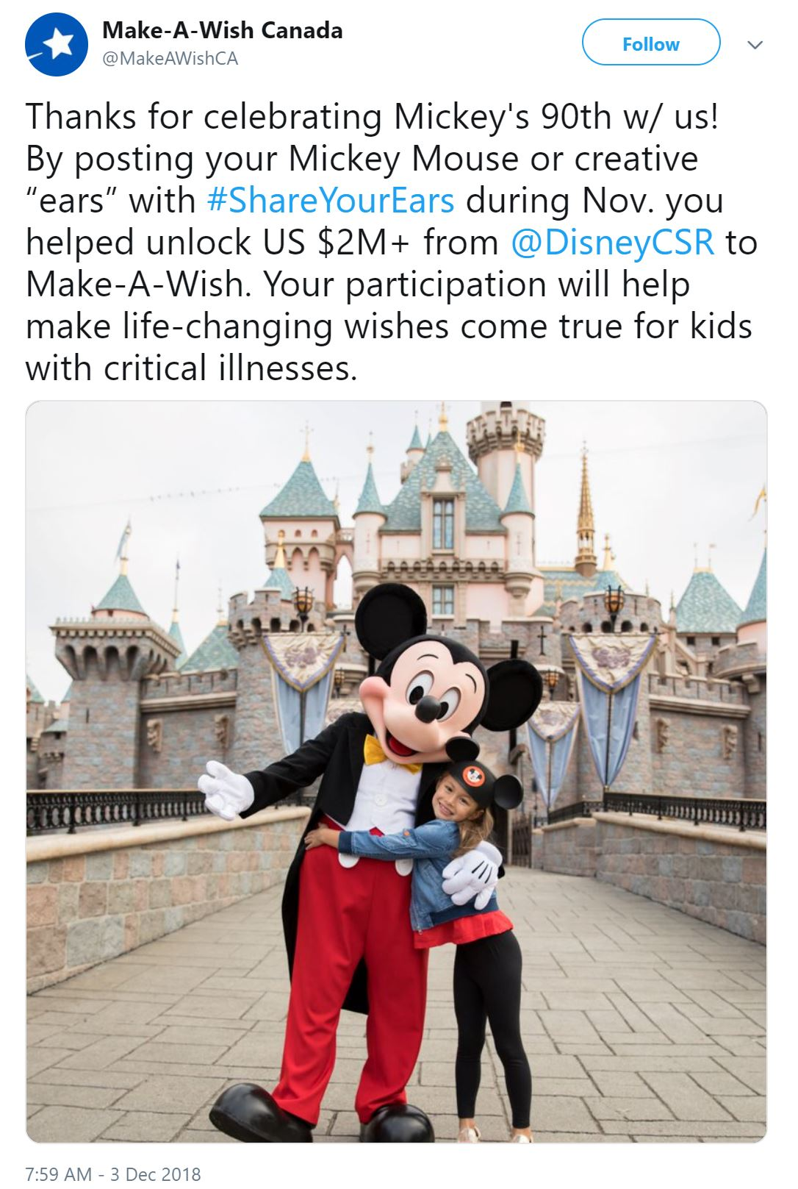
In 2017, many celebs took to Twitter to support a selfie mental health campaign. The #1in4 Campaign was part of the BBC's mind matter campaign. The goal was to highlight that one in four people are affected with mental health. (BBC, 2017) The campaign launched on the 18th of April 2017. The campaign encouraged the public to upload a selfie of themselves holding 4 fingers to represent the statics. This was a simple low budget campaign which was aimed to increase awareness, which was successful. But can selfies be used for fundraising?

Fig 3. #Shareyourears campaign
Selfie have been used to help raise money for causes. In 2018, to celebrate Mickey Mouse turning 90th. Disney hosted a two phase campaign encouraged the public to '#shareyourears' in reference to the Mickey Mouse headbands commonly sold at Disney parks. Disney promised to donate $5 to the Make a Wish Foundation for every selfie uploaded with hashtag until the goal of $2 million was reached. (6 ABC, 2018)
As of November 16^{th,} 400,000 people had joined the campaign. Disney then increased their goal to $3million. This shows the impact social media can have on a funded campaign. Ultimately Disney would have donated the money to the charity however by adding social media awareness to the campaign Disney can always profit from the advertisement generated. Which works both in favour of the charity and Disney.

Overall in this chapter, I have explored notions of identity and how identity plays a key part in how we develop our online personalities. When crafting our 'online self' one may decide to only highlight the positive aspects of one’s self rather than the negatives. When posting online we must consider the implications of this. Is an online profile a true representation of the person behind it? Personally, I believe an online profile only showcases the self we wish to be. The perfect version we aimed to be but cannot be achieved due to the normal stresses online. Daisy Ridley, an actress famous for her role in 'Star Wars' was interviewed on why she quit Instagram; “It's such a weird thing for young people to look at distorted images of thing they should be.” ( BBC News, 2017) she goes on to say; “I'd prefer to have a conversation than someone asking for a picture, but I guess people feel the need to prove they've had the interaction on social media.” (BBC News, 2017)

This furthers my belief that we validate an online profile more than the person itself. We should try not to compare ourselves to others who share their lives online as it is difficult to determine if this is a true representation of their lives. As humans we are allowed to make mistakes but in the age of the internet and social media we are almost denied this ability. So what happens when we make mistakes online from a personal and corporate point of view? In the next chapter I will analyse the effects our actions have online.

Chapter 2 : When the Internet Reacts

With the freedom to be able to post, share and watch what we like with our online audience, what happens when what we share is misinterpreted or the reaction we expected is not what we receive? In this chapter I will be exploring the effect of when social media influencers and company get it wrong and what possible effect can occur when the internet reacts.
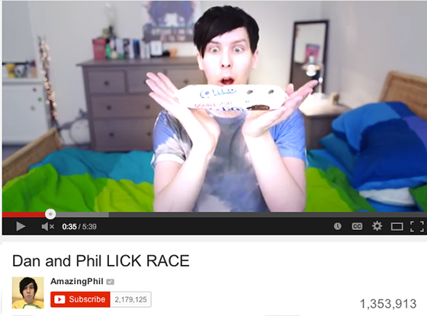
Fig 4: Lester Oreo Advert

In 2014, Oreo's brand owner Mondelez enlisted a group of British YouTubers with a large following to take part in the 'Oreo Lick Race' to promote Oreo Biscuits on the video streaming site YouTube. However, the ads were created to be entertaining, the ads received a single complaint from a journalist from the BBC who raised the questions, where the video blogs clearly labelled as ads? (Bold, 2014). Mondelez stated;

It has not intended to mislead viewers and admitted that the YouTubers had been recruited and paid to produce the content. (Bold, 2014)

One of the British YouTubers who took part in the advertisement was Phil Lester who at the time in 2014 had 2.2 million subscribers to his YouTube channel. Lester and his friend Daniel Howell took part in the advertisement. Lester clearly stated in the video that Oreo had emailed him and asked him to participate in the ad and disclaimer in the description box of the video which read; “Check out the Oreo Site for more licking action. Thanks to Oreo for making this video possible.” (Bold, 2014)

The British Advertising Standards Authority (ASA) decided to ban the advertisement because the ads did not clearly state that the video was produced as part of a marketing campaign. (Bold, 2014). Mondelez argued that all the YouTubers in question clearly referred to the fact that they were working with Oreo and the description boxes under the video made it sufficiently clear to the viewers that they were in fact paid advertisements. While the ASA agreed that the “thanks to Oreo” was referenced in all the videos in question, the ASA noted that the videos did not differ to the usual editorial style content by that YouTubers which also made the intent of the video unclear. (Bold, 2014)

“Because the statements did not fully establish the commercial intent of the videos, and because no disclosures were made before consumer engagement with the material, we concluded that the ads were not obviously identifiable as marketing communications,” ASA stated. (Sweney, 2014)

Ian Twinn, a director of public affairs in the UK advertisers' trade body ISBA, stated that he welcomed the ASA ruling and that YouTubers must also obey the rules when it comes to paid advertisements. In the UK the rules are that in a tweet a #ad must be included and on social media site Facebook and YouTube it must state it is an advert. (Sweney, 2014). Though the video did not promote any harmful content only the encouragement to take part in a marketing scheme.

It is important to consider when uploading and posting about a product online, will our opinion affect the sales and is it clearly stated that the video is intended as part of a paid or unpaid production. This is especially important when taken into consideration the demographics of the age group that the YouTuber are appealing too. For example, a YouTuber whose main audience demographic is children aged 9-12, it would be considered inappropriate to do a paid promotion which was about alcohol as the product is not for the audience age range. But what if the video uploaded is not a paid promotion but is, in fact, a video created by the user? Can they still receive criticism for the content they have decided to film and upload?

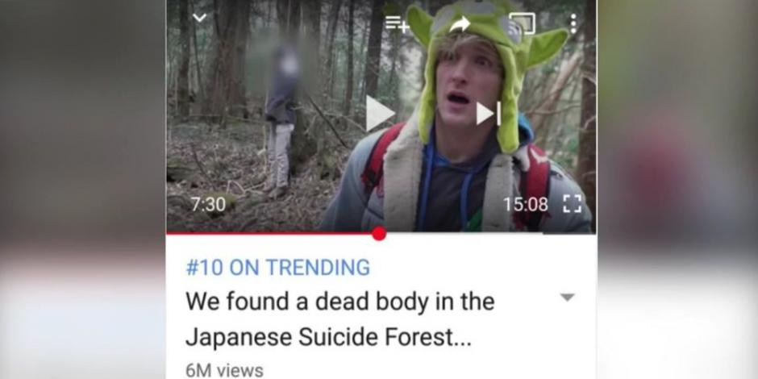

Fig 5: Logan Paul Thumbnail for Suicide Forest

At the end of 2017, Logan Paul, a 22-year-old YouTuber who at the time of the incident had over 15 million subscribers (Gillespie, 2018) Paul is famous for videos in which he boasts, pranks, and does daring stunts. On December 31st Paul uploaded a video from Aokigahara forest which is located at the base of Mt. Fiji's and is nicknamed the suicide forest locally. Due to the high number of individuals who chose to end their lives there. (O'Connor, 2018) The video depicts Paul and his friends roaming around the forest, halfway through the video the group comes across the body of a young man who has chosen to take his own life. Paul did not stop filming, though the group appeared to be in shock they continue to make jokes and begin smirking at the site in front of them. Paul then proceeded to film the body at various angles, even daring to zoom in on the hands. (Gillespie, 2018)
Paul received waves of harsh criticism from various social media sites such as Twitter and Facebook. Paul then removed the video and issued a written apology which was initially rejected by the general public as it felt Paul was brushing off the incident. Paul then released a video, in the video, Paul condoned his actions and reactions to the situation and later announced he would be taking a break from YouTube (Gillespie, 2018). Paul raised some serious ethical questions into the freedom in which the internet allows us.
Who should be to blame when the uploader abuses their right to post on social media? The user or the social media site distributing the content?

In my personal opinion I believe both are to blame. The uploader created the content for a reason. In Paul's case he wanted his video to become a viral hit, hence in the thumbnail shown in fig 3. He used a blurred image of the deceased man to draw in videos who would be nitrated by the image.
However, YouTube should have deemed the content inappropriate the moment it was uploaded to the site, due to the content displayed. Tarleton Gillespie, explains that YouTube is a distribution platform and has rules and regulations in place which governs the platform content, however, this does not mean that all users follow these regulations. YouTube current community guidelines do not allow;

nudity or sexual content, harmful or dangerous content, hateful content, violent or graphic content, harassment or bullying, spam or misleading metadata, threats, copyright, privacy, impersonation, child safety or additional policies.
(Youtube, 2017)

Paul's video in my opinion would have violated YouTube's Violent or Graphic content guideline however when researching into the guideline. YouTube states “If posting graphic content in a news or documentary context, please be mindful to provide enough information to help people understand what's going on in the video.”(YouTube, 2017). We could argue Paul did only provide information of the incident and did not show any visual graphic content, as it was censored so it did not violate YouTube guidelines. The Logan Paul Suicide forest video was not the first time the video sharing platform, YouTube, has come under fire for inappropriate content. ( Gillespie, 2018).
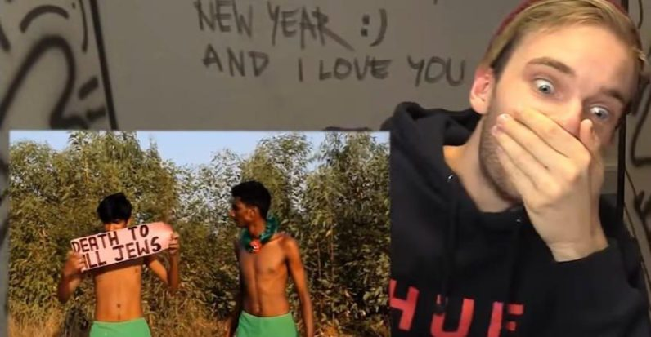
Fig 6: Pewdiepie Anti-Semitic Joke (Ghoshal, 2017)

YouTuber Pewdiepie real name Felix Kjellberg faced controversy in 2017 for including anti-Semitic humour and Nazi imagery in his vlog in which he paid two men to write a sign with the following statement “Death to all Jews.” (Gilbert, 2017) The backlash led to Kjellberg having his Disney contract terminated and YouTube cancelling future projects with the YouTube star.

Kjbellberg was quoted saying,

This originated from a video I made a couple of weeks ago. I was trying to show how crazy the modern world is, specifically some of the services available online.
I picked something that seemed absurd to me—That people on Fiverr would say anything for 5 dollars. I think it’s important to say something and I want to make one thing clear: I am in no way supporting any kind of hateful attitudes. ( Gilbert, 2017).

The main key linked between Kjellberg and Paul is both have a large following which is predominately young. Many argued due to this fact both Kjellberg and Paul's audience are predominately children, both needed to consider the content that is published is age appropriate. YouTube, however also has to be held accountable.
Many argued that YouTube should have removed the suicide forest video before Paul did. Though Paul received a “strike” against his account as a form of punishment, it is not evident that he broke any of the YouTube guidelines for displaying the victim. (Gilliespie, 2018). From the comments to critics who viewed the video, critics of the video took offence to the total disregard for the situation, Paul's senseless self-absorbed commentary and lingering on certain details of the experience e.g. showing the blurred body. (Gillespie, 2018) If the video had been shot in the form of a tasteful documentary which aimed to educate and not exploit would this change the audience's view? Paul's video was extremely un-tasteful but with YouTube's increasing platform growth, does this push more YouTubers to do more extreme things? Since the incident at the end of 2017, not much has been done to stop something like this happening again and Paul claimed he had lost 5 million dollars after being removed from YouTube preferred program (Clark, 2018) but Paul continues to still upload content on the platform and projects which were originally cancelled at the start of the year have now been put back into production such as a sequel to his film “ The Thinning” and according to the metro newspaper he has since earned millions from his publicised fight with fellow Youtuber KSI which was live-streamed on YouTube. (Kelly, 2018)
Whilst videos are a key mention of expressing our opinions what happens when a single sentence affects a whole group of people? With online social media, it is impossible to control who sees our content. With online business pages such as clothing brands, one can opt-in to receive emails with offers and other promotions for the website to keep up to date with what is going on with the brand.
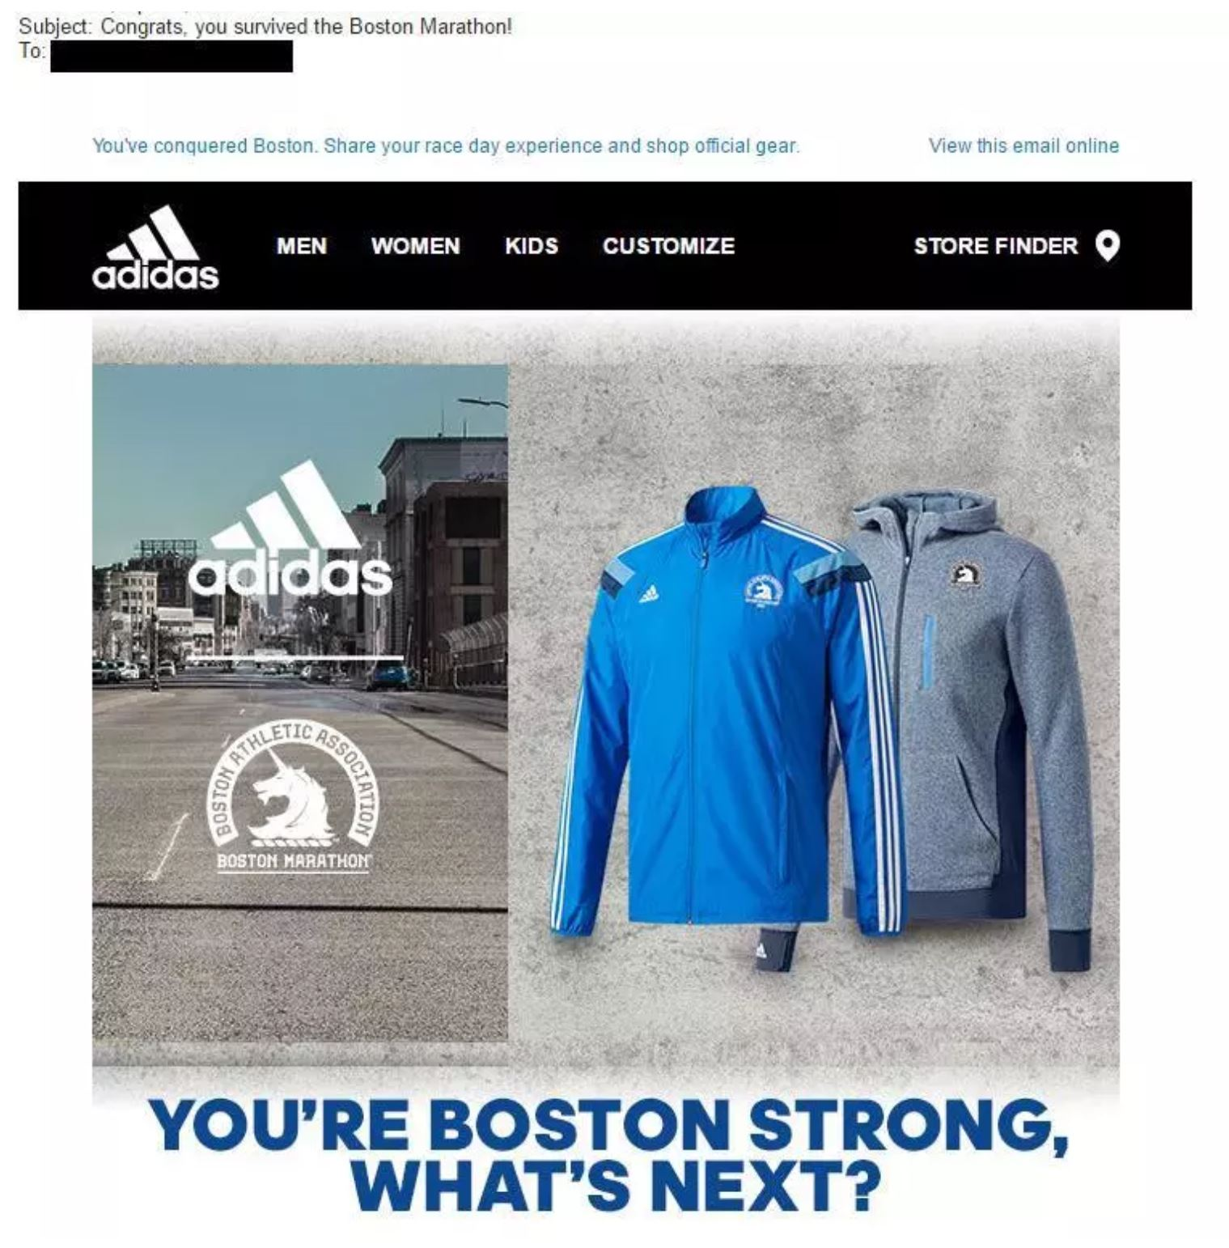
Fig 7: Adidas Boston Marathon Email (Annear, 2017)

In 2017, Adidas issued an apology after customers received an email with the following heading “ Congrats, You survived the Boston Marathon!”. (Boult, 2017). Adidas was called out on this by various media sites such as Twitter for the insensitive marketing deeming it 'too soon' due to the bombings which took place during the 2013 Boston Marathon (Boult, 2017) Adidas issued a statement explaining;

"The Boston Marathon is one of the most inspirational sporting events in the world," the statement continued. "Every year we're reminded of the hope and resiliency of the running community at this event." (Boult, 2017)

This is a great example of how a poor marketing choice can affect a business. Though the email was not viewable it does not mean that the email will not appear in the form of screenshots on various social media sites. One must take into consideration the possible reaction to any campaign uploaded online. Compared to printed media one could argue that digital media reaches a larger audience due to the accessibility of it's content. Some brands will use controversial content in order to promote the brand itself.

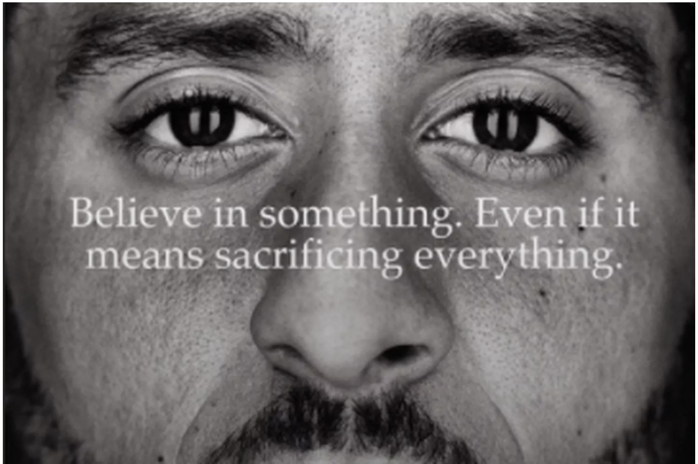
Fig 8: Nike advert featuring Colin Kapernik ( Abad-Santo ,2018)

Nike announced in 2018 that Colin Kaepernick, an American Football and Civil rights activist. (Kelner, 2018) Kaepernick became a controversial figure in 2016 when during the national anthem he refused to stand, in order to protest and draw attention to the killing of African Americans at the hands of the police. ( Kelner, 2018). Kaepernick during the 2017 season encouraged fellow team members to join in his stance which caused the American president Donald Trump to react, he was stated to say “Get that son of a bitch off the field right now. Out! He’s fired. He’s fired!” (Kelner, 2018) Trump felt the actions were Kaeprnick disrespecting the flag and his country (Abad-Santo 2018) Kaepernick was left without a club and no team would offer him a contract. The Nike advert used Kaepernick to re-enforce the message of the campaign “ Believe in something. Even if it means sacrificing everything.” (Kelner, 2018). The advert caused mix reactions, many Donald Trump supporters took to Twitter to promote boycotting Nike for their decision. Many Trump supporters also sent Nike videos of them burning there Nike apparel.
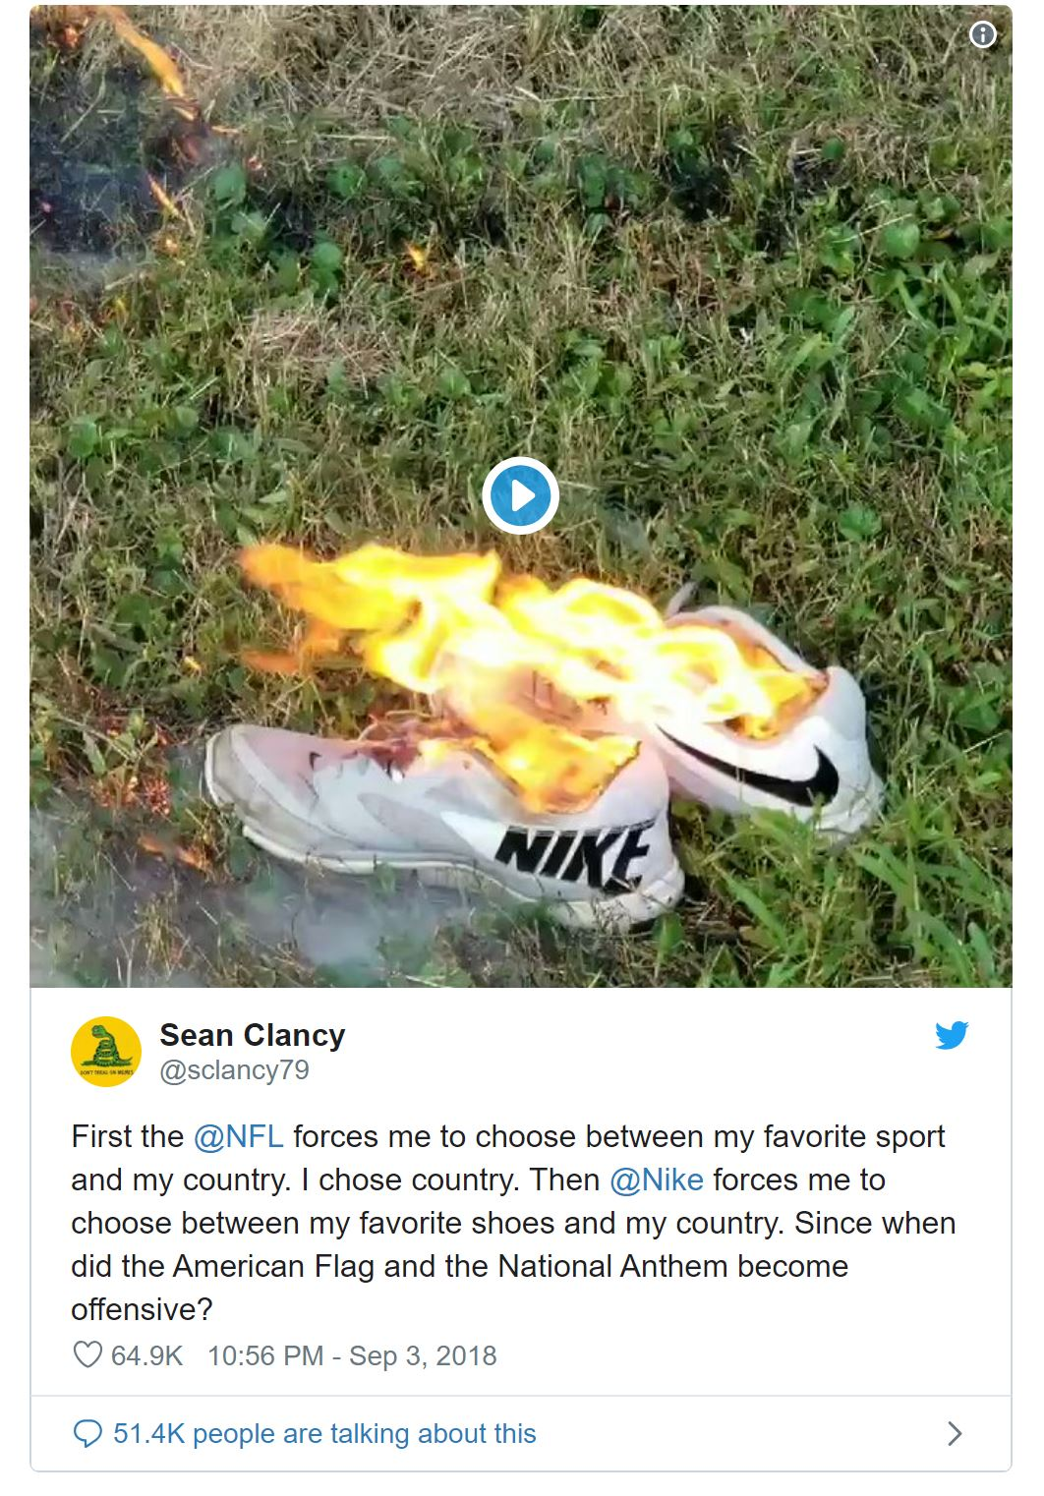
Fig 9 : Sean Clancy Tweet of him burning his Nike shoes (Abad-Santo, 2018)
Sean Clancy post was one of the first to go viral and ignited the hashtag #BurnYourNikes. Clancy post showed him burning a pair of his Nike trainers ( Abad-Santo, 2018).But did Nike expect this outcome when they picked to have Kaepernick as part of their campaign?

Nike is an extremely successful company and they know how to create a strong marketing campaign. As soon as the advert was announced it made headline generating press for Nike regardless of if the content was positive or negative. Nike share price dropped by 2% when the campaign was initially announced ( Kelner, 2018). Nike deemed Kaepernick worth the risk.

You burning your Nike gear costs Nike nothing, & gives them free advertising.
They are going to sell more to others because of the campaign.
You think a multi-billion-dollar company didn't study the cost/benefit fallout before launching the campaign? Lol.#NikeBoycott (Allbright, B, 2018)

Nike took a very public stand and subconsciously sent the message to Trump and his supporters that they do not agree with his statements. With most things online, it wasn't long until the campaign message was lost in the hordes of tweets and the campaign took on a whole new meaning. John Rick, a R&B singer tweeted his fans a photo of a pair of cut up Nike socks with the following description;
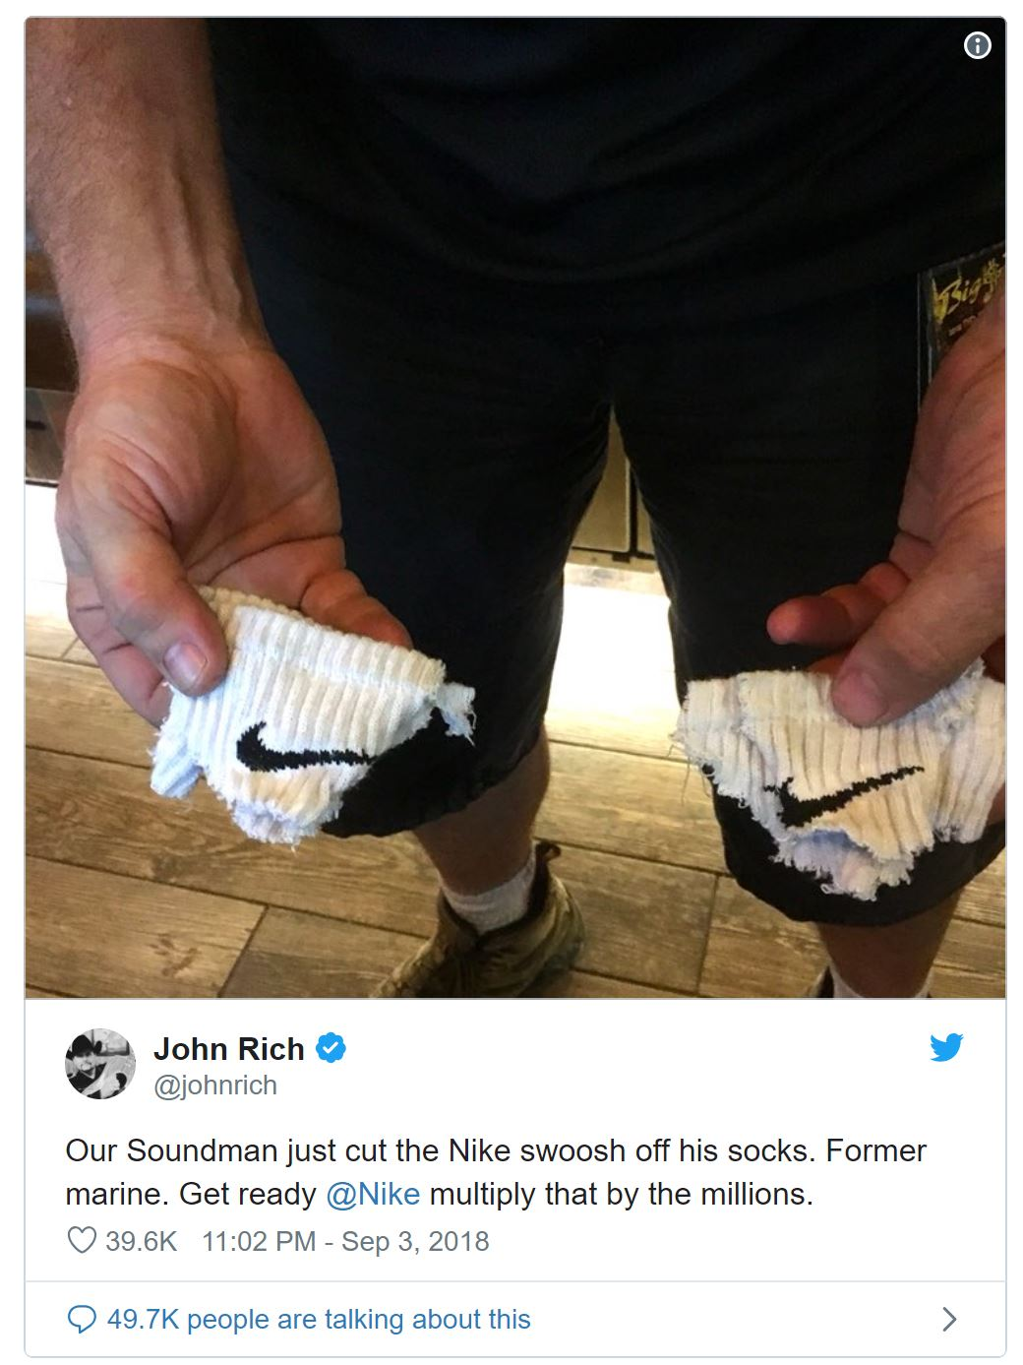
Fig 10 : John Rick Tweet about Nike (Kelner, 2018)

Our Soundman just cut the Nike swoosh off his socks. Former marine. Get ready @Nike multiply that by the millions. (Rick, 2017)

Rich tweet went viral and many felt his tweet was a poor attempt to cover up the true meaning of the campaign which was aimed to stop police brutality and make the troops a scapegoat for his actions.

Stop using the troops as an excuse to burn your Nike shit. I’m not your scapegoat. I’m gonna sit over here and continue to buy my Nike stuff, they give military a discount #NikeBoycott (Bellaw, 2018)

Though many used Twitters to tarnish Nike's brand reputation and tried to compose a scapegoat for their actions against the brand, it also had the opposite effect as the feelings which made someone burn there Nike's shoes could also encourage someone to purchase a pair. It would be difficult to say whether this advertisement campaign was a success as it depends on what your political view on the situation to start with and this make it a very effective campaign.

Conclusion

From exploring my various topics, I have been able to formulate my own opinion to my question proposed at the beginning of this essay. Social media, does honesty exist online? Can we believe everything we see and read online from both individuals and commercial users? I think it is difficult to believe everything we read or view online, we cannot determine if a post is fact or fiction from an individual or commercial business. In the same context we can take a news article out of content this is easily done online as well. The internet is the only place where perfection is openly encouraged. When expressing our own lives online we tend to only post the positive things or the best moment of our days leaving out any mistakes we have made or any negative experiences. Our selfies are edited to ensure we look our best and we wait for the likes and comments to reinforce how we want to feel. Using the internet is similar to shouting in public if we are wanted to be noticed, but the internet doesn't allow for mistakes. The internet is not kind, when an individual or company makes a mistake and a group of individuals choose to take offence, the reaction can be damaging both to the business or individual and affect the finance income and reputation. Stories are being posted daily of incidents where the internet has reacted to a post. But also, we now see stories from our normal day to day lives being shared online and reacted too. It is has become to common place where we now see an individual threaten and filmed. The video is then shared with an online audience. An example of this is United Airlines being targeted after a video went viral on twitter showing their security team removing a passenger from the plane after the flight was overbooked (Grothaus 2017). The incident in question was handled poorly by security but without the internet the video in question would have not been made public and would have been dealt with in a more formal manner. Some companies and individuals will use this mistake for their own commercial gain as any publicity is good, and due to the numbers of users online these could be more effective than using traditional advertisement methods such as print or ads. The Nike advert is a great example of how to engage a reaction from a large audience. When using social media, we must consider the reaction our images or words can have on our audience. In my opinion it is difficult to define and rate honestly online as many factors play a part in our interpretation of post, image, or video. What someone deems to be true could be considered false to someone else. What we deem as honest is subjective to only to use.

Bibliography

Books

Haig M (2018) Notes on a nervous planet .Canongate Books Ltd, Edinburgh

Turkle, S. (2017) Alone Together : Why we expect more from technology and less from each other, 2nd Ed. Hachette Book Group, New York

Whitty M (2016) Cyberpsychology : The Study of Individuals, Society and Digital Technologies
, Wiley-Blackwell , New Jersey

Vonnegut. K (1966) Mother Night,Dial Press Trade Paperbacks, New York

Journal

Barry, C., Reiter, S., Anderson, A., Schoessler, M., Sidoti, C. (2017) 'Let Me Take Another Selfie': Further Examination of the Relation Between Narcissism, Self-Perception, and Instagram Posts. EBSCOhost [online] Available at : https://web-a-ebscohost-com.ezproxy.uwtsd.ac.uk/ehost/pdfviewer/pdfviewer?vid=11&sid=8ccde082-210a-458d-afdb-01c27975ea35%40sessionmgr4008 (Accessed 11/12/2018)

Higgins, E.T (1987) Self-Discrepancy: A Theory Relating Self and Affect, Psychological Review 1987 Vol 94, No. 3, 319-340. [Online] accessed at http://persweb.wabash.edu/facstaff/hortonr/articles%20for%20class/Higgins.pdf (Accessed 11/12/2018)

Re, D. E., Wang, S. A., He, J. C., & Rule, N. O. (2016). Seflie indulgence: Self-favoring biases in perceptions of selfies. Social Psychological and Personality Science, 7, 588–596. , Sage Journals, [Online] Accessed at http://dx.doi.org/ 10.1177/1948550616644299 (Accessed 11/12/2018)

Sorokowska, A., Oleszkiewicz, A., Frackowiak, T., Pisanski, K., Chmiel, A., & Sorokowski, P. (2016). Selfies and personality: Who posts self-portrait photographs? Personality and Individual Differences, 90, 119–123. Elsevier [Online] accesed at https://pdfs.semanticscholar.org/edd6/eedab7f1e2d710348ddcd72457d209beef44.pdf (Accessed 11/12/2018)

Newspaper

6 ABC (2018) November 18, 'Share Your Ears' on social media to help Disney and Make-A-Wish® grant more wishes Available at https://6abc.com/society/share-your-ears-to-help-disney-make-a-wish-grant-more-wishes-/4603506/

Abad-Santo, A( 2018) September 6 Why the social media boycott over Colin Kaepernick is a win for Nike , Vox Available at https://www.vox.com/2018/9/4/17818148/nike-boycott-kaepernick

BBC (2017) #1in4, BBC Available at : athttp://www.bbc.co.uk/programmes/articles/1hR3ch9mP01fnwSVZtCC7vH/1in4

BBC News , (2017 ) December 7, Daisy Ridley: Social media is bad for mental health, BBC , Available at https://www.bbc.co.uk/news/entertainment-arts-42250542

Bold, B (2014) November 26, Oreo YouTubers ads banned for failing to clearly indicate marketing partnership, Campaign Live, Available at https://www.campaignlive.co.uk/article/oreo-youtubers-ads-banned-failing-clearly-indicate-marketing-partnership/1323808

Boult, A (2017) April 18, Adidas apologises for 'you survived Boston Marathon' email, The Telegraph, Available at https://www.telegraph.co.uk/news/2017/04/19/adidas-apologises-survived-boston-marathon-email/

D’Onfro, J. (2013) October 3. Twitter admits 5% of its “users” are fake. Business Insider, Available at: http://www.businessinsider.com/5-of-twitter-monthly-active-users-are-fake-2013-10 #

Flynn E, (2018) September 19, WHO'S BEHIND THE SCREEN? What does the phrase catfishing mean, and what’s the law on stealing someone’s identity online in the UK? The Sun, Available at : https://www.thesun.co.uk/fabulous/1754916/catfishing-meaning-identity-steal-online-dating-law/

Gilbert , B (2017) February, 16. YouTube's biggest star is in hot water over anti-Semitic 'jokes' — here's what's going on, The Business Insider, Available at http://uk.businessinsider.com/pewdiepie-anti-semitism-jokes-controversy-explained-2017-2/#first-some-background-on-felix-kjellberg-aka-pewdiepie-hes-a-27-year-old-swedish-man-who-dominates-youtube-his-channel-has-over-53-million-subscribers-over-20-million-more-than-the-second-most-popular-channel-1

Gillespie, T (2018) January 16, The Logan Paul YouTube controversy and what we should expect from internet platforms, Vox, Avaiable at ; https://www.vox.com/the-big-idea/2018/1/12/16881046/logan-paul-youtube-controversy-internet-companies

Kelly, E (2018) October 31, ‘Good luck trying to cancel me’: Logan Paul reflects on ‘suicide forest’ video that nearly ended his career, Metro, Available at ; https://metro.co.uk/2018/10/31/good-luck-trying-to-cancel-me-logan-paul-reflects-on-suicide-forest-video-that-nearly-ended-his-career-8093357/?ito=cbshare

Kelner, M (2018) September 4 Nike’s controversial Colin Kaepernick ad campaign its most divisive yet
The Guardian, Available at https://www.theguardian.com/sport/2018/sep/04/nike-controversial-colin-kaepernick-campaign-divisive

Kercheaval, B (2016) August 26, Texas Tech coaches are using fake social media accounts to spy on players, CBS Sports Available at https://www.cbssports.com/college-football/news/texas-tech-coaches-are-using-fake-social-media-accounts-to-spy-on-players/

O'Conor R (2018) January 2, Logan Paul: YouTube star condemned by celebrities over 'dead body' video in Japanese 'suicide forest', The independent available at https://www.independent.co.uk/arts-entertainment/logan-paul-suicide-video-youtube-forest-aokigahara-japan-celebrity-reaction-removed-comments-latest-a8137411.html

Sweney, M (2014) November 26, Vloggers must clearly tell fans when they’re getting paid by advertisers, ASA rule, The Guardian Available at; https://www.theguardian.com/media/2014/nov/26/vloggers-must-tell-fans-paid-adverts-asa-rules

Website

Allbirght, B (2018) [ Twitter ] 4 Sept 2018. Available at; https://twitter.com/AllbrightNFL/status/1036979989281787906?ref_src=twsrc%5Etfw%7Ctwcamp%5Etweetembed%7Ctwterm%5E1036979989281787906&ref_url=https%3A%2F%2Fwww.vox.com%2F2018%2F9%2F4%2F17818148%2Fnike-boycott-kaepernick (Accessed at 9/ 12 /2018)

Bellaw, K (2018) [Twitter] 4 Sept 2018 Available at; https://twitter.com/KatlinBellaw/status/1036968838745604096?ref_src=twsrc%5Etfw%7Ctwcamp%5Etweetembed%7Ctwterm%5E1036968838745604096&ref_url=https%3A%2F%2Fwww.vox.com%2F2018%2F9%2F4%2F17818148%2Fnike-boycott-kaepernick (Accessed at 9/ 12 /2018)

Cherry , K (2018) Erik Erikson's Stages of Psychosocial Development, [Online] Available at https://www.verywellmind.com/erik-eriksons-stages-of-psychosocial-development-2795740 (Accessed at 9/ 12 /2018)

Cherry , K (2018) Identity vs. Role Confusion, [Online] Available at : https://www.verywellmind.com/identity-versus-confusion-2795735 (Accessed at 9/ 12 /2018)

D'Costa, K(2014) Catfishing: The Truth About Deception Online [Online]
Avaliable at :https://blogs.scientificamerican.com/anthropology-in-practice/catfishing-the-truth-about-deception-online/ (Accessed at 9/ 12 /2018)

Firestone, L(2012) Is Social Media to Blame For the Rise In Narcissism? [Online}
https://www.psychologytoday.com/gb/blog/compassion-matters/201211/is-social-media-blame-the-rise-in-narcissism (Accessed at 9/ 12 /2018)

Grothaus, M (2017) United Airlines has a social media nightmare on its hands [Online] available at ; https://www.fastcompany.com/4034462/united-airlines-has-a-social-media-nightmare-on-its-hands
(Accessed at 9/ 12 /2018)

Oxford Dictionary (2016) Narcissism [Online} Available at ; https://en.oxforddictionaries.com/definition/narcissism (Accessed at 9/ 12 /2018)

Rick, J (2018) [Twitter] Available at https://twitter.com/johnrich/status/1036751396002050050?ref_src=twsrc%5Etfw%7Ctwcamp%5Etweetembed%7Ctwterm%5E1036751396002050050&ref_url=https%3A%2F%2Fwww.vox.com%2F2018%2F9%2F4%2F17818148%2Fnike-boycott-kaepernick
(Accessed at 9/ 12 /2018)

Schmidit, E (1999) [Quote] Available at : http://www.oxfordreference.com/view/10.1093/acref/9780191826719.001.0001/q-oro-ed4-00017947
(Accessed at 9/ 12 /2018)

We Are Social (2018) DIGITAL IN 2018: WORLD’S INTERNET USERS PASS THE 4 BILLION MARK [Online] Available at ; https://wearesocial.com/blog/2018/01/global-digital-report-2018
(Accessed at 9/ 12 /2018)

Youtube (2017)Policies and Safety [Online] Available at https://www.youtube.com/intl/en-GB/yt/about/policies/ (Accessed at 9/ 12 /2018)

